GENETIC VARIATION STUDIES OF DIFFERENT SPECIES OF CUSTARD APPLE USING RAPD MARKERS.
ABSTRACT-
Custard apples are consumed as fruit all over the world and are also used to create beverages and medications. The custard apple's acetogenin components have been shown through research to have anti-cancer capabilities. They are hence a part of the regular diet. In this regard, we have made an effort to give a geographical overview of the custard apple types found in Karnataka and have carried out genetic variation investigations to comprehend their genetic link. Selective Random Amplified Polymorphic DNA (RAPD) markers were employed in PCR analysis to determine the polymorphic loci between the genotypes sampled. Using Basic Local Alignment Search (BLAST) and Clustal Omega DNA barcoding was done to confirm the species. To find the polymorphic loci between the 4 genotypes, PCR analysis was conducted using the chosen RAPD. In order to conduct a more thorough RAPD analysis, primers OPB-11 and OPD-13 were chosen. PyElph1.4 and Past 326b software were used to create a phylogenetic tree using 2 primers. The genetic distance was calculated from raw data, and the Point parameter that drove the Joining linkage algorithm is UPGMA. The dendrogram demonstrated that clustering of the varieties was possible. Another dendrogram was created using the Unweighted Pair Group Mean (UPGMA) linking rule using genetic distance computed from a matrix database. The observed results highlight the interdependence of Annona species. The results show how closely related Annona cherimoya, Annona reticulata, Annona muricata, and Annona squamosa species are, and they also provide information on how genetics and plant breeding can be used to create effective hybrid varieties.
Keywords- Genetic variation, RAPD, Custard apples, Dendrogram , UPGMA.
INTRODUCTION
The Annonaceae family, one of the largest Magnoliidae groups, contains around 2400 species, most of which are Patropical, dispersed throughout 108 genera. Trees, shrubs, and lianas are all members of the Annonaceae family of flowering plants. The custard apple family and the soursop family are other names for them. This is the biggest Magnoliale family. It belongs to the type genus of the Annona genus, which includes many other genera that produce edible fruit, including Annona, Anonidium, Asimina, Rollinia, and Uvaria. The family is mostly found in the tropics, with few species found in temperate regions. About 900 of the remaining species are Indo-Malayan, and 900 are Neotropical[14]. Most species have fragrant barks, leaves, and flowers, however some are mid-latitude, deciduous or evergreen trees and shrubs with occasional lianas. Annonaceae and Eupomaticeae, a small family of magnoliid plants, are interconnected. Annona muricata tree parts are analogous to those of other Annona species, such as A. squamosa and A. reticulata, which are widely used as traditional remedies to cure a variety of human ailments and disorders, including cancer and parasite infections. The fruit is used to treat rheumatism, diarrhoea, dysentery, fever, malaria, neuropathic pain, and arthritis naturally. To increase a mother's milk after giving birth, skin rushes and is also eaten. Diabetes, cystitis, headaches, and insomnia are all treated with the leaves[18]. The cooked leaves are used to cure rheumatism and abscesses, and taking the leaf decoction internally is reported to provide anti-rheumatic and neuralgic effects. The custard apple is one of the most important commercially farmed fruit crops. There are no native Annona species in Asia's continent. In warm, primarily dry areas, the custard apple thrives. For its fruit, the tree is commonly cultivated in India, where it can also be found in the dry deciduous woods of Rajasthan, Andhra Pradesh, and the Deccan Plateau. The tropical fruit anona is mentioned in at least three different species in both ancient Indian art and mythological literature.
Scientific Name | Sample Code
Annona cherimola | AC
Annona reticulata | AR
Annona muricata | AM
Annona squamosa | AS
Table.1- Nomenclature of the Sample.
MATERIALS & METHODS –
2.1 Sample Collection –
The leaves of four different varieties of custard apples were taken from Bangalore's LALBAGH BOTANICAL GARDEN. For later usage, the samples were carefully gathered and stored.
2.2 DNA Isolation-
The CTAB technique is used to recover genomic DNA from Custard Apple leaves (Cetyltrimethyl Ammonium Bromide). Using a mortar and pestle, 0.5 g of the material was crushed. Using CTAB Buffer, the Extract was homogenised. In a 2 ml tube, the Sample Extract was gathered and incubated at 60 ° C for 30 minutes. After centrifuging the sample at 10,000 rpm for 10 minutes, the supernatant was collected in a fresh, clean tube. The topmost aqueous layer is carefully transferred into a different, brand-new tube after the equal parts of isoamyl alcohol and chloroform are added and centrifuged (10000 rpm for 10 minutes). Addition of cold isopropanol and overnight incubation at –20 °C precipitate DNA. Place the entire mixture in a silica-based DNA column tube. Add 750 l of wash buffer to the DNA sample. Centrifuge the combination at 10,000 rpm for 1 minute, discard the fluid, then repeat the process while spinning the tube dry for an additional 2 minutes. Place the silica columns in a brand-new collection tube, add 20 l of elution buffer, spin the mixture at 10,000 rpm for 1 minute, and then add 1 l of RNase and incubate the mixture for 30 minutes at 37 °C. For accurate quantification, the extracted leaf DNA was later run on an agarose gel electrophoresis. Using the Gel Doc's built-in camera, the appearance of DNA bands was captured. This DNA was then obtained again for the amplifying procedure.
2.3 Amplification of DNA by using PCR Technique-
PCR method is used to amplify the single or several copies of a segment of DNA by using Primers. PCR can be performed by using Template DNA (7μl) ,Forward and Reverse primers (1μl each), master mix( dNTPs ,Taq polymerase and Buffer-12.5μl)makeup the volume for 25μl by adding Nuclease free water and primers relevent to ITS2 gene .Quick spin the plate so the mixtures are properly mixed. Place the plate in Thermal cycler and set the program . The resultant PCR products were run on Gel Electrophoresis and compared the gene size with standard ladder later subjected to gel elution.
2.5 Sanger Sequencing-
The ITS02 nuclear gene and Sanger sequencing methods were used to bar code all 4 genotypes because it is essential to identify the species being examined when doing any investigation. The Internal Transcribed Spacer (ITS) region, which is a portion of the nuclear genome, is an unproductive RNA sequence that lies between the 18S and 25S rRNA Coding Regions. ITS1 and ITS2 are found in the region of the rRNA between 18S and 5.8S and 5.8S and 25S, respectivelyIn 1977, Kahl invented this technique. This purified gene product was then taken further for sequencing after the obtained bands were chopped and eluted on a 20-l gel. Primer, Template DNA, Buffer, and BDT, which includes Taq Polymerase, dNTPs, ddNTPs, and Fluorescent Big Dye Terminator The essential components were added, and then the PCR sequencer was set.
 | Temperature | Time | Cycle
Initial Denaturation | 95⁰C. | 5 minutes. | 01 cycle.
Final Denaturation | 95⁰C. | 10 seconds. | 30 cycles.
Annealing | 55⁰C. | 10seconds. | 30 cycles.
Termination | 60⁰C. | 2 minutes. | 30 cycles.
Hold | 4⁰C.
Table 2- Showing Sequencing PCR Sequences.
The quality of the PCR products was assessed using 1% Agarose Gel Electrophoresis stained with Ethidium Bromide. The PCR products were purified and sequenced using the Sequencer-Applied Biosystems(Hitachi)- 3130*1 genetic analyzer.
2.6 Data Analysis-
The DNA sequencing result file.The chromatogram peaks in Finch TV were used to inspect the AB1 data, which were then converted to FASTA and PDF files for further analysis using Seq Scanner. Using BLAST, the nucleotides of DNA sequences and other primary biological sequence data were compared. Comparing the query sequence with a library or database of sequences proved useful for locating library sequences that match the query sequences over a threshold. The top 10 hits for phylogenetic analysis were those with the lowest E.values, highest identities, and most comprehensive coverage.
2.8.Genetic diversity Analysis-
For both the presence and lack of RAPD bands, all genotypes were scored. The information was entered as discrete variables into the binary matrix, with 1 denoting the presence of bands and 0 denoting their absence. It was produced using PyElph 1.4 software. This data matrix was then the focus of additional study. In order to infer genetic relationships and phylogeny, the 0/1 matrix was utilized to create a dendrogram using UPGMA and a NJ tree using the computer programme PAST326b.
3. Statistical Analysis-
Past326b software analysis was carried out. Cluster analysis joining (Tree clustering) was utilised as the method, and raw input data from each population was used independently. The linkage rule, unweighted pair group average (UPGMA), and genetic distance were all calculated from raw data and used to manage the joining process. In UPGMA, the distance between two clusters is determined by averaging all pairs of items in the two separate clusters. The family's phylogeny contributed to a greater understanding of their evolutionary relationship. Based on the variation in RAPD molecular profiles, 4 genotypes were submitted to diversity analysis in the current study. The results were seen for the 2 primers that are utilized for analysis. DNA bands were evaluated for DNA fingerprinting analysis utilising the RAPD profile created using 2 RAPD Primers.
RESULT -
The states that make up 45–50% of the overall area and have the most widespread production of custard apples are Maharashtra, Gujarat, Assam, Bihar, Chattisgarh, Madhya Pradesh, Uttar Pradesh, Tamil Nadu, and Andhra Pradesh, Telangana, and Karnataka. In terms of custard apple production, Maharashtra tops the list, followed by other states. The Red Sitaphal, Barshi, Balanagar, Purandhar, NMK-01, 02, 03, Lakshmanphal, and Ramphal varieties of custard apples are the most common ones farmed in India. Four different types of Custard Apple juvenile leaves might be collected for Molecular investigations (Fig.1). It was subjected to genomic DNA separation, and the gel electrophoresis method was used to assess their quality, as shown in fig.3.
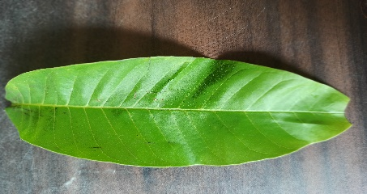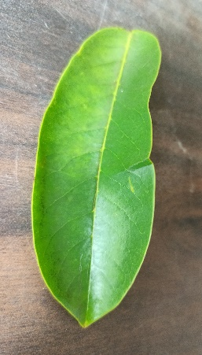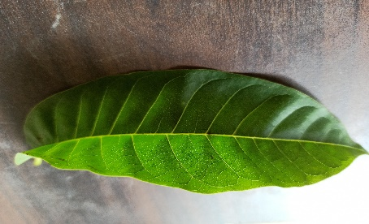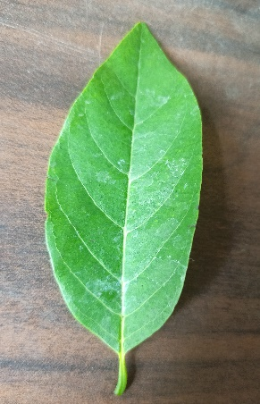
A.cherimola A.reticulata A.muricata A.squamosa
Fig 1- Young leaves of varieties of Custard Apples.
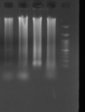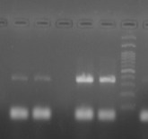
Fig.2-Genomic DNA of various Custard apple Fig.3-Showing amplified ITS02 genes
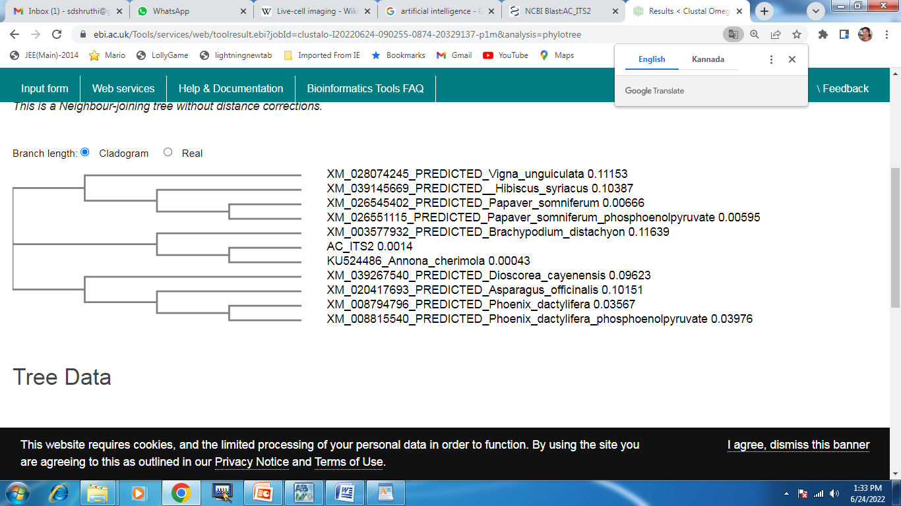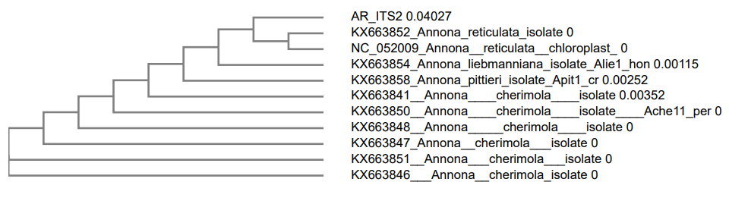

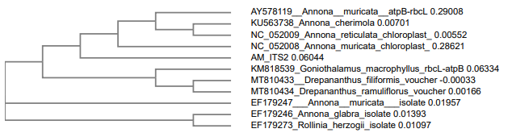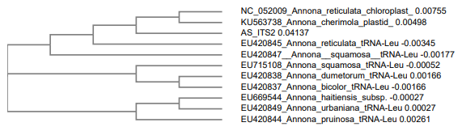

Fig.4 - Clustal Omega Phylogenetic Tree query sequence showing the closely related or identical species of Annona

The sequences acquired from capillary electrophoresis were sent to the NCBI BLAST tool in order to find unidentified sequences.
BLAST Results identifying the Species of ANNONACEAE.
SAMPLE NAME | DESCRIPTION | QUERY COVERAGE | E.VALUE | % IDENTITY | ACCESSION NUMBER | GENE
AC | Annona cherimola cultivar Conchalisa phosphoenolpyruvate carboxylase mRNA, partial cds | 91% | 0.0 | 96.98% | KU524486.1 | ITS02
AR | Annona reticulata isolate Aret2_cr maturase K (matK) gene, partial cds; chloroplast | 95% | 6e-127 | 100% | KX663852.1 | ITS02
AM | Goniothalamus macrophyllus rbcL-atpB intergenic spacer, partial sequence; chloroplast. | 88% | 0.0 | 86.96% | KM8185391 | ITS02
AS | Annona squamosa tRNA-Leu (trnL) gene and trnL-trnF intergenic spacer, partial sequence; chloroplast. | 92% | 2e-165 | 90.24% | EU7151081 | ITS02
Table.3- BLAST results identifying the species of Custard Apple varieties which was taken for study.

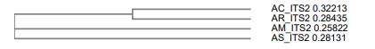
Fig.5-The Phylogenetic tree was constructed using Clustal Omega using the sequences of sample obtained by Capillary Electrophoresis.
Annona cherimola, Annona reticulata, Goniothalamus macrophyllus, and Annona squamosa are listed as the four species that have been determined. As shown in Figure - 4 phylogenetic tree is formed using the discovered species in connection to 10 neighbouring species to comprehend their evolutionary ties.
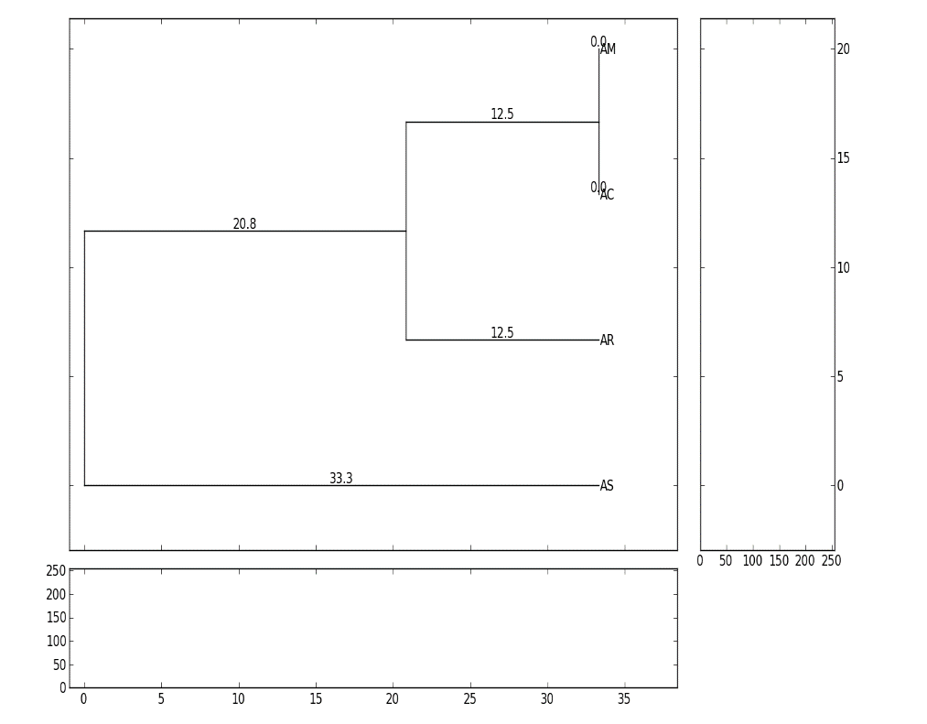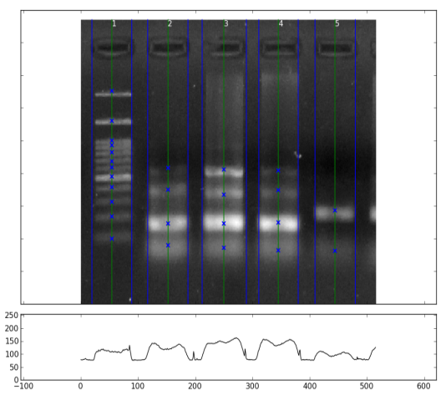
Fig.6-UPGMA Tree (OPB-11) Fig.7-Lanes & Bands (OPB-11)
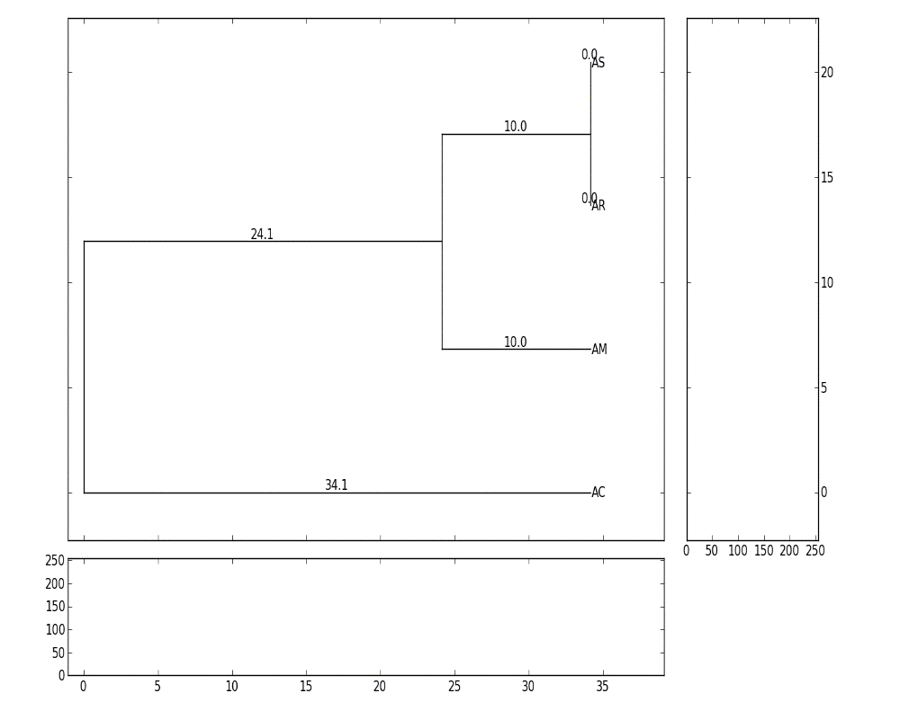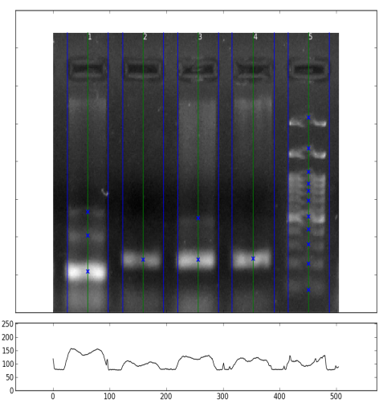
Fig.8-UPGMA Tree (OPD-13) Fig.9-Lanes & Bands (OPD-13)

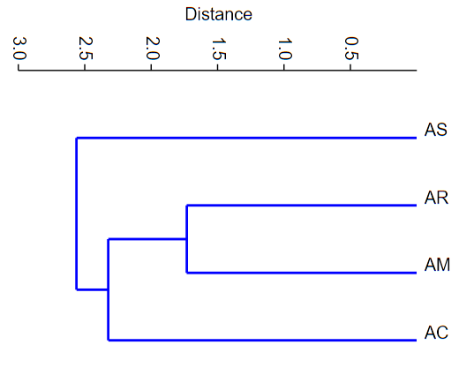
Fig.10- Using UPGMA and Euclidean distance derived from binary scores of RAPD analysis, a dendrogram depicting the clustering of four genotypes of Custard apples was created using Past326b.
The primer ITS2 was employed in genetic variation research to screen for polymorphism between species. The acquired banding pattern was studied on the gel with PyElph 1.4 to see the lanes, bands, and matching bands. A binary matrix was created based on this binary matrix, which was then utilised to create the dendrogram.The polymorphic bands obtained by four Annona species using the software are shown in Figs. 9 and 10. The resulting binary matrix was manually entered into software326b, and the output was shown in a taxonomic manner after clustering.The data from the distance matrix was turned into a UPGMA tree, which depicts the genetic link between annona species. According to the phylogenetic tree in Fig.12, the samples are connected to one another.Annona cherimoya and Annona reticulata are said to be closely linked, followed by Annona muricata and Annona squamosa, which is said to be distantly related.
DISCUSSION & CONCLUSION -
The gel pattern showed that the Annona species were distinct from one another and dispersed throughout the dendrogram, suggesting that the Annona species had been sorted. Results from the RAPD analysis using the primers OPB11 and OPD13 were transparent. Both gel plates displayed distinct bands with substantial levels of polymorphism, demonstrating that the primer-tagged sequences are spread across many loci in each species. Less similarity was observed in band matching with PyElph 1.4, though. The binary matrix produced by the same software was used for the diversity analysis. With the aid of the software Past326b, the matrix was used to create a dendrogram to display the species variety among the specimens. On the other hand, the authenticity of the study samples was verified using the Sanger sequencing method. After the ITS02 gene was amplified, the sequence was sent to Nucleotide BLAST, which looked for hits that were comparable to those that were already in the database. Using Finch TV software, the obtained.AB1 files from the sequences were examined for individual nucleotide bases and peaks before being converted to the fasta and PDF formats for data analysis. Highly bonded nucleotides and varying peak patterns were visible in these chromograms.The similarities between the identified queries were noted. Further analysis of the top 10 BLAST matches resulted in the construction of a phylogenetic tree using Clustal Omega and our query sequences. Any plant species can be authenticated using barcoding methods, which can also help with various plant conservation efforts. The first crucial stage in a precise assessment of a target species' distribution, population abundance, and threats is species delimitation and identification. Barcoding can expand information of species ranges and abundance and hasten the identification of collections, even sterile materials. With 166 recognized plant species and 41 infraspecific rank species, the Annona genus is one of the larger genera in terms of size. Despite this, there have long been disputes about the species' relationships and the genus' boundaries. Therefore, these results might be useful for improving the genus's characterization. The people choose Annona species as food sources and consider them to be edible. The initial analysis of the molecular diversity of Annona genotypes showed that grouping genotypes according to the locations of their collection centres suggested a higher level of genetic diversity. A taxon's entire genetic range has a significant influence on its long-term survival and evolution. In order to design conservation strategies, it is crucial to comprehend the level and pattern of genetic diversity. It is essential to comprehend genetic variety and probable heterotic connections among paternal lineages in hybrid breeding programmes. Future breeding between two different plants can be done as a result to create a crop with a long shelf life and rapid growth.
CONCLUSION- According to the current study, they can be employed to evaluate the genetic diversity of Custard apples. Considering those economically significant traits may help with future genomic initiatives for Custard apple taxa. The analysis has the potential to be a useful tool for organising species from various geographical areas, facilitating the preservation and use of genetic traits by prioritising accidents with advantageous economic characteristics. A prominent area of application in the near future will be the integration of polymorphism and PCR into plant improvement initiatives, which has huge promise. DNA markers are gradually replacing the outdated phenotypic-based diversity analysis. The results of this study using RAPD indicate that Annona species have a high genetic diversity.

REFERENCES –
1.Worldcat.org. Retrieved September 23, 2022, from https://www.worldcat.org/title/encyclopedia-of-public-health/oclc/272311502
2. Lv, J., Qi, J., Shi, Q., Shen, D., Zhang, S., Shao, G., Li, H., Sun, Z., Weng, Y., Shang, Y., Gu, X., Li, X., Zhu, X., Zhang, J., van Treuren, R., van Dooijeweert, W., Zhang, Z., & Huang, S. (2012). Genetic diversity and population structure of cucumber (Cucumis sativus L.). PloS One, 7(10), e46919. https://doi.org/10.1371/journal.pone.0046919
3. Hepburn, R., Neumann, P., & Radloff, S. E. (2004). Genetic variation in natural honeybee populations, Apis mellifera capensis. The Science of Nature, 91(9), 447–450. https://doi.org/10.1007/s00114-004-0556-2
4. Anuragi, H., Dhaduk, H. L., Kumar, S., Dhruve, J. J., Parekh, M. J., & Sakure, A. A. (2016). Molecular diversity of Annona species and proximate fruit composition of selected genotypes. 3 Biotech, 6(2), 204. https://doi.org/10.1007/s13205-016-0520-9
5. Nazish, T. (2017). Molecular diversity of Pakistani mango [Mangifera indica L] varieties based on microsatellite marker.
6. Sorof Uddin, M., & Cheng, Q. (2015). Recent application of biotechniques for the improvement of mango research. In Applied Plant Genomics and Biotechnology (pp. 195–212). Elsevier.
7. Cota, L. G., Vieira, F. A., Melo Júnior, A. F., Brandão, M. M., Santana, K. N. O., Guedes, M. L., & Oliveira, D. A. (2011). Genetic diversity of Annona crassiflora (Annonaceae) in northern Minas Gerais State. Genetics and Molecular Research: GMR, 10(3), 2172–2180. https://doi.org/10.4238/vol10-3gmr1188
8. Egydio-Brandão, A. P. M., Furlan, C. M., & Dos Santos, D. Y. A. C. (2016). Genetic diversity and structure of populations of Annona crassiflora mart. Of Brazilian Savanna and its association with chemical variability. Chemistry & Biodiversity, 13(8), 990–997. https://doi.org/10.1002/cbdv.201500320
9 . Victor, C. (2019). Mealybug species (Hemiptera : Coccomorpha :Pseudococcidae ) on soursop and sugar apple (Annonaceae)in North-East Brazil ,with description of a new species of Pseudococcus Westwood.
10. Larranaga, N., & Hormaza, J. I. (2015). DNA barcoding of perennial fruit tree species of agronomic interest in the genus Annona (Annonaceae). Frontiers in Plant Science, 6, 589. https://doi.org/10.3389/fpls.2015.00589
11.Shree, D., Rao, P. B. S., Gowda, S. H., & Dakappa, S. S. (2021). Geographical survey and genetic variation studies of few chilly varieties collected from different regions of Karnataka, India. International Journal of Applied Pharmaceutical Sciences and Research, 6(04), 50–56. https://doi.org/10.21477/ijapsr.6.4.02

