A STUDY ON FUNCTIONING OF LOK ADALAT SYSTEM WITH SPECIAL REFERENCES TO TAMILNADU

AUTHOR: A.NAKAPPAN
DEPARTMENT: BA.LLB(HONS)
YEAR: 4th YEAR
SAVEETHA SCHOOL OF LAW
SAVEETHA INSTITUTE OF MEDICAL AND TECHNICAL SCIENCES (SIMATS)
SAVEETHA UNIVERSITY
CHENNAI-77
CONTACT NO:915950444p
MAIL ID:Sainakappan@gmail.com

CO-AUTHOR: DR.P.ANGAYARKANNI
M.A.ML. PGFL.PHD
ASSOCIATE PROFESSOR
SAVEETHA SCHOOL OF LAW
SAVEETHA INSTITUTE OF MEDICAL AND TECHNICAL SCIENCES (SIMATS)
SAVEETHA UNIVERSITY
Chennai-77
CONTACT NO:9843088763
MAIL ID: angayarkannip.ssl@saveetha.com

A STUDY ON FUNCTIONING OF LOK ADALAT SYSTEM WITH SPECIAL REFERENCES TO TAMILNADU

A.NAKAPPAN DR.P.ANGAYARKANNI

ABSTRACT:

This paper mainly focuses on the Lok Adalat and their principles. And also talks about finally how the Lok Adalat framework in India started, its degree and ambit, need and furthermore its significance. It additionally talks about in subtleties the purview relating to Lok Adalats alongside its method to manage the cases and the forces of Lok Adalats.The idea of Lok Adalat is an imaginative Indian commitment to world law. The presentation of Lok Adalats added another section to the equity agreement arrangement of this nation and prevailing with regards to giving a strengthening discussion to the unfortunate casualties for acceptable settlement of their debates. This framework depends on Gandhian standards. It is one of the parts of ADR frameworks. In old occasions the questions were utilized to be alluded to "panchayat" which were built up at town level. Panchayat is utilized to determine the question through assertion. It has demonstrated to be a powerful option in contrast to prosecution. This very idea of settlement of contest through intervention, exchange or through an arbitral procedure known as choice of "Nyaya-Panchayat" is conceptualized and standardized in the way of thinking of Lok Adalat. It includes individuals who are straightforwardly or in a roundabout way influenced by contest goals. The sample size used in this research is 200 The independent variables used are educational qualification and income. The dependent variables used are the concept of the Adalat system in early resolution of disputes and the idea of the Adalat system. This paper explains about the structure and functions of the lok Adalat .The aim of the study on functioning of Lok adalat system with special reference to TamilNadu.

KEYWORDS:Lok Adalat, Alternate dispute resolutionFramework , Remedy ,

INTRODUCTION:
Lok Adalat or the People‘s Courts, decide the dispute with utmost expedition to make a compromise or settlement on the idea of principles of justice, equity, fair play and other legal principles. When the Lok Adalat is not ready to reach a compromise or settlement, the record of the case is returned to the Court, which initially referred the case to the Lok Adalats.Adalat is a system of alternative dispute resolution which finds its origin in India and got established as a system with the changing times. India has the history of resolving disputes through the intervention, conciliation, mediation and counselling by village elders and gentries popularly referred to as the panch or panch parmeshwar. this technique though effective was susceptible to various maladies. Therefore renovating and augmenting it with a guided system was an excellent achievement within the legal history of India.

The evolution of system traced back in the vedic times .Some times minor variations can be seen in people’s court in some villages who doesn’t have little or no access to the formal court reference to found in The relevance and functioning of this system has been discussed in the texts of Yajnavalkya, Narad, Gautama, Kautilya Brihaspati, Manu and Bhrigu. Generally, these People's Court was of three kinds namely Puga, Sreni and Kulla.During Muslim period in India, these people's court with different names as panchayats continuously functioned with minor variations. Throughout the Muslim rule there was no direct or systematic state control of the administration of justice in the villages where most of India lived.

Government initiatives related to this is The legal services Authority Act 1987 ,Alternative Dispute Redressal Mechanism ,it helps where dispute cases is pending .Section 19 of the National Legal Services Authorities Act, 1987 makes it categorically clear that the intervals of Lok Adalats is set by the respective State Legal Services Authorities, District Legal Services Authorities, Taluk Legal Services Committee, Supreme Court Legal Services Committee and supreme court Legal Services Committee. Thus, it's imperative to look at the policy adopted during this respect. a uniform and logical policy in terms of scheduling of Lok Adalats is important to make sure popularisation of this method of adjudication of disputes.

Factors affecting the topic were Awareness of people regarding such a dispute resolution mechanism,Lack of faith in other methods other than traditional trial,Economic condition of the party, Eligibility of the case.

Current trends related to the topic about mobile lok Adalat were organised in various parts of the country travel from one location to another to resolve the dispute in order to facilitate the resolution disputes through the mechanism. Even online lok adalat is now were organized in west bengal in August22 .India deliberately needs online dispute resolution in 2018,Lok Adalat clearly solving over 12 lakh cases in one day.
Comparison with other cities,states like Odisha ,Bihar , West Bengal,Jharkhand have some huge differences in building infrastructure ,maintenance and some infrastructure related to the technical facilities such as computers,telephones,internet, photo copiers, video conferencing equipment etc .In odisha above mentioned facilities are present building were present for different committees separately for taluk and district legal services committees.In Jharkhand same like Odisha but some funds differs from each state.In West Bengal inadequate infrastructure in terms of Information technology articles in comparison to other states and added to that inadequate equipments.The policies in different states vary in this respect. Jharkhand has a properly streamlined and definite Lok Adalats, in West Bengal and Bihar, there is no definite scheme and Lok Adalats are held mostly on the basis of ad hoc plans. In Jharkhand, Lok Adalats at the district level are organised every month. On the other hand, in Odisha Lok Adalats are held on a bimonthly basis and on such months where there is no National Lok Adalat. The aim of this research is to study the functioning of Lok adalat system. The sample size taken here is 200 samples. The SPSS used here is convenient sampling method.

OBJECTIVES:
● To maintain law and order in the society.
● To identify issues and factors which are more efficient function of the lok Adalat
● To understand the functions of the lok Adalat
● To study on state of affairs of tamilnadu and to regulate lok Adalat in Tamil Nadu
● To Find out the alternative reformative measures

RESEARCH METHODOLOGY:

The current study is based on empirical research. It consists of the scientific frame of research. It began with the finding of research problems based on the review of literature. The major contribution of the study is to collect the legal facts of a particular area and to test the hypothesis of a cause and effect relationship between variables. The research design is exploratory and experimental. It explored the problem tested with hypotheses and provided the solution from the analysis. Convenient sampling method is used (Non probability sampling). The sample size is 200. Data is collected through the primary and secondary sources. Questionnaire is used as the primary data collection and the articles, journals, reports, newsletters are considered as the secondary sources. The analysis is carried out for demographic statistics (Age, Gender, Educational qualification and Occupation) and hypothesis testing graphs are used.

REVIEW OF LITERATURE:
Chowbe, Vijaykumar Shrikrushna, and Priya Dhanokar. n.d. “LokAdalat A Strategic Forum for Speedy and Equitable Justice.” The concept of Lok adalat was innovative one and it discuss about the length of Lok adalat system in India ,how its originated and their importance .It also discuss about the jurisdiction pertaining to lok adalat system along procedure cases for welfare of people with speedy and equitable justice..(Chowbe and Dhanokar, n.d.)Juss, Satvinder. 2019. The book traverses a broad range of rights violations from: gender equality to sexual orientation, from judicial review of national security law to national security concerns, from water rights to forest rights of those in need, and from the persecution of Muslims in Gulberg to India’s parallel legal system of lok Adalats to resolve disputes. It calls into question India’s claim to be a contemporary liberal democracy.(Juss 2019)Khan, Sarfaraz Ahmed. 2006. Lok Adalat: An Effective Alternative Dispute Resolution Mechanism. The author tried to analyse the depth of Lok sabha ,Lok adalat and concept in related to Alternative disputes mechanisms.and Panchayat system and settlement mechanism a path provider for Lok Adalat with Constitutional directives and he concludes with analysis of Lok Adalat in India study of the overall performance of the institution(Khan 2006)Laskar, Manzoor Elahi. n.d. “Lok Adalat System in India.” The author talks about the emerging trend of dispute resolution. Legislative mechanism for Lok Adalat vis a vis scheme of legal services authorities act and . Role of judiciary in strengthening Lok Adalat. And they compared the British regime system with current system.(Laskar, n.d.)Mukherjee, Roma. 1998. Women, Law, and Free Legal Aid in India.
There is a lot of issues were raised about the herculean task of restoring the trust of the beneficiaries of legal aid services over the legal aid services. Interaction with experts on legal aid service in the Conference also provided valuable impetus for further research over the quality of legal aid services.the researcher had detailed discussion on the subject of legal aid services provided by legal aid counsels in India. (Mukherjee 1998)Nariman, Fali S. 2017. India’s Legal System It generally talks about the common modes of legal system like criminal justice system and it predominantly talks about the different aspects of contemporary practice with certain effectiveness by group or individuals towards justice system.(Nariman 2017)Nayler, W. G. 1991. “Adalat: Its Future.” The concept of Lok Adalat is an innovative Indian contribution to the world jurisprudence. The introduction of Lok Adalats added a new chapter to the justice dispensation system of this country and succeeded in providing a supplementary forum to the victims for satisfactory settlement of their disputes.(Nayler 1991)Ostfeld, Greg. 1997. “Speedy Justice and Timeless Delays:The author stated about the federal district courts of the United States face a peculiar time crunch each time they confront a new criminal prosecution. Every year, federal judges must cope with tens of thousands of criminal cases which have become increasingly complex and time-consuming.' “Public Awareness of Lok Adalat Judiciary System in Rajasthan2016.The author stated about the huge pendency of cases in court is major bottleneck in providing timely justice to victims. More than two third of these cases are pending in lower judiciary. This Lok Adalat is one of the forwarding steps in proving rapid justices to the public. The public can only approach when they are aware about the Lok Adalats. The present research is attempt to measure public awareness about lok Adalats in Rajasthan.Rafflenbeul, W. 1985. “Adalat Intravenös Bei KoronarspasmenThis paper reviews the literature on policies aiming to improve the rule of law and the operation of a legal system. And justice is created through ‘justice transactions,’ including informal help from friends, legal advice, information about law, ADR services, other forms of informal justice, and adjudication.(Rafflenbeul 1985)Sarkar (Advocate), S. K. 2006. Law Relating to Lok Adalats and Legal AidThe author describes about the Lok adalat and law related to Lok adalat and legal Aid and this paper discusses at length how the Lok Adalat system in India originated, its scope and ambit, need and also its importance. It also discusses in details the jurisdiction pertaining to Lok Adalats along with its procedure to deal with the cases and the powers of Lok Adalats.Sarkar (Advocate) 2006)Pohekar, Preeti Dilip. 2010. A Study of Ombudsman System in India with Special Reference to Lokayukta in Maharashtra. The author examines Lokayukta in Maharashtra at its micro level as well as ombudsman system in India at centre as well as in Indian States at macro level. This research based many disciplines such as Public Administration, Political Science, Sociology, Law and somewhere Economics and Psychology also. This earnestly and neatly studies the institution of ombudsman and reviewed worldwide ombudsman system. It concentrated the institutional remedies and their failure in remaining corruption.Yeh, Jiunn-Rong. 2014. Asian Courts in Context.The author reviews about Asian courts and setting the courts of each region in the context of their country's economic, political, and social dynamics, this book shows how and why Asian courts have undergone such profound transformations in recent years and predicts the future trajectories of tradition, transition and globalization to suggest the challenges .(Yeh 2014).Ostfeld, Greg. 1997. “Speedy Justice and Timeless Delays:The author stated about the federal district courts of the United States face a peculiar time crunch each time they confront a new criminal prosecution. Every year, federal judges must cope with tens of thousands of criminal cases which have become increasingly complex and time-consuming.'.“Public Awareness of Lok Adalat Judiciary System in Rajasthan2016.The author stated about the huge pendency of cases in court is major bottleneck in providing timely justice to victims. More than two third of these cases are pending in lower judiciary. This Lok Adalat is one of the forwarding steps in proving rapid justices to the public. The public can only approach when they are aware about the Lok Adalats. The present research is attempt to measure public awareness about Lok Adalats in Rajasthan..Rafflenbeul, W. 1985. “Adalat Intravenös Bei KoronarspasmenThis paper reviews the literature on policies aiming to improve the rule of law and the operation of a legal system. And justice is created through ‘justice transactions,’ including informal help from friends, legal advice, information about law, ADR services, other forms of informal justice, and adjudication.(Rafflenbeul 1985).Sarkar (Advocate), S. K. 2006. Law Relating to Lok Adalats and Legal AidThe author describes about the Lok adalat and law related to Lok adalat and legal Aid and this paper discusses at length how the Lok Adalat system in India originated, its scope and ambit, need and also its importance. It also discusses in details the jurisdiction pertaining to Lok Adalats along with its procedure to deal with the cases and the powers of Lok Adalats.Sarkar (Advocate) 2006).Pohekar, Preeti Dilip. 2010. A Study of Ombudsman System in India with Special Reference to Lokayukta in Maharashtra. The author examines Lokayukta in Maharashtra at its micro level as well as ombudsman system in India at centre as well as in Indian States at macro level. This research based many disciplines such as Public Administration, Political Science, Sociology, Law and somewhere Economics and Psychology also. This earnestly and neatly studies the institution of ombudsman and reviewed worldwide ombudsman system. It concentrated the institutional remedies and their failure in remaining corruption.Yeh, Jiunn-Rong. 2014. Asian Courts in Context.The author reviews about Asian courts and setting the courts of each region in the context of their country's economic, political, and social dynamics, this book shows how and why Asian courts have undergone such profound transformations in recent years and predicts the future trajectories of tradition, transition and globalization to suggest the challenges .(Yeh 2014)Verma, B. L. 1987. Development of Indian Legal System: Adalat System.The author has discussed about the scene in Madras and Bombay. During the period 1793 to 1861, some of the Governor-Generals showed keen interest in improving the existing Adalat system by introducing many reforms(Nakamura et al. 1989). The judges of the Supreme Court in 1986-8731 proposed the Lok-Adalats and subsequently the Act was passed to promote the social justice with the provision of such Lok Adalats..(Verma 1987)

ANALYSIS AND DISCUSSION:

- PIE CHARTS FOR INDEPENDENT VARIABLE:

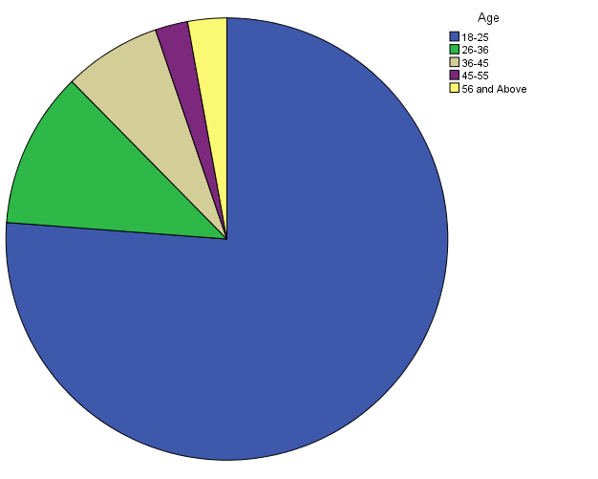
This pie chart explains clearly about the Age independent variable ,age between 18- 25 = 75%, 26-36 =11.4%, 36-45= 10.2%,44-55 =3.2%.

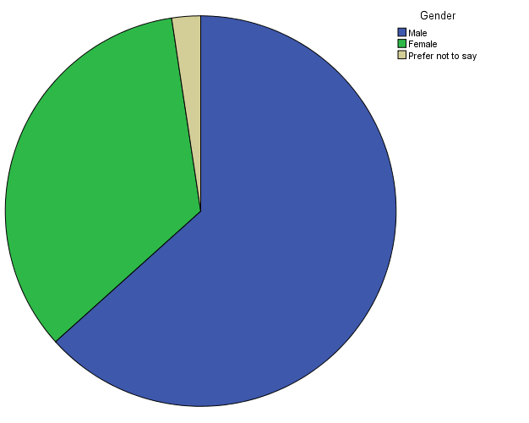
Legend:

This pie chart explains clearly about the gender independent variable , 63.3% is male , 34.3% is female ,3 is prefer not to say.

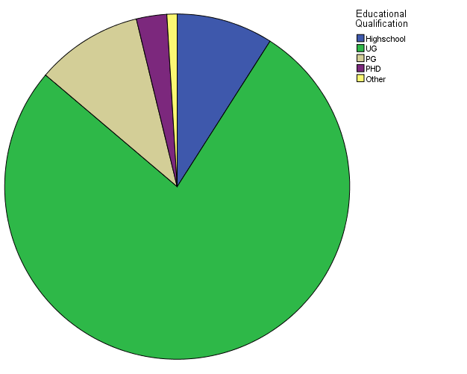

This pie chart explains clearly about the Education Qualification independent variable of the respondent. UG is 77.1% ,PG IS 9.5%, Highschool 8.6%

FIGURE:1

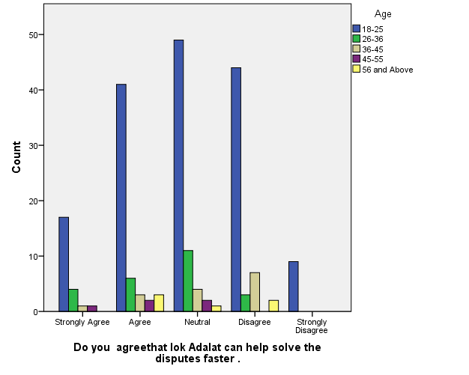
Legend:
This pie chart explains clearly about the gender independent variable , 63.3% is male , 34.3% is female ,3 is prefer not to say.
FIGURE :2

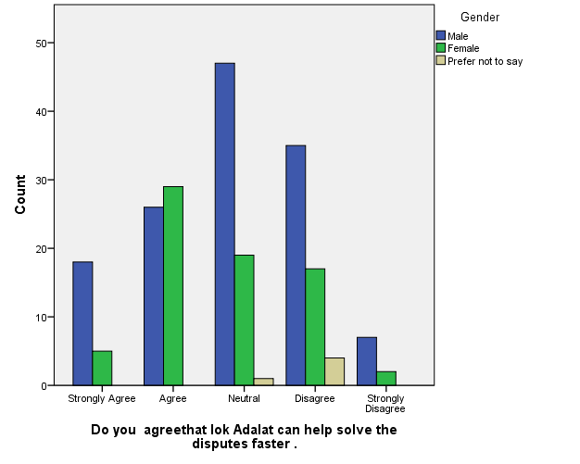

Legend :
From the graph 2,it is observed that it exhibits the gender distribution of the respondents and their agreeability on the Lok adalat can help to solve the disputes faster.
FIGURE :3

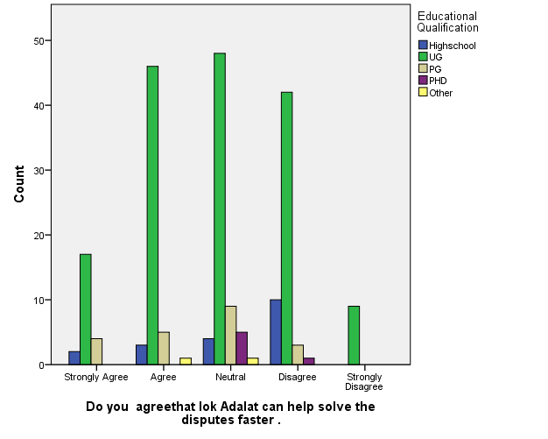

Legend :
From the graph 3 , it is observed that it exhibits the Education qualifications distribution of the respondents and their agreeability on the Lok adalat can help to solve the disputes faster.

FIGURE :4

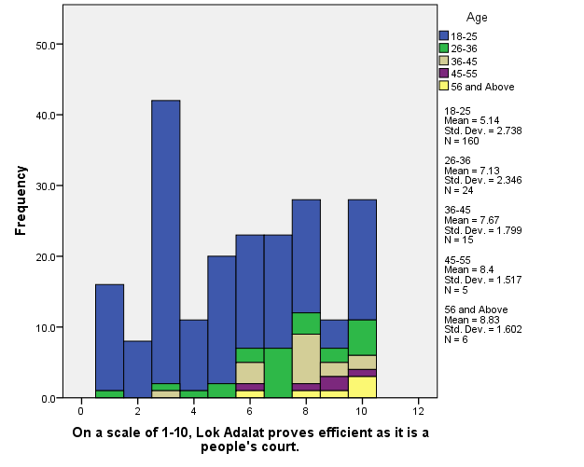
Legend :
From the graph 4, it is observed that it exhibits the Age distribution of the respondents and their opinion on the Lok Adalat proves efficient as it is a people’s court .

FIGURE :5

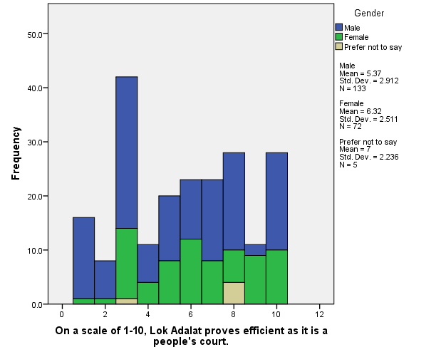

Legend :
From the graph 5, it is observed that it exhibits the gender distribution of the respondents and their opinion on the Lok Adalat proves efficient as it is a people’s court .

FIGURE :6

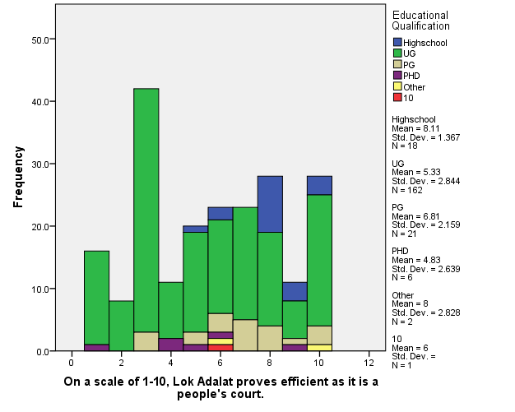

Legend :
From the graph6 , it is observed that it exhibits the Education qualifications distribution of the respondents and their opinion on the Lok Adalat proves efficient as it is a people’s court .

FIGURE :7

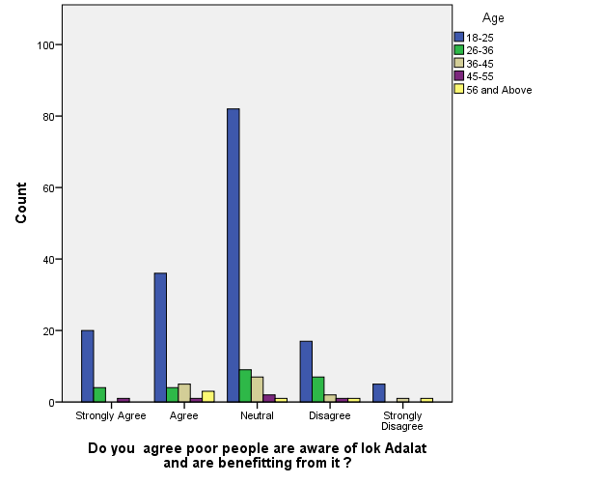

Legend :
From the graph 7, it is observed that it exhibits the Age distribution of the respondents and their agreeability on the Poor people are aware of Lok adalat and are benefiting from it .

FIGURE :8

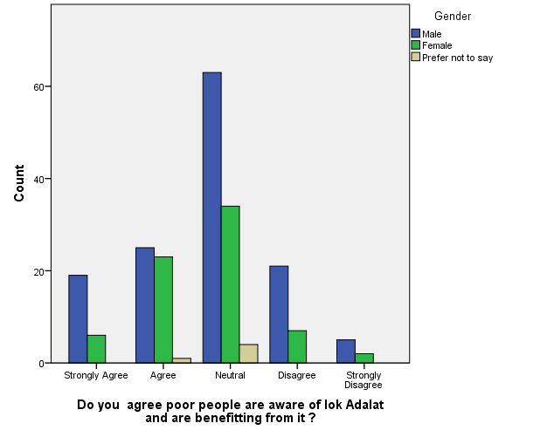

Legend :

From the graph 8, it is observed that it exhibits the gender distribution of the respondents and their agreeability on the Poor people are aware of Lok adalat and are benefiting from it .

FIGURE :9

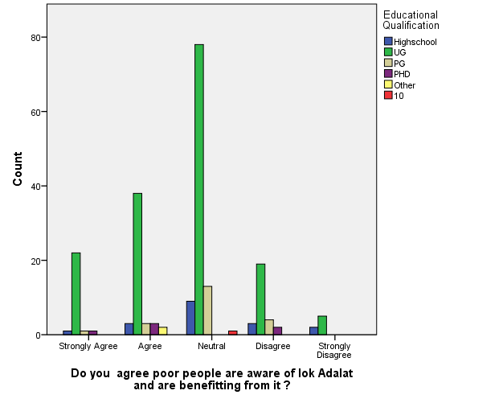

Legend :
From the graph9, it is observed that it exhibits the Education distribution of the respondents and their agreeability on the Poor people are aware of Lok adalat and are benefiting from it .

RESULTS :

From the survey : in graph 1, it is observed that it exhibits the Age distribution of the respondents and their agreeability on the Lok adalat can help to solve the disputes faster..The maximum number of responses were collected from between the age group 18to 25agrees with the statement whereas the minimum respondents between the age group 56 and above have gave least score in that statement.

From the survey : in graph2, it is observed that it exhibits the gender distribution of the respondents and their agreeability on the Lok adalat can help to solve the disputes faster.The maximum number of responses were collected from between the gender group male agrees with the statement whereas the minimum respondents between the gender group female have gave least score in that statement.

From the survey : in graph 3it is observed that it exhibits the Education qualification distribution of the respondents and their agreeability on the Lok adalat can help to solve the disputes faster.The maximum number of responses were collected from between the Educational qualifications UG have the majority respondents in Highschool second highest score and PHD have gave least score in that statement.

From the survey : in graph 4,it it is observed that it exhibits the Age distribution of the respondents and their opinion on the Lok Adalat proves efficient as it is a people’s court .The maximum number of responses were collected from between the age group 18to 25agrees with the statement whereas the minimum respondents between the age group 56 and above have gave least score in that statement.

From the survey : in graph 5, it is observed that it exhibits the gender distribution of the respondents and their opinion on the Lok Adalat proves efficient as it is a people’s court .The maximum number of responses were collected from between the gender group male agrees with the statement whereas the minimum respondents between the gender group female have gave least score in that statement.

From the survey : in graph 6,it is observed that it exhibits the Education qualifications distribution of the respondents and their opinion on the Lok Adalat proves efficient as it is a people’s court .The maximum number of responses were collected from between the Educational qualifications UG have the majority respondents in Highschool second highest score and PHD have gave least score in that statement.

From the survey : in graph 7, it is observed that it exhibits the Age distribution of the respondents and their agreeability on the Poor people are aware of Lok adalat and are benefiting from it .The maximum number of responses were collected from between the age group 18to 25agrees with the statement whereas the minimum respondents between the age group 56 and above have gave least score in that statement.

From the survey : in graph8, it is observed that it exhibits the gender distribution of the respondents and their agreeability on the Poor people are aware of Lok adalat and are benefiting from it .The maximum number of responses were collected from between the gender group male agrees with the statement whereas the minimum respondents between the gender group female have gave least score in that statement.

From the survey : in graph 9, it is observed that it exhibits the Education distribution of the respondents and their agreeability on the Poor people are aware of Lok adalat and are benefiting from it .The maximum number of responses were collected from between the Educational qualifications UG have the majority respondents in Highschool second highest score and PHD have gave least score in that statement.

.DISCUSSION:
In figure 1 lok adalat solve disputes faster in This pie chart explains clearly about the gender independent variable , 63.3% is male , 34.3% is female ,3 is prefer not to say. Where most of them are age category of 18-20 where they solve disputes have an neutral value because most of them not believe in speedy judgement that would. Be partial they but some speedy judgement in lok solve cases faster in society

IN FIgure 2 it is observed that it exhibits the gender distribution of the respondents and their agreeability on the Lok adalat can help to solve the disputes faster. Most of them responded are male where they have an neutral value because most of them not believe in speedy judgement that would. Be partial they but some speedy judgement in lok solve cases faster in society

In fig 3 it is observed that it exhibits the Education qualifications distribution of the respondents and their agreeability on the Lok adalat can help to solve the disputes faster. Where most of them where ug students they have an opinion of neutral and agree percentage is more because most of them not believe in speedy judgement that would. Be partial they but some speedy judgement in lok solve cases faster in society

In fig 4 it is observed that it exhibits the Age distribution of the respondents and their opinion on the Lok Adalat proves efficient as it is a people’s court .most of them given an two opinion 3 to4 %in scale of one to 1 to10 where the age group of 18to 25 that is complete the pending case one view and another view is reduce the court burden.

In fig 5 it is observed that it exhibits the gender distribution of the respondents and their opinion on the Lok Adalat proves efficient as it is a people’s court . Male given more opinion on it more and it benefits the society lack of problems in judiciary are solved in the society . They say it lok adalat effective in people’s
Court

In fig 6 it is observed that it exhibits the Education qualifications distribution of the respondents and their opinion on the Lok Adalat proves efficient as it is a people’s court . Education qualification UG degree more opinion on it more and it benefits the society lack of problems in judiciary are solved in the society . They say it lok adalat effective in people’s Court .

In fig 7 it is observed that it exhibits the Age distribution of the respondents and their agreeability on the Poor people are aware of Lok adalat and are benefiting from it . Where of them responded neutral vale where the people age group of 18 to 25 given because they have the opinion that I could be impartial but similarly courts burdens and people time is saved so they given neutral value

In fig 8 it is observed that it exhibits the gender distribution of the respondents and their agreeability on the Poor people are aware of Lok adalat and are benefiting from it the age group of 18 to 25 where they given neutral value where people think that peti cases solved easily by lok adalat

In fig 9 it is observed that it exhibits the Education distribution of the respondents and their agreeability on the Poor people are aware of Lok adalat and are benefiting from it .where most of them said ug degree benefitting the most because small issues of poor people solved by lok adalat people view still nutral in society the judgement can become neutral in the society.

LIMITATIONS
The Major limitation of the study is the sample frame. The sample frame Collected through online platforms like sending mail, sending links via WhatsApp is the limitation of the study, the real field experience is missed out due to corona pandemic. The restrictive area of sample size is yet another drawback of the research.Collection of data via online platform is limiting the researcher to collect data from the field.Since the data is collected on online platform wherein the respondent is not known, the original opinion of the respondent it is not found, The researcher could only come to a approximate conclusion of what the respondent is feeling to convey.

CONCLUSION:
This paper mainly focuses on the Lok Adalat and their principles. And also talks about finally how the lok Adalat framework in India started, its degree and ambit, need and furthermore its significance. It additionally talks about in subtleties the purview relating to Lok Adalats alongside its method to manage the cases and the forces of lok Adalats.The presentation of Lok Adalats added another section to the equity agreement arrangement of this nation and prevailing with regards to giving a strengthening discussion to the unfortunate casualties for acceptable settlement of their debates. This framework depends on Gandhian standards. The aim of the study on functioning of Lok adalat system with special reference to TamilNadu. The major contribution of the study is to collect the legal facts of a particular area and to test the hypothesis of a cause and effect relationship between variables. The research design is exploratory and experimental. It explored the problem tested with hypotheses and provided the solution from the analysis. Convenient sampling method is used (Non probability sampling). The sample size is 200. Data is collected through the primary and secondary sources. Questionnaire is used as the primary data collection and the articles, journals, reports, newsletters are considered as the secondary sources. The analysis is carried out for demographic statistics (Age, Gender, Educational qualification and Occupation) and hypothesis testing graphs are used.The aim of the study on functioning of Lok adalat system with special reference to TamilNadu. Where people have the neutral value that on awareness on lok adalat and their view how problems solved and benefiting by lok adalat they see it as positive aspects more compared to negative issues in their mind lok adalat so they support lok adalat.

REFERENCES:

- Baxi, Upendra. n.d. “‘Popular Justice, Participatory Development and Power Politics: The Lok Adalat in Turmoil.’” People’s Law and State Law. https://doi.org/10.1515/9783110866285.171.
- Bhalla, Sandeep. 2013. Commentary on Legal Services Authorities Act, 1987: (India). lawmystery.in.
- Bohle, F-J, and G. Wiech. 1991. “Adalat® — From the Marketing Viewpoint.” Adalat. https://doi.org/10.1007/978-3-642-85498-9_5.
- Brown, Henry J., and Arthur L. Marriott. 2011. ADR Principles and Practice.
- Chand, Hemant Kumar. 2016. Lok Adalat in India: Genesis, Law, Practice and Prospects.
- Chitkara, M. G. 1993. Lok Adalat and the Poor: A Socio-Constitutional Study.
- Chowbe, Vijaykumar Shrikrushna, and Priya Dhanokar. n.d. “Lok Adalat A Strategic Forum for Speedy and Equitable Justice.” SSRN Electronic Journal. https://doi.org/10.2139/ssrn.1766237.
- Juss, Satvinder. 2019. Human Rights in India. Routledge.
- Khan, Sarfaraz Ahmed. 2006. Lok Adalat: An Effective Alternative Dispute Resolution Mechanism. APH Publishing.
- Laskar, Manzoor Elahi. n.d. “Lok Adalat System in India.” SSRN Electronic Journal. https://doi.org/10.2139/ssrn.2420454.
- Mukherjee, Roma. 1998. Women, Law, and Free Legal Aid in India.
- Nariman, Fali S. 2017. India’s Legal System: Can It Be Saved? Penguin UK.
- Nayler, W. G. 1991. “Adalat: Its Future.” Adalat. https://doi.org/10.1007/978-3-642-85498-9_24.
- Ostfeld, Greg. 1997. “Speedy Justice and Timeless Delays: The Validity of Open-Ended ‘Ends-of-Justice’ Continuances under the Speedy Trial Act.” The University of Chicago Law Review. https://doi.org/10.2307/1600319.
- “Public Awareness of Lok Adalat Judiciary System in Rajasthan: An Empirical Approach to Law Reforms.” 2016. International Journal of Political Science. https://doi.org/10.20431/2454-9452.0201002.
- Rafflenbeul, W. 1985. “Adalat Intravenös Bei Koronarspasmen — Fallbeispiele.” Intravenöse Und Intrakoronare Anwendung von Adalat. https://doi.org/10.1007/978-3-642-70582-3_9.
- Sarkar (Advocate), S. K. 2006. Law Relating to Lok Adalats and Legal Aid: Being Commentary on the Legal Services Authorities Act, 1987 with Central & State Rules.
- Pohekar, Preeti Dilip. 2010. A Study of Ombudsman System in India with Special Reference to Lokayukta in Maharashtra. Gyan Publishing House.
- Yeh, Jiunn-Rong. 2014. Asian Courts in Context. Cambridge University Press.
- Verma, B. L. 1987. Development of Indian Legal System: Adalat System, Civil Law, Criminal Law, Revenue Law, Personal Laws, Constitutional Law.

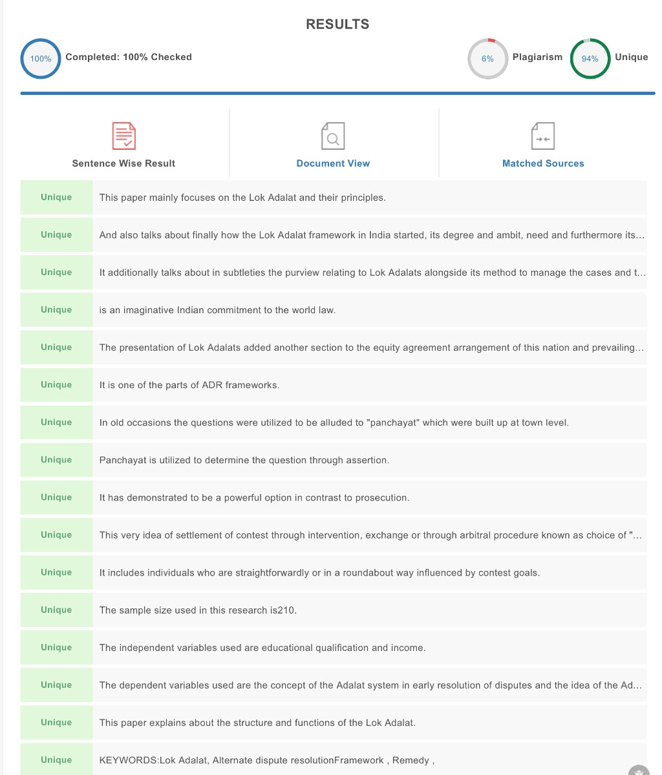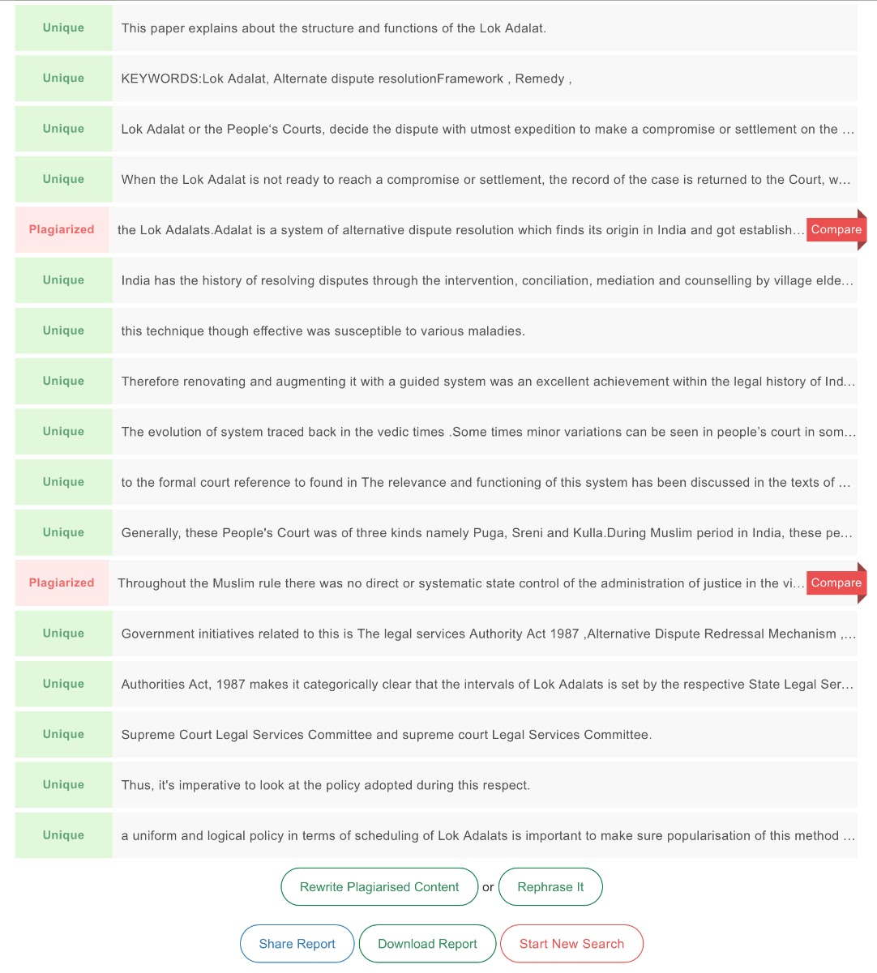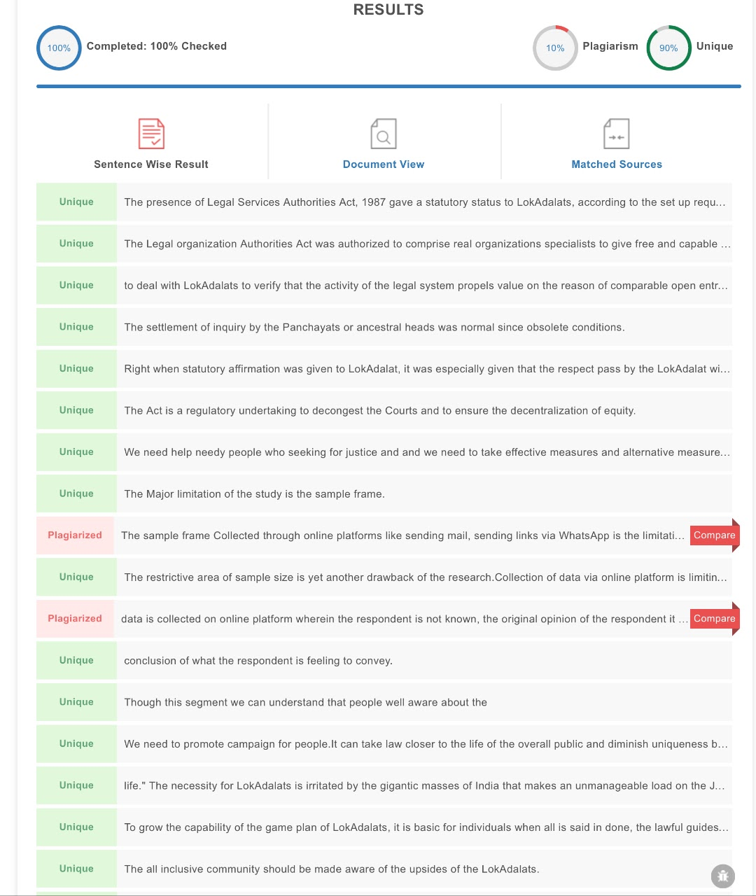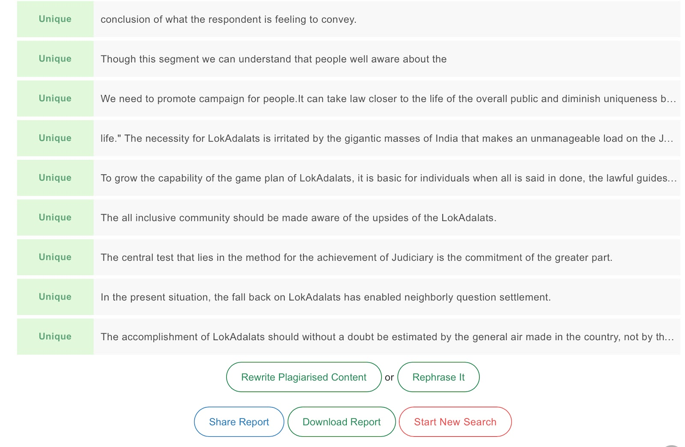

A.NAKAPPAN DEPARTMENT: BA.LLB(HONS) YEAR: 4th YEAR SAVEETHA SCHOOL OF LAWSAVEETHA INSTITUTE OF MEDICAL AND TECHNICAL SCIENCES (SIMATS) SAVEETHA UNIVERSITY CHENNAI-77CONTACT NO:9159504440 MAIL ID:Sainakappan@gmail.com
DR.P.ANGAYARKANNI M.A.ML. PGDEFL.PH.D ASSOCIATE PROFESSOR SAVEETHA SCHOOLOF LAWSAVEETHA INSTITUTE OF MEDICAL AND TECHNICAL SCIENCES (SIMATS)SAVEETHA UNIVERSITYChennai-77CONTACT NO:9843088763MAIL ID:angayarkannip.ssl@saveetha.com

