FOOD CALORIE FINDER USING MACHINE LEARNING
1- B.Murali Krishna, 2-N.Vara Prasad,3-R.Bhavani
Department MASTER OF COMPUTER APPLICATIONS RISE Krishna Sai Prakasam Group of Institutions , Ongole

Abstract: In the modern world, machine learning (ML) is a very potent and significant technology. The proposed system is subjected to the application of several suitable algorithms, including the Grab Cut segmentation method, the canny edge detection technique, and the Faster RCNN algorithm, with the aid of ML modules. This programmed primarily focuses on calculating the number of calories and other nutrients that are contained in meals. The entire process will be automated as compared to current systems, where values must be delivered manually by the user. However, all users will need to do to submit data into the system is click on the meal image. Additional procedures can be automated fast, for example, by using a closer R-CNN to understand for each food and an item for standardization. Use of the Grab Cut method yields. The volume of each food item is then computed using volume valuation formulae. Finally, it estimates the calories of each food, and experimental investigations have proven that the proposed estimation approach is useful by providing production with information about the calories and nutrients available in the food.

KEY WORDS— GrabCut segmentation method, Machine learning techniques, experimental investigations.

Introduction:

Practically 20% of deaths worldwide are caused by unnatural diets according to the World Health Organization (WHO). 39% of grown person aged 18 and over were over heavy in 2016 and 13% were obese. Maximum of the world's residents survive in nations where over heavy and fatness kill more people than underweight [1]. The core cause for fatness is the inequity amongst the quantity of caloric consumption and the energy yield. The BMI will increase risk for diseases such as cardiovascular disorders and many more. Obesity is commonly diagnosed in people with a BMI more than 30 kg/m2 [2]. The nutritional energy unit is the calorie. Because of the fast pace of life, health is the most important demand in the globe. The current calorie measurement scheme is faulty in that data such as food platter weight, food platter volume, and so on must be manually entered. A fully automated calorie measurement system is proposed to accomplish this. In this system, various ML modules are employed to determine the size of foodstuffs. The user then clicks on a snapshot of the dish in various positions (most notably in the front and top). As a result, the user must select two photographs. These photographs are then used as input by the computer, and the portion size and volume can be calculated using various algorithms. This can be accomplished using a variety of ML approaches. However, once the image is provided as an input, it is possible to define and segment at the same time. The entire process will be automated, and a final result will be obtained from a comprehensive list of dietary products including calories and other nutrients. The project is divided as follows: Section II examines recent research in a relevant field. Section III contains information about work that is relevant to the research scope. Section IV discusses the proposed technique, together with the experimental results. Section V completes the document with prospective job requirements.

LITERATURE SURVEY:

In today's world, a healthy body is determined by the number of calories ingested; therefore, calorie intake must be monitored in order to preserve excellent health. When your BMI is between 25 and 29, you are considered obese. It signifies that you are conveying an excessive amount of weight. Obesity is presumed if your BMI is greater than 30. Individuals who want to stay in shape or maintain a healthy weight must keep track of the calories they consume. Calorie estimation in the current system must be done manually. Using a deep learning technique, the suggested model will provide a one-of-a-kind solution for calorie measurement. The computation of dietary calories is critical in the medical industry. Because the calories in this dish are beneficial to one's health. This measurement is taken from the image of food in various objects, such as fruits and vegetables. This measurement is performed with the assistance of a neural network. Tensor flow is one of the most effective approaches for classifying machine learning methods. The Convolution Neural Network is used in this method to calculate the calorie content of food. An image of food is used as the input to this calculated model. The suggested CNN model calculates the food calorie value with the help of food object detection. Volume error estimation is used as the primary parameter in the outcome, while calorie error estimation is used as the secondary parameter. The volume estimation inaccuracy is steadily reduced by 20%. This suggests that the suggested CNN model outperforms the previous model in terms of accuracy.

EXISTING SYSTEM:

In contrast to current systems, which need the user to manually deliver the values, the entire process will be automated. Users will, however, merely need to click on the food image to offer it as an input to the system. Further steps, such as the use of a closer R-CNN to perceive for each food and standardization item, can be automated fast. To obtain the outline of each food, the Grab Cut algorithm is employed. The volume of each food item is then computed using volume valuation formulae. The current calorie measurement scheme is faulty in that data such as food platter weight, food platter volume, and so on must be manually entered. A fully automated calorie measurement system is proposed to accomplish this.

PROPOSED SYSTEM:

When competing with the other competitors in the ILSVRC-2012 competition, a variant of the proposed system earned the best error rate of 15.3%.

The proposed methodology is used to calculate calories from an image of a fruit and compare it to the actual one in terms of the error parameter generated from the equation. In our proposed system, I have kept the system's breadth to simply fruit and some uncooked meals, such as doughnuts and bread. Quick meals and other prepared foods cannot be quantified. The explanation is that the elements of a food item cannot be defined just by a food-related image. All of the ingredients and their total amount in the food must be known. I can improve my system by adding more prepared meals and less quick food.
OVERVIEW OF SOFTWARE ENVIRONMENT
PYTHON:
Python is a scripting language that is high-level, interpreted, interactive, and object-oriented. Python is intended to be extremely readable. It commonly uses English terms rather than punctuation, and it has fewer syntactical structures than other languages.
- Python is Interpreted: Python is processed at runtime by the interpreter. You do not need to compile your program before executing it. This is similar to PERL and PHP.
- Python is Interactive: You can actually sit at a Python prompt and interact with the interpreter directly to write your programs.
- Python is Object-Oriented: Python supports Object-Oriented style or technique of programming that encapsulates code within objects.
- Python is a Beginner's Language: Python is a great language for the beginner-level programmers and supports the development of a wide range of applications from simple text processing to WWW browsers to games.

PYTHON HISTORY:
Guido van Rossum created Python in the Netherlands' National Research Institute for Mathematics and Computer Science in the late 1980s and early 1990s.
Python is based on a number of programming languages, including ABC, Modula-3, C, C++, Algol-68, Small Talk, Unix shell, and other scripting languages.
Python is copyrighted. Like Perl, Python source code is now available under the GNU General Public License (GPL).

PYTHON FEATURES:
• straightforward to learn: Python has a few keywords, a straightforward structure, and a well-defined syntax. This enables the pupil to swiftly learn the language.
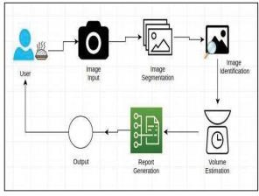
• Python code is easier to read since it is more clearly defined and evident to the eyes.
• Simple to maintain: Python's source code is relatively simple to maintain.
• A large standard library: The majority of Python's library is portable and cross-platform compatible on UNIX, Windows, and Macintosh.
• Interactive Mode: Python provides an interactive mode that enables for interactive testing and debugging of code snippets.
• Portability: Python can operate on a wide range of hardware platforms and has the same interface across them all.
- Databases: Python provides interfaces to all major commercial databases.
- GUI Programming: Python supports GUI applications that can be created and ported to many system calls, libraries and windows systems, such as Windows MFC, Macintosh, and the X Window system of Unix.
- Scalable: Python's structure and support for huge programmes is superior to shell scripting.
- OOP as well as functional and structured programming methodologies.
- It can be used as a scripting language or can be compiled to byte-code for building large applications.
- It provides very high-level dynamic data types and supports dynamic type checking.
OVER VIEW OF SYSTEM TESTING:
OOP, functional, and structured programming methods are all available.Testing is performed to detect errors. The process of looking for defects or vulnerabilities in a piece of work is known as testing. It allows you to test the operation of parts, subassemblies, assemblies, and/or a finished product. It is the process of testing software to ensure that it fulfils user expectations and does not fail in an unacceptable fashion.
SYSTEM ARCHITECTURE:

TYPES OF TESTS:
UNIT TESTING:
Unit testing test cases verify that the basic programme logic is working properly and that programme inputs result in legitimate outputs. It is critical to double-check the internal code flow and all decision branches. It is the testing of the individual software components of the programme. Prior to integration, it is done after each separate unit is completed. This is an invasive structural test that relies on knowing how it was constructed. Unit tests are fundamental tests performed at the component level that investigate a specific configuration of a system, application, or business process. Unit tests make assurance that each distinct path of a business process adheres precisely to the stated specifications and has inputs and outputs that are well-defined.

INTEGRATION TESTING:
Integration tests are performed on integrated software components to determine whether they truly operate as a single programme. Event-driven testing focuses on the primary outcome of screens or fields. Despite the fact that the individual components passed unit testing, integration tests show that the combination of the components is correct and consistent. Integration testing is especially designed to highlight issues that result from combining components.

FUNCTIONAL TEST:
Functional tests provide systematic demonstrations that functions tested are available as specified by the business and technical requirements, system documentation and user manuals.

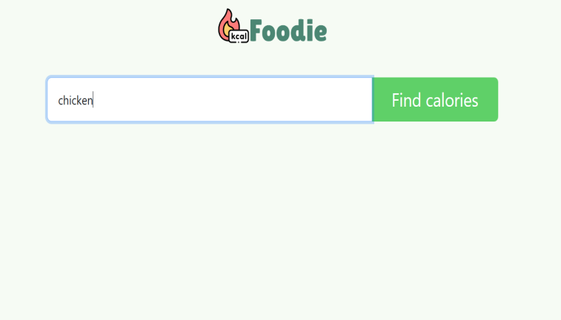
SYSTEM TEST:
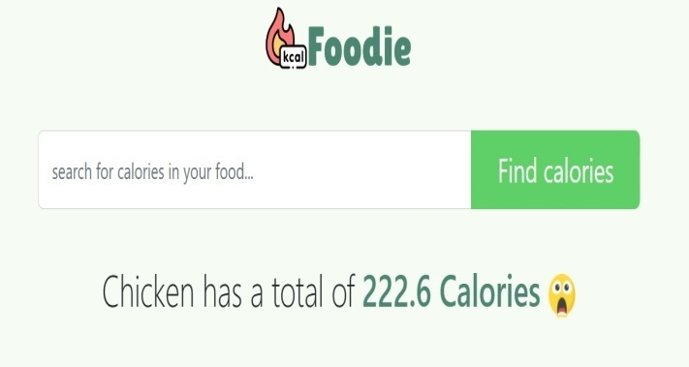
System testing verifies that the integrated software system as a whole fits the criteria. It validates a setup to ensure consistent and predictable results. The configuration oriented system integration test is a form of system testing. System testing is conducted using process descriptions and flows, with an emphasis on pre-driven process connections and integration points.

WHITE BOX TESTING:
White Box Testing is a type of testing in which the software tester is familiar with the inner workings, structure, and language of the software, or at the very least its goal. It serves a purpose. It is used to test areas that cannot be reached from a black box level.

BLACK BOX TESTING:
Black Box Testing is the process of testing software without knowing anything about the inner workings, structure, or language of the module being tested. Black box tests, like the majority of other types of tests, must be written from a definitive source document, such as a specification or requirements document. It is a testing in which the software under test is treated, as a black box.
RESULT:
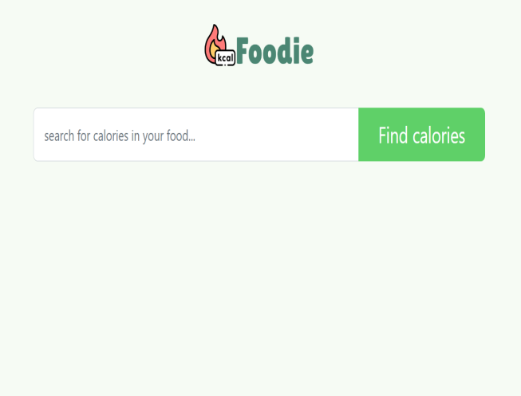

CONCLUSION:
This article presents a revolutionary calorie calculation method based on machine learning techniques. We calculated the calories of the food object using machine learning and image processing. To do this, three modules have been introduced: first, the object is detected using Faster R-CNN, and then the grab algorithm segmentation is used. Following segmentation, we calculate the volume of the food product. Finally, we calculate the calories in each food item. It was successfully introduced as a result of the findings of our method. Our technology will calculate the number of calories in a given food. Deep learning algorithms will be able to predict the quantity of calories in meals using more diverse models or designs in the future. This strategy would be beneficial to both workout fanatics and the general public.
- REFERENCES: World Health Organization (2020). “Obesity and overweight.” Accessed: April 1, 2020. [Online]. Available: https://www.who.int/news-room/fact-sheets/detail/obesity- andoverweight
- Zheng, W., McLerran, D. F., Rolland, B., Zhang, X., Inoue, M., Matsuo, K., He, J., Gupta, P. C., Ramadas, K., Tsugane, S., Irie, F., Tamakoshi, A., Gao, Y.-T., Wang, R., Shu, X.-O., Tsuji, I., Kuriyama, S., Tanaka, H., Satoh, H., … Potter, J. D. (2011). Association between Body-Mass Index and Risk of Death in More Than 1 Million Asians. New England Journal of Medicine, 364(8), pp. 719–729. https://doi.org/10.1056/nejmoa1010679
- J. Deng, W. Dong, R. Socher, L. Li, Kai Li and Li Fei-Fei, (2009). "ImageNet: A large-scale hierarchical image database," IEEE Conference on Computer Vision and Pattern Recognition, Miami, FL, 2009, pp. 248-255, https://doi.org/10.1109/CVPR.2009.5206848.
- Krizhevsky, A., Sutskever, I., & Hinton, G. E. (2017). ImageNet classification with deep convolutional neural networks. Communications of the ACM, 60(6), pp. 84–90. https://doi.org/10.1145/3065386
- Simonyan, K., & Zisserman, A. (2015). “Very Deep Convolutional Networks for Large-Scale Image Recognition”, CoRR, abs/1409.1556. Retrieved from http://arxiv.org/abs/1409.1556
C. Szegedy et al., "Going deeper with convolutions," (2015). IEEE Conference on Computer Vision and Pattern Recognition (CVPR), Boston, MA, 2015, pp. 1-9, https://doi.org/10.1109/CVPR.

