ROBOT FOR WOMENS PROTECTION USING RASPBERRY PI
Dr. CH. Venugopal Reddy*1, K. Suresh Babu*2
*1 Venugopalreddy.sai@gmail.com, Professor and HOD, Department of ECE,
*2 Suresh.raja001@gmail.com, Associate Professor, Department of ECE
RISE Krishna Sai Prakasam Group of Institutions, Ongole, Andhra Pradesh, India

ABSTRACT— Women's protection is a major concern in all regions of the world as violence against them is on the rise. It has become common for them to be physically or mentally abused. Harassment at work and in public places causes individuals to abandon their passions and goals. Although the government has passed various anti-harassment laws like IPC section 354 but the rate of harassment cases against women has not decreased. Existing systems use her CCTV cameras to record the incident, but this is not a good strategy to give secure and safety for the woman. A proposed system will patrol on the on the roads check hazaradous behaviors. As a result, women's communities will benefit more from women protection patrolling robot using raspberry pi.

KEY WORDS— Camera, Raspberry PI, IR Sensors, Sound Sensors, LED Strip, L298N Motor driver.
✦

- INTRODUCTION
The world faces serious problems related to the protection of women and our efforts must focus on them. Even we are in the 21st century, where technology is developing/increasing rapidly and new devices are being developed, women and girls still facing challenges due to some people. To reducing these issues, we use a Women Protection Patrolling Robot using Raspberry Pi to give secure and safety for women. The women protection patrolling robot is an attempt to improve women's safety using robotics. It will be a big step towards automation and security. This cause mainly due to fear of violence and physical/sexual abuse against them. This system is the best way to reduce crimes during against women.

This project mainly focused on to give a security and safety for women and girls so that they never feel helpless from any hazardous situations and social challenges. The Nirbhaya case in Delhi, which shaken the whole country. That was the biggest motivation for our project.
- LITERATURE SURVEY
Islam et al. [1] proposed “Design and Implementation of Women Auspice System by Utilizing GPS and GSM”. In this project, they used a GPS, GSM modules and PIC 16F887 microcontroller and push buttons. GPS is used for to get the location quickly. Push buttons acts as whenever the abused person push or click the button at that point, the micro-controller will get it and send an SMS to the predefined telephone number.

Muskan et al. [2] Designed “Women Safety Device Designed using IoT and Machine Learning”. It generates an alarm, the device is integrated with heartbeat sensor and temperature sensor to find out the heart rate, temperature. When heart rate and temperature is more than the threshold valve automatically sends SMS and location to predefined contact number.
Dr.M. Sivachitra. [3] Implemented “Women Safety Night Patrolling Robot” In this system the robot patrol on the roads at night time and detects the sound by using sound sensors and it will move on that side and capture the images and send it to the predefine Mail-id.
Bhuvaneswari Mehtre. [4] Proposed “A Raspberry Pi- Based Safety System for Women Security using IoT” The main aim of the system is to give secure and safety for the women. The system uses heartbeat sensors and temperature sensor and buttons and pi camera whenever the person presses the button it will capture the image and it sends the police number.

HARDWARE REQUIREMENT

Raspberry Pi

It is a low-cost credit card sized computer that plugs into a computer monitor or Tv’s. It is a cheap computer that runs Linux but it also provides a set of general-purpose input output pins that allow to control the electronic components for physical computing. This PC can do a lot work what your desktop works. This board consists HDMI ports, GPIO pins.

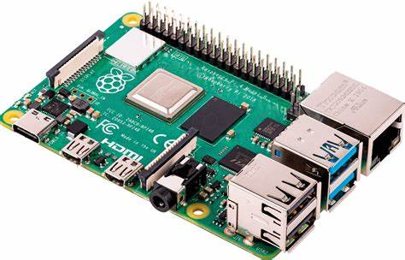

Figure 1: Raspberry Pi 4 Model B

IR Sensor
IR Sensor is most used sensor in wireless technology where remote controlling functions and detection of surrounding objects/ obstacles are involved. Infrared spectrum is categorized into three regions based on its wavelength i.e., Near Infrared, Mid Infrared, Far Infrared.
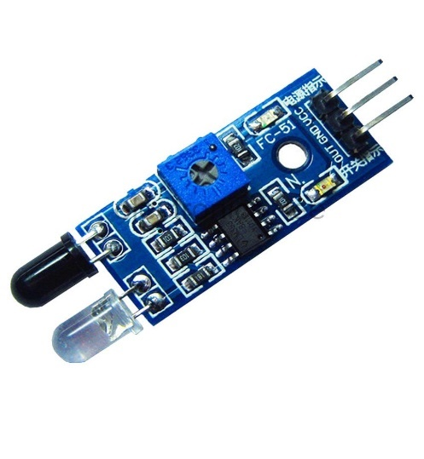
Figure 2: IR Sensor

  - Sound Sensor
The sound sensor module is a low-cost electronic sensor that can easily detect sound. It is generally used for detecting sound intensity. This sensor has a microphone for detecting sound intensity. The electret microphone detects the sound wave and then sends it to the sensor circuit board which consists of a voltage comparator IC LM393 and potentiometer. Comparator IC LM393 process this signal and convert it into a Digital Output.
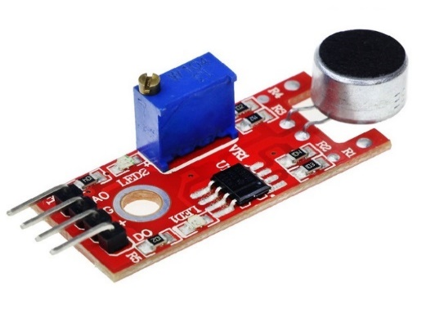
Figure 3: Sound Sensor
  - Pi Camera
The Raspberry Pi camera module can be utilized to take superior quality video, just as still photos. The module has a five- megapixel fixed focus camera that bolsters 1080p30, 720p60 video modes.
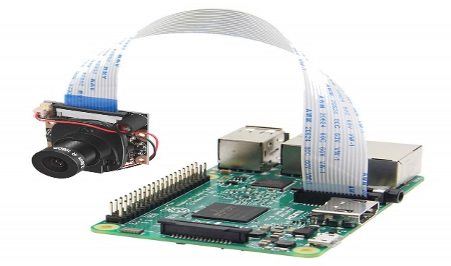
Figure 4: Pi Camera

  - L298N Motor Driver
This L298N Motor Driver Module is a high-power motor driver module for driving DC and Stepper Motors. This module consists of an L298 motor driver IC and a 78M05 5V regulator. L298N Module can control up to 4 DC motors, or 2 DC motors with directional and speed control.

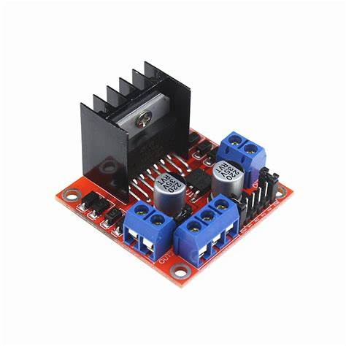
Figure 5: L298N Motor Driver

- PROPOSED SYSTEM
The main aim of this paper is giving security/safety for women. For this purpose, we use python programming. The raspberry pi is connected with camera module and IR and Sound sensors. When a woman is in danger that alert will send automatically to the concerned authorities by in the form of SMS and Video surveillance.

System Architecture
The system architecture consists a Power supply, IR sensor, Sound sensor, Raspberry Pi module which acts as input. Figure 6. shows the block diagram of women protection patrolling robot using raspberry pi which contains the raspberry pi is a low-cost single board computer for connecting raspberry pi camera for providing video surveillance of surroundings, here we are used two sound sensors for the purpose of detecting the abnormal sounds in surroundings with the help of microphone and we use IR sensors for the purpose of detecting obstacles in the surroundings.

Camera
Raspberry Pi 4 Model B
IR Sensor

Sound Sensor

Buzzer
Power Supply

Figure 6: Block Diagram of Proposed System
Whenever the person and sound detected by the Sound sensor and IR sensor the buzzer provides sound and SMS will be sent to the predefined mobile number and in that SMS, we are providing a camera access.

5. SOFTWARE IMPLEMENTATION
Python: Python is an interpreted and object-oriented programming language which was made by Guido Van Rossum in the year of 1991. It reduces the code as compared with other languages.
5.1 Working
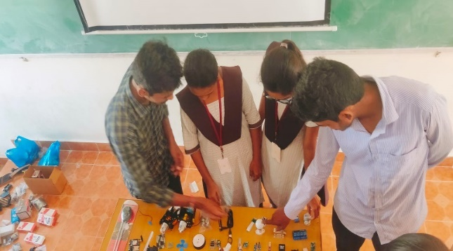
Figure 7: Discussing about the Hardware Requirements
The patrolling robot patrol on the roads and railway stations, hazardous places. In this system we are using raspberry pi, sound sensors, IR sensors, camera. The robot patrol on the roads by using the 12v power supply with the help batteries and it detecting the obstacles on the roads by using the IR sensor it goes away from that place.
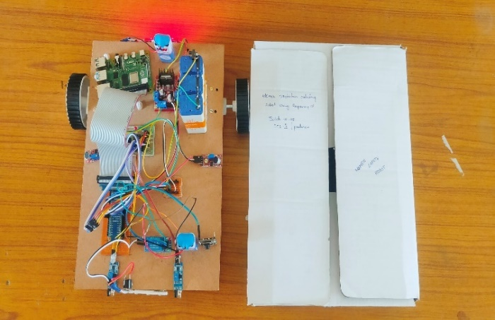
Figure 8: Prototype of Women Protection Patrolling Robot using Raspberry Pi

For example: The robot patrolling on the roads in that time there is any abnormal incident were placed it goes to that place by the use of sound sensors and provides a sound when any person will be detected by IR sensor in that activity and it sends the SMS alert and Camera access to the predefine mobile number in the term of https:192.168.1.105 then copy that link and paste it in google it will provide a video surveillance.
6. RESULT
This section represents the performance of the project model with the use of hardware raspberry pi and to obtain results we are using python as the programming language with the use of software we get the outcome of our project.
As shown in figures 9,10, SMS alert and camera access will send to the concerned authorities. In our project we are three ways for helping women first whenever the person detected to the sound sensor and IR sensor it will provide buzzer sound.

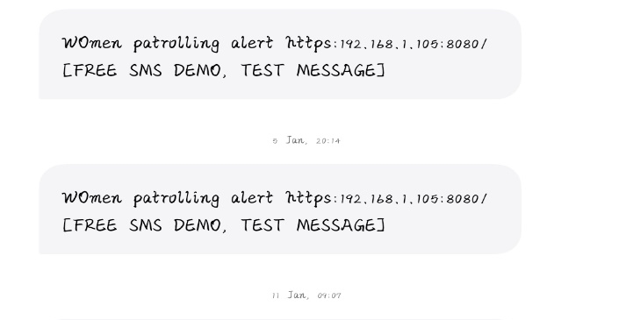
Figure 9: SMS alert
Figure 9 shows the second method of helping women from the abnormal activities whenever the sound sensor detects the sound the SMS will be sent to the concern member.
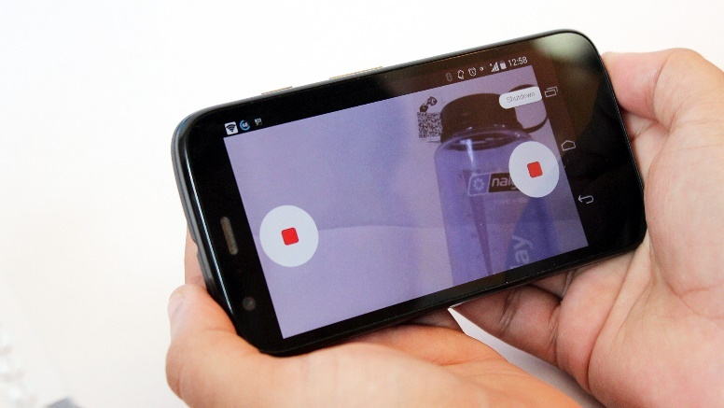
Figure 10: Live Streaming
Figure 10 shows the live streaming of pi camera whenever SMS sent in that SMS the camera IP address will be sended then copy the IP address and paste it in google then it will provide the live stream. This is the third method for women safety.
7. CONCLUSION
Till now women/Girls are suffering /facing so many problems like harassments and mistreats by some rude people at bus stations, roads ,Schools,Colleges… The system's main objective is to give secure and safety for women. This paper will allow women to immediately identify themselves with the authorities concerned when she is in danger. SMS alerting, image capture, video surveillance, producing buzzer sound. The warning will be sent both manually and automatically to the nearest police booth number and predefined mobile number.

- REFERENCES
- Naeemul Islam, Md Anisuzzaman, Sikder Sunbeam Islam, Mohammed Rabiul Hossain, Abu Jafar Mohammad Obaidullah, “Design and Implementation of Women
- Auspice System by Utilizing GPS and GSM”, International Conference on Electrical, Computer and Communication Engineering (ECCE), 2019, pp. 1-5
- A. Priyadarshini, "Women Empowerment towards developing India", IEEE Conference in Humanitarian Technology Conference,21-23 Dec 2016, Agra, India, pp.1-6.
- Navya R Sogi, Priya Chatterjee, Nethra U, Sumav, “SMARISA: A Raspberry Pi based Smart Ring for Women Safety using IoT”, Proceedings of the International Conference on Inventive Research in Computing Applications (ICIRCA 2018), pp. 451- 454.
- T. Akilan, S. Chaudhary, P. Kumari and U. Pandey, "Surveillance Robot in Hazardous Place Using IoT Technology," 2020 2nd International Conference on Advances in Computing, Communication Control
and Networking (ICACCCN), 2020, pp. 775-780.
- Vinay Kumar Chowdary Ravipati and Vineela Thonduri, "An IOT Approach for Motion detection
Using Raspberry PI", International Journal of
Innovative Science and Research Technology, vol.
2, no. 7, pp. 225-228, July 2017.
- Shoeb Maroof Shaikh, Khan Sufiyan, Asgar Ali, Mir Ibrahim and Kalpana Bodke, "Wireless Video Surveillance Robot Controlled Using Android Mobile Device", International Journal of Advance Foundation and Research in Science&Engineering (IJAFRSE), vol. 1, 2015.

- Takato Saito and Yoji Kuroda: ‘Mobile robot localization using multiple observations based on place recognition and GPS’, published in IEEE International Conference on Robotics and Automation Road detection at night based on a planar reflection model in 2013.
- T. Veeramanikandaswamy, “Implementation of spy robot for a surveillance system using Internet protocol of Raspberry pi” Published in 19 may 2017 IEEE International Conference.
- G. Anandravisekar, A. Anto Clinton, T. Mukesh Raj, L. Naveen and M. Mahendran, "IOT based Surveillance Robot" in International Journal of Engineering Research & Technology (IJERT), Tamilnadu, India:Department of Electronics and Communication Engineering Saranathan College of Engineering Trichy, 2018.

