IoT BASED SMART ENERGY METER USING LoRa TECHNOLOGY

Vijayakumar K ^{[1]} Assistant Professor, Department of ECE Sri Ramakrishna Engineering College
Coimbatore, India. vijayakumar.k@srec.ac.in

Abdul Samad N ^{[2]}
Department of ECE
Sri Ramakrishna Engineering College Coimbatore, India. abdulsamad.1902060@srec.ac.in
Deepak Raj M ^{[3]}
Department of ECE
Sri Ramakrishna Engineering College Coimbatore, India. deepakraj.1902061@srec.ac.in
Haripraveen S ^{[4]}
Department of ECE
Sri Ramakrishna Engineering College Coimbatore, India. haripraveen.1902063@srec.ac.in

Abstract— The objective of this paper is to provide a brief overview of how smart energy meters can benefit from incorporating LoRa-WAN and IoT applications. This paper proposes the use of LoRa-WAN and IoT applications in smart energy meters to enable real-time monitoring and calculation of power consumption. In today's technology-driven world, power management is crucial for the efficient operation of digital systems, and excessive power consumption can lead to system failures. By incorporating a LoRa unit into the design, the system's communication range can be extended to multiple locations within the specified range, as LoRa supports the deployment of numerous nodes. Furthermore, LoRa's bi- directional communication capability enhances the system's functionality. Compared to Wi-Fi-based IoT systems, which typically require multiple access points to cover large areas, the proposed LoRa-based solution offers cost advantages. By implementing the suggested software version on the devices, users can monitor their power consumption remotely and take necessary actions to optimize energy usage.
Keywords— Smart Energy Meters, LoRa-WAN, IoT applications, Power Consumption, Long-range Communication, Bi-directional Communication, Cost-effective Solution

I INTRODUCTION
An important research issue in smart metering is to correctly transfer the smart meter readings from consumers to the operator within the given time period by consuming minimum energy. Assuming that all appliances in a house are connected to a smart meter that is affixed with Edge device and LoRa node for processing and transferring the processed smart meter readings, respectively. The energy consumption of the appliances can be represented as an energy multivariate time series. It formulates an optimization problem for finding the suitable compressed energy time series to reduce the energy consumption and delay of the system. Finally, the system presents an algorithm for selecting the suitable spreading factors to transfer the compressed time series to the operator in the given time. The simulation and prototype results demonstrate the impact of the parameters of the compression model, network, and the number of smart meters and appliances on delay, energy consumption, and accuracy of the system.

II RELATED WORK
Preti Kumari et al. [1] proposed an energy efficient smart metering system using Edge computing in Long Range (LoRa). We assume that all appliances in a house are
connected to a smart meter that is affixed with Edge device and LoRa node for processing and transferring the processed smart meter readings, respectively. The energy consumption of the appliances can be represented as an energy multivariate time series. The system first proposes a deep learning-based compression-decompression model for reducing the size of the energy time series at the Edge devices.
Alvin Yu Sri et al. [2] proposed smart electric meter system consists of smart kWh meters, LoRa gateway, network system, and dashboard for energy usage monitoring. The system design process consists of feature design, architecture design, data flow design, LoRa gateway site planning, and platform setup. The implementation can be concluded that LoRa can be used for smart electric meters in rural areas. A gateway can reach a maximum distance of 1.58 km, with an RSSI of -99.40 dBm
±4.56 dBm. LoRa gateway availability can reach 100% by implementing gateway protection systems.

P Kanakaraja et al. [3] proposed the use of smart energy meters, which employ LoRa-WAN and IoT applications, helps in calculating power consumption from anywhere. LoRa technology offers long-range communication with low power consumption, making it ideal for IoT applications. The use of LoRa in energy meters enables long-range communication with several nodes, promoting bi-directional communication. All data collected is stored in the gateway and sent to the cloud server, which can be accessed from anywhere through mobile phones or PCs. The use of LoRa technology overcomes the limitations of 4G/GSM networks, which has led to an increasing trend in switching to LoRa by telecommunication industries.

III PROPOSED WORK
For the proposed system, an innovative approach to smart energy meters by leveraging the advantages of LoRa technology is used. Unlike traditional wireless networks like GSM or Wi-Fi, the system eliminates the need for additional towers or network access on the consumer side. This not only reduces infrastructure costs but also simplifies the deployment process. By utilizing LoRa technology, our smart energy meters enable seamless wireless communication between consumers and distributors. The energy consumption data is transmitted securely and reliably over long distances, due to the long-range capabilities of LoRa. This ensures that even remote consumers can easily connect to the system without any connectivity limitations. In the distributor side, the received data is efficiently uploaded to a dedicated

webpage, allowing consumers to access their energy consumption information conveniently at any time and from anywhere. This web-based interface provides an intuitive and user-friendly platform for consumers to monitor and analyze their energy usage patterns, empowering them to make informed decisions about their consumption habits. Moreover, by leveraging the robustness and scalability of LoRa technology, our system can accommodate many smart energy meters within a wide area network. This scalability ensures that our solution can be easily extended to cover a broad range of consumers, making it suitable for both residential and commercial applications. In summary, our proposed system overcomes the limitations of traditional wireless networks by utilizing LoRa technology. It offers a cost-effective, reliable, and scalable solution for smart energy meters, enabling seamless wireless data transmission and empowering consumers to monitor and optimize their energy consumption. We believe that our innovative approach holds great potential for revolutionizing the energy management industry and contributing to a more sustainable future.

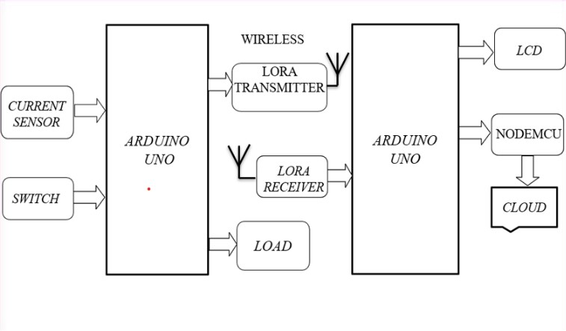

Figure 1.1 Block Diagram of the proposed work

Figure 1.1 represents the block diagram of proposed system. This connection represents the smart energy meter implemented in order to obtain readings of the consumed power supply. This system comprises of LoRa technology paired with Arduino UNO and current sensor to monitor and provide information of the consumed current. When, the switch is on and the current sensor senses the current flow, the readings are given as input to the LoRa transmitter and it is transmitted to the LoRa receiver through wireless communication. And by using Node-MCU the values are stored in cloud which can be easily accessed by the consumer. The given data set is divided into trained and tested data on this block diagram. The training set is the only one required to trainand fit the model, and the test data is only used to validate the model's performance. This model fit uses training data. This model will be validated using test data. A significant performance difference indicates that the model has not been validated. Since the dataset is made up of randomly oriented data, all noisy information, such as columns with whitespace, non-number formats, etc., needs to be excluded. an IoT based smart energy meter using LoRa technology is a simple and straightforward design that can be easily implemented using off-the-shelf components. The LoRa technology ensures that the data is transmitted over a long-range, low-power wireless network, making it ideal for remote monitoring of energy consumption.

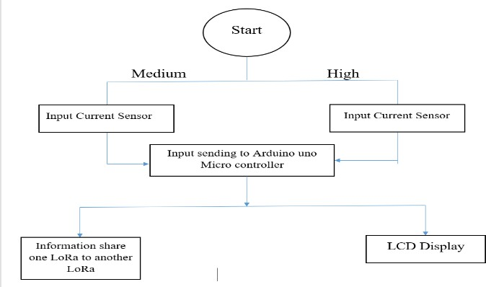
Figure 1.2 Flowchart of the proposed work

Figure 1.2 represents the flowchart of the working of hardware. When the motor rotates, a current sensor detects the amount of current consumed. This input value is transmitted to the microcontroller, which in turn sends the information to an Arduino UNO. The data is then wirelessly transmitted to a LoRa receiver using a LoRa transmitter. Finally, the current consumption output is displayed on an LCD display.

- MODULE DESCRIPTION:

- NODE MCU:

The NodeMCU development board includes an ESP8266 Wi- Fi module, a USB-to-serial chip, and a voltage regulator. It also has a number of GPIO pins, which can be used to interface with various sensors, actuators, and other electronic components. One of the main advantages of NodeMCU is its ease of use. The Lua scripting language used by NodeMCU is easy to learn and provides a quick way to develop Wi-Fi enabled projects. Additionally, NodeMCU has a large community of developers who contribute to its development and provide support for users.

- CURRENT SENSOR:
A current sensor is a device that is used to measure the flow of electrical current in a circuit. It is commonly used in a wide range of applications, including power monitoring, energy management, and motor control. Current sensors work by measuring the magnetic field produced by the current flowing through a conductor. The sensor detects the magnetic field and converts it into an electrical signal that can be measured and interpreted.

- PREDICTION:

  - Information Gathering: Collect a data set of text inputs (e.g., social media posts, emails, chat messages, etc.) with labels indicating whether each entry is 'stressed' or 'unstressed'.
  - Data preparation: Remove extraneous characters, stop words, and other redundant information from the data. To change the text into a format acceptable to the algorithm, use encoding, derivation, and lemmatization.
  - Feature extraction: Extract relevant textual characteristics such as the frequency of certain words or phrases or the degree of emotion in the text.

- RNN IMPLEMENTATION:
Recurrent neural networks are a powerful tool that allows neural networks to process data streams of arbitrary length. Ofcourse, it is required that the sequence should be a sequence of contexts, where the context is entirely generated by things in the previous part of the sequence. This is a broad simplification assumption, but recurrent neural networks are still very powerful.
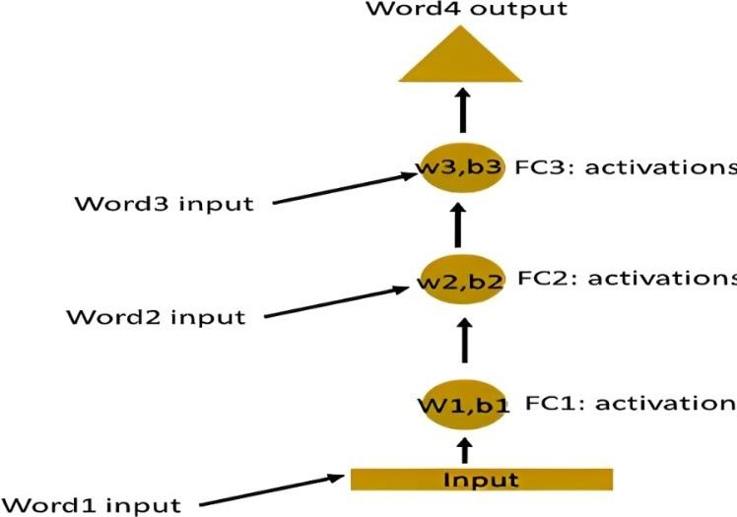

Figure 1.3 RNN implementation.

- LORA IMPLEMENTATION:

LoRa is a new wireless protocol designed specifically for long-range, low-power communications. LORA operates in the sub-gigahertz frequency range (typically 868 MHz in Europe and 915 MHz in the US) and uses spread- spectrum modulation techniques to enable long-range communication. The protocol is designed to be robust in noisy environments and to be able to penetrate through obstacles such as walls and buildings. LoRa stands for Long Range Radio and is mainly targeted for M2M and IoT networks. This technology will enable public or multi- tenant networks to connect several applications running on the same network. LoRa Technology offers a very compelling mix of long range, low power consumption and secure data transmission. Public and private networks using this technology can provide coverage that is greater in range compared to that of existing cellular networks. It is easy to plug into the existing infrastructure and offers a solution to serve battery-operated IoT applications. LORA is commonly used in Internet of Things (IoT) applications for sensor networks, smart cities, and other applications where low- power, long-range communication is required. It can be used to send small amounts of data over long distances, making it suitable for applications such as remote monitoring and control, asset tracking, and environmental monitoring.

  - RESULT ANALYSIS

Flask is a Python-based web application framework. It has several modules that make it easy for web developers to build apps without worrying about details like protocol handling, thread handling, etc. Flask offers a variety of options for developing web applications and provides us with the tools and libraries that web applications need to be created.

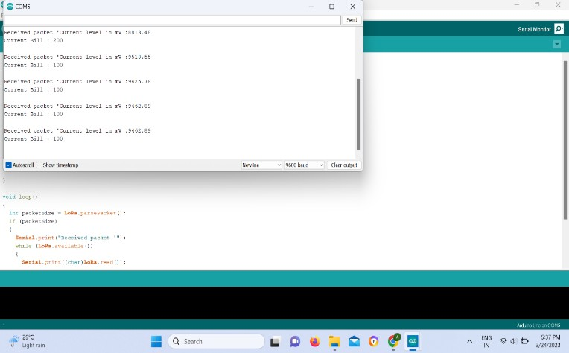

Figure 1.4 URL

Figure 1.4 represents the program that generates the application URL which is used to run the application.
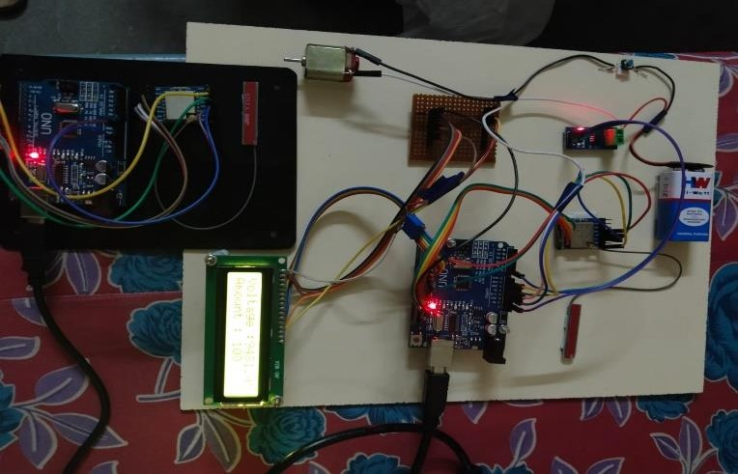
Figure 1.5 Hardware Setup

Figure 1.5 represents the hardware setup of the electricity transmission using lora.
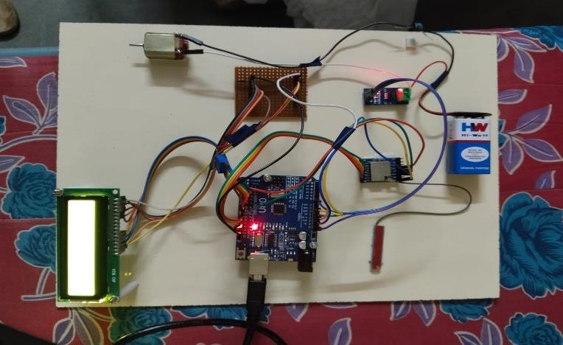

Figure 1.6 Hardware Implementation 1

Figure 1.6 represents the hardware implementation of the transmitting lora setup.

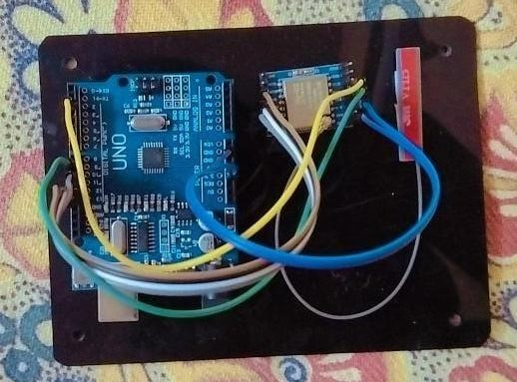
Figure 1.7 Hardware Implementation 2

Figure 1.7 represents the hardware implementation of the receiving lora setup.

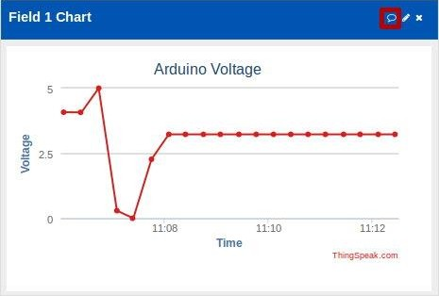

Figure 1.8 Cloud Chart

Figure 1.8 represents the graph about the used voltage and its time in the cloud for the user.

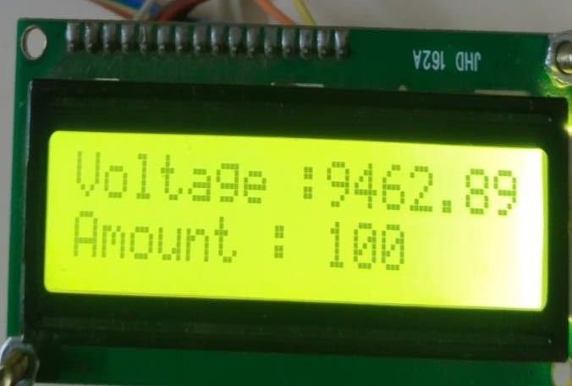

Figure 1.9 Hardware Result

Figure 1.9 represents the output of the hardware implementation. The amount of voltage used and the accurate calculation of amount is displayed.
  - CONCLUSION

Dedicated to the most recent IoT-based smart energy meters using LoRa technology offer a cost-effective and reliable solution for monitoring power consumption. With LoRa's long- range capabilities and ability to handle multiple nodes, users can monitor their energy usage from multiple locations within the prescribed range. In conclusion, the integration of LoRa technology with IoT-based energy monitoring systems presents a promising future for energy management and sustainability. With the potential to revolutionize the way we consume and manage energy, it is an exciting time for the industry, and we can expect to see significant advancements and developments in the years to come.

REFERENCES
- Preti Kumari, Rahul Mishra, Hari Prabhat Gupta, Tanima Dutta, Sajal K. Das, “An Energy Efficient Smart Metering System using Edge Computing in LoRa Network”, IEEE, 2022.

- Alvin Yu Sri, Muhammad Imam Nashiruddin, “LoRaWAN Internet of Things Network Planning for Smart Metering Services in Dense Urban”, ICoICT, 2020.

- P Kanakaraja et al., “Design and Implementation of Smart Energy Meter using LoRa-WAN and IoT Applications”, ICMAICT, 2021.

- Uvarsha, Danusha, Vaishnavi devi, Vraju, “Smart Electric Meter Using Lora”, JISPS, 2020.

- Yousaf Murtaza Rind, Muhammad Haseeb Raza, Muhammad Zubair, “Smart Energy Meters for Smart Grids, an Internet of Things Perspective”, MDPI, 2020.

- A. Anit Dayana, P. Karthika, R. Kavitha, M. Pandi Priyanka, “Smart Electric Meter using LoRA Protocols”, IJERT, 2019.

- F. Richard, R. Ragul, M. Abdul Majeed, “LoRa Based Smart Energy Meter”, IJSDR, 2021.

- P Kanakaraja et al., “Design and Implementation of Smart Energy Meter using LoRa-WAN and IoT Applications”, ICMAICT, 2021.

- Y. A. K. Reddy, K. Suganthi, P. M. Kumar, A. A. Khan, and K. S. Pavan, “LoRa—Pollution and Weather Monitoring System,” Springer, 2020.

- A. Mushtaq, S. H. Gupta, and A. Rajawat, “Design and Performance Analysis of LoRa LPWAN Antenna for IoT Applications,” 7th International Conference on Signal Processing and Integrated Networks (SPIN), 2020.

- R. S. Sinha, Y. Wei, and S.-H. Hwang, “A survey on LPWA technology: LoRa and NB-IoT,” Ict Express,2017.

- E. Aras, G. S. Ramachandran, P. Lawrence, and D. Hughes, “Exploring the security vulnerabilities of LoRa,” IEEE International Conference on Cybernetics

(CYBCONF), 2017.

- Q. Zhou, K. Zheng, L. Hou, J. Xing, and R. Xu, “Design and Implementation of Open LoRa for IoT,” IEEE, 2019.

- O. Georgiou and U. Raza, “Low power wide area network analysis”, IEEE, 2017.

- A. Zourmand, A. L. K. Hing, C. W. Hung, and M. AbdulRehman, “Internet of Things (IoT) using LoRa technology,” IEEE International Conference on Automatic Control and Intelligent Systems (I2CACIS), 2019.

