Application of Approximately 4*2 Compressors with Ultra-low Power Consumption Using Compensation Techniques
Mr. K. Suresh Babu¹, Dr. Ch. Venugopal Reddy²
¹ Suresh.raja001@gmail.com,Associate professor, Department of ECE
² venugopalreddy.sai@gmail.com, Professor and HoD, Department of ECE
Rise Krishna Sai Prakasam Group of Institutions, JNTUK Kakinada

ABSTRACT— Three new approximate 4*2 compressors are proposed in this research and used in 8-bit multipliers. A 4*2 compressor is proposed, and an error corresponding module (ECM) is presented to improve the error performance of the approximation multiplier. The project's revolutionary reduction of the estimated 4*2 compressor's outputs to one results in further gains in energy efficiency. Additionally, the proposed compressor's use in 8-bit multipliers results in a decrease in power usage. The simulation results show that the suggested approximation compressors UCAC1, UCAC2, and UCAC3 achieve optimal delay, power, and area, respectively, when compared to the exact 4*2 compressor. However, aside from MAE, the proposed multiplier maintains a respectable error performance. Additionally, they function effectively when image multiplication is used.

KEY WORDS— Approximate computing, digital multiplier, low-power, energy-efficient, 4*2 compressor.

1.INTRODUCTION
The complexity, scale, and density of integrated circuits are rapidly rising as a result of the growth of semiconductor process technology and the development of applications. However, it also quickly increases power consumption, which shortens the lifespan and reliability of equipment . Fortunately, the accuracy loss in an appropriate range does not affect the quality of what we appreciate in many applications, such as multimedia, digital signal processing, and machine learning , due to a constrained human perception. This creates the possibility that approximate computing blocks could replace full precision computing blocks.
Given that in many digital systems, multiplication is a fundamental process. In multipliers, many approximation designs are introduced. For multipliers with larger bit widths, the hybrid-radix Booth encoding method is typically used, which focuses on the approximation of the partial products generation ; whereas for multipliers with smaller bit widths, the approximation is applied in compression trees, which are set up to accumulate all the generated partial products.
Three roughly 4*2 compressors and an error-correcting module (ECM) are suggested in this study. These three 4*2 compressors are constructed using an all-encompassing approach and are based on the addition's compensating feature. Instead of using a single approximate compressor, the error performance of an approximate compressor chain is taken into account.
For the purpose of executing specialized algorithms like convolution and filtering, microprocessors and digital signal processors rely on the effective implementation of general arithmetic logic units and floating point units . When power consumption and calculation speed are restricted in most of these applications, multipliers are the essential and necessary component defining the overall circuit performance. At the circuit design level, voltage scaling and the usage of modern and emerging CMOS logic types for the implementation of its adopted combinational circuits offer significant potential for optimizing the power-delay product of the multiplier.
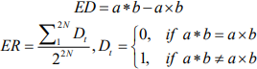
2.LITERATURE SURVEY
Vasileios Leon. proposed “Approximate Hybrid High Radix Encoding for Energy-Efficient Inexact Multipliers”. In this project we propose an approximate hybrid high radix encoding for generating the partial product in signed multiplication that encodes the most significant bits with the accurate radix-4 encoding and the least significant bits with an approximate higher radix encoding.
Chip-Hong Chang. “Ultra Low-Voltage Low-Power CMOS 4*2 and 5*2 Compressors for Fast Arithmetic Circuits ”. This paper presents several architectures and designs of low-power 4*2 and 5*2 compressors capable of operating at ultra low supply voltages .These compressor architectures static logic styles based oh the same deep sub micrometer CMOS process model are used to realize them.
Momeni. “Design and Analysis of Approximate Compressors for Multiplication”. Inexact computing is particularly interesting for computer arithmetic designs. This paper deals with the analysis and design of two new approximate 4*2 compressors for utilization in a multiplier

3.EXISTING SYSTEM

3.1 EXACT 4*2 COMPRESSORS
In multipliers, a compressor is a device that reduces the operands while adding terms of partial products. A typical M-N compressor creates an N-bit binary number from M equally weighted input bits. The 3*2 compressor, commonly referred to as a complete adder, is the most basic and popular type of compressor. It generates two outputs from three inputs that must be added together. In a similar manner, two cascaded 3*2 compressor circuits can likewise be used to create a 4*2 compressor. A 4*2 compressor is typically implemented using two complete adders that are serially coupled. 4*2 compressors are used in high-speed parallel multipliers to accelerate the partial products' compression process. Cascading is the typical method for implementing a 4*2 compressor.The system uses 5 inputs (A1, A2, A3, A4, and cin) and 3 outputs for each individual 4*2 compressor (sum, cout, and carry).

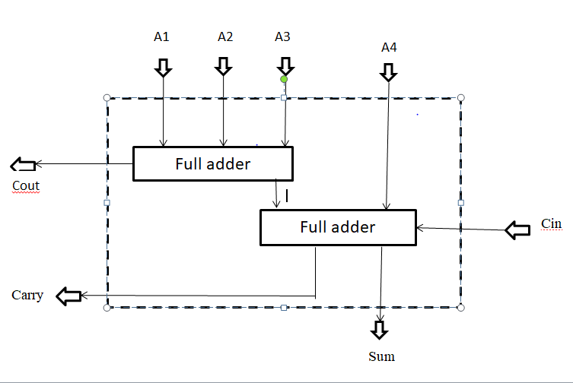

Figure 3.1: Implementation of a conventional 4*2compressor

sum = A ₁ ⊕ A₂ ⊕ A₃⊕ A₄⊕ cin

cout = (A₁⊕ A₂) A₃ + (A₁⊕A₂) A₁

carry = (A₁⊕A₂⊕A₃⊕A₄) cin+(A₁⊕A₂⊕A₃⊕A₄)A

The system uses 5 inputs (A1, A2, A3, A4, and Cin) and 3 outputs for each individual 4*2 compressor (sum, Cout, and carry).
The ability to add numbers with little carry propagation is one of the key speed-up strategies utilised in contemporary digital circuitry. The fundamental notion is that three numbers can be compressed into two numbers in a 3:2 ratio by adding the numbers while keeping the carries and sum apart. The result is a two output "adder" with a time delay that is independent of the size of its inputs, allowing all of the columns to be added simultaneously without depending on the outcome of the previous column. The right outcome can be obtained by recombining the sum and carry in a standard addition. This procedure may appear more time-consuming and ineffective, but its strength lies in the fact that any quantity, number of adders a. The carry output from the cascade serves as the carry input for the entire adder circuit.
It is actually a five-bit adder because the outputs represent the total of the inputs' five bits.
The Cout signal forms the input to the Cin of a 4:2 of the next column.
A 4*2 compressor is often implemented by using two full-adder (FA) cells, which are used to add binary values. Two complete adders coupled in serial make up a 4:1 compressor. Instead of another adder, we utilize a compressor adder because it has less carry propagation. A digital contemporary circuit known as a compressor is utilized for high speed with few gates and requires designing approach. With a quick processor and a small footprint, this compressor becomes a crucial instrument for quick multiplication adding techniques.
In multipliers, a compressor is a device that reduces the operands while adding terms of partial products. A typical M-N compressor creates an N-bit binary number from M equally weighted input bits. The 3*2 compressor, commonly referred to as a complete adder, is the most basic and popular type of compressor. It generates two outputs from three inputs that must be added together. In a similar manner, two cascaded 3*2 compressor circuits can likewise be used to create a 4*2 compressor. According to Fig, the traditional implementation of a 4*2 compressor consists of two complete adders coupled in serial. The basic equation governs the
X₁ + X₂ ₊ X₃ ₊ X₄ ₊ C_{in =} SUM + 2 (Carry + C_{out})

3.2.FUNCTIONALITY OF FULL ADDER
The adder known as a "full adder" adds three inputs and generates two outputs. A and B make up the first two inputs, and C-IN is the third input. The normal output is denoted as S, which represents SUM, while the output carry is designated as C-OUT. Eight inputs can be used to form a byte-wide adder using full adder logic, and the carry bit can be cascaded from one adder to the next
The adder circuit is crucial to most digital circuits that perform addition or subtraction. It gets its name from the fact that it combines two binary digits and a carry-in digit to create a sum and carry-out digit. As a result, it has two outputs and three inputs.
The adder circuit is crucial to most digital circuits that perform addition or subtraction. It gets its name from the fact that it combines two binary digits and a carry-in digit to create a sum and carry-out digit. As a result, it has two outputs and three inputs.
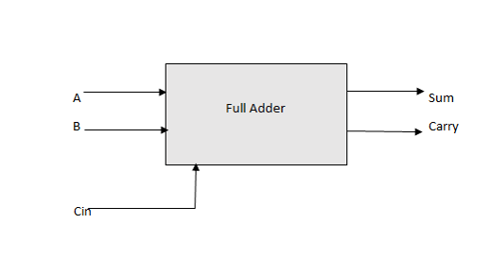
Fig3.2: Block diagram of full adder
The common implementation of a 4*2 compressor is accomplished by utilizing two full-adder (FA) To add binary numbers cells.4:2 compressor is composed of two serially connected full adders. With minimal carry propagation we use compressor adder instead of other adder. Compressor is a digital modern circuit which is used for high speed with minimum gates requires designing technique. This compressor becomes the essential tool for fast multiplication adding technique on fast processor and lesser area.
4.PROPOSED SYSTEM
The main aim of this paper is reducing power consumption and area and delay and increasing the performance of the system. This section proposes three roughly 4*2 compressors (UCAC1, UCAC2, and UCAC3). The ECM is then demonstrated in order to identify an input pattern with a high likelihood and fix the incorrect compensation in this instance. Additionally, 8-bit multipliers based on the Dadda tree are embedded into the suggested designs. All analyses are carried out using a uniform distribution. Two complete adders that are serially coupled make up a 4:2 compressor. We utilize compressor adder rather than another adder since it has less carry propagation. A digital modern circuit called a compressor uses a high speed architecture with few gates and sophisticated design.
4.1 Error metric basis:
In approximation design, error rate (ER) and error distance (ED) are two crucial measures. The ER indicator shows what percentage of the overall values are incorrect. While ED exemplifies the distinction between approximate and accurate computing outcomes. N is the bit width of the input data provide definitions for these two metrics in multiplication. The outcomes of approximate and exact multiplication are shown by the symbols a*b and ab, respectively.
4.2 Approximate 4*2 compressors:

TABLE displays the truth tables for the three compressors that have been suggested. While Fig shows the circuits of the proposed three rough compressors. Cin, Cout, and Carry are all cancelled in this work. The rational purpose of UCAC1.
All 16 input patterns are separated into five cases based on the number of logic "1" in each pattern. And they are designated as 0o, 1o, 2o, 3o, and 4o situations, accordingly. Let these two input signals be represented by a and b. The (i+1)th bit of input for A is represented by ai, and the (j+1)th bit of input for B is represented by bj,
Sum=y₁y₂+(y₁+y₂)(y₃+y₄)+y₃y₄
Sum=(y₁+y₂)(y₂+y₃)
Sum=y₂+y₄

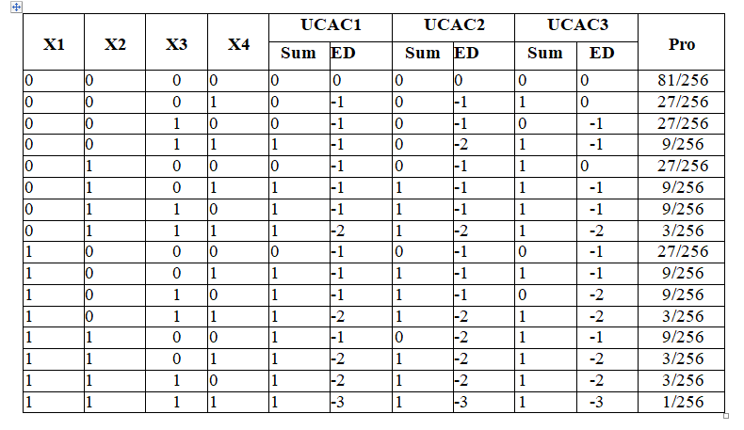

Table4.2.1: Exact 4*2 compressor truth table
These suggested designs, particularly the UCAC2 and UCAC3, have fairly straightforward architectures, as seen. However, these compressors produce a significant ED when there are more than two logic "1" inputs. Additionally, they all maintain high ERs.
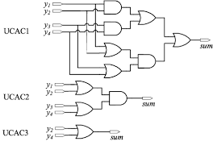
Fig4.2.1. The circuits of three proposed designs.
4.3 Error-correcting module(ECM):
A constant logic "1" is added to the following bit of the CC's MSB when the suggested compressors are embedded into the multipliers in order to provide a positive error, as seen in . However, the suggested compressors produce the right result when the 0o scenario occurs. In this scenario, the correcting bit's positive error cannot be balanced by a negative error.

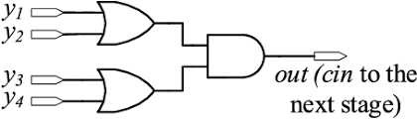
Fig.4.3.2 The circuits of error-correcting module

4.4 Approximate multiplier:
Four 8-bit multipliers (N=8) are created to analyze these blocks in accordance with how the suggested approximation compressors and ECM are designed to streamline and speed up the compression process. 1) MUL1: UCAC1 multiplier with constant correcting bit; 2) MUL2: UCAC1 multiplier and ECM; 3) MUL3: UCAC2 multiplier and ECM; 4) MUL4: UCAC3 multiplier and ECM; although approximation compressors can replace all classic 4-2 compressors, the error performance suffers . As a result, N-1 less significant bits in the suggested multipliers use the approximation compressors. And Figure depicts the compression tree.
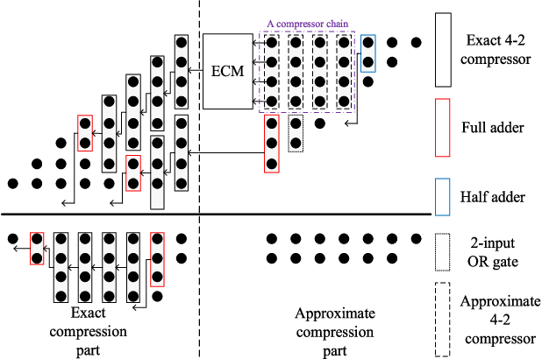

Fig.4.4.3 The compression tree of approximate multiplier

As seen in this image, the rectangles in Fig. 5 with solid or dashed lines represent various digital circuits. The neighboring exact 4*2 compressor's cin signal receives the output of the ECM. In MUL1, a constant logic "1" is used in place of the ECM. An OR gate is used to compress the partial products in order to fully benefit from the high compression ratio. This has the advantage of requiring only one compression stage to be set up in the approximation part.
5.Result:
FOR any VLSI system the major factors that analyse the system performance is power consumption delay and area observed the outputs those are
5.1 RTL Schematic :
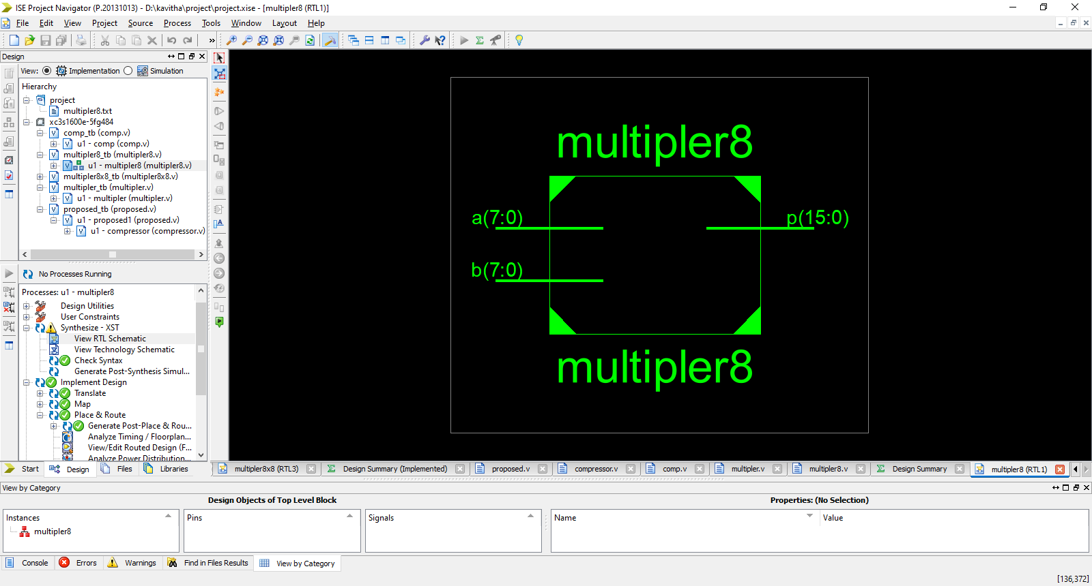
Fig 5.1.1: RTL schematic view of 4*2 compressor
Register transfer level is referred to as RTL. This suggests that the Verilog code you wrote defines how data is altered as it is transferred between registers. The combinational logic that sits between the registers transforms the data on fly.
The Verilog Real hardware is described using a subset of the Verilog language called RTL. ASIC gates and FPGA cells can both be created from RTL code. As a result, it must adhere to highly rigorous regulations.

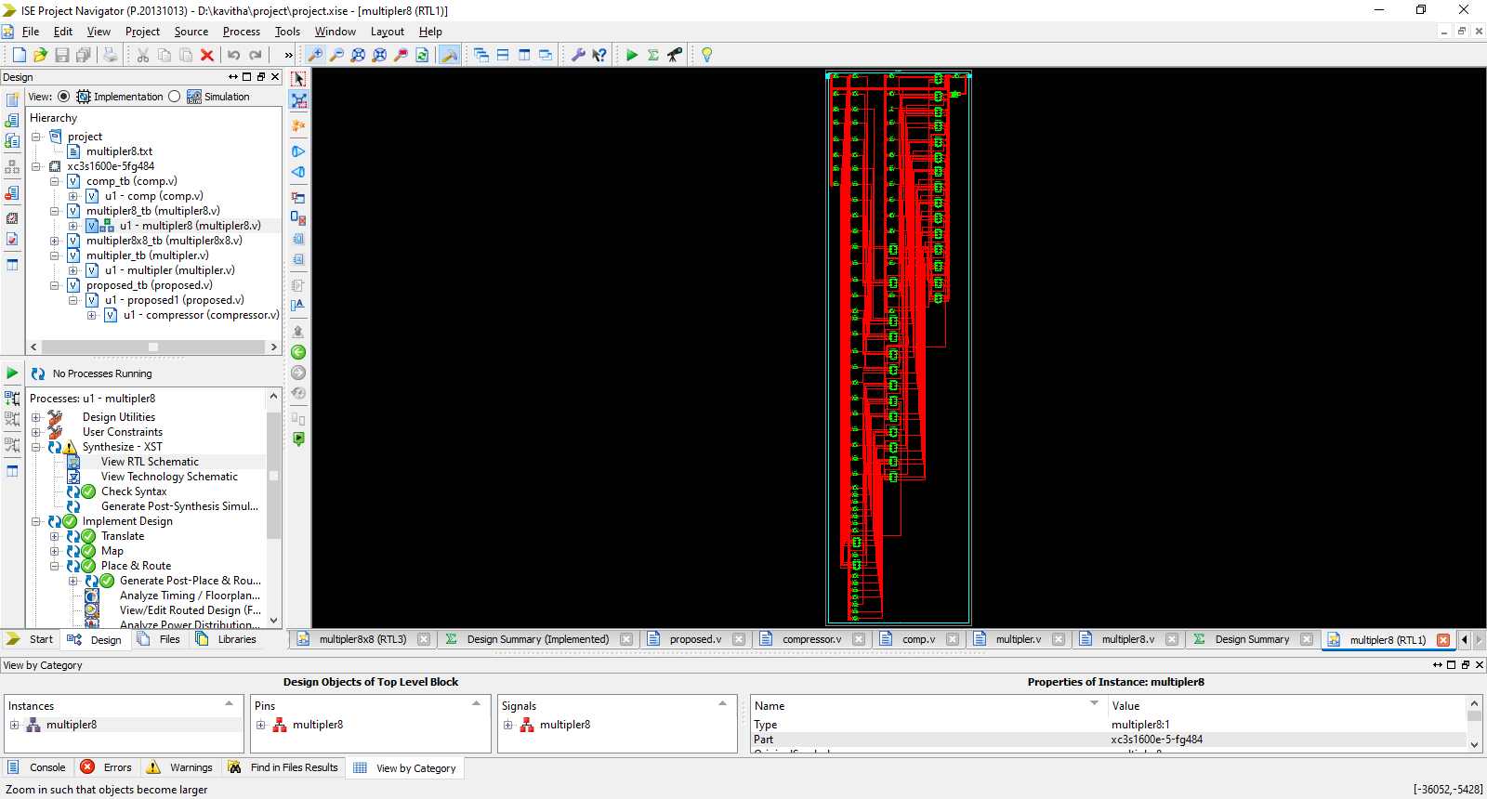
Fig 5.1.2: RTL schematic Total circuit
5.2 Power analysis:
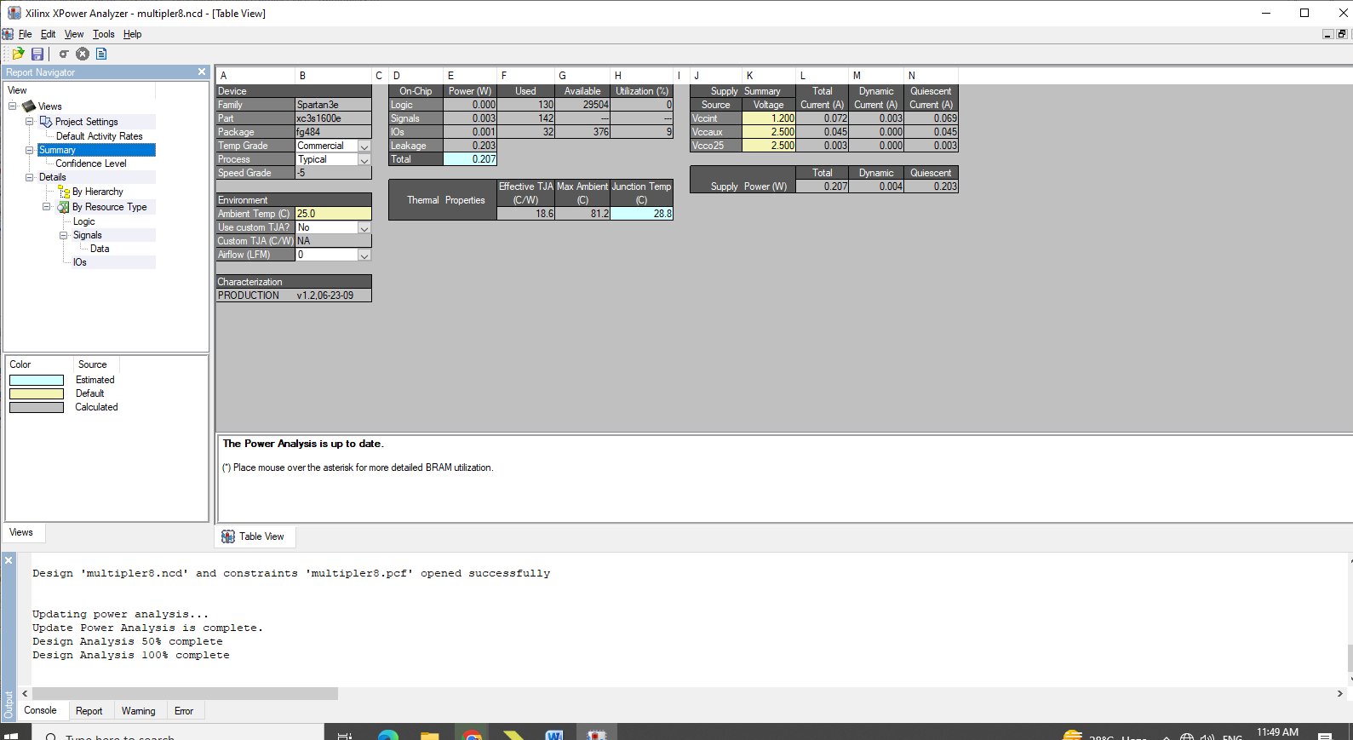
Fig 5.2.1 : power analysis of 4*2 compressor
The power analysis says that it consume 0.207 w which is less the existing system
5.3 AREA:
Area occupying is totally depend on number of LUT(look up tables)
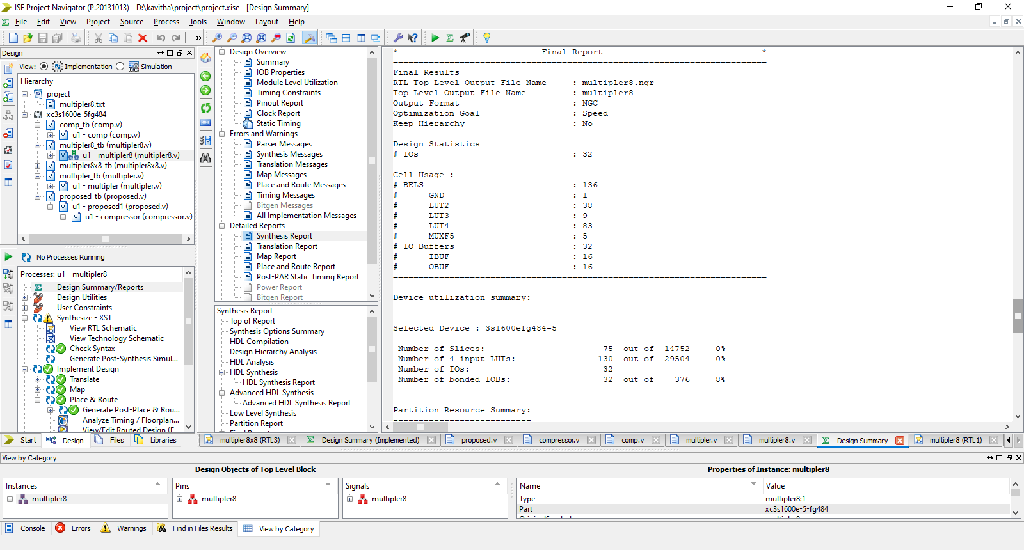
Fig 5.3.1 look-up-table Analysis
Total LUT here is 131 which is less than existing system
This is just a tiny RAM component that selects an output bit from memory using the 4 or 5 or 6 inputs it gets.

5.4 DELAY:
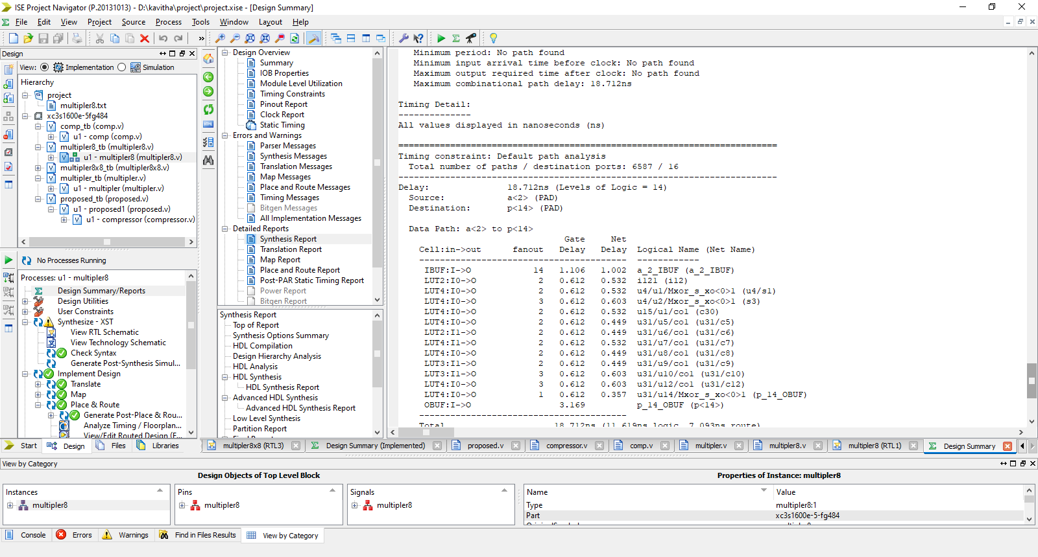
Fig 5.4.1: Delay analysis for 4*2 compressor
Delay for this system is 18.712ns which is less than existing system. Delay specify how values propagate through nets or gates. The gate delay declaration specifies a time needed to propagate a signal change from the gate input to its output .The gate delay declaration can be used in gate instantiations. The delays can also be used for delay control in procedural statements.

5.5 SIMULATION RESULT:

S. No | Parameters | Existing System | Proposed System
1 | Power | 0.406W | 0.207W
2 | Look up table | 137 | 131
3 | Delay | 21.326ns | 18.712ns

Table 5.5.1 Simulation results

Here a,b values are 2,6 respectively and output obtained is 12 correctly.
By considering the factors like delay,power consumption , area it is denoting as performance is high comparing with the existing system.

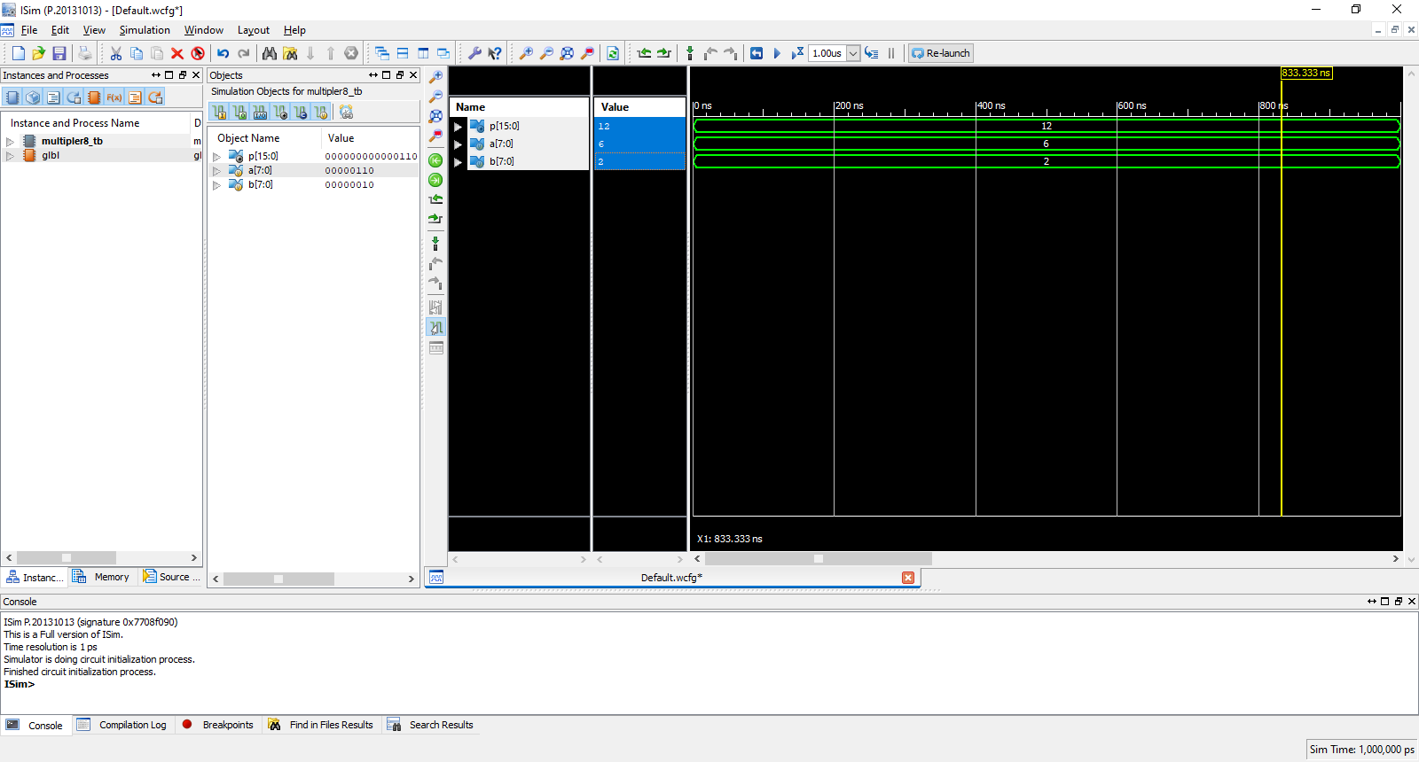
Fig 5.5.2: simulation result of 4*2 compressor
6. CONCLUSION:
Based on the compensation characteristic of addition, three ultra-low power consumption approximate 4*2 compressors are proposed. With the exact 4*2 compressor, the proposed compressors achieve a significant reduction in power consumption, area, and delay.
Among all the approximate 4*2 compressors, the proposed works innovatively reduce the number of outputs to one. Furthermore, assisted by the proposed ECM, these compressors are utilized to construct 8-bit multipliers. As the results indicate, the multipliers embedded with our compressors and ECM show good compromising between physical characteristics and accuracy.

7. REFERENCES:
[1].V. Leon, G. Zervakis, D. Soudris, and K. Pekmestzi, “Approximate Hybrid High Radix Encoding for Energy-Efficient Inexact Multipliers,” IEEE Trans. Very Large Scale Integr. (VLSI) Syst., vol. 26, no. 3, pp. 421– 430, Mar. 2018.
[2].
[3].Wang, B. H. Calhoun, and A. P. Chandrakasan, Sub-Threshold Design for Ultra Low-Power Systems, vol. 95. New York, NY, USA: Springer, 2006.
[4].L. Qian, C. Wang, W. Liu, F. Lombardi, and J. Han, “Design and evaluation of an approximate Wallace-Booth multiplier,” 2016 IEEE Int. Symp. Circuits and Syst. (ISCAS), Montreal, QC, 2016, pp. 1974-1977.
[5] X. Yi, H. Pei, Z. Zhang, H.Zhou, and Y. He. “Design of an EnergyEfficient Approximate Compressor for Error-Resilient Multiplications,” 2019 IEEE Int. Symp. Circuits and Syst. (ISCAS). Sapporo, Japan, 2019, pp. 1-5.
[6] S. Venkatachalam and S.-B. Ko. “Design of Power and Area Efficient Approximate Multipliers,” IEEE Trans. Very Large Scale Integr. (VLSI) Syst., vol. 25, no. 5, pp. 1782-1786, May 2017.
[7] D. Esposito, A. G. M. Strollo, E. Napoli, D. De. Caro, and N. Petra. “Approximate Multipliers Based on New Approximate Compressors,” IEEE Trans. Circuits and Syst. Ⅰ: Reg. Papers, vol. 65, no. 12, pp. 41

