Energy Harvesting On Airport Runway Using Piezoelectric Devices
Shahid Arif Ibushe
Pune Institute of Aviation Technology,Pune

Abstract—Exploiting ambient sources of vibration energy has become an emerging trend in the ﬁeld of energy harvesting. There are several methods by which this can be achieved, out of which piezoelectricity has emerged as one of the efﬁcient methods. For effective application of piezoelectric devices to harvest energy, it is important to recognise the sources or areas from where a large amount of vibration energy can be exploited. In this paper we present a multimorph piezoelectric device that would be employed to harvest vibrational energy from airport run-­‐ ways. We have explored the economic impact of our proposal by hypothetically employing our system on Heathrow Airport, London. Primarily the paper focuses on material selection, basic mechanical design and the economic impact of the piezoelectric harvester.
KEYWORDS:Piezoelectric, Polyvinylidene ﬂuoride, Quartz crystal, Lead zirconate titanate (PZT),M31 bacteriophage
I INTRODUCTION
The world is shrouded by an exacerbating energy crisis. Such a global scenario serves as a catalyst for change and innovation for budding technologists. Rapidly depleting conational sources of energy and the growing human population demonstrate the limited potential of our renewable resources to satiate our incredible energy demands. Flow of energy is a perpetual phenomenon; energy is neither created nor destroyed. The only limitation in this cycle is that of tapping energy and converting it to a usable form. The technical term employed for this process is harvesting. Energy harvesting from ambient waste energy for the purpose of running low-­‐ powered electronics has emerged during the last decade as an enabling technology for wireless applications. A large amount of ambient energy is present in the environment and seeing the energy demand it is imminent that we tap this potential source. The concept has ecological ramiﬁcations in reducing the chemical waste produced by replacing batteries and potential monetary gains by reducing maintenance costs. One of the most researched areas of study is the use of piezoelectric effect to harvest vibrational energy. With the advent of efﬁcient lighting systems, low power consuming sensor units and other energy efﬁcient devices both in the analog and the digital domains, there is a huge scope to power such devices by using ambient free energy available in their environment. The basic vibration to electric energy conversion mechanisms are as follows 1. Electromagnetic 2. Electrostatic 3. Piezoelectric [William and Yates, 1]. Out of all these transduction mechanisms piezoelectric ones have received considerable attention. . An energy harvester from a piezoelectric perspective can be deﬁned as a” generator device undergoing vibrations due to a speciﬁc form of excitation”. [Daniel .J. Inman et al]. Piezoelectric devices standout due to their large power densities* and ease of application. The work done by Cook-­‐Chennaut et al shows that the piezo-­‐ electric energy harvesters have larger power densities output versus voltage, when compared with thermoelectric, electro-­‐ magnetic and other energy converters. Also in piezoelectric energy harvesting usable voltage outputs can be obtained directly from the piezoelectric material itself. As another advantage, unlike electromagnetic devices, piezoelectric devices can be fabricated both in macro-­‐scale and micro-­‐scale due to the well-­‐ established thick-­‐ﬁlm and thin-­‐ﬁlm fabrication techniques

A.Piezoelectric Principle
As the ramiﬁcation of their study in 1880 brothers Pierrie and Jacques Curie proposed the electric effect in some crystals with the application of the mechanical stress, when applied parallel to the polar axis [1]. However, Lippmann proposed the inverse response using thermodynamics grounds, later veriﬁed by the Curies [2]. The word “Piezo” is derived from the Greek word meaning “to press ”. Hence, piezoelectricity is the electricity produced with the application of the mechanical pressure. The piezo effect found in some crystals is due to special electric polarization effect caused by the application of mechanical stress [3]. The electric polarization in these materials is similar to that which occurs in the solid materials. On the application of the mechanical stress they change their polarization due to reorientation of the molecular dipole on the application of the external stress. The piezo material under non resonance condition can be replaced by the capacitor which produces voltage(V) with the application of the mechanical stress.

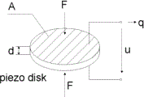
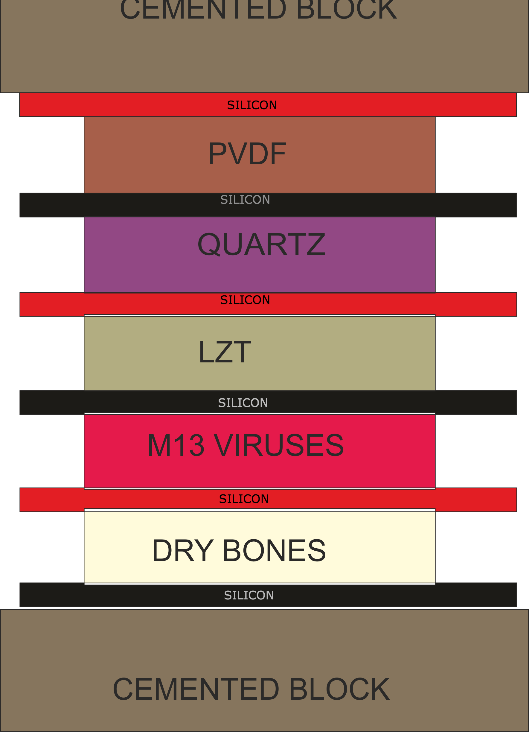
Fig. 1. Capacitance representation of Piezo material
We know that ,capacitance “C” of a material can be given by $$C=\frac{ε_{0}* A}{t}$$
where,
εo = “Electrical permittivity of the material”
A = “Area of the material”
t = “Thickness”
II HARVESTER DESIGN

The design of the harvester cell which will be used to capture the ambient pressure energy from the airport runway is of utmost importance. The efficiency of energy conversion from vibrational to electric is dependent upon the way vibrational stress is applied onto the piezoelectric cell and the characteristic properties of the materials involved in the multi-layered both the, selection of materials as well as the mechanical de--‐ sign, are important parameters. Several approaches have been used for designing high energy density harvesters, H Kim Et.al have investigated selection of suitable piezoelectric materials for energy harvesting based on piezoelectric properties such as high value of piezoelectric strain constant d, high piezoelectric stress constant g and high coefficient of electromechanical coupling k [13] [14].S Priya Et.al have utilised the principle of impedance matching for efficient extraction of energy from a harvester [14]. On the mechanical design side optimisation of geometry [15] for efficient straining has been exploited as well.

Fig. 2. Basic Design Of Harvester cell
Piezoelectric material selection
The selection of piezoceramics depends on the piezoelectric coefficients of the materials. The coefficient dij is known as piezoelectric modulus or the piezoelectric strain constant, it is the ratio of strain to applied field or charge density to applied mechanical stress, where i and j refer to the x,y or z directions of the Cartesian coordinate system. It simply implies that it is the induced polarisation in direction i when mechanical stress is applied in direction j or vice versa. The coefficient gij is known as the piezoelectric voltage constant and is equal to the open circuit field developed per unit of applied stress or as the strain developed per unit of applied charge density or electric displacement. Here i and j are used in the same context as before. Although the physical significance of the coefficients d and g maybe different but they are related to each other as:
$$g= \frac{d}{ε^{T}}$$
Where T is the dielectric constant measured at constant stress. Larger value of d and g imply higher power output from a PEH. In technical literature available [19,20] researchers have defined a figure of merit (FOM).
$FOM=g*d= \frac{d^{2}}{ε^{T}}$

$$Alternate-{FOM}_{Off-resonance}= \frac{g*d}{tanδ}$$
Where tanδ counts for dielectric losses in low frquency region[20]. It has been observed that materials having high g and high g*d generate high voltage and power when the piezoceramic is employed for energy harvesting and sensing applications [19]. Another coefficient called as the electromechanical coefficient k, defined as

$$K^{2}= \frac{Electrical Energy Stored}{Mechanical Energy Stored}$$
has been used for selecting the materials. Taking mode--‐31 as example the electromechanical coefficient can be defined as
$$k_{{31}^{2}}= \frac{d_{{31}^{2}}}{s_{{11}^{ε}}*ε_{{33}^{T}}}$$
where s11 is the elastic compliance at constant electric field and T is the positive dielectric constant for the positive33 piezo ceramic measured at constant mechanical stress After surveying the literature available for material selection [12,19,20], we employed FOM [12] and d33 as the criteria for material selection.The d33 mode of operation is selected over the d31 mode for piezo ceramics as higher As higher values of g, d and consequently FOM are observed when the selected piezo ceramics are employed in 3--‐3 mode. The selection of PVDF is an exception to the selection criteria as the d33 value for the ceramic is low, although FOM response [20] is large yet on the whole, PVDF has a higher power output. PZT PS154HE has considerably high d and FOM values and correspondingly high output power Dry bones have significant piezoelectric properties. They can be considered as a composite material consisting of 3 phases: collagen (which exhibits piezoelectric effect), extracellular mineral and pores. Collagen occupies about 40 --‐ 50 percent of the compact bone mass. The collagen fibres are highly oriented in nature. Collagen is one of the best example of pyroelectric structures in biology and under constant temperature a pyroelectric material does exhibits a piezoelectric property [Cady (1964) Guzelsu (1978)][21] The piezoelectric effect in bones was discovered by Fukada and Yasuda(1957) .Experimental results from investigations by Fukada and Yasuda(1957), Basset And Baker(1962), Shamos Et.al(1963 ) And fukada and yasuda (1959,1964) yielded the governing matrix of piezoelectric properties for a dry bovine bone. The highest value of piezoelectric coefficient of the bovine bone is about one--‐tenth of the piezoelectric coefficient d11 of quartz Williams and Berger(1974,1979) confirmed that electrical signals produced by dry bones bent in cantilever mode are similar to those produced by piezoelectric mineral crystals but differ in one aspect that is the sign of the voltage changes on end to end rotation of the mineral samples but it does not change for the bone[21]. Using viruses to produce electricity is a very novel approach [21].
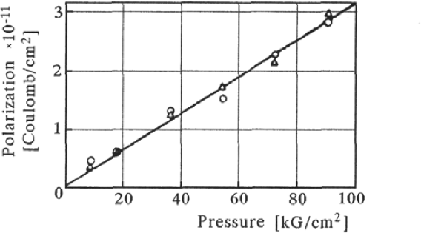
Fig. 3. Direct Piezoelectric Effect Of The Bone[21]
The piezoelectric activity of biomaterials like collagen viruses etc. does not follow classical piezoelectric theories and hence modelling and simulation on presently available software is not possible. There is large amount of ongoing research in the field our primary motive in employing viruses as piezoelectric materials was to increase the output of the device, exploit the piezoelectric properties of the bio materials on a large scale and reduce the cost of the system as M13 phage viruses are easily reproducible on a mass scale.
Mechanical design
Piezoelectric harvesters and actuators have been largely built for micro scale devices a large amount of research literature [16,] focuses on the cantilever structure of beams made up of piezoelectric materials. The cantilever design is applicable to micro electromechanical systems when ambient vibrational energy is easily available and thus it is possible to set cantilever into vibration. Our model involves harvesting the forces exerted by a moving airplane on the concrete runway. The aircraft exerts the force on the concrete, which causes deformation in the concrete due to the energy transferred from the plane to the runway. Mostly these compressive forces are dissipated as heat and friction, but by incorporating our harvester just beneath the concrete layer we can efficiently exploit these compressive forces. Our design involves multiple layers of piezoelectric materials. Each layer is separated by a layer of silicon over which the piezoelectric materials are deposited, silicon being a non piezoelectric material serves as a mechanical support and does not contribute to the electric output of the device.It also serves as an electrode from which wire connections will be made to obtain the output of the device. The wires will be directly soldered on to the silicon layer and an insulated cover will carefully encapsulate each connection. Proper soldering will ensure minimal wire breakage. We propose a cuboidal structure for our harvester cell, which will easily fit within the existing structure of the runway, without affecting the distribution of forces on the runway. Multiple layers offer an advantage as the voltage produced by each layer can be summed up by making series connection between separate layer outputs. Piezoelectric materials have high temperature stability, once polarized they tends to retain their properties up to a tem--‐ perature called as curies temperature. The Curie temperature for typical piezoelectric materials lies in the range 200 degree Celsius 500 degree Celsius.
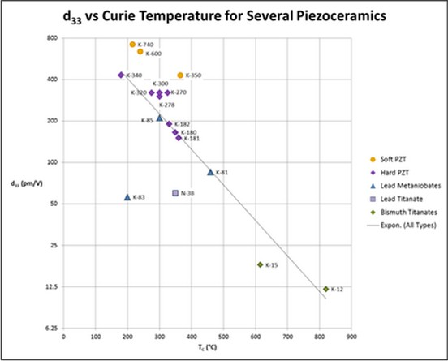
Fig. 4. d33 Vs Temperature

The runway temperatures in the hottest part of the world do not increate more than 60 degree Celsius, thus the temperature condition will not affect the functioning of the harvester. Other weather condition like snow fall and rain which pose a threat of damaging the device will we tackled by embedding the harvesters into a watertight cavity. Factors such as soil quality texture, acidity etc. does not affect our design as it is safely harboured within the concrete runway. We cannot safeguard the piezoelectric devices against adverse natural calamities, which will tend to affect the entire airport. As the harvester has prolonged temperature and mechanical stability due to the inherent nature of piezo ceramics we estimate that a single unit would require replacement only after a time span of 20--‐25 years. Cantilever structures are not suited for design as it will be difficult to set the free end of cantilever into motion which is necessary for the structure to undergo deformations and produce electrical current. The predominant forces experienced by the structure during its deployment on a runway would be normal to its plane. Hence, the cuboidal structure is most suited for our application. Multimorph design is not uncommon but the layers of piezoelectric materials are of the same type the novelty of our design lies in utilising different piezoelectric materials in multimorph design. Employing a layer of M13 bacteriophage genetically modified viruses will increase the mechanical strength, the strength can be varied by further modification of the virus.

III ECONOMIC ASPECTS OF THE MODEL
Any model is viable if its economically cheaper than the currently existing models. These days a large amount of the harvested electricity is used up in places like the airport where yearly consumption has crossed over 700 million units [4] Even though many energy harvesting methods have been implemented in these places ( like the use of solar panels, biomass plants etc. )[4,6] , the reduction in electricity
consumption has been nowhere near to the extent our model promises. our model promises to minimize the consumption. For instance, if we look at an airport like Heathrow, London, the daily consumption has crossed 701 million units [4] resulting in a yearly expenditure of 151 million USD [5]. The plantation of our harvesting piezo port devices on runways section III will reduce this consumption remarkably. plantation cost of the model per sq. foot is around 1120 USD According to the CIVIL AVIATION AUTHORITY the minimum width required for a runway is 10 m and its length depends upon the aircrafts which run on it (details are provided in an aircraft specification sheet) For a general aircraft it is around 1000m [11] and hence total plantation area would be around 10000 sq. m.

Fig. 6. Cost of materials(USD) [7,8,9,10]

As we can see from sources [7,8,9,10] the This makes the total plantation cost around 15 million USD of plantation itself and then the installed piezo ports would support the electricity consumption in these locations till their longevity section III The cycle of energy harvesting and replacement, if adopted, can yield a monetary profit of around 1495 million USD, in just a span of 10 years.

IV FUTURE WORK AND CHALLANGES
Our current paper presents the basic design of an energy harvester with potential application on an airport runway. There is an immense scope of continued research, which could include increasing the efficiency of the design, modifying the mechanical design and making alternative arrangement of layers for better electrical output. Bioengineers could focus on making changes in the genetic structure of virus.
V CONCLUSION
In conclusion, energy harvesting on airport runways using piezoelectric devices presents a compelling opportunity to tap into the renewable energy potential generated by the constant vibrations and pressure fluctuations on runways. By converting these mechanical motions into electrical energy, airports can reduce their reliance on traditional power sources and promote sustainability in their operations. The advantages of this approach include the utilization of a renewable energy source, cost reduction, environmental benefits, continuous power generation, reliability, easy integration, scalability, redundancy, noise reduction, and technological advancement. While there are potential challenges and limitations to consider, such as limited energy output and initial installation costs, ongoing advancements in piezoelectric technology can help overcome these barriers. Overall, energy harvesting using piezoelectric devices on airport runways offers a pathway to more sustainable and efficient airport operations, contributing to the aviation industry's efforts to reduce its environmental impact and embrace renewable energy solutions.

References
[1]Jacques and Pierre Curie (1880) ”Dveloppement par compression de llectricit polaire dans les cristaux hmidres faces inclines” (Development, via compression, of electric polarization in hemihedral crystals with inclined faces), Bulletin de la Socit minrologique de France, vol. 3, pages 90 -­‐ 93. Reprinted in: Jacques and Pierre Curie (1880) Dveloppement, par pression, de llectricit polaire dans les cristaux hmidres faces inclines,” Comptes rendus ... , vol. 91, pages 294 -­‐ 295. See also: Jacques and Pierre Curie (1880) ”Sur llectricit polaire dans les cristaux hmidres faces inclines” (On electric polarization in hemihedral crystals with inclined faces), Comptes rendus ... , vol. 91, pp. 383 ‐ 386
[2]W.G. GADY:Nature And Use Of Piezoelectricity,IEEE Electrical Engineering (Volume:66 , Issue: 8 ), pp.758 -­‐ 762,Aug. 1947
[3] WANG Hongijin, MENG Quingfeng, ZHANG Kai:Discussion and experimental verification relations of polarization and voltage induced of piezomaterial,Mechanical and Automation Engineering (MAEE), 2013 International Conference ,pp. 30--‐33, 21--‐23 July 2013
[4]Heathrow Airport Authority, 2012 SUSTAINABILITY PERFORMANCE SUMMARY, http : //www.heathrowairport.com/static/ HeathrowAboutU s/Downloads/P DF/Sustainability /2012s ustainabilitys ummaryr eport.pdf

[5] British Gas: Tarrif Rates, http : //www.britishgas.co.uk/products − and − services /gas − and − electricity/our − energy − tarif f s/ tarif f − rates.html
[6] Solar industru mag:solar installation and airport, http : //www.solarindustrymag.com/issues /SI1306/F EAT0 2G lareF actor.html
[7] PVDF Costing: http : //www.alibaba.com/showroom /piezoelectric − pvdf.html
[8] QUARTZ costing: http : //www.alibaba.com/trade/search?f sb = y&IndexArea = producte n&CatId = &SearchT ext = piezoelectric + quartz
[9] LZT Costing: http : //www.piezo.com/prodsheet2sq5H.html/priceinf o

[10] M13 Harvesting Cost: Bacteriophage Power Generator,Virus based Piezoelectric Energy Generation Commercial Analysis, May 20th 2013
[11] CIVIL AVIATION AUTHORITY: Guidelines For Aeroplane Landing Areas, http : //www.f lyingdoctor.org.au/IgnitionSuite /uploads/docs/92 − 1.pdf
[12] Alice Daniels, Meiling Zhu, Ashutosh Tiwari:Evaluation Of Piezoelectric material Properties For Higher Power Output From Energy Harvesters With insight Into Material Selection Using A Coupled Piezoelectric-­‐Circuit-­‐Finite Element Methold, Ultrasonics, Ferroelectrics and Frequency Control, IEEE Transactions on (Volume:60 , Issue: 12 ),pp. 2626 -­‐ 2633, Dec. 2013
[13]H. Kim, A. Batra, S. priya, K. Uchino, D. Markley, and R. E. Newnham: Energy Harvesting Using A Piezoelectric “cymbal” Transducer In A Dynamic Enviroment, jpn. J.Appl. Phys. Vol. 43, no. 9A, pp.6178-­‐6183,2004
[14]H. Kim, A. Batra, S. priya, H Stephanou, K. Uchino : Consideration Of Impedance Matching Techniques For Efﬁcient Piezoelectric Energy Harvesting, IEEE Trans. Ultrason Ferroelec. Freq. cont. Vol. 54, no. 9, pp.1851-­‐ 1859,Sept. 2007
[15]X Chen, C. H. J. Fox, and S. McWilliam:Optimisation Of An Cantilever Microswitch With Piezoelectric Accutation, j. Intell Mater. Sys. Struct., Vol:15 No.11, pp.823-­‐834,2004
[16]E.varadrajan, M.Bhanusri: Design and Simulation of Unimorph Piezoelectric Energy Harvesting System, Excerpt from the Proceedings of the 2013 COMSOL Conference in Bangalore, 2013
[17]Xue-­‐shuai YUAN, Fu-­‐jun CHEN: SUBDOMAIN COLLOCATION METHOD FOR MULTILAYERED PIEZOELECTRIC MATERIAL, Piezoelectricity, Acoustic Waves and Device Applications (SPAWDA), 2010 Symposium, pp. 441 -­‐ 446, 10-­‐13 Dec. 2010
[18] Swee L. Kok, Neil M. White and Nick R. Harris, Free-­‐StandingThick-­‐FilmPiezoelectricMultimorph Cantileversforenergyharvesting,Available[online] http : //eprints.soton.ac.uk/267652/1/(1107) − F ree − standing − thick − f ilm − piezoelectric − multimorph − cantilevers − f or − energy − harvesting.pdf
[19] Shashank Priya: Criterion For Material Selection In Design Of Bulk Piezoelectric Energy Harvesters,Vol. 57 No. 12,pp. 2610-­‐2612,December 2010
[20] Shashank Priya: Advances in energy harvesting using low proﬁle piezoelectric transducers,J Electroceram (2007) 19:165182,8 September 2006
[21]Byung Yang Lee, Jinxing Zhang, Chris Zueger, Woo Jae Chung, So Young Yoo, Eddie Wang, Joel Meyer, Ramamoorthy Ramesh, Seung Wuk Lee: Virus based piezoelectric energy generation, Nature Nanotechnology 7, 351356,2012
[22] Swee L. Kok, Neil M. White and Nick R. Harris: Free-­‐ Standing Thick-­‐Film Piezoelectric Multimorph Cantilevers for energy harvesting

