Investigating the impact of parameters on driving range of Nissan Leaf, BMW i3 and Chevrolet Bolt using MATLAB Simulink
Sanpreet Singh¹, Baljeet Singh², Arshdeep Kaur³
¹M.Tech Scholar, Department of Electrical Engineering, Guru Nanak Dev Engineering College Ludhiana, Punjab, India.
^{2,3,}Assistant Professor, Department of Electrical Engineering, Guru Nanak Dev Engineering College Ludhiana, Punjab, India.
¹Email: er.sanpreetsingh@gmail.com
²Email: er.sikand@gmail.com
³Email: arshkailay@gmail.com
-----------------------------------------------------****-----------------------------------------------------

Abstract - Lately, there has been a notable increase in the acceptance of electric vehicles (EVs) as a strategy to tackle greenhouse gas emissions and lessen dependence on fossil fuels. The distance an EV can travel without recharging is a vital factor in determining its practicality and convenience. This paper aims to examine the impact of different factors on the driving range of EVs and evaluate the economic benefits of particular EV models, with specific emphasis on the cost per kilometre.
This paper presents the creation of a MATLAB Simulink-based mathematical simulation model, which effectively represents the performance of various electric vehicle (EV) models. The simulation model incorporates several factors, including vehicle weight, driving patterns, incline of the slope, coefficient of rolling resistance, and speed, in order to assess their impact on energy usage with precision. The driving range of various electric vehicle (EV) models is observed by conducting simulation experiments in different scenarios while adjusting EV parameters. The collected data from these experiments is carefully analyzed to identify patterns and trends, offering comprehensive insights into the correlation between the investigated parameters and the driving range. The objective of this analysis is to support EV drivers in enhancing their driving range while maintaining performance.
Additionally, the study examines the economic viability of various electric vehicle (EV) models, specifically concentrating on the metric of cost per kilometre. Through a comprehensive examination of energy consumption rates and charging costs, a detailed analysis is carried out. The research presents valuable finding regarding the EV model that offers the most economical cost per kilometre for EV owners.
In general, this article adds to the current understanding of electric vehicles' performance and financial feasibility. The discoveries will give electric vehicle drivers the ability to improve their driving behaviours and make knowledgeable decisions. Potential electric vehicle owners can also profit from the economic evaluation, allowing them to choose the most economically advantageous EV choice that suits their driving habits and requirements. By utilizing the insights gained from this research, electric vehicle drivers can extend their driving distance and minimize their expenses.
Keywords – Electric Vehicle, Battery Electric Vehicle, EV Parameters, EV Cost Per Kilometre, EV Simulation Model
- INTRODUCTION
At present, the foremost threat to our planet, Earth, is undoubtedly global warming. One crucial factor contributing to this situation is the extensive dependence of modern society on fossil fuel-based transportation, which is vital for both economic and social advancements. Statistical projections indicate that more than one billion vehicles are utilized by travellers on roadways worldwide [1-2]. Currently, the world is facing two major challenges: the requirement for energy provision and its corresponding demand. As of 2021, the global oil production amounts to roughly 89.9 million barrels per day [3]. However, it is estimated that there are up to 1245 billion barrels of known oil reserves that can be accessed [4]. If the current consumption rate persists, the world's oil reserves will be exhausted within the next five decades. Furthermore, the Earth is currently confronted with a major issue caused by a worldwide discrepancy in environmental conditions. The utilization of petroleum-based products contributes to a rise in carbon dioxide (CO2) levels in the atmosphere, posing a significant threat to our planet. The heightened absorption of carbon dioxide leads to an elevation in temperatures and the occurrence of severe weather phenomena on a global scale. The increasing prevalence of electric vehicles in our modern world can be attributed to their ability to address the adverse effects of climate change caused by conventional internal combustion engine (ICE) vehicles. Electric vehicles, known for their eco-friendliness, operate without the need for gasoline or diesel fuel, relying instead on a reversible energy storage mechanism. Furthermore, these vehicles not only consume energy but also possess the capability to generate, store, and transmit electricity, making them an exceptionally promising substitute for traditional fuel-based automobiles. Consequently, the prominence of electric vehicles is steadily growing. Based on a report [5], there has been a notable upswing in the adoption of electric vehicles (EVs) in India. The country witnessed a remarkable 163% increase in the proportion of EVs, with 324,840 electric vehicles being officially registered in 2021, as compared to the previous year. Specifically, the number of two-wheeler EVs surged by an impressive 422% from 28,508 to 149,068 during the period from 2019-20 to 2020-21. Likewise, the sales of three-wheeled EVs experienced a surge of 75% from 90,216 to 157,682, while four-wheeled EV sales saw a significant rise of 230% from 4,695 to 15,860. In contrast, the sales of petrol and diesel vehicles witnessed a decline of 0.98% in 2021, with a total of 18,312,760 registrations. Notably, this decline was lower than the declines observed in the previous years of 2020 and 2019, which stood at 22.43% and 25% respectively.
Electric-powered vehicles have both positive and negative aspects. When it comes to efficiency, electricity outperforms the combustion process used in vehicles. Research [6-7] reveals that electric vehicles can travel 108 miles (173 km) using the same energy produced from 1 gallon (3.8 litres) of gasoline, regardless of the source of electricity generation. In contrast, an internal combustion engine (ICE) vehicle can only cover a distance of 33 miles (53 km) with the same amount of gasoline. However, there are also certain drawbacks to consider. One major disadvantage of numerous electric vehicles is their restricted range when operating on a single battery charge. Depending on the capacity of the battery and the prevailing conditions, electric cars can typically travel around 400 kilometres before needing to be recharged. In contrast, vehicles powered by internal combustion engines can cover a significantly greater distance on a single fuel refill, depending on the capacity of their fuel tank [8]. The limited distance electric vehicles can cover presents a hurdle to their widespread acceptance, as numerous EV drivers and potential buyers encounter "range anxiety," a feeling of uneasiness regarding the potential of running out of power before reaching their destination. The limited driving range of electric vehicles is primarily influenced by their battery usage. Therefore, it is crucial to examine the effects of various EV factors, including vehicle mass, slope, coefficient of rolling resistance, and speed, on battery consumption in order to improve the overall performance of these vehicles [9]. The investigation into the influence of these factors on the distance a vehicle can travel is carried out through the utilization of simulation software like MATLAB Simulink. Engineers and researchers are able to construct and simulate complex systems within a virtual environment by employing the robust capabilities of MATLAB Simulink. Through the utilization of Simulink, mathematical models of electric vehicles are developed, enabling the simulation of diverse scenarios in order to analyze the effects of different variables on driving range. In this study, the Backward-Facing Approach Technique is employed to mathematically simulate the components of the electric vehicle system [10].
Furthermore, the utilization of the Nissan Leaf, BMW i3, and Chevrolet Bolt EV's technical specifications was incorporated for the examination of the EV model [11-13]. To authenticate and confirm the model, the estimated driving range of the electric vehicle was determined through the FTP75 (2474 seconds) driving cycle. Developing a representation and simulation of the electric vehicle (EV) is an essential first step in the process of optimization. Consequently, this inquiry presented a model of the EV car using a commonly employed setup and assessed its performance by conducting experiments with different values of specific parameters. The proposed model will act as a basis for upcoming investigations into different techniques for improving energy utilization and will be suitable for a wide range of optimization strategies.
In our comparison phase, our primary emphasis is on the economic aspect of electric vehicles (EVs). Our aim is to identify the most financially efficient choice among EVs by analyzing their cost per kilometre. This evaluation primarily depends on the EV's watt-hour consumption per kilometre. Through the analysis of watt-hour consumption among various electric vehicle (EV) models, we can pinpoint the model that consumes the least energy, leading to reduced operational costs. It is essential to take into account the influence of electricity cost when evaluating the economic feasibility, as they directly impact the overall operational expenditure of an EV. Lastly, we conduct a comparison of the EVs based on both the cost per kilometre and the cost per charging of the battery.
- PROBLEM FORMULATION
The utilization of battery energy has a significant influence on the range of electric vehicles. Multiple parameters affecting the vehicle, such as speed, driver behaviour, transported load, aerodynamics, tire rolling resistance, and additional parameters, contribute to the battery's energy consumption. Therefore, these elements have an influence on the total distance that the automobile is capable of covering. By using less energy, electric vehicles can achieve a greater driving range. Nevertheless, the majority of these variables are predetermined by the manufacturers to be extremely optimized and are not adjustable by the driver.
There exists an alternative solution to enhance the driving range of an electric vehicle. To minimize the energy usage of an electric vehicle (EV), it is possible to prevent actions by the driver that create resistance against the vehicle's motion. This is achievable because the EV driver possesses the ability to control specific parameters, which can be modified. By adjusting these parameters, they have the capability to increase the distance their EV can travel. To enhance the distance covered by the vehicle without enlarging the battery pack, it is vital to analyze the variables that can be manipulated by the electric vehicle (EV) driver and their impact on the range of the EV.
Furthermore, it is understood that various electric vehicle (EV) models possess distinct parameters, so their impacts are also different on the vehicle, leading to variations in energy consumption measured in watt-hours per kilometer (wh/km). Consequently, the cost per kilometer also differs among these models. Therefore, we can make comparisons based on the cost per kilometer and offer recommendations to potential EV buyers regarding the most cost-effective option.
- CATEGORIZATION OF PARAMETERS
The categorization of parameters related to energy consumption in electric vehicles based on the entities that control them. Therefore, the parameters can be classified into the three subsequent groups:
- Parameters under the control of the manufacturer: The manufacturer holds authority over numerous parameters related to electric vehicles, a few of which are provided in the following list.
- Battery Capacity
- Curb Weight
- Drag Coefficient
- Frontal Area
- Parameters under the control of the driver: The driver possesses the capacity to directly manipulate specific parameters, while there exist additional parameters that the driver can indirectly affect to mitigate their effects. Presented below are several EV parameters that fall under the control of the EV driver.
Directly Control:
- Speed
- Driving style (braking and acceleration)
- Load on Vehicle (external weight carried by vehicle)
Indirectly Control:
- Rolling coefficient
- Slope angle
- Weather Parameters: Enumerated below are the weather parameters that exert an impact on the energy consumption of an EV.
- Wind Speed
- Air density and temperature
- CATEGORIZATION OF PARAMETERS
The provided block diagram illustrates various components of an electric vehicle (EV), necessary for analyzing the effects of different variables. The block diagram encompasses models for the motor, battery, transmission, vehicle body, tyre, and drive source.
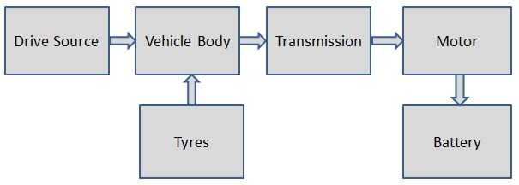
Fig. 1: Block Diagram of EV Model
- Tyre Model
The size of the wheels plays a crucial role in determining the overall performance and energy consumption of an electric vehicle (EV). It directly influences the distance the vehicle can cover using a specific amount of stored energy in the battery. However, manufacturers do not directly specify the wheel radius; instead, they utilize a specific marking format to provide this information. Manufacturers commonly employ a marking format on tyres, comprising a combination of letters and numbers, to convey important details about the tyre. Typically, the size indication follows a pattern of three numbers separated by a slash [Tyre Width] [/] [Aspect Ratio] [/] [R] [Rim Diameter], such as 250/45/R18.
In order to ascertain the radius of the wheel, it is imperative to initially compute the height of the tyre's sidewall, represented as "H."
$H=\frac{Tyre Width × Aspect Ratio}{100}$ (1)
The overall wheel diameter, D_{W}, can be determined by summing the rim diameter with twice the height of the tyre.
$D_{W}=Rim Diameter +2 ×H$ (2)
The wheel's radius, indicated as R_{W}, is equal to half of its diameter.
$R_{W}=\frac{D_{W}}{2}$ (3)
To account for the deformation of the tyre caused by the vehicle's weight, a factor of 0.95 can be applied, indicating that the tyre's radius will decrease by approximately 5% when the vehicle is under load.
$R_{W}=0.95×\frac{D_{W}}{2}$ (4)
- Vehicle Body Model
The overall force that drives the vehicle forward is known as the total tractive force (F_{TT}). Nevertheless, in order to set the vehicle in motion, this force needs to surpass the opposing force that acts on the vehicle, which is referred to as the vehicle resistance force (F_{VR}) [14].
${ F}_{TT} =F_{aero}+F_{acc}+F_{roll}+F_{grad}= F_{VR}$ (5)
Where,
"F_{aero}" represents the force needed to overcome the resistance caused by aerodynamic drag.
"F_{acc}" signifies the force necessary to accelerate the vehicle.
"F_{roll}" represents the force needed to overcome the resistance caused by rolling resistance.
"F_{grad}" represents the force necessary to overcome the resistance posed by an incline or gradient.

- Aerodynamic drag: Aerodynamic drag pertains to the force exerted by the surrounding air on a moving vehicle. It can be divided into two forms: drag arising from the vehicle's frontal area and drag caused by skin friction on the surface. The mathematical expression used to calculate aerodynamic drag is as follows:
$F_{aero}= \frac{1}{2}×ρ×A_{f}×C_{d}×(V_{v}+V_{a})$ (6)
Where,
"ρ" represents the air density (kg/m³).
"A_{f}" denotes the frontal area of the vehicle (m²).
"C_{d}" represents the coefficient of aerodynamic drag.
"V_{v}" denotes the speed or velocity of the vehicle (m/s).
"V_{a}" denotes the speed or velocity of the air (m/s).
- Acceleration Force: The energy required to counteract acceleration is known as the force of acceleration. This force can be mathematically expressed as follows:
$F_{acc}=m× \frac{dV}{dt}$ (7)
Where,
"m" represents the mass of the vehicle (kg).
"$\frac{dV}{dt}$" represent the rate of change of the vehicle's velocity, which represents its acceleration.
- Gradient Force: The force that opposes the movement of a vehicle on an incline or gradient, arising from the combination of the vehicle's weight and gravity, is known as the gradient force. The following equation represents this force.
${ F}_{grad}=m×g×sinθ$ (8)
Where,
"m" represents the vehicle's mass (kg).
"g" represents the gravitational constant, which is equivalent to 9.81 m/s².
"θ" represents the angle of the slope or incline.
- Rolling Resistance Force: Rolling resistance is the term used to describe the resistance encountered by a vehicle's wheels while rolling on a surface. It occurs due to the deformation of the tires and the friction between the tires and the road surface. Rolling resistance has an impact on the vehicle's fuel efficiency and overall performance.
$F_{roll}=m×g×C_{rr}×cosθ$ (9)
Where,
"m" represents the vehicle's mass (kg).
"g" represents the gravitational constant, which is equivalent to 9.81 m/s².
"C_{rr}" represents the coefficient of rolling resistance.
"θ" represents the angle of the slope or incline.
The following equation enables the computation of the wheel torque (W_{T}).
${ W}_{T}=F_{TT}×R_{W}$ (10)
The equation presented below is used to convert the vehicle's velocity, given in meters per second, into wheel speed (W_{N}).
$W_{N}=\frac{velocity×60}{2π×R_{W}}$ (11)
- Transmission Model
In an electric car, the transmission setup comprises a single-speed gearbox, which transfers power from the electric motor to the wheels. This design is necessary due to the broader operational capacity of electric motors in comparison to internal combustion engines, enabling them to deliver maximum torque at zero RPM. As a result, there is no requirement for a multi-speed gearbox. The provided equation is employed to convert wheel torque (W_{T}) into motor torque (M_{T}).
$M_{T}=\frac{W_{T}}{transmission efficiency×gear ratio}$ (12)
The equation given below represents the motor's rotational speed in units of revolutions per minute (rpm).
$M_{N}=W_{N}×gear ratio$ (13)
- Motor Model
In an electric car, the motor is responsible for supplying the necessary torque and power to propel the vehicle. Various types of motors, such as BLDC, PMSM, and induction motors, can be chosen for vehicle propulsion. The equation provided below allows us to calculate the power rating of the motor.
$M_{P}=\frac{2π×M_{N}×M_{T}}{60}$ (14)
The equation provided below is utilized to determine the actual power of the motor.
$M_{Pactual}=\frac{M_{P}}{motor efficiency}$ (15)
- Battery Model
In an electric vehicle, the battery pack consists of a group of individual batteries that store and supply electrical energy to the vehicle's electric motor. These batteries are typically lithium-ion cells that are interconnected to deliver the required voltage and current for vehicle propulsion. To optimize space and weight distribution, the battery pack is commonly positioned beneath the vehicle's floor. The provided equation is employed for certain calculations related to the battery model.
$Battery power B_{P}=\frac{M_{Pactual}}{motor controller efficiency}$ (16)
The calculation for determining battery capacity in ampere-hours (A-h) is as follows.
$Battery capacity=\frac{battery capacity in Wh}{battery voltage}$ (17)
The acronym SOC stands for State of Charge, and the following formula is utilized to determine the battery's SOC.
$SOC(t)=SOC(t_{0})±\int_{t_{0}}^{t}{\frac{I(t)}{C}}dt$ (18)
Where,
SOC (t) represents the state of charge at a specific time, denoted as t.
SOC (t₀) represents the initial state of charge at a time, indicated as t₀.
I (t) denote the current flowing in or out of the battery at a specific time, referred to as t.
C represents the battery capacity expressed in units of ampere-hours (Ah).
t₀ denotes the starting or initial time.
- Drive Source (Drive Cycle)
In our research paper, we investigate a drive cycle known as FTP75, which is an acronym for 'Federal Test Procedure'. It is depicted as a velocity-time graph and serves as the input driving pattern. The FTP75 cycle lasts for 2474 seconds, approximately equivalent to 41 minutes, and covers a distance of around 17.7 kilometres. This drive cycle is specifically designed to simulate demanding driving scenarios, including frequent acceleration and braking. Hence, it serves as an effective tool for evaluating the performance of electric vehicles across a wide range of real-world situations, better reflecting the driving habits of today. To replicate this driving pattern, our electric vehicle model should autonomously adhere to the inputted drive cycle. Furthermore, there are three additional inputs involving a constant velocity of around 25.8 km/hr (approximated as 26 km/hr), 59.33 km/hr (approximated as 60 km/hr), and 69.21 km/hr (approximated as 70 km/hr).
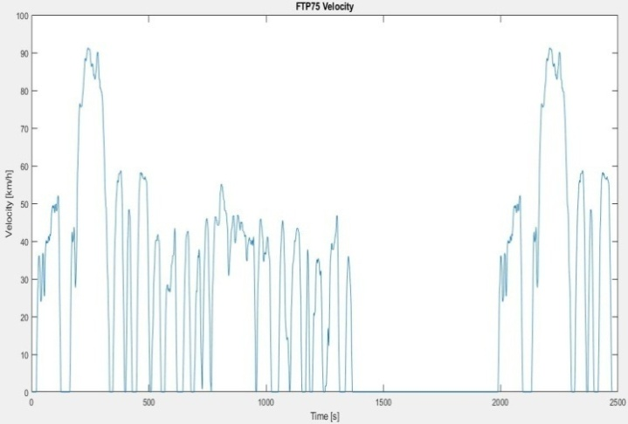
Fig. 2: FTP-75 Drive Cycle
- FTP-75 SPECIFICATIONS
Drive Cycle | FTP-75
Time (s) | 2474
Distance (km) | 17.7
Top Speed (km/h) | 91.2
Average Speed (km/h) | 25.86
- ELECTRIC VEHICLES TECHNICAL SPECIFICATIONS
To accurately assess the impact of different parameters, it is crucial to possess a comprehensive understanding of all technical specifications associated with the electric vehicle. These specifications will form the foundation for the simulation conducted in this study.
- NISSAN LEAF EV TECHNICAL SPECIFICATIONS
Parameters | Value
Mass of Vehicle (curb weight) | 1575
Tyre Marking | 215/50/R17
Drag Coefficient | 0.28
Wind Speed (km/hr) | 5
Frontal Area (m²) | 2.27
Coefficient of Rolling Resistance | 0.013
Gear Ratio | 8.19
Rated Voltage | 360
Battery Capacity (Kwh) | 40
Air Density (kg/m³) | 1.184
Rated Load (kw) | 110
Maximum Torque (Nm) | 320
Slope Angle | 0
Regenerative Braking Efficiency | 50%
Transmission Efficiency | 95%
Motor Efficiency | 95%
Motor Controller Efficiency | 95%

- BMW i3 EV TECHNICAL SPECIFICATIONS
Parameters | Value
Mass of Vehicle (curb weight) | 1345
Tyre Marking | 155/70/R19
Drag Coefficient | 0.29
Frontal Area (m²) | 2.58
Wind Speed (km/hr) | 5
Coefficient of Rolling Resistance | 0.013
Gear Ratio | 9.66
Rated Voltage | 352
Battery Capacity (Kwh) | 42.2
Air Density (kg/m³) | 1.184
Rated Load (kw) | 125
Maximum Torque (Nm) | 250
Slope Angle | 0
Regenerative Braking Efficiency | 50%
Transmission Efficiency | 95%
Motor Efficiency | 95%
Motor Controller Efficiency | 95%

- CHEVROLET BOLT EV TECHNICAL SPECIFICATIONS
Parameters | Value
Mass of Vehicle (curb weight) | 1616
Tyre Marking | 215/50/R17
Drag Coefficient | 0.30
Frontal Area (m²) | 2.54
Wind Speed (km/hr) | 5
Coefficient of Rolling Resistance | 0.013
Gear Ratio | 7.0
Rated Voltage | 350
Battery Capacity (Kwh) | 66
Air Density (kg/m³) | 1.184
Rated Load (kw) | 150
Maximum Torque (Nm) | 360
Slope Angle | 0
Regenerative Braking Efficiency | 50%
Transmission Efficiency | 95%
Motor Efficiency | 95%
Motor Controller Efficiency | 95%
- RESULTS AND DISCUSSIONS
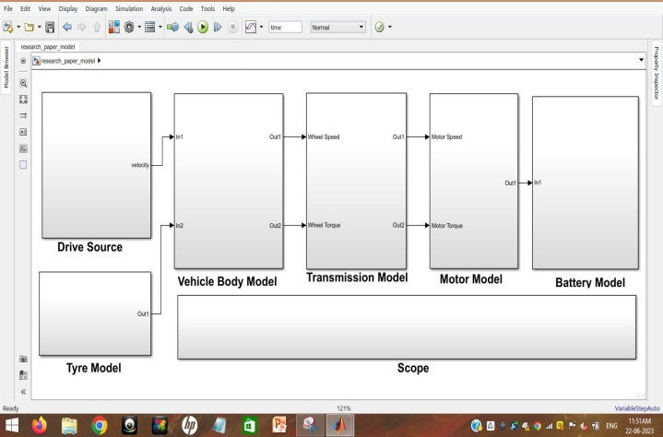
Fig. 3: MATLAB EV Model
- Analyze the influence of factors on various electric vehicles
Initially, we replicate the models of various electric vehicles (EVs) based on their specified technical details in order to ascertain their real-world performance metrics such as driving range, state of charge (SOC), and battery capacity. Subsequently, we simulate the model using diverse parameters by modifying their respective values to evaluate the influence of these parameters on the range of the distinct EVs.
- Nissan Leaf
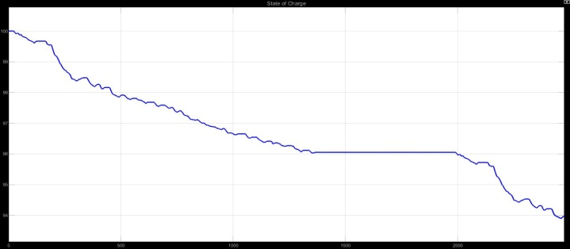
Fig. 4: SOC
After analyzing the simulation outcomes, it was observed that the Nissan Leaf electric vehicle (EV) covered a distance of 17.7 km over a period of 2474 seconds, adhering to the prescribed drive cycle. During this drive, the vehicle maintained a state of charge (SOC) of 93.96%. Additionally, the simulation results indicated that the maximum range of the Nissan Leaf EV, when fully charged, is 293.4 km, aligning with real-world driving range data. However, it is important to note that a more practical measure called the 80% depth of discharge (DOD) range reveals a distance of 234.7 km.
Speed: When the Nissan Leaf EV maintained a consistent speed of 25.8 km/hr, it covered a distance of 513.4 km. However, when the speed was increased to a steady 60 km/hr (with an average of 59.3 km/hr), the distance covered decreased to 367.6 km. Similarly, when the vehicle maintained a constant speed of 70 km/hr (with an average of 69.2 km/hr), the distance covered further decreased to 327.6 km. The transition from 25.8 km/hr to 59.3 km/hr resulted in a decrease in range by 28.3%, and from 59.3 km/hr to 69.2 km/hr, the range decrease was 10.8%.
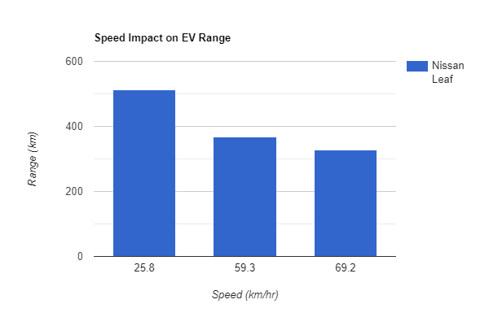
Fig. 5: Speed Impact on Nissan Leaf Range
Driving Style: In this particular situation, we conduct a comparison between the results of two simulations, both of which maintain an average speed of 25.8 km/hr. The findings indicate that the range achieved through the drive cycle simulation is 293.4 km, whereas the range obtained through the constant speed simulation, excluding any acceleration or braking, is 513.4 km. Consequently, the incorporation of sudden acceleration and braking actions during driving leads to a reduction in the vehicle's range by 42.8%.
Load on Vehicle: The results obtained from the subsequent data unequivocally demonstrate that an increase in mass of 100 kg, transitioning from 1650 kg to 1750 kg, leads to a decrease in range from 293.4 km to 280.6 km. Furthermore, an increase in weight by 400 kg results in a reduction of the vehicle's range by 15.4%. As the weight reaches 2050 kg, the range further declines to 248.1 km.
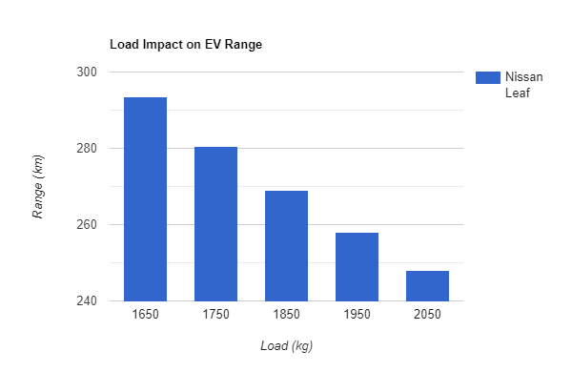
Rolling coefficient: The rolling resistance coefficient (C_{rr}) is subject to variation based on the characteristics of the surface over which vehicles travel. Table 5 presents several representative values for the rolling resistance coefficient of cars on various road surfaces.
- COEFFICIENT OF ROLLING RESISTANCE (CRR) FOR DIFFERENT SURFACE TYPES
Type of Surface | C_{rr}
Soil Road | 0.1-0.35
Macadamized Road | 0.025
Gravel Ground | 0.02
Concrete or Asphalt | 0.013

The subsequent results provide clear evidence that enhancing the coefficient value from 0.13 to 0.02 results in a decrease in the vehicle's range from 293.4 km to 236.2 km. Furthermore, when the coefficient value is raised from 0.13 (corresponding to concrete and asphalt road surfaces) to 0.1 (corresponding to soil road surfaces), there is a substantial 76% reduction in the vehicle's range.
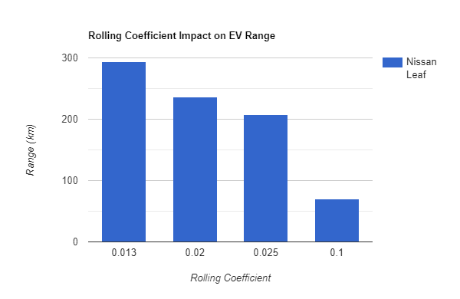
Fig. 7: Rolling Coefficient Impact on Nissan Leaf Range
Slope Angle: The results indicate that altering the slope angle from 0 degrees to 1 degree results in a range decrease for the vehicle from 293.4 km to 182 km, signifying a decline of 37.9%. Additionally, when adjusting the slope angle from 0 degrees to 5 degrees, the electric vehicle encounters a significant reduction in range by 76%.
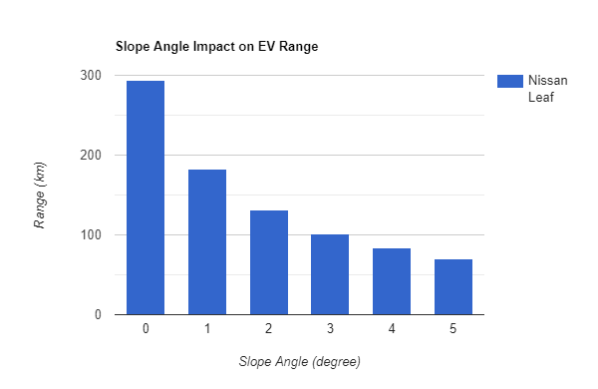
Fig. 8: Slope Angle Impact on Nissan Leaf Range
- BMW i3
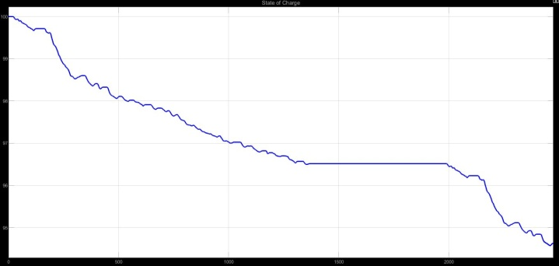
Fig. 9: SOC
Based on the provided simulation results, it was observed that the BMW i3 electric vehicle (EV) successfully completed the specified drive cycle, covering a distance of 17.7 km within a time frame of 2474 seconds. Throughout the simulation test, the vehicle maintained a state of charge (SOC) of 94.62%. The simulation also indicated that the BMW i3 has a maximum range of 329.5 km when fully charged, which aligns with real-world driving range data. However, it is worth noting that a more practical metric known as the 80% depth of discharge (DOD) range suggests a distance of 263.6 km.
Speed: The BMW i3 vehicle travelled a total distance of 603.3 km at a consistent speed of 25.8 km/hr. However, when the speed was raised to a steady 60 km/hr (with an average speed of 59.3 km/hr), the distance covered reduced to 397.3 km. Similarly, at a constant speed of 70 km/hr (with an average speed of 69.2 km/hr), the covered distance further decreased to 346.4 km. The shift from a speed of 25.8 km/hr to 59.3 km/hr led to a range reduction of 34.1%, while the change from 59.3 km/hr to 69.2 km/hr resulted in a range decrease of 12.8%.
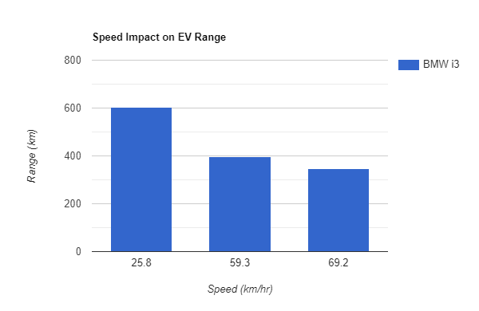
Fig. 10: Speed Impact on BMW i3 Range
Driving Style: According to the results, the drive cycle simulation yielded a range of 329.5 km, while the constant speed simulation, which excluded acceleration and braking, achieved a range of 603.3 km. This demonstrates that the inclusion of sudden acceleration and braking actions during driving leads to a significant decrease of 45.3% in the vehicle's range.
Load on Vehicle: The analysis of the collected information presents definitive proof that a rise in weight by 100 kg, going from 1420 kg to 1520 kg, causes a decrease in the distance covered from 329.5 km to 314.3 km. Furthermore, an increase in weight by 400 kg leads to a decrease in the vehicle's range by 16.2%. Upon reaching a weight of 1820 kg, the range experiences a further reduction, reaching 276 km.
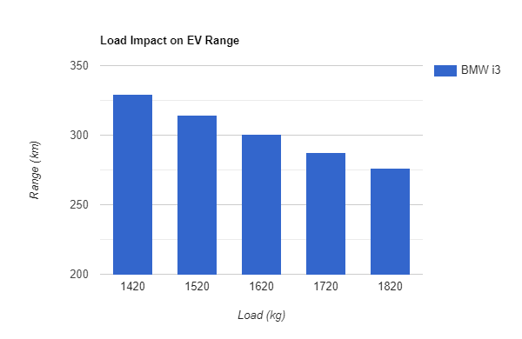
Fig. 11: Load Impact on BMW i3 Range
Rolling coefficient: In particular, when the coefficient value is increased from 0.13 to 0.02, there is a noticeable decrease in the range of the vehicle, going from 329.5 km to 269.4 km. Furthermore, when the coefficient value is raised from 0.13 (representing concrete and asphalt road surfaces) to 0.1 (representing soil road surfaces), there is a substantial decrease of 74.4% in the vehicle's range.
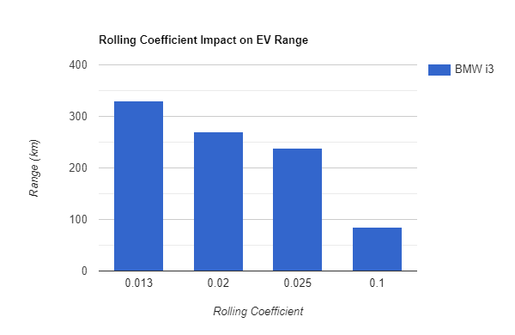
Fig. 12: Rolling Coefficient Impact on BMW i3 Range

Slope Angle: The findings suggest that modifying the slope from 0 degrees to 1 degree results in a reduction in the distance the vehicle can travel, decreasing from 329.5 km to 210.8 km, representing a decline of 36%. Additionally, modifying the slope from a flat surface to a slight incline of 5 degrees results in a substantial decrease of 74.4% in the travel distance covered by the electric vehicle.
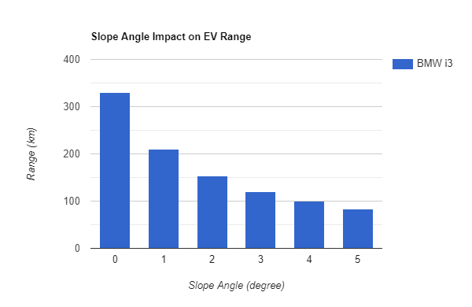
Fig. 13: Slope Angle Impact on BMW i3 Range
- Chevrolet Bolt
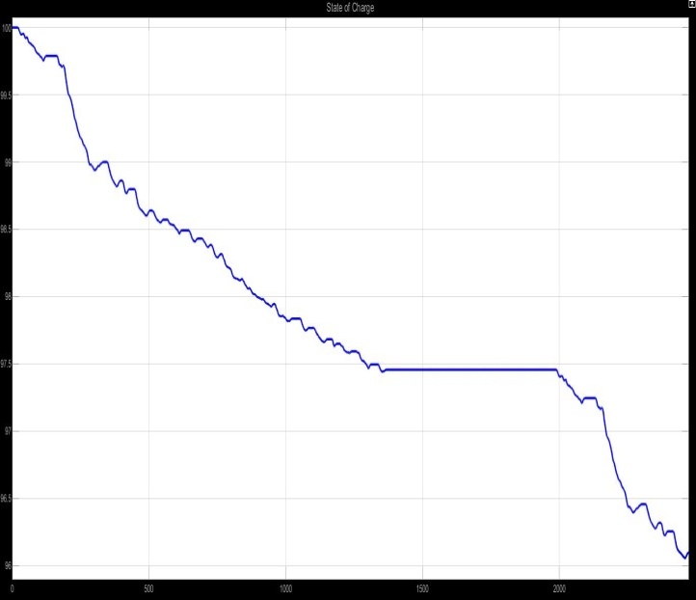
Fig. 14: SOC
The simulation findings indicated that the Chevrolet Bolt electric vehicle (EV) accomplished the designated driving pattern, travelling a distance of 17.7 km over duration of 2474 seconds. Throughout the simulation, the vehicle maintained a state of charge (SOC) of 96%. The outcomes also showcased that the Chevrolet Bolt can travel a maximum distance of 453.3 km when fully charged, which aligns with real-world driving range data. However, it is important to note that a more practical measure, known as the 80% depth of discharge (DOD) range, suggests a distance of 362.6 km.
Speed: The Chevrolet Bolt vehicle covered a distance of 810.4 km by maintaining a consistent speed of 25.8 km/hr. Nevertheless, when the speed was raised to a steady 60 km/hr (with an average speed of 59.3 km/hr), the distance travelled diminished to 557.3 km. Likewise, at a consistent speed of 70 km/hr (with an average speed of 69.2 km/hr), the distance travelled was further reduced to 491.3 km. The shift from 25.8 km/hr to 59.3 km/hr caused a reduction in range of 31.2%, while the transition from 59.3 km/hr to 69.2 km/hr led to a decrease in range of 11.8%.
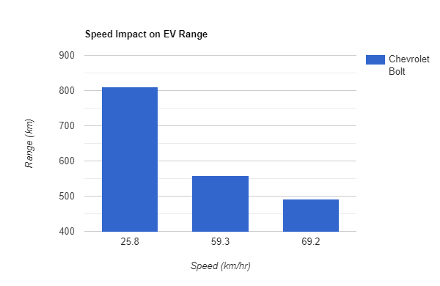
Fig. 15: Speed Impact on Chevrolet Bolt Range
Driving Style: The study's results revealed that the drive cycle simulation accomplished a distance of 453.3 km, while the constant speed simulation, which did not involve acceleration or braking, covered a distance of 810.4 km. As a result, the inclusion of abrupt acceleration and braking while driving resulted in a 44% decrease in the vehicle's range.
Load on Vehicle: Extensive analysis of the collected data provides indisputable evidence that a rise in weight from 1691 kg to 1791 kg, corresponding to a 100 kg increase, leads to a reduction in range from 453.3 km to 434.8 km. Additionally, with a weight increase of 400 kg, the range of the vehicle decreases by 14.5%. As the weight reaches 2091 kg, the range further diminishes to 387.2 km.
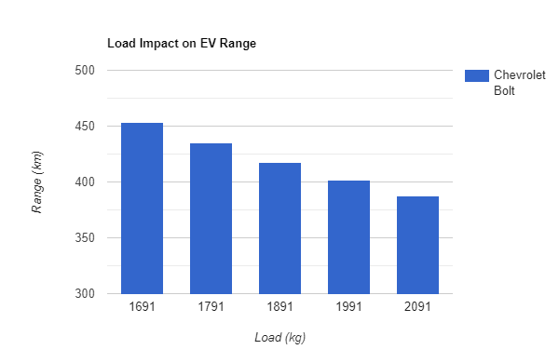
Fig. 16: Load Impact on Chevrolet Bolt Range
Rolling coefficient: When the value of the coefficient rises from 0.13 to 0.02, there is a clear decline in the range of the vehicle, dropping from 453.3 km to 367.6 km. Additionally, when the coefficient value is increased from 0.13 (which corresponds to concrete and asphalt road surfaces) to 0.1 (which represents soil road surfaces), the vehicle's range undergoes a significant reduction of 75.2%, resulting in a range of 112 km.
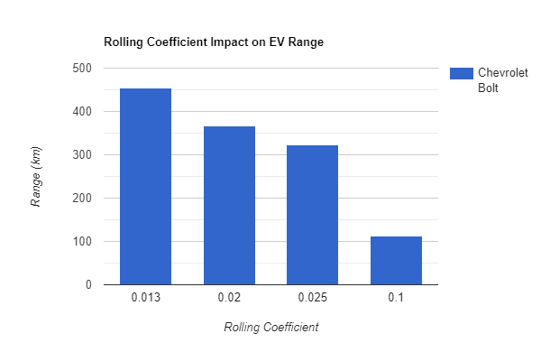
Fig. 17: Rolling Coefficient Impact on Chevrolet Bolt Range

Slope Angle: The results indicate that changing the slope from 0 degrees to 1 degree leads to a decline in the Chevrolet Bolt EV's distance capacity, dropping from 453.3 km to 285.3 km, representing a decrease of 37%. Furthermore, increasing the incline angle from 0 degrees to 5 degrees significantly reduces the range of the Chevrolet Bolt EV by 75.3%.
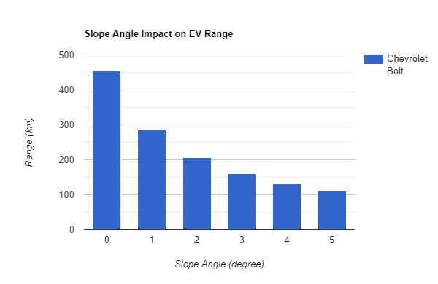
Fig. 18: Slope Angle Impact on Chevrolet Bolt Range
- Comparison of EVs
We aim to identify the most economical choice among electric vehicles (EVs) by evaluating their cost per kilometre. The assessment predominantly depends on the watt-hour consumption per kilometre of the electric vehicle (EV). Within this section, our initial comparison of electric vehicles focuses on their real-world range, followed by an evaluation based on watt-hour consumption per kilometer. Ultimately, we assess the EVs by comparing their cost per kilometer and cost per charge.
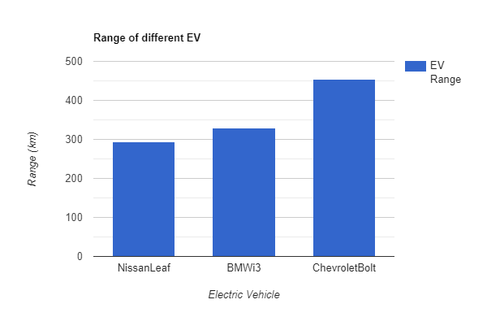
Fig. 19: Range of Different EVs
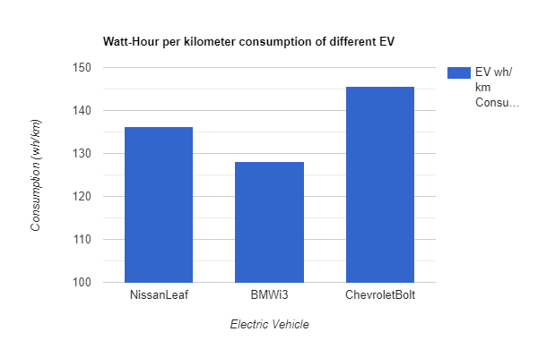
Fig. 20: Wh/km Consumption of Different EVs
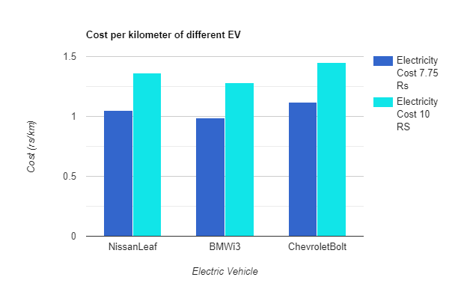
Fig. 21: Cost per Kilometre of Different EVs
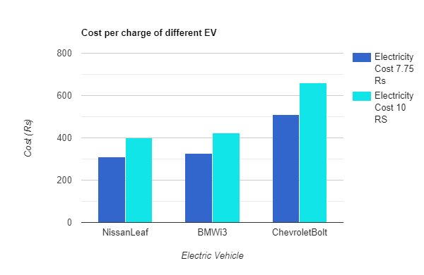
Fig. 22: Cost per Charge of Different EVs
In the comparison of various vehicles' ranges, the Chevrolet Bolt EV distinguishes itself by offering the longest range of 453.3 km. Following closely behind are the BMW i3 and Nissan Leaf, which respectively travel distances of 329.5 km and 293.4 km. Nevertheless, our research primarily centres around the results obtained from simulating the watt-hour per kilometer consumption, which represents our primary goal. When it comes to energy usage, the BMW i3 EV exhibits superior performance by achieving the lowest consumption rate of 128.1 wh/km. The Nissan Leaf and Chevrolet Bolt EV trail behind, consuming energy at rates of 136.3 wh/km and 145.6 wh/km, respectively. As a result, the anticipated cost per kilometer for the BMW i3 is projected to be lower due to its lowest wh/km value in comparison to the other simulated EVs. At electricity cost of 7.45 rs, the BMW i3 costs 0.99 rs per kilometre, the Nissan Leaf costs 1.05 rs per kilometre, and the Chevrolet Bolt costs 1.12 rs per kilometre. Likewise, when the electricity cost is 10 rs, the BMW i3 costs 1.28 rs per kilometre, the Nissan Leaf costs 1.36 rs per kilometre, and the Chevrolet Bolt costs 1.45 rs per kilometre. The cost of fully charging an electric vehicle (EV) varies depending on its battery capacity. The Chevrolet Bolt EV, with a battery capacity of 66 kWh, has the highest charging cost. It amounts to 511.5 rs when the electricity cost is 7.75 rs and 660 rs when the electricity cost is 10 rs. On the other hand, the BMW i3 and Nissan Leaf incur charging costs of 327.1 rs and 310 rs, respectively, when the electricity cost is 7.75 rs. Similarly, at an electricity cost of 10 rs, the BMW i3 and Nissan Leaf have per-charge costs of 422 rs and 400 rs, respectively.
- CONCLUSION
The purpose of this research was to investigate how different factors linked to electric vehicles (EVs), including vehicle weight, driving habits, road gradient, rolling resistance coefficient, and speed (all of which are within the control of EV drivers, either directly or indirectly), affect the driving range of various EV models. Furthermore, the study sought to determine the most cost-effective EV by analyzing the cost per kilometer.
The findings of this research demonstrate that by manipulating variables related to electric vehicles (EVs), it is possible to enhance the driving range of different EVs. For example, in this investigation, three EV models were analyzed: the Nissan Leaf, BMW i3, and Chevrolet Bolt. Our study uncovered that augmenting the load (weight) by 400 kg for every EV model led to an average decline in the range of the vehicles by 15.3%. Likewise, elevating the speed from 25.8 km/hr to 59.3 km/hr (approximately 60 km/hr) resulted in an average decrease in the vehicle range of all EV models by 31.2%. Similarly, modifying the rolling coefficient from 0.013 to 0.1 for every EV model resulted in an average decrease in the range of the vehicles by 75.2%. Furthermore, by increasing the slope angle from 0 degrees to 5 degrees, we witnessed an average decline in the driving range of each EV model by 75.2%. Additionally, adopting a vigorous driving style that entails quick acceleration and braking led to an average decrease in the range of the vehicles by 44% across all EV models. It is clear that each parameter has a unique influence on the driving range.
Furthermore, a study on the economic feasibility of owning electric vehicles (EVs) has been carried out by assessing the measure of "per km cost," which is based on the energy consumption in watt-hours per kilometer. The findings indicate that among the Nissan Leaf, Chevrolet Bolt, and BMW i3 EV models, the BMW i3 exhibits the most efficient energy consumption per kilometer. According to the study, when it comes to energy efficiency among the electric vehicles examined, the BMW i3 stands out as the most cost-effective option per kilometre. This is because the BMW i3 consumes 128.1 watt-hours per kilometre, which is lower than the consumption rates of the Nissan Leaf and Chevrolet Bolt, which are 136.3 and 145.6 watt-hours per kilometre, respectively. Thus, the research findings establish the BMW i3 as the electric vehicle model with the highest energy efficiency. The results of this study are highly important for individuals considering purchasing an electric vehicle (EV) who prioritizes long-term affordability and cost-effectiveness. These findings provide valuable insights into the comparative advantages of various EV models as well as their advantages over traditional combustion engine vehicles.
In conclusion, this study offers valuable knowledge regarding the impact of various factors on the driving range and cost per kilometer of electric vehicles (EVs). The importance of taking into account factors such as vehicle weight, driving habits, incline angle, rolling resistance, and speed is emphasized as a means to improve energy efficiency. EV owners can optimize their driving range and minimize the cost per kilometer by efficiently controlling and handling these factors.
REFERENCES
- Bimal K. Bose, “Global Warming: Energy, Environmental Pollution, and the Impact of Power Electronics,” in IEEE Industrial Electronics Magazine, Volume: 4, Issue: 1, March 2010.
- GREEN CAR REPORTS [ONLINE], Available: https://www.greencarreports.com/news/1093560_1-2-billion-vehicles-on-worlds-roads-now-2-billion-by-2035-report
- Oil Production Statistics [ONLINE], Available: https://www.statista.com/statistics/265203/global-oil-production-since-in-barrels-per-day
- Oil Production OPEC Statistics [ONLINE], Available: https://www.opec.org/opec_web/en/data_graphs/330.htm
- EV Sales in India TOI Article [ONLINE], Available: https://www.google.com/amp/s/m.timesofindia.com/business/india-business/ev-sales-up-163-in-2021-up-registers-highest-sales followed -by-karnataka-and-tamil nadu/amp_articleshow/90282217.cms
- V. Wouk, “Hybrids: then and now,” in IEEE Spectrum, Volume: 32, Issue: 7, Jul 1995.
- James F. Miller and David Howell, “The EV Everywhere Grand Challenge,” in 2013 World Electric Vehicle Symposium and Exhibition (EVS27), 2013.
- Emilia M. Szumska and Rafal S. Jureski, “Parameters Influencing on Electric Vehicle Range,” in Energies 2021,14,4821.
- A. Skuza, R. S. Jurecki, “Analysis of factors affecting the energy consumption of an EV Vehicle,” in 2022 the 13th International Conference on Automotive Safety (Automotive Safety 2022).
- A. A. Abulifa, Dr. A. C. Soh, Dr. M. K. Hassan, Dr. R. M. K. Raja Ahamd, Dr. M.A. MohdRadzi, “Mathematical Modelling and Simulation of Battery Electric Vehicle Based on Backward Facing Approach Technique,” Turkish Journal of Computer and Mathematics Education, Vol.12 No.14 (2021), 5032- 5041.
- Nissan Leaf Specifications [ONLINE], Available: https://www.evspecifications.com /en/model/f17918
- BMW i3 Specifications [ONLINE], Available: https://www.evspecifications.com /en/model/cd6382
- Chevrolet Bolt Specifications [ONLINE], Available: https://www.evspecifications.com/en/ model/0545d6
- T. V. Sarathkumar, M. Poornanand, and A.K. Goswami, “Modelling and Simulation of Electric Vehicle Drive through SAEJ227&EUDC Cycles,” in 2020 IEEE Students’ Conference on Engineering & Systems (SCES) July 10-12, 2020.
- “Fundamentals of Electric Vehicles: Technology & Economics” NPTEL [ONLINE], Available: https://archive.nptel.ac.in/courses/108/106/108106170/

