DESIGN AND IMPLEMENTATION OF CONTROL STRATEGIES FOR SMALL-SIGNAL STABILITY IN DOUBLY FED INDUCTION GENERATOR BASED WIND TURBINES USING MATLAB SIMULINK

Vijay Kumar ¹, Samreet Kaur ², Amrinder Kaur Gill ³
^{1, 2, 3}Department of Electrical Engineering, Guru Nanak Dev Engineering College, Ludhiana, Punjab, India.
¹Email: er.vijaykumar997@gmail.com
² Email: erakgill30@gmail.com
³ Email: samreetgosal@gnedc.ac.in

----------------------------------------------------------****------------------------------------------------

Abstract - A majority of the wind turbines in use today's variable speed energy systems are double fed induction generators. We went over the goals and methods used in onshore horizontal axis wind energy turbine control. Design and implementation of control the model for the simulation and the analysis of a double-fed induction generator. Among the various technologies available for wind energy conversion the DFIG is one of the preferred solution because it offers the advantage of reduced mechanical stress and optimized power capture to variable speed operation. To facilitate the electrical production control, the separated control of active and reactive powers of such as machine is considered. The results of simulations realized under the MATLAB /Simulink software are analyzed and interpreted.
Keywords--- Damping, electromechanical oscillations; power system; small-signal stability; synchronous generators, double fed induction generator. Wind energy conversion system
- INTRODUCTION
Due to the damaging effects of conventional power plants on the environment and the depletion of fossil resources, there has been a quick shift from brown energy technology to green energy[1].Globally, the use of renewable resources is recognized as a promising alternative for industrial, commercial, and home power needs. To lessen health risks linked to environmental pollution, acid rain, global warming, and soil degradation, renewable energy resources, notably wind energy, can be used [2].In the recent time, DFIG has attracted a lot of attention owing to its controllability effective. The popular of DFIG has been attributed to variable s peed operation and the ability to control the reactive power or active power of utilization of converter. The working and structure model of DFIG are totally different from the conventional generators owing to the presence of converter in the rotor circuit. the penetration of DFIG into the power system can be achieved with the application inverter and control and its operation has an influence on the small – signal stability of power system .the utilization of DFIG in power system has either or positive and negative influence on small signal stability of the network this depend on the location of DFIG[4]. For the DFIG's cutting-edge technological advantages, including flexible control, it has recently emerged as a leading wind power cultivator among rival wing power generators. In order to meet many countries' desired electrical power from renewable energy sources today and in the near future, it is anticipated that the integration of DFIG-based wind farms from a few hundreds to thousands of hundreds of capacities will expand globally [5]. Many studies in the literature have centered their research on the performance of the power system instead of focusing on the small-signal stability of the power system when utilizing a DFIG.
- Wind energy system: The past grid code design did not allow wind farms to be used in the utility network during the system disturbances. For instance, during an abrupt change in frequency or voltage or a power system fault, WTs were designed to disconnect from the network. Wind farms not permitted to be utilized in the utility network during system disturbances under the previous grid code architecture. WTs intended to disconnect from the network, for example, in the event of a sudden change in frequency, voltage, or a power system fault [10 13]. The dynamics of the electricity system may be harmed by the significant penetration of DFIG-based wind farms. Stability issues may also arise. The use of WTs causes some issues, including harmonic pollution, frequency variations, and a degraded frequency response. Determining how the DFIG application will affect the damping characteristic and oscillation mode of the power system is therefore essential [14]. The effects of DFIG on tiny signal stability and control strategies to lessen the detrimental effects on a power system's optimal performance have grown to be a public challenge. The effects of DFIG on tiny signal stability and control solutions to improve the power system's damping characteristic are discussed in this study.
The sudden increase in the power demand owing to the industrial revolution and high cost of living and an urgent need to mitigate the impacts of greenhouse gas emission on the global population have driven many research interests on how to harness renewable energy resources for various applications [12]. The WTs have been essential to the development of power solutions because of their abundance, lack of direct emissions, cleanliness, minimal maintenance requirements, lack of fuel costs, and widespread distribution. For the past few decades, the widespread acceptance of WTs has been linked to several key characteristics, including low noise pollution, straightforward design, straightforward gear building, and effective energy output. The WTs have been essential to the development of power solutions because of their abundance, lack of direct emissions, cleanliness, minimal maintenance requirements, lack of fuel costs, and widespread distribution. For the past few decades, the widespread acceptance of WTs has been linked to several key characteristics, including low noise pollution, straightforward design, straightforward gear building, and effective energy output [15].
- Power system small signal stability
The power system's ability to maintain a stable operational state in the face of a minor disturbance to its operating equilibrium is known as small signal stability. The key performance indicators (KPIs) that disturbances have the biggest an impact on are frequency, voltage, and rotor angle. Instability mechanisms including voltage stability, rotor angle stability, and frequency stability were influenced by the aforementioned KPIs. When considering the spectrum of response times, such as long and short terms, the stability of the power system can be categorize. Fig [1].
Table. I Comparison of different wind turbines
Advantage | Disadvantage
Robust and well-proven technology | Operates with a gear box
Low capital cost when compared with other WTs | It is less efficient electrically.
It has a good conversion efficiency | Contributed a large percentage of short circuit fault to the
It is energy efficient. | It has high gearbox and rotor stresses during the fault conditions.
It can be accurately controlled | Limited fault ride through capability
Reduced converter cost and inverter filters cost. | Limited voltage regulation capability.

Classification of power system Stability
The three major subcategories of power system stability are voltage stability, transient stability, and tiny signal stability. These individuals and various facets of the behavior and constancy of the power system.
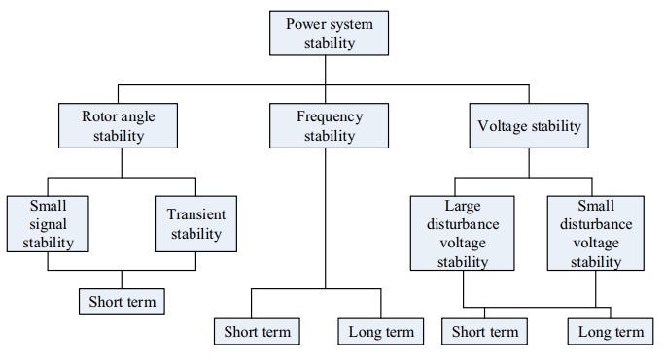
Fig 1.Classification of power system stability

The three main categories of power system stability are:
- Transient Stability: Transient stability is concerned with a power system's capacity to keep synchronism and recover from significant disruptions, such as severe faults or abrupt changes in operating circumstances. It focuses on how the system reacts in the early moments after a disruption. Maintaining system stability and preventing voltage breakdown are the fundamental goals. The examination of the system's generators' dynamic behaviour, including the swing equation and critical clearing time, is a component of transient stability analysis.
- Small Signal Stability: Analysis of tiny signal stability focuses on how the system reacts to little disruptions, including modest load changes or control actions. It evaluates how well the system can control oscillations and continue to run steadily. The system equations are linearized in the study of small signal stability, and the eigenvalues of the linearized model are examined. The study aids in the identification of dominant oscillatory modes, the design of damping controllers, and the assurance of sufficient stability margins.
- Voltage Stability: The ability of a power system to sustain appropriate voltage levels under shifting load situations is referred to as voltage stability. It evaluates how well the system can keep the voltage stable and prevent voltage collapse. A system blackout or a series of failures might result from voltage instability. Studying voltage stability indicators, such as the voltage stability margin, voltage stability index, and voltage collapse point, is a component of voltage stability analysis. Effective reactive power and voltage management must maintain the Voltage stability systems.
- Dynamic modeling
The turbine, generator, drive system, and power converter. For the WT to extract the most power at a range of wind speeds, pitch control is typically used [16]. The three-phase voltages of the machine are changed into the synchronous rotating frame, or d-q frame, to give the generator its dynamic behavior. Recent times have also seen study of the flux magnitude and angle controller (FMAC) approach. A vector control modeling approach is used to simulate the RSC and may be used to describe the flux direction of the air gap or the stator. These models also include inherent dynamics associated to them that have no influence on the stability of tiny signals, are more accurate, and call for greater computation. We simplify and minimize the practical order of DFIG-based WT for small-signal analysis using common assumptions. For instance, the grid side converter (GRC) controller, the DC-link capacitor, stator transients and stator resistance are not taken into consideration. All rotational masses are also omitted.

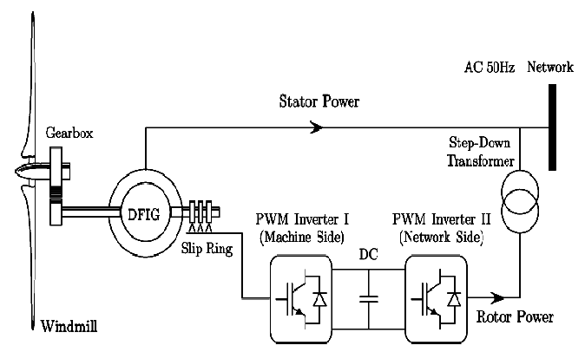
Fig 2. DFIG Wind Power Conversion systems WECS
- Wind Energy Conversion System (WECS)
We refer to the process of converting wind energy into a usable source of energy as WECS. In the past, wind energy provided mechanical energy; but, in the present, WECS has shifted its main emphasis to generating electrical energy from wind energy.[19]The aerodynamics, mechanical, and electrical components of the WECS may be divided into three independent pieces, as shown in the picture below.
Aerodynamics system: The aerodynamic parts of the WECS system include wind blades, turbine hubs, and turbine rotors. The mechanical energy from the wind is converted to kinetic energy in this system.
Mechanical System: The WECS system captures and processes the kinetic energy found in the wind turbine. The mechanical energy is converted into a form that can be integrated into the energy system through a conversion process. The lower-speed shaft, gearbox, and higher-speed shaft are mechanical parts of the WECS system that are linked to the generator.
Electric system: This part concerns the transformation of mechanical energy into electrical energy. It consists of the generator, electrical transformers, power converters, and grid connection.
Wind Turbine Components A wind turbine system's main parts are its mechanical and electrical components. It includes elements like the electrical generator, shaft, and gearbox. The wind turbines main parts are depicted in Fig 4.2 below and are further discussed below. The turbine, low-speed shaft, gearbox, high-speed shaft, and generator are the revolving masses that make up the drive train. The generator's rotor receives and converts the mechanical output power of the turbine, which is transmitted there.
- Rotor: The revolving component of a wind energy that absorbs kinetic energy from the wind is known as the rotor. Usually, it has two or more blades that are fastened to a hub in the middle. The rotor converts wind energy into rotational motion for use in wind turbines.
- Nacelle: The crucial parts of the wind energy are housed to the nacelle, a protective enclosure above the tower. It supports and safeguards the internal machinery, such as the gearbox, control systems, and generator.
- Tower: The wind turbine supported by a tall structure called a tower, which raises it to a height that will allow it to capture stronger and more reliable wind speeds. In addition to providing stability, it guarantees that the rotor positioned at the ideal height to maximize energy production.
- Generator: A crucial part of the nacelle, the generator transforms the mechanical power from the rotor's spin into electrical energy. It frequently uses electromagnetic induction to generate an output of alternating current (AC).
- Gearbox: To increase the rotor's rotational speed and enable the generator to operate more quickly for more efficient power generation, gearboxes are occasionally used in wind turbine designs. The gearbox helps to strike a balance between the rotor's relatively slow rotating speed and the generator's need for higher speed.
- Control systems: Wind turbines employ a range of control systems to monitor and improve their performance. These technologies include pitch control, which adjusts the rotor blade angle to maximize wind collection, and yaw control, which makes sure the turbine is precisely oriented to face the wind.
- Power Converter: For grid integration, a power converter is utilized to convert electrical energy generated by wind turbine generators that run at various speeds into the proper voltage and frequency. The power converter can control both reactive power flow and grid synchronization.
- Shaft: The hub of the rotor connects to the low speed shaft. The low speed shaft serves as the link between the gearbox and the rotor hub. The system's electronic controller is utilized to control various operational parameters for wind turbines. The wind turbines course is chosen using the yaw mechanism, voltage, and speed controls.
- High-speed shaft: The high-speed shaft is the main rotating shaft of the wind turbine after the gearbox. It connects the gearbox to the generator. The high-speed shaft is typically made of steel, and it is designed to be able to transmit the high torque produced by the gearbox to the generator.
- Slow-speed shaft: The low-speed shaft is the main rotating shaft of the wind turbine. It connects the hub to the gearbox. The low-speed shaft is typically made of steel, and it is designed to be able to transmit the high torque produced by the blades

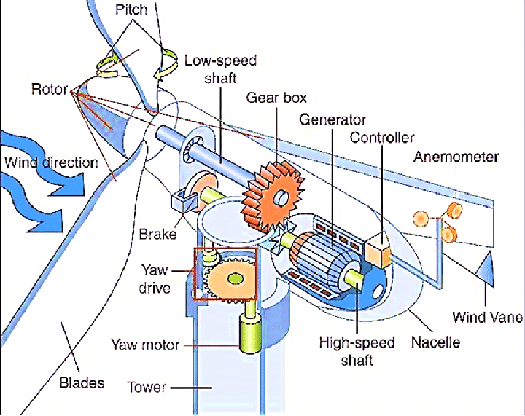
Fig 3. Wind Turbine with different components
Mathematical modeling of wind turbine
The output power of the turbine is given by the following equation:
P_{m} = ½ C_{P} ($γ β$).$ρ$.A ${vm}^{3}$
Where
Pm = mechanical output power of the turbine (W)
Cp ($αβ$) = performance coefficient of the turbine
$p^{m}$ = Air density (kg/m³)
A = turbine swept area (m²)
V = wind speed (m/s)
λ = Tip speed ratio of rotor blade tip speed to wind speed
β = Blade pith angle (deg)

- DFIG converter controllers

By using controllers created for managing the overall power output, a DFIG's energy output may be increased [30]. The use of an electronic converter to link the rotor terminals to the grid allows the DFIG to be appropriately controlled. The active power and reactive power that are transmitted to the transmission and distribution T&D lines are simultaneously controlled by the rotor frequency, which may be altered to match the grid's frequency. The most popular method for connecting the rotor and stator (grid) of a DFIG is a back-to-back voltage converter that enables a four-quadrant functioning. Due to its placements, the power converter may be divided into two groups: rotor-side converters (RSC) and grid-side converters (GSC) [30].
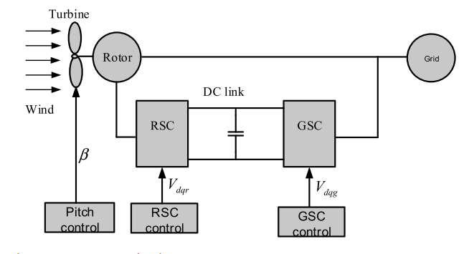
Fig 4. Doubly fed induction generator wind turbine
Rotor side converter controller (RSC)
In the use of a decoupling mechanism and the RSC controller, the DFIG is able to manage the reactive power and torque autonomously through VQR and VDR [30]. The electromagnetic torque is produced by the DFIG's rotor current's quadratic components, which are controlled. This demonstrates that the actual power (or torque) and reactive power (or voltage) supplied to the grid are controlled by the RSC controller in the DFIG [36]. The output power may be managed by the RSC, which also keeps it within the permitted range for the tracking characteristic. This allows a smooth control of the rotor speed as well as control of the reactive power and hence enhances the power quality of wind turbines.
- Methodology
The Simulink tool for analyzing of the dynamic behavior because of the increasing level of wind farm integration with utility networks. The DFIGs related to the power system have suddenly become crucial, and various studies or projects have employed the following MATLAB simulation tools to evaluate the small signal stability SSS. An electrical device that had been used for many years in a number of applications is usually referred to as a wound induction machine, or a DFIG. Its power fluctuates between several Kilowatts and Megawatts. This idea of a machine is frequently used in place of conventional synchronous or asynchronous machines. Using an electronic converter, the entire system is connected. The power exchange through the rotor to the grid is carried out by the DFIG operating the point, together with an appropriate control method. The VSCs are used in the DFIG wind turbine system despite the fact that they have several designs or converter topologies.
- Modeling of the component and present The MATLAB Simulink R2021a-based algebraic models of the DFIG can be used to carry out the current work. The model comprises an induction generator, a pulse width converter controller block, and the WECS aerodynamics system for the wind energy turbine system. The measurement of the scope's input or output blocks connects to MATLAB for analyzing results in Simulink.

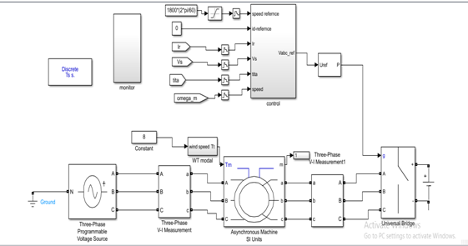
Fig 5 . Doubly Fed Induction Generator
using Simulink model

A wound induction generator is used in the asynchronous machine from the Simscap tools MATLAB collection. The Direct wiring from the generator's rotor to the electronic converter in the control system. Three-phase voltage sources, a V-I voltage or current measure universal bridges, and a DC voltage source are all utilized in the DFIG. In this modal, we're using various parameter elements. The controller block includes of the rotor-side controller and the modal for the related converters for the wind turbine. A pulse generator signal for the converters at the controller block.
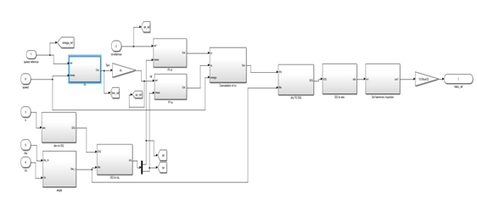
Fig 6. Doubly Fed Induction Generator rotor side controller
Asynchronous Machine Wound Induction Generator
The DFIG generator used by the Simscap library utilities is an asynchronous machine. The generator's input, the mechanical torque, originates from an aerodynamic model of wind speed when characteristics like nominal power, voltage, current, mutual inductance, or resistance are used for the stator and rotor. The inertia of the friction factor pole pairs. The MATLAB simulation that follows shows the block of the wound generator.

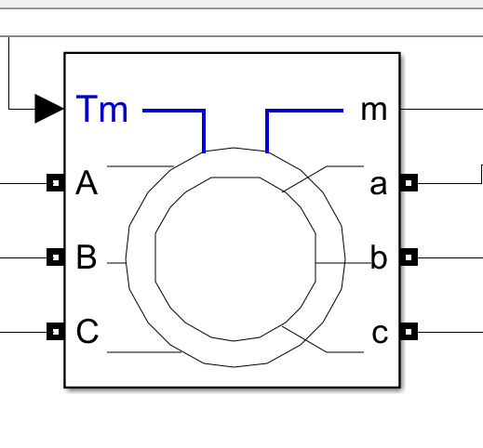
Fig 7. Asynchronous machine Wound Induction Generator Block from simulation
Table II. Asynchronous machine Generator Parameters
Parameters | Values
Pole | 2
Voltage with Stator (line-line) | 690volt
Rotor voltage | 2070volt
Rotor with resistance | 0.0029$ᾨ$
Inductance with rotor | 0.00087h
Both Stator or rotor turns ratio | 1:3
Inertia | 127 Kg.m2

Aerodynamics of Wind Turbine Model
The torque is delivered into the induction generator's output by the aerodynamics of the wind turbine type. The input parameters for a wind turbine model are the generator speed, pitch angle, and turbine speed. The power coefficient Cp ( $βγ$) depends on the wind speed and blade radius. The torque was then determined. The block responsible for calculating the turbine torque aerodynamically is represented in the accompanying diagram.

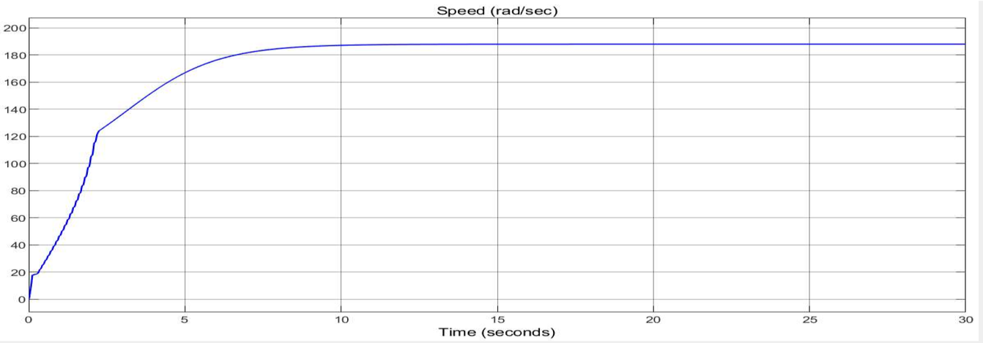
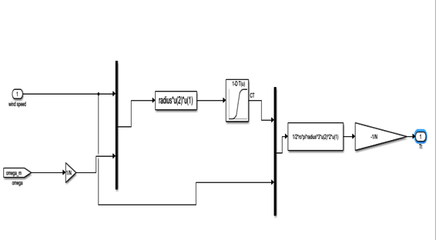
Fig 8. Wind turbine simulink modal

Table.III Aerodynamic wind turbine parameter properties:
Parameter | Rated value
Wind velocity value | 12 m/s
Beta | 32 m
Gear box ratio | 0 deg
Density | 72 m/s
In a wind turbine modal include electrical properties of the generator such as the electrical torque, losses, and control system. The controller model is responsible for regulating optimizing its performance.
- SIMULINK RESULT AND DISCUSSIONS
The average speed of the wind turbine is 12m/s .The blade, gearbox, and generator system are constructed in such a way that they enable the generator to run at synchronous speed at wind speeds of 12 m/s. The rotor current is nearly constant at the generator's synchronous speed because the system slip is equal to zero.
Fig 8. Rotor speed expressed in radians per second

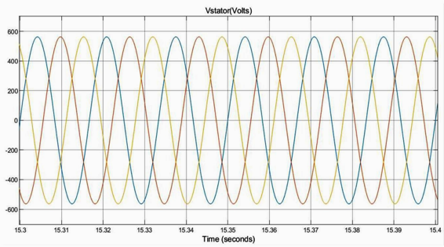
Fig 9. Three phase stator voltage per/ second
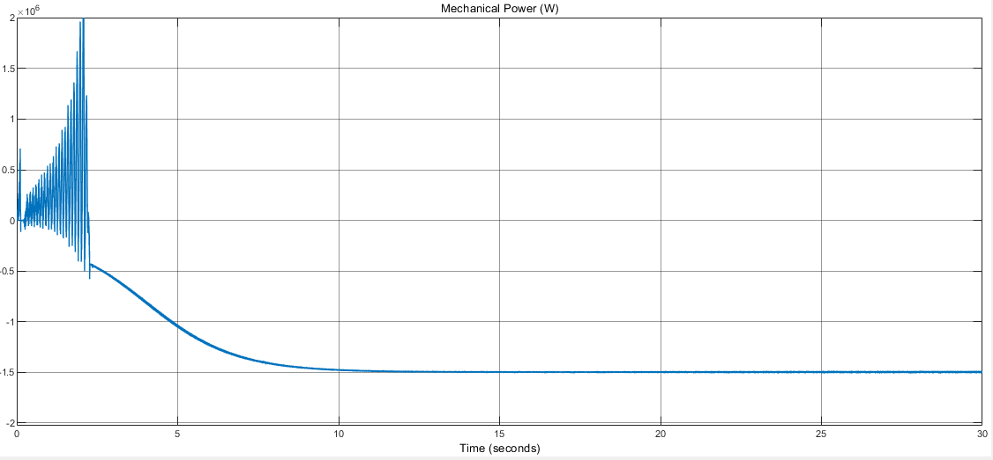
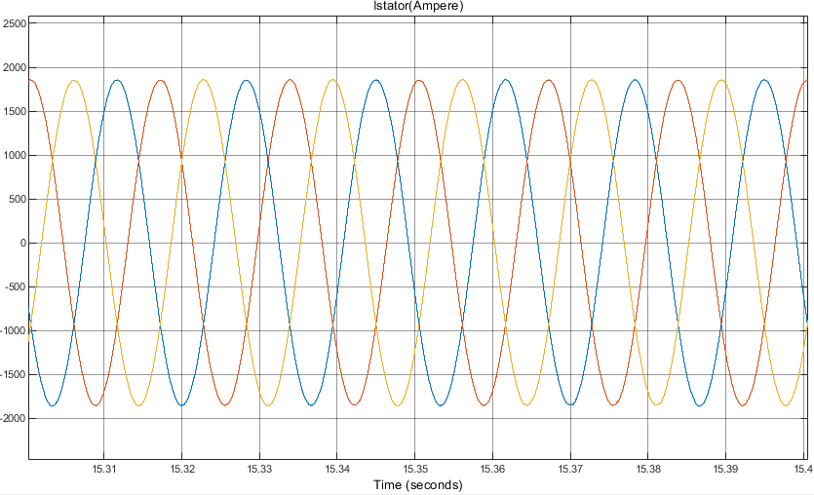
Fig 10. Three phase stator current speed / ampere

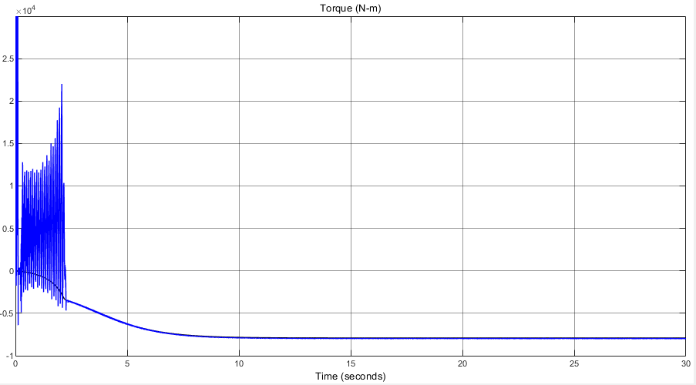
Fig 11. Torque produced from the system
Fig 12. Mechanical power produced by the turbine

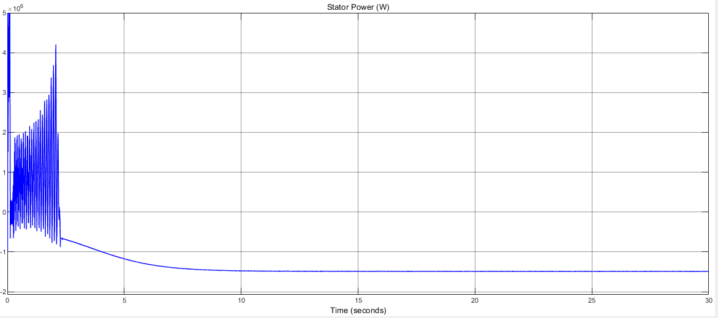
Fig 13. Stator power produced in the DFIG
Rotor side controller
The machine is operating at synchronous speed with no slip, and the simulation results show that the rotor current's frequency is practically constant .rotor frequency mostly depends on the slip when the rotor side current is DC. The torque is an accurate illustration of torque. The mechanical power capacity of the system is 2.4 MW. Since the system has zero slip, no power is generated at the rotor when it is moving at synchronous speed. All of the energy in the system is produced by the stator. An illustration of the currents’d-q components in the controller on the rotor side may be found below.

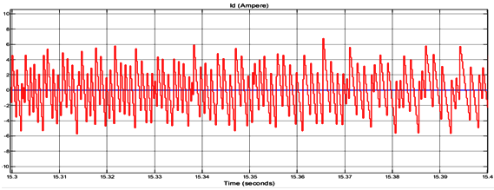Fig 14. The direct axis component of the rotor current

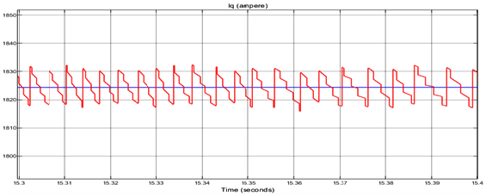
Fig 1 . The quadrature axis component rotor side current

Changing the speed of how a wind turbine is operated
The wind turbine model operated with a variable speed and a variety of wind speeds. Every 10 seconds, the velocity changed to account for the wind speed. The machine's inertia decreased to half its initial amount to speed up simulation. The provided data represents wind velocity measurements at different time intervals. It appears that the wind velocity changes over four consecutive time intervals: 0-10 seconds, 10-20 seconds, 20-30 seconds, and 30-40 seconds.

Table The following table shows the wind speed at various intervals.
Table III. The following table shows the wind speed at various intervals.
Time | Wind Velocity
0 - 10 sec | 9 M/S
10 - 20 sec | 12 M/S
20 - 30 sec | 13 M/S
30 - 40 sec | 12 M/S

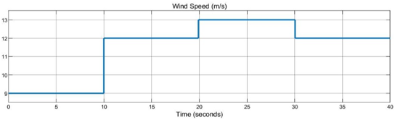

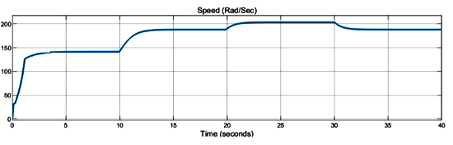
Fig 1 . Wind speed at various intervals

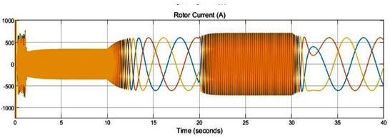

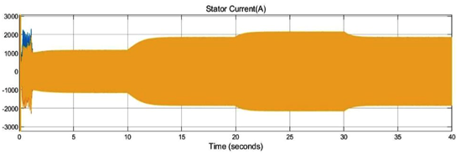
Fig 17. Variation in rotor speed, stator current,
During synchronous frequency operation, the rotor current operates as direct current. One may see how the MPPT functions by looking at the aforementioned outcome. The rotor speed adapts to a new operating point to maximize power when the wind velocity changes. Here again, the portion below illustrates how the wind speed influences the stator and rotor power produced at the stator. The results shown above demonstrate that the stator and rotor powers change according on the DFIG's operating speed. In the Every 10 to 20 and every 30 to 40 seconds, respectively, when the machine is operating at the same speed. The one and only source of the system's electrical output is the stator. The rotor power is zero since the system has zero slip at this period. The machine is operating at the sub-synchronous speed indicated in the time range of 0 to 10 seconds. The rotor and stator both supply power to the component during the 20–30 seconds when the machine is operating at super synchronous speed. The total mechanical power of the stator and rotor is equal to the system output.
In this set of parameters and equations, we have outlined various key characteristics and control strategies for a Doubly Fed Induction Generator (DFIG) system used in a wind turbine application. Let us recap the important aspects:
CONCLUSION
- DFIG Parameters: The parameters of the DFIG system are defined, including stator frequency, rated power, rotational speed, stator and rotor voltages, stator and rotor currents, torque, pole pair count, turns ratio, rotor resistance, inductances, and more. These parameters establish the basic operating conditions and characteristics of the generator.
- Rotor-Side PI Regulators: Proportional-Integral (PI) regulators are designed for the rotor side of the DFIG system. These controllers play a crucial role in regulating the current components on the rotor side, aiding in maintaining stable performance and efficient power conversion. The controller parameters are derived from system inductances, resistances, and inertia.
- Wind Turbine Modal: The parameters related to the wind turbine itself are outlined, including gearbox ratio, blade radius, and air density. These factors influence the mechanical behavior of the turbine and its interaction with the wind.
- Maximum Power Point Tracking (MPPT): The concept of MPPT is mentioned, which involves optimizing the wind turbines operation to extract maximum power from the wind under varying conditions. Parameters like maximum power coefficient (cp_max) and optimal tip speed ratio (lambda opt) play a role in determining the turbine is operating point.
REFERENCES

- Adefarati And T, Bansal RC. Integration of renewable distributed generators into the distribution system: a review. IET-Renew Power Generat. 2016;10 (7):873–884.
- Adefarati T, Bansal RC, Naidoo R, et al. Optimization of PV-Wind-battery storage microgrid system utilizing a genetic algorithm. IET-Renew Power Generat. 2020;14(19):4053–4062.
- Liu X, Bansal RC. Integrating multi-objective optimization with computational fluid dynamics to optimize boiler combustion process of a coal fired power plant. Appl Energy. 2014;130:658–669.
- “Future of wind deployment, investment, technology, grid integration and socio-economic aspects,” Available online: https://irena.org/-/media/Files/IRENA/Agency/ Publication/2019/Oct/IRENA_Future_of_wind_2019_ summ_EN.PDF, accessed: Jan, 2022
- .N. R. NKOSI ET AL.Adefarati T, Bansal RC. Reliability assessment of distribution system with the integration of renewable distributed generation. Appl Energy. 2017;185:158–171. part 1.
- Adefarati T, Bansal RC. Reliability, economic and environmental analysis of a microgrid system in the presence of renewable energy resources. Appl Energy. 2019;236:1089–1114.
- Gautam D, Vittal V, Harbour T. Impact of increased penetration of DFIG-based wind turbine generators on transient and small signal stability of power systems. IEEE Trans Power Syst. 2009 Aug;24(3):1426–1434.
- Kundur P, Balu NJ, Lauby MG. Power system stability and control. New York: McGraw-hill; 1994.
- Li J, Yu T, Yang B. A data-driven output voltage control of solid oxide fuel cell using multi-agent deep reinforcement learning. Appl Energy. 2021;304(117541):1–17.
- Li J, Yu T, Zhang X. Coordinated load frequency control of multi-area integrated energy system using multi-agent deep reinforcement learning. Appl Energy. 2022;306(117900):1–21.
- Bansal RC, Editor. Handbook of distributed generation: electric power technologies, economics and environmental impacts. Cham Switzerland: Springer; 2017.
- Yang B, Yu T, Shu H, et al. Adaptive fractional-order PID control of PMSG-based wind energy conversion system for MPPT using linear observers. It Trans Electro Energy Syst. 2018;29 1:1–18. December 2021. https://doi.org/10.1002/etep.2697
- T. Ackermann and L. So, “An overview of wind energy-status 2002,” vol. 6, pp. 67– 128, 2002.
- M. K. Johari, M. A. A. Jalil, M. Faizal, and M. Shariff, “Comparison of horizontal axis wind turbine ( HAWT ) and vertical axis wind turbine ( VAWT ),” no. October, 2018.
- T. M. Letcher, “Wind Energy Engineering-A Handbook for Onshore and Offshore Wind Turbines.”

REFERENCES

- Adefarati And T, Bansal RC. Integration of renewable distributed generators into the distribution system: a review. IET-Renew Power Generat. 2016;10 (7):873–884.
- Adefarati T, Bansal RC, Naidoo R, et al. Optimization of PV-Wind-battery storage microgrid system utilizing a genetic algorithm. IET-Renew Power Generat. 2020;14(19):4053–4062.
- Liu X, Bansal RC. Integrating multi-objective optimization with computational fluid dynamics to optimize boiler combustion process of a coal fired power plant. Appl Energy. 2014;130:658–669.
- “Future of wind deployment, investment, technology, grid integration and socio-economic aspects,” Available online: https://irena.org/-/media/Files/IRENA/Agency/ Publication/2019/Oct/IRENA_Future_of_wind_2019_ summ_EN.PDF, accessed: Jan, 2022
- .N. R. NKOSI ET AL.Adefarati T, Bansal RC. Reliability assessment of distribution system with the integration of renewable distributed generation. Appl Energy. 2017;185:158–171. part 1.
- Adefarati T, Bansal RC. Reliability, economic and environmental analysis of a microgrid system in the presence of renewable energy resources. Appl Energy. 2019;236:1089–1114.
- Gautam D, Vittal V, Harbour T. Impact of increased penetration of DFIG-based wind turbine generators on transient and small signal stability of power systems. IEEE Trans Power Syst. 2009 Aug;24(3):1426–1434.
- Kundur P, Balu NJ, Lauby MG. Power system stability and control. New York: McGraw-hill; 1994.
- Li J, Yu T, Yang B. A data-driven output voltage control of solid oxide fuel cell using multi-agent deep reinforcement learning. Appl Energy. 2021;304(117541):1–17.
- Li J, Yu T, Zhang X. Coordinated load frequency control of multi-area integrated energy system using multi-agent deep reinforcement learning. Appl Energy. 2022;306(117900):1–21.
- Bansal RC, Editor. Handbook of distributed generation: electric power technologies, economics and environmental impacts. Cham Switzerland: Springer; 2017.
- Yang B, Yu T, Shu H, et al. Adaptive fractional-order PID control of PMSG-based wind energy conversion system for MPPT using linear observers. It Trans Electro Energy Syst. 2018;29 1:1–18. December 2021. https://doi.org/10.1002/etep.2697
- T. Ackermann and L. So, “An overview of wind energy-status 2002,” vol. 6, pp. 67– 128, 2002.
- M. K. Johari, M. A. A. Jalil, M. Faizal, and M. Shariff, “Comparison of horizontal axis wind turbine ( HAWT ) and vertical axis wind turbine ( VAWT ),” no. October, 2018.
- T. M. Letcher, “Wind Energy Engineering-A Handbook for Onshore and Offshore Wind Turbines.”

