A CRITICAL STUDY ON RIGHTS OF THE CHILDREN REGARDING EDUCATION BY ANALYSING COMPULSORY EDUCATION

Author:
Mohandass. K
V th year,BA,LL.B(Hon’s),
Saveetha School of Law,
Saveetha Institute of Medical and Technical Science (SIMATS),
Saveetha University,
Chennai-600077,

Co-author:
Mrs.K. Kaliselvi B.A., B.L., LL.M.,
Asst.professor of law,
Saveetha School of Law,
Saveetha Institute of Medical and Technical Science(SIMATS),
Saveetha University,
Chennai-600077.

A CRITICAL STUDY ON RIGHTS OF THE CHILDREN REGARDING EDUCATION BY ANALYSING COMPULSORY EDUCATION

MOHANDASS
MRS.K.KALISELVI

ABSTRACT:
The study of the research on the social justice of the constitution regarding M.C.Mehta Vs State of Madras deals the constitutional provision regarding the prohibition of child labour or employment of children in hazardous factories.The research includes the responses of the people by questionnaire through convenient sampling method.Article 24 mandates that No child below age of 14 years shall be employed to work in any factory or mine or engaged in any other hazardous employment.The Employment of Children Act 1938 was among the first acts to prevent child labour. The provisions of this act did not include the construction work on projects because the construction industry was not a process specified in the Schedule to the Act. But construction work & projects were held equal to hazardous occupation The study overseen the measures taken by the government regarding the issue.The amendment of the constitution 86th enables the provision that the duty of the state to ensure free and compulsory education to children up to 14 years.It is the corresponding constitutional provision for the prohibition of child labour.The study also analyse the implementation of constitutional protection over the labour legislation.The State Government to take immediate steps for inclusion of construction work in the schedule to the Act, and to ensure that the constitutional mandate of Article 24 is not violated in any part of the country. In another case the Court has reiterated the principle that the construction work is a hazardous employment and children below 14 cannot be employed in this work.Thus the government initiatives should ensure the abolition of child labour by exposing accordingly the educational growth of the children across the nation.

KEYWORDS:
Child labour, Right against exploitation, Right to education, Constitutional protection,Welfare of the children

INTRODUCTION:
Article 24 of the Constitution prohibits employment of children below 14 years of age in factories and hazardous employment. This provision is certainly in the interest of public health and safety of life of children. Children are assets of the nation. That is why Article 39 of the Constitution imposes upon the State an obligation to ensure that the health and strength of workers, men and women, and the tender age of the children are not abused and that citizens are not forced by economic necessity to enter avocations unsuited to their age or strength. In People's Union for Democratic Rights v. Union of India,it was contended that the Employment of Children Act, 1938 was not applicable in case of employment of children in the construction work of Asiad Projects in Delhi since construction industry was not a process specified in the schedule to the Children Act.(Child Labour: A Textbook for University Students) The Court rejected this contention and held that the construction work is hazardous employment and therefore under Art. 24,no child below the age of 14 years can be employed in the construction work even if the construction industry is not specified in the schedule to the Employment of Children Act, 1938. (Sharma)The State Government to take immediate steps for inclusion of construction work in the schedule to the Act, and to ensure that the constitutional mandate of Article 24 is not violated in any part of the country. In another case the Court has reiterated the principle that the construction work is a hazardous employment and children below 14 cannot be employed in this work.The aim of the study to analyse the recommendations made regarding to the prohibition of child labour and to study the relation between article 24 and 21(A) of the Indian constitution.

OBJECTIVES:
- To study the recommendations made regarding the prohibition of child labour.
- To study the comparative articles protecting the right of the children.
- To study the relationship between article 24 and article 21 A of the Indian constitution.
- To analyse the effectiveness of the implementation of free and compulsory education by the government.

REVIEW OF LITERATURE:
The problem of child labour was rampant throughout the country, the court thought it appropriate to deal with the issue in a wider manner treating it as a national problem.the Supreme Court recognised poverty as a basic cause for child labour. The court observed that until an alternative income was assured to the family, child labour could never be effectively tackled.To ensure compliance with Child Labour (Prohibition and Regulation) Act, 1986, an employer must be asked to pay a sum of Rs 20,000 as compensation for every child employed in contravention of the provisions of the Act.(cprims.org)(Sharma and Herath)

In M. C. Mehta v. State of Tamil Nadu, the Supreme Court has held that children below the age of 14 years cannot be employed in any hazardous industry. Exhaustive guidelines were laid down as to how State Authorities should protect the economic, social and humanitarian rights of millions of children , working illegally in public and private sections(Aarsha unnikrishnan,legal service India).(Sharma and Herath; Sanghera)

The contention given by the Government is not at all acceptable. The construction work is hazardous employment and therefore, the children below 14 years must not be employed in the construction work even if the construction work is not specifically mentioned under the schedule of the Employment of Children Act, 1938. The State Government is advised to take immediate necessary steps in order to include the construction work in the schedule of the Act and to ensure that Article 24 is not violated in any part of the country.(People’ union for democratic rights vs Union of india). (Sharma and Herath; Sanghera; Rahikainen)

In our country there are millions of people who are underprivileged and deprived. They may be subjected to exploitation by their fellow human beings. One such form of exploitation in our country has been begar or forced labour without payment. Another closely related form of exploitation is buying and selling of human beings and using them as slaves. Both of these are prohibited under the Constitution. Forced labour was imposed by landlords, moneylenders and other wealthy persons in the past. Some form of bonded labour still continues in the country, especially in brick till in work. It has now been declared a crime and it is punishable.The Constitution also forbids employment of children below the age of 14 years in dangerous jobs like factories and mines.(ncert.nic.in, 20/1/2015).(Office and International Labour Office, “Child Labour and Social Protection: International Standards, Concepts and Policy Frameworks”)

The Honourable Apex Court directed that whenever the Central Government commences a construction project which is likely to last for a substantial phase of time, it should ensure that children of construction workers who are living at or near the project site are given amenities for schooling. The Court further lays down that this may be done either by the Central Government itself, or if the Central Government entrusts the project work or any part thereof to a contractor.(Salad Hydro project vs State of Jammu and kashmir,(AIR 1994 SC 177)).(Office and International Labour Office, “Social Protection as a Policy Response to Child Labour: A Review of Evidence from Impact Evaluations”)

An extremely important case relating to the adoption of Indian children by persons inside and outside India. In the absence of legislation, the Supreme Court framed elaborate guidelines in the matter. There was no law to regulate inter-country adoptions and such lack of legal regulation could cause incalculable harm to Indian children. Considering the possibility of child trade for prostitution as well as slave labor, legal regulation of such adoptions was essential. Therefore, Justice Bhagwati created a scheme for regulating both inter-country and intercountry adoptions. The Supreme Court held that any adoption in violation of or non-compliance with may lead adoption to be declared invalid and expose the person concerned to strict action including prosecution. For years, social activists have used these directions to protect children and promote desirable adoptions.(Lakshmi Kant Pandey v. Union of India: (1984) 2 SCC 244; AIR 1984 SC 469)(Office and International Labour Office, “Social Protection as a Policy Response to Child Labour: A Review of Evidence from Impact Evaluations”; Deva)

The Supreme Court held that the children of the prostitutes have the right to equality of opportunity, dignity, care, protection and rehabilitation so as to be part of the mainstream of social life without any pre-stigma attached to them. The Court directed for the constitution of a committee to formulate a scheme for the rehabilitation of such children and child prostitutes and for its implementation and submission of periodical report of its Registry.(Gaurav Jain v Union of India: (1997) 8 SCC 114; AIR 1997 SC 3021).(Parker)

Article 24 mandates that No child below age of 14 years shall be employed to work in any factory or mine or engaged in any other hazardous employment.The Employment of Children Act 1938 was among the first acts to prevent child labour. The provisions of this act did not include the construction work on projects because the construction industry was not a process specified in the Schedule to the Act. But construction work & projects were held equal to hazardous occupation by the Supreme Court.(gktoday.in mar 10,2013)(Parker; Chatterjee and Ray)

In M. C. Mehta v. State of Tamil Nadu, the Supreme Court has held that children below the age of 14 years cannot be employed in any hazardous industry. Exhaustive guidelines were laid down as to how State Authorities should protect the economic, social and humanitarian rights of millions of children , working illegally in public and private sections(Aarsha unnikrishnan,legal service India).(Hindman and Hindman)

India is a federal republic, so child slavery is a subject that can be legislated over by the central and state governments. The most important regional regulatory changes are: the 1948 Factories Legislation: The Act bans the work in factories of children under the age of 14. The law also sets out guidelines for who should be working in a business of pre-adults aged 15-18 years.No child below the age of fourteen years shall be employed to work in any factory or mine or engaged in other hazardous employment.(Right against Exploitation,law bhoomi,sep2020)(Pande)

The Honourable Apex Court directed that whenever the Central Government commences a construction project which is likely to last for a substantial phase of time, it should ensure that children of construction workers who are living at or near the project site are given amenities for schooling. The Court further lays down that this may be done either by the Central Government itself, or if the Central Government entrusts the project work or any part thereof to a contractor.(Salad Hydro project vs State of Jammu and kashmir,(AIR 1994 SC 177)).(Bakshi)

The abolition of child labour requires introduction of compulsory education. There is a saying any child out of school is a child labour. Compulsory education and child labour laws are inter-linked. Thus Article 45 of the Constitution supplements Article 24. The right to education flows directly from right to life under Article 21 of the Constitution and dignity of individuals cannot be assured unless it is accompanied by Right to Education.(A socio-legal analysis of child labour vs child rights in India, Dr. Binayak Patnaik).(Pal)

Article 24 of the Constitution bars employment of children below the age of 14 years. Article 45 is supplementary to Article 24 for if the child is not to be employed below the age of 14 years he must be kept occupied in some educational institution.In the case of M.C.Mehta Vs State of TamilNadu,the Supreme Court directed that children should not be employed in hazardous jobs in factories for manufacture of match boxes and fireworks, and positive steps should be taken for the welfare of such children as well as for improving the quality of their life.(Mr. Sandip Bhosale,LL.M Student at Rajiv Gandhi National University of Law, Patiala).

There is no child below the age of 14 years will be employed to work in any factory or mine or employed in any hazardous employment.In 1986, the Child Labour (Prohibition and Regulation) Act was enacted to prohibit the employment of children below the age of 14 in hazardous occupations identified in a list by the law.(Thea; Lee and Lee) The list included 83 occupations.The National Policy on Child Labour of 1987, implemented in 1988 focused on the rehabilitation of children working in hazardous occupations.In 2017,India took a step forward towards commitment for a child labour free India by ratifying the two Core Conventions of International Labour Organization (ILO).Convention 138- The Minimum Age Convention regarding admission of age to employment.Convention 182 regarding the worst forms of Child Labour.(Jatinverma,may11 2019).(Anderson and Nelson; “Marketing Violent Entertainment to Children: A Fifth Follow-up Review of Industry Practices in the Motion Picture, Music Recording & Electronic Game Industries”)

The Employment of Children Act 1938 was among the first acts to prevent child labour. The provisions of this act did not include the construction work on projects because the construction industry was not a process specified in the Schedule to the Act. But construction work & projects were held equal to hazardous occupation by the Supreme Court.(gktoday.in mar 10,2013)(Pal; Ambedkar and We The People of INDIA)

Article 45 is supplementary to Article 24 for if the child is not to be employed below the age of 14 years he must be kept occupied in some educational institution.In the case of M.C.Mehta Vs State of TamilNadu,the Supreme Court directed that children should not be employed in hazardous jobs in factories for manufacture of match boxes and fireworks, and positive steps should be taken for the welfare of such children as well as for improving the quality of their life.(Mr. Sandip Bhosale,LL.M Student at Rajiv Gandhi National University of Law, Patiala).(Bakshi)

The Supreme Court held that the children of the prostitutes have the right to equality of opportunity, dignity, care, protection and rehabilitation so as to be part of the mainstream of social life without any pre-stigma attached to them. The Court directed for the constitution of a committee to formulate a scheme for the rehabilitation of such children and child prostitutes and for its implementation and submission of periodical report of its Registry.(Gaurav Jain v Union of India: ((1997) 8 SCC 114).(Bakshi; Donadel et al.)

The abolition of child labour requires introduction of compulsory education. There is a saying any child out of school is a child labour. Compulsory education and child labour laws are inter-linked. Thus Article 45 of the Constitution supplements Article 24. The right to education flows directly from right to life under Article 21 of the Constitution and dignity of individuals cannot be assured unless it is accompanied by Right to Education.(A socio-legal analysis of child labour vs child rights in India, Dr. Binayak Patnaik).(Hindman and Hindman)

MATERIALS AND METHODS:
This research is an empirical research done by the author .This research is analysed by using the sampling method called ‘simple convenient sampling’ method .This research is made with a sampling size of 200 .The secondary data is collected from books, journals, articles and e-sources. The researcher has also utilised commentaries, books, treatises, articles, notes, comments and other writings to incorporate the various views of the multitude of jurists, with the intention of presenting a holistic view. The independent variables which are used in this research analysis are age, gender, occupation.The dependent variables which are used in this research analysis are the opinion of the people on the implementation of free and compulsory education to the children below the age of 14 years and the opinion the amendment to the constitution of free and compulsory education to children up to 14 years of age reduced the employment of children in the hazardous factories.

ANALYSIS:

Age:
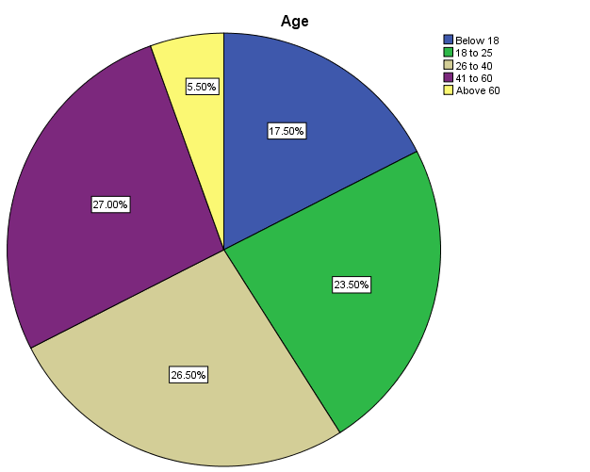
Legend:
The above represents the participation of respondents to the survey in respect to their age of the people.

Age
 |  | Frequency | Percent | Valid Percent | Cumulative Percent
Valid | Below 18 | 35 | 17.4 | 17.5 | 17.5
Valid | 18 to 25 | 47 | 23.4 | 23.5 | 41.0
Valid | 26 to 40 | 53 | 26.4 | 26.5 | 67.5
Valid | 41 to 60 | 54 | 26.9 | 27.0 | 94.5
Valid | Above 60 | 11 | 5.5 | 5.5 | 100.0
Valid | Total | 200 | 99.5 | 100.0
Missing | System | 1 | .5
Total |  | 201 | 100.0
Legend:
The above represents the frequency and percentage of age description of the people participating in the survey.

Gender
 |  | Frequency | Percent | Valid Percent | Cumulative Percent
Valid | Male | 151 | 75.1 | 75.5 | 75.5
Valid | Female | 49 | 24.4 | 24.5 | 100.0
Valid | Total | 200 | 99.5 | 100.0
Missing | System | 1 | .5
Total |  | 201 | 100.0
Legend:
The above represents the frequency and percentage of gender description of the people participating in the survey.

Occupation
 |  | Frequency | Percent | Valid Percent | Cumulative Percent
Valid | Student | 18 | 9.0 | 9.0 | 9.0
Valid | Private employee | 56 | 27.9 | 28.0 | 37.0
Valid | Government employee | 51 | 25.4 | 25.5 | 62.5
Valid | Self Employed | 60 | 29.9 | 30.0 | 92.5
Valid | Unemployed | 15 | 7.5 | 7.5 | 100.0
Valid | Total | 200 | 99.5 | 100.0
Missing | System | 1 | .5
Total |  | 201 | 100.0

Legend:
The above represents the frequency and percentage of occupational description of the people participating in the survey.

On the scale of 1-10 rate on the implementation of free and compulsory education by the government.

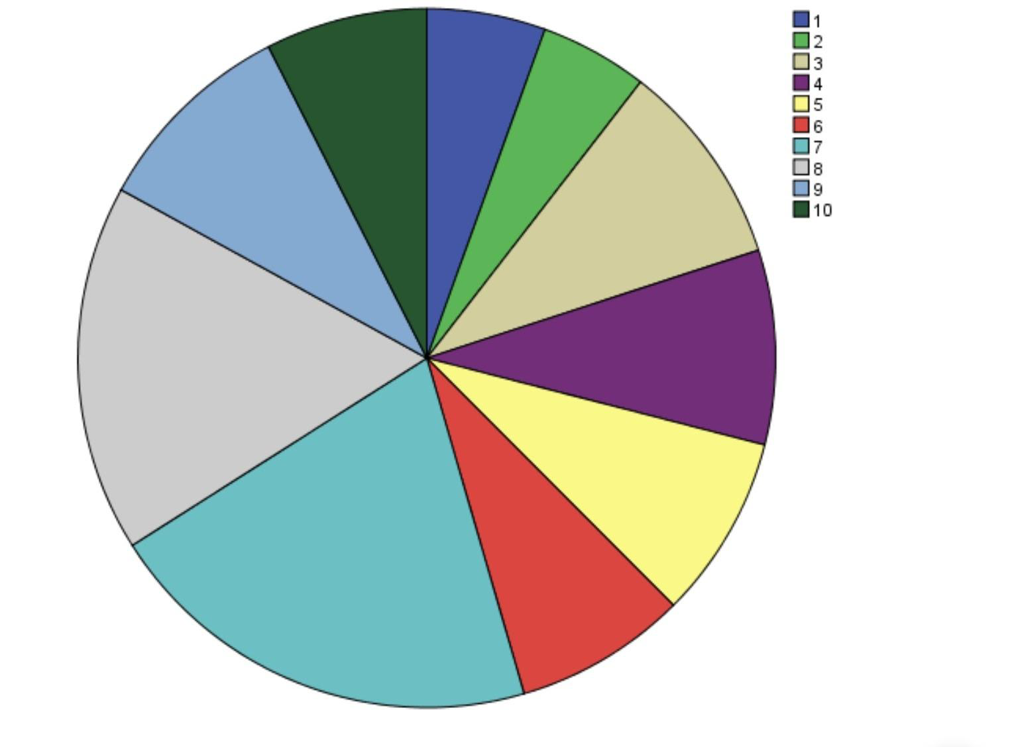

Legend:
The above pie-diagram represents the opinion on the implementation of free and compulsory education by the government on the rating scale of (1-10) accordingly.

On scale of 1-10 rate on the implementation of free and compulsory education by the government.
 |  | Frequency | Percent | Valid Percent | Cumulative Percent
Valid | 1 | 11 | 5.5 | 5.5 | 5.5
Valid | 2 | 10 | 5.0 | 5.0 | 10.5
Valid | 3 | 19 | 9.5 | 9.5 | 20.0
Valid | 4 | 18 | 9.0 | 9.0 | 29.0
Valid | 5 | 17 | 8.5 | 8.5 | 37.5
Valid | 6 | 16 | 8.0 | 8.0 | 45.5
Valid | 7 | 41 | 20.4 | 20.5 | 66.0
Valid | 8 | 34 | 16.9 | 17.0 | 83.0
Valid | 9 | 19 | 9.5 | 9.5 | 92.5
Valid | 10 | 15 | 7.5 | 7.5 | 100.0
Valid | Total | 200 | 99.5 | 100.0
Missing | System | 1 | .5
Total |  | 201 | 100.0

Legend:
The above table represents the opinion on the implementation of free and compulsory education by the government on the rating scale of (1-10).

RESULT:
From the table the opinion varies from 1-10 and the respondents opinion shows 1-11,2-10,3-19,4-18,5-17,6-16,7-41,8-34,9-19 and 10-15.

On a scale of 1-10 rate on the implementation of free and compulsory education by the government.
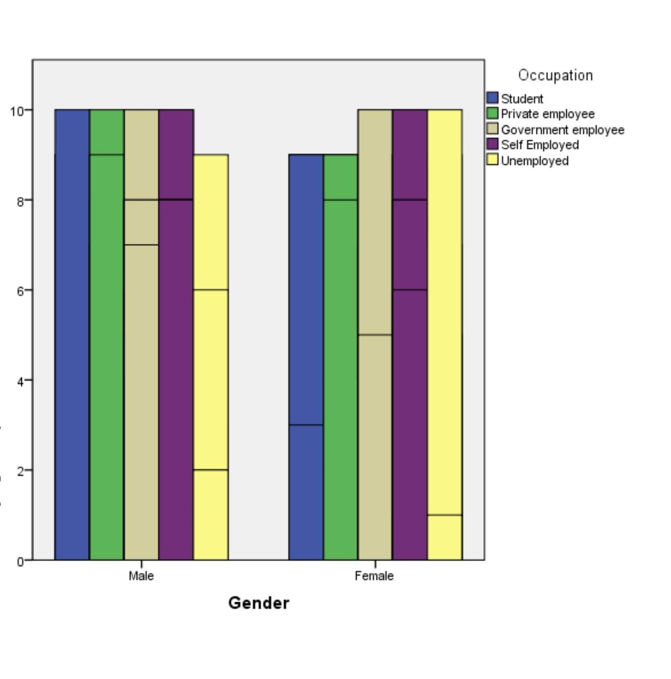Legend:
The above graph represents the opinion of the people on the implementation of free and compulsory education by the government on the rating scale of (1-10) in respect to the respondents occupation.

Age * On scale of 1-10 rate on the implementation of free and compulsory education by the government
Count
 |  | On scale of 1-10 rate that the opinion on the implementation of free and compulsory education by the government. |  |  |  |  |  |  |  |  |  | Total
 |  | 1 | 2 | 3 | 4 | 5 | 6 | 7 | 8 | 9 | 10 | Total
Age | Below 18 | 3 | 1 | 5 | 2 | 0 | 1 | 1 | 6 | 8 | 8 | 35
Age | 18 to 25 | 3 | 1 | 3 | 3 | 3 | 3 | 10 | 11 | 9 | 1 | 47
Age | 26 to 40 | 2 | 4 | 7 | 3 | 7 | 6 | 12 | 8 | 1 | 3 | 53
Age | 41 to 60 | 1 | 3 | 3 | 9 | 7 | 6 | 13 | 9 | 0 | 3 | 54
Age | Above 60 | 2 | 1 | 1 | 1 | 0 | 0 | 5 | 0 | 1 | 0 | 11
Total |  | 11 | 10 | 19 | 18 | 17 | 16 | 41 | 34 | 19 | 15 | 200

Legend:
The above table represents the opinion on the implementation of free and compulsory education by the government on the rating scale of (1-10).
RESULT:
From the table the person below 18 responds in the manner 1-3, 2-1, 3-5, 4-2, 5-0, 6-1, 7-1, 8-6, 9-8, 10-8 and the people between 18 to 25 responds 1-3, 2-1, 3-3, 4-3, 5-3, 6-3, 7-10, 8-11, 9-9, 10-1 and the respondents of 26 to 40 responds 1-2, 2-4, 3-7, 4-3, 5-7, 6-6, 7-12, 8-8, 9-1, 10-3 and the people between 41-60 responds 1-1, 2-3, 3-3, 4-9, 5-7, 6-6, 7-13, 8-9, 9-0, 10-3 and the people of above 60 responds 1-2, 2-1, 3-1, 4-1, 5-0, 6-0, 7-5, 8-0, 9-1,

On scale of 1-10 rate on the implementation of free and compulsory education by the government.
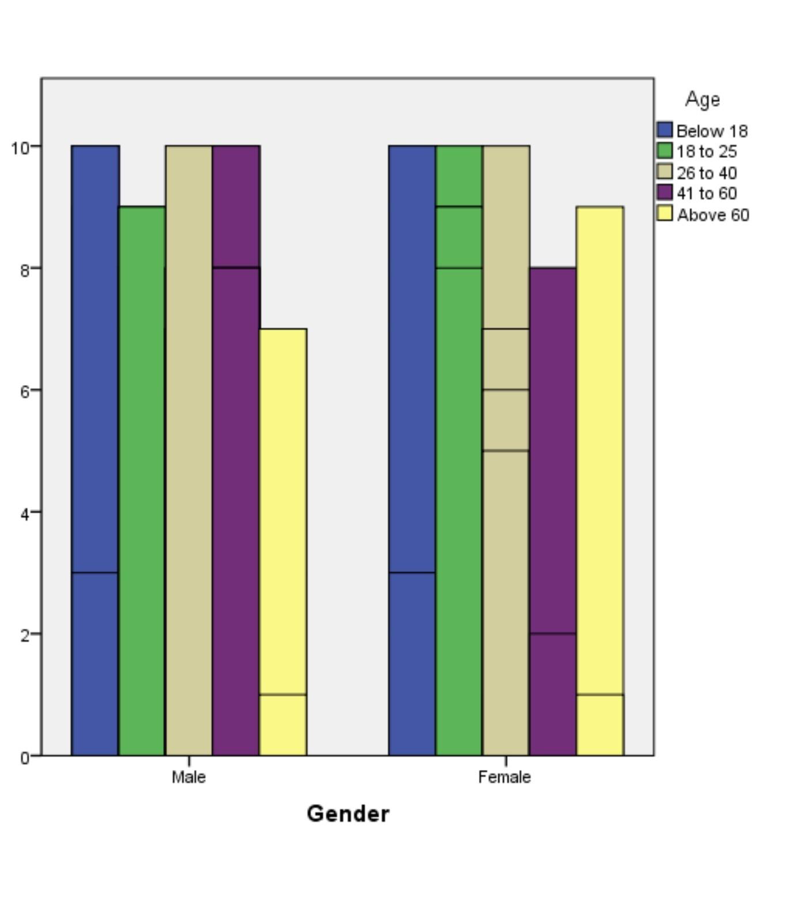Legend:
The above graph represents the opinion on the implementation of free and compulsory education by the government on the rating scale of (1-10) in respect to the age of the respondents.

Chi-Square Tests
 | Value | df | Asymptotic Significance (2-sided)
Pearson Chi-Square | 71.924ª | 36 | .000
Likelihood Ratio | 80.821 | 36 | .000
Linear-by-Linear Association | 7.261 | 1 | .007
N of Valid Cases | 200
a. 38 cells (76.0%) have expected count less than 5. The minimum expected count is .55.
from the above table the Pearson chi square value is .000 which is apparently less than 0.5 and it implies that there is a relationship between independent variable is educational qualification and dependent variable.

Employment of children below the age of 14 years has been reduced after the amendment of free and compulsory education.
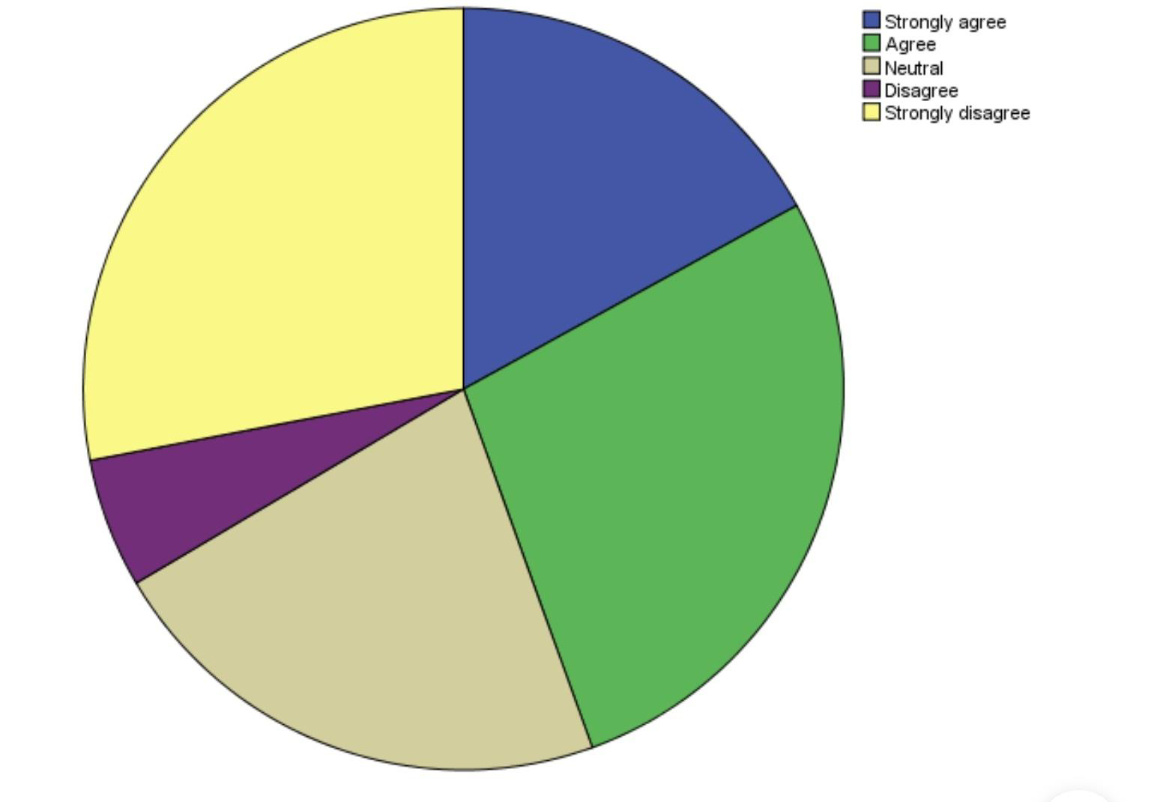

Legend:
The above pie diagram represents the opinion the employment of children below the age of 14 years has been reduced after the amendment of the free and compulsory education by the government in respective to agree,strongly agree,neutral,disagree and strongly disagree.

Employment of children below the age of 14 years has been reduced after the amendment of free and compulsory education.
 |  | Frequency | Percent | Valid Percent | Cumulative Percent
Valid | Strongly agree | 34 | 16.9 | 17.0 | 17.0
Valid | Agree | 55 | 27.4 | 27.5 | 44.5
Valid | Neutral | 44 | 21.9 | 22.0 | 66.5
Valid | Disagree | 11 | 5.5 | 5.5 | 72.0
Valid | Strongly disagree | 56 | 27.9 | 28.0 | 100.0
Valid | Total | 200 | 99.5 | 100.0
Missing | System | 1 | .5
Total |  | 201 | 100.0

Legend:
The respondents of total were collected on the study that .The study shows respondents of strongly disagree, disagree, neutral, agree, strongly agree on the opinion the employment of children below the age of 14 years has been reduced after the amendment of the free and compulsory education by the government.
RESULT:
The opinion of people varies accordingly the following strongly agree 34, agree-55, neutral-44, disagree-11, strongly disagree-56 on the matter that implementation of free and compulsory education reduced the employment of children below the age of 14 years.

Employment of children below the age of 14 years has been reduced after the amendment of free and compulsory education.

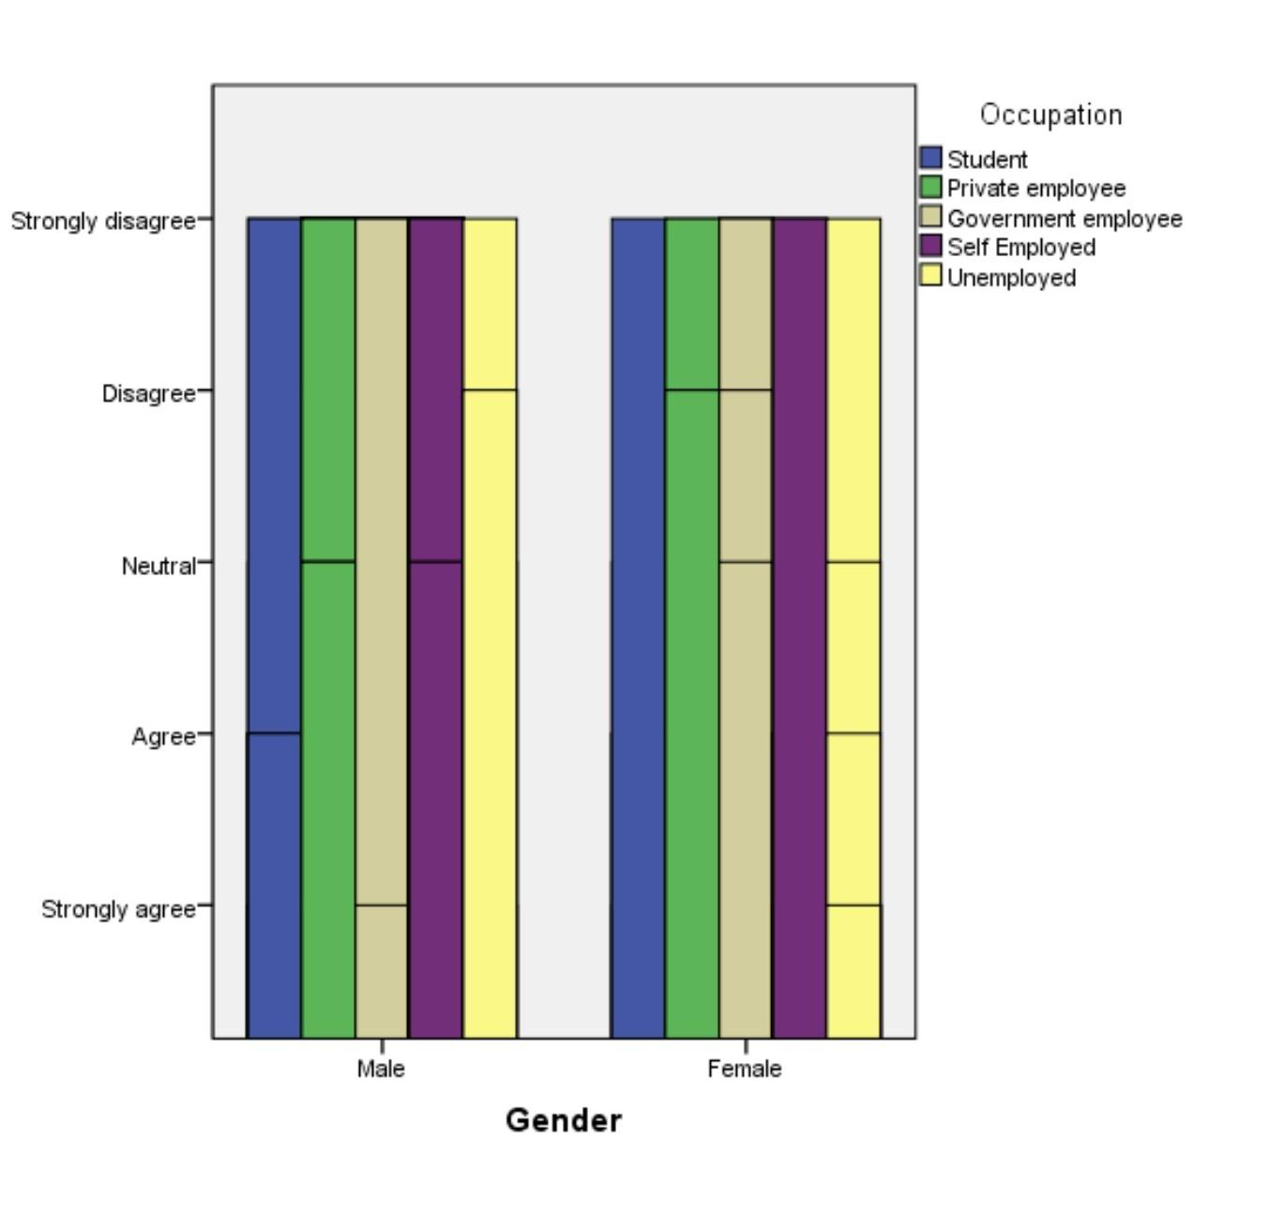
Legend:
The above graph represents the opinion that the employment of children below the age of 14 years has been reduced after the amendment of the free and compulsory education by the government.

Age * Employment of children below the age of 14 years has been reduced after the amendment of free and compulsory education.
Count
 |  | Is the employment of children below the age of 14 years has been reduced after the amendment of the free and compulsory education by the government. |  |  |  |  | Total
 |  | Strongly agree | Agree | Neutral | Disagree | Strongly disagree | Total
Age | Below 18 | 9 | 7 | 10 | 3 | 6 | 35
Age | 18 to 25 | 9 | 19 | 7 | 6 | 6 | 47
Age | 26 to 40 | 6 | 17 | 13 | 2 | 15 | 53
Age | 41 to 60 | 7 | 12 | 11 | 0 | 24 | 54
Age | Above 60 | 3 | 0 | 3 | 0 | 5 | 11
Total |  | 34 | 55 | 44 | 11 | 56 | 200

Legend:
The above table represents the opinion that the employment of children below the age of 14 years has been reduced after the amendment of the free and compulsory education by the government.

RESULT:
The opinion of people varies according to their age below 18 - 35,age 18-25 =47,age 26-40=53,age 41-60=54,age above 60=11 thus shows the variation of opinion by the respondents of the survey.

Employment of children below the age of 14 years has been reduced after the amendment of free and compulsory education.
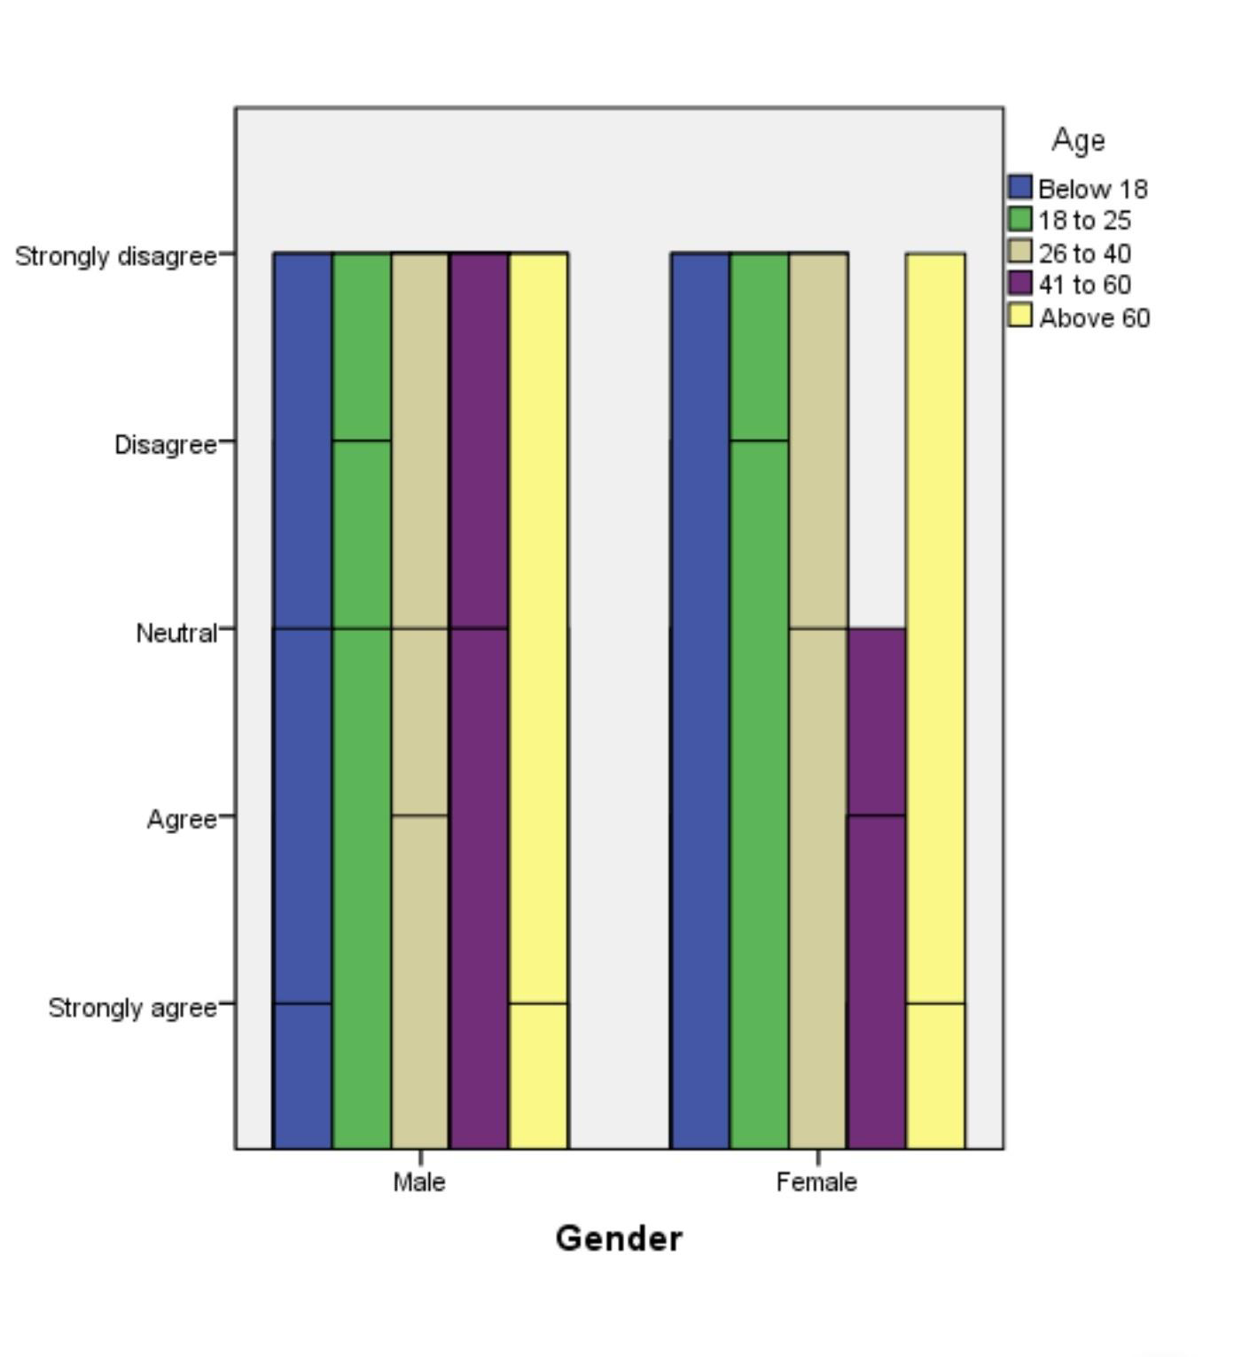
Legend:
The above graph represents the opinion the employment of children below the age of 14 years has been reduced after the amendment of the free and compulsory education by the government.

Chi-Square Tests
 | Value | df | Asymptotic Significance (2-sided)
Pearson Chi-Square | 34.325ª | 16 | .005
Likelihood Ratio | 39.535 | 16 | .001
Linear-by-Linear Association | 8.041 | 1 | .005
N of Valid Cases | 200
a. 9 cells (36.0%) have expected count less than 5. The minimum expected count is .61.
From the above table the Pearson chi square value is .000 which is apparently less than 0.5 and it implies that there is a relationship between the independent variable is educational qualification and the dependent variable.

DISCUSSION:
The analysis of the study shows that the opinion of the people on the implementation of free and compulsory education.The respondents of the survey opted maximum towards the (7-10) rate on the scale of (1-10).The respondents of about 52% opted to 10 which shows the effectiveness of the implementation of free and compulsory education by the government and correspondingly 40% of respondents feel that the government machinery fail to implement the free and compulsory education properly.Also Article 39 of the Constitution imposes upon the State an obligation to ensure that the health and strength of workers, men and women, and the tender age of the children are not abused and that citizens are not forced by economic necessity to enter avocations unsuited to their age or strength.
The opinion of reduction of employment of children below the age of 14 due to the amendment of free and compulsory education in the Indian constitution.The analysis shows the respondents of agree and strongly agree to the opinion stands with 87(44.%) and neutral to the opinion with 44(28%) and the respondents of 67(33.5) opted with disagree and strongly disagree on the opinion that employment of children below the age of 14 years is reduced due to the amendment of free and compulsory education in the Indian constitution.The government with regular inspection should ensure the implementation of article 21A of the Indian constitution and should provide the yearly report on the educational growth of the children across the nation.

SUGGESTIONS:
The study and the analysis shows the necessity of child rights and need of the child rights protection.The outcome of the study deals about the compulsory education system and reduced practice in child employment shows the efficiency of the state administration taken towards the protection of child rights.The study also analyse the implementation of constitutional protection over the labour legislation.The State Government to take immediate steps for inclusion of construction work in the schedule to the Act, and to ensure that the constitutional mandate of Article 24 is not violated in any part of the country. In another case the Court has reiterated the principle that the construction work is a hazardous employment and children below 14 cannot be employed in this work.Thus the government initiatives should ensure the abolition of child labour by exposing accordingly the educational growth of the children across the nation.

CONCLUSION:
The study overseen the measures taken by the government regarding the issue.The amendment of the constitution 86th enables the provision that the duty of the state to ensure free and compulsory education to children up to 14 years.It is the corresponding constitutional provision for the prohibition of child labour.The study also analyse the implementation of constitutional protection over the labour legislation.Right against exploitation under article 24 of the Indian constitution prohibits the employment of children below the age of 14 years in the hazardous factories.This research study analyse the employment of the children below the age of 14 years in the factories and the corresponding article 21 A of the Indian constitution.Article 21 A of the Indian constitution,the 82nd amendment provides the citizen with the fundamental right to free and compulsory education.That is why Article 39 of the Constitution imposes upon the State an obligation to ensure that the health and strength of workers, men and women, and the tender age of the children are not abused and that citizens are not forced by economic necessity to enter avocations unsuited to their age or strength.The government should be more effective and should strengthen the constitutional protection on the labour legislation.

REFERENCES:
Ambedkar, B., and We The People of INDIA. The Constitution of India: Bare Acts. 2019.
- Anderson, Viola R., and Marion Nelson. A Study of the Physical Examinations of Children Entering Industries. 1930.
- Bakshi, P. M. The Constitution of India. 2018.
- Chatterjee, Biswajit, and Runa Ray. “Types and Causes of Child Labour.” Economics of Child Labour, 2019, pp. 29–39, doi:10.1007/978-981-13-8199-7_3.
- Child Labour: A Textbook for University Students. ILO/IPEC, 2004.
- Deva, Surya. “Child Labour*.” The Role of Labour Standards in Development, 2011, doi:10.5871/bacad/9780197264911.003.0008.

BA.,LLB , Saveetha School of Law, Saveetha Institute Of Medical And Technical Science (SIMATS), Saveetha University, Chennai -77,
Assistant Professor, Saveetha School of Law, Saveetha Institute Of Medical And Technical Science (SIMATS), Saveetha University, Chennai -77,

