A STUDY ON MARRIAGE EQUALITY WITH SPECIAL REFERENCE TO LGBTQ COUPLE

AUTHOR
E. Rajaharishma
B.B.A.LLB(Hons)
Register Number: 131602054
SAVEETHA SCHOOL OF LAW
SAVEETHA INSTITUTE OF MEDICAL AND TECHNICAL SCIENCES
(SIMATS)
SAVEETHA UNIVERSITY, CHENNAI-77

CO- AUTHOR
Thousif N. MBA, LLM, MA
ASSISTANT PROFESSOR
SAVEETHA SCHOOL OF LAW
SAVEETHA INSTITUTE OF MEDICAL AND TECHNICAL SCIENCES
(SIMATS)
SAVEETHA UNIVERSITY, CHENNAI-77

A STUDY ON MARRIAGE EQUALITY WITH SPECIAL REFERENCE TO LGBTQ COUPLES.

Author:E. Rajaharishma¹
CO-Author:Thousif N ²

ABSTRACT:

Same sex marriage is the marriage between two men and two women. Although marriage has been regulated through law, religion and customs in most countries of the world has againsted it in some situations. The legal and social responsibility have ranged from celebrations on the one hand and criminalisation on the other hand. Most of the world religions at some point .Most of the world religions have at some point in their histories opposed same sex marriage for some reasons like homosexual act violates natural laws and religious tradition only recognises marriage between men and women. Denial of the recognition of human rights for any group of individuals is a denial of their humanity, which has a profound impact on health. For LGBT people, it may result in discrimination in housing and jobs (affecting the ability to purchase food, shelter, and health care); lack of benefits (affecting the ability to pay for health care and financial security); harassment and stress (affecting mental health and/or prompting substance abuse, smoking, overeating, or suicide); isolation (leading to depression)physical abuse and injuries; and/or torture and death.If heath care organizations take a rights-based approach to health provision for LGBT people by explicitly recognizing their existence and targeting health interventions to their needs, it may alleviate fear of discrimination and discrimination itself, as well as improving health outcomes.LGBT people in many societies are subjected to discrimination, abuse, torture, and sometimes state-sponsored execution. For many human rights violations, there exist laws under which countries punish perpetrators of such abuses. For LGBT people in most countries, abuses perpetrated against them are not viewed as human rights violations.This paper used both primary and secondary information collected from general public through random sampling. Research paper is in the both non-doctrinal method and doctrinal method .The sample size is 200. The primary sources of information are taken from the books and the secondary sources of information are taken from the articles of journals, working papers, thesis, and presentation papers.The right to marry whoever one wishes is an elementary human right Even political rights, like the right to vote, and nearly all other rights enumerated in the Constitution, are secondary to the inalienable human rights to 'life, liberty and the pursuit of happiness' proclaimed in the Declaration of Independence; and to this category the right to home and marriage unquestionably belongs.

KEYWORDS:

Human rights,Discrimination,Dignity, Intersectionality, Humanity.

INTRODUCTION:

Article 16 delves into the intimate lives of humans. It says every adult has the right to marry and have a family if they want to. Women and men also have the same rights during their marriages, and if they divorce. In addition, for the only time in this document, it explicitly invokes the duty of the State to provide protection, underscoring the high regard the drafters had for the family."Denying people access to marriage ,its denying them the status and dignity of being ordinary citizens in society."Article 23 of the International Covenant on Civil and Political Rights contains an express right to marry. This article analyses this provision, other United Nations human rights treaties, and relevant jurisprudence to determine whether art 23 applies to same-sex couples. In the only authoritative interpretation of art 23, Joslin v New Zealand, the United Nations Human Rights Committee found that it does not apply to same-sex couples. However, that decision is more than 12 years old and arguably would not be decided in the same way should a similar case come before the Human Rights Committee in the future. Using the principles of treaty interpretation, this article asserts that Joslin v New Zealand is no longer good law, and concludes that the right to marry should be interpreted in a non-discriminatory manner and should not be restricted exclusively to opposite-sex couples. This article also seeks to start a dialogue about the human right to marry’s intersectionality with and indivisibility from other human rights. As such, it suggests new, progressive ways of interpreting the norms of the International Covenant on Economic, Social and Cultural Rights and the Convention on the Rights of the Child as they relate to the human right to marry.The act of getting married also provides social benefits and a sense of legitimacy to a couple's relationship. The South African Constitutional Court stated in MinisterofHomeAffairs v. Fouriethat same-sex marriage couples should be able to "enjoy the same status, entitlements and responsibilities accorded to heterosexual couples through marriage".Legal marriage conveys many additional benefits and protections to couples. Only a few governments (to date, Canada, Belgium, the Netherlands, and Spain) recognize LGBT rights to marry and form a family.39 South Africa, which in 1996 became the first country to include sexual orientation in its Constitution as a status protected from discrimination, is expected to allow same-sex marriage by the end of 2006.40 In Brazil, where state and federal laws prohibit discrimination based on sexual orientation, inheritance rights are provided to same-sex couples.

OBJECTIVES:

- To study and analyse the concept of Marriage equality with special reference to LGBTQ couple.
- To study and analyse whether our judicial system really protects the couples who have engaged with same sex spouse.

MATERIALS AND METHODOLOGY:
This paper used both primary and secondary information collected from general public through random sampling. Research paper is in the both non-doctrinal method and doctrinal method .The sample size is 200. The primary sources of information are taken from the books and the secondary sources of information are taken from the articles of journals, working papers, thesis, and presentation papers.

REVIEW OF LITERATURE:

(Sharif D Rangnekar)has analysed,The government has argued that neither the Section 377 verdict or the Puttuswamy case on privacy, should be treated as conferring “a fundamental right of being recognised in a marriage under Indian personal laws”. In a sense the government suggests that decriminalising homosexuality doesn’t mean homosexuals have fundamental rights and are equal.(M. Zhao et al. 2022)(Paula Gerber)has analysed,and This article also seeks to start a dialogue about the human right to marry’s intersectionality with and indivisibility from other human rights. As such, it suggests new, progressive ways of interpreting the norms of the International Covenant on Economic, Social and Cultural Rights and the Convention on the Rights of the Child as they relate to the human right to marry.(Amirkhan and Vandenbelt 2022)(Albie Sachs) has analysed, Denying people access to marriage , it is denying them the status and dignity of being ordinary citizens in society."(Amirkhan and Vandenbelt 2022)(Jessica Brown) has analysed ,The act of getting married also provides social benefits and a sense of legitimacy to a couple's relationship. The South African Constitutional Court stated in MinisterofHomeAffairs v. Fouriethat same-sex marriage couples should be able to "enjoy the same status, entitlements and responsibilities accorded to heterosexual couples through marriage"(C. Zhao et al. 2022)(Hannah Arendt) has analysed ,The right to marry whoever one wishes is an elementary human right Even political rights, like the right to vote, and nearly all other rights enumerated in the Constitution, are secondary to the inalienable human rights to 'life, liberty and the pursuit of happiness' proclaimed in the Declaration of Independence; and to this category the right to home and marriage unquestionably belongs(C. Zhao et al. 2022; Hoy 2022).(Debera Umbersen) has analysed, In this paper the researcher conducted studies that compare same sex and different sex relationship across a range of outcomes.Relationship inevitablygothrough ups and downs , at some point couples impose stress on each other and at some point ther will provide invaluable emotional support. Family scholars must design studies address the same sex partners dating and relationship formation.(Sullivan 1997)(Eugene K Ofoso) has analysed ,The current research tested that whether the passing of government legislation signaling the prevailing attitudes of the local majority was associated with changes in citizens attitude.And this research concluded that,Both implicit and explicit bias were decreasing before same-sex marriage legalization, but decreased at a sharper rate following legalization. Moderating this effect was whether states passed legislation locally. Although states passing legislation experienced a greater decrease in bias following legislation, states that never passed legislation demonstrated increased antigay bias following federal legalization. (Heng and Shorey 2022; Bekele 2022)(Jingyi feng)has analysed So marriage should be limited to opposite-sex couples. However, the opponents rely on social studies to show that no big differences of the children in same sex families and opposite sex families have been found. They grow up as well as those from opposite-sex families. The difficulty here is that more definitive results are difficult to gain because there’s not enough samples of children raised in same sex families. The debate on children’s welfare of same-sex marriage is continuing.(Sullivan 1997; Andryszewski 2011)(Reuters) Although the African Union’s human rights commission adopted a resolution condemning violence against LGBTQ people in 2014, a group of African nations attempted to suspend the appointment of a UN expert charged with investigating anti-LGBTQ discrimination in 2016. In Ghana, where same-sex relations are an imprisonable offense, draft legislation would make identifying as gay or an LGBTQ ally a felony.(Vanita 2005)(Richard G Wight) has analysed,whether same-sex marriage was associated with nonspecific psychological distress among self-identified lesbian, gay, and bisexual adults, and whether it had the potential to offset mental health disparities between lesbian, gay, and bisexual persons and heterosexuals.And the result of this paper includes Same-sex married lesbian, gay, and bisexual persons were significantly less distressed than lesbian, gay, and bisexual persons not in a legally recognized relationship; married heterosexuals were significantly less distressed than nonmarried.(Vanita 2005; Spilsbury 2011)(Allen J. LeBlanc) has analysed and stated that Being in a legally recognized same-sex relationship, marriage in particular, appeared to diminish mental health differentials between heterosexuals and lesbian, gay, and bisexual persons. Researchers must continue to examine potential health benefits of same-sex marriage, which is at least in part a public health issue.(Vanita 2005)(M. V. Lee Badgett) has analysed ,that this research demonstrates that lesbian, gay, and bisexual persons have worse mental health outcomes than their heterosexual counterparts, highlighting important but poorly understood mental health disparities associated with sexual orientation.(Vanita 2005; Spilsbury 2011)(D Tuller)has analysed seeking a declaration recognising same sex marriage has more legal ramifications than simple legal recognition. It could also be violation of existing codified laws(Thompson 2015).(Samanwaya Rautray)has analysed The growing acceptance of same-sex marriage is occurring as broader attitudes about homosexuality are changing.Younger generations, who were more accepting than older generations 10 years ago, have only grown more-so, while there is little change among their elders.(Gibson 2018)(Benjamin Feinblum) has analysed ,the name of the “family,” same-sex “marriage” serves to validate not only such unions but the whole homosexual lifestyle in all its bisexual and transgender variants.Civil laws are structuring principles of man's life in society. As such, they play a very important and sometimes decisive role in influencing patterns of thought and behavior.(Gibson 2018; Corvino and Gallagher 2012)(Luduvic Bertron) has analysed ,granting marriage rights to same-sex couples provides equal treatment under the law and unlocks a host of government benefits that help the children of same-sex couples and society as a whole(Al Hashmi et al. 2022).(Christophe haubursin) has analysed, prohibiting gay and lesbian couples from marrying is inherently discriminatory and therefore violates the US Constitution's 14th Amendment.Marriage equality advocates said that states' same-sex marriage bans denied same-sex couples equal access to significant benefits provided by state governments to married couples.(Fallahi et al. 2022)(Ryan Andersen) has analysed, impact of marriage denial on the health and wellbeing of gay men and lesbians conceded that marriage equality is a profoundly complex and nuanced issue. But, it argued that depriving lesbians and gay men the tangible (and intangible) benefits of marriage is not only an act of discrimination it also disadvantages them by restricting their citizenship.(Zhang, Liu, and Bai 2022)(Lukas coch) has analysed,Converging lines of evidence also suggest that sexual orientation stigma and discrimination are at least associated with increased psychological distress and a generally decreased quality of life among lesbians and gay men.(Heng and Shorey 2022)(Mary Bernstein) has analysed , empowering the LGBTQ community may seem like a threat to the non LGBTQ communities. But it actually is a positive thing. At present the institution of marriage is unavailable in 38 countries for same sex marriage. This exclusion adversely affects the members of LGBTQ community in a wide array of way.(Newton 2010)

TABLES AND ANALYSIS:

Fig 1:

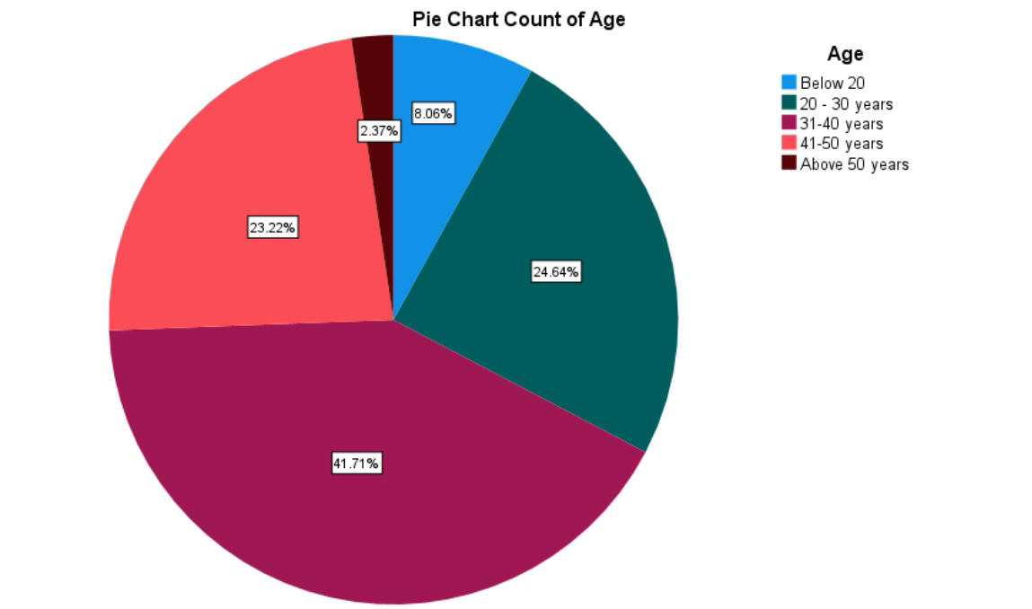

LEGEND:
Figure 1 shows the distribution of the respondents of age .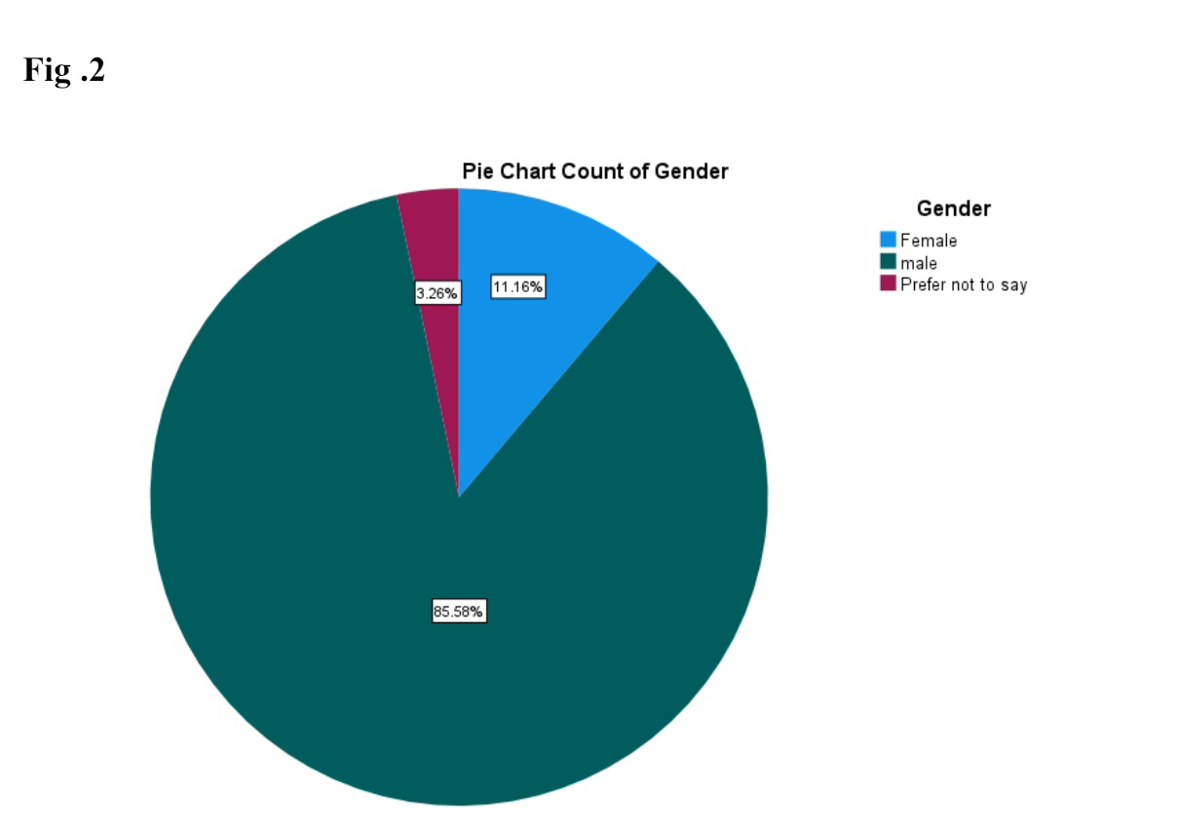

LEGEND:

Figure 2 shows the distribution of the respondents of ‘Gender’.

Fig 3:

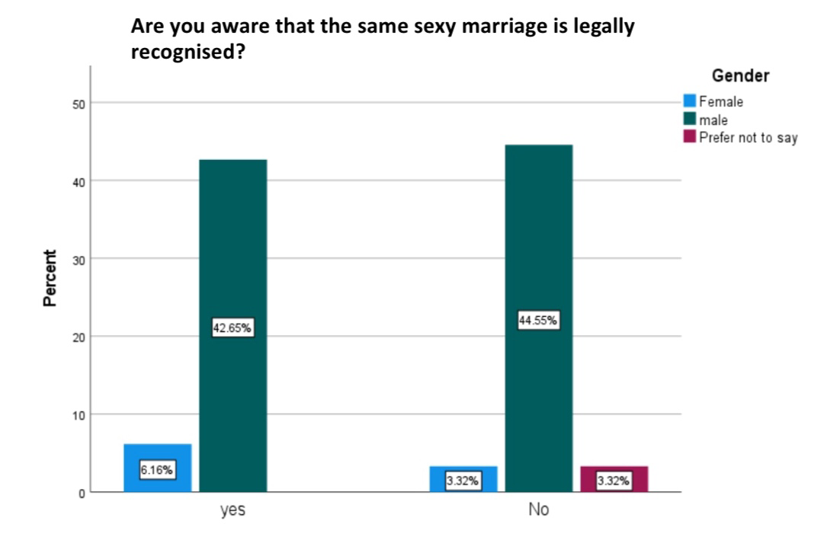

LEGEND:

Figure 5 shows the distribution of the respondents of ‘age’ and people’s opinion on whether same sex marriage is legally recognised.

Fig 4:
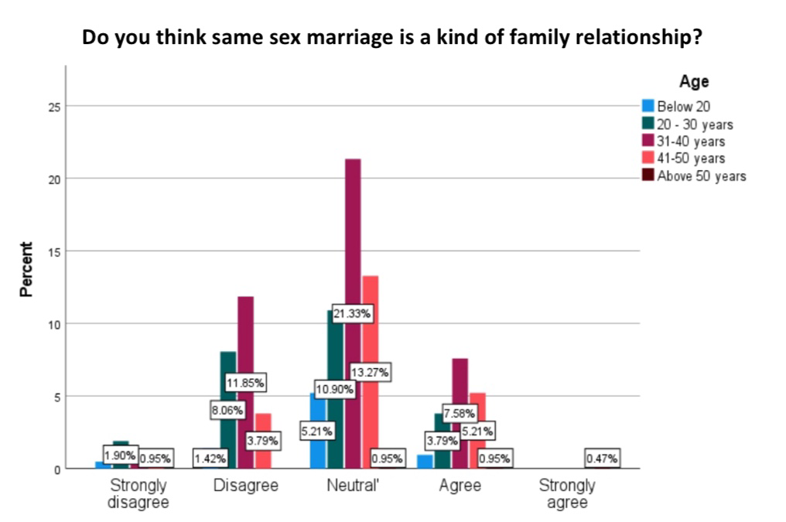

LEGEND:
Figure 3 shows the distribution of the respondents of ‘age’ and people’s opinion on whether same sex marriage is a kind of family relationship.

Fig 5:

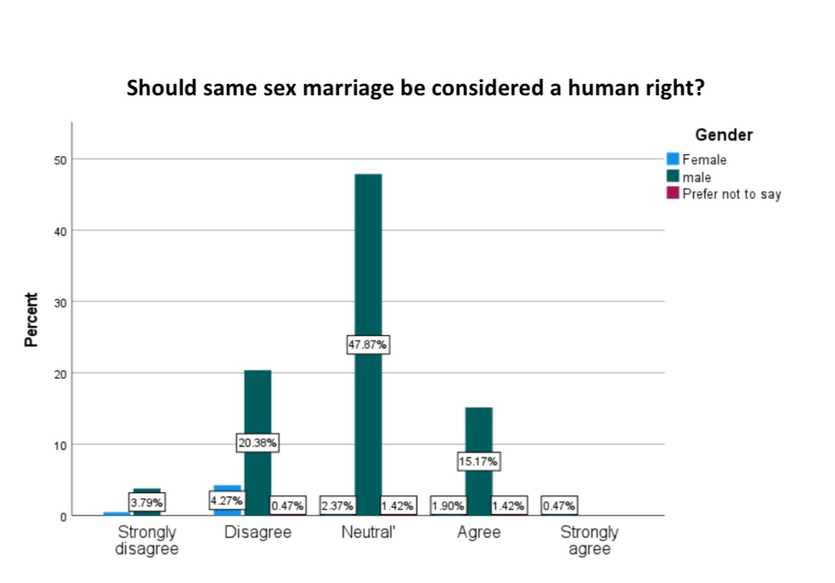

LEGEND:

Figure 3 shows the distribution of the respondents of ‘Gender’and people’s opinion on whether same sex marriage should be considered a human right.

Fig 6:

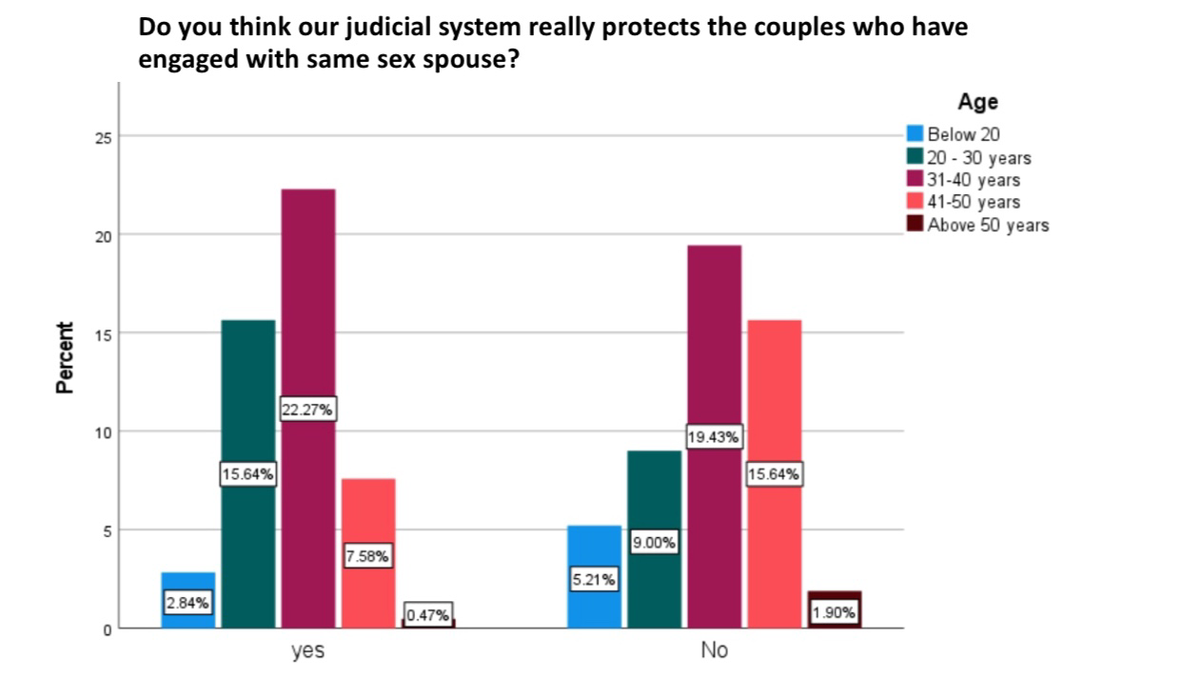
LEGEND:

Figure 5 shows the distribution of the respondents of ‘age’ and people’s opinion on whether our judicial system really protects the couples who have engaged with same sex spouse.

RESULT:

Fig 1 graph representing the age of the respondenders.41.71% of the responses were given by 31-40 years of age group people. Fig 2 represents the gender. Males have responses more when compared to female. Fig 3 carrying the question whether people is aware the same sex marriage is legally recognised.Majority of the people have responded No for this question. Fig 4 representing the question whether same sex marriage is a kind of family relationship .31-40 years of age group people have majorly responded neutral for this question. Fig 6 This graph carries the question people’s opinion on whether our judicial system really protecting the rights of the people who have engaged with same sex spouse,by gender.Majority of the people have responded neutral for this point. Male have responded more when compared to female.Fig 5 carries the question people’s opinion on whether same sex marriage need to be considered as a human right,by age. 31-40 years of age group people majorly responded neutral for this point.

DISCUSSION:

Fig 1 graph representing the age of the respondenders.41.71% of the responses were given by 31-40 years of age group people and 24.64% of the responses were given by 21-30 years of age group people. Fig 2 represents the gender. Males have responses more when compared to female. Fig 3 carrying the question whether people is aware the same sex marriage is legally recognised.Majority of the people have responded No for this question.We can see that majority of the people is unaware of the fact that same sex marriage is legally recognised.Fig 4 representing the question whether same sex marriage is a kind of family relationship.31-40 years of age group people have majorly responded neutral for this question. Fig 6 This graph carries the question people’s opinion on whether our judicial system really protecting the rights of the people who have engaged with same sex spouse,by gender.Majority of the people have responded neutral for this point. Male have responded more when compared to female.Fig 5 carries the question people’s opinion on whether same sex marriage need to be considered as a human right,by age. 31-40 years of age group people majorly responded neutral for this point.

SUGGESTION:

Several policies have been made to reduce the suffering of the LGBT communities.Government just needs to focus on execution of these policies and work out hard in alleviating this problem.Separate education may be provided and awareness camp may be conducted.

CONCLUSION:

The right to marry whoever one wishes is an elementary human right Even political rights, like the right to vote, and nearly all other rights enumerated in the Constitution, are secondary to the inalienable human rights to 'life, liberty and the pursuit of happiness' proclaimed in the Declaration of Independence; and to this category the right to home and marriage unquestionably belongs.Fig 1 graph representing the age of the respondenders.41.71% of the responses were given by 31-40 years of age group people and 24.64% of the responses were given by 21-30 years of age group people. Fig 2 represents the gender. Males have responses more when compared to female. Fig 3 carrying the question whether people is aware the same sex marriage is legally recognised.Majority of the people have responded No for this question.We can see that majority of the people is unaware of the fact that same sex marriage is legally recognised.Fig 4 representing the question whether same sex marriage is a kind of family relationship.31-40 years of age group people have majorly responded neutral for this question. Fig 6 This graph carries the question people’s opinion on whether our judicial system really protecting the rights of the people who have engaged with same sex spouse,by gender.Majority of the people have responded neutral for this point. Male have responded more when compared to female.Fig 5 carries the question people’s opinion on whether same sex marriage need to be considered as a human right,by age. 31-40 years of age group people majorly responded neutral for this point.

