SEISMIC ANALYSIS AND RETROFITTING OF BRIDGES BY USING FRAGILITY CURVES
RAJKAMAL D H¹, ASHWINI SATYANARAYANA² ,PRAKASH.P³
¹Student, Department of Civil Engineering, Dayanand Sagar College of Engineering, Shavige Malleshwara Hills, Kumaraswamy Layout, Bengaluru, Karnataka 560078, India
²Assistant Professor, Department of Civil Engineering, Dayanand Sagar College of Engineering, Shavige Malleshwara Hills, Kumaraswamy Layout, Bengaluru, Karnataka 560078, India
³Professor , Department of Civil Engineering, Dayanand Sagar College of Engineering, Shavige Malleshwara Hills, Kumaraswamy Layout, Bengaluru, Karnataka 560078, India

---------------------------------------------------------------------***---------------------------------------------------------------------
Abstract -

Bridges, integral to transportation networks, face significant challenges from seismic events, impacting infrastructure resilience and public safety. This study focuses on developing fragility curves for bridges, providing a quantitative link between ground motion intensity and structural damage probability. Fragility curves offer insights into seismic vulnerability, considering factors like structural design, material properties, and local seismic conditions. The research explores various fragility curve development methods, emphasizing analytical approaches, and details Incremental Dynamic Analysis (IDA) as a vital tool. IDA, a parametric structural analysis, is employed to forecast bridge seismic responses, facilitating the derivation of fragility curves. The methodology guides bridge-specific IDA, involving seismic hazard assessment, structural modeling, and performance metric identification. By systematically evaluating fragility curves and considering retrofitting options, informed decisions can enhance the seismic resilience of bridges, contributing to the broader field of seismic risk assessment and infrastructure resilience.

Key Words: resilience, Incremental Dynamic Analysis, retrofitting.

1.INTRODUCTION

Bridges play a crucial role in the functionality of transportation networks, facilitating the movement of people and goods. However, their susceptibility to seismic events poses significant challenges to infrastructure resilience and public safety. Understanding the seismic vulnerability of bridges is essential for developing effective risk mitigation strategies and ensuring the overall resilience of transportation systems. This study focuses on the development of fragility curves for bridges, a quantitative tool that correlates the probability of structural damage with varying levels of ground motion intensity.

Seismic fragility curves provide valuable insights into how bridges respond to seismic forces, offering a probabilistic assessment of the likelihood of different damage states at varying levels of ground shaking. The development of these curves involves comprehensive analyses that consider factors such as structural design, material properties, and local seismic conditions. By characterizing the vulnerability of bridges through fragility curves, engineers and policymakers can make informed decisions regarding retrofitting, maintenance, and emergency response planning.

The significance of this research lies in its potential to contribute to the broader field of seismic risk assessment and infrastructure resilience. Fragility curves for bridges serve as essential tools for evaluating the potential impact of earthquakes on transportation infrastructure, guiding efforts to enhance the seismic performance of bridges and mitigate the consequences of seismic events. This study seeks to advance our understanding of the seismic vulnerability of bridges, with implications for both current infrastructure and future design considerations in seismically active regions.

FRAGILITY CURVES

Fragility curves are integral tools in earthquake engineering, offering a systematic and quantitative approach to assess the vulnerability of structures under seismic loading. These curves establish a probabilistic link between ground motion intensity and the likelihood of a structure reaching or exceeding specific damage states. Understanding and developing fragility curves is essential for risk assessment, retrofitting strategies, and the creation of resilient structures in seismically active regions.

Types of Fragility Curve Development:
The development of fragility curves involves several methodologies, each tailored to address specific aspects of structural vulnerability. The primary types of fragility curve development include:

- Empirical Fragility Curve: Relies on observed damage data from past earthquakes. Analyzes the correlation between ground motion intensity and observed damage to develop a probabilistic model.

- Analytical Fragility Curve: Utilizes mathematical models and simulations to predict structural behavior under seismic forces. Incorporates structural analysis, material properties, and seismic input to estimate the likelihood of damage states.

- Hybrid Fragility Curve: Combines empirical data and analytical modeling. Integrates observed damage data with simulation results to enhance the accuracy and reliability of the fragility curve.

- Scenario-Based Fragility Curve: Focuses on hypothetical seismic scenarios based on various parameters. Evaluates the structural response under different seismic events to create a range of fragility curves.

- Component-Based Fragility Curve: Concentrates on the vulnerability of specific structural components. Analyzes the probability of failure for individual elements, such as beams, columns, or connections.
The choice of fragility curve development depends on factors such as data availability, the level of structural understanding, and the intended application. The integration of these diverse approaches contributes to a more comprehensive understanding of seismic risk, allowing for informed decision-making in the design, retrofitting, and management of structures in earthquake-prone areas.

ANALYTICAL FRAGILITY CURVES

Analytical fragility curves in earthquake engineering encompass diverse methodologies, each providing a unique approach to predicting structures' vulnerability to seismic forces. Probabilistic analytical fragility curves employ statistical techniques, such as Monte Carlo simulations, to account for uncertainties in material properties, structural parameters, and ground motion inputs. Conversely, deterministic analytical fragility curves rely on deterministic structural analyses, offering a more fixed prediction of structural performance by neglecting uncertainties.

Pushover-based analytical fragility curves extract fragility information from nonlinear static pushover analyses. These curves evaluate lateral load versus lateral displacement, estimating the probability of exceeding predefined damage states. Time-history-based analytical fragility curves utilize dynamic analysis, simulating a structure's response under various earthquake ground motion records to capture the dynamic nature of seismic loading. Nonlinear dynamic analytical fragility curves employ advanced methods to model the full spectrum of structural response, encompassing elastic to inelastic behavior.

Spectral-based and capacity spectrum method-based analytical fragility curves leverage spectral analysis and the capacity spectrum method, respectively. These approaches assess vulnerability at different frequencies and estimate fragility based on scaled ground motion intensity. The selection of an analytical fragility curve hinges on factors such as available data, desired accuracy, and the complexity of the structural system, each contributing to a nuanced understanding of structural vulnerability to seismic events.

Incremental Dynamic Analysis (IDA) can be employed to develop analytical fragility curves. IDA is a powerful method used to assess the seismic performance of structures by subjecting them to a series of incremental ground motion intensities. This process involves nonlinear dynamic analysis at each intensity level, allowing for a comprehensive evaluation of a structure's behavior under various seismic conditions.

INCREMENTAL DYNAMIC ANALYSIS

To construct an analytical fragility curve, Incremental Dynamic Analysis (IDA) is essential. IDA, as a parametric structural analysis method, is designed to forecast the seismic response of structures subjected to intense ground motion. It evaluates limit-state capacity and seismic demand through a series of nonlinear time history analyses using a diverse set of scaled ground motion records. The chosen ground motion intensity, utilized to assess seismic capacity, is incrementally increased until the structural capacity reaches global collapse.

According to Vamvatsikos (2002), IDA holds significant potential and extends beyond being merely a solution for performance-based earthquake engineering. In essence, it has the capability to provide more accurate predictions about structural behavior under seismic loads to researchers. The IDA method builds upon the traditional concept of scaling ground motion records, evolving it into a precise means of describing the complete spectrum of structural behavior, ranging from elasticity to collapse.

IDA serves as a widely applicable method and a versatile tool for evaluating structural performance, offering accurate predictions of structural responses across a broad range of intensities.

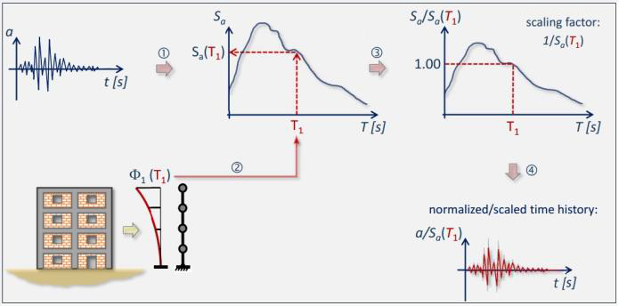

IDA – Procedure

IDA stands out as a widely recognized approach for assessing the structural performance across a range of seismic ground motions. Through a sequence of nonlinear time history analyses using multiple scaled accelerogram records of earthquake ground motion acceleration, IDA can estimate both limit-state capacity and seismic demand. This method involves incrementally increasing the intensity of the chosen ground motion until the intended limit-state seismic capacity of the entire structural system is attained.

Furthermore, the IDA process entails plotting an intensity measure (such as first mode spectral acceleration) against a damage measure, typically the maximum inter-story drift ratio. Additionally, IDA allows for the derivation of fragility curves, illustrating the anticipated damage concerning Collapse Prevention, Life Safety, and immediate occupancy based on the selected ground motion intensity.

RETROFITTING TECHNIQES FOR BRIDGES

Various retrofitting techniques are available to enhance the seismic resilience of bridges. Base isolation involves inserting isolators to minimize seismic forces, while supplemental damping devices like viscous dampers dissipate seismic energy. Strengthening structural components through methods such as column jackets, shear reinforcement, and external braces enhances the bridge's overall strength and ductility. Pile retrofitting strengthens foundations, and seismic bracing improves lateral stiffness. Fluid viscous dampers and rocking piers absorb and redistribute seismic forces. Preventive maintenance, monitoring, and innovative materials, including high-performance concrete and composites, contribute to long-term resilience. A comprehensive approach often combines these techniques based on the specific characteristics and vulnerabilities of the bridge in question. The selection process considers factors like budget, structural conditions, and desired performance levels.

METHODOLOGY

Developing an analytical fragility curve for bridges using Incremental Dynamic Analysis (IDA) involves specific considerations for the unique characteristics of bridge structures. Here is a methodology tailored to bridge applications:

- Bridge Structural Modeling:

Develop a detailed and realistic finite element model of the bridge, considering factors such as geometry, material properties, support conditions, and the presence of any seismic retrofitting or damping devices.
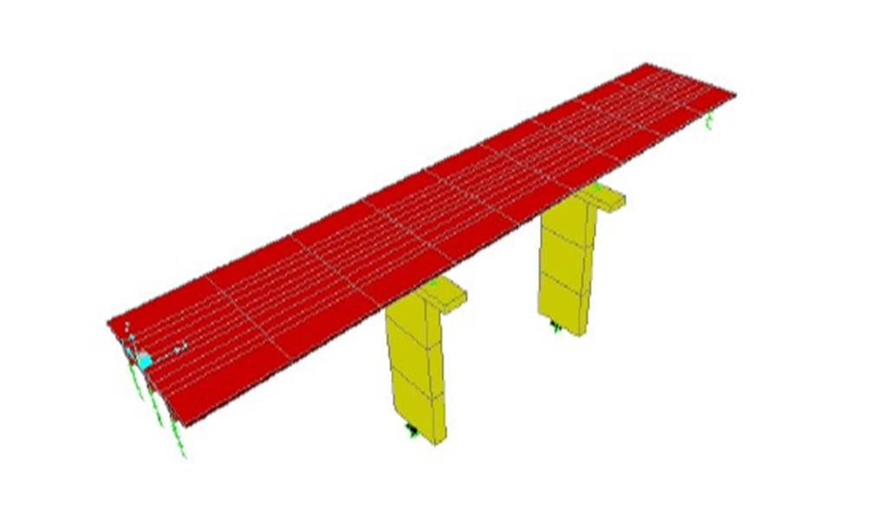
Bridge structural model

- Seismic Hazard Assessment:

Conduct a thorough seismic hazard assessment for the region of interest. Select a representative suite of ground motion records considering local seismicity and site-specific conditions.

- Selection of Bridge Performance Metrics:

Identify and define appropriate performance metrics for bridge structures. These may include maximum deck displacement, column rotations, hinge formation, or other relevant measures specific to bridge behavior.

- Incremental Dynamic Analysis (IDA):

Perform a series of nonlinear time history analyses using the selected ground motion records. Incrementally increase the intensity of ground motions until the bridge reaches predefined limit states, such as structural damage or failure.

- Response and Damage Assessment:

Extract and analyze the structural response at each intensity level, focusing on the selected performance metrics for bridges. Capture critical information such as deck movements, bearing displacements, and pier rotations.

- Plotting Intensity Measures vs. Damage Measures:

Plot the chosen intensity measures (e.g., spectral acceleration) against the selected damage measures specific to bridge components. This graphical representation helps illustrate the relationship between ground motion intensity and bridge response.

- Derive Bridge Fragility Curves:

Utilize the analysis results to derive fragility curves for the bridge. These curves should depict the probability of exceeding predefined damage states at different levels of ground motion intensity.

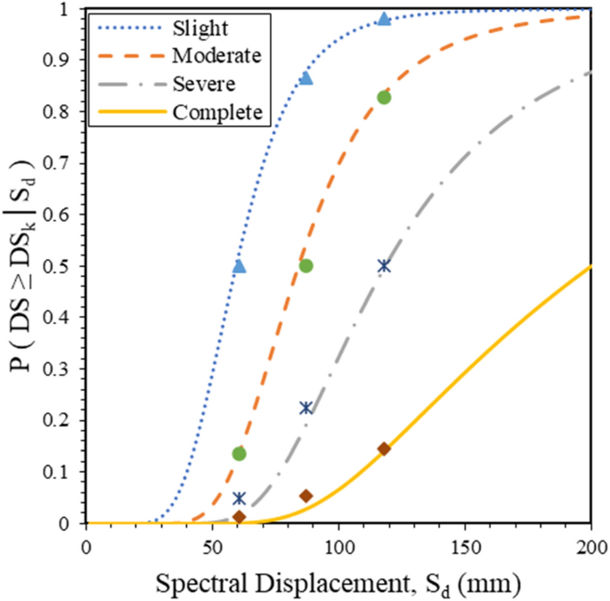

- Understand Bridge Vulnerabilities:

Analyze the fragility curves to identify the vulnerabilities of the bridge under different seismic intensity levels. Look for critical damage states and components that are most susceptible to seismic actions.

- Identify Desired Performance Levels:

Determine the desired performance levels for the bridge. These could include targets for preventing collapse, ensuring life safety, or maintaining functionality under various seismic scenarios.

- Review Retrofitting Techniques:

Investigate available retrofitting techniques that are applicable to bridge structures. Common retrofit methods include base isolation, adding supplemental damping devices, strengthening components, and implementing advanced materials.

- Evaluate Retrofit Effectiveness:

Use engineering judgment and available literature to assess the effectiveness of each retrofitting technique in addressing the vulnerabilities identified in the fragility curves. Consider factors such as cost, constructability, and potential impacts on bridge aesthetics and functionality.

- Conduct Cost-Benefit Analysis:

Perform a cost-benefit analysis for each retrofitting option. Consider the upfront costs, maintenance requirements, and potential reduction in seismic risk and damage. Evaluate whether the cost of retrofitting is justified by the expected improvement in performance.

- Consider Practicality and Implementation:

Evaluate the practicality of implementing each retrofitting technique considering the bridge's design, construction, and operational constraints. Some retrofit measures may be more suitable for specific types of bridges or construction materials.

- Perform Sensitivity Analyses:

Conduct sensitivity analyses on the fragility curves by applying different retrofitting scenarios. Assess how each retrofitting technique influences the bridge's performance and whether there are uncertainties in the predictions.

- Consult with Experts:

Seek input from structural engineering experts, especially those with experience in bridge retrofitting. Their expertise can provide valuable insights into the feasibility and effectiveness of different retrofitting options.

- Prioritize Retrofit Strategies:

Prioritize retrofitting strategies based on their effectiveness in achieving the desired performance levels, cost considerations, and practicality of implementation.

- Develop Retrofitting Plan:

Based on the evaluation, select the most suitable retrofitting technique or combination of techniques. Develop a comprehensive retrofitting plan that includes detailed design specifications, construction methods, and quality control measures.

- Monitor and Update:
Implement the chosen retrofitting strategy and monitor the bridge's performance over time. Regularly update the fragility curves based on observed performance and adjust the retrofitting plan as needed.

By systematically evaluating fragility curves and considering a range of retrofitting options, we can make informed decisions about the most effective and practical strategies to enhance the seismic resilience of a bridge structure.

- CONCLUSIONS

In conclusion, the development of fragility curves for bridges, particularly through the application of Incremental Dynamic Analysis (IDA), emerges as a crucial component in enhancing seismic resilience. The study emphasizes the significance of understanding how bridges respond to seismic forces through probabilistic assessments, offering valuable insights into potential damage states. Analytical fragility curves, utilizing methodologies such as Monte Carlo simulations, deterministic analyses, and Incremental Dynamic Analysis, play a pivotal role in this process. Furthermore, the comprehensive methodology outlined for bridge-specific IDA involves seismic hazard assessment, bridge structural modeling, performance metric identification, and damage assessment. By systematically deriving fragility curves and evaluating vulnerabilities, engineers and policymakers can then prioritize and implement retrofitting techniques tailored to specific bridge characteristics. This proactive approach, grounded in a thorough understanding of seismic risk, contributes to the long-term resilience of transportation infrastructure in seismically active regions.

REFERENCES

- Ghazal, H.; Mwafy, A.Seismic Fragility Assessment of an Existing Multi-Span RC Bridge Equipped with Risk Mitigation Systems. Buildings 2022, 12, 982.https://doi.org/10.3390/ buildings12070982

- Ehsan Omranian Adel Abdelnab, Gholamreza Abdollahzadeh, Mehdi Rostamian and Farid Hosseinpour, "Fragility Curve Development for the Seismic Vulnerability Assessment of Retrofitted RC Bridges under Mainshock-Aftershock Seismic Sequences" Structures Congress 2018

- Sotiria P. Stefanidou, Anastasios G. Sextos , Anastasios N. Kotsoglou , Nikolaos Lesgidis , Andreas J. Kappos,"Soil-structure interaction effects in analysis of seismic fragility of bridges using an intensity-based ground motion selectionprocedure",Engineering Structures 151 (2017) 366–380.

- Sopna S Nair,Sopna S Nair and Dr. P Muthupriya,"Vulnerability Assessment Using Fragility Curves", International Journal of Applied Engineering Research ISSN 0973-4562 Volume 12, Number 9 (2017) pp. 1867-1873.

- Jamie E. Padgett, Reginald DesRoches, "Methodology for the development of analytical fragility curves for retrofitted bridges",journal of the international association of earthquake engineering Volume37, Issue8 10 July 2008 1157-1174

- Skokandi ́c, D.; Vlaši ́c, A.; Kušter Mari ́c, M.; Srbi ́c, M.; Mandi ́c Ivankovi ́c, A. Seismic Assessment and Retrofitting of Existing Road Bridges: State of the Art Review. Materials 2022, 15, 2523. https:// doi.org/10.3390/ma15072523

- Shawn Parks, Mijia Yang, Sivapalan Gajan and Qiang Pei,"Strength-based differential tolerable settlement limits of bridges",Advances in Structural Engineering 1–13 The Author(s) 2017 DOI: 10.1177/1369433217706779

- Alessandra De Angelis, Michele Mucciacciaro, Maria Rosaria Pecce and Stefania Sica,"Influence of SSI on the Stiffness of Bridge Systems Founded on Caissons",analyses. DOI: 10.1061/(ASCE)BE.1943-5592.0001073. © 2017 American Society of Civil Engineers.

- Murat DICLELI , Jung -Yoon LEE and Mohamad MANSOUR,"IMPORTANCE OF SOIL-BRIDGE INTERACTION MODELING IN SEISMIC ANALYSIS OF SEISMIC-ISOLATED BRIDGES",13th World Conference on Earthquake Engineering Vancouver, B.C., Canada August 1-6, 2004 Paper No. 3147

- Shinozuka, M., Kim, SH., Kushiyama, S. et al. Fragility curves of concrete bridges retrofitted by column jacketing. Earthq. Engin. Engin. Vib. 1, 195–205 (2002). https://doi.org/10.1007/s11803-002-0065-2

