Billboard Advertising
VIDHI MISHRA¹, KANIKA SHARMA²

[1] Student, Communication Design, ATLAS SkillTech University, Mumbai, Maharashtra, India.
[2] Assistant Professor, Communication Design Department, ATLAS SkillTech University, Mumbai, Maharashtra, India.
------------------------------------------------------------***-----------------------------------------------------------------

- Abstract
This research explores the multifaceted dynamics of billboard advertising as a powerful tool for marketing campaigns. Billboards, large-scale print advertisements strategically positioned in high traffic areas, are examined through various lenses to uncover their demographic impact, impressions on viewers, marketing potential, creative expression opportunities, societal reflections, environmental concerns, and the importance of targeting a specific audience. The study delves into critical factors such as location, message clarity, and design in determining the effectiveness of billboard advertising. Insights from the research highlight that billboard advertising can significantly increase brand awareness, with case studies illustrating successful strategies. The study also emphasizes the importance of creative design and clear messaging to maximize the impact of billboard campaigns. The proposed outcomes suggest that billboard advertising can enhance brand image, increase social media engagement, and provide a favourable return on investment. In conclusion, effective billboard advertising relies on a harmonious blend of compelling content and captivating design to create a lasting impression and drive consumer action.
- Introduction:
Billboard advertising is the process of using a large-scale print advertisement to market a company, brand, product, service, or campaign. Billboards are typically placed in high traffic areas, such as along highways and in cities, so they are seen by the highest number of drivers and pedestrians.
Billboard advertising is effective for building brand awareness and broadcasting your business (or product or campaign) to as many people as possible. Because they are in such busy areas, billboards tend to have the highest number of views and impressions when compared to other marketing methods.

- Lenses:
- Demographics: refer to the age, gender, income level, and other characteristics of the traffic that passes the billboard. This information is gathered from travel surveys and local transportation authorities.

- Impressions: Are the number of people who see the billboard. This information is calculated based on the billboard’s circulation, the size of the billboard, how close it is from the road, its visibility, the speed at which traffic is passing by, and more.

- Marketing: From a marketing perspective, billboards are a way to reach a large audience with a message or advertisement. Advertisers may use billboards to create brand awareness, promote a product or service, or drive traffic to a physical or online store. The effectiveness of a billboard campaign is often measured in terms of impressions (the number of people who see the billboard) and engagement (the number of people who take action after seeing the billboard).

- Creative: Billboards are a unique canvas for creative expression. Because they are large, visually striking, and often placed in high-traffic areas, billboards offer a powerful platform for graphic designers, illustrators, and other artists to showcase their work. A well-designed billboard can capture the attention of passes by and create a memorable impression.

- Societal: Billboards can also be viewed through a societal lens, as they reflect the values and priorities of the communities in which they are placed. Some billboards may be controversial or spark debate about issues such as social justice, politics, or public health. Others may serve as landmarks or cultural touchstones, reminding people of shared experiences or important events.

- Environmental: From an environmental perspective, billboards can be seen as a form of visual pollution. They can detract from the natural beauty of a landscape, and some argue that they contribute to distracted driving and other safety hazards. In response to these concerns, some cities and states have implemented regulations on the size, placement, and content of billboards.

- Location: The location of a billboard is critical to its effectiveness. Ideally, a billboard should be placed in a high-traffic area where it will be seen by as many people as possible. Factors to consider include the proximity to major highways, public transportation, and popular destinations like shopping centers or tourist attractions.

- Message: A billboard should convey a clear and concise message that can be understood quickly by people driving by. It is important to use simple language, eye-catching visuals, and a memorable tagline or call to action.

- Design: The design of a billboard should be visually striking and attention-grabbing. Bright colors, bold fonts, and high-quality images are all effective techniques for creating a memorable billboard. However, it is important to balance creativity with clarity and simplicity to ensure that the message is not lost in the design.
Research Question: How effective is billboard advertising in increasing brand awareness?
Target Audience: The target audience for billboard advertising can vary depending on the product, service, or message being promoted. However, in general, billboard advertising tends to be most effective when targeting a large and diverse audience that is likely to see the billboard while travelling. People between the ages of 18-50 who are active and enjoy socializing. Parents with children who are traveling or commuting to and from school and professionals who are traveling for work or commuting to and from their office.
- Primary Research:
For my primary research, I conducted a survey via. Google forms to understand the effectiveness of billboard advertising.
https://forms.gle/iddbigXusAw7Gt769
The questions I asked:
- Have you seen a billboard advertisement?
- If yes, where did you see the billboard?
- Do you remember what product, service, or brand the billboard was promoting?
- In billboards, do you think less is more?
- On a scale of 1-5, how eye-catching or memorable was the billboard?
- What aspect of the billboard was eye catching?
- Did the billboard increase your awareness or interest in the advertised product, service, or brand?
- Did you take any action after seeing the billboard? (e.g. visited a website, made a purchase, etc.)
- If you did take action, what motivated you to do so? (e.g. a compelling message, a special offer, design etc.)
- Do you think billboard advertising is an effective way to promote products, services, or brands? Why or why not?
- What do you like about this billboard?
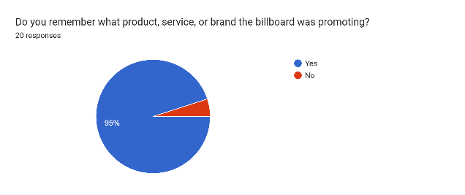
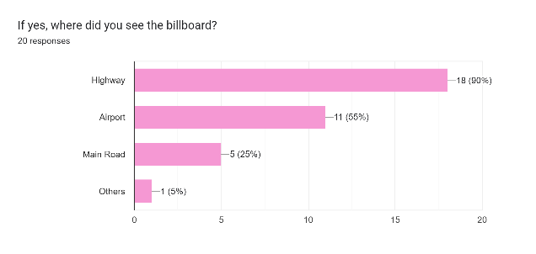
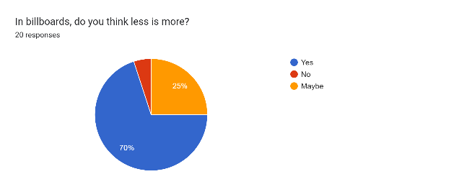
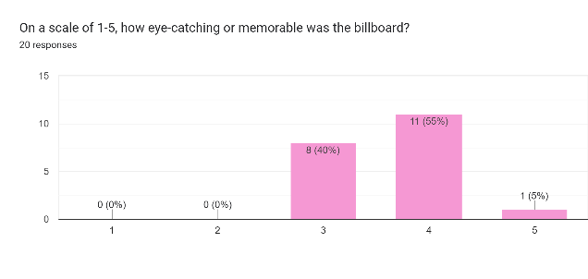
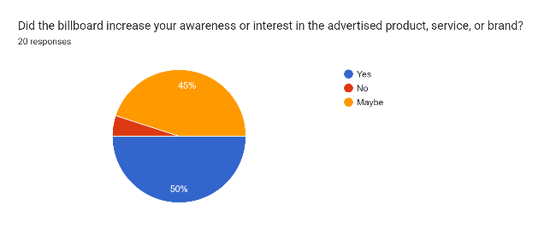
Following the feedback received, it becomes evident that a majority of individuals have encountered billboards on the highway and can recall the brand being promoted. For them, the visual design stood out more than the content, leading to heightened awareness of respondents visited the website with the intention of making a purchase. The combination of a compelling message, enticing offer, and impactful design played a pivotal role in motivating them to buy. Based on these responses, it can be inferred that billboard advertising proves to be an effective means of promoting products, services, and brands, given its broad reach and capacity to engage a diverse audience.

- Secondary Research: After studying the case studies
Coca-Cola's "Share a Coke" Campaign
A popular brand that has been around for more than a century is Coca-Cola. In order, to encourage customers to buy personalized Coca-Cola bottles and share them with friends and family, Coca-Cola launched its "Share a Coke" campaign in 2011. The worldwide campaign, which included the United States, Australia, and the United Kingdom, was a huge success and was launched.
The "Share a Coke" campaign's use of billboard advertising was one of its primary components. Coca-Cola displayed customized bottles with various names on them on billboards to advertise the promotion. The phrase "Have a Coke with..." were written on the billboards. This tailored strategy assisted in capturing customers' interest and motivating them to interact with the business.
Billboard advertisements were thoughtfully positioned in big city centers and well-travelled tourist locations. As a result, the campaign received the most attention and reached the largest possible audience. Coca-Cola additionally urged customers via social media to post images of their customized bottles online with the hashtag #shareacoke. This increased the campaign's visibility and helped create talk about it.
Finally, Coca-"Share Cola's a Coke" marketing initiative is a superb illustration of how hoarding advertising may be employed to develop an effective marketing strategy. Coca-Cola was able to engage consumers and create discussion around the campaign by placing customized billboards in high-traffic areas and utilizing social media. This led to an increase in sales and brand awareness.
Amul’s Outdoor Advertising Campaign
Amul is a well-liked dairy brand in India that is renowned for its premium goods and creative marketing strategies. Amul started a hoarding campaign in Mumbai, India's largest city, in 2019 to advertise their selection of ice creams.
The campaign was unique in that it used billboards to showcase the brand's wide range of ice cream flavors in a fun and creative way. The billboards featured colorful and eye-catching illustrations of different ice cream flavors, accompanied by catchy taglines that highlighted the taste and quality of the products.
To provide maximum exposure to the intended population, the billboards were carefully positioned in high-traffic areas including busy intersections and highways. A robust social media presence was also used to support the campaign, with Amul urging users to post images of themselves enjoying the company's ice cream products online with the hashtag #AmulIceCream.
The campaign was a huge success, with Amul reporting a significant increase in sales of its ice cream products in Mumbai. The brand was also awarded various advertising awards for the campaign, including a Gold Lion at the Cannes Lions International Festival of Creativity.
In conclusion, Amul's billboard campaign is a great example of how outdoor advertising can be used to promote a product in India. By using creative and eye-catching visuals, and leveraging social media, Amul was able to engage customers and increase sales of its ice cream products in Mumbai.
McDonald’s Outdoor Advertising Campaign
A well-known fast-food chain in India, McDonald's is renowned for its creative marketing strategies. In Mumbai, India's largest city, McDonald's started a hoarding advertising campaign in 2017.
The advertising campaign included eye-catching billboards to display the brand's well-liked burger menu. The billboards included images of several burgers that were larger than life, along with catchy taglines that emphasized the flavor and caliber of the goods.
To provide maximum exposure to the intended population, the billboards were carefully positioned in high-traffic areas including busy intersections and highways. Strong social media support for the campaign was provided by McDonald's, which urged customers to post images of themselves enjoying the company's burgers online with the hashtag #McDonaldsIndia.
As a result of the promotion, McDonald's reported a large boost in burger sales in Mumbai. With the campaign, the company also received several advertising honors, including a Gold Lion at the Cannes Lions International Festival of Creativity.
Amazon Prime Video’s Outdoor Advertising Campaign
In India, Amazon Prime Video is a well-liked streaming service that is renowned for its excellent content and creative marketing strategies. In Mumbai, India's largest city, Amazon Prime Video started a hoarding campaign to advertise its original series "Mirzapur."
In a unique and striking approach, the campaign employed billboards to highlight the rough and intense tone of the series. The characters from the programmed were depicted in stark black and white on the billboards, and the taglines emphasized the dark and violent themes of the drama.
The billboards were strategically placed in high-traffic areas, such as busy intersections and highways, to ensure maximum exposure to the target audience. The campaign was also supported by a strong social media presence, with Amazon Prime Video encouraging customers to share pictures of themselves watching the series on social media using the hashtag #MirzapurOnPrime.
The campaign was a huge success, with Amazon Prime Video reporting a significant increase in subscriptions and views of the "Mirzapur" series in India. The brand was also awarded various advertising awards for the campaign, including a Gold at the Outdoor Advertising Awards.
In conclusion, these case studies showcase how billboard advertising can be used effectively to promote different products and services in India. By using creative and eye-catching visuals, and leveraging social media, brands can engage customers and increase sales of their products and services.
- Research Insights
Billboards can draw in lookers' attention. 71% of people frequently glance at the advertisements on billboards along the highway. Billboards can be strategically placed in locations where the target audience is likely to be found. For example, billboards advertising luxury cars are often placed in affluent areas. Because they have a wide audience and are visible to many people, billboards can be an inexpensive form of advertising.
The efficacy of the boards depends on its creative design. According to research by the Outdoor Advertising Association of America, using contrasting colors and big, strong letters made it more likely that the message will stick in readers' minds.
While billboards can draw attention, there is a limited amount of interaction time because most people pass them fast. Because of this, the message must be clear and precise.
Billboard advertising can be an effective way to create brand awareness and reach a broad audience. However, it is essential to consider factors such as location, design, and message to ensure maximum impact.
- Proposed Outcome
Brand awareness: Thanks to billboards' ability to quickly and widely reach a huge number of individuals. People are more likely to recall a brand after seeing a well-designed hoarding with an engaging message.
Brand image improvement: By showing the company in a favorable manner, billboards can aid in brand image improvement. Customers may be more loyal to a company if they see a hoarding that supports social causes or emphasizes its environmental commitment.
Improved social media involvement: By encouraging people to take pictures of billboards and post them on social media sites, billboards can increase social media engagement. This may broaden the campaign's audience and improve brand awareness.
Increased ROI: When compared to other forms of advertising like TV, radio, or print ads, billboards can offer a high ROI. A well-designed hoarding can reach a huge number of people for a relatively low cost, making it an efficient advertising alternative for small enterprises.
Overall, the potential outcomes of billboard advertising can be positive if executed effectively. It is important for brands to carefully plan and execute their billboard campaigns to ensure maximum impact and return on investment.
- Conclusion
According to me, content and design are important in creating an effective billboard advertisement. The design should be eye-catching and visually appealing, while the content should be concise, clear, and tailored to the target audience. A well-designed billboard with poor content, or a poorly designed billboard with great content, will likely fail to achieve its intended purpose. Billboards can increase brand awareness by reaching, a large number of people in a short amount of time. A well-designed billboard with a catchy message can leave a lasting impression on people and help them remember the brand. Billboard advertising is to create a memorable impression in the minds of potential customers and drive them to act.
When used properly, billboard advertising can be a powerful marketing technique for companies wanting to build interest in their products, raise brand awareness, and change consumer behavior. The layout and messaging of the board, its position, and how long it is up will all have an effect on how effective it is as advertising. The likelihood that customers will remember the commercial and act can be increased by using eye-catching imagery, clear language, and a compelling call-to-action.
- References
https://blog.hubspot.com/marketing/billboard-advertising
https://en.wikipedia.org/wiki/Share_a_Coke
https://www.socialsamosa.com/2021/06/throwback-amul-story-real-milk-real-ice-cream-campaign/
https://saundersoutdoor.com/brand-awareness
https://www.bmediagroup.com/news/outdoor-advertising-analysis/
https://www.digitalvidya.com/blog/case-study-on-coca-colas-share-a-coke-campaign/
https://www.marketing91.com/marketing-mix-of-amul-ice-cream/
https://trak.in/tags/business/2010/08/21/mcdonalds-ooh-advertising-campaign/
https://www.financialexpress.com/industry/ott-players-hog-hoardings-netflix-amazon-prime-hotstar-lead-outdoor-ad-spends/1561281/
https://www.livemint.com/companies/news/video-streaming-platforms-return-to-splurge-on-outdoor-advertising-11655316236906.html

