IOT BASED WATER LEVEL CONTROLLER
Mr.Gawali S.M¹, Mr.Swami M.V.², Miss.Kulkarni R.R.³
M.Tech ECE¹, ME VLSI&ESY², Diploma E&TC³
Lecturer Electronics & Telecommunication Department
Vishweshwaryya Polytechnic Dilip Nagar Almala, Maharashtra, India

Abstract:
The objective of the project is to measure the level of water in the tank and notify the user about the water level through
LCD display. This not only helps to keep the tank full but also making it more convenient for our day-to-day chores and also avoiding
Water wastage.

Keywords: LCD Display, Ultrasonic Sensor, Arduino, Pump, Relay Switch, Microcontroller.

INDRODUCTION

In relation with the current framework with so much work and too less time to spare, it is very difficult to keep in touch with the water level in the tanks. Water is essential in every hour of our lives. Hardly anyone keeps in track of the level of water in the overhead tanks.
In this project, the water is being measured by using ultrasonic sensors. Initially, the tank is considered to be empty. When the sound waves are transmitted in the environment, they are reflected back as ECHO.
The motor pump is automatically turned ON when the water level becomes low and turned OFF when the tank is full. Automatic water level monitoring system uses network of things i.e. this model uses its own local area network to maintain communication between the nodes Microcontrollers calculate and make decisions based on the program given by the developer.
In this model we are going to use an Arduino as a microcontroller. Arduino is a very minute part of embedded systems; in fact you can call it as an application product of embedded system. Arduino is
Just any other microcontroller board, with a specifically designed API and software which makes programming it very easy. Arduino is just a drop of water in Embedded System Ocean.

BLOCK DIAGRAM:

- POWER SUPPLY:-
Circuit requires 5V DC for LCD module, arduino uno
Board, GSM modem and GPS required 12V. This power supply can be provided 12V transformer to charge 12V battery with rectifier, filter, with regulator of 5V.
ARDUINO UNO BOARD here we using arduino board for only programming purpose, we have implemented this project using atmega328 microcontroller.

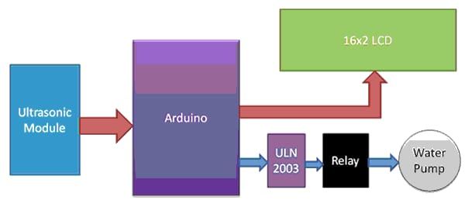

FIGURE.1. BLOCK DIAGRAM

POWER (USB / BARREL JACK)
Every Arduino board needs a way to be connected to a power source. The Arduino UNO can be powered from a USB cable coming from your computer or a wall power supply (like this) that is terminated in a barrel jack. In the picture above the USB connection is labeled (1) and the barrel jack is labeled. The USB connection is also how you will load code onto your Arduino board.

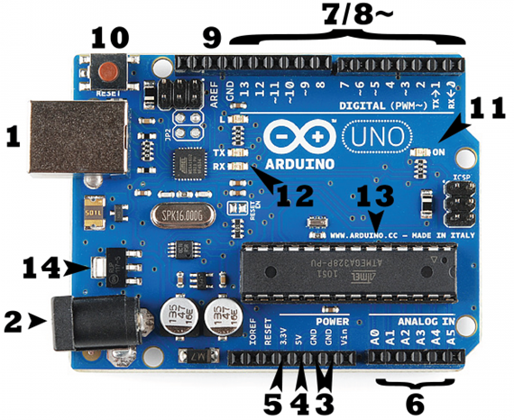

- PINS (5V, 3.3V, GND, ANALOG, DIGITAL, PWM, AREF)
The pins on your Arduino are the places where you connect wires to construct a circuit (probably in conjunction with a breadboard / PCBs and some wire. They usually have black plastic ‘headers’ that allow you to just plug a wire right into the board. The Arduino has several different kinds of pins, each of which is labeled on the board and used for different functions.
GND (3): Short for ‘Ground’. There are several GND pins on the Arduino, any of which can be used to ground your circuit.
5V (4) & 3.3V (5): As you might guess, the 5V pin supplies 5 volts of power, and the 3.3V pin supplies 3.3 volts of power. Most of the simple components used with the Arduino run happily off of 5 or 3.3 volts.
Analog (6): The area of pins under the ‘Analog In’ label (A0 through A5 on the UNO) are Analog In pins. These pins can read the signal from an analog sensor (like a light sensor) and convert it into a digital value that we can read.
Digital (7): Across from the analog pins are the digital pins (0 through 13 on the UNO). These pins can be used for both digital input (like telling if a button is pushed) and digital output (like powering an LED).
PWM (8): You may have noticed the tilde (~) next to some of the digital pins (3, 5, 6, 9, 10, and 11 on the UNO). These pins act as normal digital pins, but can also be used for something called Pulse-Width Modulation (PWM).
AREF (9): Stands for Analog Reference. Most of the time you can leave this pin alone. It is sometimes used to set an external reference voltage (between 0 and 5 Volts) as the upper limit for the analog input pins.

RESET BUTTON
The Arduino has a reset button (10). Pushing it will temporarily connect the reset pin to ground and restart any code that is loaded on the Arduino. This can be very useful if your code doesn’t repeat, but you want to test it multiple times.

POWER LED INDICATOR

Just beneath and to the right of the word “UNO” on your circuit board, there’s a tiny LED next to the word ‘ON’ (11). This

LED should light up whenever you plug your Arduino into a power source. If this light doesn’t turn on, there’s a good chance something is wrong. Time to re-check your circuit.

TX RX LEDs

TX is short for transmit, RX is short for receive. These markings appear quite a bit in electronics to indicate the pins responsible for serial communication. In our case, there are two places on the Arduino UNO where TX and RX appear – once by digital pins 0 and 1, and a second time next to the TX and RX indicator LEDs (12). These LEDs will give us some nice visual indications whenever our Arduino is receiving or transmitting data (like when we’re loading a new program onto the board).

- LM35 temperature sensor

The LM35 series are precision integrated-circuit temperature sensors, whose output voltage is linearly proportional to the Celsius (Centigrade) temperature. ... The LM35 is rated to operate over a −55˚ to +150˚C temperature range, while the LM35C is rated for a −40˚ to +110˚C range (−10˚ with improved accuracy).

- Ultrasonic Sensor

Technical Specifications
- Power Supply − +5V DC
- Quiescent Current − <2mA
- Working Current − 15mA
- Effectual Angle − <15°
- Ranging Distance − 2cm – 400 cm/1″ – 13ft
- Resolution − 0.3 cm
- Measuring Angle − 30 degree

The HC-SR04 Ultrasonic (US) sensor is a 4 pin module, whose pin names are Vcc, Trigger, Echo and Ground respectively. This sensor is a very popular sensor used in many applications where measuring distance or sensing objects are required. The module has two eyes like projects in the front which forms the Ultrasonic transmitter and Receiver. The sensor works with the simple high school formula that
Distance = Speed × Time
The Ultrasonic transmitter transmits an ultrasonic wave, this wave travels in air and when it gets objected by any material it gets reflected back toward the sensor this reflected wave is observed by the Ultrasonic receiver module as shown in the picture below
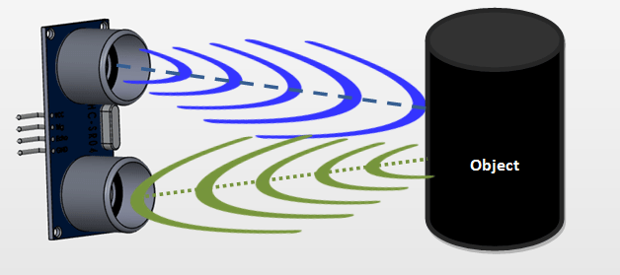
Now, to calculate the distance using the above formulae, we should know the Speed and time. Since we are using the Ultrasonic wave we know the universal speed of US wave at room conditions which is 330m/s. The circuitry inbuilt on the module will calculate the time taken for the US wave to come back and turns on the echo pin high for that same particular amount of time, this way we can also know the time taken. Now simply calculate the distance using a microcontroller or microprocessor.

- DASH SENSOR

Here Dash sensor detect, dash. Dash detected output is given to microcontroller to detect and takes further action.

- GSM MODEM

A GSM modem is a specialized type of modem which accepts a SIM card, and operates over a subscription to a mobile operator, just like a mobile phone. From the mobile operator perspective, a GSM modem looks just like a mobile phone.
GSM Modem comes in interfaces like USB, and Serial. GSM
Modem is however the main difference is that GSM Modem
is wireless, while dial-up modem is wired (telephone previously).
GSM is used here to interface with microcontroller and
Microcontroller command to the GSM modem with AT
(Abbreviation of Attention) command set implemented in our program. If Voltage difference in microcontroller and GSM modem voltage level shifter IC required using.

LED indicators connected to the operation are working now, as like LED RED for vehicle stop, LED green for vehicle on.

- GPS MODEM

A GPS modem is a specialized type of modem which detects location from satellite directly with longitude and latitude coded format.
GPS Modem comes in interfaces like USB, and Serial. GPS Modem is However global positioning system.
GPS is used here to interface with microcontroller and microcontroller command to the GPS modem with AT (abbreviation of Attention) command set implemented in our program. If voltage difference in microcontroller and GPS modem voltage level shifter IC required using.
As switch is pressed, location along longitude and latitude find out and SMS sending done over GSM to the stored mobile numbers.

- LCD DISPLAY
LCD (Liquid Crystal Display) screen is an electronic display module and find a wide range of applications. A 16x2 LCD display is very basic module and is very commonly used in various devices and circuits. These modules are preferred over seven segments and other multi segment LEDs. The reasons being: LCDs are economical; easily programmable; have no limitation of displaying special & even custom characters (unlike in seven segments), animations and so on.
A 16x2 LCD means it can display 16 characters per line and there are 2 such lines. In this LCD each character is displayed in 5x7 pixel matrix. This LCD has two registers, namely, Command and Data.

WORKING:
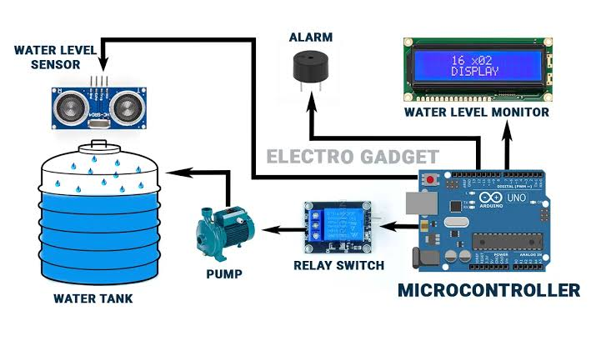

FIGURE.2. CIRCUIT DIAGRAM

Here circuit requires 5V and 12V regulated DC supply. We used here 230V to 12V-0-12V step down transformer. The output AC of transformer 12V is rectified by center tap rectifier. Rectified output is pulsating it is pure by the capacitor filter of 1000uf 25V. Now the out of capacitor is DC 12V-15V to charge the battery according to transformer ratings given to the arduino board, which is required

to convert in 5V regulated for microcontroller and other devices, here we have used LM7805 regulator for getting 5V regulated DC. For LCD display.
In this arduino board (microcontroller) works with 16MHz frequency used for (timer configuration), the unwanted frequency produced is bypassed by the capacitor of 27pf capacitor. Reset pin is connected to resistor of 10K whenever reset requires the reset switch (2 lead push to ON switch/ micro push to switch) required to press.
LCD data pins (AD4 to AD7) is connected to the pin 10, pin 11, pin12, pin 13 to send the data for the LCD display. The control pins of LCD display is connected to pin 8, pin 9, respectively take action as RS, E. Variable resistor of 10K (or fixed 2.2K) is connected to the adjust contrast of 16X2 LCD display. 10uf capacitor is used to cancel loading effect and 0.1uf is used to bypass the unwanted spikes produced in the circuit.

According to programming conditions in arduino board, when sensors sense the physical condition microcontroller takes action to get location from GSM and send location to stored mobile number from GSM.

Pin 0 RXD (0) and 1 TXD (1) are serial communication pins used to interface with GPS and GSM modem. This modem has TXD and RXD pins for transmit and receive data or commands serially. Microcontroller (arduino board) works with 5V DC and GPS/ GSM works with same supply so level shifter IC not required to

Communicate each other. In GSM module fast LED blinking notify searching for network connectivity. Slowly blink notify connected with network, now we can transmit SMS with location in longitude and latitude format.
All capacitors of 0.1uf near analog/ digital/ microcontroller ICs are connected to reduce spikes in the circuit, spikes produced by inductive load/ sparking contacts of loads and capacitor of 1000uf/25V at regulator output is connected for the cancel loading effect in the circuit while driving the high current source.

- ADVANTAGES :

- It requires very little maintenance.
- It can show the incitation of water levels in any type of tank.
- It can save electricity and also less water is used to regulate supply.
- Easy Installation with LED Monitoring.
- Reliable Electronic Design.

- APPLICTIONS

- It can be used in large scale to control the water level in dams to prevent flood and other such problems.
- It can be used to control water wastage in the municipality corporation tanks which supply water in a particular area.
- It can widely be used in industrial purposes as well.

- CONCLUSION:

Automation of the various components around us has been widely increased to reduce human intervention and save time. It is known that improper water management can have harmful effects on both the system and the environment.

REFERENCES:

- Microcontroller Based Automated Water Level Sensing and Controlling: Design and Implementation Issue Proceedings of the World Congress on Engineering and Computer Science, pp 220-225.

- Osama Mahfooz, Mujtaba Memon, and Asim Iftikhar, “Project Review on Water Level Sensing Using PLC,” Journal of Engineering & Technology Science, vol. 2, no. 2, pp. 160-170,2012.

- Jagadesh Boopathi, “555 Timer Based Water Level Controller,” Electronics Tutorials by Jagansindia, Inc., 23 June 2013.

- Abdullah, A. (2008). ; Eater Level in Tank acing Sensors and P1D Controller. Btech Thesis, University Malaysia Sa-rawak, Sarawak, 123p.

- http://ece.jagansindia.in/2013/06/555-timer-based-water-level-controller.

