REALTIME CHAT APPLICATION

Sumit Kumar  University Institute of Engineering Chandigarh University  Punjab, India  sk1664839@gmail.com | Banpreet Singh  University Institute of Engineering Chandigarh University  Punjab, India  banpreet943@gmail.com | Amit Kumar  University Institute of Engineering Chandigarh University  Punjab, India  amitkumarshakya2002@gmail.com
Anand Kumar  University Institute of Engineering Chandigarh University  Punjab, India  anandmr2507@gmail.com | Aman Sharma  University Institute of Engineering Chandigarh University  Punjab, India  aman132sharma@gmaiil.com | Komal  Assistant Professor University Institute of Engineering  Chandigarh University Punjab, India  Komal.e14375@cumail.in

Abstract: The communication, interchange and exchange of messages in the Internet is referred to as chat. It is composed of two or more persons who are communicating by means of a chat enabled service or software. Talk may be conducted over the Internet using text, audio or video. There are two basic components of a chat application, through the server and client. A server is a machine program or device that's capable of providing functionality to different programs and devices. Clients that would like to communicate with one another are connected to the server. Instead of a peer-to-peer chat, the chat application that we'll make will be more like a talk room. So, you can connect to a chat server and send messages from more than one user. Every message is transmitted to all the chat users that are signed in. This chat application has been designed in such a way that it will not only provide chat functionality but will also support clean user interfaces and solid app structures on the secure broadcast network. In a communication medium, this is an effort to go further in terms of Internet security. The exit of the existing chat applications has greatly influenced the UI User Interface design to provide users with a familiar yet fresh user experience. The application’s implementation was based on a new but efficient set of node JS, React, Chat Engine API, CSS and JavaScript, where react was for the app structure, node for server setup, and Chat Engine API for all the functions and UI User Interface. Data transfer from the client to the server as well as back to the client was conducted using an end-to-end connection stream. It concluded that the application was working well without any delays.

Keywords: Client, Server, Chat, Databases, React, API, UI.

INTRODUCTION

The Realtime Chat Application project serves as a response to the ever-growing demand for
instant communication in today's digital world. As remote work and virtual interactions become more prevalent, the necessity for efficient messaging and video chat tools is at an all-time high. The ongoing COVID-19 crisis has only magnified this urgency, highlighting the crucial role of online communication in maintaining social connections with colleagues, loved ones, and friends amidst periods of isolation.

This project tackles various modern issues to offer a seamless and trustworthy chat platform for users. Primarily, it recognizes the utmost significance of privacy and security in virtual interactions, striving to safeguard individuals from cyber threats such as hacking and data breaches through robust security measures and encryption.

One of our key priorities is ensuring accessibility for all users, recognizing the various devices people use to access the internet. The Realtime Chat Application is designed to be seamlessly accessible on laptops, desktops, tablets, and smartphones, catering to the needs of all users.

Furthermore, our project places a strong emphasis on intuitive design that simplifies

communication and customization. Our goal is to provide a user-friendly experience with functionalities that foster connections and enable personalization for a more engaging interaction.

LITERATURE REVIEW
Mohamad Afendee Mohamed et al. stated that Applications in the area of chat are increasingly used as a substitute for existing communication technologies, e.g., telephones and telegraphs. It may be used for education, business or entertainment by people equipped with advanced features. An ability to communicate text is a fundamental requirement for chat, but the new releases now support video and audio communications as well. In some ways, peer-to-peer has already proven to be a popular architecture at the moment and it's been chosen by many companies as their preferred option when designing chat applications like Skype. However, in order to register users, log on and list friends, Skype uses a centralized server. In fact, in the event of a compromise, this notion could have been disastrous. In this study, we proposed a chat application that is based on pure peer-to-peer architecture that totally rid of centralized or third-party elements. [1]

Shivani Sharma et al. presented a chat application based on Google Firebase where they said Communication via the Internet has become an essential part of everyday life. The possibility of communicating through the Internet allows clients to interact quickly and effectively with others. Think about it, in the quickest possible manner and with minimal delay or no interruption, an Internet communication application should be able to remove any written or photographic material or a few other documents. Firebase is one of the stages enabling constant database and cloud administration, which enables application designers to perform these applications in a seamless manner. If communication is to continue, text may be considered as a stage. In contrast to other
stages, such as the iOS, Android gives you a better opportunity to create different applications for texting. To develop a product application that will allow the ongoing communication of administrative clients to start, is an essential aim of this paper. A framework that was built on android will allow clients to communicate via telegrams, assisted by the Internet. The framework means that web links must be used to connect both devices. With Google's Firebase backend on board, this application is based on android. [2]

Raja Naeem Akramet al. said in their paper that the way we look at the world around us has been changed by two technologies since the 1990s. Internet and mobile telephony, in particular smartphones, are such technologies. The Internet provides an inexpensive, easily accessible way of exploring and communicating with distant people. The platform of smartphones has brought together a number of services and it is likely that social networking will be the most important. Consumers' concerns about safety and privacy are growing as the number of interconnections and use of online services increases. They assessed in their paper the safety and privacy enhancing features of existing mobile chat services, which they state to be: The requirements of security and privacy. [3]

Parikshit Bhoyar et al. noted that to instantly communicate with people they've come across a variety of chat applications. In web apps, they have been using different types of chat applications. Text messages to be sent between users when pressed the Enter key are supported by all these chat applications. But the majority of these conversations are useless, unless there is some problem that has to be solved with diagrams. This problem has been solved by the chat application they intended to use, which has integrated a paint like editor into the chat window, so that diagrams can be drawn and sent through the chat. Many professionals such as schools, universities and industrial undertakings could benefit from this. This is why we're going to build this application for these organizations on the

LAN. To exchange ideas and talk on the LAN, people could benefit from a lot of features in this chat application. They used the Client- Server architecture to design this application. Although their primary objective was to provide communication through diagrams and figures, they also added a range of other features in the chat app such as predictive texting, themes, voice messages for smileys etc. which enabled them to create an enhanced chat application. [4]

Rohan Nikhare et al. proposed that Communication is a way of using technology for connecting people with ideas that don't exist within their own borders. For a long time, this technology has been available but just recently it was adopted. The example of a chat server is their project. This application consists of two components, client applications that run in the user's Web browser or a server application running on any network servers. A client must be connected to a server that they can use for private and group chatting in order to begin their conversation. At the last minute, security measures were put in place. The world was in our hands as the internet's most recent developments occurred. From transferring information to purchasing, it all happens online. The Internet's making the world go round a bit. There's also an online version of this project. The importance of dialogue in daily life and its impact on the technological world is emphasized in this paper. The objective of this project is to develop a chat system with JavaScript programming language and network concept. This app allows both private and public transmission of messages. Sharing of resources, such as files, images, videos and so on, is also enabled by this feature. To communicate or interact with other users on the Internet, this online application is intended. It's more reliable and safe alternative to the existing conventional systems. A Web Based Communication App has been built on the JavaScript, React.js and client server concepts. The proper structure is used to build this app for future development. It could be placed in any of the private institutions like
colleges, IT parks and so on [5]. Real-time Chat Application is a very important tool for today’s world as it helps everyone in contacting from anywhere and talk with them at real time without any type of issue [6]. Nowadays, efforts are made by developers to enhance user experience related to the application. Direct communication between Internet users, who are on the internet or inversely use it, can be achieved through this program in the Web. Social networking is the most common task usually performed by people on the internet. Real-time chat applications have become increasingly popular in the recent years [7]. Online chat refers to any type of chat that happens between users either through texts or through images[8].

METHODOLOGY
Creating a chat application begins with a crucial step: designing a database schema. This intricate structure stores valuable information such as user details, chat rooms, and messages. After careful consideration, the Google Firebase platform was selected as the database solution. Its adaptability and seamless integration with various application development tools made it the clear choice.

With the database schema in place, the focus then shifted to building the server-side API responsible for handling requests from the client-side application. To achieve this, the team turned to Express.js. This powerful and versatile web application framework, built on top of Node.js, was the perfect choice for creating the server-side API. With its exceptional performance and extensive features, Express.js proved to be the ideal tool for the job.

We opted for AngularJS as our client-side framework, as its flexibility and user- friendliness make it the perfect fit for our interface. Developed with JavaScript, AngularJS provides a solid foundation for creating dynamic views, making the process of creating web applications a breeze. This

allows programmers to effortlessly design sophisticated user interfaces, thanks to the use of reusable code.

To ensure real-time messaging capabilities - a crucial component for our chat application - we integrated socket.io, a powerful JavaScript library designed for real-time applications. The socket.io protocol enables seamless communication between the client and server, facilitating instant updates and notifications.

To further enhance security, we implemented user authentication through the use of JSON Web Tokens (JWT). With this feature, users can securely transmit information without any concerns.

After being launched onto a cloud hosting service with Node.js, the application came to life. Thanks to Node.js, JavaScript can now be executed on the server side, leveraging the powerful Chrome V8 JavaScript engine. This allows for efficient handling of high volumes of traffic, resulting in robust and effective server-side.

The technologies used in the formation of real time chat application are elaborated here:

- Google Firebase
With its cloud-based backend infrastructure, real-time database, and authentication and hosting services, Google Firebase is a versatile platform for mobile and web app development. Its real- time database enables the development of dynamic and responsive apps, while Firebase Authentication simplifies user management. What's more, Firebase is known for its scalability and real-time capabilities.

- Node.JS
Node.js, built on the V8 JavaScript engine, is a server-side runtime environment that offers open-source software. With its ability to run JavaScript code outside of web browsers, it serves as a flexible platform for developing server-side
applications. The architecture of Node.js is noteworthy for its event-driven design, which enables efficient management of I/O operations and supports scalability. Additionally, the vast pool of packages and libraries accessible via npm (Node Package Manager) makes it effortless to create a variety of applications, including web servers, APIs, and real-time applications.

- React
React is a highly sought-after JavaScript library that is widely utilized for designing user interfaces on web applications. By streamlining the creation of dynamic and engaging front-end components, React makes the process much more efficient. Its architecture is based on components, allowing for the easy reuse of self- contained pieces of code, ultimately improving code organization and maintenance. Additionally, React leverages a virtual DOM that minimizes the need for real DOM manipulation, leading to faster rendering times and an overall enhanced user experience.

- HTML
HTML, short for Hypertext Markup Language, is the main pillar of the internet. It is a versatile and adaptable language used to structure and create webpages. Its significance lies in its ability to make web content accessible across multiple devices and browsers. With its flexible and scalable features, HTML empowers developers to effortlessly modify and update web pages. Being a platform- independent language, it ensures that webpages can be accessed on any device with a web browser, be it a desktop, tablet, or smartphone.

- CSS
Cascading Style Sheets, or CSS, is a vital component of modern web design. Web developers leverage this technology to dictate elements such as fonts, colors, spacing, and layout on their websites. By

applying CSS rules to HTML elements, they can carefully craft the appearance and layout of a webpage. One of the greatest benefits of CSS is its ability to separate design from content, giving developers the freedom to make design updates without impacting the underlying data. This not only simplifies maintenance, but also allows for a more adaptable and dynamic website. As CSS continues to evolve, with new features and capabilities, the possibilities for creating visually appealing and user-friendly web experiences are endless.

- JavaScript
JavaScript, a versatile programming language, can significantly enhance the interactivity and functionality of a web page. This high-level language is interpreted by web browsers, eliminating the need for compilation before execution. It is widely used in creating dynamic web content, including pop-ups, form validation, and animations. From simple scripts that manipulate specific page elements to developing intricate applications like video games and social media platforms, JavaScript offers endless possibilities.

EXPERIMENTAL WORK

Our focus for our web application development was to create a cutting-edge communication platform for our users. To achieve this, we utilized the MERN stack, a popular and modern technology stack widely used in the industry. This involved incorporating React for the frontend, Node.js for the backend, and Google Firebase for data storage.

Our development process began with setting up the necessary tools and libraries and creating a solid outline of our application's architecture. This laid the groundwork for our project structure and was a crucial starting point in our development journey.
Embarking on our web application development journey, our main focus revolved around constructing a state-of-the-art real-time communication platform. Embracing the industry's contemporary and highly sought after MERN stack, we utilized React for our frontend, Node.js for the backend, and Google Firebase for efficient data storage. Moving forward with our project, the second stage entailed crafting the database schema and building robust controllers and models for our application.

We also integrated RESTful APIs to facilitate easy data retrieval and manipulation, as well as user authentication and authorization protocols to guarantee the security of our users' sensitive information. The third and final stage saw us fashion a user-friendly frontend interface using React, ensuring seamless navigation and optimal user experience. Our goal was to create a smooth and intuitive platform for our users, encouraging maximum engagement and satisfaction.

The last step of our project focused on testing and debugging, successfully eradicating any errors and ensuring top-notch performance. Then, we took the next step and deployed the application on 'Netlify' - a cloud platform - granting convenient access to users.

To sum up, we created a chat application utilizing Mern Stack technology with Google Firebase as the backend, presenting users with a seamless and effective solution for real-time communication.
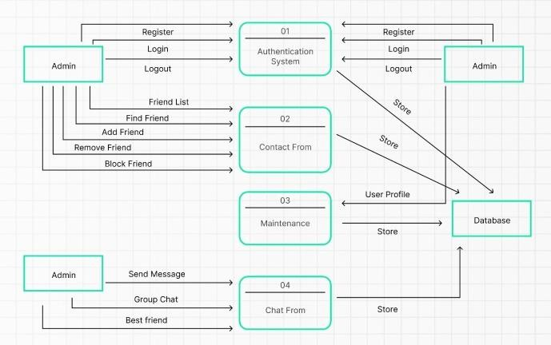
Fig 3.1: Data Flow Diagram

The workflow of a chat application can be broken down into several key steps:

- User Registration and Authentication: The first and foremost step is for a user to register for an account. The process involves providing personal information and creating login credentials. Once registered, users can access the application by logging in with their email and password.

- Chat Rooms: Upon logging in, users can either create a new chat room or join an existing one by using a designated code or room name. These chat rooms serve as spaces for users to engage in conversations with other members who have joined the same room.

- Message Exchange: The core of a chat application lies in its ability to facilitate real- time message exchange. Through the use of web sockets, the application offers a seamless and dynamic conversational experience for users.

- Access Control: Our app prioritizes user security by implementing effective access control measures. With a mandatory log in process, only authorized users have access to specific chat rooms, safeguarding user data and privacy.

- Error handling and notification features: Elevating the user experience, our app has robust error handling and notification features. In the event of an attempt to join a non- existent chat room, users will be prompted with an error message. Moreover, notifications can be sent to users who have received new messages while being offline.

RESULT ANALYSIS

The Realtime Chat Application serves as an elegant and captivating chat platform, expertly crafted with cutting-edge technologies including React and Firebase. Our team's vision was to not only deliver seamless
communication, but also to create a visually engaging and intuitive user experience.

With a keen eye for design, our application boasts a stunning aesthetic that is sure to captivate users. The user interface has been thoughtfully constructed, incorporating a modern and user-friendly layout that elevates the overall user experience. Every detail, from our carefully chosen color palette to the typography and overall design elements, work in harmony to establish a visually appealing and cohesive environment.

One of the standout features of this application is its combination of both style and substance. Not only is it visually appealing, but it also boasts a wide range of practical features. From managing user accounts to providing seamless authentication, the application has a robust feature set designed to enhance the user experience.

Navigation through conversations is effortless, with users able to access their latest interactions and initiate new ones with ease thanks to the carefully crafted user flows. Fueling this impressive platform are the technologies of React and Firebase, which work together to deliver a responsive and real- time experience. React, a dynamic JavaScript library used for creating user interfaces, contributes to the application's speed and interactivity. Meanwhile, Firebase, a comprehensive backend-as-a-service platform, allows for real-time synchronization of messages, ensuring that users can stay connected in real-time.

Embark on your journey by easily setting up a new account, granting you full access to the myriad of features offered by the application. Upon logging in, a vibrant and immersive chat interface awaits, allowing you to seamlessly scroll through your latest discussions.

With a strong emphasis on real-time interactions, the chat application delivers a fluid and engaging experience. Simply click on existing conversations to view messages, or

effortlessly begin a new one by searching for a specific user. This convenient feature streamlines the process of starting a conversation and is complemented by a user- friendly search function, providing you with the ability to seek out and initiate chats with specific individuals.
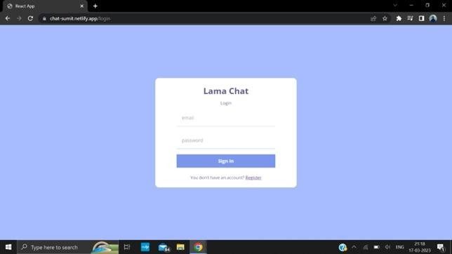
Fig 4.1: Sign-up/Log-in Interface

The Realtime Chat Application goes beyond just sending text messages - users also have the ability to share images, making for a more engaging communication experience. What makes this app stand out is its real-time functionality. Messages are delivered and displayed in real-time, allowing for dynamic and immediate conversations between users.
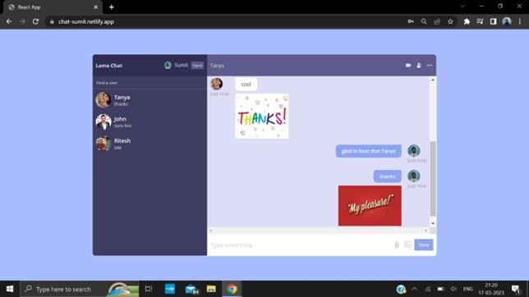
Fig 4.2: Chatting Interface

Overall, the Realtime Chat Application is a user-focused communication platform. It was built using React and Firebase, offering features such as account creation, effortless login, easy navigation between conversations, support for both text and image messaging, and most importantly, real-time messaging capabilities. With its versatility and efficiency, this app is the perfect tool for staying connected with others.

CONCLUSION

The journey of developing our chat application has been filled with challenges and successes. By harnessing the power of Google Firebase, React, and Node.js, we have created a dynamic platform for real-time communication and collaboration. This technology allows us to cater to the diverse needs of different industries and use cases.

Our team has prioritized creating a user- friendly experience throughout the development process. To ensure smooth and secure communication, we have implemented features such as robust user authentication and real-time message updates. These components work together to provide a seamless platform for users to confidently engage and interact with one another. An important aspect of our application is the constant drive to improve and enhance the user experience. Because of this, our application is equipped to manage a significant number of users and a high volume of message traffic, all while maintaining optimal performance. This level of reliability is crucial in providing a seamless and continuous communication experience for all users.

FUTURE SCOPE
As we work towards our main objective of creating a user-friendly chat application, we have an exciting roadmap in store. Our plans include introducing a variety of new features to elevate the user experience, such as the ability to share videos and voice messages.

Additionally, we are considering developing a mobile app with the same advanced technology used on our website. This would allow for seamless communication on the go, making our platform even more convenient for users.

In our dedication to keeping our community safe, we are exploring the use of a machine-

learning model to monitor and filter messages. This would ensure that our platform remains secure and is not used for any malicious purposes.

Moreover, we understand the importance of providing a safe and secure platform for our users. By utilizing this mechanism, we can guarantee consistent backups of the codebase and database on separate servers, providing protection against unforeseen emergencies or data corruption.

REFERENCES

- Jhalak Mittal, ArushiGarg, Shivani Sharma, Online Chatting Application, International Journal of Research in Engineering, IT and Social Sciences,
April 2020
- R. Gayathri, C. Kalieswar, Multi-User Chat Application, International Journal of Engineering and Advanced Technology (IJEAT), 2020
- Ashutosh Kumar, Atul Singh, Research paper on Group chatting Application, Galgotias University, 2022
- Dr. Abhay Kasetwar, Rohan Nikhare, Priya Warande, Development of Chat Application, International Journal for Research in Applied Science & Engineering Technology (IJRASET), 2022
- Anna Sophie Kümpel Using Messaging Apps in Audience Research: An Approach to Study Everyday Information and News Use Practices, Digital Journalism, 10:1, 188-199, 2022
- Mohamad Afendee Mohamed, Abdullah Muhammed and Mustafa Man, A Secure Chat Application Based on Pure Peer-to-Peer Architecture, Journal of Computer Science, 2015
- S Karthick, R John Victor, S Manikandan, Bhargavi Goswami, Professional chat application based on
natural language processing, IEEE, 2018
- Somen Nayak, Surajit Das, Saikat Das, Siddharth Sarker, Preyoshi Sarker, Aniket Dey, Anirban Sinha, Jyotirmoy Saha, Aniket Banerjee, An application for end to end secure messaging service on Android supported device, IEEE, 2017

