A STUDY ON ENVIRONMENTAL INFORMATION DISCLOSURE BY INDIAN GOVERNMENT AND INDUSTRIES

AUTHOR
S.Sushil
Register number : 131802022
BBA,LLB(HONS), 5th Year
Saveetha School of Law
Saveetha Institute of Medical and Technical Sciences (SIMATS)
Saveetha University
Sushilsridhar21@gmail.com
Mobile no : 9384613121

CO-AUTHOR
Mrs.padmapriya
Assistant Professor of Law,
Saveetha School of Law
Saveetha Institute of Medical and Technical Sciences (SIMATS)
Mail.ID :padmapriyas.ssl@saveetha.com
Contact No. 8056246039

A STUDY ON ENVIRONMENTAL INFORMATION DISCLOSURE BY INDIAN GOVERNMENT AND INDUSTRIES
Author:Sushil.S
Co . Author:Mrs.padmapriya
ABSTRACT:
Government and industry environmental information disclosure is an important means to promote environmental supervision and law enforcement, and improve the level of environmental management. Public knowledge management is crucially dependent on public access to information – in particular, information on environmental risks. Yet most existing systems of governance favour administrative or corporate secrecy, thereby monopolizing environmental information in the hands of governmental authorities or private stakeholders. This paper describes innovative initiatives to establish civil society's 'right to know', by mandatory disclosure of government-held information and of industry-held environmental risk data (through the worldwide spread of Pollutant Release and Transfer Registers, and through court-enforced access to 'privileged' documentation However, the paper also highlights continuing transparency deficits (sometimes resulting in 'manufactured uncertainty') with regard to risk-sensitive information of common concern. Therefore, this paper believes that the government should strengthen the disclosure of environmental information based on urban economic development to ensure the sustainability of urban economic development. The researcher has done a study on the same based on certain questions framed by the researcher. The respondents belonged to various age groups, educational and occupational backgrounds to whom the survey questions based on awareness level on the topic of agreeability on certain aspects and opinions on the concept were asked. The results are formulated and the hypothesis has been either proven or altered as any research should be. The tools used for the research include Statistical Tools for Social Sciences (SPSS). In conclusion the people should be given enough awareness so as to the rights they have towards obtaining information regarding the environment.

KEYWORDS : Environmental supervision, Environmental information disclosure, Green economy, Industry and government, Threshold effect.
INTRODUCTION:
In India and elsewhere, maintaining environmental balance with rapid industrial growth is the subject of any safe policy. In the last few decades, several environmental laws have been enacted and numerous institutions set up to implement the objectives of these laws. But this traditional form of environmental protection, establishment of environmental legislation, standards, and punitive action in the case of failure to meet these regulatory requirements has been ineffective in controlling the environmental impacts caused by corporate activities. In developing and industrialized countries, these mandatory command and control approaches are costly and fail to achieve the expected goals when (i) emission sources are widely scattered across administrative boundaries; (ii) the gap is wide for the abatement cost caused by the use of obsolete machinery in industrial production process; and (iii) regulating agencies lack capacity and will to implement the standards.As a reaction to such shortcomings, a second wave of policy tools beginning from the 1970s witnessed the emergence of market-based approaches, mainly in industrialized economies as in the United States (US) and Europe. These include tradable permits, emission charges, and deposit refunds. In some cases, these market-based instruments have substituted regulatory approaches, but in most cases complimented them by enhancing flexibility, therefore improving the efficiency for pollution control policies. Noteworthy examples in Asia include emission charging systems being implemented in the People’s Republic of China (PRC), Malaysia, and Thailand, with varying degrees of success. Nevertheless, even in industrialized economies like the US, Germany, and Japan, this second wave of environmental policy tools have not been able to fully solve the environmental problems. In the industrialized countries, the system is overburdened by the sheer number of substances to be controlled. The reason for the limited use of market-based approaches in developing countries is due to difficulties associated with the capacity of environmental agencies to design, implement, monitor, and enforce such approaches in conjunction with other instruments. The ineffectiveness of regulative and market-based approaches to protect the environment highlight the significance of informal policy tools, such as public disclosure of corporate environmental information and rating schemes for improving environmental performance. A rating system involves categorizing different firms on the basis of their environmental profile. In recent years, the reliance on information disclosure and rating has been made effective with the information revolution. According to Kolk (2004), this formed the beginning of the third wave of voluntary approaches that aim to improve corporate environmental performance. The expanding roles of disclosure strategies stem from (i) an increasing perceived need for more effective tools rather than simply relying on traditional command and control approaches, (ii) a rising demand for environmental information from communities and markets, and (iii) decreasing cost of information collection and dissemination.To conduct a study on environmental information disclosure by Indian government and industries
OBJECTIVES:
● To study the scope and applicability of RTI act.
● To study the awareness level amongst people regarding the related laws
● To study the applicability of RTI with respect to environmental issues
● To study the need for environmental information disclosure

REVIEW OF LITERATURE:
(Rowat 1966, p; Schwan;) Historically, there have been significant differences between and among national administrative laws with regard to government-held information. While most European countries (including Britain, France, and Germany) have had a notorious tradition of secrecy with regard to a broad range of data kept by public authorities partly out of a legitimate concern with effective governance (Dahl 1994; Rowan-Robinson et al.1973), – the one major exception was Sweden: Starting with the Freedom of the Press Act of 1766, Swedish citizens have had a right of access to public data, unmatched in any other legal system . Other Nordic countries followed much later: Finland’s Publicity of Documents Act in 1951; Denmark’s Public Access Act in 1970 (Offentlighedslov; Holm 1986). Even so, the Scandinavian approach to government-held information remained unusual among the prevailing pattern of ‘arcane administration’ in Europe, where access to files by citizens was long viewed as incompatible with the principles. Initially, European countries other than those in Scandinavia were slow to follow suit. Among the first examples in continental Europe was the Dutch Administrative Transparency Act of 1978 (Netherlands ; Luebbe-Wolff; Rutteman 2001). More than ten years later, after considerable debate in the European Commission and Parliament, Council Directive No. 313 of 1990 on Freedom of Access to Information on the Environment mandated the enactment of transparency legislation in all EU member countries (Fluck & Theuer 2003). Sen et.al. (2003) identified environment disclosure practices of Oil and Petrochemicals, Steel, Cement and Mining industries. In their study, content analysis of annual reports about waste disposal cost and other environmental liability costs state that annual reports disclose more of qualitative information. Salama et. al. (2006) examined the association between corporate environmental disclosure and earning management and its impact on Corporate Governance by using signaling, agency, stakeholder and legitimacy theory. They found no significant statistical association between various measures of accrual and environmental disclosure for a sample of 245 UK non financial firms. Devi (2008) defined content analysis as "the scientific study of content of communication. It is the study of the content with reference to the meanings, contexts and intentions contained in messages." This study has in principle adopted the methodology of content analysis used by Al Tuwariji et.al. (2004), Sen et.al. (2010) and Siddique Salina et.al. (2011). Malarvizhi et. al. (2008), has analyzed that Indian companies follow diverse reporting practices in annual reports as well as sustainability reports. The study found Indian companies have not yet developed a systematic approach to environmental accounting and reporting and regulatory authorities lack proper environmental reporting guidelines. Hossain et. al. (2008) examined the relationship between environmental disclosure and corporate attributes of Bangladeshi companies by modeling a disclosure index and found significant differences in the levels of environmental disclosure as measured by mean value. They found few companies in Bangladesh are providing qualitative information on a voluntary basis. Sahay (2009) has discussed sustainability and its reporting in the Indian context by discussing various legislative measures and competitive advantages of environmental disclosure in various sectors like automobile, power, fertilizers, mining & metallurgy, oil & gas, pulp and paper. It was found that voluntary environmental disclosure by Indian companies seemed to be aimed more for publicity rather than providing environmental facts and figures. Pramanik et.al(2009) Environmental reporting barring a few cases is unsystematic and non comparable, however some industrial factors and some units in different sectors report good quality of information which needs to be encouraged and rewarded. In Environmental reporting literature, prior research studies have been conducted in many countries on various perspectives of environmental accounting and reporting. Chauhan(2010) Voluntary disclosure theory argues that better environmental performers will communicate with stakeholders using hard or verifiable disclosures which are difficult to mimic by poor environmental performers. On the other hand, socio-political theories suggest that poor environmental performers will use soft or unverifiable disclosures in their attempt to alter their public image, Clakson et.al (2011). Gupta (2011) revealed in his study that companies are well aware of the facts that environmental issues will affect the business and industry in the near future. The companies in India do not have a proper environmental accounting system to determine the environment related costs, benefits, assets and liabilities. Indian companies fail to provide adequate disclosure on the environment. Ranga and Garg(2014), have studied the conceptual framework of environmental reporting practices. They concluded similar views; environmental accounting is about making environmental related costs more transparent with corporate accounting systems and reports. Anand and Srinivasa (2014) The developing countries like India are facing the twin problems of protecting the environment and promoting economic development. A tradeoff between environmental protection and development is required. The status of environmental reporting in India is in the preliminary stage, and very few corporations give adequate information regarding environmental issues. In India, the level of environmental related disclosures in the corporate annual reports, both financial and Non-financial is not an encouraging level.Mostafa et al(2015) The proportion of companies disclosing and extent of that disclosure are small and the quantity is low. The relationship between industry membership and the extent of the environmental disclosure has been investigated by many theoretical and empirical studies due to the fact that each sector has some distinctive characteristics that may relate to risks to society, potential growth, employment, competition and government interference (Ahmad et al., 2015). Normally Companies operating in environmentally sensitive industries disclose more environmental information than companies operating in non- environmentally sensitive industries The extent of environmental disclosure in annual reports may differ from industry to industry and the result indicated that company size and industry membership are positively related to the extent of environmental disclosure (Akbas, 2015). Shukla and Vyas(2016) presented the theoretical foundation of environmental accounting and reporting with special reference to industries like ONGC, BPCL. Environmental reports of two Indian Petroleum & Gas companies named ONGC and BPCL were studied for three consecutive years 2008, 2009 and 2010. The findings of the study showed that BPCL & ONGC were totally concerned about the major issues of environment that directly hamper the environmental performance and they agreed that they should pay their duty with their best by providing full information about environmental related disclosure. Kundra (2018)Canalyzed that industry type influenced only energy and community involvement. provided an insight into the scenario of green initiatives in Indian context. Also attempted to check environmental initiatives were industry specific or not. A sample for the study was 50 Nifty companies and the required data collected from companies’ websites .Yadav (2019) An index was prepared with 40 items and content analysis used. The study revealed that, green initiatives were industry specific to some extent, going green was the new trend in the modern business. Companies operating in India were also serious about this issue and are reporting their green practices., examined the general trends in corporate environmental internet reporting practices and to gain an insight into the corporate environmental internet reporting practices of selected companies.(Andersen; Holstad 1979; Petrén) It was observed that Indian companies followed diverse reporting practices on the internet viz., stand-alone environmental reporting or reporting along with the Annual/Financial Reports, or Sustainability Reporting. Involvement and commitment of corporate accountants in environmental management appeared to be limited due to lack of regional reporting guidelines.

METHODOLOGY:
The researcher has done an empirical study on the topic. The primary information for the research was collected through field study from 200 selected respondents which included the general public with a well framed and structured survey questionnaire. A convenience sampling method was used to collect the data.The questions put forward in the survey to the respondents were specifically to the consumers. The independent variables used were gender, occupation and educational qualification. The secondary sources used by the researcher for the study are by referring to books, research articles, e-sources, articles, journals , newspapers. The researcher has used graphs to analyze the data collected.

ANALYSIS:

QUESTION 1: On a scale of 1 to 5 rate as to whether information regarding environmental risks should be disclosed to the public

FIGURE 1:
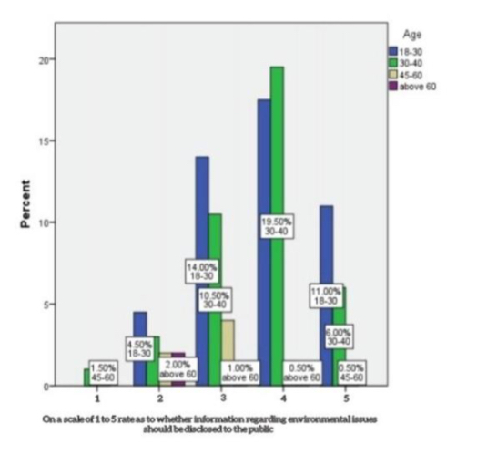
LEGEND: The above graph shows the response on a scale 1 to 5 (where 1 is least disagreeableness while 5 denotes otherwise) of respondents of varying age groups as to whether information regarding environmental risks should be disclosed to the public

FIGURE 2:
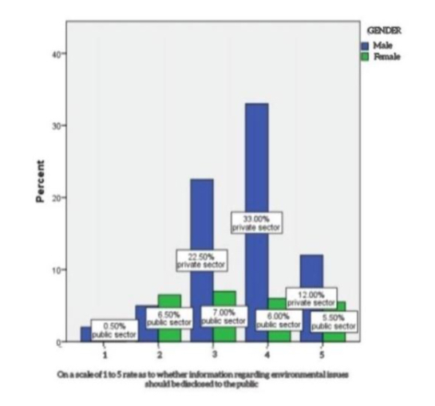
LEGEND:The above graph shows the response on a scale 1 to 5 (where 1 is least disagreeableness while 5 denotes otherwise) of respondents with respect to gender as to whether information regarding environmental risks should be disclosed to the public

QUESTION 2: Are you aware RTI is also applicable to private companies?
FIGURE 3:
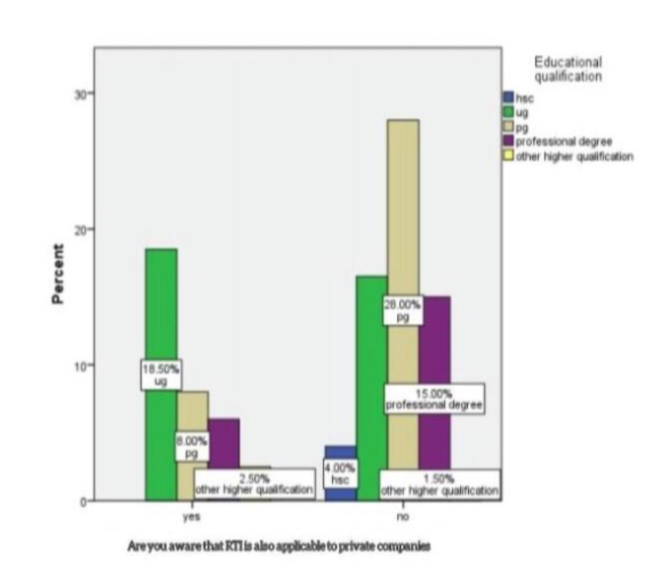
LEGEND: The above graph shows the awareness level on RTI’s applicability in the private sector of respondents from varying educational backgrounds.

FIGURE 4:
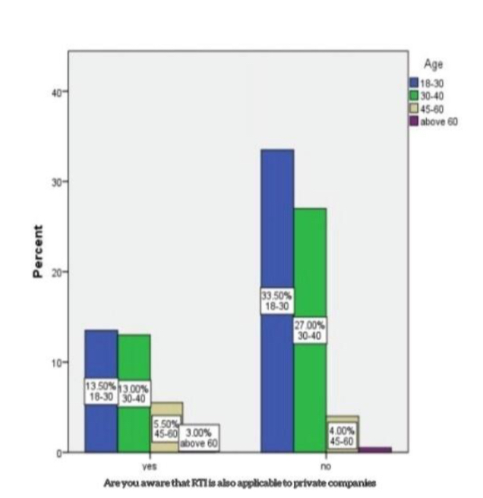
LEGEND: The above graph shows the awareness level on RTI’s applicability in the private sector of respondents with respect to gender

QUESTION 4: Do you think RTI is necessary with respect to environmental issues?
FIGURE 5:
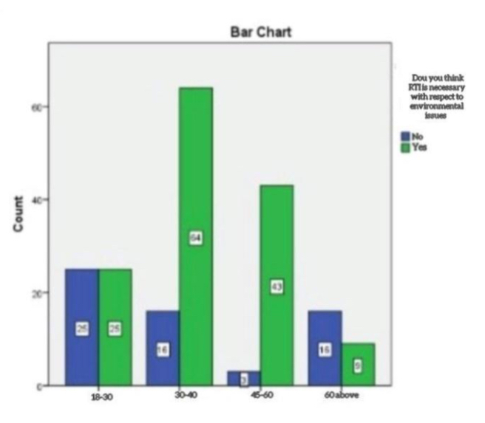
LEGEND:The above graph shows the opinion of respondents of varying age groups as to whether RTI is necessary with respect to environmental issues

QUESTION 5: Rate your agreeableness that RTI is being used to its full potential with respect to environmental issues
FIGURE 6:
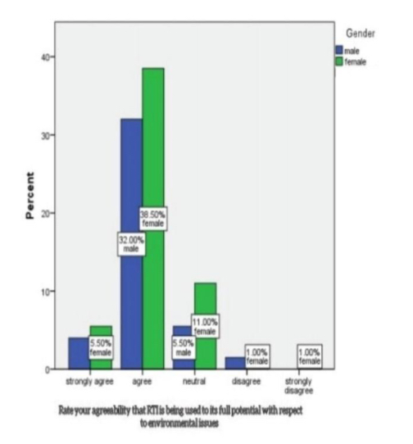
LEGEND: The above graph shows the agreeableness of respondents as to the statement RTI is being used to its full potential with respect to environmental issues

FIGURE 7:
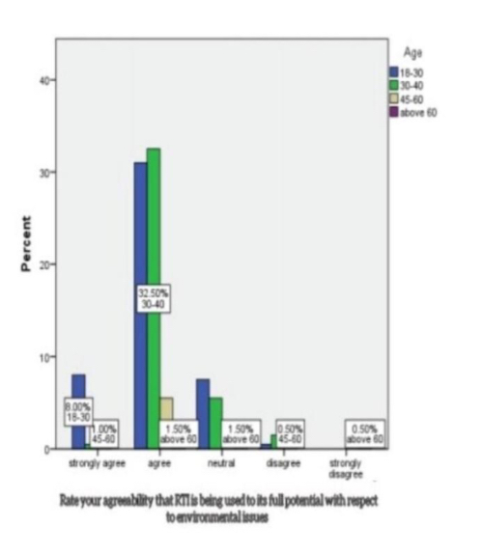
LEGEND: The above graph shows the agreeableness of respondents as to the statement RTI is being used to its full potential with respect to environmental issues

QUESTION 6: Reason as to why RTI should be available in the environmental aspect
FIGURE 8:
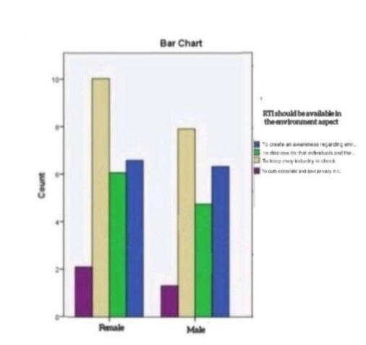
LEGEND: The above graph shows what respondent with respect to gender think is the reason as to why RTI should be available in the environmental aspect from the given options

FIGURE 9:
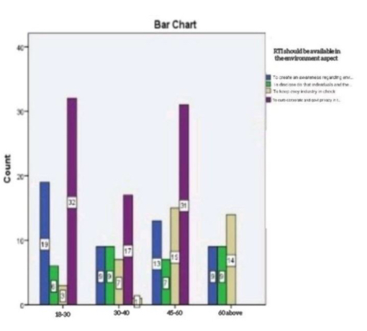
LEGEND:The above graph shows what respondent with respect to age group think is the reason as to why RTI should be available in the environmental aspect from the given options

RESULTS:
From Fig.1 and Fig. 2 we can infer that the majority of the respondents of the age group 18 to 40 have, when asked as to whether information regarding environmental issues should be disclosed to the public, have stated that it should be disclosed, while people of the age group 45 to 60 have taken a neutral stance. With respect to gender agreeability on the part of men is higher in comparison. From Fig. 3 and Fig 4 we can infer that the majority of the respondents with respect to age and educational qualification have a minimum level of awareness that RTI is also applicable to private companies; the Undergraduates alone have a higher awareness of the fact. From Fig.5 we can infer that people of the age group 30 to 60 agree that RTI is necessary with respect to the environmental aspect while the people of the age groups 18 to 30 and 60 above have a neutral or contradicting stance. From Fig.6 and Fig.7 we can Infer that irrespective of gender and age the majority of the respondents agree that RTI is being used to its full potential with respect to environmental issues. From Fig.8 and Fig.9 we can infer that people consider that RTI should be available in the environmental aspect so as to keep every industry in check and to curb the exploitation of the environment.

DISCUSSION:
From Fig.1 and Fig. 2 we can infer that the majority of the respondents of the age group 18 to 40 have, when asked as to whether information regarding environmental issues should be disclosed to the public, have stated that it should be disclosed, while people of the age group 45 to 60 have taken a neutral stance this may be due to the fact that people are concerned about the environment as of now that ever before seeing the adverse effects that it has on them. With respect to gender agreeability on the part of men is higher in comparison This may be due to the fact that majority of the respondents were men. From Fig. 3 and Fig 4 we can infer that the majority of the respondents with respect to age and educational qualification have a minimum level of awareness that RTI is also applicable to private companies; the Undergraduates alone have a higher awareness of the fact. This may be due to the fact that the act as such only mentions explicitly that only government bodies are included and the reason reason as to why under graduate may be aware of the fact is that most of them are laws students. Fig.5 we can infer that people of the age group 30 to 60 agree that RTI is necessary with respect to the environmental aspect while the people of the age groups 18 to 30 and 60 above have a neutral or contradicting stance.This may be because they are unaware of the uses of the RTI act and its potential. From Fig.6 and Fig.7 we can Infer that irrespective of gender and age the majority of the respondents agree that RTI is being used to its full potential with respect to environmental issues; this may be due to the fact that various awareness programmes have been conducted and the availability of internet too has expanded the scope of the act even to remote places . From Fig.8 and Fig.9 we can infer that people consider that RTI should be available in the environmental aspect so as to keep every industry in check and to curb the exploitation of the environment. This may be due to the fact that the majority of the pollution caused is by industries and if they are kept in check pollution would decrease.

LIMITATIONS:
The limitations to the study include issues with sample and selection, insufficient sample size for statistical measurement, lack of previous research studies on the topic, limited access to data and time constraints.

SUGGESTION:
In order to save the spirit of RTI and especially with respect to this environmental aspect the laws and authorities should enhance accountability & clarity in role, create more awareness amongst people , improve convenience in filing requests, enable environment & capacity building, improve efficiencies at Information Commission, third party audit to ensure compliance with provisions/ guidelines of the RTI Act by Public Authority.

CONCLUSION:
In conclusion the environmental disclosure practices of Indian government and industries and also have studied the impact of different independent variables on EDI. Through year-wise pooled regression we found that except for size and certification variables none of the independent variables of our regression model are significant. In all the years of our study, size and environmental certification are positively associated with EDI and are significant. This indicates that the higher the size of the company is, the higher the environmental disclosure. This also shows that in India, bigger companies disclose more of environmental information due to their possibility of coming under the scanner by the public, media, government and/or other stakeholders. Disclosure of more environmental information by large-sized companies may be the result of stakeholder’s pressure or may be purely voluntary in nature. The result also shows that environmental certification is positively associated with EDI. The result is quite logical as an environmentally certified company from an environmental rating agency has to follow a number of guidelines and hence has more to disclose. Environmental certification reduces the agency cost as it reduces the monitoring cost since the firms voluntarily follow a set of externally set measured objectives. Although the companies under study are diversified, yet we do not see changes in EDI. This indicates that firms from varied sectors have understood the importance of disclosing information about their environmental activities and take this disclosure of information seriously. Profitability, multinational status, leverage and the nature of the firm do not matter in environmental disclosure. It indicates that it does not mean that the firms that are profitable or that have taken loans would disclose information about the environment. In order to sustain themselves in a global market over a long period of time, firms have to disclose environmental information irrespective of their multinational or domestic status, leverage or earning capacity.

REFERENCE:
Rowat, Donald C. 1966. The Problem of Administrative Secrecy. International Review of Administrative Sciences 32, 99-106

Dahl, Robert A. 1973. A Democratic Dilemma: System Effectiveness versus Citizen Participation. Political Science Quarterly 109, 23-34

Andersen, Stanley V. 1979. Public Access to Government Files in Sweden. American Journal of Comparative Law 21, 419-473

Offentlighedslov 1986 = Public Access to Documents in Administrative Files. Danish Act No. 280,
Netherlands 2001= Wet Openbaarheid van Bestuur (Administrative Transparency Act) of 9 November 2001.Netherlands Staatsblad [1978] 581, in force 1 May 1980

Fluck, Jürgen, and Andreas Theuer, editors. 2003 -. Informationsfreiheitsrecht mit Umweltinformations- und Verbraucherinformationsrecht. Heidelberg: Müller (loose-leaf collection)

Salama, Aly, Sun, Nan, Hussainey, Khaled and Habbash, Murya (2006), "Corporate Environmental Disclosure, Corporate Governance and Earnings Management

Devi Prasad B (2008), Chapter: Content Analysis in "A method of Social Science Research", pp.174-193, New Delhi: Rawat Publications, 2008

Malarvizhi P., Yadav S. (2008), "Corporate environmental disclosures on the Internet: An empirical analysis of Indian companies" Issues in Social & Environmental Accounting, Vol 2(2), 211–232

Hossain, M. M., M. Alam, M. A. Islam, and A. Hecimovic. (2015), Do stakeholders or social obligations drive corporate social and environmental responsibility reporting? Managerial views from a developing
country. Qualitative Research in Accounting & Management, Vol. 12 No. 3, pp. 287-314.

Pramanik, Bass, Gary D., and Alair MacLean. 1993. Enhancing the Public’s Right-to-Know About Environmental Issues. Villanova Environmental Law Journal 4, 287-310

Bennett, Robert, and John Kyl. 2001. Critical Infrastructure Information Security Act. U.S. Senate Bill 107-1456 Clackson, Bitton, Asaf, Mark David Neuman, and Stanton A. Glantz. 2002. Tobacco Industry Attempts to Subvert European Union Tobacco Advertising Legislation. San Francisco: University of California Center for Tobacco Control Research and Education

Mostafa et al. The Transparent Society: Will Technology Force Us to Choose Between Privacy and Freedom ? Reading/MA

Kundra. Access to Documents: A General Principle of Community Law? European Law Review 27, 194-205

Cowen et.al ,Bullinger, Martin2018 . Western Germany. In Rowat, 217-236
Anand and Srinivasa, 2014. The Law and Economics of Environmental Information as Regulation. Environmental Law Reporter 31, 10773-10789

Ahmad et al.2001, International Right-to-Know: Strategies to Increase Corporate Accountability in the Midst of Globalization. Washington/DC: Natural Resources Defense Council CEC 2001 = North American Commission for Environmental Cooperation. Taking Stock: North American Pollutant Releases and Transfers 1998. Montréal/Québec:

Cowen et.al (2018) CEC Cha, Ariana E. 2018. Risks Prompt U.S. to Limit Access to Data. Washington Post (24 February 2018), A-1 Chaloupka, Frank J., and Kenneth E. Warner. 2000. The Economics of Smoking. In The Handbook of Health Economics, edited by Joseph P. Newhouse and Anthony J. Culyer. Amsterdam: North Holland, 1541-1647

Shukla and Vyas, 2018 . Winning the Right to Know: A Handbook for Toxics Activists.
Akbas, Ciresi, Michael V., Roberta B. Walburn, and Tara D. Sutton. 1999. Decades of Deceit: Document Discovery in the Minnesota Tobacco Litigation. William Mitchell Law Review 25, 477-566

Cohen, Mark A. 2001. Information as a Policy Instrument in Protecting the Environment: What Have We Learned? Environmental Law Reporter 31, 10425-10431
Chauhan. 2010. Transparency after 9/11: Balancing the „Right-to-Know“ with the Need for
PLAGIARISM-REPORT: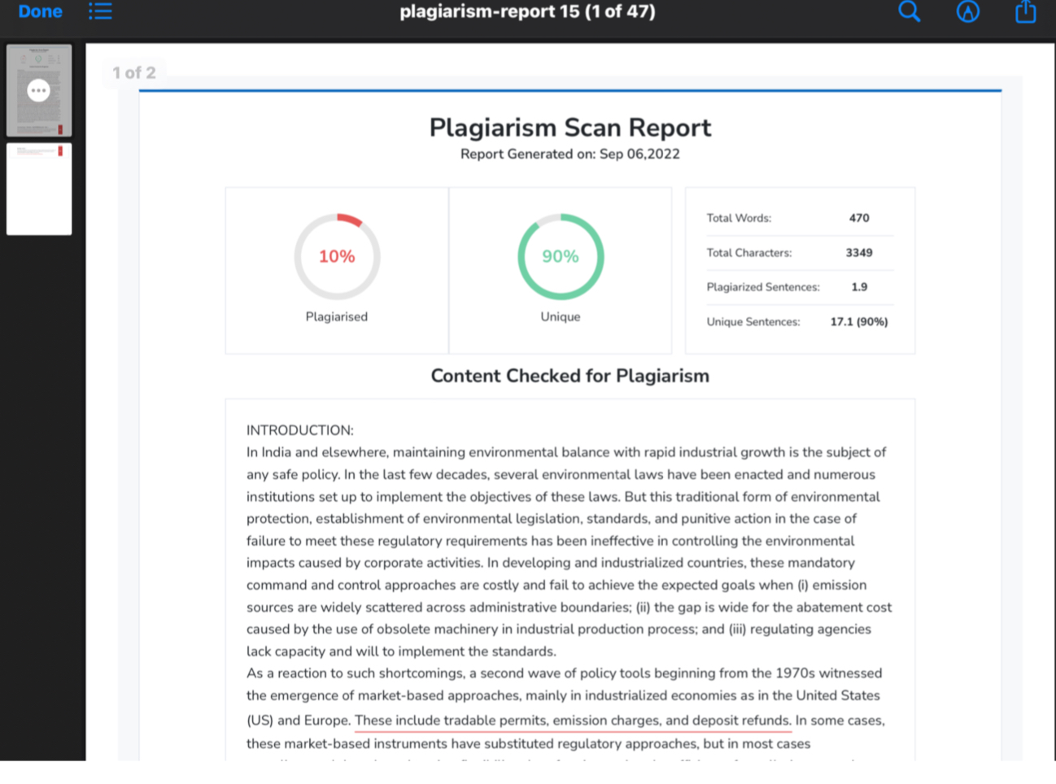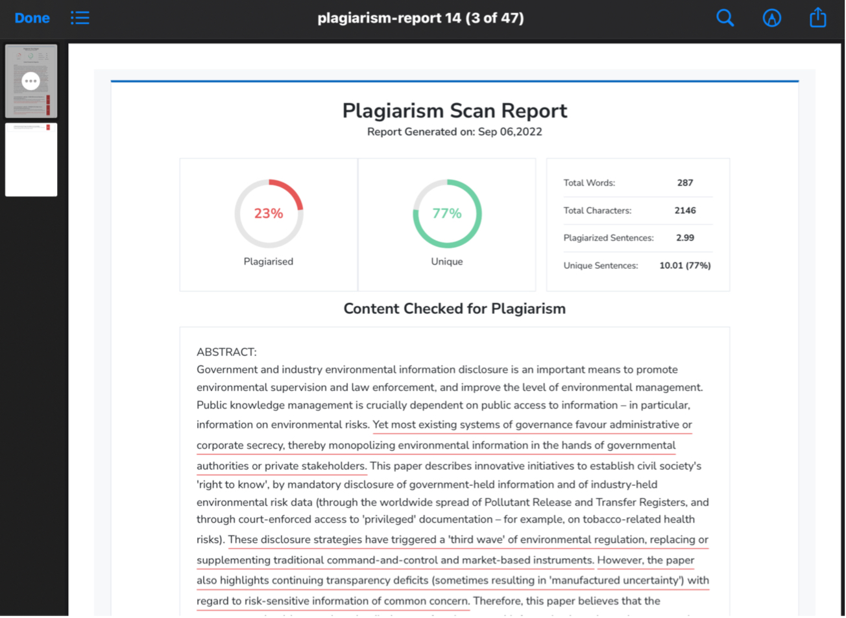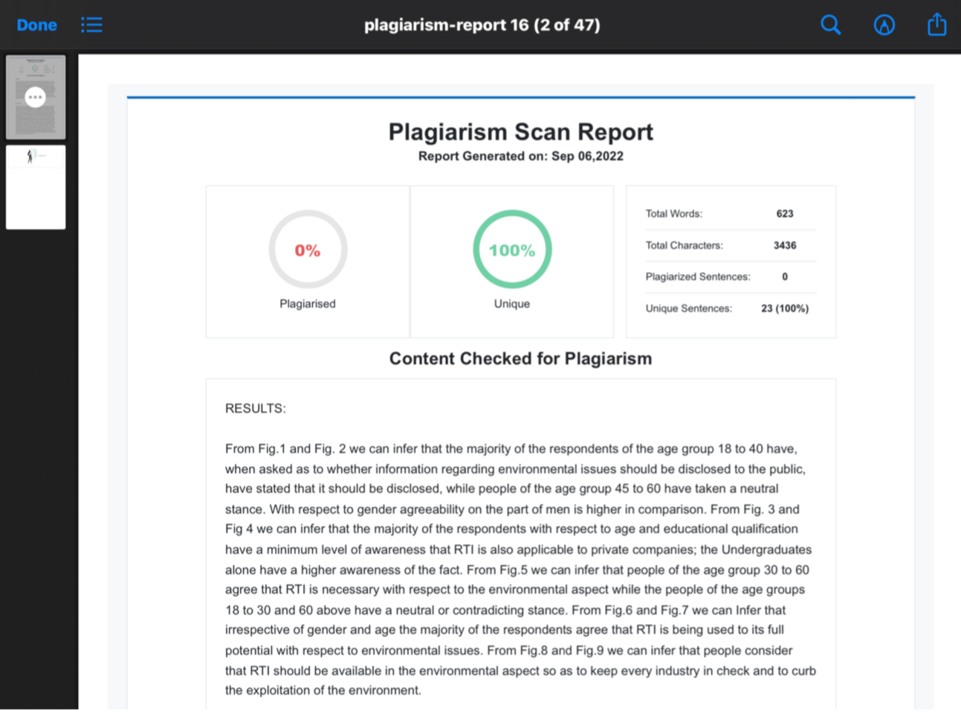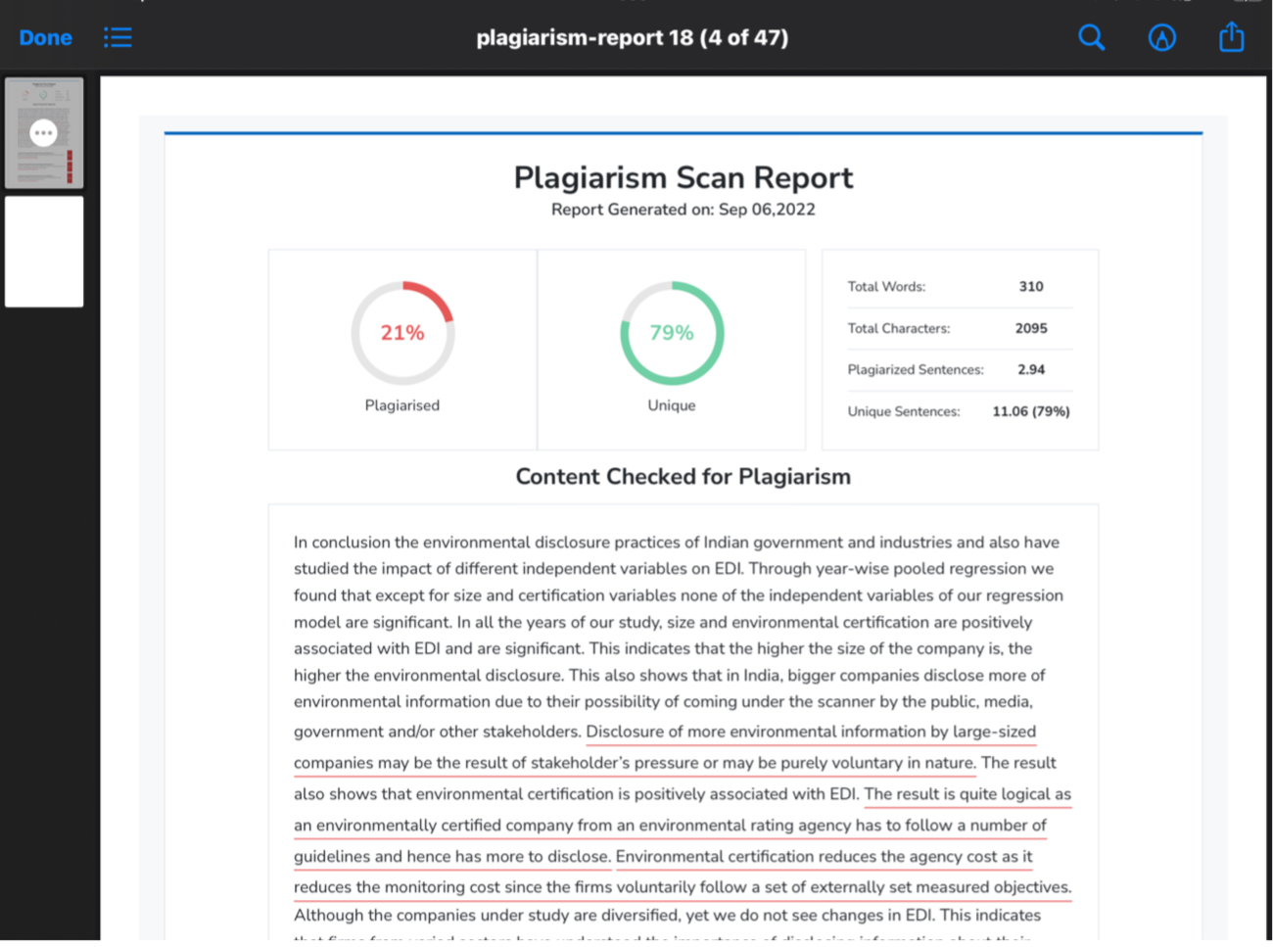

Sushil.s 5th year BBA.;LLB (Hons),Saveetha School of Law ,Saveetha Institute of Medical and Technical Sciences,Chennai, Email id : sushilsridhar21@gmail.com
Mrs.padmapriya Assistant Professor of Law Professor of Saveetha School of Law, Saveetha InstituteofMedical and Technical Sciences,Chennai.Email id : rajavinyagasls.ssl@saveetha.com

