Exploring Submerged Hazards: Innovations In Submarine Rock And Mine Detection

Abstract—Underwater mines are common explosive bombs that are placed around a coastal region of a country, deep under the ocean to ensure safety, defence and security. This could be a threat to a submarine or any civilian boats that crosses over the mine. Though it provides enormous security, it is also a threat to marines which may mistake it as a rock. Due to its similar appearance, size, and placings in ocean bed, a rock can appear to be and mine and vice versa. Moreover, absence of light under ocean due to attenuation makes it impossible to capture a image to be processed. Here, we use the SONAR technique to explore the ocean bed and identify rocks and mines accurately. The dataset contains 60 different angles under which rocks and mines are recorded with specific value. The main objective is to enhance the model using Ensemble learning techniques. Standalone algorithms to overcome overfitting, under fitting and feature selection. Bagging to improve stability and reduce bias value.

Keywords—Convolution Network, Logistic regression, K-Nearest Neighbors, Support Vector Machine, Naive Bayes, Decision tree, Random Forest, AdaBoost.

I.INTRODUCTION
It is vital to distinguish between underwater mines and rocks because accidental encounters with mine would cause the life-or-death situation. To differentiate them, we use methods like capturing underwater images using side scan sonar and observing the values of these rocks and mines using sonar frequency beams that bounces back to the sonar transducer. We implement various algorithms to find rocks and mines precisely from one another such that it does not possesses a severe threat to ships and submarines and other underwater explorers. Moreover, to human endangerment, it is also a threat to environment if they are misidentified as one another. Accidental encounters with rocks would harm the ships and marine lives. However, with mines, when it is encountered by mishap, they explode underwater which causes physical damage to other underwater vehicles as the force of explosion can rupture the hull of a vessel, leading to flooding, structural damage, and potentially sinking which leads to fatalities. Other environmental impact it has is, generation of shockwaves which travels through water and it emits toxic substances which would be a threat to marine lives.

It also aids military as it is utmost important to distinguish these both. False alarms or misidentifications can have at most consequences. Ensuring the accurate recognition of mines is crucial for defensive and offensive military

operations, as well as for protecting maritime trade routes. These laws are designed to ensure the safety of navigation and to protect the marine environment. Violating these regulations can result in legal consequences and environmental liabilities. Therefore, it is important to differentiate between underwater rocks and mines to preserve environment, safety, and security.

II.LITERATURE SURVEY
David P. Williams et. al [1] proposed the concept of synthetic aperture sonar to detect objects using resonant zone downrange that checks the threshold of sub-patches of SAS image. Gubnitsky et. al [5] observed the object under various central frequency by applying Jain's fairness index which is also known as Kullback–Leibler divergence. This detects eccentricities of spectral domain. Fayaz et. al [6] used a different approach on applying CNN, RCNN and YOLO based framework on pictures taken underwater. The author compares the above three algorithms to conclude RCNN has a better performance.

Ojha introduced Bathymetric neural network that identifies dregs margin of the obstacle in real time. Furthermore, t is studies along with side scan sonar which enables high track solutions [14]. Sitha Ram et. al [7] has concluded AdaBoost has a better performance compared to other algorithms but it has not been checked for cross-validation. Yue Sun uses spark distributed cloud computing platform for memory-based parallelization of decision tree classification algorithm [8]. They have used ID3 and CART algorithms to evaluate accurate underwater acoustic signals. Langer and Knauer used Johnson’s criteria to analyse underwater objects using side scan sonar with probabilistic neural network. Six screening-based algorithms are used for detecting ROIs and snake algorithm is used to eliminate shadowed area.

S. C. James et. al [17] used Simulating WAves Nearshore (SWAN) Fortran wave modelling to forecast wave conditions. It allows CNN deep learning model to consider, how bathymetry affects wave heights and how depending on incoming wave direction, waves are diffracted around the coastline. Monika et. al [13] states SVM model performs better in terms of accuracy when compared to KNN. This experiment has the dataset of laboratorial values. Therefore, the only drawback of this project is the laboratorial data that is used to find SONAR values, thus lacking the real-world essence of the data.

Konstantinos et. al [9] concluded that on using decision tree based adaptive modulation, so that the BER rate is fairly precise. Since underwater channels are highly variable, influenced by factors like water temperature, salinity, and movement. This variability can make it challenging to adapt modulation schemes effectively in real-time. Thus, reflecting the natural realm and in harmony with the nature, the decision tree does not always give away the accurate BER rate.

Guangyao Han et.al [20] proposed an algorithm sparse wavelet transform matrix also focus on the edge information of sonar image and conclude that Peak Signal-to-Noise Ratio and Structural Similarity Index performance outperform the normal wavelet transforms. By implementing human vision like system, it has high utilization of band width that preserves the edges with less data availability. This paper also focuses on implementing human vision like system to create sparse wavelets, so that it retains the edges of the sonar images. RDNN classification [3] using SVM and neural network algorithms were employed to differentiate sonar data. Principal Component Analysis and a standalone architecture were utilized to incorporate the bagging ensemble framework for classifying sonar and ionosphere datasets by using back propagation.

Since RNNs require high-quality data for training, If the sonar data contains noise or artifacts, it can negatively impact the model's performance. The neural network approach for detecting rocks or mines yielded significantly improved results, achieving an average accuracy of 100% with no standard deviation when assessed using k-fold validation. It is important to note that Recurrent Neural Networks (RNNs) require high-quality data during the training process. If the sonar data includes noise or artifacts, it has the potential to adversely affect the model's performance.

Sheezan Fayaz et.al [6] has optimized GAN model that has been created to enhance the accuracy of current tracking systems when dealing with underwater data that may be distorted. The technique used on this is the AdaBoost which obtains higher frequency while compared to other boosting techniques. Thus, the model efficiently transforms the distorted underwater data into clear, non-distorted, or enhanced versions, thereby improving tracking performance. Only drawback of this technique is that the model would not work well in case of over-fitting of the data when checking for cross validation.

Jun Liu et.al [16] has proposed a model that involves KNN regression technique to enhance the initial dataset by filling in significant gaps. The objective is to create a new dataset that is evenly spaced, with data points precisely 1 meter apart. The approach detailed in this paper results in a substantial enhancement in the vertical data resolution when applied to training the k-nearest neighbor regression model. Because of the significant expenses associated with underwater nodes and their protective equipment, merely increasing the deployment of sparsity underwater nodes will not address the problem.

Leonardo et.al [10] this paper talks about Convolutional Neural Network-based Automatic Target Recognition. It uses 175 Forward Looking Sonar acoustical frames that are responsible for recognizing underwater objects which understands the surrounding by using sound data and it also uses specific instance of Single Shot MultiBox Detector which invokes Root Mean Square optimization algorithm.
Stanisław et.al [11] has used deep convolutional neural network to detect underwater objects using synthetic aperture sonar image. Manual settings are not required in this case because it uses speckle noise to analyze the condition of surroundings and the effects of sidelobe is observed.

III.EXISTING METHOD

Machine learning models can classify and identify these underwater hazards such as mine or rock by detecting the unique acoustic signatures of objects. In this process features like signal frequency, amplitude, and echo characteristics are crucial. To analyze the temporal patterns in acoustic data Recurrent Neural Networks (RNNs) are commonly employed, it is classified based on their distinct sound profiles. Specific acoustic patterns are recognized by RNNs which is associated with different objects and making it highly effective in underwater environment. Moreover, the combination of acoustic signal processing with machine learning techniques enables the development of accurate systems for the identification and classification of underwater mines and rocks. These systems are crucial for enhancing safety in maritime operations, underwater exploration, and military applications.

As existing method deals about acoustic signals from sonar transducer, we enhance the detection of rock and mines using images that are formed by side scan sonar. By employing this method, one can have more accurate prediction about the object present underwater.

IV.PROPOSED METHOD
A Predictive system for underwater submarine rock and mine detection is developed using machine learning on a dataset obtained by sending sonar signals in 60 different angles to strike the metal cylinders and it bounces back to the transducer present in submarine. And for images side scan sonar is used. Based on their unique frequency characteristics our models precisely differentiate between rock and mine. We implemented new algorithms to improve the safety and effectiveness of Mine Countermeasure (MCM) in classifying mines and protecting naval vessels. Sonar images are given as the input and these algorithms examine texture based, geometrical and spectral features. Moreover, machine learning has limitations, deep learning overcomes them with its ability to work with huge amount of data and it makes easier to classify rock or mine.

Deep learning algorithms face provocations in mine detection due to limited high quality data availability. Sonar simulation and augmentation label this issue. Transfer learning and algorithm fusion improve reliability. By combining classical image processing with deep learning inflate performance and reduces unbalanced data effects. Sonar, utilizing acoustic waves and measures the time taken to bounce back the object allows to calculate the distance. For transmission and reflection we will use properties like water properties, frequency effect performance and hydrophones.

V.METHODOLOGY

- Convolutional Neural Network:
Using Convolutional Neural Networks for sonar images classification because CNNs has specialized architecture and unique capabilities to identify patterns within images. CNNs are adept at learning local features or patterns within images, such as edges, corners, and textures. Moreover, CNNs possess translation invariance, enabling them to recognize patterns regardless of their position in the image and their hierarchical structure allows for the learning of complex features by combining simpler ones, making them proficient at understanding image content. With parameter sharing in convolutional layers, CNNs reduce the number of parameters, enhancing efficiency and reducing overfitting risks.

Firstly, the sonar images are passed over to learnable filters which slides over the input sonar images which is responsible for capturing unique and distinct features. Max pooling is used in this case to analyze interspersed between convolutional layers, to reduce spatial dimensions while preserving essential information, enhancing the network's robustness and computational efficiency. Then follows the fully connected layers, where the high-level reasoning takes place based on the flattened feature maps. These layers culminate in an output layer, which produces class probabilities in classification tasks. During training, CNNs learn from labeled data by minimizing a loss function, optimizing filter weights and biases through gradient descent and backpropagation. This iterative process continues until the model achieves satisfactory performance.

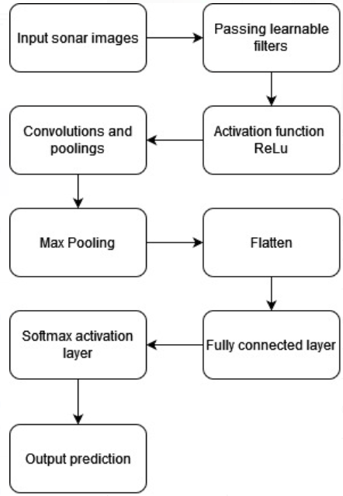
- Ensemble Learning:
To enhance predictive accuracy and improve model robustness ensemble methods support the collective capabilities of multiple machine learning algorithms. To get accurate results algorithms like Logistic Regression, K-Nearest Neighbors (KNN), Support Vector Machine (SVM), Naive Bayes, Decision Tree, Random Forest, and AdaBoost can be ensembled. Each and every algorithm of these gives distinct strengths to the ensemble's overall predictive power. To illustrate, K-Nearest Neighbors gives valuable probabilistic outputs, KNN excels at instance-based predictions, SVMs refine decision boundaries, and Naive Bayes accurately handles probabilistic classification, Decision Trees capture complex relationships, Random Forests offer effective bagging techniques, and AdaBoost stands out in boosting performance. Ensembles often achieve superior performance in machine learning across many applications, including classification and regression tasks by combining these diverse perspectives and strategies.

Ensemble learning is effective in learning strategies and sources of error. This makes more robust predictions. However, it's important to maintain a balance between model diversity and computational resources, as ensembles with too many base models can become computationally expensive. It is used in competitions and real-world applications where achieving high predictive accuracy is crucial. And compared to other models it gives accurate results.

VI.IMPLEMENTATION

a) Sensor Systems
A sonar system typically starts with a transducer, which is a device that emits sound waves into the water. These sound waves are often in the form of high-frequency acoustic pulses. Underwater sonar systems use acoustic waves to capture images of underwater environments by emitting sound pulses, receiving echoes, and processing the data to create images. When the sound waves encounter an object, they bounce back as echoes. These echoes are received by the same transducer or another receiving transducer. For images side scan sonar is used to capture underwater objects. Additionally, they collect numerical data on mines and rocks based on the acoustic back-scatter of sound waves. This involves analyzing the strength or intensity of the echoes received from underwater objects.

b) Data Collection
For the collection of numerical data, sonar systems emit acoustic signals into the water and measure the time it takes for these signals to travel to objects and return as echoes. This time-based data, along with the intensity or amplitude of the echoes, is a fundamental component of the data collection process. This echoed data provides crucial information about distances to underwater objects and their acoustic characteristics. These data values are recorded at 60 different angles for 104 rocks and 104 mines.

Simultaneously, sonar systems can collect images of the underwater environment. These data-driven images are formed by processing the echoes received from objects and underwater features. We use side-scan sonar to create detailed two-dimensional images of the seafloor and any objects or structures on it. The intensity of echoes is used to create grayscale images, where brighter regions correspond to stronger echoes.

c)Preprocessing
The sonar image data are divided into training, testing and validation batches. We have a total of 7 batches with 4 batches in training, 2 batches in validation and 1 batch for testing. As of sonar dataset, 80% of sonar data is allocated training and remaining for testing the prediction model.

d)Feature Extraction and classification algorithms
Now implementing Conv2D deep model, firstly we create an empty sequential model. Giving 256x256x3 image as input, we add 2D convolutional layer to the model with 16 filters and each of these having a 3x3 kernel with stride value 1. ReLu activation function is used in this case to tackle vanishing gradient problem. Then we add a 2D max-pooling layer to the sequential model. We repeat the steps again with lower number of filters for 3 iterations to capture high level feature and manage computational complexity. Then flattering out the model, we use dense function to reduce to 256 layers using ReLu activation function. Doing the same for the next dense layer, we use sigmoid for binary classification of whether the image belongs to mine or rock classification.

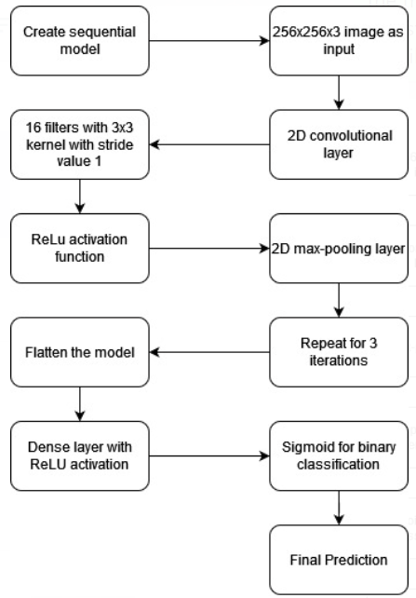

As for sonar data, we use ensemble techniques to observe the best performing algorithms out of all the algorithms. It is observed that K-Nearest Neighbors performs better than any other algorithm. Even after scaling, scaled K-Nearest Neighbors has the better performance. Thus, opting for KNN model, by applying threshold which is also enhanced with regularization techniques to prevent overfitting. Once the training is done, now the model is ready to predict the new data by estimate probabilities and classify examples into one of the two possible outcomes i.e., the object is rock or mine.

e) Training and testing
Training and testing for submarine rock and mine detection involves several steps to improve the effectiveness and reliability of the detection system. In training it go through steps like data collection gather a diverse and representative dataset of underwater environments where submarine rocks and mines are expected to be encountered, data preprocessing clean and preprocess the collected data to handle noise, sensor signals and missing values, feature extraction may include features object size, shape, acoustic characteristics, and motion patterns, splitting the dataset divide the dataset into three parts which is named as training, testing and validation, selecting models consider ensemble methods like Random Forests or AdaBoosting for improved accuracy, train rain the selected models on the training data using the ground truth labels, model evaluation assess the models performance in stints of fp and fn, which are critical in mine classification applications, fine-tuning refines the models based on the expected results.

In testing it has several steps like test data preparation it uses a separate, previously unseen test dataset that was not used during training or validation, model testing records the model predictions and compare them to the ground truth labels for evaluation, performance evaluation analyze the confusion matrix in labels of tp, tn, fp, and fn, generalization testing test the models on new data collected in different locations or at different times to validate their robustness, threshold tuning Adjust decision thresholds if necessary to achieve a balance between false positives and false negatives, based on the specific operational requirements, documentation and reporting provides clear and concise reports to stakeholders summarizing the performance of the detection system, continuous improvement periodically re-evaluate the detection system with new data and make necessary updates to the models to adapt to changing underwater conditions and threats. Training and testing given below (see table 1)

TRAINING | TESTING
Data collection | Data preparation
Data preprocessing | Model testing
Feature extraction | Performance evaluation
Splitting the dataset | Generalization testing
Selecting models | Threshold tuning
Train the selected models | Documentation &reporting
Model evaluation | Continuous improvement

f) User interface

This UI serves as an intuitive platform for interacting with a machine learning model designed to distinguish between rocks and mines in underwater sonar data. Users can upload sonar images or data samples, and the model will provide real-time predictions, revealing whether the object in question is a rock or a mine. This user interface, built on Streamlit, enhances the accessibility and usability of the rock and mine detection system, making it a valuable tool for various underwater applications.

As of underwater image, the input is read in the image format and the model evaluates the image based on pre-trained data. As of echoed values, the data of all 60 degrees are read as input and the pre trained model evaluates the input data as rock or mine.

g) Validation
Validation typically involves assessing the system's performance under various conditions, including different underwater environments and potential challenges. It involves several steps diverse dataset use a diverse and representative dataset for validation that covers a wide range of underwater conditions, including different water depths, seabed types, and environmental factors, ground truth data can be obtained through manual surveys, underwater robots, or historical records, Employ cross-validation techniques, such as k-fold to improve the system's performance more rigorously, performance metrics consider using domain-specific metrics that account for the operational context and constraints, analyze false positives and false negatives carefully, as they have different implications in submarine rock and mine detection, use statistical tests to determine if the observed performance improvements are statistically significant, real world testing conduct field tests and exercises in real operational environments if possible, document the entire validation process, including dataset details, evaluation methodology, results, and any issues encountered, continuous improvement regularly re-evaluate the detection system as new data becomes available or as the system is updated and improved.

VII. Results
Experimental outcomes are described below, by using each possible combination of features.

- K nearest neighbor
KNN is a supervised machine learning algorithm that can be applied to submarine rock and mine detection, specifically in the context of classification tasks. This technique is a simple yet effective algorithm that can be used for object classification when you have a labeled dataset of sensor data and corresponding labels. The accuracy for normal and scaled is shown (see table 2).

And the output values are given below.

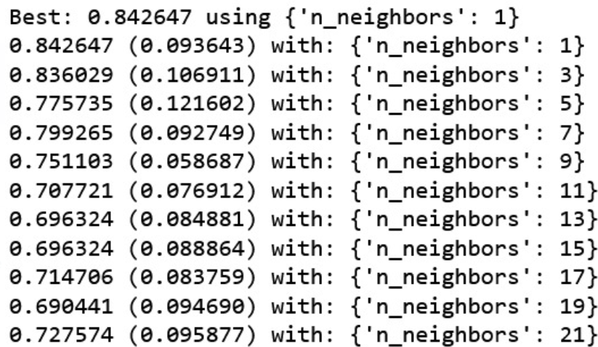

Table 2: Classification rate for knn
Model | mean | std
KNN | 0.758456 | 0.105791
Scaled KNN | 0.837500 | 0.102055

- Support Vector Machine
In the second set of observations, it is noticed that SVM works efficiently with polynomial kernel for both submarine rock and mine (see table 3)

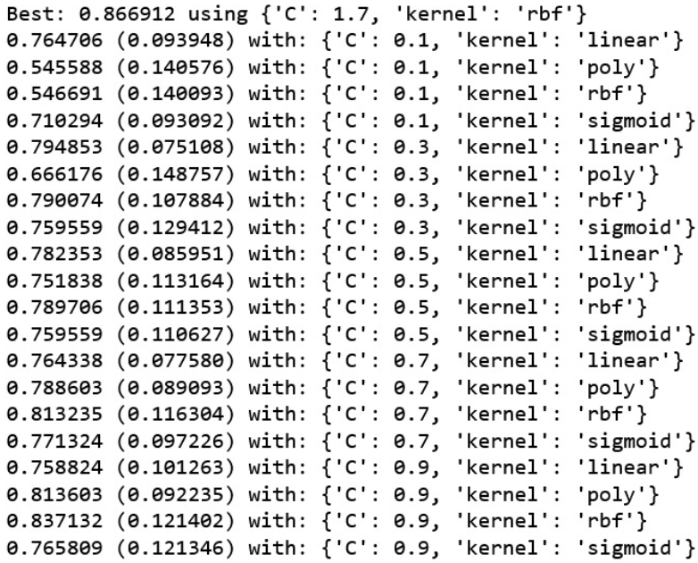
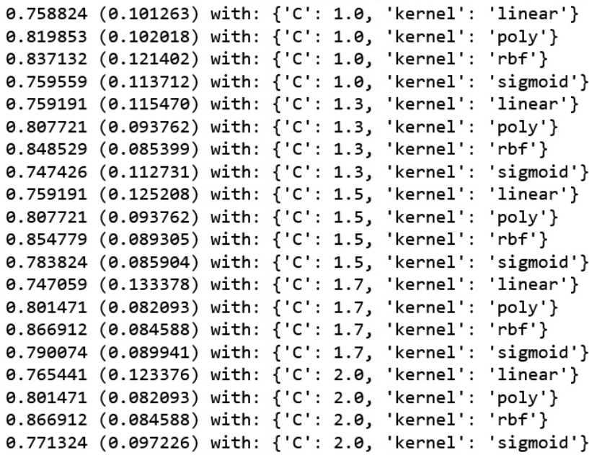

Table 3: Classification for svm

Model | mean | std
SVM | 0.601471 | 0.160777
Scaled SVM | 0.855147 | 0.091620

- Decision tree
As of the third batch decision tree performs accurately for the classification of submarine rock and mine (see table 4)

Table 4: Classification for decision tree
Model | mean | std
CART | 0.718382 | 0.092559
Scaled CART | 0.681250 | 0.103413

- Logistic Regression
For fourth set of findings, it executes deliberately with good accuracy (see table 5)

Table 5: Classification for logistic regression

Model | mean | std
LR | 0.770956 | 0.058802
Scaled LR | 0.818750 | 0.066706

- Confusion matrix
It displays the counts of true positives, true negatives, false positives, and false negatives which is shown below (see table 6)

Table 6: Values for confusion matrix

18 | 5
3 | 16

- Classification report
Confusion matrix helps to evaluate the model's accuracy, precision, recall, and other classification metrics shown below (see table 7)

Table 7: Values for classification report

 | Precision | Recall | F1-Score | Support
Mine | 0.86 | 0.78 | 0.82 | 23
Rock | 0.76 | 0.84 | 0.80 | 19
Accuracy | - | - | 0.81 | 42
Macro avg | 0.81 | 0.81 | 0.81 | 42
Weighted avg | 0.81 | 0.81 | 0.81 | 42

- Image dataset
In image dataset it contains images for both submarine rock and mine. Based on the image model will predict whether it is rock or mine (see table 8). The output results for submarine rock and mine detection is shown (see figure 1 and 2). It gives result with accuracy 100%.

Table 8: output results

Precision | 1.0
Result | 1.0
Accuracy | 1.0

Figure 1: Submarine rock

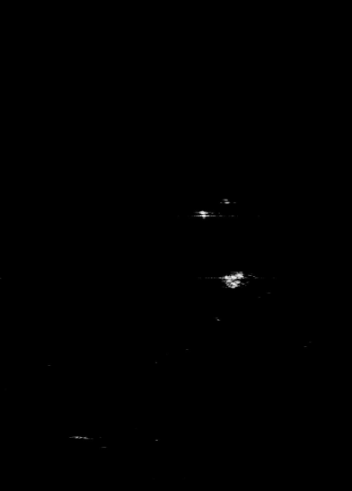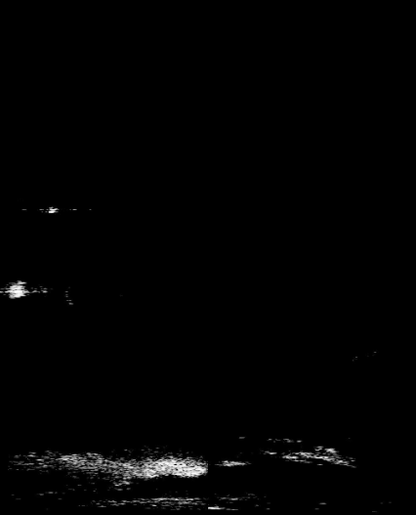

Figure 2: mine

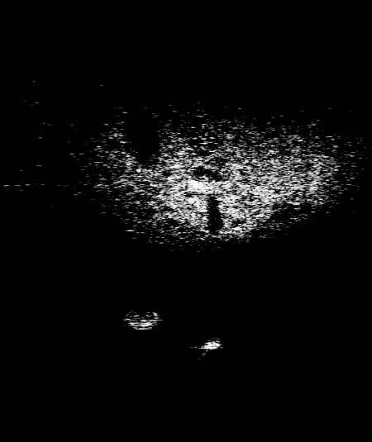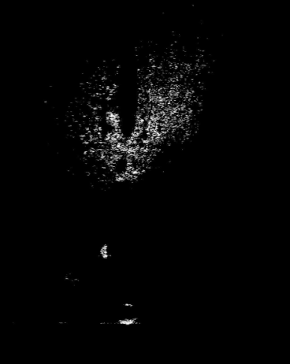

VIII.CONCLUSION

In conclusion, our study on underwater mine vs. rock detection utilizing both sonar transducer data values and sonar images has yielded valuable insights and outcomes. Through the application of Convolutional Neural Networks for sonar image classification, we have demonstrated the efficiency of deep learning in accurately discerning between submerged objects. Meanwhile, for sonar data values, our exploration of ensemble learning techniques has revealed that logistic regression emerges as the optimal choice, showcasing its proficiency in handling this specific type of data. The combination of these approaches not only enhances the robustness of our detection system but also underscores the importance of selecting the most suitable methods for different data modalities, ultimately contributing to more reliable and precise underwater object classification in challenging environments.

IX.FUTURE ENHANCEMENT

In future, some hybrid approaches can be used to get more efficient solutions. The field of submarine rock and mine detection is continually evolving, driven by advancements in technology and the need for improved safety and security in underwater environments. Here are some potential future enhancements like advanced sensor technologies it involves Integration of multi-modal sensors to capture a broader range of information about underwater objects, enhanced real-time data fusion techniques that combine data from multiple sensors. Technologies like sonar images from sonar transducer could be implemented for better enhancement of our model. This provides double standard verification for our model.

X.REFERENCES
- D. P. Williams, “The Mondrian detection algorithm for sonar imagery,”IEEE Trans. Geosci. Remote Sens., vol. 56, no. 2, pp. 1091–1102,Feb. 2018.
- Shantanu, Aman Saraf, Atharv Tiwari, Mukesh Kumar and S Manonmani, "Underwater Mines Detection using Neural Network", INTERNATIONAL JOURNAL OF ENGINEERING RESEARCH & TECHNOLOGY (IJERT), vol. 09, no. 04, April 2020 A
- RDNN for classification and prediction of Rock/Mine in underwater acoustics ORCiD0000-0003-1422-0330.
- S. Khaledi, H. Mann, J. Perkovich and S. Zayed, "Design of an underwater mine detection system", 2014 Systems and Information Engineering Design Symposium (SIEDS), pp. 78-83, 2014.
- Guy Gubnitsky , Asaf Giladi, and Roee Diamant, “Validation of Targets in Sonar Imagery Using Multispectral Analysis”, IEEE JOURNAL OF OCEANIC ENGINEERING, VOL. 47, NO. 4, OCTOBER 2022.
[6] Sheezan Fayaz, Shabir A. Parah, G. J. Qureshi,2021, "Underwater object detection: architectures and algorithms – a comprehensive review",DOI:10.1007/s11042-022-12502-1.
[7] M Sitha Ram, Palavalli Sai Navyatha, Ranga Laxmi Aparna Ashitha, Senapathi Anand Jagadeesh Kumar, “Machine Learning based Underwater Mine Detection”, DOI: 10.1109/ICICCS56967.2023. 10142384.
[8] Yue Sun, Peng Yuan and Guijuan L, “Research on Classification and Recognition of Underwater Targets Based on Spark’s Decision Tree Technolog”, 2020 IEEE.
[9] Konstantinos Pelekanakis, Luca Cazzanti, Giovanni Zappa and João Alves, “Decision Tree-Based Adaptive Modulation for Underwater Acoustic Communications”, IEEE Xplore.
[10] Leonardo Zacchini, Alberto Topini, Matteo Franchi , Nicola Secciani , Vincenzo Manzari, Lorenzo Bazzarello, Mirko Stifani and Alessandro Ridolfi , “Autonomous Underwater Environment Perceiving and Modeling: An Experimental Campaign With FeelHippo AUV for Forward Looking Sonar-Based Automatic Target Recognition and Data Association”, IEEE JOURNAL OF OCEANIC ENGINEERING, VOL. 48, NO. 2, APRIL 2023.
[11] Stanisław Ho˙zy ´n, “A Review of Underwater Mine Detection and Classification in Sonar Imagery”, Electronics 2021, 10, 2943. https://doi.org/10.3390/electronics10232943.
[12] Guy Gubnitsky , Asaf Giladi, and Roee Diamant, “Validation of Targets in Sonar Imagery Using Multispectral Analysis”, IEEE JOURNAL OF OCEANIC ENGINEERING, VOL. 47, NO. 4, OCTOBER 2022.
[13] Monika S, Shakthi Sagar M, Merin Meleet, “Prediction of Underwater Sonar Targets”, IJARCCE, DOI: 10.17148/IJARCCE.2022.11793.
[14] Yiping Xie , Nils Bore , and John Folkesson, “Bathymetric Reconstruction From Sidescan Sonar With Deep Neural Networks”, IEEE JOURNAL OF OCEANIC ENGINEERING, VOL. 48, NO. 2, APRIL 2023.
[15] Elakkiya S, Jincy Francis, Rejina Parvin J, Tamilmalar S.N, “Classification of SONAR Targets Using Advanced Neural Classifiers”, IJPAM, Volume 114 No. 12 2017, 627-637.
[16] Jun Liu, Yu Gou, Tong Zhang, Xinyi Jiang, XinQi Du, XuanZhang, “A-KNN: An adaptive method for constructing high-resolution ocean models”, IEEE
[17] S. C. James, Y. Zhang, and F. O’Donncha, “A machine learning framework to forecast wave conditions,” Coastal Engineering, vol. 137, pp. 1–10, 2018.
[18] Padmaja, V., Rajendran, V. Vijayalakshmi, P, “Study on metal mine detection from underwater sonar images using data mining and machine learning techniques”, Springer, J Ambient Intell Human Comput12,5083–5092(2021).https://doi.org/10.1007/s12652-020-01958-4.
[19] Danesh, S.A.; “Real Time Active Sonar Simulation in a Deep Ocean Environment”, Massachusetts Institute of Technology: Cambridge, MA, USA, 2013.

[20] Guangyao Han; Junfei Cui; Yishan Su; Xiaomei Fu “Human Vision System based Sparse Wavelet Transform for Underwater Acoustic Sonar Image Transmission”, IEEE

