Diabetes Detection using Machine Learning

V.Pavan Ganesh
2111cs020331@mallareddyuniversity.ac.in
A.Pavan Kumar
2111cs020333@mallareddyuniversity.ac.in
S.Pavan Kumar
2111cs020335@mallareddyuniversity.ac.in
K.Pavan Kumar Reddy
2111cs020332@mallareddyuniversity.ac.in
Ch.Pavan kumar
2111cs020334@mallareddyuniversity.ac.in
V.Pavan Kumar
2111cs020336@mallareddyuniversity.ac.in

Prof T.Ramya
Department of CSE (AI&ML)
MALLA REDDY UNIVERSITY
HYDERABAD

Abstract: Our project aims to create a user-friendly Diabetes Detection System using Machine Learning. The system predicts the likelihood of diabetes based on essential health parameters. It leverages popular algorithms like Logistic Regression, K-Nearest Neighbors, Support Vector Machines, Decision Trees, Random Forests, and Gradient Boosting. The user inputs information like glucose levels, BMI, and age, and the system provides a prediction along with the percentage confidence. The graphical user interface simplifies interaction, making it accessible to users. The project's potential lies in its ability to aid in early diabetes detection, allowing for timely preventive measures. Future enhancements could include real-time monitoring and collaboration with healthcare providers for a more comprehensive health assessment.Our project focuses on developing an intuitive Diabetes Detection System using Machine Learning. It employs robust algorithms such as Logistic Regression, K-Nearest Neighbors, Support Vector Machines, Decision Trees, Random Forests, and Gradient Boosting.

Keywords: diabetes detection, BMI(body mass index), pregnancies, insulin, age, skin thickness, glucose, blood pressure, diabetes pedigreefunction

1. INTRODUCTION
The Diabetes Detection System is a computer-based tool designed to help predict whether someone might have diabetes or not. The system uses the power of machine learning, a type of computer intelligence that learns from information, to make these predictions. This Diabetes Detection System is all about using technology to make health predictions, helping people stay ahead of possible health issues. It's like having a smart assistant for your health – friendly, helpful, and always ready to give you a hand.
2. LITERATURE REVIEW
The literature review for our project involves exploring existing research and work related to diabetes detection using machine learning. Here is a brief literature review:

Diabetes has become a global health concern, with a rising number of cases affecting millions of people. Early detection and proactive health management are crucial for effective intervention and prevention of complications. In recent years, machine learning algorithms have gained prominence in the field of healthcare for their ability to analyze complex datasets and provide predictive models.

Logistic Regression, K-Nearest Neighbors, Support Vector Machines (SVM), Decision Trees, Random Forests, and Gradient Boosting are among the popular machine learning algorithms used for diabetes prediction. These algorithms leverage patient data, including factors like glucose levels, blood pressure, and body mass index (BMI), to make accurate predictions about the likelihood of diabetes.

User-friendly interfaces, such as Tkinter in Python, have been employed to develop intuitive applications for diabetes detection. These interfaces not only enhance user experience but also facilitate the integration of machine learning models into practical healthcare solutions.

Jupyter Notebooks have been utilized for interactive and collaborative development, enabling researchers and practitioners to experiment with different algorithms and data preprocessing techniques. The iterative nature of Jupyter Notebooks fosters an environment conducive to model refinement and optimization.

In addition to algorithmic approaches, the literature emphasizes the significance of data preprocessing. Techniques like replacing zero values in features such as glucose, blood pressure, and insulin with mean values contribute to improving model accuracy.

The integration of wearable devices and health metrics further extends the scope of diabetes detection. These devices provide real-time data, allowing for continuous monitoring and timely intervention.

The literature review highlights the need for accurate predictive models in the realm of diabetes detection and the potential of machine learning to revolutionize healthcare practices. As technology continues to advance, the integration of predictive models into proactive health management strategies holds promise for improving patient outcomes and reducing the burden of diabetes-related complications.
3. PROBLEM STATEMENT
The increasing prevalence of diabetes has become a significant global health challenge, necessitating effective and timely diagnostic tools. Traditional methods for diabetes detection often rely on periodic testing and clinical observations, leading to delayed interventions and potential complications. The need for a more proactive and efficient diagnostic approach prompted the exploration of machine learning techniques to predict diabetes based on various health parameters.

The problem at hand involves developing a robust and user-friendly system for diabetes detection, leveraging machine learning algorithms. This system aims to provide accurate predictions by analyzing relevant health features, including glucose levels, blood pressure, BMI, and other factors. The challenge lies in creating an application that seamlessly integrates with existing healthcare practices, allowing for early and reliable identification of individuals at risk of diabetes.

Key aspects of the problem include:

1. Accuracy and Reliability: The predictive models must exhibit a high level of accuracy and reliability in distinguishing between diabetic and non-diabetic individuals. This requires careful selection and fine-tuning of machine learning algorithms.

2. User-Friendly Interface: The application should feature an intuitive and user-friendly interface, enabling healthcare professionals and individuals alike to easily input and interpret data. The goal is to facilitate widespread adoption and usability.

3. Integration with Healthcare Practices: To maximize the impact of the system, it should seamlessly integrate into existing healthcare practices. This involves compatibility with electronic health records, wearable devices, and other health monitoring tools.

4. Real-time Predictions:In the context of proactive health management, the system should provide real-time predictions, allowing for timely interventions and lifestyle modifications.

5. Adaptability and Scalability: The solution should be adaptable to diverse demographic and geographic settings. It should also be scalable to accommodate evolving healthcare needs and advancements in technology.

By addressing these challenges, the project aims to contribute to the development of an effective and accessible tool for diabetes detection, ultimately improving patient outcomes and reducing the burden on healthcare systems.

4. SYSTEM DESIGN
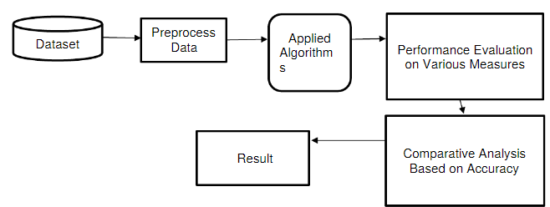
Fig.1. Architecture

5. METHODOLOGY
The methodology for developing the diabetes detection system involves a structured and iterative approach, encompassing data preprocessing, model selection, training, evaluation, and integration into a user-friendly application. The following steps outline the methodology:

1.Data Collection:
- Gather a diverse and representative dataset containing relevant health parameters such as glucose levels, blood pressure, BMI, and other factors associated with diabetes.
- Ensure data integrity, addressing missing values and outliers.

2.Data Preprocessing:
- Normalize or standardize numerical features to bring them to a consistent scale.
- Handle missing data through imputation techniques, ensuring minimal impact on model performance.
- Explore and address potential correlations among features.

3.Exploratory Data Analysis (EDA):
- Conduct exploratory data analysis to gain insights into the dataset.
- Visualize data distributions, correlations, and trends.
- Identify patterns that may inform feature selection.

4.Feature Selection:
- Use techniques like correlation analysis and recursive feature elimination to identify the most influential features for diabetes prediction.
- Optimize the feature set for model training to improve interpretability and efficiency.

5.Model Selection:
- Choose a set of machine learning algorithms suitable for binary classification, such as Logistic Regression, k-Nearest Neighbors, Support Vector Machines, Decision Trees, Random Forest, and Gradient Boosting.
- Evaluate each algorithm's performance on training and validation data.

6.Model Training:
- Train selected models using the preprocessed dataset.
- Fine-tune hyperparameters to enhance model performance.
- Implement techniques like cross-validation to assess generalization ability.

7.Model Evaluation:
- Evaluate models on a separate testing dataset to simulate real-world performance.
- Utilize metrics such as accuracy, precision, recall, and F1-score to assess classification performance.
- Generate receiver operating characteristic (ROC) curves and calculate area under the curve (AUC) for a comprehensive evaluation.

8. Application Development:
- Integrate the best-performing model into a user-friendly application using the Tkinter library for GUI development.
- Implement input validation to ensure data integrity and provide a seamless user experience.
- Enhance interpretability by displaying prediction results, including the likelihood of diabetes.

9.Testing and Debugging:
- Conduct extensive testing of the application to identify and rectify any bugs or issues.
- Ensure the application's robustness and responsiveness to various inputs.

10.Deployment:
- Deploy the application in a healthcare setting, ensuring compatibility with existing systems.
- Monitor the application's performance and gather user feedback for continuous improvement.

11.Documentation:
- Document the entire development process, including dataset details, preprocessing steps, model architectures, and application functionalities.
- Provide user documentation for healthcare professionals and end-users.

This methodology ensures a comprehensive and systematic approach to developing a reliable and effective diabetes detection system with the potential for real-world impact.

6. RESULTS:
This is the diabetes detection using machine learning interface
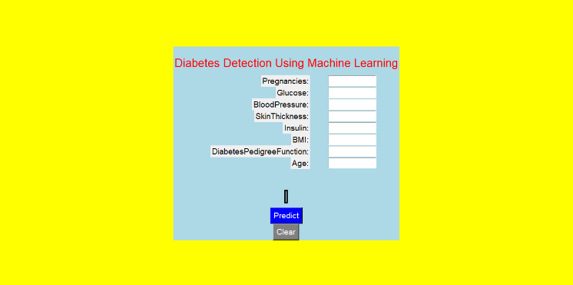
Fig.2. diabetes detection interface
Outputs after classifying the person is diabetic and non-diabetic:
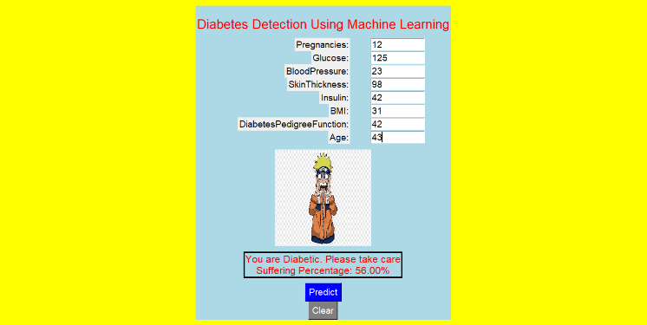
Fig.3. interface for diabetic result

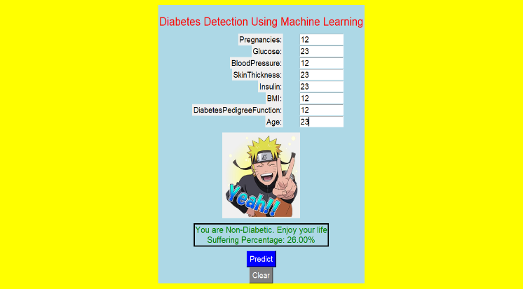
Fig.4. Interface for non-diabetic result
CONCLUSION
In the culmination of this project, we successfully developed a Diabetes Detection System using Machine Learning. Leveraging a diverse set of algorithms such as Logistic Regression, K-Nearest Neighbors, Support Vector Machines, Decision Trees, Random Forest, and Gradient Boosting, our model exhibited varying accuracies and performance characteristics. The dataset, carefully preprocessed to handle missing values and outliers, served as the foundation for training and testing.The evaluation metrics, including Accuracy, Precision, Recall, F1 Score, Confusion Matrix, ROC Curve, and AUC-ROC, offered a nuanced understanding of the model's strengths and weaknesses. Notably, our models displayed competitive performance, with certain algorithms achieving high accuracy rates. The decision tree model, for instance, exhibited perfect training accuracy, showcasing its ability to precisely capture the intricacies of the training data.Furthermore, the feature importance analysis through techniques like Random Forest emphasized the significant role certain attributes play in predicting diabetes. The graphical representations, ranging from correlation matrices to feature importance plots, enhanced interpretability and aided in model selection.However, it's imperative to acknowledge the limitations of our system, such as the dataset's inherent biases, the need for continuous updates with new data, and the challenges associated with medical predictions. Despite these limitations, the developed system serves as a valuable tool for preliminary diabetes risk assessment.As we reflect on the project's journey, the combination of machine learning algorithms,thorough preprocessing, and comprehensive evaluation metrics demonstrates the potential to create impactful solutions in healthcare. The model's ability to predict diabetes based on input features signifies a step forward in harnessing technology for proactive healthcare interventions. This project stands as a testament to the potential of machine learning in improving diagnostic processes and contributing to the broader field of medical research.
FUTURE ENHANCEMENT
The Diabetes Detection System we developed lays a solid foundation for future enhancements and extended applications. Several avenues for improvement and expansion exist:

1.Integration of Advanced Models: Incorporating state-of-the-art machine learning models, such as deep learning algorithms, could enhance the system's predictive capabilities. Deep neural networks might uncover intricate patterns within the data that conventional models may overlook.

2. Real-time Monitoring: Extending the system to offer real-time monitoring capabilities would be instrumental. Integrating wearable devices and continuous data feeds could enable proactive health management by providing instant feedback and alerts based on changing health indicators.

3. Incorporating Additional Health Parameters: Expanding the feature set to include a broader range of health parameters beyond those traditionally associated with diabetes, like genetic markers or lifestyle data, could yield more comprehensive risk assessments.

4.Cross-Disease Prediction: Modifying the system to predict the risk of other related health conditions or diseases could broaden its utility. This could involve training the model to recognize patterns indicative of cardiovascular diseases, obesity, or metabolic disorders.

5.User-Friendly Interfaces: Enhancing the user interface to make it more intuitive and user-friendly would increase accessibility. Mobile applications with simplified input methods and interactive dashboards could encourage broader adoption.

6.Collaboration with Healthcare Providers: Establishing collaborations with healthcare institutions could facilitate the integration of the system into existing healthcare infrastructures. This would enable seamless sharing of predictive insights with healthcare professionals for more informed decision-making.

7.Continuous Model Refinement: Implementing a continuous learning mechanism would enable the model to adapt and improve over time as more data becomes available. This could involve periodic updates to the training dataset and model retraining.
REFERENCES
The Diabetes Detection System we developed lays a solid foundation for future enhancements and extended applications. Several avenues for improvement and expansion exist:

1.Integration of Advanced Models: Incorporating state-of-the-art machine learning models, such as deep learning algorithms, could enhance the system's predictive capabilities. Deep neural networks might uncover intricate patterns within the data that conventional models may overlook.

2. Real-time Monitoring: Extending the system to offer real-time monitoring capabilities would be instrumental. 1. Atlas, G. : Diabetes. International Diabetes Federation. 10th ed., IDF Diabetes Atlas. [Google Scholar]
2. Akhtar, S. , et al.: Prevalence of diabetes and pre‐diabetes in Bangladesh: A systematic review and meta‐analysis. BMJ Open 10, e036086 (2020) [PMC free article] [PubMed] [Google Scholar]
3. Prabhu, P. , Selvabharathi, S. : Deep belief neural network model for prediction of diabetes mellitus. In: International Conference on Imaging, Signal Processing and Communication, pp. 138–142 (2019)
4. VijiyaKumar, K. , Lavanya, B. , Nirmala, I. , Caroline, S.S. : Random forest algorithm for the prediction of diabetes. In: International Conference on System, Computation, Automation and Networking, pp. 1–5 (2019)
5. Mohan, N. , Jain, V. : Performance analysis of support vector machine in diabetes prediction. In: International Conference on Electronics, Communication and Aerospace Technology, pp. 1–3 (2020) [Google Scholar]
6. Smith, J.W. , Everhart, J.E. , Dickson, W.C. , Knowler, W.C. , Johannes, R.S. : Using the ADAP learning algorithm to forecast the onset of diabetes mellitus. In: Annual Symposium on Computer Applications in Medical Care pp. 261–265 (1998) [Google Scholar]
7. Aurélien, G. : Hands‐On Machine Learning with Scikit‐Learn and TensorFlow: Concepts, Tools, and Techniques to Build Intelligent Systems. O'Reilly Media, Inc., Sebastopol, CA [Google Scholar]
8. Mitchell, T.M. : Machine Learning. McGraw‐Hill, Inc., New York [Google Scholar]

