THE IMPACTS OF MICRO FINANCING ON THE PERFORMANCE OF WOMEN ENTREPRENEUR

AUTHOR
A.Varun Kartik BBA LLB (HONS)
Saveetha School of Law
Saveetha Institute of Medical andTechnical Sciences (SIMATS)

CO-AUTHOR
Mr. Gautham Shanmugam B.E.. M.B.A
Assistant Professor of law
Department of management
Saveetha School of Law
Saveetha Institute of Medical andTechnical Sciences (SIMATS)

THE IMPACTS OF MICRO FINANCING ON THE PERFORMANCE OF WOMEN ENTREPRENEUR
Author: A.Varun kartik
Co-author: Mr. Gautham Shanmugam
Abstract:
Microfinance on women entrepreneurship is growing as a powerful instrument to promote rural employment in the present-day economy. Most of financial services and microfinance schemes have come up with various related services for reducing poverty and empowering the women of the society. Micro Finance is growing as a effective instrument for poverty remedy in the new fiscal system. A maturity of the microfinance programmes has give you with the clean end of reducing poverty and empowering ladies. Microfinance operations like the tone help bank relation operation in India were precipitously dealing for their fantastic profitable impact and the belief that they empower women. Research has shown that investing in ladies gives the only manner to ameliorate fitness, nutrients, hygiene, and academic norms for families and accordingly for the complete of society. Hence, a special help for women in both profitable and non- profitable immolations is vital numerous leading public and particular quarter banks are furnishing schemes solely designed for girls to set up their veritably own gambles. The prevailing work is an attempt to examine the position of microfinance as an important tool in promoting girls entrepreneurship in India. The research method followed here is empirical research. A total of 200 samples have been taken out of which is taken through convenient sampling methods. The sample frames taken by the researcher are various people from online. Now, the need is for knowledge regarding availability to loans, colorful backing agencies, procedures regarding instrument, mindfulness on government weal programmes, provocation, specialized skill and support from family government and other organisation.

Keynotes: Entrepreneur, Women , Microfinance, Education, Business

Introduction:

The term micro finance is of recent origin and is generally used in addressing issues related to poverty relief, fiscal support to micro entrepreneurs, gender development etc. There is, still, no statutory description of micro finance. The taskforce on supportitative policy and Regulatory Framework for Microfinance has defined microfinance as “ Provision of providence, credit and other fiscal services and products of veritably small quantities to the poor in pastoral, semi-civic or civic areas for enabling them to raise their income situations and ameliorate living norms ”. The term “ Micro ” literally means “ small ”. But the task force has not defined any quantum. still as per Micro Credit Special Cell of the Reserve Bank Of India. All over the world, the significant of women entry into the pool over the once three decades has produced profound metamorphoses in the association of families, society, the frugality, and civic life. Since the late 1950s, women's profitable conditioning have been steadily adding. Women have always laboriously shared in their original husbandry. In Africa, for illustration, women produce 80 percent of the food and in Asia 60 percent and in Latin America 40 percent. In numerous cases, women not only produce the food but request it as well, which gives them a well- developed knowledge of original requests and guests. This is a small illustration of the significance of women's work in society. It doesn't illustrate the real extent of women's donation, especially in developing countries, not only to the labour force, but also their part as a significant income- source for the family. Women, especially poor maters , must divide their time between work" productive part" and family" reproductive part", and balancing all the demands. Time is precious for these women, as their livelihoods depend largely on their capability to fulfil the multiple demands of the ménage and the business. In malignancy of the remarkable significance of women's participation, their jobs have been considered as an" redundant income" to family survival or simply to ameliorate its living conditions. also, microenterprises possessed by women have been considered as a way to meet primary requirements rather of a profitable source of income. part of Microfinance in Women Entrepreneurship is although men, as well as women, face difficulties in establishing an fresh enterprise, women have walls to overcome. Among them are negative socio-artistic stations, legal walls, practical external walls, lack of education and particular difficulties. In malignancy of this, for women and especially for poor women, microenterprise power has surfaced as a strategy for provident survival. One of the most essential factors contributing to success in micro entrepreneurship is access to capital and fiscal services. For colorful reasons, women have had less access to these services than men. In this environment, credit for microenterprise development has been a pivotal issue over the once two decades. Research has shown that investing in women offers the most effective means to ameliorate health, nutrition, hygiene, and educational norms for families and accordingly for the total of society. therefore, a special support for women in both fiscal andnon-financial services is necessary. Regarding limited- access to fiscal services, women depend largely on their own limited cash coffers or, in some cases, loans from extended family members for investment capital. lower quantities of investment capital effectively limit women to a narrow range of low- return conditioning which bear minimum capital expenses, many tools and outfit and calculate on ranch yield or affordable raw accoutrements . Aim is to study on impact of micro financing on the performance of women entrepreneur.

Objectives:

- To explore the Role of Women in Economy.
- To assess the Microfinance as an instrument for Women Entrepreneurship.
- To evaluate the effectiveness of Microfinance as an instrument for the development of Women Entrepreneurship.

Review of literature:
The modern concept of microfinance was found in the 1970s when Muhammad Yunus established Grameen Bank in Bangladesh.(Travis 2013; Godwin 2003) The establishment of Grameen Bank in Bangladesh has seen the role of microfinance as important source of financial resource (capital) for women entrepreneurs. Microfinance as defined by World Bank Report.(Bayer 2007; Dinwoodie 2017) Microfinance as “provision of a broad range of financial services such as deposits, loans, payment services, money transfers and insurance to poor and low- income households and their micro enterprises”.(Bayer 2007) It argues, access to financing as one of the most critical factors contributing to business success and it is also the greatest single issue faced by women entrepreneurs to start-up their business.(Apa and Pollicino 2013) Financial resources as internal resources are the key to business success.(Riordan 2016) Women mostly labelled as “risky” borrowers and less credit worthy than men which make them difficult to secure financial capital that is crucial for their business grow.(Riordan 2016; Taddeo and Floridi 2017) The poor and women entrepreneurs do not have experience in running business, borrowing and repayment financial history, also the amount requested are small make financial institutions are hesitant to consider as it is not cost effective .(MacKinnon et al. 2015) financial resource is identified as major barriers for women entrepreneurs in starting and running business , microfinance is financial services that are made available to those who would not normally have access to it and has been increasingly recognised as a powerful tool to rejuvenate struggling economies . Microfinance plays as capital resource for entrepreneurs and create opportunity for entrepreneurs to generate income. (Akdeniz 2016) Most of previous studies agreed that credit assistance to entrepreneurs especially women, aids entrepreneurs performance which best resulted in improved income, output, investment, employment and welfare of the entrepreneurs. (Beldiman 2015) The Study conducted in Nigeria, Tanzania, Haiti, Kenya, Malawi were found to have positive impact on women entrepreneurs’ performance. (Frankel and Gervais 2014) The study conducted by Ekpe in Nigeria also supported that microfinance has positive impact on women entrepreneurs’ performance.(Potts 2011) Fairlie & Robb resulted the same on their study on survey conducted by U.S Bureau of the Census, lower levels of start up capital and previous work experience tend to lower performance of women owned firms. (Wang 2018) The study of accessing microfinance provider in Sri Lanka has identified that microfinance as an effective mechanism in providing financial services and recognized as an effective mechanism for bringing equal opportunity for women by providing capital through repayment technologies. (Gathegi et al. 2014) The study greed, microcredit financing significantly lead to the success and positively affect to entrepreneurs success. (Rowland, Kohl, and Charlesworth 2016) The study identify the relationship and effect of mi- crofinance on the women entrepreneurs in Pakistan. This study divided into two parts, in the first part try to investigate the small medium enterprises entrepreneurial orientation in Khabar pakhton khowayn (KPK) and the se- cond part consisted of Likert scale.(Turenne 2015) The study conducted the research on Role of Microfinance Institutions in Entrepreneurship Development in Pakistan.(Smith 2007) The aim was of the study was to measure the role of microfinance institutions in entrepreneurship development and also measure the level of satisfaction to words their clients.(Lichtman and Posner, n.d.) It found that a substantial amount of women’s loans is straight spent by male kin, yet the female borrowers bear the obligation for reimbursement. (Friedmann 2015) The author conducted research on” Role of microfinance fac- tors on the sustainability of women managed micro and small enterprises (MSEs) in Kenya”.(Rimmer 2007) It claims, the awfully poor might use microcredit as a means to deal with unanticipated expenditures and fre- quently become trapped in indebtedness.(Travis 2013)

Methodology:
The research methodology followed here is empirical research. A total of 200 samples have been taken out of which is taken through convenience sampling. Independent variables used in the research are age, gender, income and education qualification . The dependent variables are that, Does micro-financing help in the performance of women entrepreneurs? ,Is education really important for micro financing? The statistical tool used by the researcher is correlation and graphical representation.

Analysis:

FIGURE 1

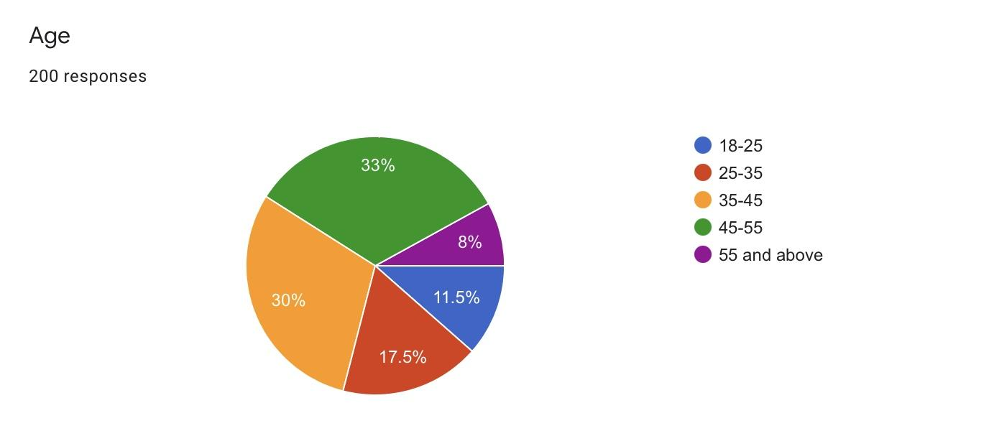

LEGEND - FIGURE 1 Shows the various age groups pertaining to the age of the respondents.

FIGURE 2

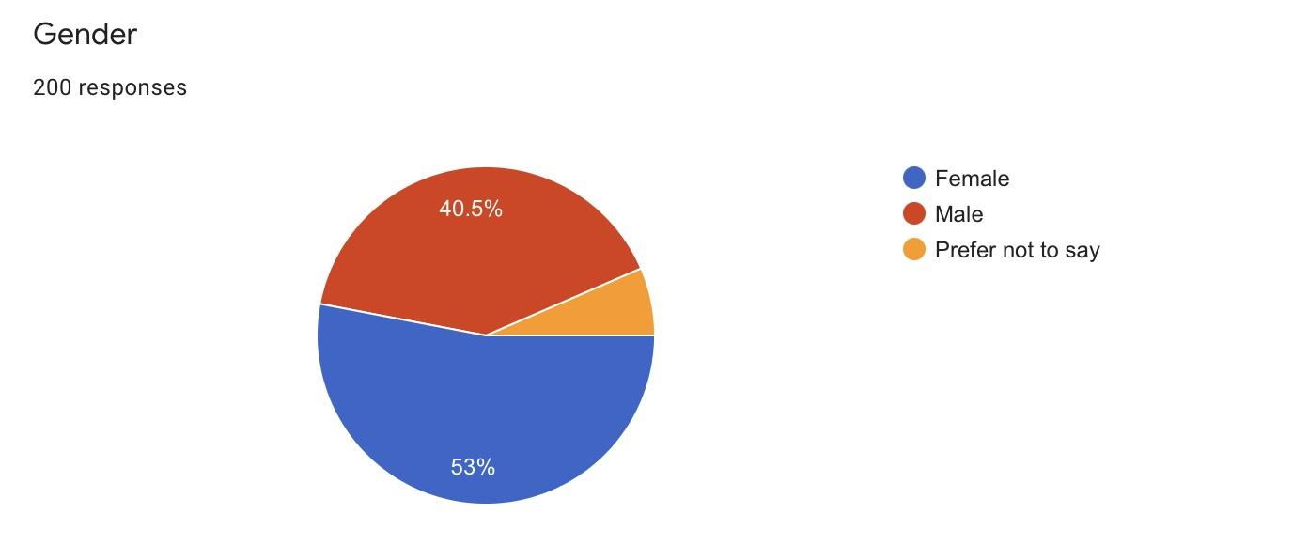

LEGEND- FIGURE 2 Shows the various age groups pertaining to the gender of the respondents.

FIGURE 3

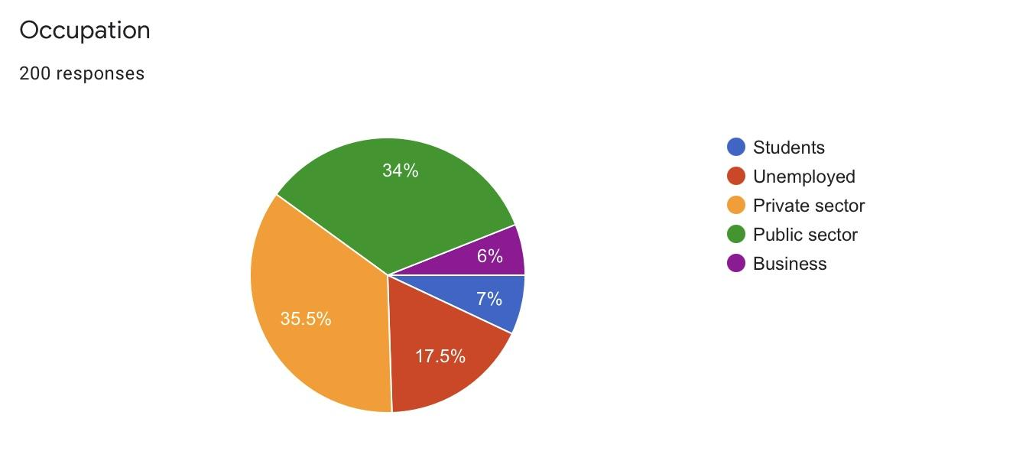

LEGEND- FIGURE 3 Shows the various age groups pertaining to the occupation of the respondents.

FIGURE 4
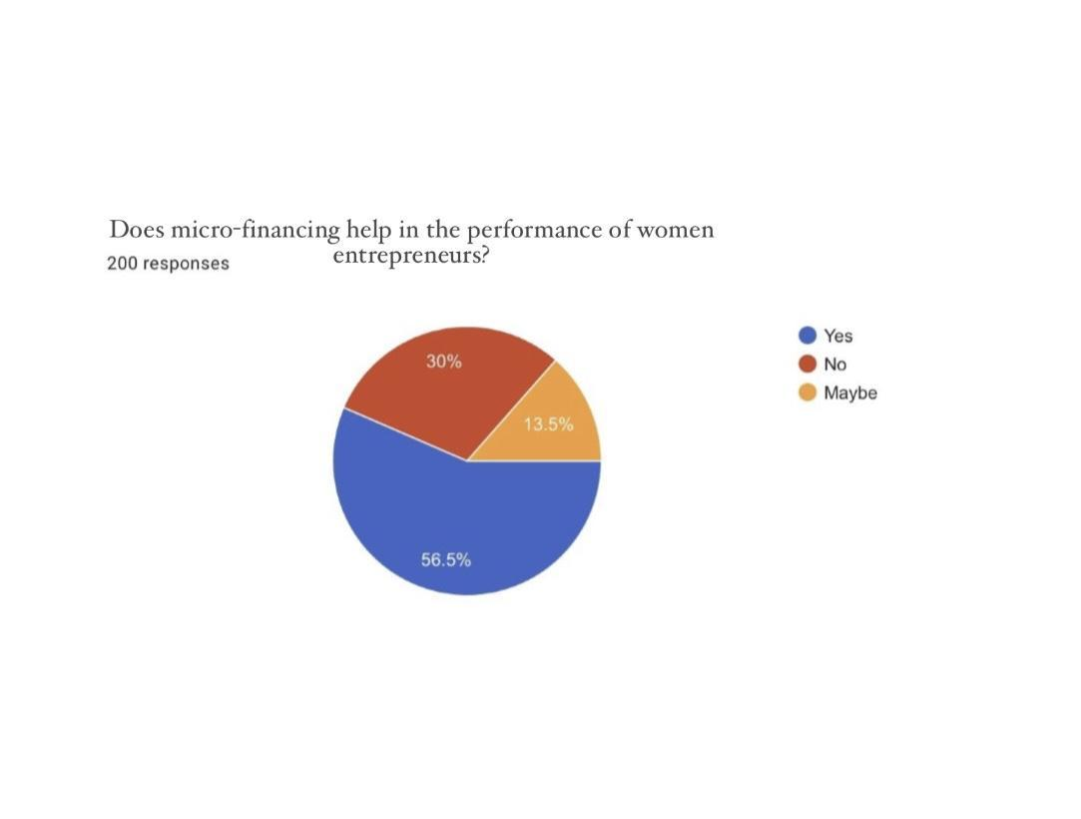LEGEND- FIGURE 4 Shows the various age groups pertaining to the respondents and their opinion on does microfinance help in the performance of women entrepreneurs.

FIGURE 5
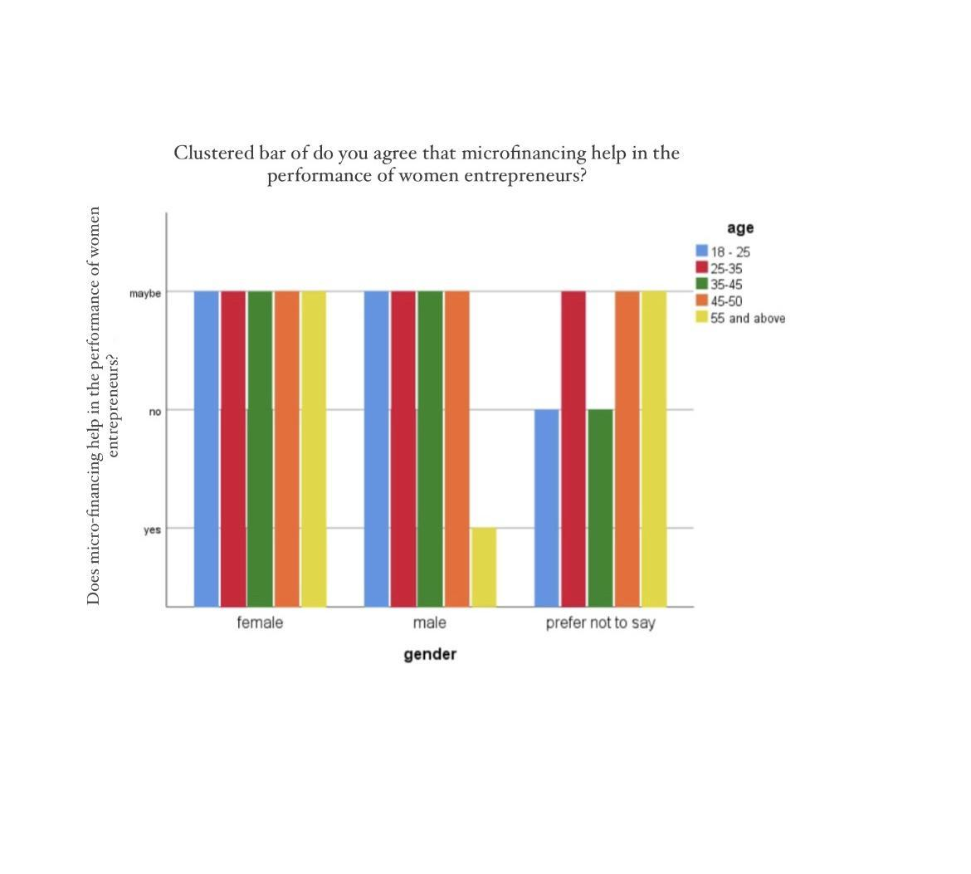LEGEND- FIGURE 5 Shows the various age groups pertaining to the gender and age of the respondents and their opinion on does microfinance help in the performance of women entrepreneurs.

FIGURE 6
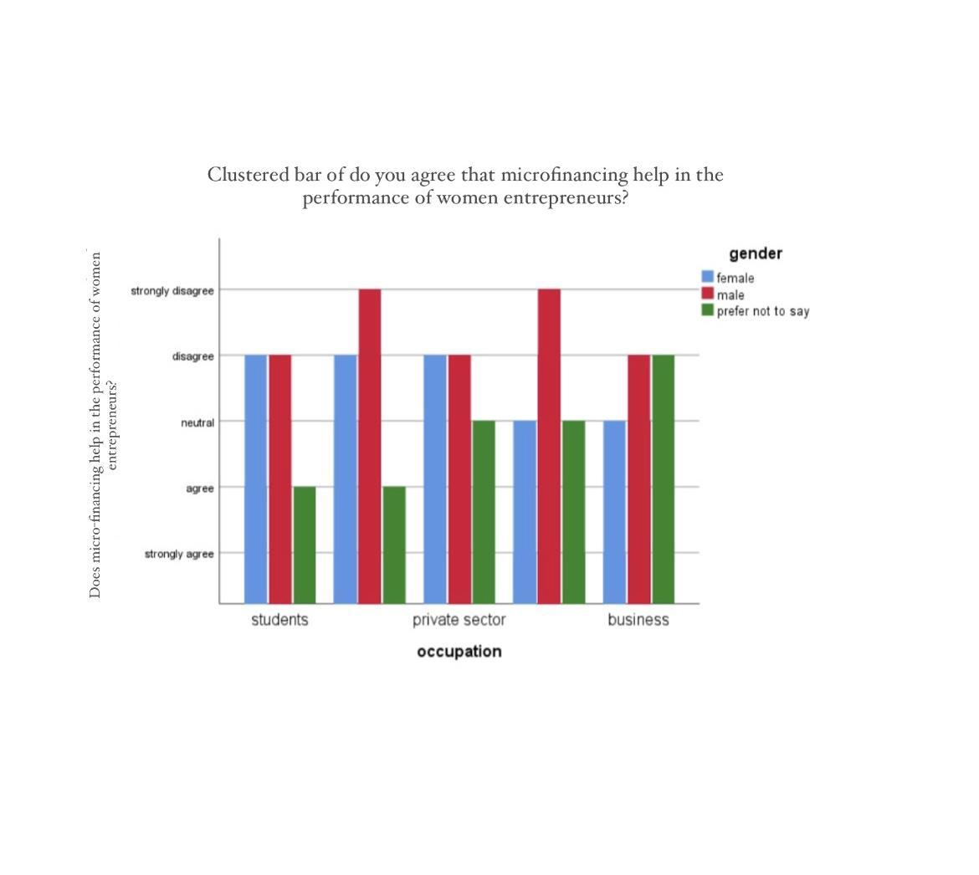LEGEND- FIGURE 6 Shows the various age groups pertaining to the occupation and gender of the respondents and their opinion on does microfinance help in the performance of women entrepreneurs.

FIGURE 7

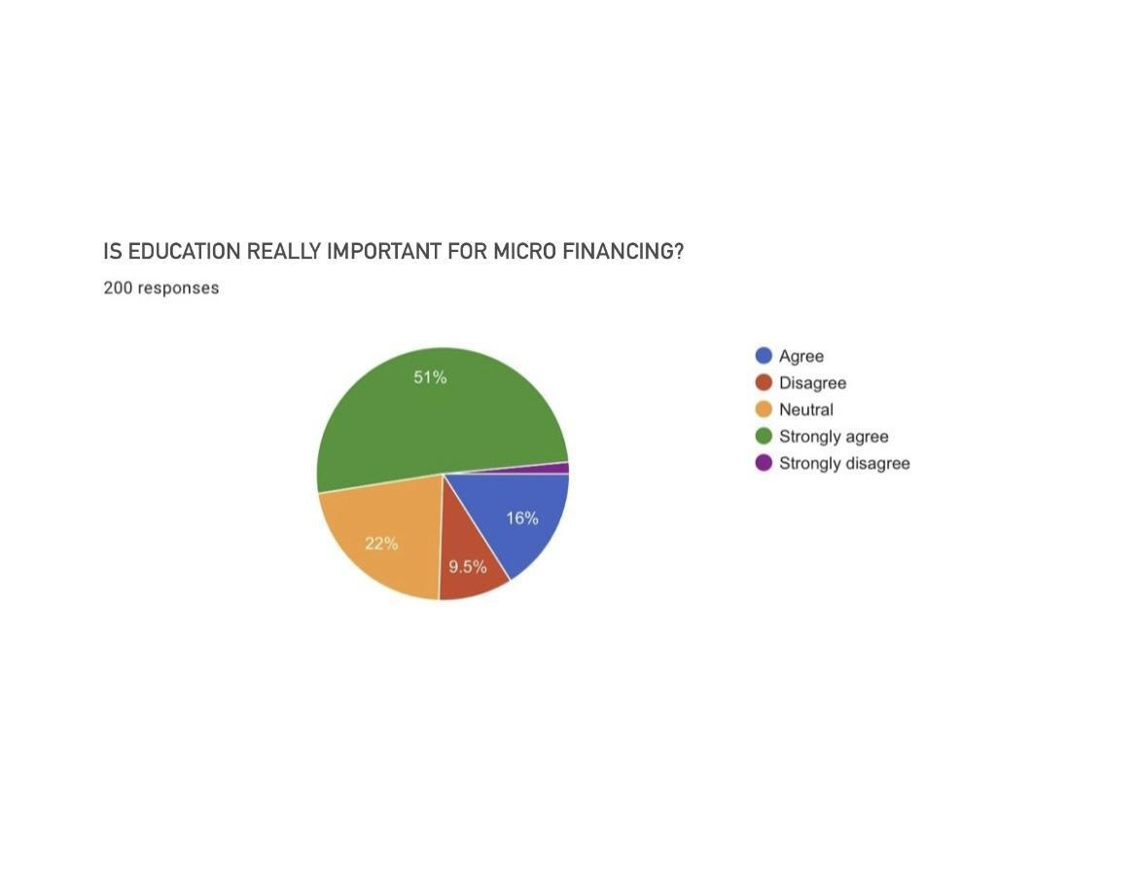LEGEND- FIGURE 7 Shows the various age groups pertaining to the respondents and their opinion on education really important for micre financing.

FIGURE 8
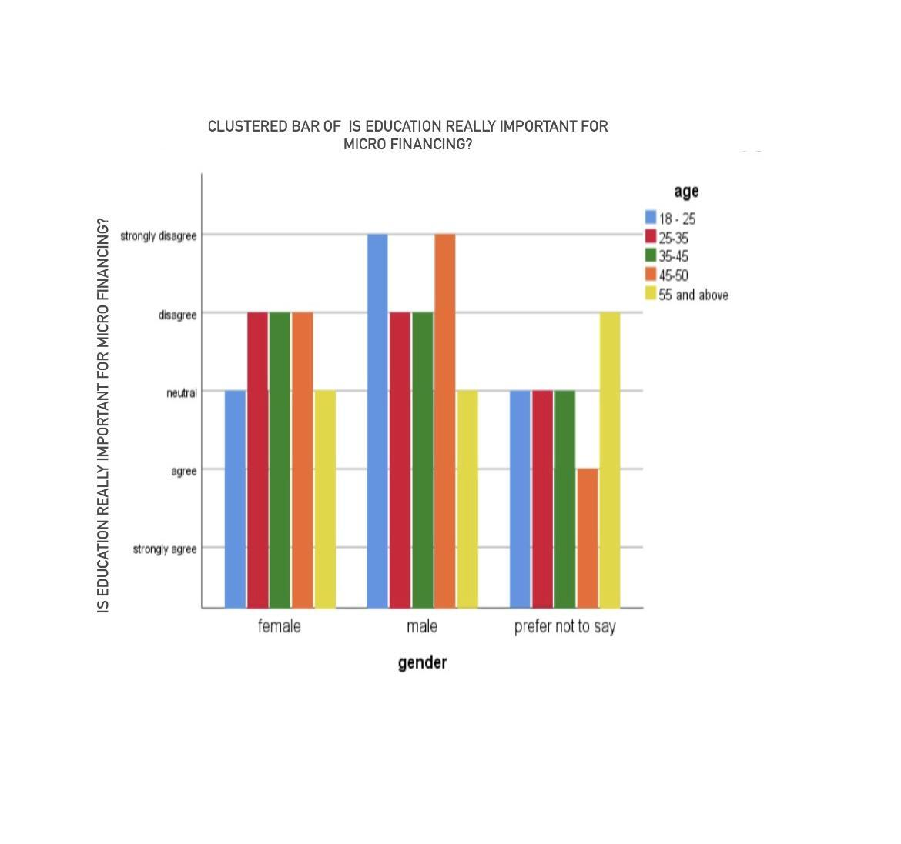
LEGEND- FIGURE 8 Shows the various age groups pertaining to the gender and age of the respondents and their opinion on do education really important for micre financing.

FIGURE 9
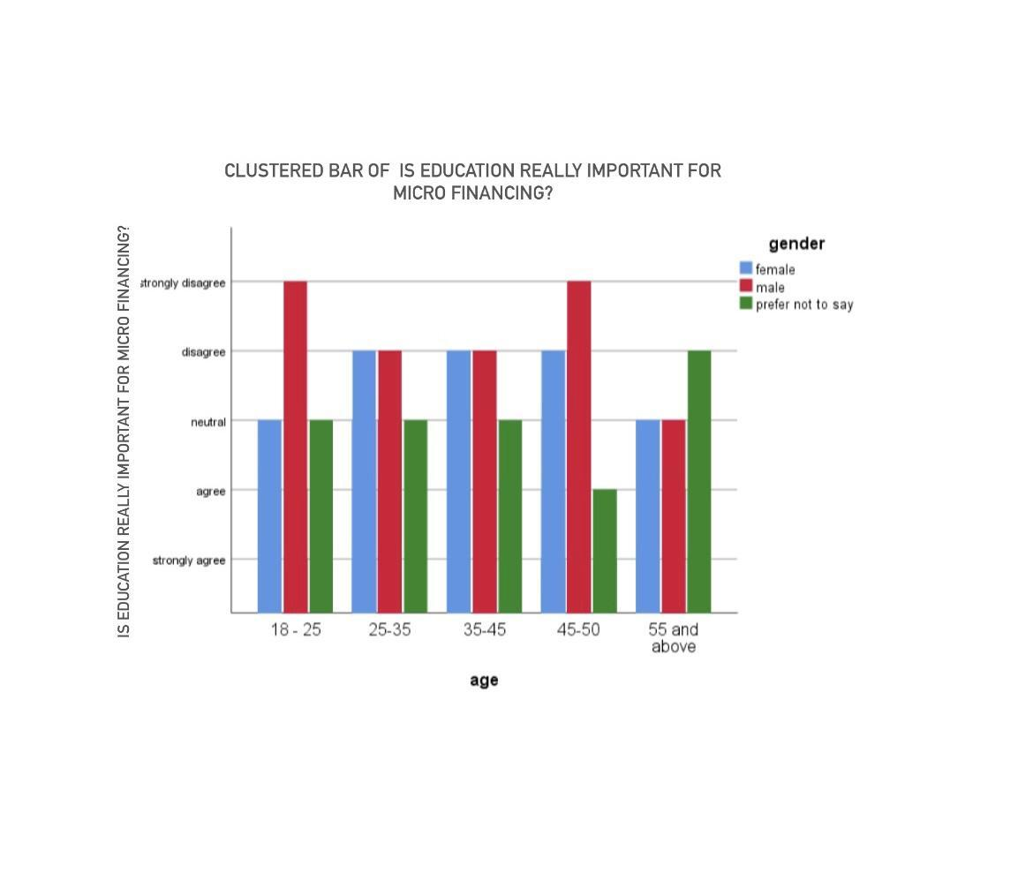
LEGEND- FIGURE 9 Shows the various age groups pertaining to the age and gender respondents and their opinion on do education really important for micre financing.

Result:

The frequency table is created out of the survey responses received from several people. Among the persons who are between 18-25 years they 30% sample responses taken and between the 25-35 years here were about 17.5% sample responses taken, who were above 35-45 years there were 11.5% sample responses taken and those who are below 45-55 years, there were 33% sample responses for this survey. (FIGURE 1) The frequency table is created out of the survey responses received from several people. Among the samples, the number of female responses are comparatively less when compared to the number of responses by male samples. Where the sample response from female person 40.5% and the response from male (58.7%) in number. And 10.9% of responses by the people prefer not to say.(FIGURE 2) The frequency table is created out of the survey responses received from several people. Among the samples, the number of students responses are 7%, number of responses by unemployed are 17.5% samples. Where the sample response from private sector people are 35.5% the response from public sector are 34% And 6% of responses by pepper who occupied business.(FIGURE 3) It is observed that the age distribution of the respondents among different gender of the respondents, their opinions on awareness about micro-financing help in the performance of women entrepreneurs is observed.It is observed that 56.5% say yes to the statement, which indicates they are aware of the micro-financing help in the performance of women entrepreneurs. 30% say no to the statement, which means they are not aware of the micro-financing help in the performance of women entrepreneurs . 13.5% are neutral.(FIGURE 4) It has been analysed that from the survey done of the gender and age component from the total of 200 responses. It is analysed that male in the age group of below 18-25 years are neutral to the statement, in the age group of 25 to 35 say yes to the statement and in the age group of 35 to 45 stands in neutral to the statement, and in the age group of above 45-50 also stands in female in neutral to the statement. Females in the age group of below 18-25 years are neutral to the statement, in the age group of 25 to 35 years are neutral to the statement and in the age group of 35 to 45 are also neutral to the statement, and in the age group of 45-50 years say yes to the statement and age group of above 55 are also neutral to the statement,which indicates that people are not completely aware of the statement.People in the category of prefer not to say in the age group of below 18-25 years says no to the statement, in the age group of 25 to 35 are neutral to the statement and in the age group of 35 to 45 are neutral and in the age group of above 55 years are also neutral to the statement.(FIGURE 5) It has been analysed from the survey done of the occupation and gender from the total of 200 responses . It is analysed that students of male category disagree with the statement, people in the category of public sector strongly disagree to the statement which indicates that people are not aware of micro-financing help in the performance of women entrepreneurs, private sector of male category disagree to the statement and people in the category of business sector are also disagree to the statement.Female in the category of unemployment disagree with the statement,public sector in the female category disagree with the statement which means they aren’t aware not of the statement and people in the private sector are also disagree with the statement.People in the category of business sector stands with neutral, which indicates that people don’t have complete knowledge about the micro-financing help in the performance of women entrepreneurs.(FIGURE 6) It is observed that the age distribution of the respondents among different genders of the respondents, their awareness on education really important for micro financing is observed that 22% agree to the statement, it indicates that these many people are aware about the education really important for micro financing. 9.5% disagree with the statement, 16% are neutral to the statement, 51% strongly agree with the statement.(FIGURE 7) It has been analysed that from the survey done of the gender and age component from the total of 200 responses. It is analysed that male in the age group of below 18-25 years are disagree with the statement, in the age group of 25 to 35 disagree with the statement, in the age group of 35 to 45 disagree with the statement, in the age group of above 45-50 in disagree with the statement and people in the age group of 55 and above are neutral to the statement.Females in the age group of below 18-25 years are neutral to the statement, in the age group of 25 to 35 years disagree with the statement and in the age group of 35 to 45 are also disagree with the statement, and in the age group of 45-50 years disagree with the statement and age group of above 55 years are neutral to the statement,which indicates that people are not completely aware of the statement.People in the category of prefer not to say in the age group of below 18-25 years are neutral to the statement, in the age group of 25 to 35 are neutral to the statement ,in the age group of 35 to 45 years are neutral , age group of 45-50 agree to the statement.(FIGURE 8) It has been analysed that from the survey done of the gender and age component from the total of 200 responses. It is analysed that the age group of 18-25 in female category stands in neutral to the statement,male strongly disagree with the statement and people prefer not to say stands neutral to the statement.Female in the age of 25-35 disagree with the statement,male disagree with the statement and people in the category of prefer not say neutral to the statement.It is observed that female in the age group of 35-45 disagree with the statement,male disagree with statement and people prefer not to say stands neutral to the statement.Female in the age of 45-50 disagree with the statement,male strongly disagree with statement and people prefer not to say agree with the statement.It is observed that female in the age group of of 55 and above are neutral to the statement, male stands neutral to the statement and people prefer not say disagree with the statement.(FIGURE 9)

Discussion

From the survey the various age groups pertaining to the age of the respondents. In this more at the age of 18-25 years they 30% sample responses taken. Thus, on the whole there were about 200 samples taken for the present survey.(FIGURE 1) From the survey the various age groups pertaining to the gender of the respondents. In this more at the male gender of 58.7% sample responses taken. Thus, on the whole there were about 200 samples taken for the present survey.(FIGURE 2) From the survey the various age groups pertaining to the occupation of the respondents. In this more at the sample response from private sector people are 35.5% the response from public sector are 34%. Thus, on the whole there were about 200 samples taken for the present survey.(FIGURE 3) From the survey the various age groups pertaining to the respondents and their opinion on does microfinance help in the performance of women entrepreneurs.. It is observed that 56.5% say yes to the statement, which indicates that people don’t have complete knowledge about the micro-financing help in the performance of women entrepreneurs.(FIGURE 4) It has been analysed that from the survey done of the gender and age component from the total of 200 responses ,the Y axis represent does micro-financing help in the performance of women entrepreneurs X axis being gender and scale being age, it is observed that male in the age group of 18-25 say yes to the statement,which indicates that people are completely aware of micro-financing help in the performance of women entrepreneurs and rest of the age group people aren’t completely aware of the statement.(FIGURE 5) It has been analysed from the survey done of the occupation and gender from the total of 200 responses, the Y axis being are you agree that micro-financing help in the performance of women entrepreneurs ,X axis represents their occupation. It is observed that students of male agree with the statement. people in the public sector of female agree with the statement which indicates that people don’t have complete knowledge about the micro-financing help in the performance of women entrepreneurs.(FIGURE 6) The various age groups pertaining to the respondents and their opinion on education really important for micre financing. It is observed that Female in the age of 18-25 and above 55 are neutral to the statement. People prefer not say in age group of 45-50 agree with the statement observed that 22% agree to the statement, it indicates that these many people are aware about the education really important for micro financing.(FIGURE 7) It has been analysed that Y axis being agree that education really important for micro financing. X axis being gender and scale being age, It is observed that Female in the age of 18-25 and above 55 are neutral to the statement. People prefer not say in age group of 45-50 agree with the statement. which indicates that people are aware of the statement and in the age group of above 55 years disagree with the statement.(FIGURE 8) It has been analysed that from the survey done of the gender and age component from the total of 200 responses, the Y axis being agree that education really important for micro financing ,X axis being age and scale being gender, it is observed that male in the age group of 45-50 agree to the statement which indicates that people are aware of Is education really important for micro financing .(FIGURE 9)

Limitation:

The major limitation of my study is the sample frame which is in saveetha thandalam campus. There is a major constraint in the sample frame as it is limited to a small area. Thus, it proves to be difficult to extrapolate it to a larger population. Another limitation is the sample size of 200 which cannot be used to assume the thinking of the entire population in a particular country, state, or city. The physical factors have a larger impact, thus, limiting the study. Moreover, there are difficulties faced to collect the data using google forms due to the denial of people to fill forms.

Conclusion:

In moment’s environment we're in an enhanced position where women donation in the field of entrepreneurship is adding at a noteworthy rate. sweats are being taken at the frugality for laws which has guaranteed equal rights of donation in political process and equal chances and rights in education and employment. In malignancy of this there are many lacking parameters which needs to be addressed soon. Short- term backing programmes should be concentrated which aims at adding the productivity of women's labour by furnishing credit, technology, and skill training. Micro finance programmes should offer women with detailed customized products through suitable styles, which can propose competitiveness to their business and their families. Women entrepreneurship is both about women ‟ s position in the society and about the part of entrepreneurship in the same society. Women entrepreneurs face numerous obstacles, specifically in selling their product, that have to be overcome in order to give them access to the same openings as men. The entry of pastoral women in micro- enterprises must be encouraged and exacerbated. pastoral women can do prodigies by their operative and competent involvement in entrepreneurial conditioning. The pastoral women have the introductory indigenous knowledge, skill, implicit and coffers to establish and manage enterprise. Now, the need is for knowledge regarding availability to loans, colorful backing agencies, procedures regarding instrument, mindfulness on government weal programmes, provocation, specialized skill and support from family government and other organisation.

Reference:

- Allard, J. “The Role of Inert Anode in the Aluminum Industry and Its Impact on Greenhouse Gas (GHGS) Emission and Other Pollutants.” vol. 150, 2018, p. 012011, doi:10.1088/1755-1315/150/1/012011.
- Greenhouse Gas Control Technologies 7, 2005, pp. 1441–1441, doi:10.1016/b978-008044704-9/50161-0.
- Amir, Khaled Ibne, and Tanvir Ahmed. “Climate Change and Its Impact on Food Security in Bangladesh: A Case Study on Kalapara, Patuakhali, Bangladesh.” Journal of Earth Science & Climatic Change, vol. 4, no. 5, 2013, doi:10.4172/2157-7617.1000155.
- Banik, Chumki, et al. Comparing Biochar-Swine Manure Mixture to Conventional Manure Impact on Soil Nutrient Availability and Plant Uptake – A Greenhouse Study. doi:10.20944/preprints202102.0417.v1.
- Grün, Gunnar, et al. “Low Humidity in the Aircraft Cabin Environment and Its Impact on Well-Being – Results from a Laboratory Study.” vol. 121, no. 1-2, 2007, pp. 153–63, doi:10.1016/j.agee.2006.12.009.
- Building and Environment, vol. 47, 2012, pp. 23–31, doi:10.1016/j.buildenv.2011.05.004.
- He, Bowen, and Ke J. Ding. “Localize the Impact of Global Greenhouse Gases Emissions under an Uncertain Future: A Case Study in Western Cape, South Africa.” Earth, vol. 2, no. 1, 2021, pp. 111–23, doi:10.3390/earth2010007.
- Hutchings, N. J., et al. “Modelling Spatial Heterogeneity in Grazed Grassland and Its Effects on Nitrogen Cycling and Greenhouse Gas Emissions.” vol. 47, 2012, pp. 23–31, doi:10.1016/j.buildenv.2011.05.004.
- Agriculture, Ecosystems & Environment, vol. 121, no. 1-2, 2007, pp. 153–63, doi:10.1016/j.agee.2006.12.009.
- Liu, Junfeng, et al. “Two-Year Comparative Study of Snow Cover Dynamics and Its Impact Factors on Glacier Surface.” Environmental Earth Sciences, vol. 75, no. 3, 2016, doi:10.1007/s12665-015-5075-2

​Author - A.varun kartik , Saveetha School of Law, Saveetha Institute of Medical And Technical Sciences(SIMATS),
​Co-Author -Mr. Gautham Shanmugam, Assistant Professor of law, Department of management , Saveetha School of Law, Saveetha Institute of Medical And Technical Sciences(SIMATS)

