A STUDY ON GREENHOUSE EFFECTS AND ITS IMPACT ON ENVIRONMENT

AUTHOR
A.Varun kartik (131702019),
VI year - B.B.A., LL.B., (HONS),
Saveetha School of Law,
Saveetha Institute of Medical and Technical Sciences,

CO-AUTHOR
Dr. R. Chandrasekar,
Associate Professor,
Saveetha School of Law,
Saveetha Institute of Medical and Technical Sciences,

A STUDY ON GREENHOUSE EFFECTS AND ITS IMPACT ON ENVIRONMENT
AUTHOR: A. Varun kartik CO- AUTHOR: Dr. R. Chandrasekar

ABSTRACT
The buildup of so-called “greenhouse gases” in the atmosphere - CO2 in particular-appears to be having an adverse impact on the global climate. This paper briefly reviews current expectations with regard to physical and biological effects, their potential costs to society, A number of gases are involved in the human caused enhancement of the greenhouse effect. These gases include: carbon dioxide; methane; nitrous oxide; CFCs and ozone. Out of all these gases the most important is carbon dioxide which accounts for around 55% of the change in the intensity of the Earth's greenhouse effect. The consequence of the greenhouse effect is that there will be a rise in the sea levels around the world and likely costs of abatement. The consequences of global warming are horrendous and there is a need for action now. There must be a massive movement towards environmentally friendly strategies that minimise product of carbon dioxide and methane and which maximise preoccupation of carbon dioxide. The major arrears and action must be taken by the industrialized countries because they are largely to condemn. still, the developing and industrializing countries must also consider the problem. The research methodology followed here is empirical research. A total of 200 samples have been taken out of which is taken through convenience sampling. Independent variables used in the research are age, gender, income and education qualification . The dependent variables are does human action is causing an increase in global temperature and do you agree that greenhouse effect is natural phenomenon beneficial for us.

KEYBOARDS
Greenhouse gases, Atmosphere, Global climate change , Methane , Global warming.

INTRODUCTION

Climatologists believe that adding atmospheric attention of carbon dioxide and other “ hothouse feasts ” released by mortal exertion, analogous as burning of reactionary powers and deforestation, are warming the Earth. Global Warming Increase of hothouse feasts attention causes a reduction in gregarious infrared radiation, thus the Earth's climate must change ever to restore the balance between incoming and gregarious radiation. This “ climatic change ” will include a “ global warming ” of the Earth's face and the lower atmosphere as warming up is the simplest way for the climate to get relieve of the spare energy. still, a small rise in temperature will induce multitudinous other changes, for illustration, pall cover and wind patterns. Some of these changes may act to enhance the warming, others to offset it.Using complex climate models, the" Intergovernmental Panel on Climate Change" in their third assessment report has read that global mean face temperature will rise by 1.4 °C to 5.8 °C by the end of 2100.

This projection takes into account the goods of aerosols which tend to cool the climate as well as the delaying goods of the abyss which have a large thermal capacity. still, there are multitudinous misgivings associated with this projection analogous as future emigration rates of hothouse feasts, climate feedbacks, and the size of the ocean detention. goods and the prognostications of the goods of global warming include Melting of the ice cap with increased ocean situations and release of the trapped feasts( there's extensively farther methane in the ice cap than in the atmosphere) with the need to dislocate peoples from present ocean position areas. Chaotic downfall changes, performing in dearths or cataracts and eventually massive erosion. dropped crop yields and dropped pastoralist land vacuity( the coastal and swash planes are constantly the most rich soils), with posterior starvation and malnutrition.

The consequences of global warming are horrendous and there is a need for action now. There must be a massive movement towards environmentally friendly strategies that minimise product of carbon dioxide and methane and which maximise preoccupation of carbon dioxide. The major arrears and action must be taken by the industrialized countries because they are largely to condemn. still, the developing and industrializing countries must also consider the problem. The medium is generally known as the “ hothouse effect ” is what makes the Earth livable . These feasts in the atmosphere act like the glass of a hothouse, letting the sun in and preventing heat from escaping. But the mortal exertion has altered the chemical composition of the atmosphere through the buildup of greenhouse feasts primarily carbon dioxide, methane, and nitrous oxide. Rise in environmental temperature and changes in combined processes are directly connected to adding anthropogenic greenhouse gas( GHG) emigrations in the atmosphere.

This rise in temperature was vehemently argued to be generally touched off by the emigration of carbon predicated mixes from reactionary powers consumption for power generation. The attention of carbon dioxide, methane, and nitrous oxide are each known to be adding and in recent time, so their hothouse feasts, principally chlorofluorocarbons( CFCs), have been added in significant quantities to the atmosphere.Social, anthropological, profitable and political considerations have been the major determinants of Aid programmes but the growing environmental extremity due to global warming is likely to dominate multitudinous issues in the future. The hothouse effect is the most serious issue facing the world moment and which needs immediate attention by governmental and aid agencies. Aim: To study the hothouse effect and its impact on the terrain.

OBJECTIVES
To introduce what a greenhouse is and its impact on the environment.
To introduce how it causes global warming.
How to overcome its bad effects.

LITERATURE REVIEW

- Godwin(2003). Urbanization, energy use and greenhouse effects in economic development:This paper seeks an exploratory assessment of the possible global greenhouse consequences of economic development in general and urbanization in particular, especially insofar as they relate to changing patterns of energy use.First, the nature of the relationship between urbanization and increased resource use is elaborated upon, and the impact of the development transition upon levels of energy consumption is empirically analysed in a multiple regression framework, using cross-national variations in urbanization and other development indicators to estimate a fixed-effects model of the determinants of energy usage.
- Dinwoodie(2017). Greenhouse Effects due to Man-Made Perturbations of Trace Gases—Nitrous oxide, methane, ammonia, and a number of other trace constituents in the earth's atmosphere have infrared absorption bands in the spectral region 7 to 14 µm and contribute to the atmospheric greenhouse effect. The concentrations of these trace gases may undergo substantial changes because of man's activities.
- Bayer(2007). Contributions of Agroecosystems to Global Climate Change —Changes in the Earth's climate due to anthropogenically induced increases in the atmospheric greenhouse effect are anticipated in the near future. This chapter introduces the topic of greenhouse gases and climate change, and summarizes knowledge of agricultural contributions to the greenhouse effect.
- Apa and Pollicino(2013). Optimizing Nitrogen Management in Food and Energy Production and Environmental Protection: 2nd International Nitrogen Conference—Nitrogen (N) is applied worldwide to produce food. It is in the atmosphere, soil, and water and is essential to all life. N for agriculture includes fertilizer, biologically fixed, manure, recycled crop residue, and soil-mineralized N. Presently, fertilizer N is a major source of N, and animal manure N is inefficiently used.
- Riordan(2016). Water vapour and greenhouse trapping: The role of far infrared absorption—The impact of far infrared absorption is assessed by calculating the spectral variation of the total and water vapour greenhouse effects, for the sub‐arctic winter (SAW) and tropical (TRP) standard atmospheres.
- Taddeo and Floridi(2017). Drying of biomass for utilising in co-firing with coal and its impact on the environment – Coal is the most widely used primary fuel for energy generation but it emits toxic gasses after combustion. Whereas, biomass is a renewable energy source and it is used for environment friendly energy production.
- MacKinnon et al.(2015). The Greenhouse Gas Emissions Produced by Cement Production and Its Impact on Environment:The purpose of this study is to investigate and explain the review of cement processing and its impact on cement manufacturing emissions on the environment. For instance, the cement industry is contributing to global warming and climate change in the world. The processes of cement manufacturing are extremely energy intensive which utilize high fuel consumption and finally it results in the emissions.
- Akdeniz(2016). Environmental performance evaluation of thermal insulation materials and its impact on the building:The purpose of this paper is to examine the building's environmental performance through the insulation's material selection. Contemporary insulation materials achieve thermal conductivity values of less than 0.04 W/mK, whilst a plethora of materials, which fulfil specific requirements like mechanical and physical features according to the object specific specifications, can be found in the market.
- Beldiman(2015). Climate Change and Its Impact on Nepalese Agriculture—Exponential growth of CO2 and other greenhouse gasses in the atmosphere is causing climate change. It affects agriculture, forestry, human health, biodiversity, snow cover and aquatic to mountain ecosystems. Changes in climatic factors like temperature, solar radiation and precipitation have potentials to influence crop production. Despite many efforts possible on combating impacts of climate change, there are still difficulties in Nepalese agriculture.
- Frankel and Gervais(2014). Enteric methane mitigation technologies for ruminant livestock: a synthesis of current research and future directions:Enteric methane (CH4) emission in ruminants, which is produced via fermentation of feeds in the rumen and lower digestive tract by methanogenic archaea, represents a loss of 2% to 12% of gross energy of feeds and contributes to global greenhouse effects. Globally, about 80 million tonnes of CH4 is produced annually from enteric fermentation mainly from ruminants.
- Potts(2011). Sulfur in olivine‐hosted melt inclusions from the Emeishan picrites: Implications for S degassing and its impact on environment::Large‐volume (>0.3 × 106 km3) basaltic lavas that erupted ~260 Ma ago in southwest China form the Emeishan large igneous province. The relationship between the Emeishan volcanism and the end‐Guadalupian mass extinction is still unresolved.
- Wang(2018). The value of gas exchange as a service by rice paddies in suburban Shanghai, PR China:Valuing ecosystem services is crucial for making the importance of ecosystem functioning explicit to the public and decision makers as well as scientists. Investigations of the value of agricultural ecosystems have focused mainly on value food and fibre production and have been carried out at relatively coarse scales.
- Gathegi et al.(2014). Environmental management and its impact on the operations function:Recently, corporations have been confronted with a number of global environmental challenges such as global warming, acid rain, depletion of natural resources, waste management, green consumerism and pollution prevention. There is growing pressure to deliver products and services which are environmentally compatible.
- Rowland, Kohl, and Charlesworth (2016). Antibiotic Use in Agriculture and Its Impact on the Terrestrial Environment:Since their discovery, antibiotics have been instrumental in treating infectious diseases that were previously known to kill humans and animals. However, their widespread use as an additive in animal feeds has raised concerns about the development of antibiotic‐resistant microorganisms.
- Turenne(2015). Molecular C dynamics downstream: The biochemical decomposition sequence and its impact on soil organic matter structure and function:Advances in spectroscopic and other chemical methods have greatly enhanced our ability to characterize soil organic matter chemistry. As a result, the molecular characteristics of soil are now known for a range of ecosystems, soil types, and management intensities.
- Smith(2007). Reclamation-induced tidal restriction increases dissolved carbon and greenhouse gases diffusive fluxes in salt marsh creeks:Coastal reclamation increased dissolved carbon, NH4+-N and NO2−-N in marsh creeks.Changes in flow velocity, salinity, Chl-a, and pH were the main influence factors. Intertidal creeks play an important role in transporting nutrients between coastal ecosystems and ocean. Reclamation is a predominant anthropogenic disturbance in coastal regions; however, the influence of reclamation on carbon and nitrogen species and greenhouse gas (GHG) fluxes in creeks remains unclear.
- Friedmann(2015). Climate Change in China from 1880 to 1998 and its Impact on the Environmental Condition: The global mean surface air temperature or the Northern Hemisphere mean SAT has increased since the late nineteenth century, but the mean precipitation around the world has not formed a definite tendency to increase. A lot of studies showed that different climate and environmental changes during the past 100 years over various regions in the world were experienced.
- Lichtman and Posner(2007). Effect of above‐ground plant species on soil microbial community structure and its impact on suppression of Rhizoctonia solani AG3:The extent of soil microbial diversity is seen to be critical to the maintenance of soil health and quality. Different agricultural practices are able to affect soil microbial diversity and thus the level of suppressiveness of plant diseases. In a 4‐year field experiment, we investigated the microbial diversity of soil under different agricultural regimes.
- Rimmer(2007). Efficient hybrid modeling of CO2 absorption in aqueous solution of piperazine: Applications to energy and environment:Effective tools are introduced to obtain solubility of CO2 in PZ solutions.Parametric sensitivity analysis identifies important factors affecting CO2 capturing.Carbon dioxide considerably contributes to the greenhouse effects and consequently, to the global warming. (Amir and Ahmed)Thus, reduction of CO2 emissions/concentration in the atmosphere is an important goal for various industrial and environmental sectors.
- Travis(2013). Biogeochemistry of selenium and its impact on food chain quality and human health:In areas where soils are low in bioavailable selenium (Se), potential Se deficiencies cause health risks for humans.(National Research Council, Division on Earth and Life Studies, Board on Atmospheric Sciences and Climate, et al.) Though higher plants have been considered not to require this element, the experience with low-Se soils in Finland has provided evidence that the supplementation of commercial fertilizers with sodium selenate affects positively not only the nutritive value of the whole food chain from soil to plants, animals and humans but also the quantity of plant yields.

METHODOLOGY

The research methodology followed here is empirical research. A total of 200 samples have been taken out of which is taken through convenience sampling. Independent variables used in the research are age, gender, income and education qualification . The dependent variables are does human action is causing an increase in global temperature and do you agree that greenhouse effect is natural phenomenon beneficial for us.

ANALYSIS

FIGURE 1

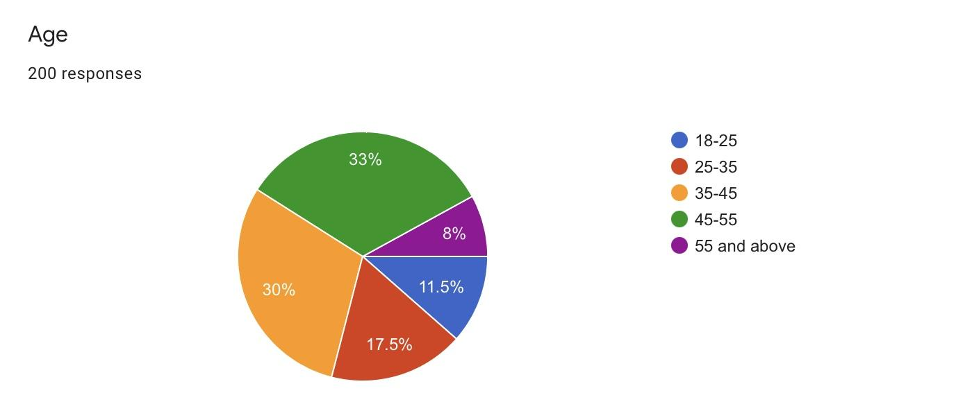

LEGEND: The various age groups pertaining to the age of the respondents.

FIGURE 2

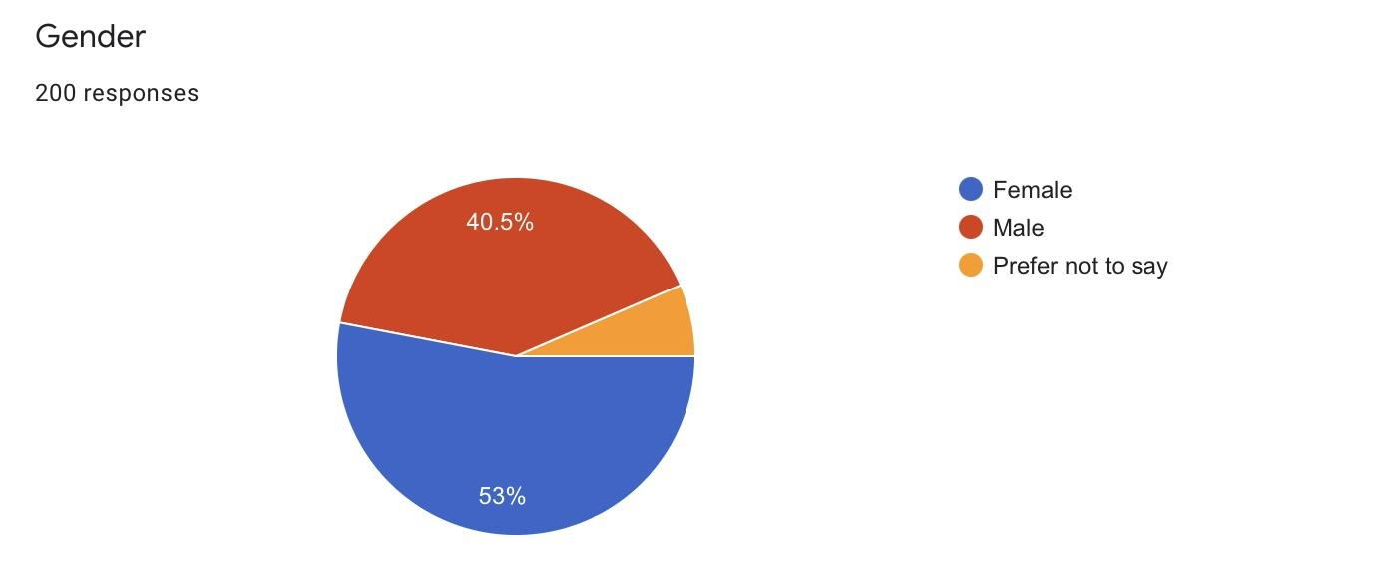

LEGEND: The various age groups pertaining to the gender of the respondents.

FIGURE 3

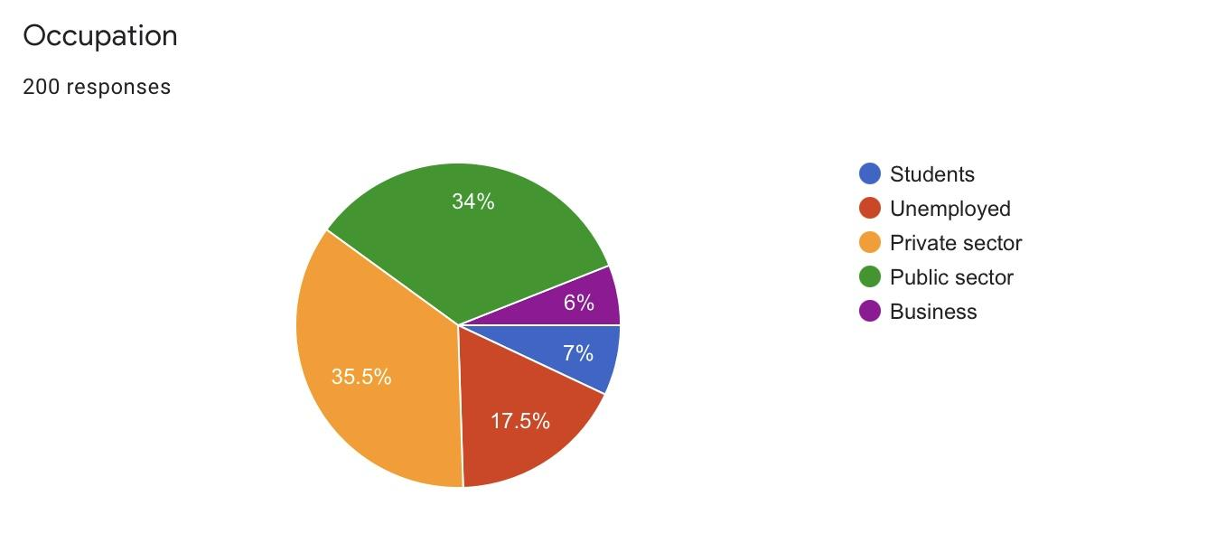

LEGEND: The various age groups pertaining to the occupation of the respondents.

FIGURE 4

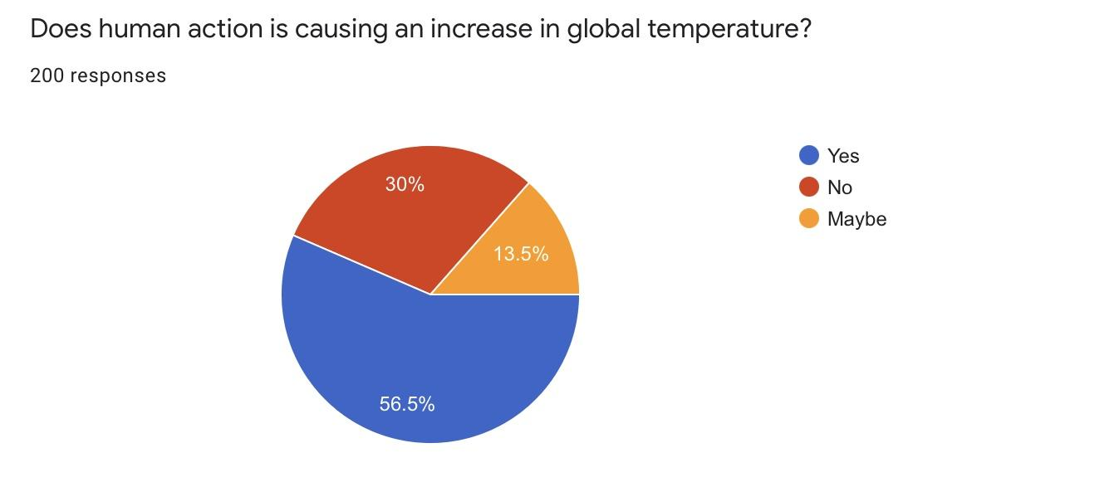

LEGEND: The various age groups pertaining to the respondents and their opinion on does human action is causing an increase in global temperature

FIGURE 5

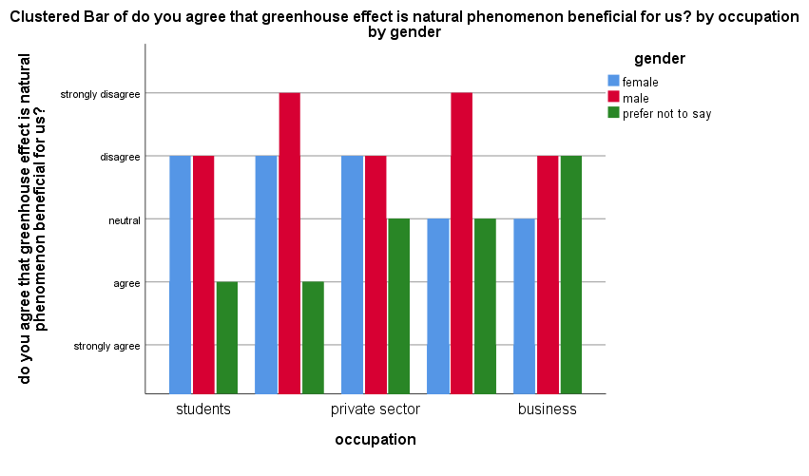

LEGEND: The various age groups pertaining to the occupation and gender of the respondents and their opinion on do you agree that greenhouse effect is natural phenomenon beneficial for us.

FIGURE 6

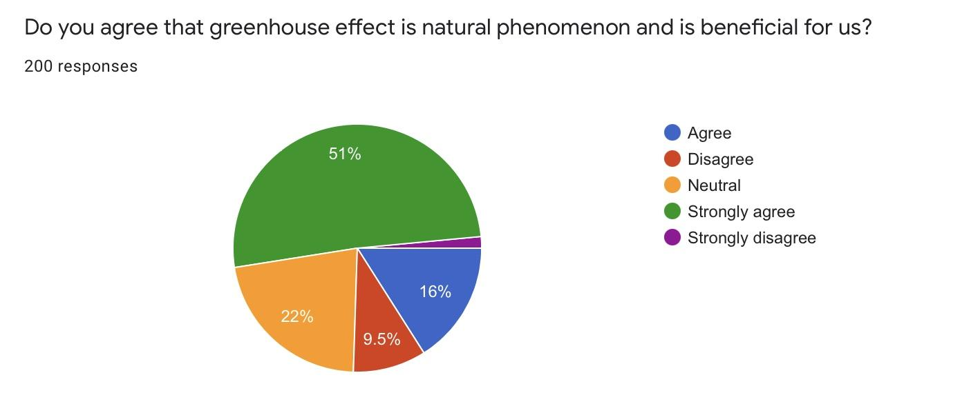

LEGEND: The various age groups pertaining to the respondents and their opinion on do you agree that greenhouse effects are a natural phenomenon and it's beneficial for us.

FIGURE 7

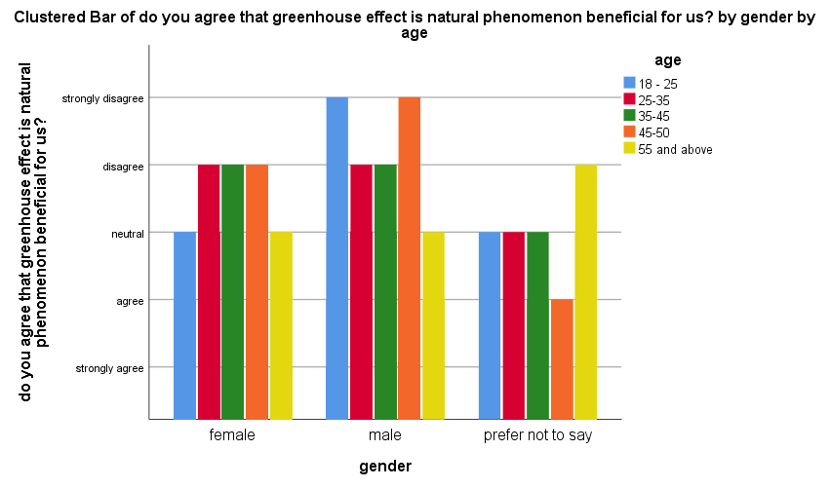

LEGEND: The various age groups pertaining to the gender and age of the respondents and their opinion on do you agree that greenhouse effect is natural phenomenon beneficial for us.

FIGURE 8

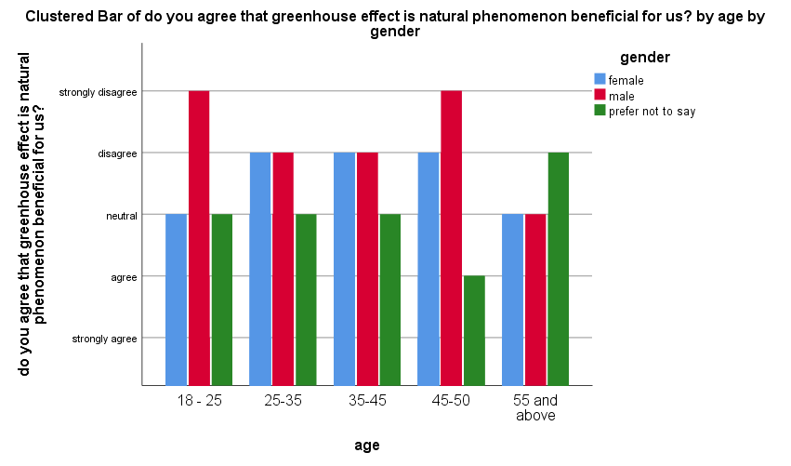

LEGEND: The various age groups pertaining to the age and gender of the respondents and their opinion on do you agree that greenhouse effect is natural phenomenon beneficial for us.

RESULTS

- Figure 1- With respect to the current survey results, the frequency table is created out of the survey responses received from several people. The present frequency pie chart is based on the age of the persons. Among the persons who are between 18-25 years they 30% sample responses taken and between the 25-35 years here were about 17.5% sample responses taken, who were above 35-45 years there were 11.5% sample responses taken and those who are below 45-55 years, there were 33% sample responses for this survey. Thus, on the whole there were about 200 samples taken for the present survey.
- Figure 2- With respect to the current survey results, the frequency table is created out of the survey responses received from several people. The present frequency table is based on the gender of persons who were taken as samples. Among the samples, the number of female responses are comparatively less when compared to the number of responses by male samples. Where the sample response from female person 40.5% pand the response from male (58.7%%) in number. And 10.9% of responses by the people prefer not to say.Thus, on the whole there were about 202 samples taken for the present survey.
- Figure 3- With respect to the current survey results, the frequency table is created out of the survey responses received from several people. The present frequency table is based on the occupation of persons who were taken as samples. Among the samples, the number of students responses are 7%, number of responses by unemployed are 17.5% samples. Where the sample response from private sector people are 35.5% the response from public sector are 34%.And 6% of responses by pepper who occupied business.Thus, on the whole there were about 202 samples taken for the present survey.
- Figure 4- From the chart, it is observed that the age distribution of the respondents among different gender of the respondents, their opinions on awareness about global temperature and human action causes an increases is observed.It is observed that 56.5% say yes to the statement, which indicates they are aware of the global temperature and human action causes increases. 30% say no to the statement, which means they are not aware of the global temperature and human action causes an increase. 13.5% are neutral, which indicates that people don’t have complete knowledge about the human action causing an increase in global temperature.
- Figure 5- From the above graph it has been analysed from the survey done of the occupation and gender from the total of 200 responses, the Y axis being Are you agree that greenhouse effect is a natural phenomena and it’s beneficial for us ,X axis represents their occupation. It is analysed that students of male category disagree with the statement, people in the category of public sector strongly disagree to the statement which indicates that people are not aware of greenhouse effect is a natural phenomena and it’s beneficial to us ,private sector of male category disagree to the statement and people in the category of business sector are also disagree to the statement.Female in the category of unemployment disagree with the statement,public sector in the female category disagree with the statement which means they aren’t aware not of the statement and people in the private sector are also disagree with the statement.People in the category of business sector stands with neutral, which indicates that people don’t have complete knowledge about the greenhouse effects are a natural phenomenon and it's beneficial for us.
- Figure 6- From the chart. it is observed that the age distribution of the respondents among different genders of the respondents, their awareness on Greenhouse effects are a natural phenomenon and it's beneficial for us is observed that 22% agree to the statement, it indicates that these many people are aware about the greenhouse effects are a natural phenomenon. 9.5% disagree with the statement, 16% are neutral to the statement, 51% strongly agree with the statement which indicates that people are aware that greenhouse effects are a natural phenomenon and it's beneficial for us In total, there are 200 responses.
- Figure 7- From the above graph, it has been analysed that from the survey done of the gender and age component from the total of 200 responses, the Y axis being agree that greenhouse effects are a natural phenomenon and it's beneficial for us X axis being gender and scale being age, it is analysed that male in the age group of below 18-25 years are disagree with the statement, in the age group of 25 to 35 disagree with the statement, in the age group of 35 to 45 disagree with the statement, in the age group of above 45-50 in disagree with the statement and people in the age group of 55 and above are neutral to the statement.Females in the age group of below 18-25 years are neutral to the statement, in the age group of 25 to 35 years disagree with the statement and in the age group of 35 to 45 are also disagree with the statement, and in the age group of 45-50 years disagree with the statement and age group of above 55 years are neutral to the statement,which indicates that people are not completely aware of the statement.People in the category of prefer not to say in the age group of below 18-25 years are neutral to the statement, in the age group of 25 to 35 are neutral to the statement ,in the age group of 35 to 45 years are neutral , age group of 45-50 agree to the statement which indicates that people are aware of the statement and in the age group of above 55 years disagree with the statement.Thus there are totally 200 responses.
- Figure 8- From the above graph it has been analysed that from the survey done of the gender and age component from the total of 200 responses, the Y axis being agree that greenhouse effects are a natural phenomenon and it's beneficial for us ,X axis being age and scale being gender, it is analysed that the age group of 18-25 in female category stands in neutral to the statement,male strongly disagree with the statement and people prefer not to say stands neutral to the statement.Female in the age of 25-35 disagree with the statement,male disagree with the statement and people in the category of prefer not say neutral to the statement.It is observed that female in the age group of 35-45 disagree with the statement,male disagree with statement and people prefer not to say stands neutral to the statement.Female in the age of 45-50 disagree with the statement,male strongly disagree with statement and people prefer not to say agree with the statement.It is observed that female in the age group of of 55 and above are neutral to the statement, male stands neutral to the statement and people prefer not say disagree with the statement,which indicates that people aren’t completely aware of the statement.Thus there are totally 200 responses.

DISCUSSIONS

- Figure 1- From the survey the various age groups pertaining to the age of the respondents. In this more at the age of 18-25 years they 30% sample responses taken.
- Figure 2- From the survey the various age groups pertaining to the gender of the respondents. In this more at the male gender of 58.7% sample responses taken.
- Figure 3- From the survey the various age groups pertaining to the occupation of the respondents. In this more at the public sector of 35.5% sample responses taken.
- Figure 4- From the survey the various age groups pertaining to the respondents and their opinion on does human action is causing an increase in global temperature. It is observed that 56.5% say yes to the statement, which indicates they are aware human action is causing an increase in global temperature.
- Figure 5- From the above graph, it has been analysed from the survey done of the occupation and gender from the total of 200 responses, the Y axis being Are you agree that greenhouse effect is a natural phenomena and it’s beneficial for us ,X axis represents their occupation.It is observed that students of male agree with the statement ,people in the public sector of female agree with the statement which indicates that people are aware of the statement.
- Figure 6- From the graph, The various age groups pertaining to the respondents and their opinion on do you agree that greenhouse effects are a natural phenomenon and it's beneficial for us. It is observed that Female in the age of 18-25 and above 55 are neutral to the statement.People prefer not say in age group of 45-50 agree with the statement.
- Figure 7- From the graph, it has been analysed that Y axis being agree that greenhouse effects are a natural phenomenon and it's beneficial for us X axis being gender and scale being age,It is observed that Female in the age of 18-25 and above 55 are neutral to the statement.People prefer not say in age group of 45-50 agree with the statement.

- Figure 8- From the above graph, it has been analysed that from the survey done of the gender and age component from the total of 200 responses, the Y axis being agree that greenhouse effects are a natural phenomenon and it's beneficial for us ,X axis being age and scale being gender, it is observed that male in the age group of 45-50 agree to the statement which indicates that people are aware of the greenhouse effects are a natural phenomenon and it's beneficial for us.The greenhouse effect is a natural process where the atmosphere traps some of the sun's energy, warming the Earth enough to support life.

LIMITATION

The major limitation of my study is the sample frame which is in poonamallee bus stand. There is a major constraint in the sample frame as it is limited to a small area. Thus, it proves to be difficult to extrapolate it to a larger population. Another limitation is the sample size of 200 which cannot be used to assume the thinking of the entire population in a particular country, state, or city. The physical factors have a larger impact, thus, limiting the study. Moreover, there are difficulties faced to collect the data using google forms due to the denial of people to fill forms.

CONCLUSION

The greenhouse effect is a natural process where the atmosphere traps some of the sun's energy, warming the Earth enough to support life. Although the greenhouse effect is a nature cycle, humans have greatly increased the concentrations of greenhouse gases, thus causing a significant increase in the overall greenhouse effect. A number of gases are involved in the human caused enhancement of the greenhouse effect. These gases include: carbon dioxide; methane; nitrous oxide; CFCs and ozone. Out of all these gases the most important is carbon dioxide which accounts for around 55% of the change in the intensity of the Earth's greenhouse effect. The consequence of the greenhouse effect is that there will be a rise in the sea levels around the world, there will be dramatic climate changes, and agriculture will suffer from the fluxes of the weather. However, it's not too late to cut back on greenhouse gas emissions. Some effective ways to reduce emissions are: use cleaner fuels, use energy efficient machines, develop alternative sources for energy and to plant more trees.The global warming is horrendous and there is a need for action now. There must be a massive movement towards environmentally friendly strategies that minimise production of carbon dioxide and methane and which maximise fixation of carbon dioxide. The major responsibilities and action must be taken by the industrialized countries because they are largely to blame. However, the developing and industrializing countries must also consider the problem.

REFERENCE

- Agarwal, Deepak, and Md Usmangani Ansari. 2017. INDIA Handbook 2018 for Competitive Exams - Schemes, Yojanas, Policies, Bill & Acts, Amendments, Judgements, Summits, Organisations, Tribunals, Committees. Disha Publications.
- Brown, Ashley C., Jon Stern, Bernard William Tenenbaum, and Defne Gencer. 2006. Handbook for Evaluating Infrastructure Regulatory Systems. World Bank Publications.
- Bryant, Lyndall. 2015. “Developer Charges and Housing Affordabilty in Brisbane, Australia.” In 22nd Annual European Real Estate Society Conference. https://doi.org/10.15396/eres2015_294.
- CFP Board. 2013. The Financial Planning Competency Handbook. John Wiley & Sons.
- ———. 2015. Financial Planning Competency Handbook. John Wiley & Sons.
- Cheng Zheng, Cheng Zheng, and Tao Duan. 2011. “Inspection on Project Superviser by Real Estate Developer Based on Game Theory.” In MSIE 2011. https://doi.org/10.1109/msie.2011.5707561.
- Contosta, David R. 2000. Woodward, George (1863-1952), Political Reformer and Suburban Real Estate Developer.
- Drahos, Peter. 2017. Regulatory Theory: Foundations and Applications. ANU Press.
- Hepp, John H. 2000. Corbin, Austin (1827-1896), Financier, Real Estate Developer, and Railroad Executive.
- Ingham, Patricia. 2000. Invisible Writing and the Victorian Novel: Readings in Language and Ideology. Manchester University Press.

AUTHOR- A.Varun kartik , Saveetha School of Law, Saveetha Institute of Medical and Technical Sciences, .
CO-AUTHOR - Dr. R. Chandrasekar, Associate Professor, Saveetha School of Law, Saveetha Institute of Medical and Technical Science.

