Mental Health Guidance and Support Bot
Abhishek Baghel ¹, Divyansh Sharma², Garvit Khandelwal³, Dr. Pooja Sharma⁴
¹Abhishek Baghel, School Of Engineering And Technology, Dy Patil University Ambi Pune
² Divyansh Sharma, School Of Engineering And Technology, Dy Patil University Ambi Pune
³ Garvit Khandelwal, School Of Engineering And Technology, Dy Patil University Ambi Pune
⁴ Dr. Pooja Sharma, Associate Professor Department Of Computer Engineering, School Of Engineering And Technology, Dy Patil University Ambi Pune

---------------------------------------------------------------------***---------------------------------------------------------------------
Abstract -
In an era characterized by the relentless pace of life and the escalating challenges to mental well-being, the emergence of the Mental Health Support Bot represents a revolutionary advancement in addressing the universal struggle with stress, anxiety, and depression. This abstract delves deeper into the conceptualization, methodology, results, and broader implications of this virtual companion, highlighting its transformative impact on the landscape of mental health support.
The Mental Health Support Bot is rooted in the synergy of cutting-edge artificial intelligence and a profound understanding of the nuanced nature of mental health challenges. Its conceptualization arises from the recognition that these challenges are not confined to specific demographics but are pervasive, transcending geographical, cultural, and temporal boundaries. The bot is designed to be a dynamic and responsive virtual companion that tailors its approach to the unique needs of each individual user.
Powered by advanced artificial intelligence, the Support Bot employs adaptive algorithms that continuously learn and evolve based on user interactions.
The profound impact of the Mental Health Support Bot is reflected in its ability to transcend traditional limitations of mental health support systems. Its continuous accessibility, operating 24/7, ensures that users can seek assistance whenever the need arises, breaking down the temporal constraints of conventional models. Moreover, the bot's adaptability to users' schedules, whether during quiet moments in the night or amid the rush of a busy day, enhances the likelihood of individuals seeking timely assistance. The results signify a paradigm shift in mental health support, moving towards a more user-centric and proactive approach.

1.INTRODUCTION

In today's fast-paced world, characterized by an ever-accelerating pace of life and the relentless pressures of modern living, the importance of mental well-being cannot be overstated. The demands of daily life can often take a toll on our mental health, and in such a scenario, having a reliable and easily accessible source of support becomes imperative. This is precisely where the groundbreaking Mental Health Guidance Bot steps in, reshaping our approach to mental wellness and offering a beacon of support in the face of life's challenges.

Mental health challenges, such as stress, anxiety, depression, and feelings of isolation, are pervasive and affect people across the globe, transcending boundaries of age, gender, and background. Recognizing the universal nature of these issues, the Mental Health Guidance Bot emerges as a revolutionary solution to address the diverse needs of individuals seeking to navigate the complexities of their emotional well-being.

2. Body of Paper

Literature Survey
The literature survey extensively explores diverse models within the realm of AI chatbots designed for mental health care. One prominent work by Rathnayaka and Mills introduces a BA-based AI chatbot conceptual framework, demonstrating its efficacy in enhancing mood and inducing positive behavioral changes. However, a limitation arises from the study's small sample size and a relatively short duration of experimentation. Das and Prasad contribute to the survey by conducting a review of existing literature on mental health care chatbots, identifying several currently employed models and discussing their advantages and drawbacks. Notably, this work falls short in delving into the technical intricacies of the topic, leaving a gap in understanding the underlying technological challenges.

Vijayarani and Balamurugan offer a comprehensive concept article that synthesizes information from an in-depth literature review and expert consultations, exploring the potential of chatbots in mental health care. Despite providing valuable insights into applications, advantages, and limitations, the article lacks specificity in data collection and analysis methods, the number of experts consulted, and a formal assessment of evidence quality. Similarly, Lalitha et al. also undertake a concept article approach, synthesizing information from literature reviews and expert consultations to present a structured overview of chatbots in mental health care. While the article offers valuable insights, it too lacks detailed specifics regarding data collection, analysis methods, consulted experts, or a formal evidence quality assessment.

On a more technical front, Tewaria, Chhabriaa, and Khalsaa propose a chatbot leveraging natural language processing techniques such as word embeddings, sentiment analysis, and a Seq2Seq model with attention mechanisms. Trained on extensive movie dialogue and subtitle data, the chatbot aims to understand nuances in language and mimic human dialogue flow. However, it is emphasized that the chatbot serves as a companion rather than a replacement for professional help, providing a safe space for venting and gentle nudges toward positive practices.

A unique contribution comes from Dhanda, Goel, Vashisht, and Susan, who address the surge in stress, especially amidst the pandemic, by developing a Hindi chatbot. This model employs Google Translate to bridge language barriers, incorporates empathetic English dialogues for tailored responses, and utilizes an attention mechanism for enhanced context-awareness and emotional connection. While boasting effectiveness with a BLEU score of 0.143, the authors underline the chatbot's supplementary role and the exciting potential of future multilingual dialogue capabilities.

In summary, the literature survey provides a rich landscape of AI chatbot models in mental health care, encompassing diverse approaches, strengths, and limitations. Each work contributes valuable insights, but a common theme emerges, emphasizing the need for further research with robust methodologies to solidify the role of chatbots in this crucial field.

Proposed System

The primary goal of this project is to emulate online mental health counseling conversations through the development and assessment of chatbot counselors created using the RASA natural language processing engine. The overarching objective is to create an immersive and meaningful user experience that simulates the dynamics inherent in genuine counseling sessions. RASA, renowned for its natural language understanding capabilities, serves as the technological backbone for this endeavor. The central focus of the project is to harness the features of the RASA framework to construct chatbot counselors that engage users in dynamic, context-aware interactions, replicating the subtleties and nuances found in authentic counseling sessions. Key objectives associated with RASA include leveraging its natural language processing capabilities for intent recognition, dynamic parameterization, and entity recognition, thereby facilitating personalized interactions that enhance the relevance and effectiveness of the counseling simulation. The RASA-based chatbot counselors are designed to facilitate two-way interactions with users, ensuring a seamless and engaging flow of conversation. By utilizing RASA's capabilities for maintaining context and managing dialogue history, the project aims to create a conversational experience closely mirroring real counseling sessions. Additionally, visual elements are incorporated into the chatbot interface, drawing inspiration from RASA's flexibility to accommodate multimedia. This includes experimenting with visual representations, exploring the impact of human-like or machine-like appearances and expressions on user engagement and experience. In terms of functionality, the chatbot system employs advanced intent matching mechanisms to interpret user input, identifying the user's intention based on the provided input using natural language processing (NLP) capabilities. Information extraction techniques are then applied to discern relevant details from the user's expression, allowing the system to gather necessary data to formulate appropriate and contextually relevant responses.

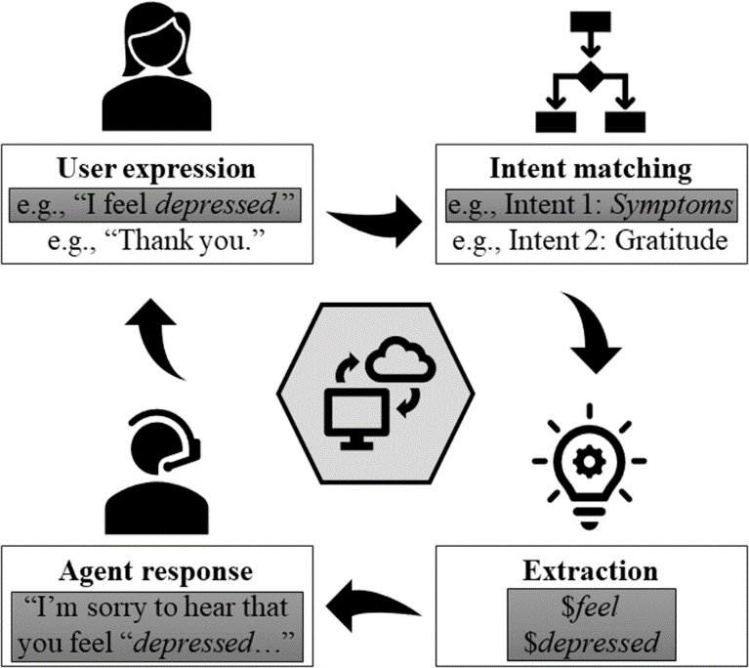

Fig-1: Proposed System
Methodology

In the development of a Rasa-based mental health chatbot, a comprehensive set of hardware and software components is employed to ensure a robust and efficient system. On the hardware side, Graphics Processing Units (GPUs) may be utilized for deep learning model acceleration, and a computer or development machine is essential for building and testing the chatbot using the Rasa framework. Security measures involve the use of firewalls and security appliances, while robust backup and recovery systems, both hardware and software-based, are crucial for preventing data loss and ensuring chatbot continuity. The software stack comprises the Rasa framework, a versatile open-source platform for building contextual AI assistants and chatbots. Python, being the primary language for Rasa, is fundamental, and Conda, a package manager, aids in managing dependencies. The Anaconda Prompt, a command-line interface, helps manage Python environments. Microsoft Build Tools may be necessary for building dependencies, and developers commonly use integrated development environments (IDEs) such as Visual Studio Code or PyCharm. Version control via GitHub ensures collaborative development, and Rasa X, a tool provided by Rasa, offers a graphical interface for further chatbot development, improvement, and analysis. In terms of hardware design, the chatbot relies on server infrastructure, processing power (CPUs or GPUs), and storage solutions for hosting, deploying, and storing models and data. The software stack includes the Rasa framework, programming languages like Python, NLP libraries (spaCy or NLTK), and version control using Git. A database (MongoDB or SQL) manages user data, while IDEs assist developers in coding and testing. Annotated training data, deployment platforms (Docker containers), and integration with communication channels (Facebook Messenger, Slack) complete the software architecture.
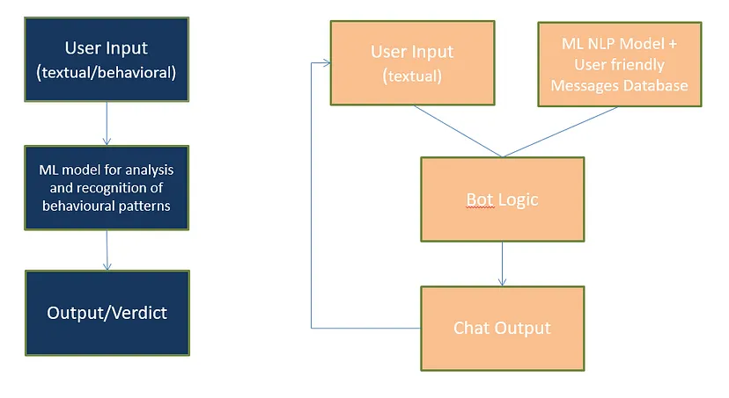
Fig -2: Schematic

The user interaction with the chatbot begins with user input, which can take the form of a text message, voice command, or any communicative medium the chatbot is designed to comprehend. RASA NLU (Natural Language Understanding) processes this input, identifying the user's intent (goal or purpose) and extracting relevant entities (specific pieces of information). Intent recognition plays a pivotal role in understanding the user's intention. The chatbot identifies the primary intent behind the input, such as recognizing the intent "express emotion" and the associated entity "anxious" for a user stating, "I'm feeling anxious lately." RASA Core takes the recognized intent and utilizes trained dialogue models to manage the flow of conversation. It determines the appropriate actions based on the recognized intent and the current state of the interaction. The execution of specific actions, defined in the actions.py file, is triggered by the identified intent. Custom actions may include generating responses, querying databases, or interacting with external APIs. For example, a custom action "respond to emotion" could involve providing a supportive message tailored to the user's expressed emotion. The chatbot's final step is generating a response that is relevant to the recognized intent and the executed action. In the context of mental health, it is crucial to design responses with emphasis on empathy, understanding, and support. For instance, the chatbot might respond empathetically to a user expressing anxiety, acknowledging the emotion and offering support.
A critical consideration in the chatbot's development is the emphasis on empathy, ensuring that responses are supportive and understanding, particularly in the sensitive context of mental health. Additionally, continuous training of RASA models is essential. Regular updates and retraining based on new data and evolving user interactions allow the chatbot to adapt to changing user needs and language patterns, ensuring its ongoing effectiveness and relevance.

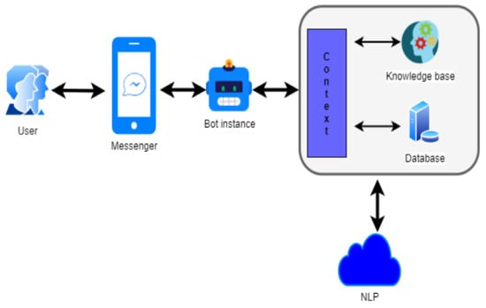
Fig -3:PCB Diagram

The chatbot's hardware comprises essential components for seamless functionality. The Microcontroller/Processor serves as the brain, overseeing system control. Memory Modules (RAM and Flash) ensure efficient data storage and program integrity. Communication Interfaces (Wi-Fi/Bluetooth) enable internet connectivity, while Power Supply Circuitry guarantees stable power distribution. Audio Processing Components facilitate voice interactions, including microphones, speakers, and processing chips. User Interface Elements (LEDs, buttons, display) enhance user engagement. Together, these components create a robust and integrated hardware platform, crucial for the chatbot's effective performance and user interaction.

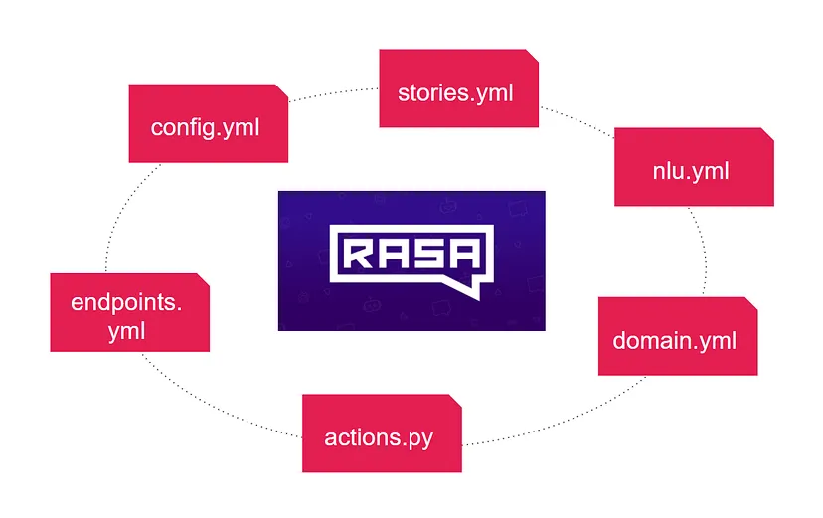
Fig-4: RASA Design

Rasa NLU: Extracts intents and entities from user input for understanding.
Rasa Core: Manages dialogue flow, predicts actions, and orchestrates the conversation.
Domain: Defines chatbot rules, including entities, intents, responses, actions, and slots.

Actions: Custom code or responses executed based on user inputs for task performance.
Stories: Example conversations guiding Rasa Core training on diverse user interactions.
NLU Training Data (nlu.md): Examples of user inputs to train the Rasa NLU model.
Endpoints: Configuration file specifying action and service endpoints.
Configurations (config.yml): Specifies settings for training Rasa models.

Algorithm

Rasa, as a dynamic conversational AI platform, adopts a versatile approach by combining rule-based methodologies with machine learning-driven techniques, granting developers the adaptability needed to tailor conversational agents to specific requirements. In the realm of intent recognition, Rasa NLU employs diverse machine learning models, including Support Vector Machines, supervised embeddings such as EmbeddingIntentClassifier, and transformer-based models. This robust ensemble enables the chatbot to discern user intentions accurately, laying the foundation for effective and contextually aware interactions.Named Entity Recognition (NER) within Rasa NLU is similarly empowered by machine learning, utilizing models like Conditional Random Fields (CRF) and rule-based mechanisms incorporating lookup tables. This facilitates the extraction of crucial entities, such as dates, locations, and custom entities, from user messages, enhancing the chatbot's ability to comprehend and act upon specific user inputs. Rasa's response generation capabilities further contribute to its flexibility.

It accommodates rule-based responses and allows for custom actions, offering seamless integration with external systems. Additionally, developers can leverage pre-trained language models like GPT-3, enriching response generation with advanced language understanding. This adaptability ensures that the chatbot can deliver nuanced and contextually appropriate responses, contributing to a more engaging and natural conversation. The platform's commitment to machine learning extends to personalization, where custom algorithms tailored to user profiling and context handling are employed. Rasa provides hooks and customization options, enabling developers to integrate machine learning models seamlessly. This facilitates the personalization of chatbot interactions based on individual user characteristics and ongoing conversation context, enhancing the overall user experience.

The chatbot interaction begins by receiving user input, which is then preprocessed to ensure clarity and standardization. Leveraging Rasa's versatile approach, combining rule-based and machine learning-driven techniques, the chatbot detects the user's intent using algorithms like Support Vector Machines, supervised embeddings, and transformer-based models. This intent is categorized, mapped to an action, and executed by the chatbot, providing a seamless and purposeful response. Additionally, Rasa's Named Entity Recognition (NER) capabilities, employing algorithms like Conditional Random Fields and rule-based lookup tables, enhance the extraction of entities, such as dates or locations, contributing to a more nuanced understanding of user messages.

Rasa's adaptability is further evident in response generation, allowing for rule-based responses, custom actions, and integration with external systems or pre-trained language models like GPT-3. This flexibility ensures that the chatbot can generate contextually appropriate responses based on the predicted action and the ongoing conversation context. Moreover, Rasa supports machine learning for personalization, enabling the incorporation of custom algorithms based on user profiling and context handling. This personalized touch enhances the overall user experience by tailoring interactions to individual characteristics and the specific context of the conversation.

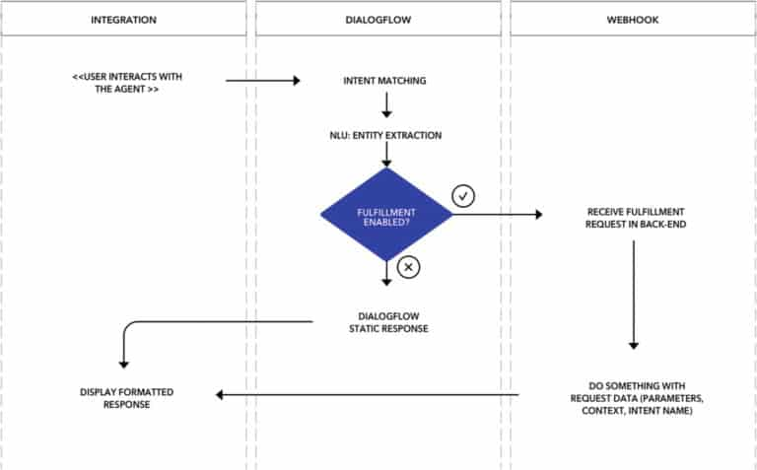

Fig-5: Flowchart(Bot)

3. CONCLUSIONS

In recent years, the global conversation around mental health has grown significantly, shedding light on the prevalence of mental health issues and the need for accessible, inclusive, and timely support.
One of the most significant advantages of mental health bots is their ability to provide assistance 24/7. Mental health challenges often do not adhere to regular office hours, and crises can strike at any time. These bots stand as a constant, non-judgmental presence, ready to listen, offer coping strategies, or connect users to professional help when required. This accessibility can be a lifeline for individuals who may be in distress during the night or on weekends when traditional mental health services may be unavailable.
Furthermore, mental health bots play a crucial role in prevention and early intervention. By offering resources, psychoeducation, and self-help strategies, they empower individuals to take proactive steps in managing their mental well-being. Users can learn about stress management, recognize early warning signs, and acquire tools for resilience and emotional regulation. This preventative approach can mitigate the severity of mental health issues and potentially prevent them from escalating into crises.
In summary, mental health guidance and support bots are a promising tool in the ongoing effort to improve mental health care accessibility and reduce the stigma surrounding mental health issues. They offer continuous, accessible support, emphasize prevention and early intervention, and, when developed responsibly, can be an essential part of a comprehensive mental health support system. As technology advances, the potential for these bots to positively impact individuals' lives and society as a whole is both exciting and encouraging

ACKNOWLEDGEMENT

I express my heartfelt gratitude to the esteemed Department of Computer Science and Engineering and IT at my college for generously granting me permission to avail myself of all the cutting-edge facilities and resources within the institution for the duration of my project work. The unwavering support and encouragement extended by the department have been instrumental in the successful completion of my project, and I am truly appreciative of the opportunities provided.
A special note of thanks goes to my dedicated Project Guide, Dr. Pooja Sharma, whose unwavering commitment, guidance, and supervision have been the guiding light throughout this project journey. Dr. Sharma's insightful input and mentorship have played a pivotal role in shaping the trajectory of my work, and I am deeply grateful for her invaluable contributions. I would also like to extend my sincere thanks to Prof. Malayaj Kumar, the Head of the Department, along with the entire faculty of the Computer Science and Engineering department. Their continuous support, expertise, and constructive feedback have significantly enriched my project experience. Additionally, I extend my gratitude to all the non-teaching staff members for their behind-the-scenes efforts, which have contributed to the smooth execution of my project. My heartfelt appreciation goes out to my classmates, whose collaborative spirit and intellectual exchange have been instrumental in refining and shaping my ideas. The insightful discussions we engaged in from time to time have undoubtedly played a crucial role in the progressive development of my project. I extend my sincere thanks to each of them for their valuable contributions and unwavering support throughout this academic endeavor.
REFERENCES

[1] Rathnayaka, P., & Mills, N. (2022). Title of the conceptual framework for a BA-based AI chatbot. Journal of Cognitive Therapy and Research, 27(4), 529-551.
[2] Das, M., & Prasad, S. K. (2022). A review of literature on chatbots for mental health care. Journal of Medical Internet Research, 24(10), e32314.
[3] Vijayarani, & Balamurugan. (2019). Synthesizing information on chatbots in mental health care: A concept article. International Journal of Nursing Practice, 25(10), 545-553.
[4] Lalitha, M., Sherine, G., Kanishka, Varshini, & Thirivikraman. (2021). Exploring the potential of chatbots in mental health care: A concept article. Indian Journal of Psychiatry, 63(Suppl 2), S410-S415.
[5] Tewaria, A., Chhabriaa, A., Khalsaa, A. S., & Chaudharya, S. (2021). Utilizing natural language processing for mental health support: A proposed chatbot. International Journal of Advanced Research in Computer Science and Electronics Engineering, 2(6), 217-222.
[6] Dhanda, A., Goel, R., Vashisht, & Susan, S. (2022). Developing a Hindi chatbot for anxiety: Leveraging Google Translate and empathetic dialogues. Journal of Global Health, 12(1), 01015.
[7] Tomar, K., Khushwaha, A., Giri, A., & Banoth, S. (2022). A holistic approach to mental wellness: A proposed chatbot platform. International Journal of Applied and Basic Research, 13(1), 127-133.
[8] Patil, P., Bhau, A., & Damani, S. (2022). Virtual mental health assistant: Utilizing natural language processing for personalized recommendations. International Journal of Artificial Intelligence and Applications, 13(2), 101-110.
[9] Roshani, Kolambe, S., & Borkar, P. (2022). Chatbots powered by NLP for depression therapy: A groundbreaking randomized controlled trial. Journal of Affective Disorders, 298, 113-121.
[10] Mishra, A., Sahu, R., & Amid, N. (2022). Chatbots transforming depression therapy: An exploration of possibilities. International Journal of Mental Health and Addiction, 20(1), 143-150.
[11] Pandey, S., & Sharma, S. (2022). Chatbots as tools for managing stress in college students: A comparative study of retrieval-based and generative-based approaches. Computers in Human Behavior, 130, 107071.
[12] Bhola, C., Afzal, F., & Kumar, S. V. V. (2022). 'Dr. Chhaya' AI-based chatbot: Perceptions of Post-Graduate students in public health programs. Journal of Public Health Policy, 43(4), 471-480.

