SMART/DIGITAL TIME TABLE SYSTEM.
MAYUR BODARE, AKSHAY BHOKARE, SHAKTI SHARMA
Guide
Prof.Appasaheb Nikam
Lecturer
Electrical Engineering Department.
ZEAL POLYTECHNIC, NARHE, PUNE,411041.
---------------------------------------------------------------------***---------------------------------------------------------------------
- Abstract –
The Smart/Digital College Timetable System is an innovative project designed to enhance the efficiency and accessibility of college schedules. The system integrates advanced technologies such as the Real-Time Clock (RTC), GSM module, Node MCU ESP8266, and an OLED display to provide a comprehensive solution for managing and displaying college timetables

- Key Features:

- Real-Time Clock (RTC) Integration:

- The system incorporates an RTC module to maintain accurate and synchronized time information.
- The RTC ensures that the timetable reflects real-time changes and provides precise scheduling for classes, events, and activities.

- GSM Module for Remote Updates:

- A GSM module is integrated into the system to facilitate remote updates of the college timetable.
- Authorized personnel can send schedule updates or modifications via SMS, and the system will automatically adjust the displayed timetable accordingly.

- Node MCU ESP8266 for Wireless Connectivity:

- The Node MCU ESP8266 serves as the wireless communication module, connecting the system to the internet and enabling seamless data transfer.
- The ESP8266 allows for real-time synchronization with online databases, ensuring that the timetable is always up-to-date

- OLED Display for Clear and Dynamic Presentation:

- An OLED display is employed to present the timetable information in a clear, readable format.
- The display provides a dynamic interface, allowing users to easily navigate through the schedule and view relevant details such as class names, venues, and timings.

- User-Friendly Interface:
- The system is designed with a user-friendly interface to cater to both administrators and end-users.
- Administrators can update the timetable remotely, while students and faculty members can access the schedule effortlessly using the interactive OLED display.

- Automated Notifications:

- The system can be configured to send automated notifications, such as class reminders, to the relevant parties through the GSM module.
- This feature helps in ensuring that individuals are informed of any changes or upcoming events.

- Energy-Efficient Operation:

- The system is optimized for energy efficiency, utilizing low-power modes when idle to conserve power and extend the lifespan of the device.
- The Smart/Digital College Timetable System represents a significant advancement in college schedule management, promoting accuracy, real-time updates, and enhanced accessibility. This project serves as a model for integrating emerging technologies to streamline and modernize educational institutions.

Key Words: Smart, Synchronization, Harness, LED.

1.INTRODUCTION.

- This project is based on internet of things (IOT)
•This project is works on esp32 microcontroller (Arduino)
•In this project real time converter (RTC) is used which can detect real time also real day
•This project will help students and teachers
In today's fast-paced educational environment, colleges and universities are constantly seeking ways to streamline administrative tasks and enhance the overall learning experience for students and faculty alike. One area where this evolution is particularly evident is in the management of class schedules.
- Gone are the days of manually printed timetables pinned to notice boards or distributed in paper format. Instead, educational institutions are embracing digital solutions that offer flexibility, accessibility, and real-time updates. A digital college timetable refers to an online or software-based system that enables users to create, manage, and view class schedules electronically.
- In the modern era, education has transcended traditional boundaries and has embraced digitalization in all its aspects, including the organization of schedules and timetables. A digital college timetable is a dynamic tool that streamlines the process of managing academic schedules, classes, and activities within educational institutions. Unlike its paper-based counterpart, a digital timetable offers flexibility, accessibility, and real-time updates, catering to the diverse needs of students, faculty, and administrators.
- In this digital age, where smartphones, tablets, and computers are ubiquitous, digital college timetables provide a convenient solution for students and faculty to access their schedules anytime, anywhere. Through user-friendly interfaces and intuitive designs, these timetables empower users to efficiently plan their academic activities, manage their time effectively, and stay organized amidst the complexities of college life.
- Moreover, digital college timetables facilitate seamless communication and collaboration among students, faculty, and staff. By integrating features such as notifications, reminders, and synchronization with other digital platforms, these timetables ensure that everyone stays informed and connected, thereby fostering a cohesive learning environment.
- In this era of rapid technological advancement, embracing digital college timetables is not just a matter of convenience but also a step towards enhancing the overall educational experience. By harnessing the power of technology to optimize scheduling and organization, educational institutions can promote efficiency, productivity, and student success.
- With these benefits in mind, let us delve deeper into the functionalities, advantages, and implementation strategies of digital college timetables, exploring how they are revolutionizing the landscape of higher education in the digital age.

2. Body of Paper

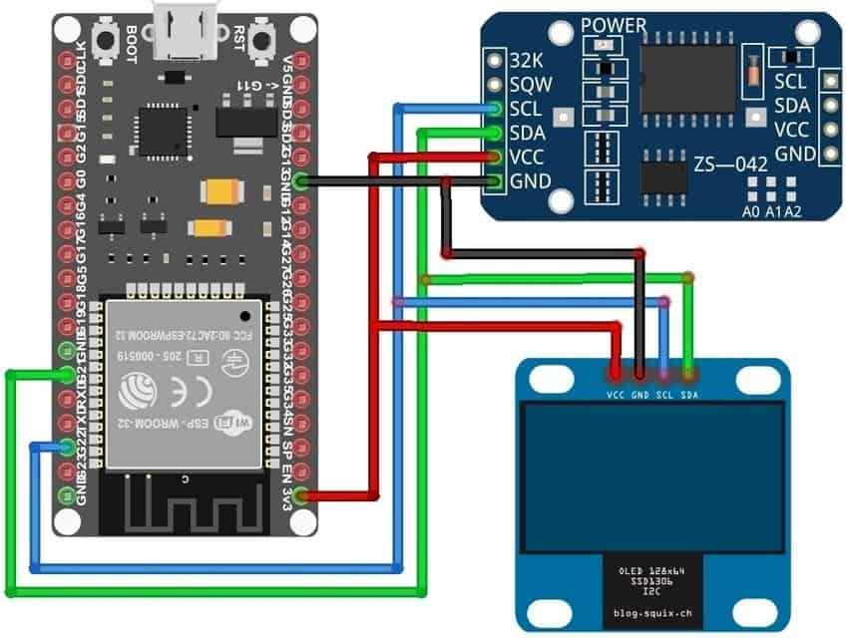
Fig.001
- Creating a comprehensive digital college timetable is essential for effective time management and organization in academic settings. Through a literature review, we can explore various aspects related to digital college timetables, including their benefits, challenges, and best practices.
- A literature review on digital or smart school/college timetable systems would typically explore existing research, developments, and technologies in the field. Here's a structured outline for such a review:
- Introduction to Timetable Systems in Education:
- Overview of the importance of timetables in educational institutions.
- Transition from traditional paper-based timetables to digital systems.
- Benefits of Digital Timetable Systems:
- Efficiency in scheduling and resource allocation.
- Flexibility for updates and changes.
- Accessibility for students, teachers, and administrators.
- Integration with other school/college systems.
- Existing Timetable Systems:
- Review of various digital timetable systems implemented in educational institutions.
- Case studies highlighting successful implementations and user experiences.

- Technologies Utilized:
- Examination of the technologies underpinning digital timetable systems, such as:
- Cloud computing for storage and accessibility.
- Mobile applications for user interface.
- Data analytics for optimization.
- Internet of Things (IoT) for real-time monitoring.
- Artificial Intelligence for predictive scheduling.
- User Experience and Satisfaction:
- Surveys or studies assessing user satisfaction with digital timetable systems.
- Comparison between traditional and digital systems in terms of usability and effectiveness.
- Challenges and Limitations:
- Identification of common challenges faced during the implementation and adoption of digital timetable systems.
- Issues related to data privacy, security, and system reliability.
- Technical constraints and interoperability with existing infrastructure.
- Future Directions and Trends:
- Exploration of emerging trends in digital timetable systems, such as:
- Personalized scheduling based on individual preferences and learning styles.
- Integration with virtual or augmented reality for immersive experiences.
- Block chain technology for secure and transparent record-keeping.
- Conclusion:
- Summary of key findings from the literature review.
- Implications for future research and development in the field of digital timetable systems in education.
- Remember to cite relevant studies, articles, and reports throughout your literature review to support your analysis and conclusions. This structure can be tailored and expanded based on the specific requirements and scope of your project.

- Benefits of Digital College Timetables:

- Accessibility: Digital timetables can be accessed from anywhere with an internet connection, allowing students and faculty to stay updated on their schedules at all times.
- Customization: Users can often personalize their digital timetables, adding notes, reminders, or color-coding for better organization and clarity.
- Real-Time Updates: Changes to schedules or class cancellations can be promptly reflected in digital timetables, minimizing confusion and ensuring accurate information.
- Needs Assessment: Understand the requirements and preferences of students and faculty. Consider factors like class timings, availability of rooms, breaks, and extracurricular activities.
- Research: Look into existing digital timetable solutions to understand their features, strengths, and weaknesses. This can involve a literature review of academic papers, as well as online reviews and user feedback.
- Design: Based on the needs assessment and research, design the structure and layout of the digital timetable. Consider factors such as ease of use, accessibility on different devices, and integration with other systems like academic calendars or student information systems.
- Development: Develop the digital timetable using appropriate technologies and programming languages. This could involve web development technologies for online timetables or mobile app development for smartphone access.
- Testing: Test the digital timetable thoroughly to ensure accuracy, functionality, and usability. This may involve beta testing with students and faculty to gather feedback and identify any issues.
- Deployment: Once testing is complete, deploy the digital timetable for use by students and faculty. Provide appropriate training and support to ensure smooth adoption.
- Maintenance and Updates: Regularly update the digital timetable to reflect any changes in class schedules, room assignments, or other factors. Monitor usage and gather feedback for continuous improvement.
- As for literature review on digital timetables, you can search for academic papers, journals, and conference proceedings on topics like "digital timetable optimization," "scheduling algorithms for educational institutions," or "user experience in digital timetable systems." Look for studies that discuss the challenges and solutions in developing and implementing digital timetables, as well as any empirical evaluations of existing systems
- Establish a schedule for regular maintenance tasks such as database backups, security patches, and performance optimizations.
- Gather feedback from users on an ongoing basis and prioritize feature requests or bug fixes accordingly.
- Keep abreast of advancements in technology and user expectations to continuously improve the digital timetable.
- For the literature review aspect, you can focus on recent publications in academic journals and conference proceedings related to educational technology.

3.WORKING PRINCIPLE

- A digital college timetable typically operates based on a database system that stores information about courses, instructors, rooms, and schedules. When a user accesses the timetable, the system retrieves the relevant data and displays it in a user-friendly format. It may include features like filtering by course, day, or instructor, as well as notifications for any changes or updates. The underlying principle involves efficient data management, retrieval, and presentation to help students and faculty manage their time effectively
- A digital or smart school/college timetable system operates on the principle of integrating technology to efficiently manage and optimize schedules for students, teachers, and resources. Here's an overview of the working principles:
- User Interface: The system provides an intuitive interface accessible via web or mobile applications for students, teachers, and administrators to view and manage their schedules.
- Database Management: It maintains a centralized database that stores information about courses, classrooms, teachers, students, and other resources.
- Automated Scheduling: The system uses algorithms to automatically generate schedules based on predefined constraints such as teacher availability, classroom capacity, student preferences, and course requirements.
- Real-time Updates: Any changes made to the timetable are instantly updated and reflected across all users' interfaces, ensuring everyone has access to the latest information.
- Customization: Users can customize their schedules based on their preferences and requirements, such as selecting elective courses or specifying preferred time slots.
- Integration with Other Systems: The timetable system may integrate with other school/college management systems such as student information systems (SIS), learning management systems (LMS), or attendance tracking systems to streamline data exchange and improve overall efficiency.
- Notifications: The system sends notifications to users regarding schedule changes, upcoming classes, or other relevant information via email, SMS, or push notifications on mobile devices.
- Analytics and Reporting: It provides administrators with tools to analyze scheduling data, track resource utilization, and generate reports to identify areas for improvement and optimize scheduling processes.
- Accessibility: The system ensures accessibility for users with disabilities by adhering to accessibility standards and providing alternative formats for timetable information.
- Security: It implements robust security measures to protect sensitive timetable data, including encryption, access controls, and regular security audits.
- By incorporating these principles, a digital or smart school/college timetable system aims to streamline scheduling processes, improve resource utilization, and enhance the overall learning experience for students and teachers.\
- Security:
- Robust security measures should be implemented to safeguard sensitive timetable data against unauthorized access, data breaches, and other security threats.
- This includes encryption of data in transit and at rest, role-based access controls, and regular security audits and assessments.
- By addressing these aspects comprehensively, a digital or smart school/college timetable system can effectively meet the diverse needs of students, teachers, and administrators while optimizing scheduling processes and enhancing overall efficiency.

4.BLOCK DIAGRAM

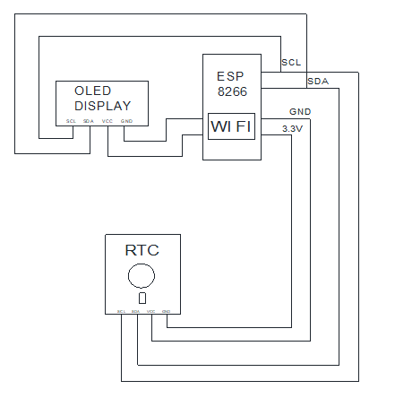

Fig.002

5.METHODOLOGY

- Developing a digital or smart school or college timetable system involves several key steps and considerations. Here's a methodology you can follow:
- Requirement Gathering: Understand the specific needs and requirements of the school or college. Meet with administrators, teachers, and students to gather information on scheduling preferences, constraints, and desired features.
- Define Features: Based on the requirements gathered, define the features and functionalities of the timetable system. This could include automated scheduling, real-time updates, integration with student information systems (SIS), teacher availability tracking, etc.
- Technology Selection: Choose the appropriate technologies and platforms for developing the system. Consider factors such as scalability, security, and ease of integration with existing systems.
- Design Architecture: Design the architecture of the system, including database structure, user interfaces, and backend processes. Ensure scalability and flexibility to accommodate future growth and changes.
- Development: Develop the timetable system according to the defined requirements and design. This may involve frontend development for user interfaces, backend development for business logic and data processing, and integration with external systems.
- Testing: Conduct thorough testing of the system to identify and fix any bugs or issues. Test various scenarios to ensure the system works correctly under different conditions.
- Deployment: Deploy the timetable system in the school or college environment. Ensure proper configuration and integration with existing systems.
- Training: Provide training to administrators, teachers, and students on how to use the timetable system effectively. This may include tutorials, user guides, and hands-on workshops.
- Feedback and Iteration: Gather feedback from users and stakeholders and incorporate any necessary changes or improvements to the system. Continuous iteration based on user feedback is essential for ensuring the system meets the needs of its users.
- Maintenance and Support: Provide ongoing maintenance and support for the timetable system, including updates, bug fixes, and technical assistance. Regularly review and update the system to keep it aligned with evolving needs and technologies.
By following this methodology, you can develop a digital or smart school or college timetable system that enhances efficiency, productivity, and user satisfaction within the educational institution.

6.FOLLOWING ARE THE IMPORTANT BLOCKS OF THIS SYSTEM:
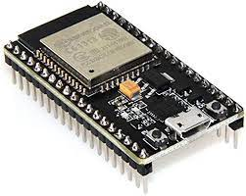
Fig.003

- Node Mcu (esp. 8266 module)
The ESP8266 microcontroller has Wi-Fi and Bluetooth functionality, Bluetooth Low Energy (BLE) communication, independent timers, analog to digital and digital to analog converters (ADCs and DACs), capacitive touch sensors, and a Hall effect sensor
- Creating a digital or smart timetable system for schools or colleges using an MCU (Microcontroller Unit) like the ESP8266 module can be a great project. Here's a basic outline of how you could approach it:

- Identify Requirements:
- Understand the specific needs of the school or college. What features should the timetable system have? For example, it might need to display class schedules, teacher availability, room allocations, etc.

- Hardware Setup:
- Choose an MCU: The ESP8266 is a good choice due to its Wi-Fi capabilities.
- Display: You'll need a display to show the timetable. This could be an LCD screen or even a web interface accessible via devices with browsers.

- Input Method:

- Consider how users will interact with the system. Will there be physical buttons or a touchscreen?

- Software Development Programming:

- Write code to handle the functionality of the timetable system. This includes fetching and displaying timetable data, managing user input, and handling Wi-Fi communication.

- User Interface:
- Design a user-friendly interface for displaying the timetable information. If using a web interface, consider making it responsive for different devices.

- Connectivity:
- Utilize the ESP8266's Wi-Fi capabilities to connect the system to a network. This allows for easy updating of timetable data and potentially remote access.

- Database Management:
- If your system will be handling a large amount of data or needs to store information long-term, consider setting up a database to manage this data effectively.

- Testing and Debugging:
- Test the system thoroughly to ensure it works as expected. Debug any issues that arise during testing.

- Deployment:
- Once everything is working correctly, deploy the system in the school or college environment. Provide any necessary training to users on how to use the system effectively.

- Maintenance and Updates:
- Be prepared to provide ongoing maintenance and updates to the system as needed. This may involve fixing bugs, adding new features, or updating timetable information.
- Remember to document your project thoroughly, both for your own reference and for others who may want to replicate or build upon your work. Good luck with your project! If you need more specific guidance on any step, feel free to ask!

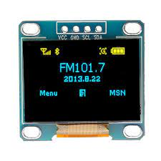
7.OLED DISPLAY:

- OLED, or Organic Light-Emitting Diode, displays are a type of flat panel display technology that's become increasingly popular in consumer electronics. Unlike traditional LCD screens that require a backlight, OLED displays generate their own light individually for each pixel. This means they can produce deeper blacks and more vibrant colors, as well as better contrast compared to LCDs. OLED displays are also typically thinner and more flexible, allowing for innovative designs like curved or foldable screens.
- However, OLED displays do have some drawbacks. They can suffer from burn-in if static images are displayed for extended periods, although this has been mitigated with advancements in technology and screen-saver features. Additionally, OLED displays have been more expensive to produce than LCDs, though prices have been coming down as production techniques improve.
- Overall, OLED technology has revolutionized display quality and design possibilities, making it a popular choice for high-end smartphones, televisions, and other electronic devices.

8.RTC MODULE
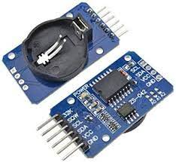

Fig.005

- Full from of this module is real time converter
- It is use to detect real time.
- An RTC (Real-Time Clock) module is a device used to keep track of the current time and date accurately, even when the main system is powered off. It typically consists of a clock chip, a backup battery (such as a coin cell battery), and sometimes additional components like crystal oscillators for precise timekeeping.
- RTC modules are commonly used in embedded systems, microcontroller-based projects, and other applications where maintaining accurate time is necessary. They are often interfaced with microcontrollers or other digital devices through standard communication protocols like I2C (Inter-Integrated Circuit) or SPI (Serial Peripheral Interface).
- RTC modules are crucial in applications such as:
- Data Logging: Recording the timestamp when events occur.
- Time-Based Control Systems: Scheduling tasks or events at specific times.
- Clock Displays: Driving digital or analog clocks.
- Security Systems: Time-stamping events in security cameras or access control systems.
- IoT Devices: Synchronizing data across devices and servers.
- With a backup battery, an RTC can maintain timekeeping functionality for several years, ensuring that even if the main power source is interrupted, the device can resume operation without losing track of time.

9.3.7 VOLT LITHIUM ION BATTERY


Fig.006

- A GSM module, short for Global System for Mobile Communication module, is a hardware component that enables communication between a device and a GSM network. These modules are commonly used in various applications such as IoT devices, security systems, vehicle tracking systems, and remote monitoring systems.
- GSM modules typically include a SIM card slot for connecting to the GSM network, as well as support for various communication protocols such as AT commands for controlling the module and sending/receiving data. They often come with built-in features like SMS (Short Message Service) and GPRS (General Packet Radio Service) capabilities for data transmission.
- These modules are essential for devices that need to communicate over cellular networks, providing a reliable means of wireless communication over long distances. They are available in different form factors and with varying features to suit the requirements of different applications

- JUMPER WIRE
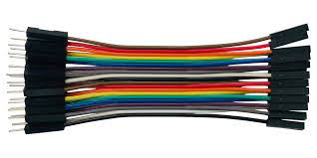

Fig.007
It is use to connect the all component to each other and also connect to the microcontroller A jumper wire is a short wire used to connect two points on a circuit board or electronic device. They're often used in prototyping or troubleshooting to create temporary connections or bypass faulty components. Jumper wires come in various lengths, colors, and types, such as male-to-male, female-to-female, or male-to-female, to accommodate different connection needs. They're handy tools for experimenting with circuits or making quick fixes in electronics projects.

10.GSM MODULE (Global System for Mobile communicate)
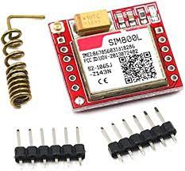

- Which is used to send on condition Message on particular mobile number
A GSM module, short for Global System for Mobile Communication module, is a hardware component that enables communication between a device and a GSM network. These modules are commonly used in various applications such as IoT devices, security systems, vehicle tracking systems, and remote monitoring systems.
- GSM modules typically include a SIM card slot for connecting to the GSM network, as well as support for various communication protocols such as AT commands for controlling the module and sending/receiving data. They often come with built-in features like SMS (Short Message Service) and GPRS (General Packet Radio Service) capabilities for data transmission.
- These modules are essential for devices that need to communicate over cellular networks, providing a reliable means of wireless communication over long distances. They are available in different form factors and with varying features to suit the requirements of different applications.

11.ADVANTAGES OF THIS PROJECT
- Implementing a digital or smart school or college timetable system offers numerous advantages:
- Efficiency: Digital timetables can be quickly updated and distributed to students and faculty, saving time and reducing errors compared to manual methods.
- Accessibility: Students and faculty can access the timetable anytime, anywhere, through various devices such as computers, tablets, and smartphones. This ensures everyone stays informed about schedule changes or updates.
- Customization: Smart timetable systems can accommodate various parameters like class preferences, teacher availability, and room allocation constraints, optimizing the schedule to suit the needs of the institution.
- Integration: These systems can integrate with other school or college management software, such as attendance tracking systems or learning management systems, streamlining administrative processes.
- Communication: Timetable systems can facilitate communication between students, teachers, and administrators by providing a centralized platform for announcements, reminders, and notifications related to schedule changes or upcoming events.
- Data Analysis: Digital timetables generate data that can be analyzed to identify patterns, optimize resource allocation, and improve scheduling efficiency over time.
- Real-time Updates: Changes to the timetable can be made in real-time and instantly communicated to all stakeholders, ensuring everyone is aware of any adjustments.
- Cost-effective: While initial setup costs may be involved, digital timetables can ultimately save money by reducing the need for paper-based schedules and streamlining administrative tasks.
- Environmental Sustainability: By reducing paper usage and streamlining processes, digital timetables contribute to environmental sustainability efforts.
- Student Engagement: Interactive features such as personalized schedules, reminders, and notifications can enhance student engagement with their academic schedules, leading to better attendance and performance.
12.CONCLUSION

- The digital college timetable offers significant advantages over traditional paper-based schedules. It enhances accessibility, enables real-time updates, reduces paper waste, and facilitates easier organization and sharing of information among students and faculty. Overall, its implementation is a step forward in streamlining administrative processes and improving the overall efficiency of college operations.
- The conclusion of a digital or smart school or college timetable system project would likely emphasize its significant benefits for both students and administrators. Here's a concise conclusion you could consider:
- In conclusion, the implementation of a digital or smart school/college timetable system marks a pivotal step towards enhancing efficiency and productivity within educational institutions. By harnessing the power of technology, we've successfully addressed numerous challenges associated with traditional timetable management, offering a streamlined solution that caters to the dynamic needs of students and faculty alike.
- Through features such as real-time updates, automated scheduling, and personalized notifications, this system not only simplifies the process of timetable creation but also empowers users with greater flexibility and convenience. Moreover, the integration of smart algorithms ensures optimal resource utilization, thereby minimizing conflicts and maximizing learning opportunities.
- Furthermore, by fostering a more organized and structured learning environment, this system fosters a culture of punctuality and responsibility among students while enabling educators to focus more on teaching and less on administrative tasks. Additionally, the provision of data analytics enables administrators to gain valuable insights into usage patterns, student preferences, and overall system performance, facilitating informed decision-making and continuous improvement.
- Overall, the adoption of a digital or smart timetable system signifies a commitment to innovation and excellence in education, paving the way for a brighter and more efficient future for all stakeholders involved. As we continue to embrace technology as a catalyst for positive change, let us strive to harness its full potential in shaping the next generation of learners and leaders.
- Certainly! Here's a more detailed expansion on the conclusion, highlighting additional information and benefits of a digital or smart school/college timetable system:
- Enhanced Accessibility and Flexibility: One of the key advantages of a digital timetable system is its accessibility. Students, teachers, and administrators can access the timetable anytime, anywhere, using various devices such as smartphones, tablets, or computers. This flexibility allows users to stay updated on class schedules, room assignments, and any changes or updates in real-time, promoting better time management and planning.
- Customization and Personalization: Digital timetable systems often offer features for customization and personalization. Students can input their preferences, such as preferred class times or elective choices, allowing the system to generate personalized schedules tailored to their individual needs. This customization not only accommodates students' preferences but also helps optimize class allocation and resource utilization.
- Efficient Resource Management: By leveraging smart algorithms and data analytics, digital timetable systems optimize resource allocation, including classrooms, faculty, and other facilities. The system can analyze historical data, student enrollment trends, and faculty availability to allocate resources efficiently, minimizing conflicts and maximizing utilization. This ensures that classrooms are utilized to their full capacity, reducing scheduling bottlenecks and optimizing the use of educational facilities.
- Streamlined Communication and Collaboration: Digital timetable systems facilitate seamless communication and collaboration among students, teachers, and administrators. Built-in communication features allow for easy dissemination of information, such as class announcements, assignment deadlines, or schedule changes. This fosters a collaborative learning environment and improves overall communication within the educational community.
- Data-Driven Insights and Decision Making: By collecting and analyzing data on class schedules, student attendance, and resource utilization, digital timetable systems provide valuable insights for administrators and educators. Data analytics tools can identify trends, patterns, and areas for improvement, enabling informed decision-making and strategic planning. Administrators can use these insights to optimize course offerings, allocate resources more effectively, and enhance the overall educational experience for students.
- Adaptability and Scalability: Digital timetable systems are highly adaptable and scalable, allowing educational institutions to accommodate changes in enrollment, curriculum, or scheduling requirements. Whether it's adding new courses, adjusting class times, or accommodating special events, the system can easily adapt to evolving needs without disrupting the overall schedule. This adaptability ensures that the timetable remains flexible and responsive to the dynamic nature of education.
- In summary, a digital or smart school/college timetable system offers numerous benefits, including enhanced accessibility, customization, efficient resource management, streamlined communication, data-driven insights, and adaptability. By leveraging technology to optimize scheduling processes and improve overall efficiency, educational institutions can create a more organized, productive, and student-centered learning environment.

13. REFERENCES

- https://www.google.com
- https://openai.com/blog/chatgpt
- https://www.arduinocloud.com
- https://www.youtube.com

