AARMS

A PROJECT REPORT

Submitted by

YASH DHARMENDRA JARIWALA

200303105021

In partial fulfillment for the award of the degree of

BACHELOR OF ENGINEERING
in

Computer Science Engineering

Parul Institute of Engineering and Technology, Limbda





Parul University, Limbda
March-2024

Parul Institute of Engineering & Technology, Limbda

CERTIFICATE

This is to certify that the project report submitted along with the project entitled Internship has been carried out by Yash Dharmendra Jariwala under my guidance in partial fulfillment for the degree of Bachelor of Engineering in Computer Science Engineering, 8th Semester of Parul University, Vadodara during the AY 2023-24.

Ishan Rajani & Rahul Moud Dr. Amit Bharve

Internal Guide Head of the Department



Date: 02/02/2024

TO WHOM IT MAY CONCERN

This is to certify that Yash Dharmendra Jariwala, a student of Parul University has successfully completed his/her internship in the field of Full Stack Development from 1st January 2024 to 1st July 2024 (Total number of Weeks: 24) under the guidance of Shubham Soni. His internship activities include React JS. He is currently learning Node.js and TypeScript. During the period of his internship program with us, he was exposed to different processes and was found diligent, hardworking and curious.

We wish him every success in his life and career.

For O2h Group



Nikita Pritmani
Human Resource Manager

Parul Institute of Engineering & Technology, Limbda

DECLARATION

We hereby declare that the Internship report submitted along with the Internship entitled AARMS submitted in partial fulfillment for the degree of Bachelor of Engineering in Computer Science Engineering to Parul University, Vadodara, is a bonafide record of original project work carried out by me at O2h Technology under the supervision of Ishan Rajani & Rahul Moud and that no part of this report has been directly copied from any students’ reports or taken from any other source, without providing due reference.

Name of the Student Sign of Student

1 Yash Dharmendra Jariwala

ACKNOWLEDGEMENT

First I would like to thank Lubna Narmawala, HR, Head of o2h technology, Ahmedabad for giving me the opportunity to do an internship within the organization. I would also like to thank all the people that worked along with me in o2h technology, Ahmedabad with their patience and openness they created an enjoyable working environment. It is indeed with a great sense of pleasure and immense sense of gratitude that I acknowledge the help of these individuals.
I am thankful to Parul Institute of Engineering and Technology for giving me an opportunity to develop this project. Ishan Rajani & Rahul Moud (Internal Guide) is the main force behind all these. The project became successful only because of their valuable suggestions, proper co-operation and complete guidance in developing this project. It was also the support from the staff members who spend their valuable time in providing us all the relevant and confidential college information which has helped us in preparing our project. I also express my sincere thanks to our HOD, who allowed to use all the resources of the institute.

Yours sincerely
Yash Dharmendra Jariwala 200303105021

ABSTRACT

AARMS is one of the reliable Projects which helps us in sprint planning and help allocation resources properly and helps perform the sprint in a well-managed and structured way. In Agile Methodology all tasks are divided into sprints. It defines what can be delivered and how that work will be achieved. Sprint Planning takes to much effort and time , so to reduce that we are developing this web app which automates the sprint planning. This application provides various modules for various roles in the company and also has different departments sprint and so we can manage the resources properly so that the employees may not feel overburdened or stressed. It will help to measure the resource availability, helps to manage and maintain the team structure, project management, and data visualization . With AARMS, sprint planning becomes a breeze, enabling teams to optimize their resources, enhance productivity, and deliver successful sprints in an agile and efficient manner.

List of Figures
2.2 SDLC 4
  - Database design 14
  - ER Diagram 15
  - System dataflow diagram 16
    - Launch Screen… 16
    - Forgot password Screen… 17
    - Dashboard… 17
    - Sprint Screen… 18
    - Data and Report Screen… 18
    - Add User… 19
    - Adding a new project 19
    - Availability Module 20
    - Department Module 20

Table of Content

Acknowledgement i

Abstract ii
List of Figures iii
Table of Contents iv
Chapter 1 Overview of the company 1
  - About Company 1
  - History 1
  - Scope of work 1
  - Vision 1
Chapter 2 Overview of different company department 2
  - List the technical specifications of major equipment used in each department 3
  - Project Plan 4
Chapter 3 Introduction to Project 7
  - Project Summary 7
  - Purpose 7
  - Objective 7
  - Scope 8
  - Technology 8
  - Project Planning 9
Chapter 4 System Analysis 12
  - Study of Current System 12
  - Problem and weakness of current system 12
  - System Feasibility 12
    - Does the system contribute to the overall objective of the 12
organization
    - Can the system be implemented using the current technology and 12
within the given cost and schedule constraints
  - Activity of New System 13
  - Features of New System 13
  - Selection of Hardware and Software 13
Chapter 5 System Design 14
  - Database design 14
  - E-R Diagram 15
  - System data flow diagram 16
  - Interface Design 16
    - Launch screen 16
    - Forgot Password Screen 17
    - Dashboard 17
    - Sprint Screen 18
    - Data and Report Screen 18
    - Add User 19
    - Adding a new project 19
    - Availability Module 20
    - Department Module 20
Chapter 6 Implementation 21
  - Implementation platform 21
  - Process Specification 21
  - Result / Outcome 21
Chapter 7 Conclusion and Discussion 22
  - Overall Analysis of internship 22
  - Dates of Continuous Evaluation (CE-I and CE-II) 22
  - Limitation and future enhancements 22
  - Summary of Internship / Project work 22
References 23

CHAPTER 1 OVERVIEW OF THE COMPANY

ABOUT COMPANY

o2h Technology is a division of the o2h group which seeds new ideas in life-science, technology and green innovation. The tech team has broad development capabilities and have an exceptional track record in delivering end to end projects covering Web, Mobile, Cloud, Software, AI and Blockchain. We use agile methodologies structured into short sprints to ensure quick and methodical development.O2h technology uses agile methodologies structured into short sprints to ensure quick and methodical development . We work with companies all over the world and have support and consultancy teams in the USA, UK and India. Whether start-up, scale-up or an established business, our partners can rely on o2h Technology to deliver quality and support.

HISTORY

O2h technology is a division of the o2h group which seeds new ideas in life-science, technology and innovation. Technology was officially founded in 2017 to support cross fertilization of ideas being generated from within the life-science and investment divisions.

SCOPE OF WORK

The project will consist of a resource allocation algorithm that will auto allocate resources to the task of the project depending on the availability and skills of the resource. It will also consist of project management, data visualization and report extraction.

VISION

The vision at o2h is seeding new ideas and nurturing ideas and help the people and the future goal is to become the best idea factory .

CHAPTER 2 OVERVIEW OF DIFFERENT DEPARTMENT OF
COMPANY

Any organization needs different teams in order to work . These team they work as the pillars of the organization. O2h technology has several departments like Business Analyst, Designers , Frontend, Backend, Quality Assurance, DevOps.

Business Analyst

Business analysts play a vital role in identifying and analyzing areas of improvement within a business, with the aim of increasing efficiency and strengthening business processes. Through their comprehensive analysis, business analysts identify opportunities for optimization and work closely with stakeholders across various levels of the business hierarchy to communicate their findings and recommendations. Business analysts utilize their expertise in data analysis, process mapping, and problem solving to assess existing business processes, systems, and operations.

Designers

A design department manager oversees various creative and design projects for an organization. They collaborate with other members of a design team, ensure projects are cost-effective, and maintain an up-to-date understanding of their target market.

Front-end

A front-end developer builds the front-end portion of websites and web applications— that is, the part that users actually see and interact with. A front-end developer creates websites and applications using web languages such as HTML, CSS, and JavaScript allow users to access and interact with the site or app.

Back-end

A back-end web developer is responsible for server-side web application logic and integration of the work front-end web developers do. Back-end developers usually write web services and APIs used by front-end developers and mobile application developers

Quality Assurance

A QA engineer creates tests that identify issues with software before a product launch.
These tests entail other tasks such as developing and running new tests and reporting their results to stakeholders, who will collaborate to fix program bugs or problems.

DevOps

DevOps is all about the unification and automation of processes, and DevOps engineers are instrumental in combining code, application maintenance, and application management. All of these tasks rely on understanding not only development life cycles, but DevOps culture, and its philosophy, practices, and tools.

  - TECHNICAL SPECIFICATIONS

Tools
    - Balsamiq
    - Figma
    - VS Code
    - Jira
    - Bitbucket
    - Postman
    - GitHub

Technologies
    - JavaScript
    - React JS
    - HTML/CSS/ Bootstrap
    - Nodejs
    - Java
    - Typescript

Database
    - MySQL/ MongoDB

PROJECT PLAN

Strategy:
    - Sketching the idea
    - Developing a strategy
    - Requirement Gathering
    - Business Analysis
    - Prepare Documents
    - Create Wireframes

Design :
    - Research on the requirements
    - Clear wireframes and prototypes
    - Building the design
    - Adjusting to user requirements

Development :
    - See the design and create user interface
    - Defining the backend
    - Testing the prototype
    - Unit testing
    - Make APIs

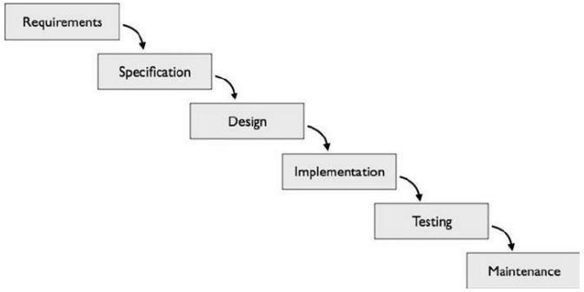
Fig 2.2 SDLC

Explain in details about each stage of production.

- Requirement

We have collected all the information regarding the project. Once requirement gathering is done, an analysis is done to check the feasibility of the development of a product. Once the requirement is clearly understood, the SRS (Software Requirement Specification) document is created. This document should be thoroughly understood by the developers and also be reviewed by the customer.

Specification

Once the requirement analysis is done the next step is to clearly define and document the product requirements and get them approved from the customer or the market analysts. This is done through an SRS (Software Requirement Specification) document which consists of all the product requirements to be designed and developed during the project life cycle. Based on the requirements specified in SRS, usually more than one design approach for the product architecture is proposed and documented in a DDS Design Document

Design

In this phase, the requirement gathered in the SRS document is used as an input and software architecture that is used for implementing system development is derived. We have designed all the public pages like homepage, FAQ Page, contact us page, about us page, login page, signup page etc. through HTML, CSS, JavaScript.

Implementing or Coding

Implementation/Coding started according to the requirement. The Software design is translated into source code. All the components of the software are implemented in this phase. Php, jQuery etc. are used for implementation. We used MVC Structure for implementation.

Testing

Testing starts once the coding is complete and the modules are released for testing. In this phase, the developed software is tested thoroughly and any defects found are assigned back to get them

fixed. Testers refer to the SRS document to make sure that the software is as per the customer’s standard.

Maintenance

After the deployment of a product on the production environment, maintenance of the product i.e., if any issue comes up and needs to be fixed or any enhancement is to be done is taken care by the developers.

CHAPTER 3 INTRODUCTION TO PROJECT

This document is used to well define the description of “AARMS” . Efforts have been made to complete the project and define it well. The final product will contain only features or functions mentioned in this document and no assumptions are made by other parties involved in developing/testing/ implementing or using the product. If any changes are required in future it will be formally raised and may be included in the second phase of the development.

PROJECT SUMMARY

AARMS is completely based on the resources and it will contain a resource allocation algorithm that will auto allocate resources to the task of the project depending on the availability and skills of the resource. It will also consist of project management, data visualization and report extraction that will help solve the problem and will help to complete the process in a well- managed and structured way.

PURPOSE

In our company the allocation of resources is done manually and that takes time to process . The allocation of the resources is done sprint wise (14 days) so whenever the sprint was completed the leads have to sit together discuss for the next sprint so we have decided to make something that helped allocate the resources in a well-managed and structured way and it can be done by one person without any meetings to be arranged and the project AARMS is developed.

OBJECTIVE

- Resource Allocation Automation: AARMS aims to automate the resource allocation process in the company, eliminating the need for manual allocation and reducing the time and effort required. The system will utilize a resource allocation algorithm that takes into account the availability and skills of the resources to efficiently allocate them to tasks in the project.

- Project Management: AARMS will provide project management functionalities that enable efficient planning, tracking, and monitoring of projects. This includes features such as task assignment, progress tracking, and team collaboration, ensuring that projects are managed in a

well-structured and organized manner.

- Data Visualization and Reporting: AARMS will offer data visualization and reporting capabilities, providing meaningful insights and reports that help in decision-making and performance evaluation. This includes visualizing resource utilization, project progress, and other key metrics, enabling stakeholders to have a clear view of the project status and resource availability.

- Streamlined Sprint Planning: AARMS will streamline the sprint planning process by automating resource allocation and eliminating the need for manual meetings to discuss resource allocation for each sprint. This will help in making the sprint planning process more efficient, structured, and time-saving.

- Improved Resource Management: AARMS aims to optimize resource management by ensuring that resources are allocated based on their availability and skills, preventing overburdening or stress among employees. This will result in improved resource utilization and productivity.

SCOPE

The major objective is to make AARMS properly managed and errorless, with the help of these the users can have a perfect sprint that is only possible when the resources and the allocation is done properly and these systems will be helpful in saving time and efforts for users. headings, paragraphs, lists and so on and to supplement that text with interactive forms, embedded images and other objects.

METHODOLOGY

At first the requirements are gathered and analyzed. It will also consist of research, writing, flowchart, wireframe, design and resource allocation algorithm that will auto allocate resources to the task of the project depending on the availability and skills of the resource. It will also consist of project management, data visualization and report extraction.

TECHNOLOGY

Front End:
    - HTML (Hypertext Markup Language): HTML is the standard markup language used for creating the structure and content of web pages. It uses tags to define elements such as headings, paragraphs, images, links, forms, and more, which are rendered by web browsers to display web pages.

    - CSS (Cascading Style Sheets): CSS is a style sheet language used for controlling the layout and appearance of web pages. It allows web developers to apply styles, such as fonts, colors, spacing, and positioning, to HTML elements, giving web pages a visually appealing and consistent look and feel.

    - React: React is a popular JavaScript library for building user interfaces in web applications. It allows developers to create reusable UI components that can efficiently render and update UI elements based on changes in application state. React uses a virtual DOM (Document Object Model) to efficiently update only the parts of the UI that need to be changed, resulting in faster and more efficient user interfaces

Back End:
Node.js, TypeScript - Node.js is a server-side JavaScript runtime, used for building scalable and high-performance web servers, while TypeScript is a typed superset of JavaScript, providing additional features such as static typing and interfaces, making it a popular choice for building robust and maintainable back-end applications.

    - Quality Analysis: Postman - Postman is an API testing tool that provides an easy-to-use interface for creating, testing, and managing API requests and responses, making it essential for quality assurance and testing in API-driven applications.

sometimes even before any development activity starts. Project planning consists of following essential activities:

    - Scheduling manpower and other resources needed to develop the system.
    - Staff organization and staffing plans.
    - Risk identification, analysis, and accurate planning.
    - Estimating some of the basic attributes of the project like cost, duration and efforts.

Framework:
    - MUI - MUI (Material-UI) is a React UI framework that provides predesigned components based on Material Design guidelines, allowing for rapid development of modern and visually appealing user interfaces.

    - Wireframes: Balsamiq - Balsamiq is a wireframing tool used for creating low-fidelity mockups and wireframes of user interfaces, allowing for quick visualization of UI layouts and interactions in the early stages of design and prototyping.

    - Database: MySQL - MySQL is an open-source relational database management system used for storing and retrieving data in a structured manner, commonly used in web applications for data storage and retrieval.

PROJECT PLANNING

Project planning is a discipline addressing how to complete a project in a certain timeframe, usually with defined stages and designated resources. One view of project planning divides the activity into these steps: setting measurable objectives. identifying deliverables.
    - Setting measurable objectives
    - Identifying deliverables
    - Scheduling
    - Planning tasks

Internship Development approach

O2h technology follows a simple and transparent process of development where the customer is involved. It makes an approach to building a better platform. Customers can file bugs or can give requirements to our customer support team. The customer support team interacts with the project

manager and discusses technical requirements. After that, the development team develops a feature, and the QA team checks that and then passes it to the customer.

Internship Effort and time

      - Firstly we analyzed the project requirements and then we researched about what technology is suitable for our project.
      - After comparing and analyzing all the technologies we decided to go to React JS.
      - We started designing our webapp.
      - And at the same time we started creating a database schema.
      - After the design was ready we started building frontend pages and connected them with backend logic.
      - We also resolved all the bugs and errors.

Roles and Responsibilities

This phase defines the role and responsibilities of each and every member involved in developing the system. My designation at o2h technology is trainee as Full Stack Developer.

Here is my roles and Responsibilities :
      - My primary role is to ensure the website is visually appealing and easy to navigate.
      - As a team member I complete assigned tasks and deliverables according to the project plan.
      - Collaborate with other team members and stakeholders.
      - Participates in project meetings and provides updates on work status.
      - I am responsible for the complete end-to-end coding of the website and its performance and capacity.
In this Project . Each member was responsible for each and every part of developing the system. Each of the group members has sufficient knowledge in several programming languages.
In this website my Role is to develop the AARMS dashboard with the use of React JS, apply all the learning modules in this project. How to interact with the login page and all modules and check all API integration.

CHAPTER 4 SYSTEM ANALYSIS

STUDY OF CURRENT SYSTEM

    - Resources allocation using spreadsheet
    - Hour meeting once in a week
    - Effort estimation and time estimation is done

PROBLEM AND WEAKNESS OF CURRENT SYSTEM

Following are the weaknesses of current system
    - Hourly meeting a week for just planning the sprint may be not effective
    - The resources are sometimes over allocated and that causes more work and makes a person stressed.
    - This process was done using spreadsheet.

SYSTEM FEASIBILITY

Does the system contribute to the overall objectives of the organization?

Yes , the system can be implemented using the current technology and within the cost and schedule constraints as it is already completed by us in the given criteria and it is feasible to implement.

Can the system be implemented using the current technology and within the given cost and schedule constraints?
Yes , the system can be implemented using the current technology and within the cost and schedule constraints as it is already completed by us in the given criteria and it is feasible to implement.

ACTIVITY IN NEW SYSTEM

The AARMS mainly is developed in order to help in sprint planning by making a web app that single handedly can be used and help waste less time and can decide on the allocation of

resources in a well-managed and structured way.

FEATURES OF NEW SYSTEM

    - Can allocate the resource in a structured way.
    - No need to use spreadsheets
    - Data visualization helps see the report properly
    - No resource is now over allocated

SELECTION OF HARDWARE , SOFTWARE AND TECHNOLOGY

Hardware : Computer, Processor: (min) i5 processor, Ram: 8 GB
Software : VS Code, Bit bucket, Jira, POSTMAN, Balsamiq, Figma, Balsamiq
Technology : ReactJS, Redux, MU+I, MySQL
OS : Windows, MacOS

CHAPTER 5 SYSTEM DESIGN

System design is the process of creating a blueprint or plan for the construction of a complex system, such as a software application, a computer network, or a physical infrastructure. It involves defining the architecture, components, modules, interfaces, data flows, and other key aspects of the system to meet its intended purpose, functionality, and performance requirements.
System design typically follows the system analysis phase, where requirements are gathered, analyzed, and documented. The system design phase translates the requirements into a detailed design that can be implemented and tested

DATABASE DESIGN

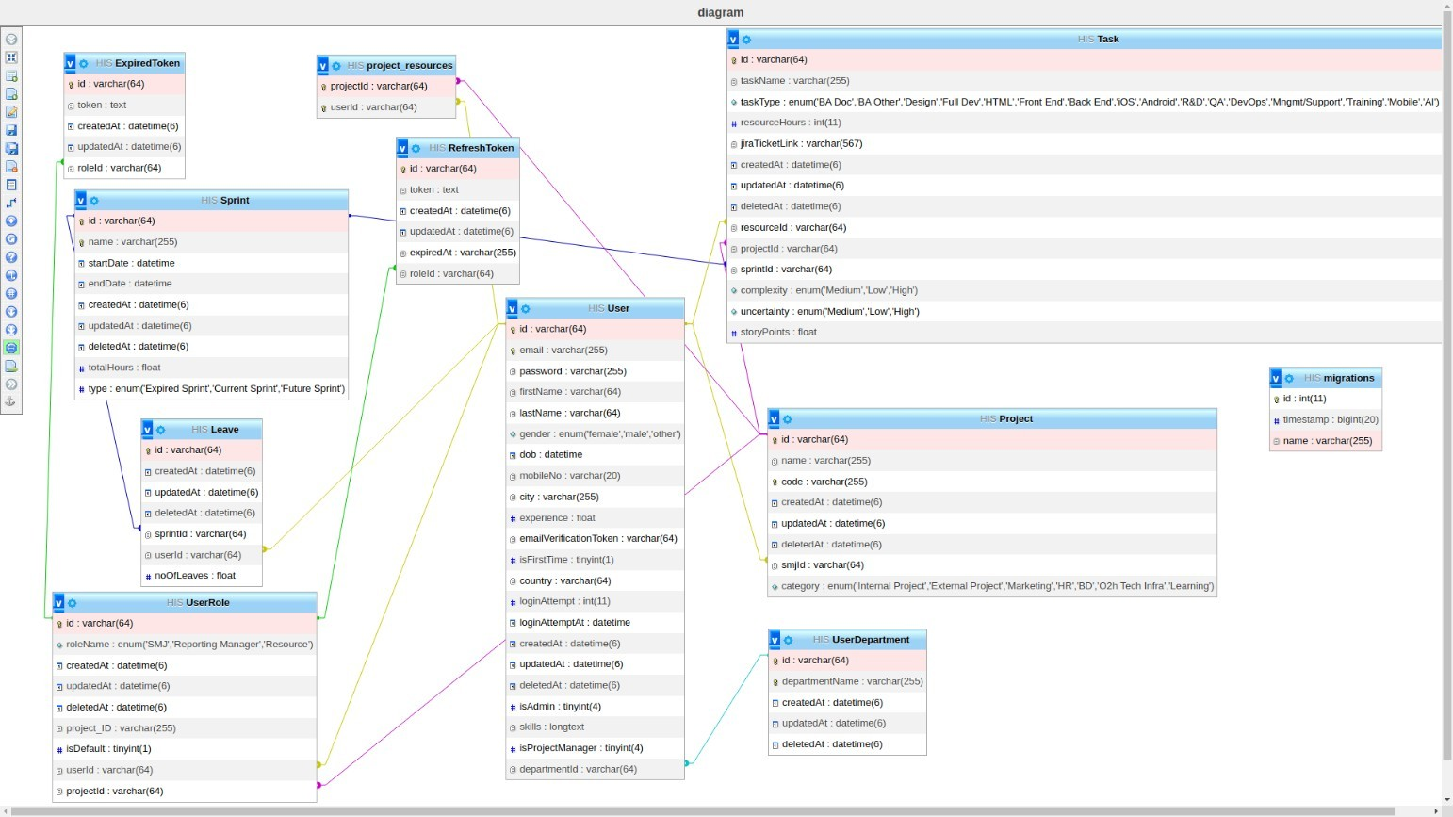

Fig 5.1 Database design

Database design is the process of creating a structured and organized plan for designing a database system that efficiently stores, manages, and retrieves data. It involves defining the structure, format, and relationships of the data, as well as specifying the rules and constraints for data manipulation and retrieval.
In fig 5.1 the database design is shown. It indicates that how all modules are connected to each other and shown all functionality of each modules.

E-R DIAGRAM

An Entity-Relationship (ER) diagram is a visual representation of the logical structure of a database system. It is used to model the relationships between entities (e.g., objects, concepts, or real-world entities) in a database and their attributes (e.g., properties, characteristics, or fields).
ER diagrams use various symbols and notations to represent entities, relationships, and attributes, which can be used to define the structure of a database system.
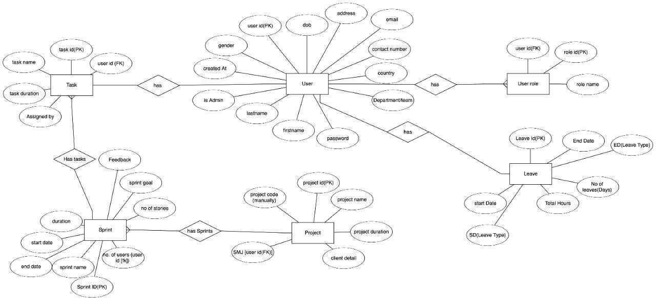
Fig 5.2 E-R model diagram

SYSTEM DATAFLOW DIAGRAM

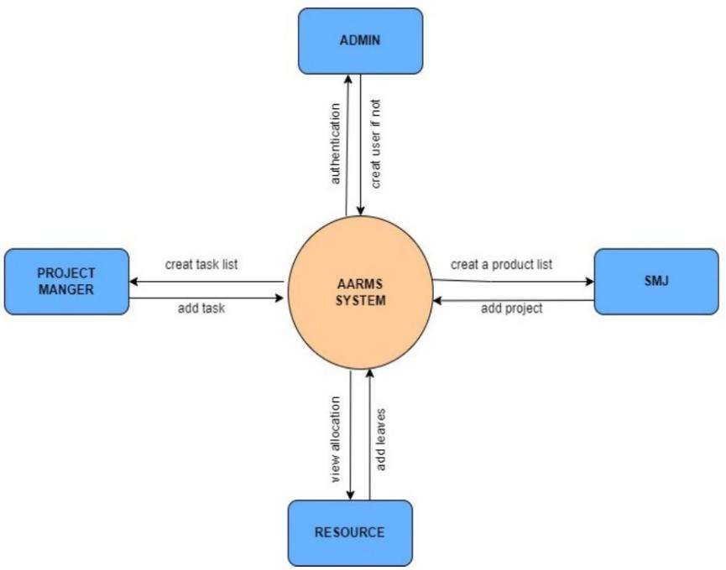

INTERFACE DESIGN

Launch screen
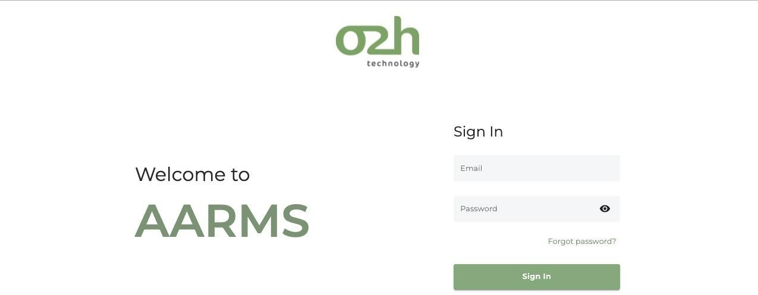

Fig 5.4.1 Launch screen

Forgot password screen
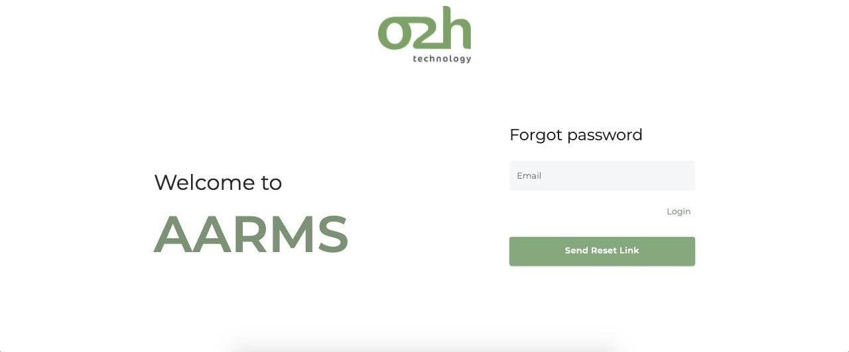

Fig 5.4.2 Forgot password screen

Dashboard
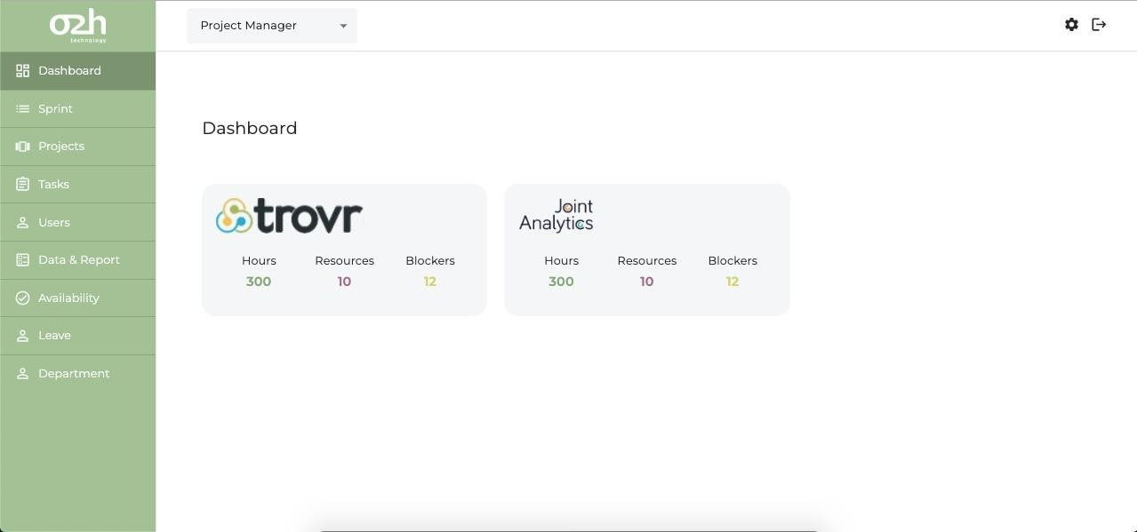

Fig 5.4.3 Dashboard

The Dashboard contains all the projects we are working on with the hours allocated an the total no of resources (users) are allocated to this project with any blockers that can affect the progress

Sprint screen
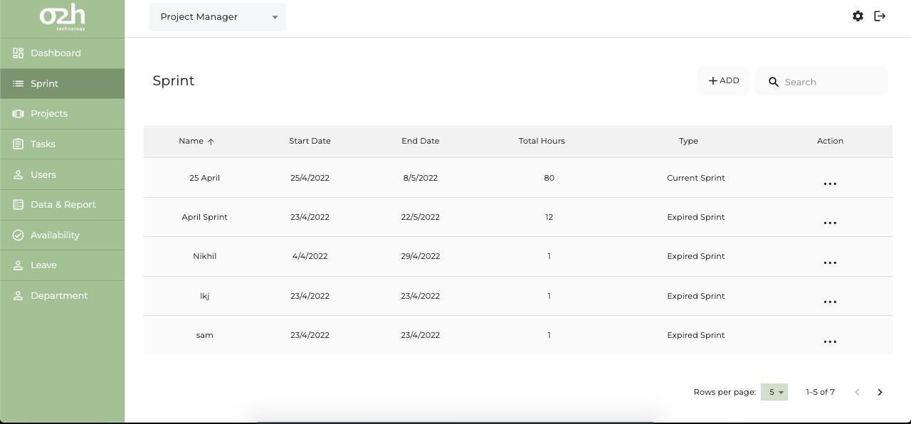

Fig 5.4.4 Sprint screen

These page shows the sprint details including the resources name, the duration and the total hours allocated to it.

Data and report screen
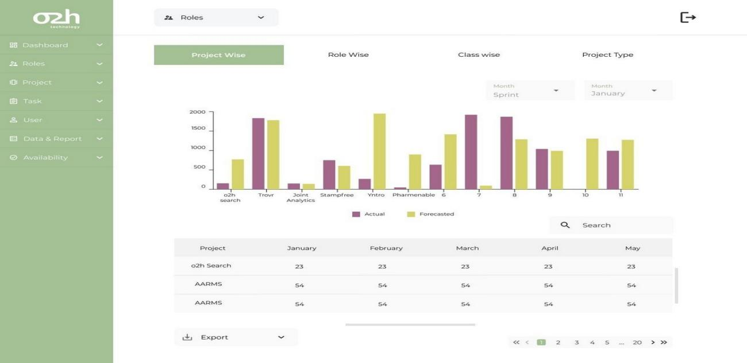

Fig 5.4.5 Data and report screen

This is the screen where the allocator can see the progress by data visualization and can also download the report using the export option.

Add User
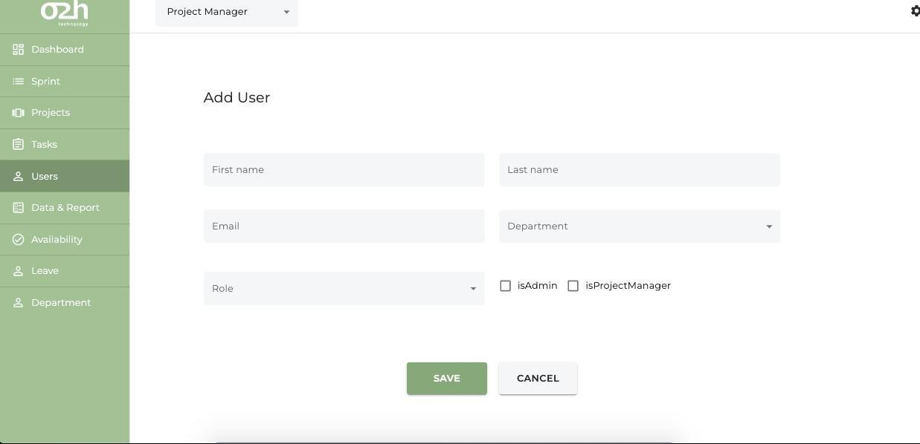

Fig 5.4.6 Add user

Whenever a user has to be added the details of the employee is added by the lead and then the resources can be allocated to him .

Adding a new project
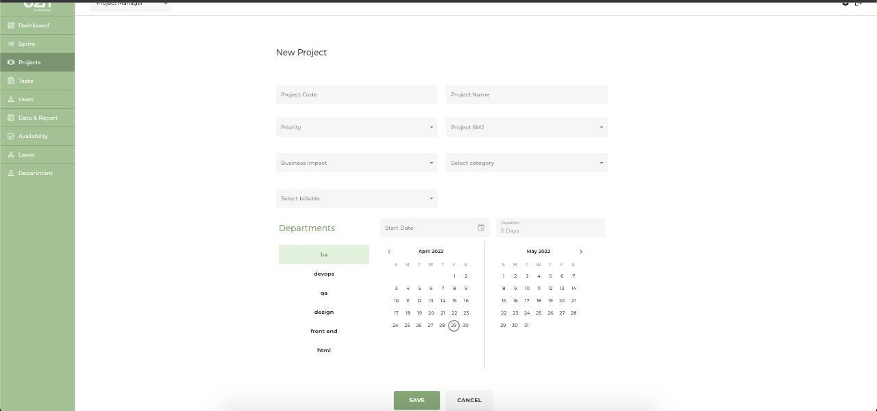

Fig 5.4.7 Adding a new project

Availability Module
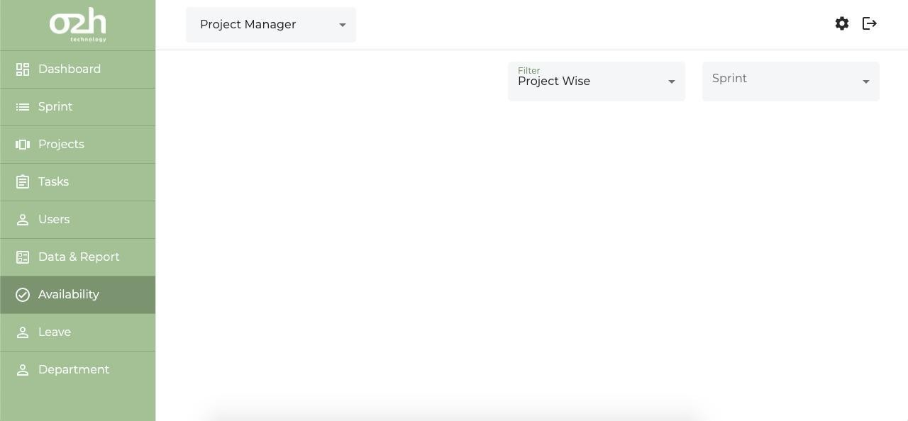

Fig 5.4.8 Availability module

This is the main bar that helps navigate to any of the modules.
Each module has add and search option so that we can add new sprint, project. Task, user, leave.

Department module
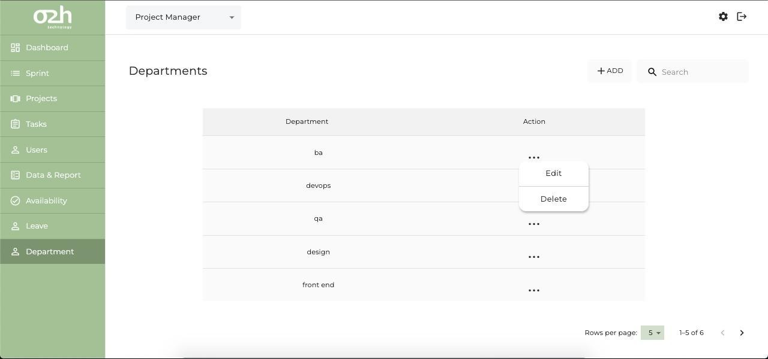
Fig 5.4.9 Department

CHAPTER 6 IMPEMENTATION

IMPELEMENTATION PLATFORM

- Jira for project management and daily task.
- Git used for version control
- Figma for design
- Bit Bucket is used for source code repository
- VS code for the development
- Postman for API testing
- MySQL database for store data
- Jenkins is used for deployment

PROCESS SPECIFICATION

The process includes agile methodology for every task we divide the whole process into chunks . we have daily scrum meeting with the product manager and the updates on the project and we follow the scrum also so the tasks with the desired outcomes are to be completed. The lifecycle includes: To Do -> In progress->done->Testing/Review-> Released.

RESULT / OUTCOMES

With the help of all departments and the hard efforts the project is going perfect and also have listed down any changes require for the future purpose. We are developing the web app which will help our company plan the sprint effortlessly and with few of the processes left will now be used by the company.

CHAPTER 7 CONCLUSION AND DISCUSSION

OVERALL ANALYSIS OF INTERNSHIP

My overall experience while doing this internship was amazing. I got to learn new things, Software, methods which will help me in future not only technical things but taught us how to work in a group, how to manage deadlines and how different teams work together to build one project . The work environment and the rich culture at o2h technology is really amazing . I am grateful that I got the chance to work at O2h Technology.

DATES OF CONTINOUS EVALUATION (CE-I AND CE-II)

- 6th February , 2024
- 26th March , 2024

LIMITATIONS AND FUTURE ENHENCEMENTS

- Currently the task updates is not allocated automatically it has to be done manually by the leads of any team.
- This task update will be done automatically in the future phase.

SUMMARY OF INTERNSHIP / PROJECT WORK

The Agile Automated Resource Management System (AARMS) is an innovative project designed to streamline and automate sprint planning processes within an organization following the Agile methodology. By breaking down tasks into manageable sprints, AARMS facilitates effective resource allocation and structured sprint execution. Recognizing the significant time and effort typically involved in sprint planning, the web application aims to minimize these challenges by automating various aspects of the process.
AARMS offers distinct modules tailored to different roles and departments within the company, ensuring efficient resource management and preventing employee burnout. It provides tools to measure resource availability, maintain team structures, manage projects, and visualize data, thereby enhancing overall productivity and project success. With AARMS, sprint planning becomes simplified and efficient, empowering teams to optimize resources and achieve their goals in an agile and well-managed manner.

References

- https://www.w3schools.com/html/
- https://javascript.info/
- https://getbootstrap.com/
- https://www.tutorialspoint.com/css/index.htm

