A STUDY ON IMPACT OF COVID -19 ON EDUCATION

Prof. Vivek Gupta¹(Assistant professor),Parul Bansal², Himanshi Bhansali³, Archit Kumar⁴, Dhanush A⁵, Sridhar Kejriwal ,( center for management studies- Jain (Deemed -to-be-university).

ABSTRACT

Universally, the COVID-19 scourge has seriously aggravated the instruction framework, driving to an uncommon move towards online learning. This think about analyse the numerous consequences of this alter, looking at how it gather essential information, we performed a intensive investigation of the body of writing as of now in presence as well as overviews and interviews. Our inquire about uncovers a nuanced interaction between openings and boundaries. On the one hand, we found that the unexpected move to online instruction made already-existing instructive incongruities more awful by putting destitute understudies at a major impediment when it comes to get to innovation and strong learning settings. Be that as it may, the alter too advertised chances for inventive approaches to educating and learning, underscoring how innovation can offer assistance overcome calculated and geographic deterrents. This paper calls for focused on approach intercessions to address the computerized isolate and guarantee comprehensive and even handed quality education for all understudies within the post-pandemic world.
KEYWORDS

COVID-19, Pandemic, Online Learning, Distance Education, Access to Technology, Learning Outcomes, Student Engagement, Virtual Classroom, E-Learning Platforms, Digital Literacy, Inclusive Education, Quality of Education, Educational Challenges, Learning Disruption, Future of Education.

- INTRODUCTION

The globe was gone up against with an unparalleled around the world catastrophe within the to begin with quarter of 2020, which significantly and rapidly changed the direction of human history. Governments, organizations, and individuals all over the world had to bargain with a wide run of already unheard-of challenges as a result of the COVID-19 widespread. Instruction was one of the areas of way of life that was most profoundly changed among the numerous other ranges that were too seriously affected. The objective of this inquire about article is to examine and analyse the complex impacts of COVID-19 on scholastics at all levels of education—primary, auxiliary, and tertiary—as well as over a run of territorial, social, and cultural settings.
The widespread had a troublesome affect on instruction over the entire instruction continuum, not fair in one zone or at one level of educating. The move from rudimentary school kids to college understudies and grown-up learners was quick and careful. All levels of instructive teach had to rapidly alter to this modern reality by joining farther learning strategies, postponing or cancelling institutionalized exams, and sanctioning security controls to defend both understudies and workers. This exposition looks for to clarify the complex impacts of these adjustments and assess their long-term effects on learning, social advancement, and mental wellbeing.
A seismic move within the customary classroom-based instructive worldview brought about from the brief shutdown of schools, colleges, and teach all through the world due to the COVID-19 flare-up. Earlier to the widespread, the thought of farther learning had been quickly picking up ubiquity, and it rapidly became the standard way that all students were instructed. This unexpected move highlighted concerns approximately the effectiveness of farther learning in comparison to in-person instruction and uncovered disparities in get to to innovation and web network. Whereas a few understudies adjusted well to the online setting, others found it troublesome, and numerous had expanded stretch and mental wellbeing issues.
The advanced gap was one of the most issues that risen in the early stages of the plague. Understudies from low-income families in some cases needed the web get to and innovation required to completely lock in in remove learning. Their instructive accomplishments were affected by this crevice, which also made as of now existing instructive imbalances more awful. We are going look at the size of this digital divide, its impacts on scholastic fulfilment and potential arrangements to shut this crevice within the future as we go more into this ponder article.
There were troubles for both guardians and instructors as a result of the quick switch to remote learning. Guardians saw themselves accepting additional errands as teachers and carers as a result of instructors having to quickly adjust to modern directions strategies and innovation. The level of help given to both instructors and understudies as well as the quality of instruction shifted greatly. The absence of face-to-face experiences has incited concerns around kids' social and enthusiastic development as well as the work of schools in advancing a feeling of having a place.
This think about will see at these and other vital components of the pandemic's impact on scholastics. We are going examine how understudies managed with the obstacles of remove learning, centering on the parts of inspiration, self-regulation, and engagement in determining scholastic accomplishments. In expansion, we'll see into the mental wellbeing results of expanded social segregation as well as unsettling influences to schedules, extracurricular exercises, and peer connections.
Past the prompt results on instruction, the COVID-19 scourge has far-reaching repercussions for academia's future. Universities and colleges experienced financial difficulties as enrolment declined and costs for security measures and innovation framework taken off. These organizations need to rethink their trade methodologies and alter to a rapidly changing environment. Besides, the plague hurried the take-up of online instruction whereas raising concerns about the esteem of a conventional college degree.
As we advance through this investigate consider, we are going see at the long-term suggestions of these developments, such as future changes within the higher education industry, the role of online learning, and changing understudy and manager desires. We'll too dissect the pandemic's lessons and the opportunity it may have produced for instructive advancement and alter.
In conclusion, the COVID-19 widespread caused an unparalleled disturbance within the scholarly environment that had an affect on learners, instructors, and educate at all levels. This think about will see at the various ways that the pandemic has influenced instruction, from the advanced crevice to the challenges of remove considering to the long-term impacts on long-standing time of higher instruction. We look for to superior comprehend the pandemic's colossal effects and the different directions the calling of education may go within the post-COVID time by digging into these challenging themes.

The effect of COVID-19 on instruction has been phenomenal and has formed how understudies learn, how instructors educate and how instructive teach work. In this presentation, we layout the main ways the widespread has influenced instruction.
Disturbances to conventional learning:
COVID-19 has constrained schools and colleges to shut in numerous nations, disturbing conventional in-person learning. This sudden move to remove and online learning has displayed noteworthy challenges for students, teachers and guardians. The advanced isolate:
The widespread has uncovered and exacerbated existing inequalities in access to innovation and the web. Numerous understudies needed the vital gear and dependable Web associations for online learning, driving to abbrevation in instructive results.
Appropriation of Technology:
Educate have quickly embraced a assortment of innovations to encourage separate learning, including video conferencing stages, learning administration frameworks, and online learning assets. This quickened the integration of innovation into instruction. Impact on mental wellbeing:
The long-term nature of the widespread and the transition to separate learning has influenced the mental wellbeing of understudies. Separation, vulnerability and the challenges of adjusting to unused learning situations expanded stress and uneasiness.
Instructor adaptation:
Teachers had to adjust to unused instructing strategies, frequently with small preparing or arrangement. They had to navigate how to engage students with screens and guarantee instructive objectives. Misfortune of learning:
Drawn out school closures have brought about in noteworthy learning misfortunes for numerous understudies, particularly impeded students. The disturbance of the scholastic calendar and diminished ponder time contributed to this issue.
Changes in Assessment:
Conventional evaluation strategies have confronted impediments within the online learning environment. Instructors are investigating elective evaluation methodologies, counting project-based evaluations and open-ended exams. Reforming education:
The widespread has started dialogs around rebuilding the instruction framework. Numerous addressed the significance of conventional educating models and supported a more adaptable, student approach.
Crossover learning:
A few teach have embraced cross breed learning models that combine face-to-face and online learning to adjust to changing circumstances. This approach advertised adaptability whereas keeping up a few face-to-face interaction.. Long-term impacts:
As the pandemic dies down, its effect on education continues to shape the long run of learning. Numerous teach proceeded to offer online choices, and the lessons of the pandemic influenced educational approach and hone. In this arrangement on the effect of COVID-19 on instruction, we dig into these points and explore the challenges, advancements and long-term changes that the widespread has brought to the instruction division.
Review Of Literature

COVID-19 has had a significant and wide-ranging effect on the educational system, with repercussions felt from early childhood education to higher education. Among the principal effects are: Shift to Remote Learning: A swift transition has occurred in favour of remote learning as a result of the closing of colleges and institutions to stop the virus's spread. In order to enable remote learning, this has involved the introduction of digital resources, video conferencing tools, and internet platforms. But not everyone has had an easy adjustment, with pre-existing inequities being made worse by differences in access to technology and internet connectivity. Loss of Learning and Achievement Gap: Students, especially those from impoverished families, are concerned about learning loss as a result of prolonged periods of remote learning and interrupted schooling. Due to the fact that pupils from low-income households or those with fewer resources may find it more difficult to learn remotely than their classmates, the closing of schools has worsened already existent achievement discrepancies. Challenges for Teachers: Teachers have encountered several difficulties in adjusting to remote learning, such as the requirement to pick up new technology, create online lesson plans, and assist students in virtual settings. Effectively assessing learning in online environments and retaining student interest have also been challenges raised by a number of teachers. Effect on Mental Health: The epidemic has had a negative impact on people's mental health and general wellbeing, including parents, teachers, and pupils. Members of the education community have experienced emotions of anxiety, sadness, and burnout due to social isolation, uncertainty, and elevated stress levels. Digital Divide: The move to online learning has brought attention to and made the already existing inequalities in internet and technology access worse. The digital divide may be exacerbated by students from low-income families, remote locations, or marginalized communities who may not have access to the devices or internet needed to fully engage in online learning. Modifications to Assessment and Evaluation: Conventional approaches to assessment and evaluation have been reassessed in light of the pandemic. In light of the discontinuation of standardized testing and the difficulties associated with conducting exams from a distance, educators have looked into alternate approaches to evaluating student learning, including portfolios, project-based assessments, and adaptive online assessments. Education Systems' Reshaping: In response to the crisis, education systems have been compelled to innovate and adapt due to the pandemic. Schools and colleges have had to review their procedures and rules, giving careful consideration to matters like technology use in the classroom, hygienic practices, and class numbers. There could be long-term effects of some of these modifications on education. Accessibility Variability: Students' access to technology and the internet has a significant impact on the quality of their education. While those without such resources had substantial obstacles in accessing and engaging with educational information, students with dependable internet access and sufficient gadgets may have had an easier time making the switch to online learning. Effectiveness of Remote Learning Platforms: The quality of education was significantly influenced by the effectiveness of remote learning platforms. While antiquated or difficult platforms would have hampered student engagement and learning results, well-designed and user-friendly platforms with interactive features, multimedia information, and collaboration opportunities tended to improve the learning experience. Teacher Readiness and Assistance: The degree to which teachers were ready for the shift to remote instruction and the assistance they received had an impact on the standard of education. Teachers were better prepared to provide their students with high-quality educational experiences when they had access to tools for online instruction, training, and advice. The difficulty that many instructors had adjusting to new technologies and teaching strategies, however, may have had an effect on the standard of instruction. Engagement and Interaction: The quality of education was greatly impacted by the degree of student engagement and interaction in online learning settings. To keep pupils motivated and promote learning, teachers and students needed to communicate effectively. Collaborative activities, chances for active engagement, and effective communication were also crucial.Higher levels of engagement and improved educational achievements were frequently observed in schools and classrooms where educators placed a high priority on creating a feeling of community and connection. Assessment and Feedback systems: In distant learning environments, the efficacy of assessment and feedback systems was a determining factor in educational quality. A higher standard of education was attained by educators who used a variety of real and authentic assessment techniques, gave prompt, helpful comments, and provided chances for reflection and development . Nonetheless, the trustworthiness of assessment outcomes might have been influenced by difficulties in maintaining academic integrity and remotely conducting tests. Equity and Inclusion: The pandemic brought attention to the gaps in access to high-quality education that already existed and emphasized how critical it is to address equity-related concerns .All students benefited from a more equitable and superior educational experience at schools and educational institutions that prioritized equity and inclusion initiatives. These included addressing socioeconomic barriers to learning, offering accommodations for students from diverse backgrounds, and supporting students with disabilities. Innovations in Education: In spite of the difficulties caused by the epidemic, educational institutions and teachers have been investigating novel methods of instruction and learning. Technological advancements like individualized learning pathways, flipped classrooms, virtual labs, and immersive simulations have made it possible to improve the standard of instruction and meaningfully engage students. Parental Involvement and Support: During the epidemic, parents' degree of involvement and support in their children's education had an impact on the quality of schooling. Better educational outcomes were a result of parents who supported their children's academic and emotional needs, actively participated in their education, and created a favorable learning environment at home.
III. RESEACH METHODOLOGY
The investigate required a efficient stream of the activities that offer assistance to make strides the viability of result and accomplishment of the targets. To create the orderly approach, there are two sorts of methods of insight utilized, interpretive and positivism.
For current investigate related to the examination of the affect of COVID-19 on the instruction framework and institution, the analyst has chosen interpretive inquire about reasoning. By considering this logic, the analyst has collected and examined the distinctive suppositions of respondents and recognizes the key activities to make strides the circumstance. Separated from this, interpretive reasoning has made a difference to preserve openness
Deductive and demonstrative inquire about approaches are utilized for picking up an understanding of the factors of the ponder and keeping up the stream of the investigation. For conducting current investigate, the analyst has connected the characteristic approach that moreover bolsters in expanding unwavering quality and legitimacy. By executing this approach, the analyst has collected information for the examination of the affect of COVID-19 on the instructive framework and institution utilizing the survey strategy (Fletcher, 2017). This was taken a toll and time successful and disposed of the issues related to the security of the respondents.
The key approach of the inquire about ponder is created by applying the suitable plan. For accomplishing the proposed result, the analyst might apply the exploratory, expressive and casual plan. The current inquire about is based on information collected from the survey and to dissect the affect of Covid-19 on the instructive framework, the clear plan was valuable. This kind of plan has made a difference to dissect and social, financial and specialized angles of the COVID-19 on the institution and bolster in picking up the in-depth information of issues and potential obstructions within the advertising of online learning and changing the existing classroom approach of consider .
Agreeing to inquire about strategy capacities, to investigate in a proficient way, two sorts of ponder have been taken after that include subjective and quantitative. For the current inquire about, the analyst has connected clear plan and collected the information utilizing the survey strategy. Subsequently, the consider was based on the quantitative sort and made a difference to meet the targets of the think about .
By utilizing this sort, the analyst has made accentuation on coordinate and backhanded components that might impact the instruction framework and approaches of teach due to episode of Covid-19. It has too bolstered in examining the distinctive factors for distinguishing the affect on online learning due to changes in financial, statistic and work level of individuals .For inquire about, information was collected from understudies, instructors and guardians of open and private establishing .
A add up to of 100 respondents were chosen by the comfort testing method. The think about has made the utilize of as it were essential information for accomplishing the destinations of the ponder. A web survey was created and sent to all the respondents. Reactions were too collected online from respondents as confront to confront interaction was not conceivable amid the widespread time.
The analyst has used a organized survey. Due to the widespread circumstance, the analyst arranged the survey utilizing Google records and send joins to the understudies and resources utilizing WhatsApp, Facebook and mail. The information was collected and examined utilizing IBM SPSS program 20. For factual examination figure investigation, bunch measurements and free test test was utilized for this ponder. Information is collected from a add up to of 100 respondents.

V. DATA ANALYSIS AND INTERPRETATION
We shared the questionnaire to a set of people and these were the responses collected and the data collected is analysed as follows

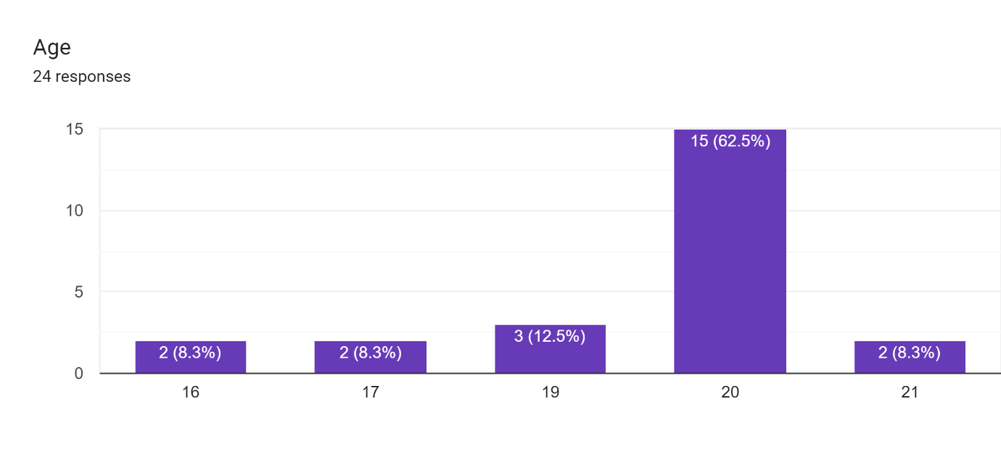
Major people are of the age groups 20 and others are equally distributed among the ages 16, 17, 19 and 21.

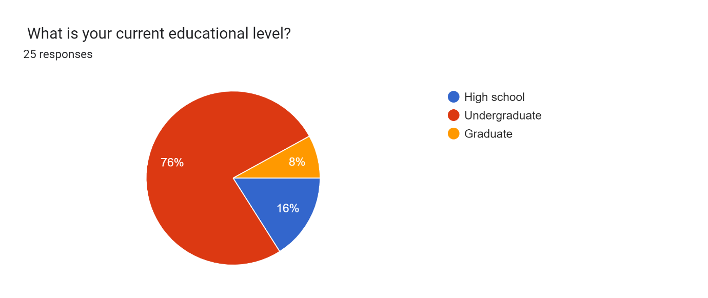
Major of 76% of the respondents are undergraduates whereas 16% are high schoolers and 8% are graduates.

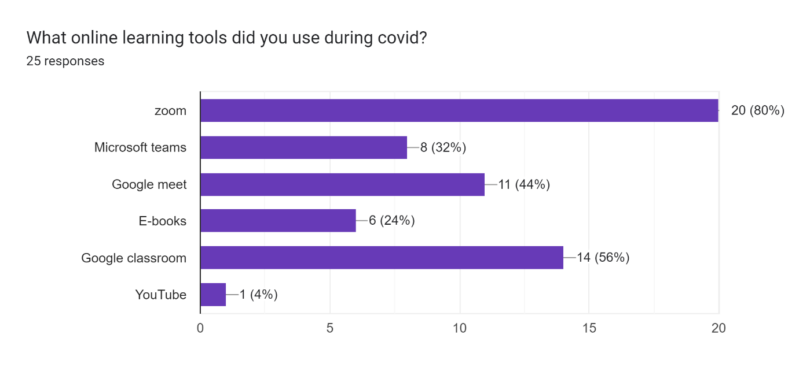
During the shift to online education , majority of 80% of the respondents used zoom platform and 56% used google classroom and a few of them even used google meet , Microsoft teams etc for their studies.

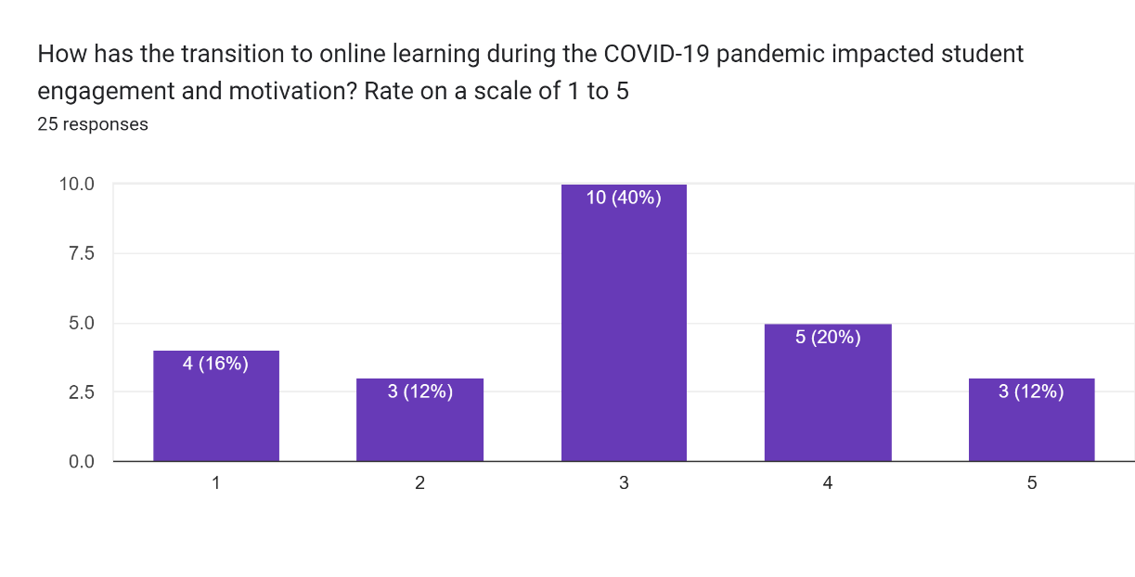
The shift to online studies has affected the student motivation also to a great extent.
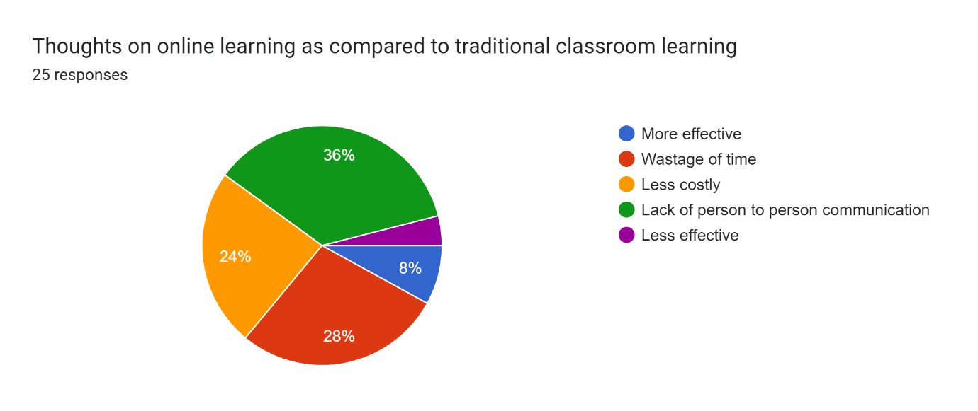
36% and also a majority of respondents feel that online education lacks person to person communication effectively
28% feel that online education is a wastage of time
24% believe that it is cost effective
And a very few feel that it is effective.

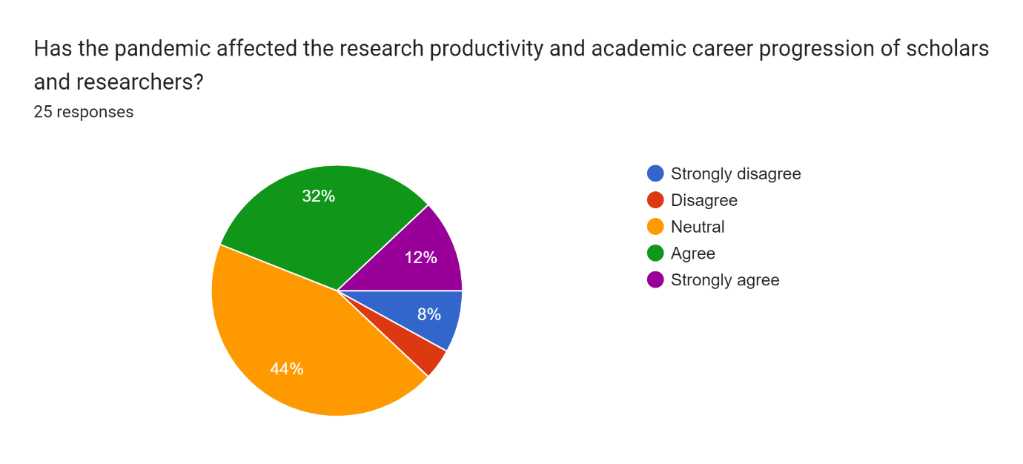
Many respondents feel that Online has affected research productivity in students as well as scholars but many feel that it is neutral and has not affected much i.e there is no impact.
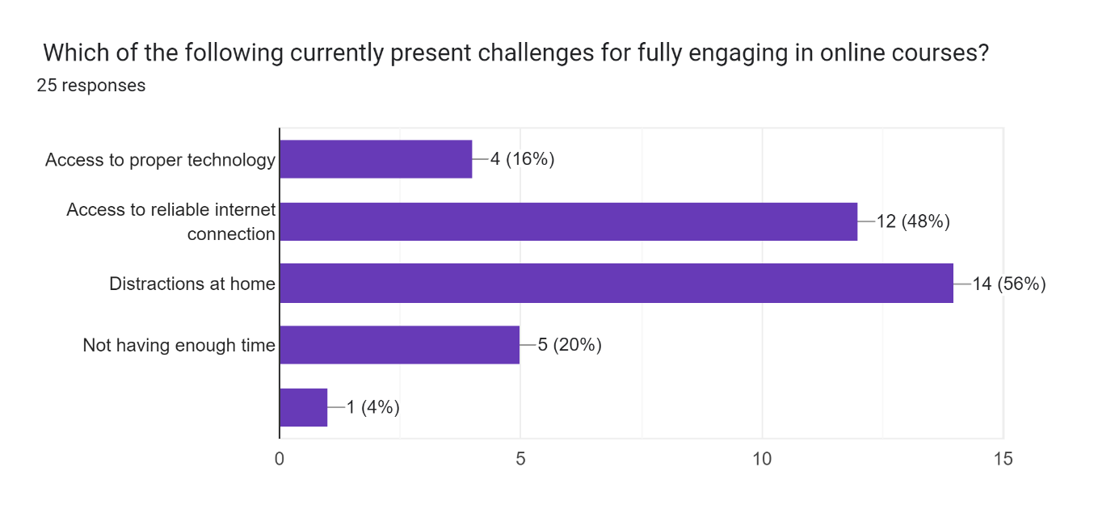
Online education comes with a lot of challenges and difficulties and many of them feel that major challenges for students are the distractions at home , others majorly being access to reliable internet connection and technology.

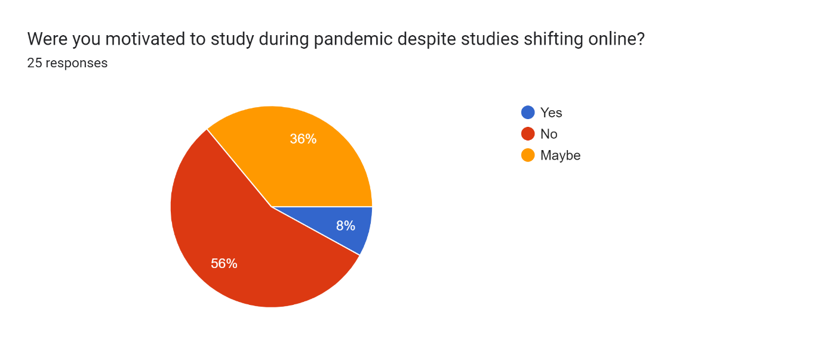
Major of the respondents i.e 56% were not motivated to study during pandemic and lost their concentration as well as their interest in studies.
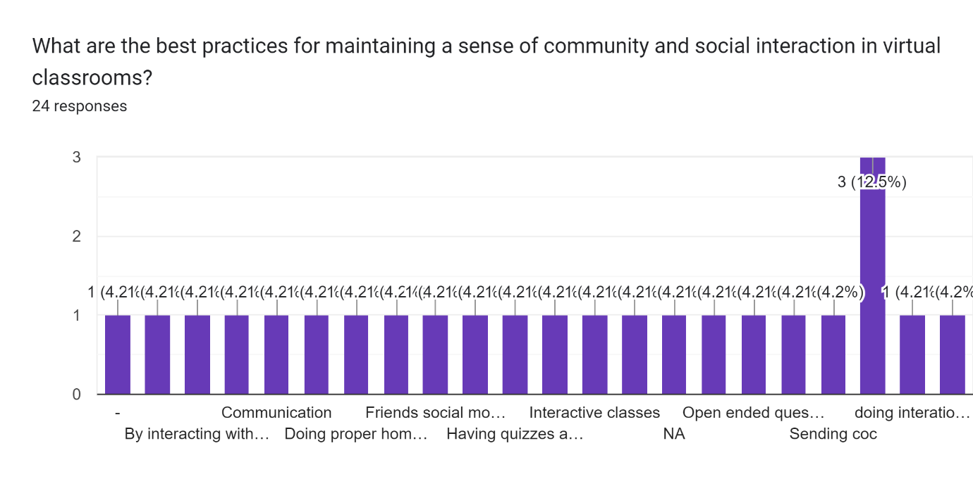

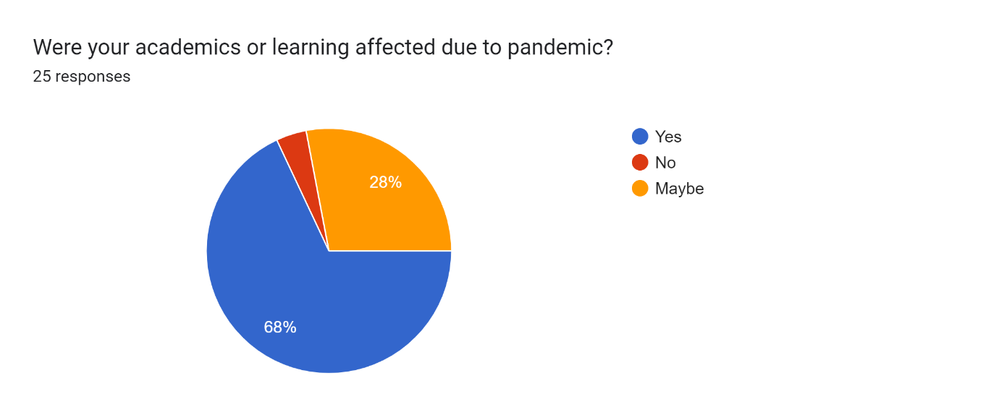
Most of the student’s learning and academics were affected due to pandemic.
They could not concentrate and lost interest in studies due to online studies and the effectiveness also reduced to a great extent.
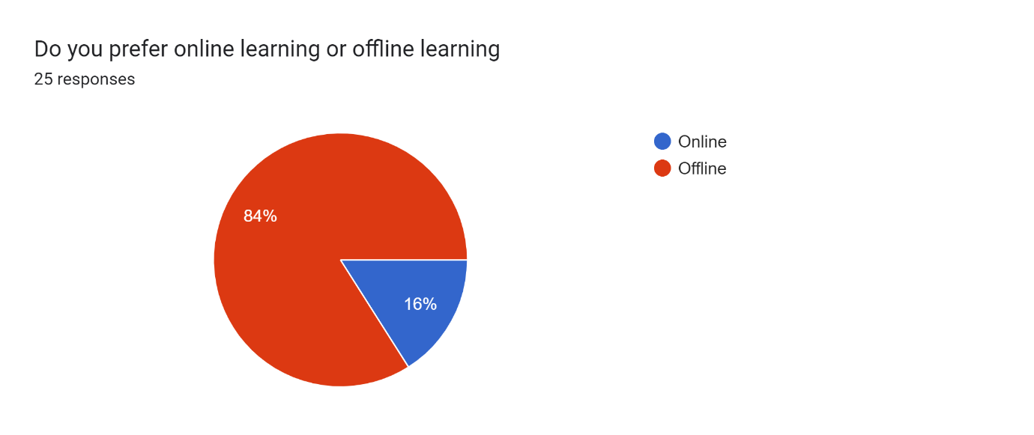
84% of the people prefer offline learning and find that effective compared to online learning.

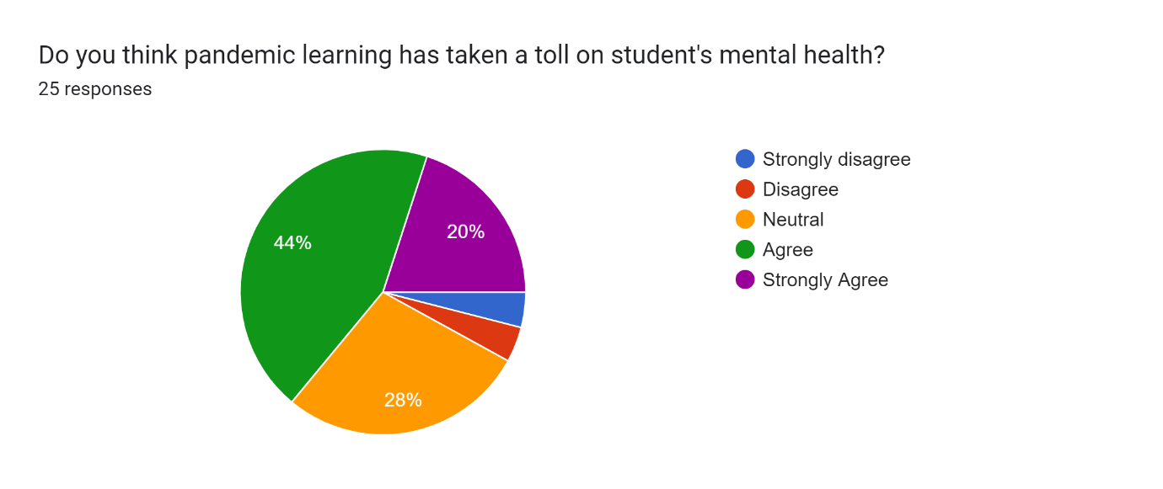Students’s mental health was also greatly affected due to pandemic and online learning and 44% of the responds agree to the above statement , 20% are true believers of the above statement .
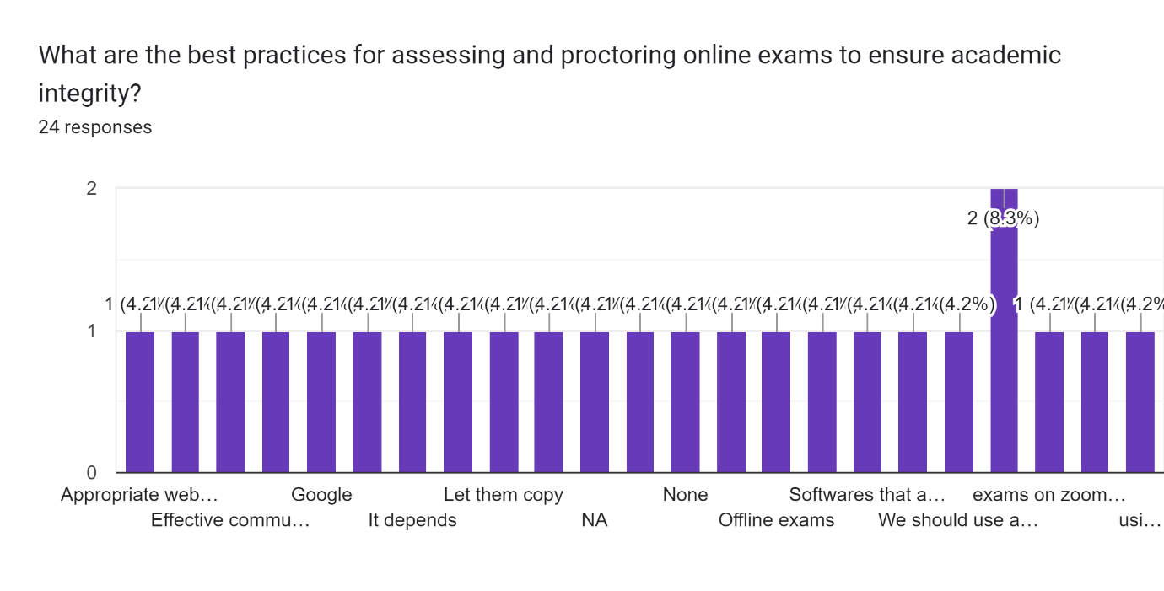

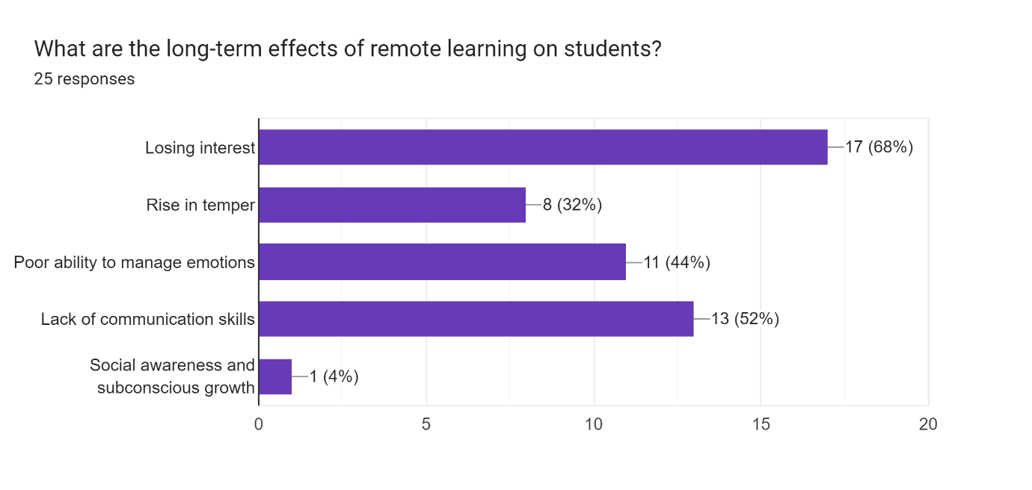

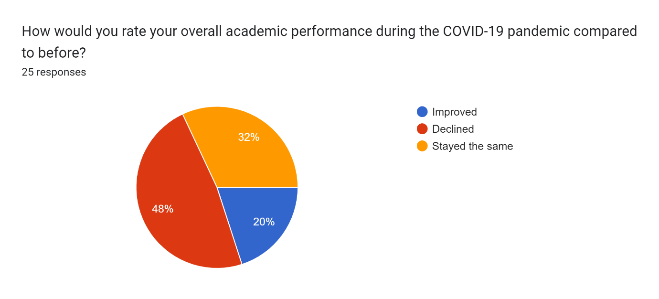

Students’ overall academic performance has drastically declined due to covid-19 pandemic – 48% believe that
Whereas 20% feel that their academic performance has improved

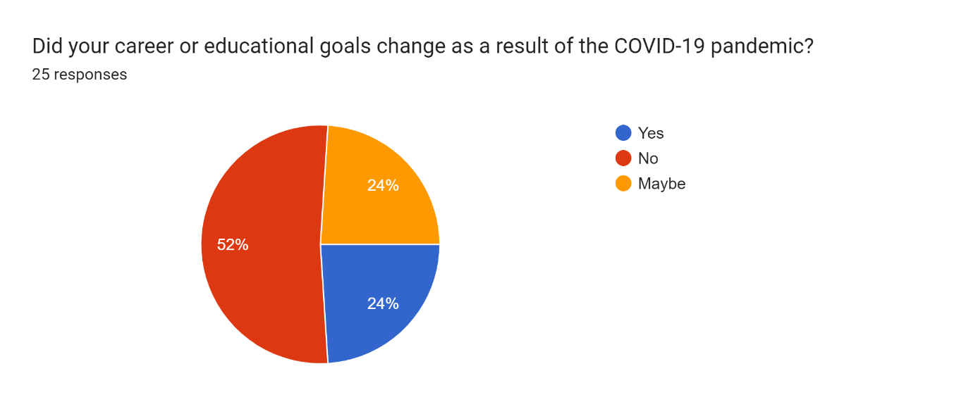

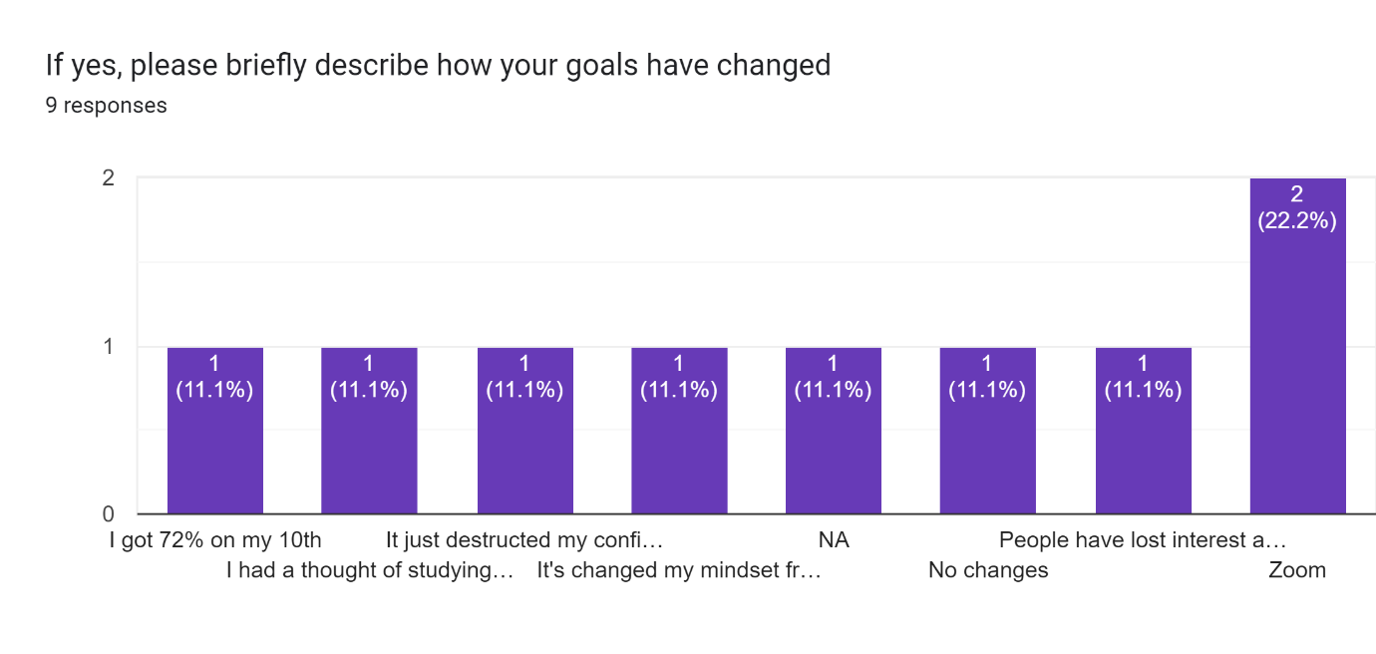

What strategies or coping mechanisms did you find most effective in managing the challenges brought about by the pandemic and its impact on academics?
24 responses
Zoom
Google
-
Nothing
Being attentive
Idk.
Substance
Chats
playing games, reading books, learning new things, etc.
We can't do exams properly in real classroom
Nothing
K
Hobbies,
Study regularly
Na
Exercise kept my mind focused. Playing Sports alone and indoor games.
Continuous reading
Predict , prepare and perceive
NA
Strategies like maintaining proper record of students who are present and are attending classes
Social media, streaming platforms
Having discipline and controlling your time effectively
na

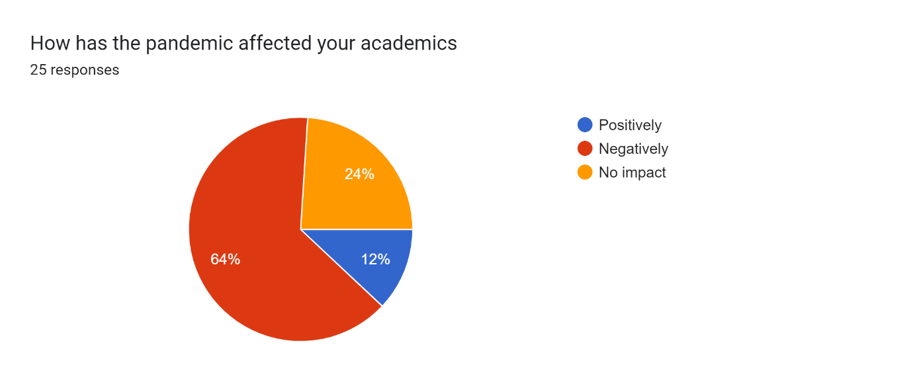

In conclusion the pandemic has had a negative impact on the studies and academic progressions of majority of the students

VI. CONCLUSION AND RECOMMENDATIONS

In conclusion, the information displayed highlights the complex scene of instructive impacts related with disturbances such as regular learning varieties, school closures due to harsh climate, non-appearance, and the move to virtual instruction amid the COVID-19 widespread.

Regular learning considers demonstrate a verifiable slant of scholastic lull, especially in science, amid expanded breaks, with talks about encompassing the degree of summer learning misfortune and its commitment to financial abberations. Comparisons with weather-related closures emphasize the potential negative results of startling intrusions on understudy accomplishment.

Truancy ponders emphasize the reliable negative relationship between missed guidelines time and scholastic execution, with understudies from lower-income families encountering more critical mishaps. The information uncovers a straight relationship, showing that each extra nonappearance contributes to a comparable misfortune of learning.

The move to virtual instruction amid the widespread uncovers both potential benefits and challenges. Whereas online instruction offers a implies to proceed learning remotely, concerns emerge with respect to unequal get to to assets, constrained teacher-student interaction, and the by and large adequacy of virtual learning, especially given the exceptional circumstances of the COVID-19 school closures.

In rundown, the assorted ponders recommend that lost lesson, whether due to regular breaks, unexpected closures, or virtual instruction, may unfavorably influence understudy learning. The discoveries call for focused on mediations to address abberations in assets, back successful farther learning, and emphasize the significance of keeping up instructive coherence amid disturbances.
Whereas the current plague presents uncommon challenges with multifaceted viewpoints connected to understudy accomplishment, the ponder gives important experiences for foreseeing potential impacts of COVID-19 on instruction. In spite of the uniqueness of this event, the data-driven forecasts offer a run of scenarios and speculations almost the changes in learning amid the 2019–2020 school year and the expected shifts within the 2020–2021 scholastic year.
Proposal
Based on the comprehensive information and investigations displayed, a few proposals can be proposed to direct teachers, policymakers, and educate in tending to the challenges postured by the COVID-19 widespread on understudy learning:

1. **Moderate Learning Misfortune:
**
- Create focused on intercessions to moderate the potential learning misfortune caused by amplified school closures. Center on subjects like arithmetic, where misfortunes are frequently more articulated.

2. **Address Financial Incongruities:
**
- Execute methodologies to address financial abberations in learning results, considering the watched affect on understudies from lower-income families. Tailor intercessions to bolster these understudies in both in-person and virtual learning situations.

3. **Consider Regular Learning Designs:
**
- Recognize the similitudes between COVID-19-related closures and regular learning designs. Actualize techniques that recognize the challenges related with expanded breaks, especially in keeping up progression in arithmetic instruction.

4. **Plan for Unexpected Closures:
**
- Learn from inquire about on weather-related and normal disaster-related closures to plan for unanticipated disturbances. Create possibility plans that guarantee progression in learning indeed amid unforeseen occasions, considering both in-person and inaccessible learning scenarios.

5. **Address Non-appearance:
**
- Prioritize endeavors to decrease non-appearance amid normal school a long time. Recognize the negative affect of nonattendances on exam comes about, particularly for minority and low-income understudies. Execute focused on intercessions to back participation and address the root causes of inveterate truancy.

6. **Improve Virtual Instruction Procedures:
**
- Progress virtual instruction techniques by tending to the challenges highlighted within the think about. Give extra assets to guarantee impartial get to to online learning, upgrade teacher-student interaction, and offer preparing to teachers for viable virtual instruction.

7. **Assess and Alter Farther Learning Programs:
**
- Routinely assess the adequacy of farther learning programs, considering components such as teacher-student interaction and asset openness. Make vital alterations based on criticism and rising information to improve the affect of virtual instruction.

8. **Arrange for Accomplishment Crevice Compounding:
**
- Be proactive in arranging mediations to avoid the worsening of accomplishment holes, particularly by school-level financial status. Consider the watched varieties in inaccessible learning openness and execute focused on measures to guarantee value in instructive results.

9. **Ceaseless Observing and Adjustment:
**
- Build up instruments for ceaseless checking of understudy advance, learning rates, and accomplishment crevices. Utilize real-time information to adjust methodologies, distinguish challenges, and actualize convenient mediations to bolster understudy learning.

10. **Contribute in Educator Preparing:
**
- Recognize the significance of educator preparing in virtual instruction. Contribute in proficient improvement programs to prepare teachers with the abilities required for viable online instructing, subsequently improving the by and large quality of farther learning encounters.

By executing these suggestions, instructive partners can work towards tending to the multifaceted challenges displayed by the widespread and cultivating a more strong and evenhanded instruction framework.
VII. LIMITATIONS AND FUTURE SCOPE
The COVID-19 far reaching affected teacher systems over the world.
[1] The number of cases of COVID-19 started to rise in Walk 2020 and various teacher teach and colleges experienced closure. Most countries chosen to by chance close educator teach in orchestrate to decrease the spread of COVID-19. UNESCO gages that at the stature of the closures in April 2020, national educator shutdowns affected approximately 1.6 billion understudies in 200 countries:
94% of the understudy masses and one-fifth of the around the world masses. Closures are surveyed to have persevered for an ordinary of 41 weeks (10.3 months). They have had vital negative impacts on understudy learning, which are expected to have noteworthy long-term proposals for both instruction and benefit. In the midst of the far reaching, instruction budgets and official offer assistance program budgets for instruction have lessened.
The lockdowns have too much affected as of presently blocked understudies, and understudies in moo and center compensation nations.
Scarcer instruction choices influenced people with few budgetary resources, though those with more found instruction
Advanced online programs moved the labor of instruction from schools to families and individuals, and hence, people all over who depended on schools rather than computers and homeschooling had more difficulty School closures shed light on diverse social and budgetary issues, tallying understudy debt, digital learning ,food security, and home ,as well as get to to childcare, health care, housing, internet, and inadequacy services. The influence was more genuine for hindered children and their families, causing ruined learning, compromised food, childcare issues, and following monetary taken a toll to families who might not work
The spread of COVID-19 has driven to the closure of teacher teach all over the world. This attempted the preparation of colleges to deal with a crisis that requires the help of advanced development tallying gear and computer program to engage practical online learning. Such closure animated the change of the online learning circumstances so that learning would not be disrupted.1 Numerous educate have finished up inquisitive approximately how to best pass on course substance online, bolt in learners and conduct evaluations. Hence, COVID-19 while being a peril to mankind, has progressed teach to contribute in online learning.
Online learning systems are web-based computer program for scattering, taking after, and supervising courses over the Internet. It incorporates the execution of headways in development to arrange, arrange and give the learning substance, and to empower two-way communication between understudies and faculty. They contain highlights such as whiteboards, chat rooms, overviews, tests, exchange get-togethers and thinks about that allow educates and understudies to communicate online and share course substance side by side. These can offer useful and supportive ways to realize learning targets. In Pakistan, the instruct are utilizing Microsoft Groups, Google meet, Edmodo and Moodle as learning organization systems along with their applications for video conferencing. Other commonly utilized video conferencing courses of action join Zoom, Skype for commerce, Adobe interface etc.
Concurring to our composing review, three past considers were found, supporting online learning from Pakistan. With the increase in utilize of online modalities in the midst of COVID-19, it is fundamental to overview their ampleness with regards to instructing and learning from diverse stakeholders. Therefore, the current consider explores the insight of staff people and understudies with regard to the inclinations, restrictions and recommendations for online learning in Pakistan. The consider is lucky as Higher Instruction Commission (HEC) is inside the handle of executing online learning over all the colleges in Pakistan. The revelations will offer help recognize the desired changes on require introduce to make it more commonsense and useful.
Future scope
Within the middle of the wake of the around the world crisis on account of the COVID-19 broad in 2020, the teacher portion was hugely influenced. With teacher teach closed for an dubious period, helplessness waited sweeping among learners as well as instructors. In any case, eLearning app advancement came to the secure by giving shrewd arrangements that introduced in bunch blocked off learning procedures. The year 2020 has seen the rise of innovative eLearning courses of action to fulfil the challenging need of the educator fragment. These savvy learning progresses have changed the learning methodology interior and out. Computerized learning is the unused commonplace!
The nonstop float of learning through progressed learning gadgets has illustrated especially advantageous to corporate specialists with dynamic plans but has antagonistically influenced a certain chunk of learners. As per industry pros, this float is here to stay inside the a long time to come. Presently, the preeminent charming address that's holding up inside the minds of partners of this division is:
How will the more distant learning incline influence end of the of learning?
This article explores the effect of the COVID-19 widespread on future learning and teaching. But a few time recently we burrow more significant, let's have a see at how the advanced eLearning incline has influenced learners and teachers.
COVID-19-induced challenges:
Underprivileged understudies without web get to have been hit troublesome by the present day online educator designs. It ought to be about shocking for them to continue their instruction.
Various gatekeepers cannot bear online educating as they have persevered wage cuts or work mishap in the midst of the far reaching.
This sudden modify inside the teaching-learning procedure has made perplexity among instructors due to require of experience and nonattendance of reasonable ways for interaction.
Open-Source eLearning Courses of action
Governments over the globe are to arrange open-source eLearning courses of action to supply instruction to all understudies in any case of their specialized obstacles. Mobile-friendly courses of action and significantly accessible online sections for teacher-student interaction are pointing so that in fact the marginalized and ruined understudies can continue their instruction.
Blended Learning Procedures
Various of you must be considering:
“What changes will be made to classroom structure or support in the midst of and after the COVID-19 pandemic?” It is believed that post-COIVID-19, a technique of blended learning will be incorporated within the instruction industry. Blended learning implies to a combination of eLearning devices and face-to-face learning to obtain the benefits of both universes. The online mode of homework settlement and lighter school sacks are the expected comes about of this approach. In expansion, blended learning will zero in on the existing restrictions within the ordinary teacher system and act as a promising elective within the occasion that such crisis circumstances rise inside the coming a long time.
Personalized Learning By AI
AI has gifted progressed learning with imaginative strategies that are way more inquisitively and locks in as compared to the ordinary ones. The reason is AI enables the creation of personalized learning experiences that are custom-made to suit specific needs. This kind of learning may well be a boon within the space of higher instruction wherein the one-size-fits-all strategy comes up brief to succeed. Determination of a personalized learning approach will help colleges and colleges resolve common issues like tall dropout rates, need of tools to bolt in understudies, etc. This approach will in addition enable the instructors to track each student's learning result, in this manner making way for more successful educating strategies.
Rising Ask For Skill-Based, Short-Duration Courses
The COVID-19 emergency has presented in precariousness within the work publicize as well. In this way, to keep up deftness and stay up to date with the foremost later capacities like AI, data analytics, machine learning, significant learning, etc., specialists as well as freshers are selecting for industry-ready courses to scale up their aptitudes and thus stay ingenious for a long period. Quality online learning programs and online planning sessions are being favoured the preeminent. As a result, the client expectation inquiry theories in EdTech things is on the rise,

References
1. UNESCO. (2020). COVID-19 Educational Disruption and Response. Retrieved from http://www.uis.unesco.org/covid-19-educational-disruption-and-response

2. Viner, R. M., Russell, S. J., Croker, H., Packer, J., Ward, J., Stansfield, C., ... & Booy, R. (2020). School closure and management practices during coronavirus outbreaks including COVID-19: a rapid systematic review. The Lancet Child & Adolescent Health, 4(5), 397-404. https://doi.org/10.1016/S2352-4642(20)30095-X

3. World Bank. (2020). The COVID-19 pandemic: Shocks to education and policy responses. Retrieved from https://openknowledge.worldbank.org/handle/10986/33696

4. Di Pietro, G., Biagi, F., Costa, P., Karpiński, Z., & Mazza, J. (2020). The Likely Impact of COVID-19 on Education: Reflections Based on the Existing Literature and Recent International Datasets. Publications, 8(2), 32. https://doi.org/10.3390/publications8020032

5. United Nations. (2020). Policy Brief: Education during COVID-19 and beyond. Retrieved from https://www.un.org/sites/un2.un.org/files/sg_policy_brief_covid-19_and_education_august_2020.pdf

6. Sonwalkar, P. (2020). The impact of COVID-19 pandemic on education: A review. International Journal of Multidisciplinary Educational Research, 9(8), 139-146. https://doi.org/10.18410/ijmer.2020.98.15

7. Lee, J. (2020). Mental health effects of school closures during COVID-19. The Lancet Child & Adolescent Health, 4(6), 421. https://doi.org/10.1016/S2352-4642(20)30109-7

8. Van Lancker, W., & Parolin, Z. (2020). COVID-19, school closures, and child poverty: a social crisis in the making. The Lancet Public Health, 5(5), e243-e244. https://doi.org/10.1016/S2468-2667(20)30084-0

