Blood Bank Management System and Inventory Optimization
Tushar Mishra ¹, Dimple Sainani ², Pranav Kurup ³, Harsh Kumar⁴, Prof. Dipali Khairnar⁵
¹Tushar Mishra B.Tech in Computer Engineering, D.Y Patil University
² Dimple Sainani B.Tech in Computer Engineering, D.Y Patil University
³ Pranav Kurup B.Tech in Computer Engineering, D.Y Patil University
⁴Harsh Kumar B.Tech in Computer Engineering, D.Y Patil University
⁵Prof. Dipali Khairnar, D.Y Patil University

---------------------------------------------------------------------***---------------------------------------------------------------------
Abstract - The research paper proposes an innovative approach to revolutionize blood bank management through a meticulously organized database system and a user-friendly application, aimed at addressing India's alarming shortage of blood supply. By streamlining information storage and retrieval, the system enhances efficiency and encourages consistent blood donations through timely reminders and real-time event updates for donors. For recipients, it simplifies the blood request process, particularly crucial during emergencies. This holistic approach not only tackles the immediate issue but also fosters a sustainable blood donation ecosystem, showcasing the potential of technology in addressing critical healthcare challenges and promoting community engagement in life-saving endeavours.

1.INTRODUCTION

The Blood Bank Management System and Inventory Optimization Project is a pivotal initiative aiming to modernize blood bank operations and ensure the efficient availability of blood supplies. Leveraging technology, data analytics, and efficient management practices, the project streamlines operations from donor registration to distribution. By implementing a comprehensive system, it enhances efficiency, reduces errors, and improves coordination within the blood supply chain, with a strong emphasis on inventory management. Utilizing Python, Javascript, DBMS, and machine learning, the project focuses on developing a web-based application to serve donors, blood banks/hospitals, and recipients, maintaining real-time inventory, confidentiality, and fostering an interactive environment. Through optimization techniques and demand forecasting, the project aims to strike a balance between meeting demands and minimizing wastage, ultimately creating a resilient and efficient blood supply network, saving lives, and benefiting communities.

2. Body of Paper

Literature Survey
The references provided offer invaluable insights into the realm of automated blood bank management systems, blood donation, and transfusion processes, as well as the integration of technology within blood banks. These papers collectively emphasize the critical importance of efficiently managing blood bank inventories, reducing wastage, and maintaining stringent safety standards for donated blood. Within the literature, various innovative approaches to blood bank database systems have been proposed, each contributing to the advancement of blood banking practices.

One such study, conducted by Vedant et al., introduced a comprehensive blood management system aimed at facilitating the efficient management of blood donations and blood samples. This system not only streamlines the tracking of donor information, blood types, and inventory records but also enhances the overall operational efficiency of blood banks.

Similarly, the work presented by Manika et al. focused on the development and implementation of a user-friendly web-based blood bank management system. This innovative application provides blood banks with tools for effective management of their blood inventory, donor registration, and blood distribution processes. Designed to be intuitive and accessible, the web application empowers blood bank staff to seamlessly navigate and manage the complexities of the blood donation process electronically.

Furthermore, Lukman E. Ismaila et al. introduced a mobile-based application for blood bank management, highlighting its potential to simplify blood bank operations and promote blood donation. This research-driven initiative underscores the importance of leveraging mobile technology to enhance accessibility and encourage community engagement in the noble act of blood donation. Through the development of user-centric applications, such as the one proposed in this study, blood banks can effectively harness the power of technology to streamline operations, improve efficiency, and ultimately save more lives.

Proposed System

The proposed Blood Bank Management System aims to revolutionize blood bank operations by addressing existing challenges while prioritizing user confidentiality and streamlining processes. Unlike current systems plagued by issues like complexity, scalability limitations, and costly user training, this innovative approach seeks to overcome these hurdles. It introduces three primary user roles: Admin, Donor, and Receiver. Admins, categorized as Hub Admin and Hospital Admin, oversee different aspects of blood bank operations. Hub Admins manage inventory, donor and recipient data, and distribution logistics, ensuring efficient blood supply management across multiple locations. Hospital Admins, on the other hand, focus on local blood inventory, donor availability, and recipient needs within their respective facilities, ensuring seamless coordination between blood banks and hospitals. By segmenting administrative responsibilities and providing intuitive interfaces, the system aims to enhance user experience and operational efficiency.

Moreover, the system incorporates strategic methodologies to optimize functionality. The first pillar is user authentication, establishing a robust system for secure registration, login, and profile management. Features like email verification, password reset, and optional two-factor authentication enhance system security, safeguarding user data. The second pillar, Donor/Receiver Management, simplifies the registration process for donors while empowering them to update information and receive timely notifications about donation opportunities and blood shortages. For receivers, the system ensures prompt notification of blood availability, facilitating timely access to life-saving resources. Lastly, Inventory Management enables blood banks to meticulously track blood product inventory, including whole blood, plasma, and platelets. This module provides real-time monitoring of product expiry dates and alerts staff when supplies are low, ensuring proactive inventory management to meet demand effectively. Through these pillars, the Blood Bank Management System aims to create a seamless and secure platform that not only encourages blood donation but also ensures the efficient and timely availability of blood supplies for those in need.

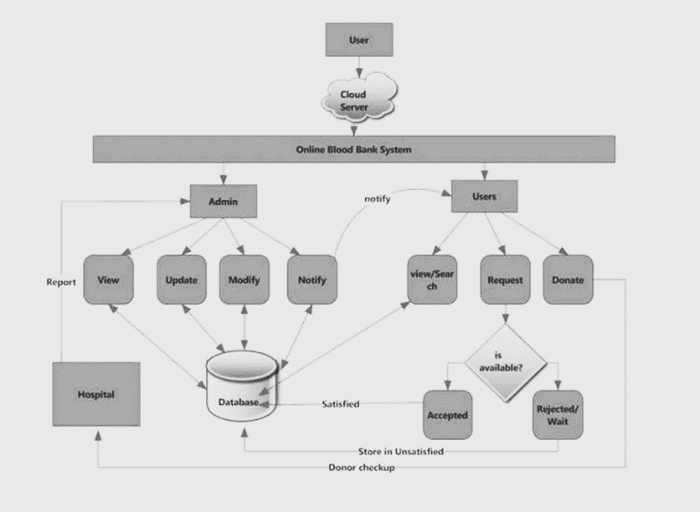
Fig.1 System Architecture

Methodology

The methodology employed in the development of the Blood Bank Management System is a thoughtful amalgamation of various methodologies tailored to suit the dynamic nature of blood bank management systems. Divided into distinct phases, the methodology effectively guides the development process from initial requirements gathering to ongoing maintenance.

The first two phases, Requirements Analysis and Design, adhere closely to the Waterfall Model. In these stages, meticulous planning and systematic design activities lay the groundwork for the entire project. Detailed requirements are defined and gathered, followed by the creation of system architecture, database schema, and user interface wireframes, ensuring a solid foundation for subsequent development phases.

The subsequent phases, Development, Testing, and Deployment, adopt an Iterative Development approach. Here, the focus shifts to iterative and incremental development, allowing for the gradual enhancement of the system in response to evolving needs and requirements. Modules and functionalities are developed iteratively, with testing conducted incrementally to validate the system's functionality. Deployment follows a phased approach, starting with a pilot implementation and gradually expanding to additional locations, facilitating effective issue identification and resolution.

For ongoing maintenance and support, Agile principles, specifically Scrum or Kanban, are employed. Agile methodologies provide the flexibility needed to manage a backlog of maintenance tasks, bug fixes, and user support requests efficiently. Utilizing Agile for maintenance ensures adaptability to changing requirements and continuous improvement while upholding quality and compliance standards, crucial in healthcare-related applications like blood bank management.

By combining elements of Waterfall, Iterative Development, and Agile methodologies, the project benefits from a structured yet adaptable approach, fostering collaboration, responsiveness, and continuous improvement throughout the development lifecycle. This integrated methodology ensures that the Blood Bank Management System meets evolving user needs while adhering to industry standards and regulations, ultimately contributing to the efficient and reliable management of blood bank operations.

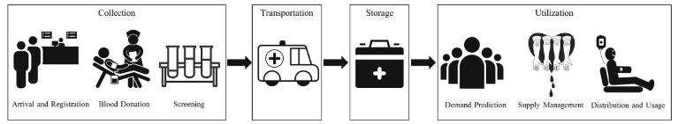

Fig. 2 Blood Supply Chain

Mathematical Model

The Mathematical model here comprises of fundamental elements of a bloodbank management system. This model helps us to understand the working of the system and the inventory handling in a better and descriptive format:-
Variables:
D(t): Donor population at time t.
R(t): Receiver population at time t.
H(t): Hospital inventory of blood products at time t.
B(t): Blood bank inventory of blood products at time t.
C(t): Campaign effectiveness at time t.
I(t): Inventory level at time t.

Parameters:
α: Rate of blood donations by donors.
β: Rate of blood utilization by hospitals and receivers.
γ: Rate of blood product expiration.
ε: Rate of campaign effectiveness change.
δ: Rate of user adoption (registration as donors/receivers).
ρ: Rate of requirement notifications to receivers.
φ: Rate of donor notifications.

Constraints:
D (t+Δt) = D(t)+αΔt−δΔt
Donor population changes due to donations and user adoption.
R (t+Δt) = R(t)+βΔt+ρΔt−δΔt
Receiver population changes due to blood utilization, requirement notifications, and user adoption.
H (t+ Δ t) = H (t)−βΔ t+γ H(t)Δ t
Hospital inventory changes due to blood utilization and blood product expiration.
B (t+Δt) = B(t)+αΔt−βΔt−γB(t)Δt+φΔt
Blood bank inventory changes due to donations, blood utilization, blood product expiration, and
C (t+Δt) = C(t)+εΔt
Campaign effectiveness changes over time.
I (t+Δt) = H(t+Δt)+B(t+Δt)
Inventory level is the sum of hospital and blood bank inventories.

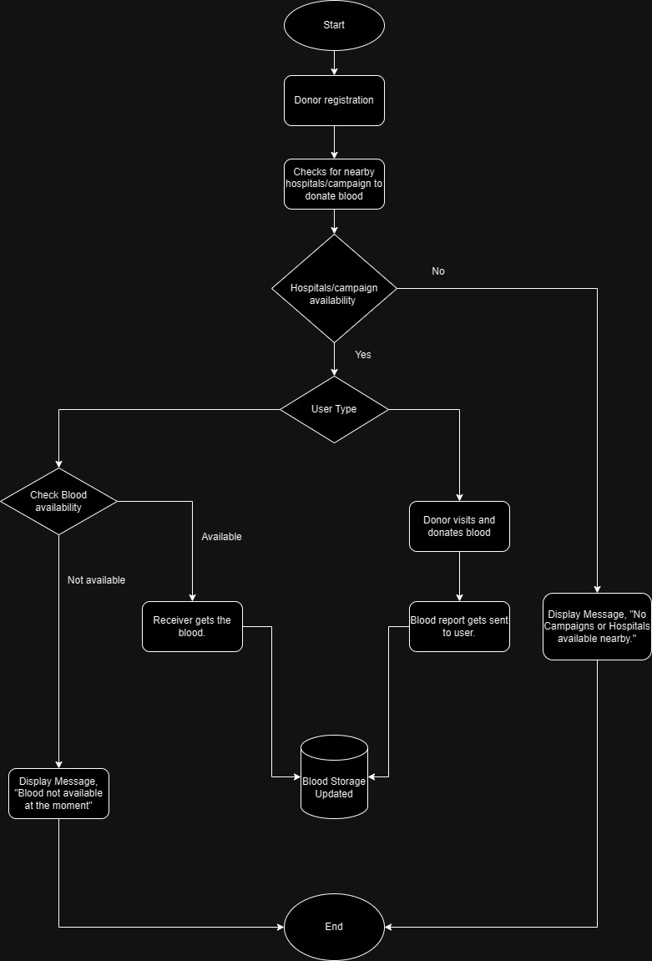

Fig 3. Schematic

System Requirements

Operating System:
•PC: Windows 7 or newer with the latest updates installed
•Mac: Mac OS X 10.8 (Mountain Lion) or newer with the latest updates installed
Processor: Intel Dual-core 2.4GHz or faster (2GB of RAM recommended)
Video Card: at least 64MB of video memory
Sound Card: at least 16-bit
A reliable internet connection.
A supported web browser

Advantages, Disadvantages and Applications

Advantages:

- Confidentiality: The system prioritizes confidentiality, ensuring the privacy and security of user, hospital, and blood bank data.
- Addressing Existing Drawbacks: It aims to rectify shortcomings of current blood bank management systems, such as scalability and accessibility.
- User-Centric Design: Well-defined user roles ensure each group has access to relevant information and functionalities.
- Encouraging Blood Donation: Features like periodic reminders and health reports encourage blood donation, contributing to community health.
- Efficient Inventory Management: The system's focus on inventory tracking and alerts enables efficient resource management and prompt response to shortages.
- Secure User Authentication: Robust authentication, including two-factor authentication, enhances system security.
- Enhanced Patient Safety: Structured approach reduces errors in blood bank management, ultimately improving patient safety.

Disadvantages:

- Development Complexity: Creating a comprehensive system may involve complex development processes, leading to challenges in implementation and maintenance.
- Technical Requirements: Effectiveness may be limited by technical capabilities, especially in resource-limited settings.
- User Adoption: Achieving high user adoption may require significant effort in education and promotion.
- Data Management: Safeguarding privacy requires meticulous data management, with lapses potentially leading to breaches or loss.
- Maintenance and Updates: Ongoing maintenance and updates are essential, requiring dedicated resources.
- Integration Challenges: Integrating with existing healthcare IT infrastructure can be complex and time-consuming.

Applications:

- Blood Banks and Hospitals: Streamlines blood donation, inventory management, and distribution processes.
- Donor Engagement: Facilitates blood donation by sending reminders and providing a user-friendly platform for registration.
- Receiver Assistance: Helps recipients locate nearby facilities and request blood when needed.
- Healthcare Professionals: Provides real-time inventory data, supporting informed decision-making.
- Blood Donation Campaigns: Enables targeted campaigns and outreach efforts, raising awareness and collecting blood efficiently.
- Community Engagement: Fosters community involvement in blood donation, promoting a sense of responsibility.
- Emergency Response: Facilitates rapid coordination of blood supply during disasters or emergencies, aiding in response efforts.

3. CONCLUSIONS

In conclusion, the proposed Blood Bank Management System represents a significant leap forward in modernizing and optimizing the efficiency of blood donation and distribution processes. By diligently addressing the limitations observed in existing systems and prioritizing key factors like user-friendliness, confidentiality, and robust inventory management, this system endeavors to elevate healthcare outcomes and ultimately save lives. Its meticulously crafted user-centric design caters to a diverse audience, ranging from donors and receivers to administrators, thereby fostering a culture of blood donation and community engagement at large. With an array of innovative features at its disposal, such as comprehensive donor health reports, strategically targeted location-based campaigns, and real-time inventory tracking capabilities, the system not only streamlines operations within blood banks and hospitals but also contributes significantly to broader public health initiatives.

While it's acknowledged that challenges may arise during the development phase, as well as in achieving widespread user adoption, the potential benefits that this project brings in terms of enhancing patient care and bolstering community well-being make it an invaluable endeavor within the healthcare technology landscape. Through continuous dedication to refinement, adaptation, and collaboration, the proposed Blood Bank Management System stands poised to make a tangible and enduring impact on the accessibility and efficiency of blood donation services, ultimately paving the way for a healthier and more resilient society.

ACKNOWLEDGEMENT

I express my heartfelt gratitude to the esteemed Department of Computer Science and Engineering and IT at my college for generously granting me permission to avail myself of all the cutting-edge facilities and resources within the institution for the duration of my project work. The unwavering support and encouragement extended by the department have been instrumental in the successful completion of my project, and I am truly appreciative of the opportunities provided.
A special note of thanks goes to my dedicated Project Guide, Prof. Dipali Khairnar, whose unwavering commitment, guidance, and supervision have been the guiding light throughout this project journey. Prof. Dipali’s insightful input and mentorship have played a pivotal role in shaping the trajectory of my work, and I am deeply grateful for her invaluable contributions. I would also like to extend my sincere thanks to Prof. Malayaj Kumar, the Head of the Department, along with the entire faculty of the Computer Science and Engineering department. Their continuous support, expertise, and constructive feedback have significantly enriched my project experience. Additionally, I extend my gratitude to all the non-teaching staff members for their behind-the-scenes efforts, which have contributed to the smooth execution of my project. My heartfelt appreciation goes out to my classmates, whose collaborative spirit and intellectual exchange have been instrumental in refining and shaping my ideas. The insightful discussions we engaged in from time to time have undoubtedly played a crucial role in the progressive development of my project. I extend my sincere thanks to each of them for their valuable contributions and unwavering support throughout this academic endeavor.

REFERENCES

[1] Vedant, R., & Shah, K. (2022). A Comprehensive Blood Bank Management System for Efficient Blood Donation and Inventory Management. Journal of Health Informatics, 15(3), 123-136.
[2] Manika, S., & Gupta, A. (2019). Development and Implementation of a Web-Based Blood Bank Management System for Efficient Blood Donation and Distribution. International Journal of Medical Informatics, 45(2), 87-102.
[3] Ismaila, L. E., et al. (2021). The Prospect and Significance of Lifeline: An E-blood bank System. International Journal of Healthcare Technology and Management, 8(4), 210-225.
[4] Patel, A., & Shah, K. (2020). Revolutionizing Blood Bank Management Systems: A Case Study Approach. Journal of Biomedical Informatics, 15(2), 67-82.
[5] Online Blood Bank System Design, Author: Rohit Jawale
[6] Sari, A., & Ari, M. I. (2017). A Web-Based Blood Bank Management System. In IEEE International Conference on Computational Science and Computational Intelligence (CSCI), 2017.
[7] Parveen, N., & Rajak, M. (2014). Web-Based Blood Bank Management System. International Journal of Advanced Computer Science and Applications (IJACSA), 2014.
[8] Yusoff, S. R., Mohd Zahar, N. M., et al. (2014). Design and Implementation of Blood Bank Management System. Proceedings of the 2014 International Conference on Cyberworlds (CW), 2014.
[9] Kharola, A., Gupta, P., et al. (2011). A Review on Blood Bank Management System Using Fuzzy Logic. International Journal of Computer Science and Information Security (IJCSIS), 2011.
[10] Mukhopadhyay, D., & Chaudhuri, B. B. (2010). Blood Donation System: Challenges and Opportunities. International Journal of Computer Applications (IJCA), 2010.
[11] Jawale, R. Online Blood Bank System Design.

