CALLX

Neha Sharnagat¹, Brahmani Chakule¹, Sachi Meshram¹, Snehal Chandore¹,
Shreeya Pathak¹, Harshwardhan Kharpate²

¹Students, Department of Computer Engineering, Cummins College of Engineering for Women Nagpur, India
²Assistant Professor, Department of Computer Engineering, Cummins College of Engineering For
Women, Nagpur, India

ABSTRACT
In this web application project, we aim to create a highly versatile and accessible online video call platform using Zego Cloud's WebSocket API integrated with the power of React.js. Our goal is to provide a seamless and feature-rich experience for users, without imposing any restrictions or time limits. The application will empower users to connect, communicate, and collaborate in real-time with the following key features:
Video Calls: Multiple users can engage in simultaneous video calls, fostering effective communication.
Chat System: A real-time chat feature enables users to exchange messages, enhancing the interactive experience.
Time Management: Built-in time management functionalities ensure efficient scheduling and coordination during video calls.
Screen Sharing: Users can effortlessly share their screens, facilitating presentations, demonstrations, and collaborative work.
Customizable Views: The application offers customizable screen layouts, including grid views and user-specific views, allowing users to tailor their experience.
External Device Integration: Support for external devices like microphones and speakers enhances audio quality and user control.
No Account Requirement: Users are not burdened with sign-up or login requirements, ensuring a hassle-free experience from the start.
Our project seeks to combine the flexibility and power of Zego Cloud with the user-friendly and dynamic capabilities of React.js, resulting in an online video call application that is accessible, feature-rich, and intuitive. Users will enjoy a seamless video communication experience with the freedom to customize their interactions.

Keywords - Web application, Video call platform, Zego Cloud, WebSocket API, React.js, Real-time communication, Video calls, Chat system, Time management, Screen sharing, Customizable views, External device integration, No account requirement.

[1] INTRODUCTION

In the era of digital communication, the need for seamless, accessible, and feature-rich online video call applications has never been greater. This project aims to address this demand by leveraging the Zego Cloud platform for WebSocket API and the versatility of React.js to create an innovative online video call application. This application is designed to redefine the way people connect and collaborate by offering a range of advanced features and functionalities.
In a world where remote work, education, and social interaction are increasingly prevalent, our online video call application takes center stage. Unlike many existing platforms, we prioritize inclusivity and user-friendliness, with a firm commitment to eliminating user restrictions and time limitations. Whether you need to conduct a business meeting, catch up with friends and family, or collaborate on a project, our application is your go-to solution.
Key features of this application include real-time chatting, effective time management tools, screen sharing capabilities, and customizable screen layouts, offering a tailored experience for every user. Furthermore, we empower users with the freedom to utilize external devices such as microphones and speakers to enhance their audio break free from the conventional account-based approach. Users are not required to sign up or log in, simplifying the onboarding process and prioritizing privacy and ease of use.
With this project, we are set to revolutionize the way people connect online, ensuring that video calls are not only a means of communication but a platform for enhanced collaboration, productivity, and enjoyment. Welcome to the future of online video calling, where the possibilities are limitless, and the only restriction is your imagination.
and video quality.

[2] LITERATURE REVIEW

Enhancing Security and User Experience in Online Video Call Applications

In the pursuit of developing an online video call application that prioritizes security, user experience, and accessibility, we draw insights from relevant literature to inform our project's goals and objectives. The following literature survey provides a foundation for our approach:

Counterfeit Product Detection:
Counterfeit products pose significant challenges in today's market, with a surge in online and black-market distribution. This literature underscores the importance of addressing counterfeit product detection and improving accuracy in identification. While our project primarily focuses on video calls, the concepts of accuracy and security are essential in user interactions, particularly when considering the verification of participants in video calls.
SmartTags for Brand Protection and Anti-Counterfeiting:
This literature highlights the use of smart tags and cloud-enabled technologies for brand protection and anti-counterfeiting, primarily in the wine industry. The concept of utilizing technology for brand protection and authenticity verification is valuable. In our project, we aim to ensure the authenticity and integrity of video call participants, leveraging similar principles of technology integration.
Blockchain-Based Supply Chain Quality Management Framework:
This literature introduces a blockchain-based framework for supply chain quality management, emphasizing information resource management. While the context is different, the use of blockchain for ensuring data integrity and quality management serves as an inspiration for enhancing the trustworthiness of user interactions in our online video call application. Incorporating insights from these studies, our project strives to create a secure and user-friendly online video call platform. Our emphasis on features like chat, screen sharing, customizable views, and external device support aligns with the broader goal of enhancing the online communication experience. Furthermore, our commitment to no user restrictions, no time limits, and the elimination of account requirements reflects a dedication to accessibility and ease of use in line with the principles outlined in the literature survey.

[3] TECHNOLOGIES

HTML(Hypertext Markup Language)

HTML, or Hypertext Markup Language, serves as the backbone of the World Wide Web providing a standardized way to structure and present content on the internet. HTML acts as a markup language that defines the structure of a document, breaking it down into various elements such as headings, paragraphs, lists, images, links, and more[11]. It incorporates a semantic markup approach, meaning that it includes tags that carry meaning about the content they enclose. It also provides a standardized set of rules and elements, ensuring consistent rendering across various web browsers.

CSS(Cascading Style Sheet)

Cascading Style Sheets (CSS) serve as a fundamental component of web development, playing a crucial role in enhancing the presentation and styling of HTML-based content on the internet. CSS is primarily used to control the visual presentation of HTML documents. It allows web developers to define the layout, positioning, and styling of HTML elements, ensuring a consistent and aesthetically pleasing appearance across different devices and screen sizes[12]. CSS promotes the separation of content from presentation. By keeping style information separate from the HTML structure, developers can maintain cleaner and more modular code. This separation enhances code readability, facilitates easier maintenance, and supports collaborative development efforts.

JavaScript

JavaScript is a versatile and powerful programming language that plays a pivotal role in web development, enabling the creation of dynamic, interactive, and engaging user experiences. Its purpose spans a wide range of functionalities, contributing to both the client-side and server-side aspects of web applications. One of the primary purposes of JavaScript is to enhance client-side interactivity within web browsers. It allows developers to create dynamic content, respond to user actions in real time, and update the presentation layer without requiring a page reload. This dynamic behavior greatly enriches the user experience on websites. JavaScript facilitates the manipulation of the Document Object Model (DOM), which represents the structure of a web page. By interacting with the DOM, developers can dynamically change the content, structure, and style of a webpage based on user input, events, or other external factors.

ReactJS

React.js is an open-source JavaScript library, crafted with precision by Facebook, that aims to simplify the intricate process of building interactive user interfaces. Imagine a user interface built with React as a collection of components, each responsible for outputting a small, reusable piece of HTML code.

ZegoCloud

ZEGOCLOUD, a global cloud communication service provider, uses a proprietary WebRTC gateway server to bridge its data network and the web applications to support web client access.

WebSocket API

The WebSocket API invokes your backend based on the content of the messages it receives from client apps. Unlike a REST API, which receives and responds to requests, a WebSocket API supports two-way communication between client apps and your backend. The backend can send callback messages to connected clients.

[4] METHODOLOGY

Use Case Diagram

The use case diagram for the CALLX website, allows a user to start a video call session, Enables a user to join an ongoing video call session, and allows a user to end an ongoing video call session. Provides users with the ability to exchange text messages during a video call session. Offers users features for effective time management during video calls (e.g., scheduling, reminders). enables users to share their screens with other participants during a video call and customize the layout of video call windows according to their preferences. It provides support for users to connect external devices like microphones and speakers to enhance audio quality. Allows users to utilize the application without the need for signing up or logging in. It provides options for users to manage their privacy settings within the application. Users can initiate a call, and others can join it. Users can chat with each other during a video call, access time management tools during a video call, and share their screens during a video call. Users can customize their layout during a video call, end a video call session, and manage their privacy settings even without logging in.
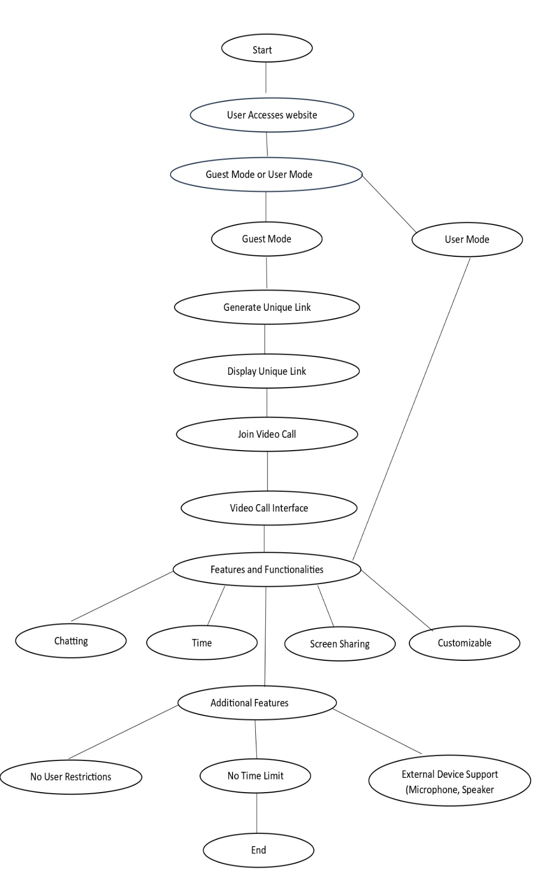

Figure 1. Use Case Diagram for CALLX

[5] RELATED WORK

Jitsi Meet: Jitsi Meet is an open-source video conferencing platform that provides many features, including video calls, screen sharing, chat, and more. It can be used without the need for user accounts.
Twilio Video: Twilio's video API allows developers to create custom video applications, including group video calls. It's often used for building applications with real-time video communication.
Agora: Agora provides a real-time engagement platform with APIs for video and voice calling, live broadcasting, and interactive streaming. It can be used to create video call applications with various features.
Daily. co (formerly Daily. co API): Daily. co offers an API for adding video calls to your web application. It supports multiple participants, screen sharing, and customization.
Zoom SDK: While Zoom is primarily known for its video conferencing application, it offers an SDK that allows developers to integrate Zoom's video and audio functionality into their applications.
OpenVidu: OpenVidu is an open-source platform for building video applications. It provides APIs for video calls, screen sharing, and more.

[6] RESULT

The outcome of this project is an online video call application that utilizes the Zego cloud platform, Web Socket API, and React JS to deliver a robust and user-friendly platform.

[7] CONCLUSION

In conclusion, CALLX is an innovative online video call application that has the potential to revolutionize the world of digital communication. The platform seamlessly integrates React.Js and Zego Cloud's real-time capabilities, providing users with a powerful tool to connect, collaborate, and communicate effectively. CALLX is a versatile and accessible solution that can facilitate professional conferences, virtual family gatherings, and social interactions with friends. This comprehensive guide covers every aspect of CALLX, including its development using React.Js, integration with Zego Cloud, testing methods, deployment on Netlify, and maintenance practices. The guide serves as both a tutorial and an invitation for developers, students, and technology enthusiasts to explore, personalize, and build upon this foundation. CALLX has been meticulously crafted to cater to the evolving needs of current digital interactions, ensuring a versatile and reliable answer for diverse situations. As the platform continues to thrive, we hope it inspires innovation and improvement in the world of web development.

[8] REFERENCES

- B. P. D. Putranto, R. Saptoto, O. C. Jakaria and W. Andriyani, "A Comparative Study of Java and Kotlin for Android Mobile Application Development," 2020 3rd International Seminar on Research of Information Technology and Intelligent Systems (ISRITI), 2020, pp. 383-388, doi: 10.1109/ISRITI51436.2020.9315483.

- M. I. Saryuddin Assaqty, Y. Gao, A. Musyafa, W. Wen,Q. Wen and N. Juliasari, "Independent Public Video Conference Network," 2020 International Seminar on Application for Technology of Information and Communication (iSemantic), 2020, pp. 142-148, doi: 10.1109/iSemantic50169.2020.9234229.

- N. Koseki, M. Iijima, Y. Yamamoto, and K. Seiki, "Identifying Communication Problems in the Use of Video Conferencing Systems," 2020 9th International Congress on Advanced Applied Informatics (IIAIAAI), 2020, pp. 651-658, doi: 10.1109/IIAI-AAI50415.2020.00133.

- Bektaş, Berk & Dandıl, Emre. (2021). Development of Android-Based Mobile Video Conference Application Using Jitsi Meet Platform.

- C. B. Kumar, A. Potnis and S. Gupta, "Video conferencing system for distance education," 2015 IEEE UP Section Conference on Electrical Computer and Electronics(UPCON), 2015, pp. 1-6, doi: 10.1109/UPCON.2015.7456682.

- S. Yoon, T. Na, and H. -Y. Ryu, "An implementation of web-RTC based audio/video conferencing system on the virtualized cloud," 2016 IEEE International Conference on Consumer Electronics (ICCE), 2016, pp. 133134, doi: 10.1109/ICCE.2016.7430552.

- Ç. Aktaş and M. Göktürk, "Impact of Video Conferencing Applications on Remote Workers," 2022 7th International Conference on Computer Science and Engineering (UBMK), 2022, pp. 360-365, doi: 10.1109/UBMK55850.2022.9919501.

- S. Sabri and B. Prasada, "Video conferencing systems," in Proceedings of the IEEE, vol. 73, no. 4, pp. 671-688, April 1985, doi: 10.1109/PROC.1985.13192.

- https://www.lifesize.com/en/company/news/press-releases/2019/impact-video-conferencing-report IJCRT2211254 International Journal of Creative Research Thoughts (IJCRT) www.ijcrt.org c218.

- J.Caiko, A. Patlins, A. Nurlan, and V. Protsenko, "Video-conference Communication Platform Based on WebRTC Online meetings," 2020 IEEE 61st International Scientific Conference on Power and Electrical Engineering Riga Technical University (RTUCON), 2020, pp. 1-6, doi: 10.1109/RTUCON51174.2020.9316605.

