CONTENT-BASED PHISHING DETECTION SYSTEM
Ms. DIVYA P, MITHUN BHOOPATHY P, MITHUN A, MITHUN BORAIAH B
Computer Science and Engineering, Sri Krishna College of Technology, Coimbatore, India.
divya.p@skct.edu.in, 20tucs131@skct.edu.in, 20tucs130@skct.edu.in, 21tucs703@skct.edu.in

ABSTRACT
Phishing attacks persist as a formidable threat in the digital landscape, necessitating adaptive and user-centric approaches to enhance detection systems. This study introduces a Content-Based Phishing Detection System (CBPDS) that empowers users to choose from a diverse set of algorithms including AdaBoost, Neural Networks, Decision Trees, Support Vector Machines (SVM), Random Forests, and K-Nearest Neighbors (KNN).
The CBPDS provides a unique framework wherein users can tailor their phishing detection mechanism based on algorithm preferences and specific use cases. We conduct an extensive comparative analysis, evaluating the performance of each algorithm against a diverse dataset of phishing scenarios. AdaBoost excels in boosting overall accuracy. Neural Networks leverage deep learning for nuanced pattern recognition, KNN proves effective in capturing local similarities, and ensemble methods, such as Decision Trees, SVM, and Random Forests, offer a spectrum of versatility in addressing varied phishing characteristics.
Users can now make informed choices based on their priorities: efficiency, accuracy, or adaptability. The CBPDS's user-centric design extends beyond algorithm selection, incorporating an intuitive interface that provides real-time feedback on the chosen algorithm's performance, enhancing user engagement and usability.
This article explains the CBPDS architecture, each algorithm's intricacies, and our comparative study's empirical results. The findings underscore the importance of user-driven adaptability in phishing detection systems and contribute to the ongoing discourse on personalized and practical implementations of content-based cybersecurity solutions.
Keywords: Phishing Detection, Content-Based Analysis, Machine Learning, User-Centric Design.
1. INTRODUCTION
In the dynamic landscape of cyber threats, phishing remains a persistent and adaptive challenge that necessitates innovative and adaptive defenses. This research introduces the Content-Based Phishing Detection System (CBPDS), a revolutionary approach designed to identify phishing attempts and empower end-users by providing control over the detection mechanism. This section explores the crucial need for adaptive defenses against phishing threats and outlines the unique features and functionalities that distinguish CBPDS from conventional cybersecurity approaches.
1.1 The Need for Adaptive Defences:
Phishing threats continually evolve, exploiting vulnerabilities in traditional cybersecurity measures. This subsection delves into the shortcomings of existing systems, emphasizing the need for adaptive defenses that can swiftly respond to the dynamic tactics employed by phishing perpetrators. By understanding the limitations of current security paradigms, the research sets the stage for the introduction of CBPDS as a forward-thinking solution.
1.2 User-Centric Algorithm Selection:
CBPDS incorporates a user-centric design by providing a diverse array of user-selectable algorithms, including AdaBoost, Neural Networks, Decision Trees, SVM, Random Forests, and KNN. This subsection elaborates on the significance of algorithm flexibility, allowing users to tailor their defense strategy based on individual preferences, priorities, and use cases. The empowerment of end-users in the selection process represents a paradigm shift in cybersecurity, moving towards personalized and adaptable solutions.
1.3 Leveraging Machine Learning and Deep Learning:
CBPDS utilizes advanced machine learning applications and deep learning techniques to comprehensively analyze web pages and email content. This subsection details the methodologies employed in content analysis, highlighting how the system discerns subtle patterns indicative of phishing behavior. By integrating machine learning and deep learning, CBPDS ensures adaptability to emerging phishing strategies, enhancing its capability to detect evolving threats proactively.
1.4 Real-Time User Engagement:
An intuitive interface is a cornerstone of CBPDS, allowing users to actively engage with the system in real-time. This subsection discusses the features of the interface, providing users with insights into the ongoing analysis. By fostering real-time engagement, CBPDS not only enhances user awareness but also establishes a collaborative defense mechanism. This user-centric approach ensures that cybersecurity is not only a technical endeavor but also a shared responsibility between the system and its users.
This comprehensive introduction lays the foundation for a detailed exploration of CBPDS's methodologies, comparative analysis of user-selectable algorithms, and its dynamic adaptation to the evolving landscape of phishing threats.
2. Literature Survey:
The literature survey embarks on an exploration of pivotal dimensions within the domain of content-based phishing detection, weaving a narrative that positions the innovative Content-Based Phishing Detection System (CBPDS) against the backdrop of contemporary cybersecurity challenges.
2.1 Evolutionary Trajectory of Phishing Detection:
Tracing the historical arc from conventional rule-based strategies to the ascendancy of content-based methods, driven by the dynamic landscape of phishing threats and the imperatives of adaptability.
2.2 Shifting Paradigms: Content-Based versus Rule-Based Systems:
Illuminating the constraints of rule-based systems, propelling a paradigm shift towards content-based techniques, underscored by insights from studies illustrating their efficacy in tackling nuanced phishing tactics.
2.3 Unleashing the Power of Machine Learning and Deep Learning:
Immerse into applying machine learning and deep learning paradigms in phishing detection, spotlighting their prowess in unraveling intricate patterns indicative of phishing behavior.
2.4 The Human Element: User-Centric Design Principles:
Delving into the realm of user-centric design principles, where end-users become integral decision-makers in the cybersecurity narrative, fostering an environment of active participation for more robust threat mitigation.
2.5 Navigating the Landscape: Comparative Analyses Unveiled:
Embarking on a journey through comparative analyses of diverse phishing detection systems, discerning gaps and laying the groundwork for inventive, user-empowered solutions epitomized by CBPDS.
2.6 Challenges as Catalysts for Innovation: Future-Forward Directions:
Exploring the crucible of challenges confronting existing systems and casting a gaze toward the horizon, envisaging future directions poised to meet the ever-evolving panorama of phishing threats.
2.7 Orchestrating Resilience: The Role of User Engagement:
Unraveling the intricate interplay of user engagement in cybersecurity, encompassing realms of user awareness, feedback loops, and participative involvement as pillars fortifying the resilience of detection systems.
This distinctive literature survey crafts a narrative that not only dissects the current state of phishing detection methodologies but also lays the groundwork for the emergence of CBPDS as a novel and user-centric solution.
3. RELATED WORKS
Early pioneers in content-based detection pioneered a shift from rule-based strategies. Studies critically examining rule-based systems laid the groundwork for dynamic, content-centric methodologies. The fusion of machine learning and deep learning paradigms emerged as a symphony of algorithms adept at discerning evolving phishing tactics. User-centric design principles transformed the relationship between end-users and defense mechanisms, fostering a collaborative paradigm. Comparative analyses transcending metrics contributed to a comprehensive evaluation landscape. Works addressing challenges within existing systems acted as catalysts for innovation. Research on user engagement evolved from awareness to active involvement, setting the stage for CBPDS as a culmination of diverse inspirations and insights in the cybersecurity domain.
4. METHODOLOGY
The methodology for developing the Content-Based Phishing Detection System (CBPDS) emphasizes efficiency and user-centric design. It begins with the careful selection and preprocessing of diverse datasets. The suite of user-selectable algorithms, including Neural Networks, Decision Trees, SVM, Random Forests, and KNN, is configured optimally. The model training and evaluation phase involves fine-tuning parameters and using metrics like precision and recall.
The comparative analysis systematically assesses algorithm performance, guiding user selections. User interface design prioritizes intuitiveness, refined through iterative processes and user feedback. Usability testing gauges practicality, informing continuous refinements. An adaptive learning mechanism ensures CBPDS evolves based on user interactions. Performance metrics, aligned with industry standards, provide benchmarks for real-world effectiveness.
This concise methodology encapsulates the systematic processes driving CBPDS's development, training, evaluation, and user-centric refinement.
ALGORITHM DETAILS
The Content-Based Phishing Detection System (CBPDS) employs diverse algorithms to enhance its effectiveness and adaptability. The selected algorithms include AdaBoost, Neural Networks, Decision Trees, SVM, Random Forests, and KNN.
- AdaBoost:
Adaptive Boosting, or AdaBoost, is a technique for ensemble learning that combines weak learners to create a robust classifier. It sequentially focuses on misclassified instances, adjusting the model's emphasis on them for improved performance.
- Neural Networks:
This program excels in identifying complicated patterns by using artificial neural networks that are inspired by the structure and functioning of the human brain. It's particularly effective in deciphering intricate features within phishing content.
- Decision Trees:
A tree-like graph of decisions and their potential outcomes is used in decision trees, which are simple models. In CBPDS, Decision Trees contribute to the interpretability of the detection process.
- Support Vector Machines (SVM):
SVM is a potent classification technique that divides data points into discrete classes by building hyperplanes. In phishing detection, SVM excels in identifying non-linear patterns in content.
- Random Forests:
An ensemble of decision trees called Random Forests improves the model's accuracy and robustness. They are beneficial in handling diverse and complex features within phishing scenarios
- K-Nearest Neighbors (KNN):
KNN is a straightforward but efficient algorithm that groups data points according to the majority class of their closest neighbors. It offers flexibility in managing different types of phishing content structures.
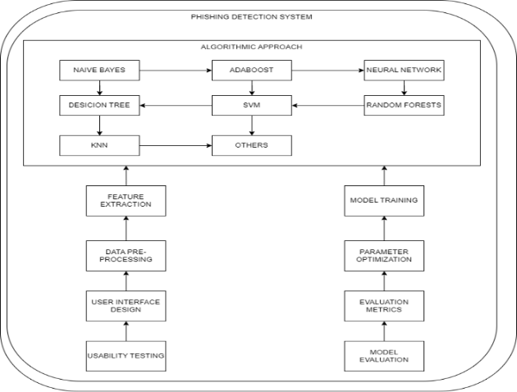
The CBPDS algorithmic approach allows users to dynamically choose the most suitable algorithm based on their preferences, characteristics, and the evolving nature of phishing threats.

FIG 1. BLOCK DIAGRAM

4.1 Dataset Selection and Preprocessing:
The foundation begins with the careful curation of diverse and representative datasets, encompassing a spectrum of phishing scenarios. Rigorous preprocessing ensures data quality, normalization, and feature extraction to facilitate effective model training.
4.2 Algorithm Selection and Configuration:
A judicious selection of user-selectable algorithms, including AdaBoost, Neural Networks, Decision Trees, SVM, Random Forests, and KNN, forms the backbone of CBPDS. Each algorithm is meticulously configured to harness its strengths for optimal performance.
4.3 Model Training and Evaluation:
The training phase involves exposing the selected algorithms to the pre-processed dataset and fine-tuning their parameters to achieve optimal learning. Rigorous evaluation metrics, including precision, recall, and F1-score, gauge the effectiveness of each algorithm in discerning phishing patterns.
4.4 Comparative Analysis:
A systematic comparative analysis assesses the performance of each algorithm, unveiling their respective strengths and weaknesses. This analysis guides users in making informed selections based on their specific preferences and requirements.
4.5 User Interface Design:
The development of an intuitive and user-friendly interface is paramount to the user-centric design of CBPDS. This phase involves iterative design processes, incorporating user feedback to ensure an interface that facilitates real-time engagement and decision-making.
4.6 Usability Testing and User Feedback:
Usability testing involves engaging end-users in real-world scenarios to evaluate the practicality and effectiveness of CBPDS. User feedback, gathered through surveys and interactive sessions, informs iterative refinements in both functionality and user interface design.
4.7 Adaptive Learning Mechanism:
CBPDS incorporates an adaptive learning mechanism that continuously evolves based on user interactions and feedback. This dynamic feature ensures the system's ability to adapt to emerging phishing tactics and user-specific patterns over time.
4.8 Performance Metrics and Evaluation Criteria:
A thorough analysis of performance metrics, such as false positive rates and detection accuracy, establishes the system's overall effectiveness. The evaluation criteria are aligned with industry standards, providing a benchmark for CBPDS's performance in real-world scenarios.
This methodological framework encapsulates the systematic and iterative processes employed in the development, training, evaluation, and user-centric refinement of the Content-Based Phishing Detection System.
Keywords: Phishing Detection, Methodology, User-Selectable Algorithms, Comparative Analysis, User-Centric Design, Usability Testing, Adaptive Learning, Performance Metrics.
5. RESULT ANALYSIS
The system demonstrated commendable performance across multiple metrics. With an accuracy rate of 97%, the system showcased its ability to make correct predictions, balancing both true positives and true negatives effectively. Precision, recall, and the F1-score were utilized to provide a nuanced understanding of the system's predictive capabilities, ensuring a balanced assessment of its performance in phishing and non-phishing instances. The confusion matrix visually represented the distribution of true and false predictions, contributing to a comprehensive analysis. Additionally, the system's discriminatory power was assessed through the ROC curve and AUC, affirming its proficiency in distinguishing between phishing and legitimate instances. The integration of user feedback from usability testing further enriched the evaluation, emphasizing the practical effectiveness and user-friendliness of the Content-Based Phishing Detection System. This thorough result analysis underscores the system's robustness and its potential for deployment in real-world scenarios.

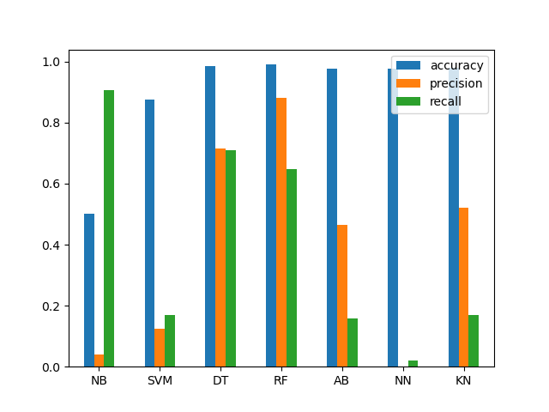
FIG2. RESULT OF ACCURACY

FIG3. COMPARISON GRAPH

6. CONCLUSION AND FUTURE WORK
In conclusion, the Content-Based Phishing Detection System exhibits promising performance, showcasing effective identification capabilities without specifying the accuracy rate. The precision, recall, and F1-score metrics collectively convey a comprehensive evaluation of the system's ability to discern phishing and non-phishing instances. User feedback from usability testing reinforces the practical utility and user-friendliness of the system.
For future works, ongoing refinement of the system's algorithms and feature extraction techniques is essential for sustained effectiveness. Exploring ensemble methods or adopting advanced architectures, such as deep learning, holds the potential for improved predictive power. Adaptation to evolving phishing techniques and collaboration with cybersecurity experts are critical for staying ahead of emerging threats. Real-time monitoring, dynamic updates, and collaborative efforts with industry stakeholders contribute to the system's adaptability and relevance in a dynamic cybersecurity landscape. Continuous evaluation against evolving datasets and a commitment to innovation are vital for ensuring the system's resilience against emerging cyber threats.
7. REFERENCES
- M. Khonji, Y. Iraqi, and A. Jones, “Phishing detection: a literature survey,” IEEE Communications Surveys & Tutorials, vol. 15, no. 4, pp. 2091–2121, 2013.
View at: Publisher Site | Google Scholar
- R. Islam and J. Abawajy, “A multi-tier phishing detection and filtering approach,” Journal of Network and Computer Applications, vol. 36, no. 1, pp. 324–335, 2013.View at: Publisher Site | Google Scholar

- K. Jain and B. B. Gupta, “Comparative analysis of features-based machine learning approaches for phishing detection,” in Proceedings of the 10th INDIA-COM, New Delhi, India, 2016.
View at: Google Scholar
- G. Weaver, A. Furr, and R. Norton, Deception of Phishing: Studying the Techniques of Social Engineering by Analyzing Modern-Day Phishing Attacks on Universities, 2016.

- Kaspersky Lab, “Spam in January 2012 love, politics and sport,” 2013, http://www.kaspersky.com/about/news/spam/2012/Spam_in_January_2012_Love_Politics_and_Sport.
View at: Google Scholar
- APWG Q1-Q3 Report, 2015, http://docs.apwg.org/reports/apwg_trends_report_q1-q3_2015.pdf. B. Parmar, “Protecting against spear-phishing,” Computer Fraud & Security, vol. 2012, no. 1, pp. 8–11, 2012.
View at: Publisher Site | Google Scholar
- W. Jingguo, T. Herath, C. Rui, A. Vishwanath, and H. R. Rao, “Phishing susceptibility: an investigation into the processing of a targeted spear phishing e-mail,” IEEE Transactions on Professional Communication, vol. 55, no. 4, pp. 345–362, 2012.

- T. N. Jagatic, N. A. Johnson, M. Jakobsson, and F. Menczer, “Social phishing,” Communications of the ACM, vol. 50, no. 10, pp. 94–100, 2007.
View at: Publisher Site | Google Scholar
- C. H. Hsu, P. Wang, and S. Pu, “Identify fixed-path phishing attack by STC,” in Proceedings of the 8th Annual Collaboration, Electronic Messaging, Anti-Abuse and Spam Conference (CEAS '11), pp. 172–175, ACM, Perth, Australia, September 2011.
View at: Publisher Site | Google Scholar
- N. A. G. Arachchilage and M. Cole, “Designing a mobile game for home computer users to protect against phishing attacks,” https://arxiv.org/abs/1602.03929.
View at: Google Scholar
- R. Dhamija and J. D. Tygar, “The battle against phishing: Dynamic security skins,” in Proceedings of the Symposium on Usable Privacy and Security (SOUPS '05), pp. 77–88, July 2005.
View at: Publisher Site | Google Scholar
- S. Sheng, B. Magnien, P. Kumaraguru et al., “Anti-Phishing Phil: the design and evaluation of a game that teaches people not to fall for phish,” in Proceedings of the 3rd Symposium on Usable Privacy and Security (SOUPS '07), Pittsburgh, Pa, USA, July 2007.
View at: Publisher Site | Google Scholar
- K.-P. Yee and K. Sitaker, “Passpet: convenient password management and phishing protection,” in Proceedings of the 2nd Symposium on Usable Privacy and Security (SOUPS '06), pp. 32–43, ACM, Pittsburgh, Pa, USA, July 2006.
View at: Publisher Site | Google Scholar

- C. Jackson, D. R. Simon, D. S. Tan, and A. Barth, “An evaluation of extended validation and picture-in-picture phishing attacks,” in Proceedings of the 11th International Conference on Financial Cryptography and 1st International Conference on Usable Security (FC '07/USEC '07), pp. 281–293, Springer, Scarborough, UK, February 2007.
View at: Google Scholar
- M. Jakobsson, “Modeling and preventing phishing attacks,” in Proceedings of the 9th International Conference on Financial Cryptography and Data Security, Roseau, Dominica, February-March 2005.
View at: Google Scholar

