A STUDY ON THE EFFECT OF EMPLOYEE WELFARE MEASURES ON EMPLOYEE PERFORMANCE AT SRI HARI ASSOCIATES
¹Varalakshmi K and ²Madhiyarsi S
¹MBA student Jerusalem College of Engineering, Chennai
²Professor MBA, Jerusalem College of Engineering, Chennai
ABSTRACT
The research project entitled ‘A STUDY ON THE EFFECT OF EMPLOYEE WELFARE MEASURES ON EMPLOYEE PERFORMANCE AT SRI HARI ASSOCIATES’ is an attempt to identify the effect of employee welfare measures on employee performance, the date were collected through questionnaires. This research study aims to investigate and analyze whether there is an impact of welfare measures on the employees performance at Sri Hari Associates. The research design used for this study is descriptive in nature. The descriptive study helps the researcher to find out various characteristics of the population. The simple random sampling technique was adopted for selecting sample units from the population. The method of data collection for the study includes both primary and secondary data. The population for the study is 200 employees were working in Sri Hari Associates. A sample of 120 employees was helped to analyze the effect of employee welfare measures on employee performance. The statistical tool used for analyzing and interpreting the effect of welfare measures are includes percentage analysis (chi square, anova, weighted average). The results were presented with the help of charts and diagrams were drawn from the analyzing of data. The suggestions and conclusions have been made based on the findings.
Keywords: Welfare measures, Performance, benefits
INTRODUCTION
In today's highly competitive and rapidly evolving business world, organizations recognize that a content and motivated workforce is instrumental in achieving sustainable success. Employee welfare measures go beyond traditional compensation structures and encompass a range of policies and practices aimed at supporting employees in various facets of their lives. These measures may include health and wellness programs, flexible work arrangements, professional development opportunities, and initiatives that promote a healthy work-life balance.
This study seeks to explore and evaluate the effectiveness of employee welfare measures in fostering a positive work environment, enhancing employee engagement, and ultimately contributing to organizational success. By understanding the impact of welfare initiatives on employee satisfaction, productivity, and retention, organizations can make informed decisions about resource allocation and continually improve their strategies to meet the evolving needs of their workforce.
REVIEW OF LITERATURE
Gayithri, 2022 the title is “Impact of welfare measures on the employee performance with particular reference of sollys consulting and solutions pvt ltd” ,the important study was conducted on impact of Welfare measures on Employee Performance at Sollys consulting and solutions private limited in Bangalore. It means efforts to make a workers life worth living. Employee welfare provided for the better living of employee. The study was conducted to determine the impact of employee welfare facilities on the employee performance. Welfare is the pre-requisite of minimal level of well-being and social support for all citizens. Organization provides welfare facilities to their employees to maintain their motivation level high. The main objective is to determine the satisfaction levels of workers with regards to welfare services and to propose some measures for improving welfare measures in the organization. Research was sustained by stratified random sampling of 32 employees from various departments. Structured questionnaire was used for collecting the data. The data was analysed through the percentage analysis and cross tabulation method by using SPSS software. The main findings of the study are the majority of employees were satisfied with the statutory and non-statutory welfare measures. Majority of employees were highly satisfied with social security training program facilities by in identifying the needs of each employee.
(Agusioma, Nyakwara & Mwiti, 2019) the objective of the study was to determine effect of staff conflict resolution on employee performance at Public Service Commission in Kenya. The specific objectives were to establish the influence of retirement benefits, allowances/benefits, compensation and medical insurance on organization performance the Public Service Commission in Kenya. This research adopted descriptive survey research design approach. The study sample size of 141 respondents was selected. The study selected the respondents using stratified proportionate random sampling technique. Data was collected mainly by use of semi structured questionnaires. Correlation and regression analysis were used to achieve the study objectives. The study found that staff welfare was positively and significantly affected employee performance. Therefore an increase in these factors will result in increased accessibility to increased employee performance. The study concludes that staff welfare is essential in creating a sense of recognition and satisfaction among the employees which improves their productivity. It is therefore also concluded that unbiased and competitive employee welfare framework should be established to evade poor employee turnover. The study recommends the managers and human resource practitioners to highly prioritize staff welfare as a key strategic practice in the organizations. Therefore, Human Resource Management is recommended to be undertaken as a tool for ensuring staff welfare is well addressed. It will help them in understanding the issues that affect the employees and their productivity.
Waititu, Kihara & Senaji, 2017 the title is “Effect Of Employee Welfare Programme On Employee Performance: A Case Study Of Kenya Railways Corporation” The general objective of this study was to determine the effects of employee welfare programs on employee performance in Kenya Railways Corporation The study used descriptive survey research design. The study targeted a population of 1720 employees. The target population was stratified into two administration and academic staff. Out of this population, a sample of 172 respondents was obtained through stratified random sampling. The primary data was collected through a semi structured questionnaire. The questionnaires were administered to the academic and administrative staff at Kenya Railways Corporation. The questionnaires were administered through personal contact to allow for further investigation. The questionnaires were then picked later by the researcher to be used for data analysis. Specifically, descriptive statistics was used to summarize the data and put it in presentable formats and prepare it for correlation and regression analysis and inferential statistical analysis. The study recommends that remuneration policies; occupational health and training and development should be adopted by the Kenya Railways Corporation to improve on employee performance in the organization.

METHODOLOGY
The objective of this study is to Study on the effect of employee welfare measures on employee performance at Sri Hari associates and to study the satisfaction level of employees in employee welfare measures with respect to their demographic factors and analyze the effect of employee welfare measures on employee’s performance and to identify the association between working atmosphere and improvement in employees work life in the organization.
The limitation of the study is that the data was gathered during working hours, when employees were preoccupied with everyday tasks and therefore less responsive. Because of small scale industry there is a less welfare facilities were providing to the employees. So can’t able to study more welfare measures. Descriptive Research design has been used in this study. Descriptive research is a research method used to try and determine the characteristics of a population or particular phenomenon. Using descriptive research you can identify patterns in the characteristics of a group to essentially establish everything you need to understand apart from why something has happened. The primary data for the study has been collected through Questionnaire. Secondary data has been collected from insurance journals, magazines, insurance websites, etc.
ANALYSIS
- Chi square test
- Anova
1. PERCENTAGE ANALYSIS FOR AGE VARIABLE
TABLE 1 CHART 1
 | Frequency | Percentage%
Less than 15 years | 0 | 0
16-25years | 52 | 52
26-35years | 46 | 46
36-45years | 9 | 9
Above 45 years | 13 | 13
Total | 120 | 120.0

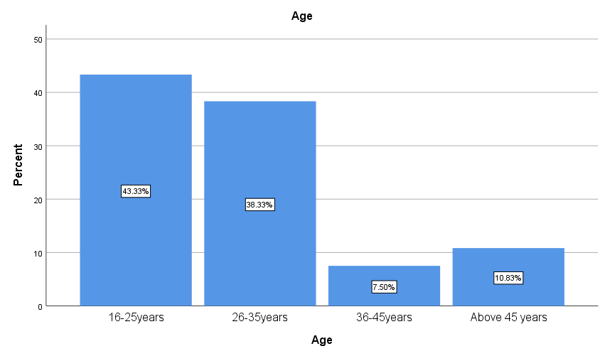

Inference:
From the above table it shows that out of 120 employees 52% are between 16 to 25 years, 46% are 26 to 35years, 9% are 36 to 45 years, and 13% are above 45 years.

2. PERCENTAGE ANALYSIS FOR GENDERVARIABLE

TABLE 2 CHART 2

 | Frequency | Percentage%
Male | 86 | 86
Female | 34 | 34
Total | 120 | 120
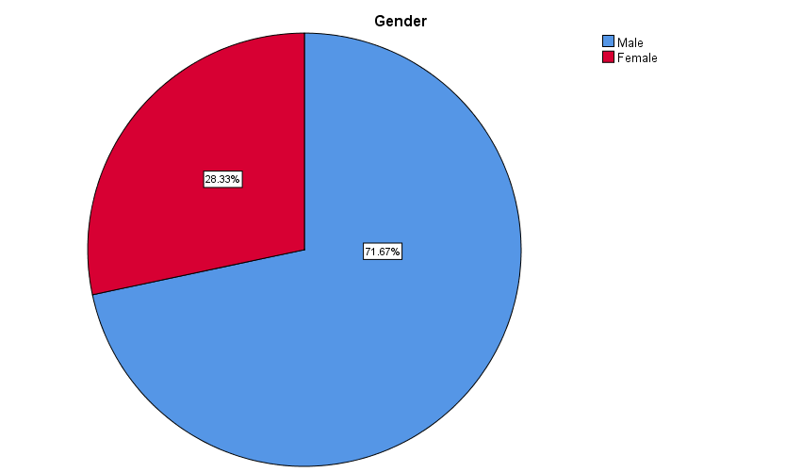

Inference:
From the above table it shows that out of 120 employees 86% are male and 34% are female.

3. PERCENTAGE ANALYSIS FOR MARITAL STATUS OF THE EMPLOYEES
TABLE 3 CHART 3

 | Frequency | Percentage
Single | 43 | 43
Married | 77 | 77
Total | 120 | 120
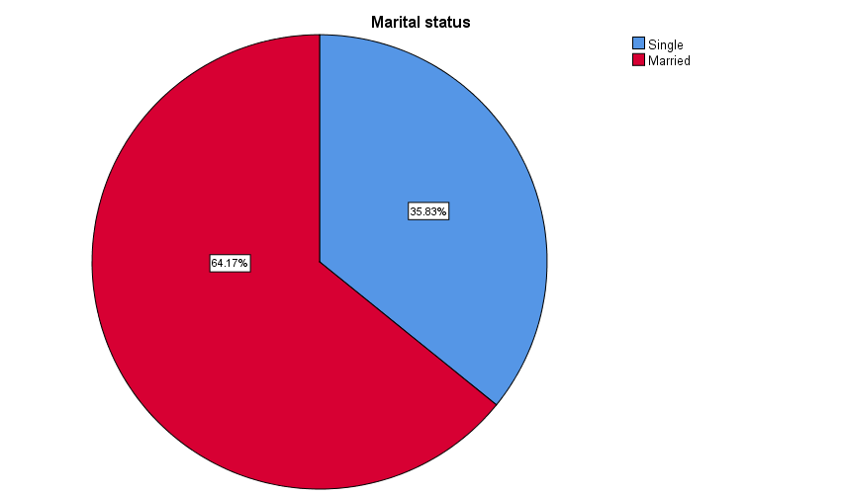
Inference:
From the above table it shows that out of 120 respondent 43% is single, 77% are married.

4. PERCENTAGE ANALYSIS FOR YEARS OF EXPERIENCE OF THE EMPLOYEES
TABLE 4

CHART 4

 | Frequency | Percentage%
Less than 1 year | 12 | 12
1-5 years | 49 | 49
6-10 years | 46 | 46
11-15 years | 13 | 13
Total | 120 | 120

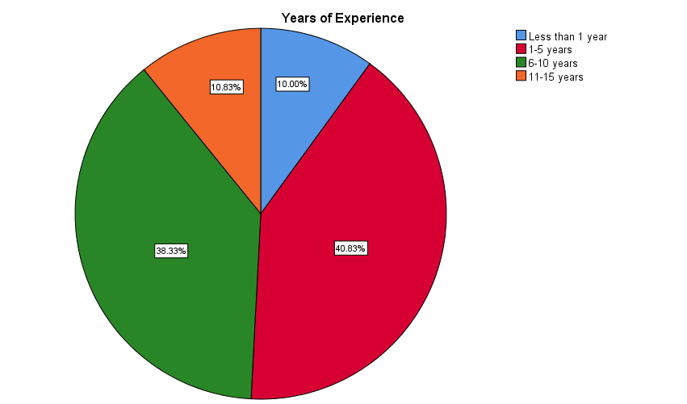

Inference:
From the above table it shows that out of 120 employees 12% of employees having less than 1 year experience, 49% are having 1-5 years, 46% having 6-10 years of experience and 13% having 11-15 years of experience.
5. PERCENTAGE ANALYSIS FOR MONTHLY INCOME OF THE EMPLOYEES
TABLE 5 CHART 5
 | Frequency | Percentage
Less than 10000 | 3 | 3
10001-20000 | 20 | 20
20001-30000 | 29 | 29
30001-40000 | 22 | 22
40001-50000 | 34 | 34
Above 50000 | 12 | 12
Total | 120 | 120

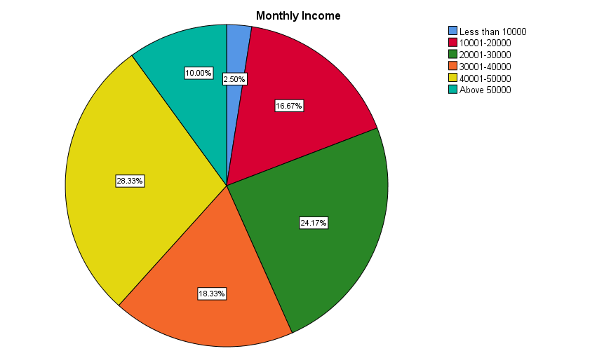

Inference:
From the above table it shows that out of 120 employees 3% are earning below 10000, 20% are earning10001 to 20000, 29% are earning 20001 to 30000, 22% are earning 30001 to 40000 , 34% are earning 40001 to 50000, 12% are earning above 50000.

1. CHI SQUARE TEST
To find out the association between gender and employees satisfaction level of the present welfare facilities provided by the company.
H0: There is no association between gender and employees satisfaction level of the present welfare facilities provided by the company.
H1: There is an association between gender and employees satisfaction level of the present welfare facilities provided by the company.
Test Statistics
 | Gender | What is your satisfaction level towards the present welfare facilities provided by the organization?
Chi-Square | 22.533ª | 94.083^{b}
Df | 1 | 4
Asymp. Sig. | .000 | .000
a. 0 cells (0.0%) have expected frequencies less than 5. The minimum expected cell frequency is 60.0.
b. 0 cells (0.0%) have expected frequencies less than 5. The minimum expected cell frequency is 24.0.

Inference:
From the above table, we can find that the significant value is 0.000, which is less than table value 0.05, so the Null hypothesis is rejected and Alternative hypothesis is accepted.
Therefore there is an association between gender and employees satisfaction level of the present welfare facilities provided by the company.

2. CHI-SQUARE ANALYSIS

To find out the association between gender and satisfaction level towards accommodation facility provided by the organization.
H0: There is no association between gender and satisfaction towards accommodation facility provided by the organization.
H1: There is an association between gender and satisfaction towards accommodation facility provided by the organization.

Test Statistics
 | Gender | Are you satisfied with the accommodation facility provided?
Chi-Square | 22.533ª | 86.700ª
df | 1 | 1
Asymp. Sig. | .000 | .000
a. 0 cells (0.0%) have expected frequencies less than 5. The minimum expected cell frequency is 60.0.
INFERENCE

From the above table, we can find that the significant value is 0.000, which is less than table value 0.05, so the Null hypothesis is rejected and Alternative hypothesis is accepted.
Therefore there is an association between gender and satisfaction towards accommodation facility provided by the organization.

3. ANOVA
To find out the significance difference between income and employees experienced an improvement in work life balance due to the implemented welfare measures.
H0: There is no significance difference between income and employees experienced an improvement in work life balance due to the implemented welfare measures.
H1: There is a significance difference between income and employees experienced an improvement in work life balance due to the implemented welfare measures.

ANOVA
Have you experienced an improvement in your work-life balance due to the implemented employee welfare measures?
 | Sum of Squares | df | Mean Square | F | Sig.
Between Groups | 2.718 | 5 | .544 | 5.955 | .000
Within Groups | 10.407 | 114 | .091
Total | 13.125 | 119

INFERENCE

The above table shows that the one way ANOVA was conducted to identify influence of income and employees experienced an improvement in work life balance due to the implemented welfare measures. The significant value p=0.000 so, there is a significant difference between income and employees experienced an improvement in work life balance due to the implemented welfare measures.

4. CORRELATION
To find out the relationship between employee welfare measures provided by the organization and welfare provided will motivate employees.
H0: There is no relationship between employee welfare measures provided by the organization and welfare provided will motivate employees.
H1: There is a relationship between employee welfare measures provided by the organization and welfare provided will motivate employees.

Correlations
 |  | The employee welfare measures provided by the organization have a positive impact on your job performance? | “Welfare facilities provided will motivate work to work sincerely”
The employee welfare measures provided by the organization have a positive impact on your job performance? | Pearson Correlation | 1 | .516**
 | Sig. (2-tailed) |  | .000
 | N | 120 | 120
“Welfare facilities provided will motivate work to work sincerely” how far you agree with this statement? | Pearson Correlation | .516** | 1
 | Sig. (2-tailed) | .000
 | N | 120 | 120
**. Correlation is significant at the 0.01 level (2-tailed).

INFERENCE:
From the above table, we can find that the significant value is 0.000, which is less than table value 0.05, so the Null hypothesis is rejected and Alternative hypothesis is accepted. Therefore there is a relationship between employee welfare measures provided by the organization and welfare provided will motivate employees.
FINDINGS
According to the study, out of 120 employees 52% are between 16 to 25 years, 46% are 26 to 35years, 9% are 36 to 45 years, and 13% are above 45 years. According to the study, out of 120 employees 86% are male and 34% are female. According to the study, out of 120 employees 55% are master’s degree, 52% are bachelor’s degree, 9% are schooling and 4% are others. According to the study, out of 120 respondent 43% is single, 77% are married. According to the study, out of 120 employees 12% of employees having less than 1 year experience, 49% are having 1-5 years, 46% having 6-10 years of experience and 13% having 11-15 years of experience. According to the study, out of 120 employees 3% are earning below 10000, 20% are earning10001 to 20000, 29% are earning 20001 to 30000, 22% are earning 30001 to 40000, 34% are earning 40001 to 50000, 12% are earning above 50000. According to the study, out of 120 employees 117 employees are aware of welfare measures provided at the Sri Hari Associates and 3 employees are not having aware of welfare measures provided at Sri Hari Associates. According to the study, we can find that the significant value is 0.000, which is less than table value 0.05, so the Null hypothesis is rejected and Alternative hypothesis is accepted. Therefore there is an association between gender and employees satisfaction level of the present welfare facilities provided by the company. According to the study, we can find that the significant value is 0.000, which is less than table value 0.05, so the Null hypothesis is rejected and Alternative hypothesis is accepted. Therefore there is an association between gender and satisfaction towards accommodation facility provided by the organization. According to the study, that the one way ANOVA was conducted to identify influence of income and employees experienced an improvement in work life balance due to the implemented welfare measures. The significant value p=0.000 so, there is a significant difference between income and employees experienced an improvement in work life balance due to the implemented welfare measures. According to the study, we can find that the significant value is 0.000, which is less than table value 0.05, so the Null hypothesis is rejected and Alternative hypothesis is accepted. Therefore there is a relationship between employee welfare measures provided by the organization and welfare provided will motivate employees

SUGGESTIONS
Employee welfare measures refer taking care of well-being of the employees by employer. The suggestion for this study is the company needs to improve the safety measures and medical benefits offered to the employees; many of them have selected neutral and dissatisfaction for ambulance service in the organization. So the company needs to improve the ambulance service for both employees and labors working in the organization.
The company also needs to concentrate more on the monetary benefits like PF, bonus, travelling allowance etc. to the employees because majority of the employees are selected neutral for monetary benefits when compared to other welfare measures provided by the Sri Hari Associates. The company should conduct any welfare programs to improve the communication skills of the employees.
The company needs to improve and include more welfare measures for the employees to increase their performance. There is no so much welfare facilities are provided to the employees by the Sri Hari Associates like education benefits, uniforms and protective clothing, insurance, etc. The company should concentrate on welfare measures to improve the performance of the employees.
CONCLUSION
The study indicates that employee’s welfare measures are responsible to maintain employees in the organization. The employees have provided effective welfare measures. All employees are satisfied with the different welfare facilities provided by the organization. The motivation, medical facilities, canteen facilities, safety measures, grievance handling, etc. these are the important factors that effects on employee’s performance at the workplace. It has been concluded all the employees are satisfied and agree with the welfare facilities provided by the organization which in turn it builds the confidence, motivation and also increase the performance of the employees in the organization. In this study the most of the employees are highly satisfied with the welfare facilities provided by the Sri Hari Associates. And there is a positive impact or effect of welfare measures on employee’s performance. Almost 82% of employees agree that there is a positive effect of welfare measures on employee performance.

REFERENCE
- Lalitha, K., & Priyanka, T. (2014). A study on employee welfare measures with reference to IT industry. International Journal of Engineering Technology, Management and Applied Sciences, 2(7), 7-11.
- Srinu, C., & Kumaraswamy, T. (2017). A Study on Employee Welfare Measures with Special Reference to National Thermal Power Corporation Limited, Simhadri, Vishkapatnam. IMPACT: International Journal of Research in Applied, Natural and Social Sciences (IMPACT: IJRANSS), 5(11), 37-52.
- Chandrasekaran, P., & Ganeshprabhu, P. (2020). A Study on Employee Welfare Measures in Construction Industry in India. International Journal of Scientific and Technology Research, 9(2), 990-995.
- Varsha, N., & Raju, G. N. D. (2023). A STUDY ON EMPLOYEE WELFARE. Journal of Engineering Sciences, 14(06).
- Waititu, F., Kihara, P., & Senaji, T. (2017). Effect of employee welfare programme on employee performance: A case study of Kenya Railways Corporation. International academic journal of human resource and business administration, 2(3), 611-631.
- Keitany, B. J. (2014). Perceived relationship between employee welfare programs and employee performance at Kenya Pipeline Company (Doctoral dissertation, University of Nairobi).
- Tiwari, U. (2014). A Study on Employee Welfare Facilities and Its Impact on Employees Efficiency at V Indha Telelinks Ltd. Rewa (MP) India. Abhinav International Monthly Refereed Journal of Research in Management & Technology, 3(11), 1-7.
- Wei, Y., Nan, H., & Wei, G. (2020). The impact of employee welfare on innovation performance: Evidence from China's manufacturing corporations. International Journal of Production Economics, 228, 107753.
- Agusioma, N. L., Nyakwara, S., & Mwiti, E. (2019). The Influence of staff welfare on employee performance at Public Service Commission in Kenya. Asian Journal of Business and Management, 7(5).

