Enhancing Data Privacy and Security in Fog Computing

Harsh Dev
MCA, AIIT
Amity University
Noida, India
email-harshdev412@gmail.com
Dr. Rajbala Simon
Associate Professor, AIIT
Amity University
Noida,India
email- rsimon@amity.edu

Abstract— Fog computing is a decentralized computing architecture that provides advantages over typical cloud computing, including higher security, dependability, and lower latency. Due to the growth of the Internet of Things, it is growing in popularity, but it also brings with it new technological and security challenges. Due to their frequent usage and resource constraints, fog nodes are vulnerable to malware and other security risks. Fog computing security research has to be done more, and the survey focuses on these technological challenges. Similar to traditional data centers, fog computing presents security and privacy problems, but it is appropriate for a range of Internet of Things services. Fog computing poses special opportunities and challenges for protecting data security and privacy because of its distributed architecture and edge computing capabilities. In order to effectively address these challenges, this paper examines the significance of improving data privacy and security in fog computing environments and talks about a number of different strategies, technologies, and approaches. By means of an extensive examination of extant literature, case studies, and practical applications, the objective of this study is to offer insights into the present condition of data privacy and security in fog computing and suggest improvements for protecting mechanisms.

Keywords- fog; fog computing; cloud computing security; privacy; IoT; privacy challenges; security challenges

Introduction
These days, cloud computing is a widely used computing paradigm that can give end users access to resources that can be configured on any device, at any time, from any location. The field of cloud computing has advanced significantly in recent years. However, because of the great distance between the cloud and end users, cloud computing's drawbacks (such excessive latency) are becoming more apparent as the Internet of Things grows.
Fog computing [11] is a solution that aims to address this issue by expanding the cloud to the network's edge. Specifically, fog computing adds a layer of intermediary technology called fog, which is meant to handle communication data between end users and the cloud. Fog computing is therefore typically viewed as a continuation of cloud computing.
An extension of the cloud computing platform is fog computing. In between the cloud server and the end devices, fog serves as a mediator. them enhances the features of cloud computing rather than completely replacing them. Fog gives these edge devices access to computer resources and operates in closer proximity to them. [2] The scalability and reliability problems with the conventional IoT-cloud architecture are resolved by fog computing. Fog nodes improve data security, accuracy, consistency, and latency rate—a crucial component for applications like medical data—by operating at the edge and being more widely dispersed geographically. Better quality of service (QoS) is achieved in addition to saving the total bandwidth to the cloud.
In other words, fog computing is also referred to as fogging or fog networks. Its distributed architecture incorporates several endpoints for data collection and transfer as well as the cloud. By allocating resources (such programs and the data they generate) logically within this adaptable framework, users can maximize efficiency. The structure aims to place essential analytical services closer to the edge of the network, where they are needed. As a result, users must transfer data over shorter distances, improving network performance and overall efficiency.

Data privacy and security play a pivotal role in fog computing due to the decentralized nature of data processing and storage. By extending cloud capabilities to the network's edge, fog computing makes it possible to analyze and make decisions in real time near the source of the data. However, there are special difficulties with data security and privacy brought about by this distributed architecture. Sensitive data must be kept private, accessible, and intact because it is processed and transferred through a variety of edge devices and fog nodes. Without sufficient protections, there is a serious risk of malicious attacks, unauthorized access, and data breaches, which could jeopardize sensitive information and erode user and stakeholder trust.
Fog computing architecture is able to overcome the security challenges of the traditional IoT cloud architecture to some extent. [16] Fog, operating at the edge and acting as a middle layer, improves data security, accuracy, and consistency while lowering latency and raising overall quality of service. IoT-Fog-cloud architecture is going to be widely used in the near future due to the growing number of IoT devices being developed and the growing need for quick computation. By creating a dependable real-time data monitoring system application with the aforementioned architecture at its centre, the implementation can be improved in the future. And to provide a computational demonstration of the extent to which fog can improve the conventional IoT-Cloud architecture.

LITERATURE REVIEW
Various cryptography techniques are employed to ensure data security and privacy. Asymmetric and symmetric encryption are the two main categories of encryption. A public key is used for encryption in the asymmetric encryption technique, while a private key is used for decryption. The private key, which is used for both encryption and decryption, is the only key used in symmetric encryption. Symmetric encryption [6] requires less processing power because it uses a single secret key for both encryption and decryption, making it much safer, easier to use, and 1000 times faster. The Advance Encryption Standard (AES) symmetric encryption method is the main topic of this paper.
Prior to AES, there were other, more antiquated algorithms called 3-DES and DES. The Data Encryption Standard [7] generates a 64-bit Cipher text using a 56-bit key size and 16-bit block size plaintext. This is a fairly weak encryption algorithm. Using the brute force method, it can be easily cracked in a day. Thus, it cannot be regarded as a safe method of encrypting private medical information. Similar to DES, Triple Data Encryption Standard (3DES) uses a 16-bit block size but allows for a key size of 56, 112, or 168 bits. Even though it is more secure than DES, it is still easily cracked.
To address the aforementioned problems, the AES algorithm is presented. The US government has adopted the symmetric block cipher standard AES. It is regarded as a more sophisticated, safe, and effective standard.
A cloud-based SAML-based authentication model has been proposed by Jing et al. [8]. The author examined the security flaws in the bidirectional authentication process and added a link by utilizing the certificate authority and the identity provider's challenge response to solve the issue. Both service providers and users receive the session key from it. It offers certain techniques that ensure the session's fundamental security, resolving certain issues with information transmission. Replay attacks in resource transformation can be thwarted by using uniform identity resource management.
A model for a secure identity and access management (IAM) system in a cloud environment has been developed by Indu et al. [10]. By creating IAM with multiple authentication and authorization protocols, it was accomplished. It shows the user's original identities being hidden and their identities being validated. Several security protocols that are included in the cloud identity management system can help achieve this.

Fog Computing Architecture

Without relying on centralized computing, like cloud computing, fog computing decentralizes the computing infrastructure. A paradigm called fog computing is put out to combine the cloud with Internet of Things concepts to enable location awareness, low latency, and user mobility. Edge computing, sometimes referred to as fog computing, places datacenters at the edge of networks, providing location awareness, low latency, and enhanced quality-of-service (QoS) for applications that require near real-time processing. Transportation, industrial automation, agriculture, and other smart city applications are typical examples. Heterogeneous devices, including switches, access points, endpoints, and edge devices, are supported by fog infrastructure. Because fog servers inherit cloud services from network edges, they are regarded as small datacenters.

The datacenters are positioned to benefit from several applications in smart cities and are ideal for big data analytics, distributed data collection, and near real-time applications.
To get around latency problems, fog computing is used. Due to the restricted sources available at the fog server, fog computing, on the other hand, ignores the cloud entirely and always uses the cloud for complicated processing. Because of its heterogeneous organization and pervasive connectivity, fog computing is giving rise to a number of new research questions. The deployment of the fog computing environment and its needs are critical concerns in the fog computing paradigm. This is because the devices found in fog environments are diverse.
Consequently, the question that needs to be answered is: How will fog computing address the novel difficulties of managing resources and handling failures in such a diverse environment? Therefore, it is imperative to examine the fundamental prerequisites for several associated elements such as deployment concerns, modeling, resource administration, redundancy, and functionalities. One major problem with the fog hierarchy is security, which was addressed in this article along with solutions for the various layers of the fog hierarchy.

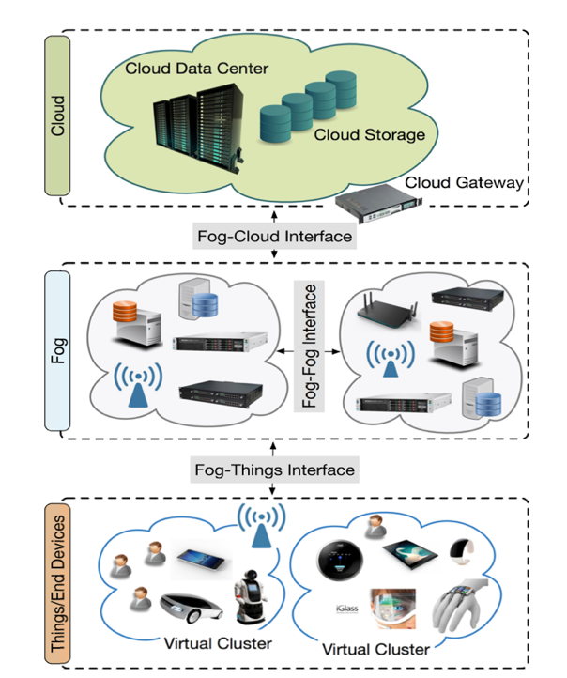

FIGURE 1. Three-tier fog computing architecture.

Security and Privacy Challenges in IoT
The Internet of Things (IoT) may provide security and privacy issues even though it has the potential to be a key component in providing end consumers with a wide range of services more effectively and efficiently. The main security and privacy issues in IoT contexts are outlined below.

AUTHENTICATION-

For IoT devices to be secure, authentication is a fundamental prerequisite. The memory and CPU power needed to carry out the cryptographic operations necessary for an authentication protocol are sadly lacking in a lot of IoT devices. These limited resource devices can contract out costly computations and storage to a fog device, which will carry out the authentication protocol. [13] An approach to smart grid wide-area measurement system key management (WAKE) was put forth by Yee Wei Law and colleagues (2005). Using multicast authentication for secure communications, public-key infrastructure (PKI) is the foundation of this model. Although it might be able to address the issue, traditional PKI-based authentication is not well suited for Internet of Things systems.

TRUST-
Because of the way the Internet of Things (IoT) environment works, integrating different gadgets and sensors from different actuators, the following question comes up: How much can we trust Internet of Things devices? When and how to trust IoT devices is not well-measured by any effective mechanism. IoT service consumers must decide if it makes sense to forgo using particular IoT services in the lack of a trust metric. Therefore, building trust amongst IoT devices is essential to creating secure environments that maintain the dependability and security of IoT services. Reputation-based trust models have been effectively implemented in a variety of contexts, including online social networks.

ROGUE NODE DETECTION-
For malevolent intentions, a malevolent IoT node may pose as a legitimate entity in order to exchange and gather data produced by other IoT devices. A hybrid framework developed by Liran Ma and colleagues can identify rogue access points in Wi-Fi-based access networks.7. Their method keeps the networks safe from rogue access points even when the adversaries have specialized gear. Because trust management in different schemes is complex, it might be challenging to solve this issue in the Internet of Things. However, rogue nodes in Internet of Things environments can be identified using a model based on trust measurements, which offers a limited degree of security protection.

PRIVACY-
The research community is becoming more aware of the privacy breaches involving user data, location, and usage in Internet of Things environments. The inability of the resource-constrained IoT devices to encrypt or decrypt generated data leaves it open to advertisements. The location privacy that can be used to determine the location of an IoT device is another privacy concern. A lot of Internet of Things applications, particularly those related to mobile computing, are location-based services. Based on the communication patterns, an adversary can determine the location of the IoT device. The protection of a user's usage pattern of some generated data by Internet of Things devices, like those in the smart grid, is the final privacy concern. [1] Smart meter readings, for example, can disclose a variety of IoT client usage patterns, including the number of occupants in the home, when they turn on the TV, and when they are at home. Numerous privacy-preserving strategies have been put forth for various Internet of Things applications, including ad hoc networks in cars, smart grids, and healthcare systems.3,8 Nonetheless, the methods available for implementing successful and efficient privacy-preserving schemes are restricted by the resource-constrained IoT devices.[17]

ACCESS CONTROL-
Access control is a security mechanism that makes sure data collected from an IoT device or other resource can only be accessed by authorized entities. To ensure that only reliable parties are able to carry out specific tasks in the Internet of Things, like updating software on IoT devices, sending commands to IoT devices, or accessing device data, access control is necessary. Because there are so many "things" with constrained resources (power and bandwidth), the Internet of Things poses new difficulties for access control. Furthermore, controlling access to widely dispersed data is a difficult task in and of itself. [3]

INTRUSION DETECTION-
When malicious IoT devices or inappropriate behaviour is detected, intrusion detection techniques identify it and alert other network users to take the necessary action. The majority of IoT strategies now in use concentrate on a small number of ineffective attacks. It is challenging to identify both insider and outsider attacks on such widely used platforms due to the nature of IoT environments. Another difficult task is designing complex intrusion detection methods that make use of the limited resources available in the Internet of Things. The main difficulty lies in developing and optimizing a detection system that can function in expansive, widely dispersed, and highly mobile environments. [12]

DATA PROTECTION-
The exponential amount of data produced by the Internet of Things is growing as more devices are added. Both the communication and the processing levels of this data must be maintained. Owing to resource constraints, processing data on IoT devices is challenging; as a result, data is typically sent to the cloud for additional processing and analysis. At this point, the processing stage and its aftermath should protect the data integrity. The inability of IoT devices to perform encryption or decryption poses a significant obstacle when determining the authenticity and integrity of data.

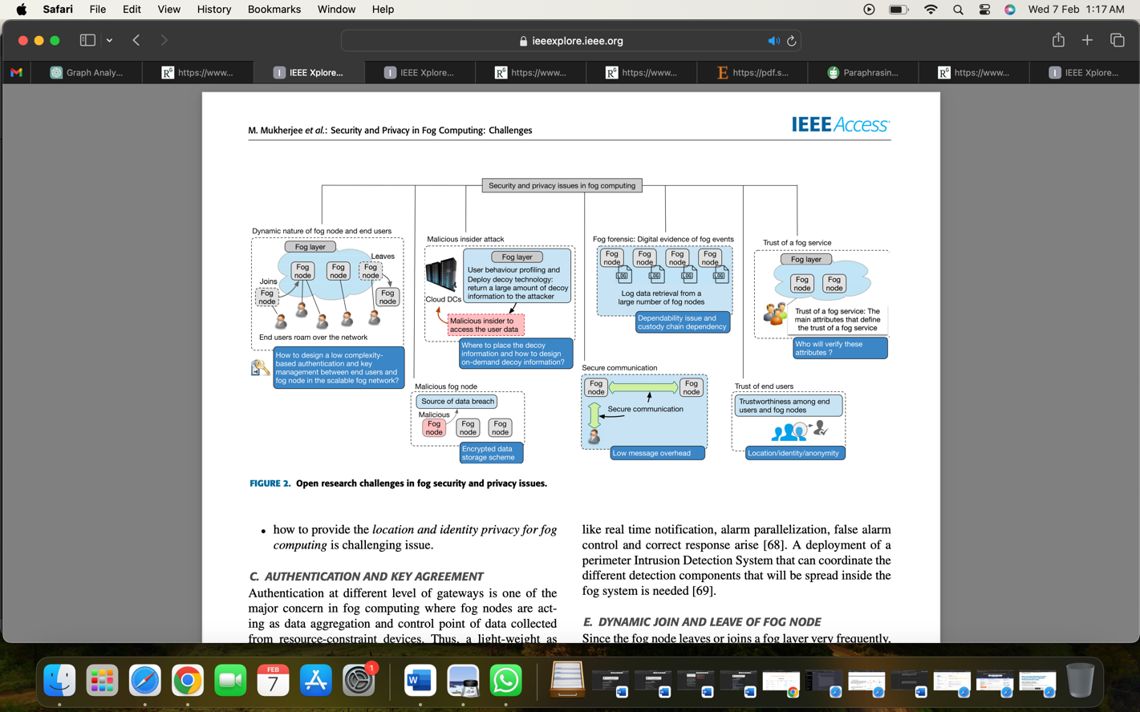
FIGURE 2. Open research challenges in fog security and privacy issues.
V. CHALLENGES IN DATA PRIVACY AND SECURITY IN FOG
1. Lack of Standardization: The absence of standards is one of the main problems with fog computing. Since fog computing is still in its infancy, data security and privacy standards are undefined. Because of this, enterprises find it challenging to guarantee the security of their data in fog computing settings.
2. Data Access Control: It is challenging to manage access to sensitive data in fog computing because data is dispersed among several devices at the network's edge. The ownership and management of fog nodes are frequently inconsistent, making the establishment of a single access control system difficult.
3. Network Heterogeneity: With a vast range of hardware and operating systems, fog computing environments are extremely heterogeneous. Because of this, it is challenging to put in place a standardized security system that can safeguard data on all devices.
4. Limited Resources: The amount of storage, processing power, and bandwidth available to edge devices in fog computing is restricted. This makes it difficult to put strong security measures in place because devices with limited resources might not be able to use traditional security solutions.
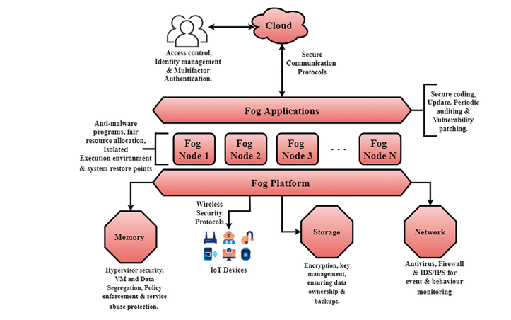
FIGURE 3. Security solutions of fog computing.
VI. SOLUTIONS FOR ENHANCING DATA PRIVACY AND SECURITY IN FOG COMPUTING
1. Encryption: In fog computing environments, encryption is a commonly used technique for data security. Data can be shielded from unwanted access during transmission and storage by encrypting it at the source. But encryption can also add latency, which could impair fog nodes' ability to process information in real time.
2. Secure Communication Protocols: Data transmitted between fog nodes can be kept safe by utilizing secure communication protocols like Transport Layer Security (TLS). By offering data encryption and authentication, these protocols make sure that information is not altered or intercepted by nefarious parties.
3. Access Control Mechanisms: In fog computing environments, access to data can be managed through the use of access control mechanisms like attribute-based access control (ABAC) and role-based access control (RBAC). Whereas ABAC bases access decisions on characteristics like user identity and location, RBAC grants access based on predefined roles.
4. Data Fragmentation: This technique entails dividing data into more manageable chunks and dispersing them among several fog nodes. In the event of a data breach, this can lessen the damage and help avoid a single point of failure. Furthermore, since sensitive data is not kept in one place, data fragmentation can also enhance data privacy.
5. Intrusion Detection Systems: To monitor network traffic and identify any malicious activity, fog computing environments can make use of intrusion detection systems (IDS). IDS can assist in locating possible security risks, sound an alarm, or take proactive steps to lessen the threat.
6. Secure Virtualization: Multiple users can access the same hardware resources without sacrificing the security of their data by using secure virtualization to create isolated and secure virtual environments within fog nodes. Better fog node utilization and resource optimization may also be accomplished with this.
VII. CONCLUSION
Although security and privacy concerns in cloud computing have been thoroughly examined, a number of unique features of fog computing, along with a larger number of fog devices at the network's edge, make these concerns unsuitable for fog computing.
Furthermore, a lot of fresh security and privacy risks surface that weren't there in cloud computing that was centrally managed. We have outlined the key privacy and security concerns in fog computing in this article. The state-of-the-art for addressing security and privacy issues related to fog computing is then surveyed in this article. In summary, this survey aims to provide an overview of current research contributions and future research directions to address various privacy and security challenges in fog computing.
A promising technology that could completely change how data is handled and processed at the network's edge is fog computing. But as fog computing becomes more widely used, security and privacy of data are becoming big issues. It is challenging to implement strong security measures in fog computing due to issues like lack of standardization and resource constraints. Nonetheless, enterprises can improve data security and privacy in fog computing environments by implementing solutions like intrusion detection systems, access control methods, and encryption. To maintain end users' faith and confidence in this new technology, fog computing companies must place a high priority on data privacy and security.
In fog computing, data privacy is essential to safeguarding sensitive information against cyberattacks and unwanted access. By combining strategies like data anonymization, access control, and encryption, the problems with data privacy can be solved. Furthermore, fog computing can guarantee data privacy and regulatory compliance through the use of automated data privacy policies and data governance. To win over users' trust and avert possible data breaches, businesses must put data privacy first when using fog computing.

References
- S. Yi, Z. Qin, and Q. Li, ‘‘Security and privacy issues of fog computing: A survey,’’ in Proc. 10th Int. Conf. Wireless Algorithms, Syst., Appl. (WASA), Aug. 2015, pp. 685–695.
- Wang, Qixu, Dajiang Chen, Ning Zhang, Zhe Ding, and Zhiguang Qin. "PCP: A Privacy- Preserving Content-Based Publish–Subscribe Scheme With Differential Privacy in Fog Computing." IEEE Access 5 (2017): 17962- 17974.
- J. Ni, A. Zhang, X. Lin, and X. S. Shen, ‘‘Security, privacy, and fairness in fog-based vehicular crowdsensing,’’ IEEE Commun. Mag., vol. 55, no. 6, pp. 146–152, Jun. 2017.
- H. Freeman and T. Zhang, ‘‘The emerging era of fog computing and networking [the president’s page],’’ IEEE Commun. Mag.,vol. 54, no. 6, pp. 4–5, Jun. 2016.
- Alrawais, Arwa, Abdulrahman Alhothaily, Chunqiang Hu, and Xiuzhen Cheng. "Fog computing for the internet of things: Security and privacy issues." IEEE Internet Computing 21, no. 2 (2017): 34-42.
- Mukherjee, Mithun, Rakesh Matam, Lei Shu, Leandros Maglaras, Mohamed Amine Ferrag, Nikumani Choudhury, and Vikas Kumar. "Security and privacy in fog computing: Challenges." IEEE Access 5 (2017): 19293- 19304.
- Kaur J, Agrawal A, Khan RA. Security issues in fog environment: a systematic literature review. Int J Wirel Inf Netw. 2020;27:467-483.
- D.Jing, J.Yan, A.Fujiang, and Z.Ying,‘‘An improved uniform identity authentication method based on SAML in cloud environment,’’ in Proc. IEEE 3rd Int. Conf. Data Sci. Cyberspace (DSC), Jun. 2018, pp. 762–767.
- Praveen Kumar, Nabeel Zaidi, and Tanupriya Choudhur “Fog Computing: Common Security Issues and Proposed Countermeasures” 5th International Conference on System Modeling & Advancement in Research Trends, 2016, pp. 311-315
- I.Indu,P.M.R.Anand,andV.Bhaskar,‘‘Identityandaccessmanagement in cloud environment: Mechanisms and challenges,’’ Eng. Sci. Technol., Int. J., vol. 21, no. 4, pp. 574–588, Aug. 2018.
- C. Guo, P. Tian, and C.-C. Chang, ‘‘Privacy preserving weighted simi- larity search scheme for encrypted data,’’ IET Inf. Secur., vol. 13, no. 1, pp. 61–69, Jan. 2019.
- K. Hwang, S. Kulkareni, and Y. Hu, “Cloud Security with Virtualized Defense and Reputation-Based Trust Man- agement,” Proc. 8th IEEE Int’l Conf. Dependable, Auto- nomic, and Secure Computing (DASC), 2009, pp. 717–722.
- A. Alhothaily, A. Alrawais, and X. Cheng, “A Novel Verification Method for Payment Card Systems,” J. Personal and Ubiquitous Computing, vol. 19, no. 7, 2015, pp. 1145–1156.
- C. Dsouza, G.-J. Ahn, and M. Taguinod, “Policy-Driven Security Management for Fog Computing: Preliminary Framework and a Case Study,” Proc. 15th Int’l Conf. Information Reuse and Integration, 2014, pp. 16–23.
- S. Sarkar, S. Chatterjee, and S. Misra, "Assessment of the suitability of fog computing in the context of Internet of things," IEEE Trans. Cloud Comput. [Figure 1]
- M. Al Faruque and K. Vatanparvar, “Energy Manage- ment-as-a-Service Over Fog Computing Platform,” IEEE Internet of Things J., vol. 3, no. 2, 2012, pp. 161–169.
- W. K. Ng, Y. Wen, and H. Zhu, ‘‘Private data deduplication protocols in Cloud storage,’’ in Proc. 27th Annu. ACM Symp. Appl. Comput. (SAC), Mar. 2012, pp. 441–446.
- Jumani AK, Shi J, Laghari AA, Hu Z, Nabi A, Qian H. Fog computing security: A review. Security and Privacy. 2023;e313. doi: 10.1002/spy2.313 [Figure 2,3]

