Hybrid Model For Lung Cancer Prediction Using Machine Learning
Vasundara devi G^{1, a)}, Lavanya R^{2, b)}, Lohitha S^{2, c)}, Nirupa P^{2, d)}, Pujitha V^{2, e)}
¹Ass.Prof., Computer Science & Engineering, Madanapalle Institute of Technology & Science, Madanapalle, India
²UG Scholar, Computer Science & Engineering, Madanapalle Institute of Technology & Science, Madanapalle, India
^{a)} vasundaradevi@mits.ac.in
^{b)} ranganalavanya@gmail.com
^{c)} slohitha2003@gmail.com
^{d)} nirupapatharlapalli2002@gmail.com
^{e)} vutukuripujitha30@gmail.com
Abstract. One of the leading causes of death due to cancer in this generation is lung cancer. Lung cancer kills considerably more young individuals than it does elderly people when compared to other malignancies. Previously, Random Forest and Gaussian Naïve Bayes were used to identify lung cancer. The average accuracy of the model's lung cancer predictions is lower. We presented an innovative Hybrid Model combining Random Forest with Gaussian Naïve Bayes. To save many lives, the suggested model detects lung cancer early. The dataset of patients affected by lung cancer at various stages was used for experimental purposes. Examining the correctness of the suggested model, Random Forest, and Gaussian Naïve Bayes is the main goal of the experiment. The proposed hybrid model results in 99% accuracy while the accuracy of Gaussian Naïve Bayes is 92% and Random Forest is 98%.
Keywords: Lung cancer, Gaussian Naive Bayes, Random Forest, Hybrid Model, Machine Learning

introduction
The human body's major respiratory function is carried out by the lungs, which are essential organs.They are situated on both sides of the chest, the left is smaller to make space for the heart. The lungs expand during inhalation and contract during exhalation, causing the chest to rise and fall. The lungs are vital to the blood's ability to absorb oxygen. camparing to breast,colon and cervical cancers the lung cancer is the most common in both women and men which leads to more deaths. Breathing in introduces oxygen, and exhaling removes carbon dioxide. Air travels through the pharynx,larynx,trachea and bronchi which enters through the oral or nasal cavities before reaching the lungs.. Before the bronchi reach the alveoli, where oxygen is taken in and carbon dioxide is expelled by capillaries, they split into smaller branches. Since breathing allows the blood to contain oxygen, breathing is a continual process that is necessary for human survival. However, the main causes of death in wealthy nations are chronic inflammation, environmental pollutants, and lung disorders brought on by smoking. Smoking might hinder the lungs' ability to clear themselves, even though they can do so naturally through phlegm and other processes. Respiratory disorders fall into various categories and can also be caused by genetic and environmental factors. The combined diseases of chronic bronchitis and emphysema sometimes result in COPD. The main cause of this is smoking. Chronic bronchitis causes irritation and damage to the lining of the bronchi, which runs to the lungs from the trachea. Its main symptoms are increased mucus production, an exacerbated cough, and shortness of breath. Emphysema symptoms include coughing, shortness of breath, decreased activity tolerance, and exertional dyspnea Asthma is a chronic respiratory disorder that affects the bronchi and bronchioles, narrowing the airways and causing wheezing and shortness of breath. The amount of sweat and mucus generated is altered by a genetic disorder called cystic fibrosis, which can lead to long-term lung damage and repeated lung infections. The bacterial infection known as tuberculosis mainly affects the lungs, resulting in tissue damage and inflammation. Pneumonia is a group of infectious disorders brought on by bacterial or viral lung infections. Lung cancer kills more people than breast, colon, and cervical cancers combined. Lung cancer is the most frequent one which occurs in both women and men.The most common indicator of lung cancer is coughing, which is often linked to both smoking and chronic obstructive pulmonary disease. Other typical symptoms of lung cancer that need to be addressed include a persistent change in coughing pattern, shortness of breath, expectoration, chest pain, fever, weight loss, and hemoptysishis.

RELATED WORK
In[1], the authors have proposed a lung cancer prediction model using different algorithms such as KNN, SVM, and Logistic Regression models. The author used dataset attributes such as age, gender, alcohol use, genetic risk, chest pain, and smoking. They have achieved an accuracy of 92.3% using their proposed work.
In[2], the authors have proposed lung cancer detection using image processing techniques and SVM. The author achieved an accuracy of 85% using their proposed work.
In[3], the authors have proposed a KNN model for early-stage of lung cancer. The author used dataset attributes such as age, gender, dust, air pollution, dry cough, allergy, and obesity. They have achieved an accuracy of 88.5% using their proposed model.
In[4], the authors have proposed a deep learning model for lung cancer prediction and diagnosis, which contains Softmax-Regression. The authors have used a dataset and achieved an accuracy of 94.5% using their proposed model.
In[5], the authors have proposed the combination of K-Means and CNN is made using deep learning and patch processing for lung cancer prediction.. The authors used image processing techniques and achieved an accuracy of 90.3% using their proposed models.
In[6], the authors have proposed an artificial intelligence-based lung cancer prediction model. The authors used different algorithms such as CNN, SVM and they have achieved an accuracy of 91.07% using their proposed model.
In[7 ], the authors have proposed a lung cancer incidence prediction using SVM. The author used dataset attributes such as age, gender, obesity, and cough and they achieved an accuracy of 94.4 using their model.

PROPOSED WORK
We will describe the methods we used to assess the risk of developing lung cancer, including the major processes and the dataset we used. We will also record the frequency of the nominal characteristics with respect to the different subtypes of lung cancer.
3.1 Dataset Collection
In this paper, the dataset named “Lung Cancer” is taken from the Kaggle Platform . There are 309 cases in this dataset, and there are 16 attributes total-15 predictive and 1 class. It is possible to accurately predict lung cancer by using characteristics that characterize the symptoms. lung cancer is the class attribute ;Age, Gender, yellow fingers, smoking, peer pressure, anxiety, tiredness, chronic illness, wheezing, allergy, coughing, alcohol, shortness of breath, difficulty swallowing, and discomfort in the chest are among the predicting factors.

3.2 Preprocessing the Data
Preparing the data for analysis entails cleaning and formatting it. It involves activities including processing categorizing variables, standardizing numerical data, and eliminating missing values. To balance it and anticipate an accurate model performance with no bias, we employed ADASYN's oversampling technique.
3.3 Choosing Features
This entails picking the dataset's most pertinent elements that can be used to forecast lung cancer. Principal component analysis, mutual information, and correlation analysis are a few methods that can be used for this.
3.4 Model Training

Using the preprocessed and chosen features, the Gaussian Naive Bayes and Random Forest models are trained. Models are fitted to training data throughout the training process.
3.5 Model Assessment

This entails assessing the effectiveness of the Random Forest and Gaussian Naive Bayes models independently using methods like confusion matrix, ROC curve, and cross-validation.
3.6 Combination of Models
In order to create a hybrid model, the Gaussian Naive Bayes and Random Forest models are combined. Techniques like stacking, boosting, and bagging can be used for this.
3.7 Study of Hybrid Models
This entails applying the same methods as for the separate models to assess the hybrid model's performance.
3.8 Forecast
In order to do this, additional, unobserved data must be predicted using the hybrid model.
3.9 Model Improvement
This entails fine-tuning the model to enhance its performance on the validation data by modifying the feature selection process or model parameters.

3.10 Final Model Evaluation

This entails assessing the improved hybrid model's performance on the test data to make sure it can accurately and consistently forecast lung cancer.

Algorithm
import necessary libraries such as pandas,numpy, matplotlib, seaborn
From sklearn import GuassianNB,RandomForestClassifier, train_test_split
For the analysis import classification_report,accuracy_score,f1_score
Training dataset (X_train, y_train)
Test dataset (X_test)
Number of decision trees(N)
STEPS:
1.Split the training dataset into two parts: X_train_NB and X_train_RF
2.Train a Gaussian Naive Bayes model on X_train_NB and y_train.
3.Train N decision trees on X_train_RF and y_train, each with a random subset of features.
4.For each test sample in X_test:
a.Use the trained Gaussian Naive Bayes model to predict the probability of each class.
b.Use the N trained decision trees to predict the probability of each class.
c.Combine the predicted probabilities of each class by taking the majority vote of the predicted class labels from the Naive Bayes model and the decision trees.
d.Assign the predicted class label with the highest probability for the test sample.
5.Return the predicted class labels for all test samples as y_pred.
6.Finally, the predicted class labels for test dataset (y_pred)

Results and discussion
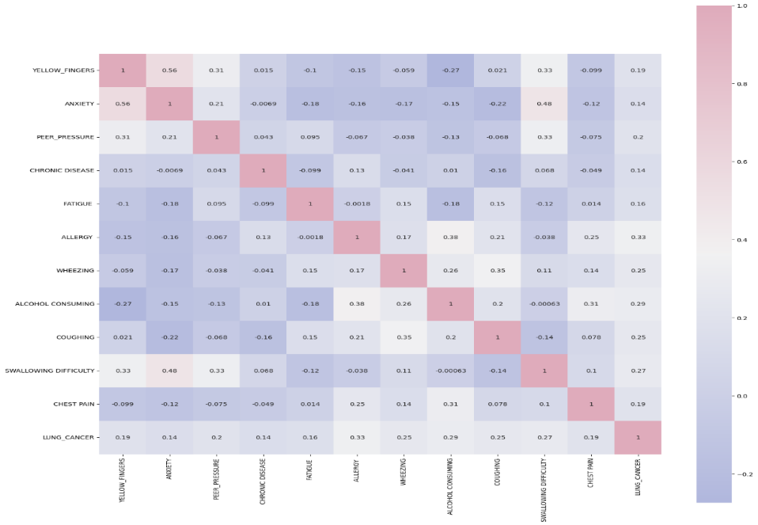

When compared to each model alone, a combination of Gaussian Naive Bayes and Random Forest models may offer superior accuracy and generalization capabilities. To assess how well these models predict lung cancer Metrics including accuracy, precision, recall, and F1-score can be used. It is crucial to remember that amount and quality of the dataset, selected features, and hyperparameters set during the phase of training can all affect how well the models perform.

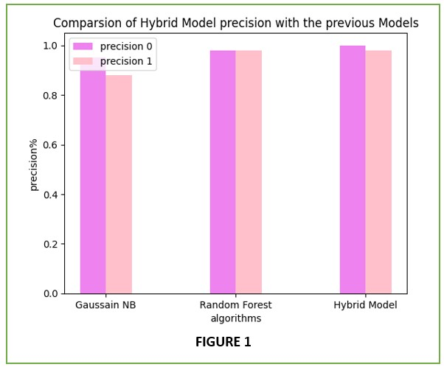

Figure: 1 precision

Figure 1 shows that, when compared to the other two models (Random Forest and Gaussian Naive Bayes), the Hybrid Model yields better precision. This indicates that the Hybrid Model model has fewer incorrect negative predictions (false negatives) and more accurate positive predictions.

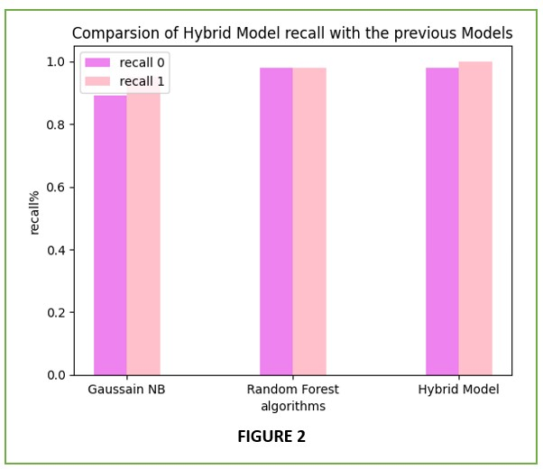

Figure: 2 Recall
In contrast to the two models (Gaussain NB and RandomForest), the has a Hybrid Model rate of good predictions, as shown in Figure 2.

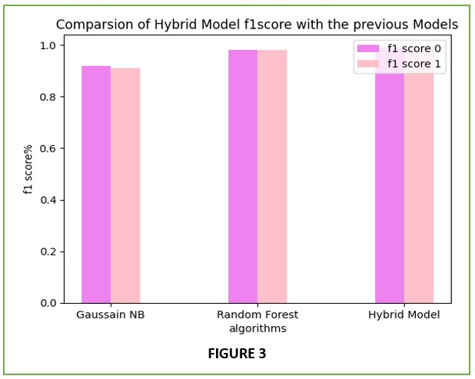

Figure 3: F1-score
Figure 3 shows that when comparing the Hybrid Model to the other two models, the combination of the two evaluation metrics computes a better value.

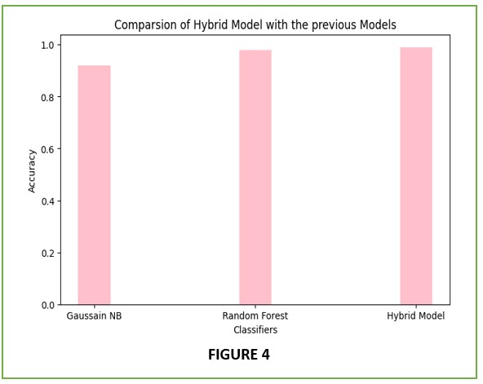

Fig. 4: Accuracy
Figure 4 displays the accuracy of the Random Forest, Gaussian Naive Bayes, and proposed models. Our suggested approach may provide more resilience and accuracy when predicting lung cancer.

CONCLUSION
Conclusion In this work, we investigated the application of Random Forest and Gaussian Naive Bayes models for lung cancer prediction. We also suggested a hybrid model that combines the predictions of the two models through a voting mechanism. We compared the models' outputs after assessing the models' performance on a dataset of patients with lung cancer. Based on our experimental findings, In terms of accuracy and F1 score, the Random Forest model out performed than Gaussian Naive Bayes model. However, the voting mechanism-based combined model fared better than any of the separate models, suggesting that merging diverse models could increase prediction accuracy. To determine which traits are most crucial for predicting lung cancer, we also performed feature selection. The top characteristics found by both models were similar, according to our data, suggesting their significance in lung cancer prediction. To sum up, our research shows that combining Random Forest and Gaussian Naive Bayes models can enhance the model's resilience and prediction accuracy in the context of lung cancer prediction. To further enhance the efficacy of the lung cancer prediction model, additional studies can look into alternative strategies for mixing several models or incorporating more sophisticated machine learning techniques, such as deep learning.

References
- Y. Gültepe and . , "Performance of lung cancer prediction methods using different classification algorithms," Computers, Materials & Continua, vol. 67, no.2, pp. 2015–2028, 2021.
- Taxonomic indexes for differentiating malignancy of lung nodules on CT images Original Articles Silva, Giovanni Lucca França da; Carvalho Filho, Antonio Oseas de; Silva, Aristófanes Corrêa; Paiva, Anselmo Cardoso de; Gattass, Marcelo
- Lung Cancer Prediction Using Machine Learning (2020) Vasupalli Saranya, Maddila Suresh Kumar by using dataset
- R. Fakoor, F. Ladak, A. Nazi, and M. Huber, "Using deep learning to enhance cancer diagnosis and classification," in Proceedings of the International Conference on Machine Learning(2022).
- Venkatesh, C., Chinnababu, J., Kiran, A. et al. A hybrid model for lung cancer prediction using patch processing and deep learning on CT images. Multimed Tools Appl(2023)
- Machine Learning Approaches for Lung Cancer Prediction: (2021) A Review X. Wang, S. Han, C. Zhang.
- Lung Cancer Incidence Prediction Using Machine Learning Algorithms Kubra Tuncal ,Boran Sekeroglu,Cagri Ozkan.;January 2020
- Suresh Kumar, S. Sivaramakrishnan, T. N. Vasanthi (2021), “Prediction of Lung Cancer using Machine Learning Techniques with Feature Selection”.
- "A Machine Learning Framework for Predicting Lung Cancer Risk Based on Clinical and Genetic Data" by Xiaoyu Hu, Yan Zhao, and Wei Wang (2020)
- "Predicting Lung Cancer Survival Using Machine Learning Models and Clinical Data" by Zhaohui Zhang, Yajing Du, and Jun Wei (2020)
- "Lung Cancer Prediction Using Ensemble Learning Methods: A Comparative Study" by Xiaotong Zhang, Qingfeng Zhou, and Wenxiao Du (2022)
- "Predicting Lung Cancer Risk Using Machine Learning Models and Smoking Behavior Data" by Xinyi Li, Jie Zheng, and Hao Zhang (2021).
- "Deep Learning-Based Prediction Models for Lung Cancer Risk Assessment: A Comparative Study" by Ming Yang, Junqian Li, Jing Yang, et al. (2022)
- "Lung Cancer Prediction Using Machine Learning Models and Smoking History: A Comparative Study" by Ghadah Almeshal, Bushra Almotairi, and Fawaz Almazrouei (2022).
- "Deep Learning-Based Prediction Models for Lung Cancer Risk Assessment: A Comparative Study" by Ming Yang, Junqian Li, Jing Yang, et al. (2022).

