A Comparative Study on the Molluscan Diversity in the Selected Beaches of Kollam and Thiruvananthapuram districts of Kerala ,India
Aiswariya Sunil¹& Athira M²
¹Aiswariya Sunil Department of Zoology , Mar Thoma College for Women Perumbavoor, Ernakulam Kerala,
²Athira M Department of Zoology , Mar Thoma College for Women Perumbavoor, Ernakulam Kerala,
---------------------------------------------------------------------***---------------------------------------------------------------------
Abstract - Biodiversity of bivalves and gastropods at Pozhikkara and Kappil beaches of kollam and thiruvananthapuram Districts of Kerala was assessed in this study. A total count of 1130 molluscs were collected in which 24 species belonging to 19 families of two classes ; Class gastropods and Class bivalves were observed. Study was carried from December-2022 to May 2023 by using Beachcombing method in sandy areas and scrapping of molluscs in the Rocky areas selected for the study . In family of Muricidae three species were found and in Babylonidae ,Turitellidae and Bursidae two species of each was observed ,remaining families were included with one species each were recorded from the study areas .Perna perna and Donax scrotum were seen in large number during the study period. . Cymaticum perryi ,Natica marochinesis ,Faunus ater and Nipponaphera quasilla were least in number during study period
KeyWords:Pozhikkara,Kappil,Mollusc,Beachcombing,Bivalves,Gastropods

1.INTRODUCTION

Biodiversity generally refers to variety and variability of life on earth .According to IUCN Biodiversity defined as biological diversity encompasses all species of plants , animals and microorganisms and the ecosystem and ecological processes of which they are parts . It include both the number and frequency of ecosystem , species ,or genes in a given assemblages . Biodiversity, is commonly measured by ecologists and biogeographists as species richness, or the number of species found at a particular point in space or time (Fernandez et al., 2007). Mollusca is one of the most diverse groups of animals on the planet , which at least 50,000 living species (and more likely around 2,00,000) . It include such familiar organisms as snails , octopuses , oysters , and chitons . Molluscs are a clade of organisms that all have soft bodies which typically have a head and a foot region .Often their bodies are covered by a hard exoskeleton , as in shells of snails and clams or the plates of Chitons. Molluscs have been classified based on their morphological, anatomical and biological features and they are second only to Arthropod in numerical abundance. The number of species identified under phylum molluscs varied from 80,000 to 1, 00, 000 (Shanmugam and Vai Ramani, 2009). Molluscs have high protein content (Bykov, 1974) the shells are rich in calcium carbonate which is a major source of raw material for the lime industries. The molluscan shells form one of the important raw material for many calcium based industries, since 33 to 40% of the shell is calcium 90 to 98% of which occurs as calcium carbonate. Shell grit forms an important ingredient in the preparation of dental Cream, Talcum powder and in carbide industry, people from various parts of the world using powdered molluscan shell as an ailment for various complications ranging from skin disease to rickets and asthma (Subba Rao, 2003), molluscs have been used in the preparation of ayuruvedic and homeopathic medicines form a long time.

2. Body of Paper

The study was conducted in two beaches of Kerala Pozhikkara and kappil beaches from December 2022 to May 2023 , for a period of 6 months . Pozhikkara beach is located at the South Western tip of Kollam’s coastal area along the arabian sea coast .It is about 12km from Paravur town . Kappil beach is located in Edava Panchayat of Varkala Taluk of thiruvanthapuram district of Kerala Both the beaches have the backwater meeting points .
SL.NO | FAMILY | COMMON NAME | SCIENTIFIC NAME
GASTROPODS
1. | Rostellariidae | Indian tibia | Tibia curta
2. | Ficidae | Paper fig shell | Ficus ficus
3. | Turbinellidae | Chank shell | Turbinella pyrum
4. | Babyloniidae | Spiral babylon | Babylonia spirata
5. | Cymattidae | Robin redbreast tritons | Cymaticum perryi
6. | Muricidae | Ramose murex | Chicoreous ramosus
7. | Fasciolariidae | Nicobar spindle | Fusinus nicobaricus
8. | Muricidae | Toad purpura | Thais bufo
9. | Cassiade | Grey bonnet or Glaucus bonnet | Phalium glaucum
10. | Bursidae | Frog shell | Bursa rana
11. | Muricidae | Rudolphs pupura or  Salmon lipped whelk | Purpura panama
12. | Pachychilladae | Black devil snail | Faunus ater
13 . | Turitella |  | Turritella attenuata
14 | Trochidea | Radiate top shell | Trochus radiatus
15. | Bursidae | Frilled frog shell | Bursa crumena
16 . | Babylonidae | Indian Babylon | Babylonia zeylanica
17. | Turritella | Tower shells | Turritella duplicate
18 | Cancellaridae | Nutmeg snail | Nipponaphera quasilla
BIVALVES
19 | Arcidae | Arc clams | Anadara indica
20. | Mactridae |  | Mactra turgida
21. | Veneridae | Venus clams | Sunetta scripta
22. | Glycymerididae | Bitter sweet clams | Glycemeris glycemeris
23. | Mytillidae | Brown mussel | Perna perna
24 | Donaxidae | Leather donax | Donax scrotum
The specimens were collected from both the sandy areas and rocky areas of both the beaches. For the collection of mollusc from shore ; Beachcombing method was followed .The molluscs attached to the rocks were Collected by scrapping using knives and foreceps . The collected specimens were cleaned, sundried and photographed for further study. The collected specimens were identified with the help of expert advice and using reference book ,and recorded the data including date of collection and numbers of specimens.
Diversity index was calculated using Simpsons Diversity Index which takes into account both the number and abundance of species and is useful in comparing similar habitats in different areas
Simpson's Index of Diversity formula
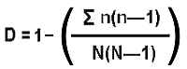
n = the total number of organisms of a particular species
N = the total number of organisms of all species
The value of D ranges between 0 and 1. With this index, 1 represents infinite diversity and 0, no diversity.
From the samples collected and the observations done on the two study areas during the study period from December 2022 to May 2023 a total of 1130 number of molluses in which 25 species were identified which belongs to 19 families and 2 classes from both the study areas.710 numbers were found in site 1 which belongs to 19 families and 420 numbers were found in site 2 which belongs to 13 families .

Table -1: Checklist of Mollusc identified in Site 1

Table 1 :Checklist of Mollusc Identified in Site 2

SL.NO | FAMILY | COMMON NAME | SCIENTIFIC NAME
Gastropods
1. | Rostellariidae | Indian tibia | Tibia curta
2. | Turbinellidae | Chank shell | Turbinella pyrum
3.. | Babyloniidae | Spiral babylon | Babylonia spirata
4. | Cymattidae | Robin redbreast tritons | Cymaticum perryi
5. | Muricidae | Ramose murex | Chicoreous ramosus
6. | Babylonidae | Indian Babylon | Babylonia zeylanica
7. | Turritella | Tower shells | Turritella duplicate
8 | Trochidea | Radiate top shell | Trochus radiatus
9 | Muricidae | Toad purpura | Thais bufo
10 | Turitella |  | Turritella attenuata
11 | Muricidae | Rudolphs pupura or  Salmon lipped whelk | Purpura panama
12 | Naticidae | Red Banded Moon Snail | Natica marochinesis
Bivalves
13 | Arcidae | Arc clams | Anadara indica
14. | Veneridae | Venus clams | Sunetta scripta
15 . | Mytillidae | Brown mussel | Perna perna
16. | Donacidae | Wedge clam | Donax scrotum
17 | Mactridae |  | Mactra turgida

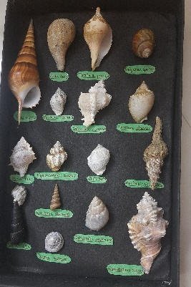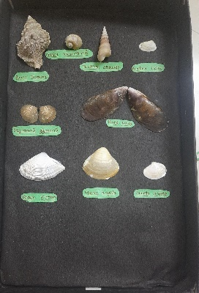
Figure 1: Samples of collected specimens

Charts

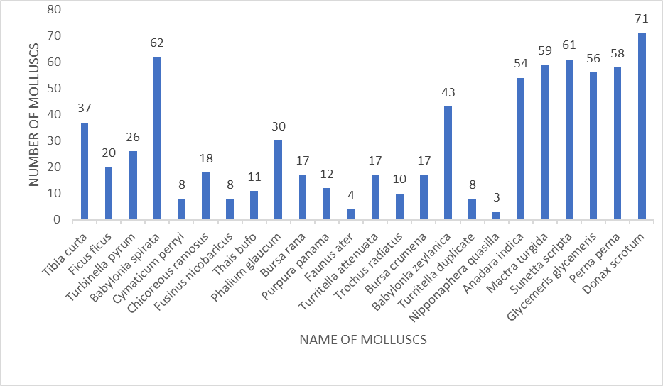
Chart 1: Bar diagram showing the Distribution of Mollusc in Pozhikkara beach
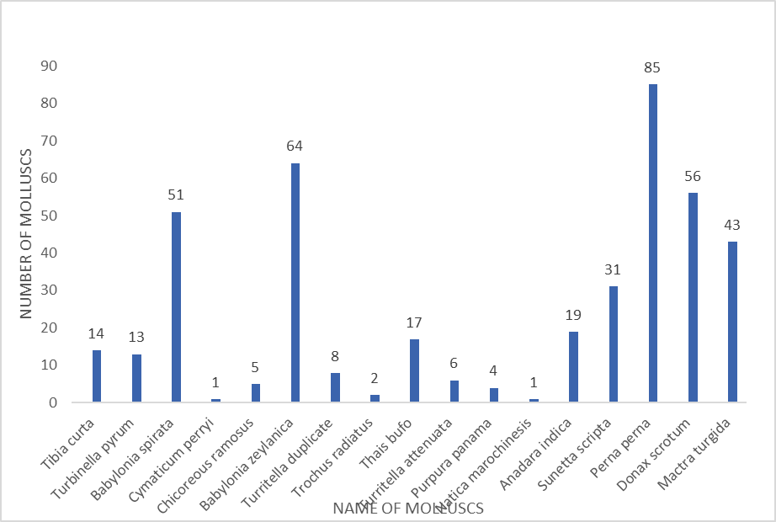
Chart 2 : Bar diagram showing the Distribution of Mollusc in kappil beach
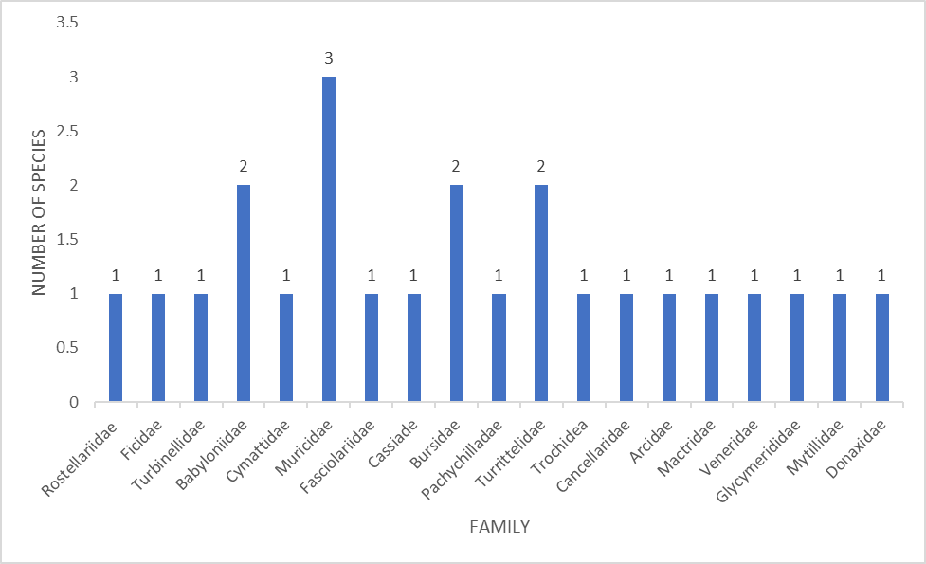
Chart 3 : Bar diagram showing the families of molluscs identified in Pozhikkara Beach
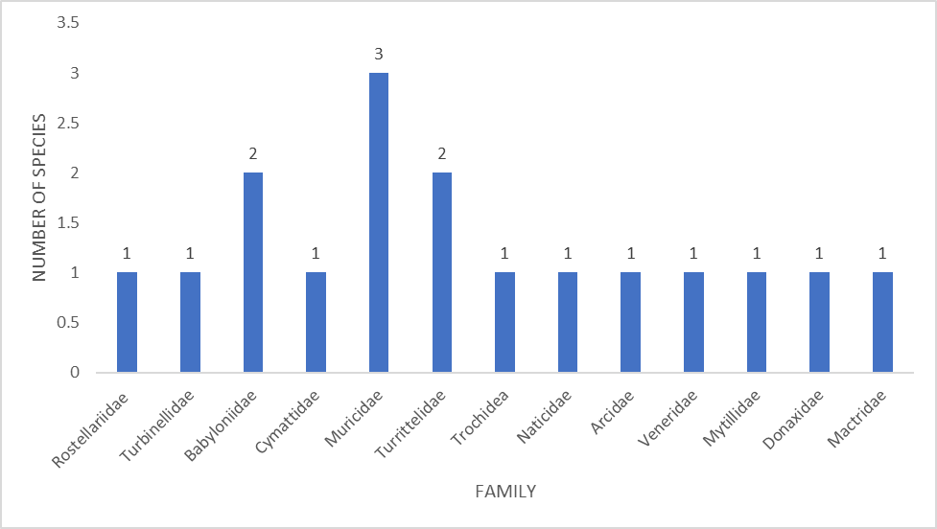
Chart 4 : Bar diagram showing the families of molluscs identified in Kappil Beach
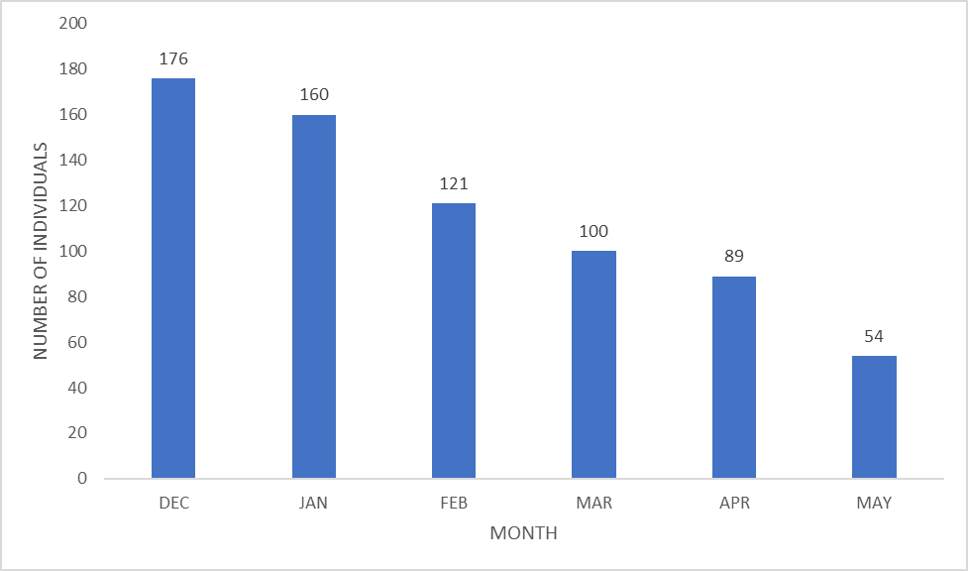
Chart 4 : Bar diagram showing the monthly variation of molluscs in Pozhikkara Beach
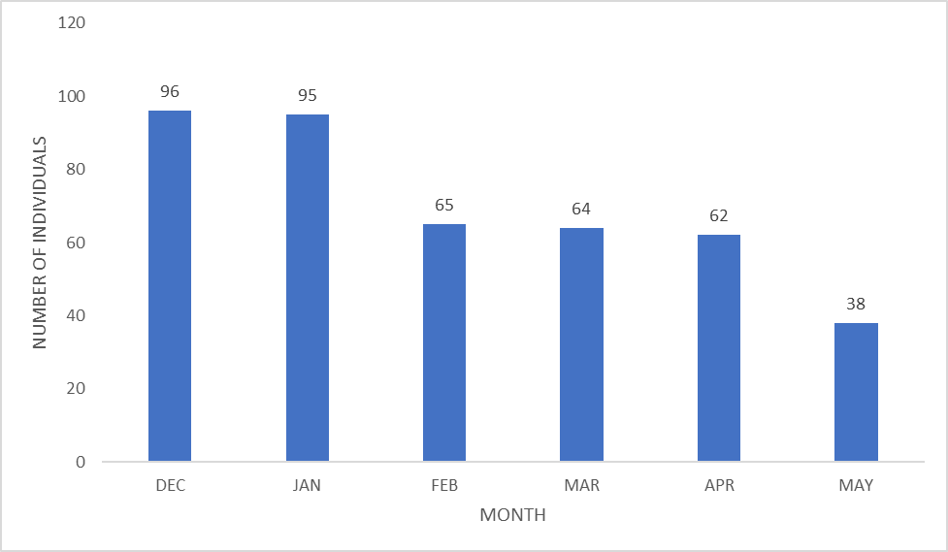
Chart 5 : Bar diagram showing the monthly variation of molluscs in Kappil Beach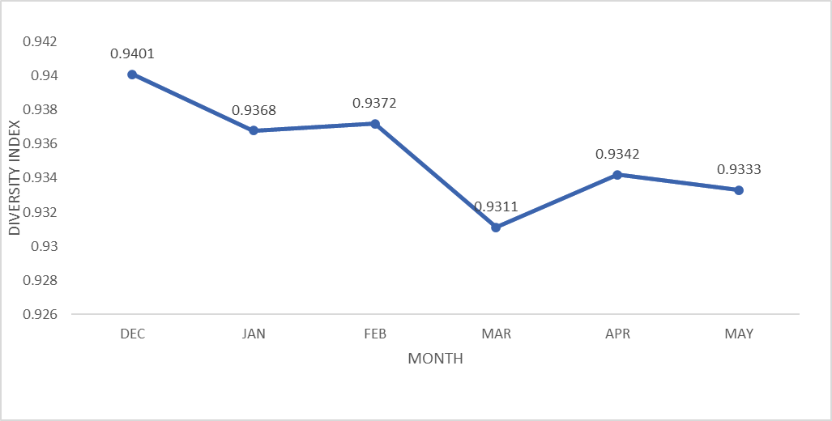
Chart 6: Diversity index shown by the molluscs identified in Pozhikara Beach
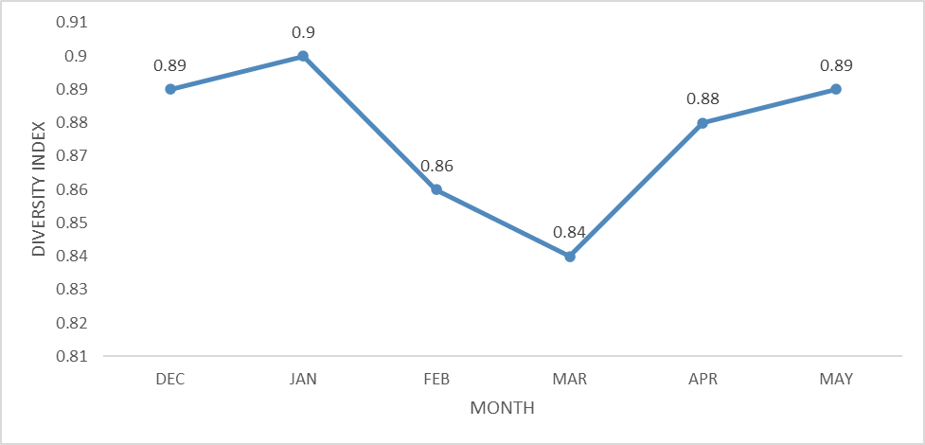
Chart 7: Diversity index shown by the molluscs identified in Kappil Beach
3. CONCLUSIONS
The present study focused on the distribution of Molluscs in Pozhikkara and Kappil beaches suggested that there are about 24 species identified during the study period belonging to 19 Families and 2 Classes . Different kinds of molluscs, their names as well as their taxonomic positions were studied from both the study areas and found that each and every species is different from one another, they vary in size , colour, shape and their patterns . Donax scrotum were recorded abundantly in pozhikkara beach while Perna perna were recorded abundantly in Kappil beach during the study period. Most number of species were found in the Families Mytillidae, Babylonidae, Bursidae and Turritellidae .The number of molluscs were gradullay decreased from the December to May , that may be due to pollution , over exploitation of some molluscs species as a source of commercial activities ,environmental disturbances in the marine water or may be due to the adverse climatic conditions and change in temperature .

ACKNOWLEDGEMENT
I express my sincere gratitude to Ms.ATHIRA. M Assistant Professor in the department of Zoology. Mar Thoma College for Women, Perumbavoor, for critical, enthusiastic guidance and inspiring encouragement throughout the work and I am also thankful to Dr. B HARI , Professor, P.G.& Research Department of Zoology ,Sree Narayana College, Kollam for the support, valuable informations and the greatful guidance of my work.

REFERENCES
- Anandaraj .T ,et al ., “Biodiversity of Marine Molluscs in East Coastal Area of Thanjavur District, Tamilnadu ,India” . International Journal of Pharmaceutical & Biological Archives ,3(1) ,2012.pp no 131-133 .
- Ghasemi S, et al., “Abundance of Molluscs (Gastropods)At Mangroves Forests of Iran”. Journal of American Science ,7(1),2011 .pp no 660-669.
- Hyman , Henrietta ,Libbie .1993 . “The Invertebrates volume VI Mollusca I” .CBS Publishers & Distributers , New Delhi.pp no. 323-343.
- Jeeva ,Chinnusamy, et al., “Distribution of Gastropods in the intertidal Environment of South ,Middle and North Andaman Islands ,India” Open Journal of Marine Science ,08(1),2018 .pp no 1-23 .
- K.K Appukuttan & K. Ramadoss .“Edible and ornamental gastropod resources”. Bullletin of Central Marine Fisheries Research Institute. 2000.pp: 525-535 .
- Kay ,E, Alison .(1986.) “The Conservation Biology of Molluscs” IUCN, Gland, Switzerland.pp:1-72 .
- Khade ,N, Sunil et al., “Diversity and statistical analysis of marine gastropods, Raigad District ,Maharashtra”.International Journal of Fauna and Biological Studies ,3(3),2016. pp no.01-04 .
- Kumar , Ankit & Vyas,Vipin (2012). “Diversity of molluscan communities in river Narmada, India”.Journal of chemical, biological and physical Sciences. 2(3). 2012 .pp:1407-1412.
- Linse , Katrin . “Abundance and diversity of Mollusca in the Beagle Channel”. Zoological Institute and Zoological Museum, University of Hamburg, Germany. 63(1). 1999.pp no:391-397.
- M. Arumugam et al., “Studies on molluscan diversity of great Nicobar Island”. Open Journal of Marine Science, 8 (1), 2010, pp no :275-282.
- P. S Sary and R.B Kiran, Pramod . “New distributional recodes of muricid snails (mollusca: gastropoda) from the Arabian Sea”. Journal of aquatic biology and fisheries. vol.4, 2016 .pp: 166-168.

