The Future of Space Exploration
Muhammed Raiyan A¹, Manju Bargavi²
¹Department of CS & IT JAIN(Deemed-To-Be-University) Bangalore, India raiyanaaliyar@gmail.com
² Professor Department of CS & IT JAIN(Demmed-To-Be-University) Bangalore, India b.manju@jainuniversity.ac.in

---------------------------------------------------------------------***---------------------------------------------------------------------

Abstract — This research study conducts a complete analysis of the diverse future of space travel by tying together historical legacies, current dynamics, and potential paths. The study covers the current era, looking at significant turning events, technological advancements, the influence of commercial groups, and the growing space tourism industry. By discussing upcoming space missions, technological developments that may revolutionise space travel, the difficulties of international collaboration, and the implications for society, future directions are demonstrated. As we examine the problems of technical advancements, economic feasibility, and environmental sustainability, suggested solutions emerge, demonstrating the field's adaptability to changing circumstances.[2] Examined are the moral and social repercussions of human existence away from Earth, emphasising the importance of international inclusivity and collaboration. The study's conclusion emphasises the value of continuous adaptation, interdisciplinary collaboration, and a shared commitment to responsible discovery with an eye towards the future. The exciting future of space travel will be determined by sustained study, policy development, and a shared vision for humanity's cosmic trip.[4]

Key Words: — Space exploration, future trends, historical milestones, technological advancements, private space entities, space tourism, upcoming missions, interplanetary travel, international collaboration, societal implications, ethical considerations, sustainability, economic viability, interdisciplinary research, cultural contributions, global governance, continuous adaptation.

INTRODUCTION

Human technological accomplishment has been characterised by space exploration, which has expanded our understanding of the cosmos and pushed the boundaries of what is feasible. As we approach a new era, the subject of space exploration has immense possibilities as well as challenges. This research paper will look at past space exploration trends, technological advancements, and possible missions that could impact the path of our cosmic adventure in order to gain a better understanding of the future of space exploration.
In the last few decades, space exploration has reached previously unheard-of heights thanks to the efforts of NASA, ESA, Roscosmos, and private businesses like SpaceX and Blue Origin. Ongoing missions to Mars, lunar exploration endeavours, and collaborative work on the International Space Station (ISS) demonstrate the dynamic nature of the region. The purpose of this study is to review the background of space exploration, assess current developments, and predict the missions and technological breakthroughs that will define future space exploration by humans.[2]

Historical context of space exploration
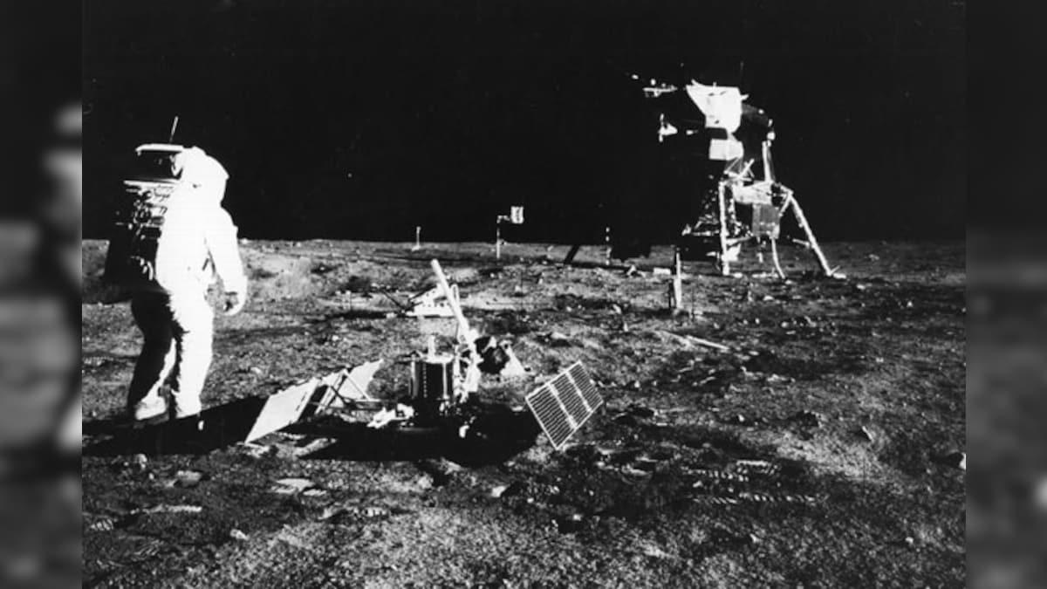
Fig -1: NASA/Chris Giersc

- Significant Achievers in Space Research

There have been several significant achievements in space travel history that have drawn attention from people all across the world. These landmarks symbolise every significant development in our understanding of the universe, from the historic Apollo moon landings of the 1960s to the arrival of Mars rovers. These achievements have improved scientific knowledge and inspired the next generation to think beyond what is now thought achievable in the event that Earth's atmosphere is disrupted.

B. The Space Agencies' Evolution

Space agencies have worked together to make space travel for humanity possible. NASA has led the way in space exploration since its establishment in 1958, working on initiatives like the Space Shuttle programme and the Hubble Space Telescope. The European Space Agency (ESA) and the Russian space agency.[3]

C. Insights from Previous Expeditions

While space exploration is acknowledged for its accomplishments, earlier missions have also imparted invaluable knowledge. Incidents such as those that beset the Space Shuttle Challenger and Columbia have brought attention to the risks and complexities associated with space travel. These experiences have contributed to advancements in technology, safety protocols, and mission planning.
This just functions as a research study outline. It is vital to expand each component with more details, evidence, and analysis in line with the specific goals of your study and the corpus of previous research. Remember to properly credit all of the sources you utilised in your final document.[3]

Current trends and developments

A. Current Missions and Their Goals

In recent years, there has been a significant surge in space exploration activities, with a focus on both the Moon and Mars. NASA's Perseverance Rover mission in 2020 is one example of the ongoing efforts to explore the Martian surface in search of signs of prehistoric life and to gather items for a potential return to Earth. NASA's Artemis programme aims to investigate the Moon concurrently with the goal of establishing a permanent human settlement by the mid-2020s.[4]

B. Space Technology Advances

Technological innovation continues to be the primary driver behind the advancement of space exploration. The efficiency and capacities of spacecraft have increased thanks to developments in robotics, artificial intelligence, and propulsion systems. Thanks to companies like SpaceX, reusable rocket technology has evolved and significantly reduced the cost of orbital travel.

C. International Partnerships and Collaboration

Space exploration continues to be propelled by international cooperation. An emblem of international cooperation is the International Space Station (ISS), which provides a platform for microgravity scientific study. Cooperation is not limited to low Earth orbit; coalitions are forming for upcoming missions to Mars and the moon.[4]

D. The Function of Private Space Companies

Space exploration is seeing an increase in the involvement of private companies. SpaceX, led by Elon Musk, has achieved notable achievements, including the construction of the Crew Dragon spacecraft and the Falcon and Starship rockets. Under Jeff Bezos' direction, Blue Origin is creating reusable launch rockets with intentions to explore the moon. These companies contribute to space's democratisation.[4]

Future missions and objectives

A. Mars Exploration

One of the main goals of upcoming space exploration is the possibility of human expeditions to Mars. There are proposals to send humans to the Red Planet, building on the knowledge gathered from robotic trips. To make Martian exploration a reality, issues like long-duration space travel, life support systems, and habitat architecture are being aggressively tackled. [1]

B. The Artemis Programme and Lunar Exploration

In an effort to conduct the first crewed lunar flights since the Apollo period, NASA's Artemis programme seeks to send people back to the Moon. The goal of the project is to create a long-term lunar presence by using the Moon as a test bed for systems and technologies that will be essential for upcoming deep-space missions, such as those to Mars.

C. Research in Deep Space

Future missions will focus on celestial bodies in the outer solar system, including asteroids and the moons of gas giants, in addition to the Moon and Mars. Our knowledge of planetary creation, evolution, and possible resources that might aid in upcoming exploration projects will be increased by these missions.

D. Look for Habitable Exoplanets and Extraterrestrial Life

Technology developments in telescopes, such as the impending James Webb Space Telescope, have the potential to completely transform the hunt for extraterrestrial life. There are exciting possibilities for finding extrasolar life if far-off exoplanets with possibly livable conditions are explored.[3]

NASA: 60 year and counting – The future

NASA's future will always be a tale of science, technology, and human exploration. To find out more about what it will take to enable human exploration of Mars and beyond, we plan to return to the Moon. We will keep fostering the growth of a thriving low-Earth orbit economy that builds upon the achievements of the International Space Station thus far. NASA engineers will create new technology to fulfil the demands of advanced space exploration and enhance domestic air travel. Our experts will endeavour to deepen our knowledge of the planet Earth and its place in the cosmos. We'll keep working to find the answer to the query, "Are we alone?"[1]

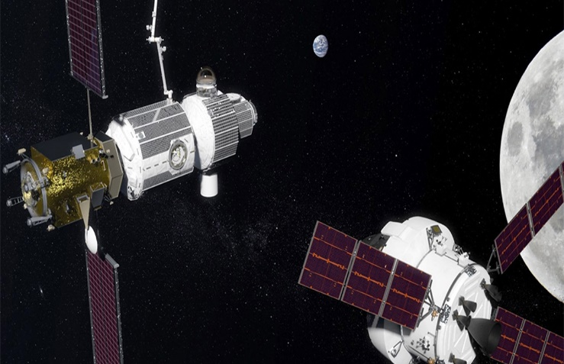
Fig -2 : NASA/Chris Giersc

NASA's lunar gateway, an artist's concept. It will include habitation, logistical, and airlock capabilities in addition to at least a power and propulsion aspect. In 2022, the power and propulsion element will launch first, to be placed in close proximity to the Moon; other elements will follow suit in the following years.NASA provided the image.

Moon 2024

Over the past fifty years, NASA has persistently endeavoured to expand its understanding in order to fulfil the potential of American creativity and leadership in space exploration. NASA plans to advance its lunar exploration efforts by sending astronauts to land on the lunar South Pole by 2024.

In order to "lead an innovative and sustainable programme of exploration with commercial and international partners to enable human expansion across the solar system," NASA is carrying out the President's Space Policy Directive-1. NASA is about to make low-Earth orbit commercially viable. NASA will be able to return to the Moon in 2024 and stay there for good thanks to these experiences and collaborations. [1]

NASA's largest rocket, the Space Launch System (SLS), the Orion spacecraft, and the Gateway lunar command module form the backbone of the agency's deep space exploration programme. In collaboration with its partners, NASA intends to use the Gateway lunar command module, which is currently orbiting the Moon, as a staging point for missions that will enable astronauts to access previously unexplored areas of the lunar surface.[1]

Mission planning and simulating

A. Trajectory Calculations and Orbital Dynamics

Algorithmic Trajectory Planning:
Algorithms that take into account orbital dynamics, mission objectives, and gravitational forces are used to compute spacecraft trajectories .Sophisticated mathematical models calculate the best routes, taking into consideration things like fuel efficiency and gravitational assistance. These algorithms are essential for precision navigation, fuel conservation, and route planning on interplanetary missions.

Before real missions, computer simulations are used to model how spacecraft will behave in various conditions. Simulations are useful for confirming mission plans, spotting possible hazards, and refining trajectory computations. The spacecraft's ability to handle a range of situations and difficulties that it may face on its voyage is tested virtually.

Virtual Reality (VR)
Simulations Astronaut Training:

Astronauts can practice space-related duties in realistic situations by using virtual reality simulations. In a mock space environment, astronauts can rehearse spacewalks, emergency protocols, and ship operations. Developing interactive and immersive VR simulations is a necessary step in preparing astronauts for the rigors of space travel.

Aeronautics
NASA's aeronautical research has benefited aviation, national security, and our economy for many years. The U.S. will lead the globe in the global aviation economy with the support of ongoing research and development of new aeronautics technology, which will have rising benefits globally. NASA is revolutionising aviation through the development of quieter, cleaner aircraft technology as well as quieter supersonic travel over land.

Quiet Supersonic Technology
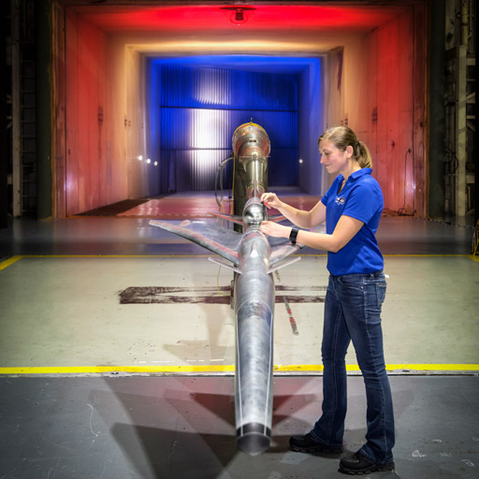 Fig -3 : NASA/Chris Giersc

Inside the 14-by-22-foot Subsonic Tunnel at NASA Langley Research Centre, the Quiet Supersonic Technology (Que SST) Preliminary Design Model is being tested. NASA's proposed Low-Boom flying Demonstration experimental aircraft, or X-plane, is currently at the QueSST Preliminary Design stage of development. The X-plane is intended to reduce fuel consumption, pollutants, and noise while enabling supersonic flying over land. [1]

A rendering of NASA's X-57 "Maxwell" aircraft by an artist. The X-57, the first all-electric X-plane, will be flown to show off the potential advantages of electric power for aviation's future. The X-57 aims to achieve zero in-flight carbon emissions, a 500 percent boost in high-speed cruise efficiency, and a substantially quieter flight for the surrounding population. [1]

Earth

When you think of NASA, you probably think of space exploration, but there are a lot of advantages to NASA's activities that affect Earth and its people on a local level. New technologies will be used in Earth science study to further our understanding of the planet as a system and how it reacts to changes brought about by us or by nature. To assist enhance the quality of life on Earth, scientists use satellites, aircraft, and ground-based observations to collect data about the continuous natural and man-made changes to the planet's land, water, and air.

Landsat 9
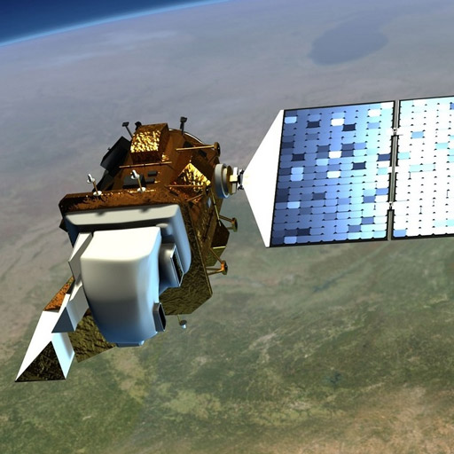
Fig -4: NASA

In 2020, NASA's most well-known Earth Science initiative will resume with the launch of Landsat 9. With the help of Landsat 9, we will be able to measure changes in the earth's surface at a scale that will allow us to distinguish between natural and human-caused changes. When concerns about resource availability and land use emerge, Landsat 9 will support decision-makers in making well-informed management choices. Therefore, Landsat 9 will play a crucial role in the global plan for tracking Earth's condition and health. [1]

Swot
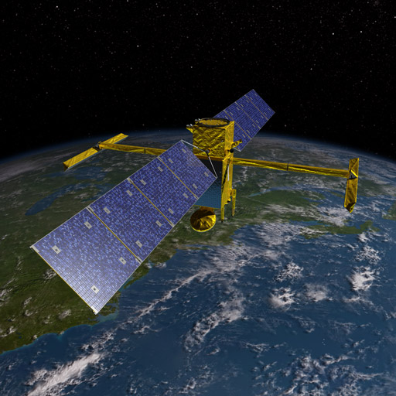
Fig -5: NASA

The Surface Water and Ocean Topography (SWOT) project, slated for launch in 2022, is an artistic representation of the first worldwide study of Earth's surface water. SWOT will support societal necessities like dams and shipping while keeping an eye on how water bodies evolve over time.

Cygnss
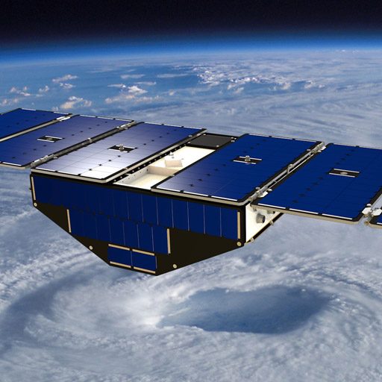
Fig -6: NASA

One of the eight Cyclone Global Navigation Satellite System (CYGNSS) satellites that are orbiting above a hurricane is depicted in an artist's concept. With the aid of GPS technology, CYGNSS is able to detect ocean winds, providing scientists with a more accurate and timely assessment of a storm's strength and trajectory. [1]

Technological advancements

NASA had to develop new technology when it was founded 60 years ago in order to reach where we needed to go, and we will carry on pushing technological frontiers in the future. NASA's tiny satellites are an example of new, developing technologies that provide chances for study and exploration with little financial outlay. Three-year trips to Mars and deep space exploration present new difficulties: Are you able to handle it anymore? Can it be made or grown in space? Can you perform maintenance and repairs on your own? NASA will continue to incorporate solutions to these and other issues into home-improvement technologies.

3D Printer
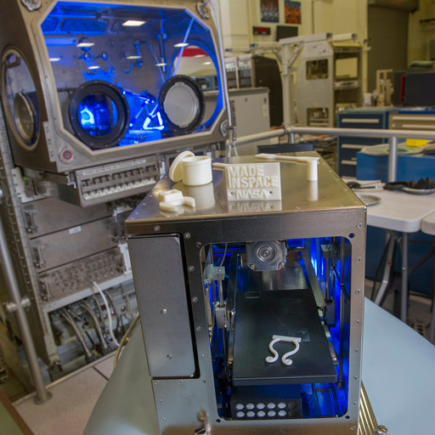
Fig -7: NASA/Emmett Given

The 3D printer on the International Space Station creates plastic items. NASA is working on more sophisticated printers that can incorporate materials such as regolith and metals. Having the ability to fabricate components in space will be useful in an emergency.

Rassor
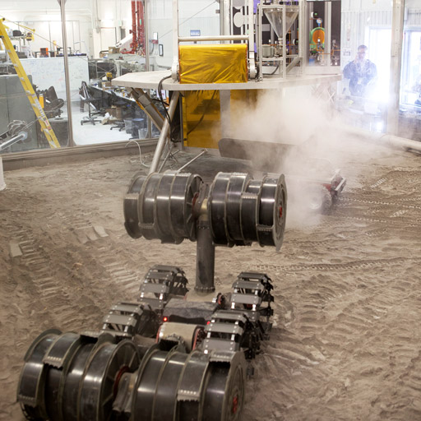
Fig -8: NASA

Excavating simulated alien soils is NASA's Regolith Advanced Surface Systems Operations Robot (RASSOR). NASA is working on technology to dig into regolith, which is the space term for "soil," on the Moon, Mars, and asteroids to extract oxygen, potable water, and other materials needed to sustain plant and human life as well as fuel sources. [1]

DTN
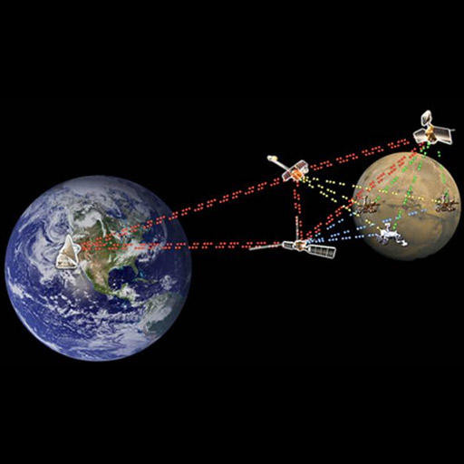
Fig -9 : NASA

Any spacecraft's communication with Earth is a difficult task, partly because of the great distances involved. The delay and risk of disruption or data loss are substantial when data are sent and received over thousands, millions, or even billions of miles. For both robotic and human missions, deep space travel requires the use of advanced communication technology. Disruption/Delay NASA has developed Tolerant Networking (DTN) as a dependable internetworking option for space missions. DTN will make it possible for users of the Solar System Internet to get data automatically, regardless of how far apart or sporadic their connections may be. [1]

Challenges and solutions

Difficulties with Technology
Developing strong communication systems for deep-space operations, guaranteeing life support systems for prolonged missions, and radiation exposure during interplanetary flight are only a few of the formidable technological problems associated with space exploration. Current investigations endeavour to tackle these obstacles by means of advancements in materials science, radiation shielding, and sophisticated propulsion systems.

Environmental Difficulties

Two important environmental considerations are the control of space debris and planetary protection. International organisations and space agencies are developing policies and technology to reduce the amount of trash entering space and avoid contaminating celestial bodies while they are being explored. [1]

C. Financial and Economic Obstacles

Investment in space exploration must be made in large quantities. Balancing mission expenses with benefits to science and society is a financial and economic problem. Strategies such as international collaboration, commercial initiatives, and public-private partnerships are being investigated to overcome financing constraints.

D. Suggested Remedies and Contingencies

Solutions that have been suggested cover a wide range of tactics, such as enhanced international cooperation, public-private partnerships, and the creation of affordable, reusable technologies. Strict debris mitigation procedures and planetary preservation guidelines must be followed in order to mitigate environmental problems.

Space tourism and commercialization

A. The Space Tourism Industry's Growth

As interest in space tourism grows, the field of space exploration is reaching beyond academic institutions and governmental organisations. Commercial spaceflight development is an active pursuit of private firms like SpaceX and Blue Origin. This change is a major turning point that might increase private access to space and support the growing space tourism sector.

B. Private Space Exploration Firms

The dynamics of space exploration are changing due to the engagement of commercial firms. At the vanguard of commercial space endeavours is SpaceX, with its reusable rocket technology and lofty goals for interplanetary travel. Blue Origin's focus on suborbital space tourism and reusable launch vehicles aligns with the larger goal of increasing human presence in space.

C. Consequences for Commercial Space Activities in the Future

As the commercial space industry expands, legal frameworks, safety requirements, and ethical considerations become more important. In order to ensure that commercial space operations are developed responsibly and to strike a balance between innovation and the requirements of safety, environmental sustainability, and fair access, it is imperative that these challenges be addressed. [1]

Human Spaceflight

Neil Armstrong, an astronaut from Apollo 11, set foot on the Moon over fifty years ago. Now, NASA is getting ready for a big new age of sustainable human space travel and exploration. The organisation is developing the Orion spacecraft and the Space Launch System rocket for human deep space travel. NASA will create new opportunities in lunar orbit, including a platform to support surface exploration and act as a gateway to Mars, with the assistance of commercial and international partners. [1]

Beam
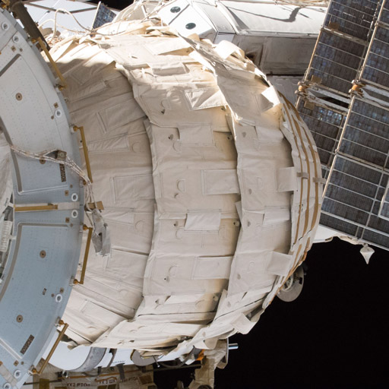
Fig -10 : NASA

To test the technology, Bigelow Aerospace built the Bigelow Expandable Activity Module (BEAM), which was docked with the International Space Station's Tranquilly module. For possible future space missions, lightweight expandable or "inflatable" homes require a lot less cargo volume.

Orian Spacecrafy
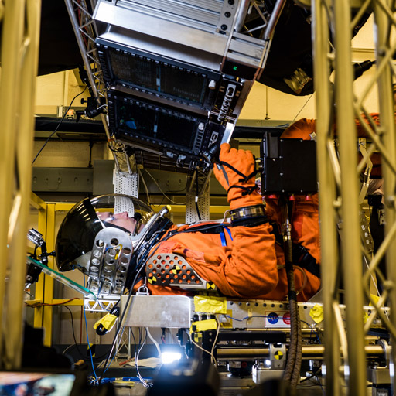
Fig -11 : NASA

Human settlement beyond earth

A. The idea of setting up human colonies on the moon and Mars

Scientists, decision-makers, and the general public are all fascinated by the idea of building human settlements on moons and planets like Mars. The goal of projects like SpaceX's Starship project is to bring humans to Mars, and lunar bases are meant to serve as stepping stones for future exploration and colonisation.[5]

B. Difficulties and Possibilities in Human Settlement

There are many difficulties associated with human habitation beyond Earth, including as the creation of sustainable habitats, life support systems, and the mental health of occupants. Addressing these issues requires developing self-sufficient ecosystems and comprehending the physiological effects of prolonged space travel.

C. Legal, Ethical, and Social Aspects

There are significant societal, ethical, and legal issues that are brought up by the idea of human settlement in space. In the quest for human colonisation beyond Earth, ethical considerations including as property rights, governance frameworks, and the morality of modifying celestial bodies need to be collectively addressed on a global basis.[5]
Space Challenges ans solutions

A. Difficulties with Technology

The space exploration advances are accompanied by complex technological obstacles. To facilitate the development of sustainable life support systems, reduce the consequences of extended space exposure, and provide communication infrastructure robust enough to withstand the great distances of deep space, creative solutions are needed in order to pioneer interplanetary travel. To overcome these obstacles, research in radiation shielding, materials science, and propulsion technologies is essential.

B. Environmental Difficulties

There are many environmental issues related to managing space debris and following planetary protection procedures. Creating thorough plans for mitigating debris and improving procedures to keep celestial bodies clean are crucial as the number of space missions rises. To reduce the environmental impact of space travel, scientists and space agencies are working together to investigate environmentally friendly propulsion systems and mission designs.[5]

C. Financial and Economic Obstacles

A recurring problem is ensuring that large-scale space exploration programmes are financially feasible. Sustainable funding approaches are needed to balance the costs of scientific research, state-of-the-art technology, and public interest. In order to reduce financial barriers, public-private collaborations, crowdsourcing campaigns, and international cooperation are becoming more and more popular. This is encouraging a shared dedication to the ongoing study of our cosmic neighbourhood.

D. Suggested Remedies and Contingencies

Researchers and space agencies support interdisciplinary cooperation as a solution to these problems. Projects like the Artemis Accords, a global framework for lunar exploration, are examples of cooperative frameworks that aim to solve ethical and technological issues. In addition, the goal of developing reusable spacecraft technology—such as that of SpaceX's Falcon and Starship programs—is to lower mission costs, making space exploration more affordable.[5]

Societal implication and ethical considerration

A. Diversity and International Cooperation

The advancement of space exploration necessitates the promotion of inclusion and international collaboration. All countries should equally benefit from and gain knowledge from space exploration. Programmes such as the United Nations Office for Outer Space Affairs (UNOOSA) highlight the global community's shared role in advancing international collaboration in the peaceful use and exploration of outer space.

B. Human Settlement's Ethical Aspects

The possibility of human habitation beyond Earth raises a number of ethical questions. Careful thought must be given to issues like the autonomy of alien colonies, possible effects on native extraterrestrial life, and how to treat spacefaring communities morally. Frameworks and ethical standards are necessary to direct the creation of policies that uphold the inherent.[6]

C. Inspirational and Educative Effect

Space exploration is a great stimulant for projects that are inspirational and informative. In addition to piqueing curiosity, the search for information beyond Earth offers a forum for scientific instruction. Programmes like STEM outreach, space-related educational materials, and commercial space access democratisation help to create a more scientifically informed and inspired global public.

Future consideration

When thinking about space exploration's future, current research must keep tackling new problems, advancing technology fixes, and navigating the morally complicated issues raised by our goals for space travel. In order to shape a future where space exploration benefits all of humankind, it will be essential to engage various perspectives, promote international collaboration, and prioritise sustainability.[6]

Future Public perception and outreach

The perception of the general public is crucial to the ongoing support of space exploration programmes. As commercial enterprises and space agencies take on large-scale missions, efficient outreach and communication strategies become essential. Public engagement via movies, educational initiatives, and interactive experiences not only generates excitement but also develops a more profound comprehension of the scientific and societal implications of space exploration.

Universe
James Webb Space Telescope

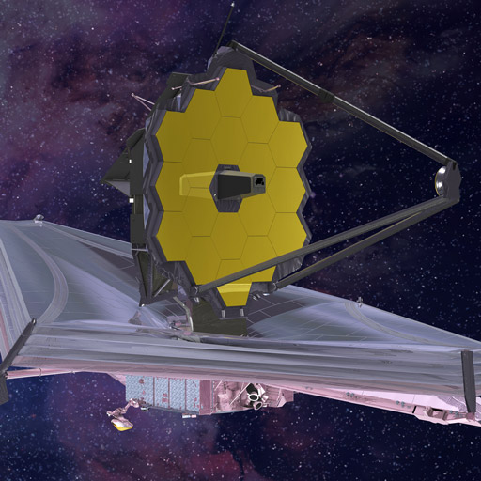
Fig -12: NASA

The next great space research observatory in the world will be the James Webb Space Telescope, a NASA-led project in association with the European and Canadian space agencies. Webb will investigate the mysterious architecture and beginnings of our cosmos, as well as uncover questions about our solar system and far-off worlds orbiting other stars. Webb will investigate every stage of the universe's history, from the first bright lights following the Big Bang to the creation of solar systems and the development of our own solar system. With Webb, new avenues for researching planet atmospheres surrounding other stars and their relationships to planetary systems will become possible. [1]

Parker solar probe
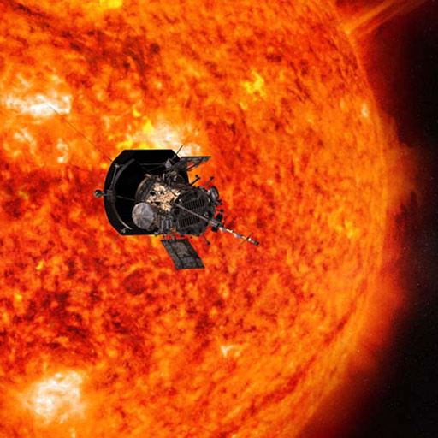
Fig -13 : NASA
The Parker Solar Probe, a NASA project, will be the first to "touch" the Sun. The spacecraft, which is roughly the size of a small car, will pass 4 million miles from the surface of our star and enter the Sun's atmosphere directly.[1]

Culture and artistic contribution

Cultural and creative manifestations will always be a part of space exploration. Creative pursuits such as music, literature, and visual arts captivate people's attention globally and add to a larger cultural story. By bridging the gap between the public and scientific spheres, artists and storytellers frequently act as translators, helping to shape a common understanding of humanity's place in the universe.

Space policy and intervational governance

International governance frameworks and strong space regulations are important in light of the changing face of space exploration. Creating explicit regulatory rules is essential as the number of commercial entities involved in space activities rises. Maintaining a cooperative and peaceful space environment depends critically on international cooperation in setting standards for appropriate space behaviour, resource use, and dispute resolution.

Interdisciplinary reseach collabration

Because space exploration is interdisciplinary, scientists, engineers, ethicists, sociologists, and policymakers must work together. A holistic understanding of the technological, ethical, and societal aspects of space travel will guide space exploration's future by fostering the integration of multiple perspectives and complete answers to difficulties.

Continuity and adaptability

The area of space exploration is dynamic and ever-changing, requiring constant adaptation to new technological advancements and unanticipated obstacles. Our exploration activities will stay robust and adaptive to the complexity of the cosmic frontier because to our dedication to continuous study, development, and learning from both achievements and failures.

Societal Implications and Ethical Considerations

A. Cultural and Educational Impact

The influence of space exploration extends beyond scientific realms, permeating culture and education. The awe-inspiring images of distant planets and galaxies captured by space telescopes, combined with the tales of human perseverance in the cosmos, contribute to a collective sense of wonder. Museums, documentaries, and educational programs centered around space exploration become crucial tools for inspiring future generations, fostering a sense of curiosity and discovery.[7]

Global Perspectives and Inclusivity

As humanity ventures further into the cosmos, fostering global perspectives and inclusivity becomes paramount. Collaborative efforts, such as the International Space Station (ISS), exemplify the potential for nations to work together in the peaceful exploration of space. Initiatives that involve diverse voices and perspectives ensure that the benefits and opportunities arising from space exploration are accessible to people worldwide, transcending geopolitical boundaries.

Public Perception and Outreach

A. Science Communication Strategies

Public perception of space exploration is shaped by effective science communication strategies. Engaging narratives, captivating visuals, and interactive experiences help bridge the gap between scientific endeavors and public understanding. Utilizing social media, educational platforms, and outreach programs, space agencies and organizations can cultivate a broader appreciation for the importance and impact of space exploration on our collective future.[7]

B. Inspirational Leadership and Role Models

The role of inspirational leadership and role models in the space sector cannot be overstated. Visionary figures like astronauts, scientists, and engineers serve as beacons of inspiration, motivating individuals to pursue careers in STEM (Science, Technology, Engineering, and Mathematics) fields. Highlighting the diverse backgrounds and contributions of individuals in the space industry encourages a more inclusive and dynamic workforce.

Space Policy and International Governance

A. Space Debris Management

One of the pressing challenges in space policy revolves around the management of space debris. The increasing congestion of Earth's orbit with defunct satellites and fragments poses risks to active missions. Developing international agreements and technologies for active debris removal and responsible satellite disposal are critical steps in ensuring the long-term sustainability of space activities.[6]

B. Outer Space as a Shared Resource

As private entities venture into space activities, the question of resource utilization and property rights gains prominence. The ethical allocation of celestial resources, including minerals from asteroids or lunar surfaces, requires a thoughtful approach. Establishing international frameworks that ensure fairness, transparency, and prevent space-based resource exploitation is essential for the equitable and sustainable future of space exploration.

Interdisciplinary Research Collaborations

A. Psychological and Sociological Aspects

Beyond the technical and scientific facets, the psychological and sociological impacts of space exploration on individuals and society are areas of burgeoning research. Long-duration space missions, potential human settlement on other planets, and the isolation of astronauts raise questions about the psychological well-being and social dynamics in confined extraterrestrial environments. Interdisciplinary collaborations with psychologists and sociologists are crucial to addressing these challenges and ensuring the mental health of space travelers.[7]

Continuity and Adaptability

A. Technological Evolution

The continuity of space exploration relies on technological evolution. Ongoing research into advanced propulsion systems, artificial intelligence, and sustainable life support technologies is imperative. The adaptability to emerging technologies not only enhances mission capabilities but also opens up new possibilities for exploration beyond our current understanding.

B. Citizen Science and Engagement

In an era of increasing connectivity, citizen science and public engagement initiatives have the potential to revolutionize space exploration. Platforms that enable enthusiasts to contribute to data analysis, observation, and even problem-solving in space missions not only expand the pool of available resources but also democratize
participation in scientific discovery.[7]

Advanced Concepts and Speculative Technologies

A. Warp Drives and Faster-Than-Light Travel

Exploring the frontiers of theoretical physics, scientists are investigating the possibility of warp drives for faster-than-light (FTL) travel. Concepts like the Alcubierre drive, inspired by general relativity, propose the manipulation of spacetime to enable rapid interstellar travel. While currently speculative, these ideas push the boundaries of our understanding and may reshape the future of long-distance space exploration.

Interstellar Probes and Robotic Exploration
Beyond our immediate celestial neighbors, the concept of interstellar probes gains traction. Proposals like Breakthrough Starshot envision tiny spacecraft propelled by powerful lasers to reach nearby star systems within our lifetime. The development of autonomous, self-repairing robotic probes capable of navigating and exploring distant regions of our galaxy is an area of research that holds promise for the future of deep-space exploration.[6]

The Search for Extraterrestrial Intelligence (SETI)

A. Advancements in Radio Astronomy and Exoplanet Detection

Recent advancements in radio astronomy and exoplanet detection techniques have intensified the search for extraterrestrial intelligence (SETI). Projects like the Breakthrough Listen initiative employ cutting-edge radio telescopes to scan the cosmos for signals indicative of intelligent civilizations. The discovery of potentially habitable exoplanets further fuels speculation about the existence of extraterrestrial life.

B. Messaging to Extraterrestrial Civilizations

The ethical considerations surrounding messaging to potential extraterrestrial civilizations (METI) are gaining attention. As humanity contemplates sending intentional signals into space, questions about the potential consequences and the need for global consensus on such endeavors emerge. Ethicists, scientists, and policymakers are engaged in discussions to establish guidelines for responsible communication with potential extraterrestrial beings.[6]

Theoretical Frontiers: Quantum Communication in Space

A. Quantum Entanglement for Secure Communication
Exploring the intersection of quantum mechanics and space communication, researchers are investigating the use of quantum entanglement for secure communication over vast distances. Quantum communication holds the promise of ultra-secure information transfer, with potential applications in interplanetary and interstellar communication networks.

B. Quantum Computing for Space Exploration

The advent of quantum computing introduces new possibilities for space exploration. Quantum computers have the potential to solve complex problems, optimize spacecraft trajectories, and enhance data processing capabilities. Collaborations between quantum computing experts and space agencies are at the forefront of research into the practical applications of quantum technologies in space missions.[6]

Conclusion

To sum up, space exploration's future is an exciting journey with unmatched potential and complex difficulties. The cosmic frontier draws humanity into unexplored regions with theoretical innovations like warp vehicles and moral dilemmas like communicating with extraterrestrial civilizations. Interstellar travel and the possibility of extraterrestrial life raise important questions about the effects on global cooperation, education, and society. This intergalactic voyage is not without difficulties, though. The ethical distribution of resources, the control of space debris, and the psychological health of astronauts all require creative thinking and teamwork. We are not just adding to our scientific understanding as we explore the cosmic unknown; rather, we are setting out on a life-changing adventure that speaks to the core of what it means to be human. Deep space exploration has a tale still to be told, one that inspires us to dream, explore, and rediscover our role in the universe.

Reference

The National Aeronautics And Space Administration (Nasa). 60 Counting. Article Published By Nasa. URL(NASA: 60 Years and Counting - The Future)

The Future Of Space Exploration. Nov23,2021. ATLANTA,GA. Article Publishede By Giorgia Tech. URl(The Future of Space Exploration | Research (gatech.edu))

The White House Space Council, “A New Era For Deep Space Exploration And Development,” July 23, 2020, URL(https://www.whitehouse.gov/wp‐ content/uploads/2020/07/A‐New‐Era‐for‐Space‐Exploration‐and‐Development‐07‐23‐ 2020.pdf.)

National Space Society, “NSS RoadMap To Space Settlement” [ 3rd Edition, 2019], URL(https://space.nss.org/nss‐roadmap‐to‐space‐settlement‐3rd‐edition‐2018‐contents/.)

Zubrin, R., “The Case for Space: How the Revolution in Spaceflight Opens Up a Future of Limitless Possibility,” Prometheus Books, 2019.

Wikipedia ,“Asteroid”, URL https://en.wikipedia.org/wiki/Asteroid.

Wikipedia, ‘Ore Resources On Mars” URL(https://en.wikipedia.org/wiki/Ore_resources_on_Mars#:~:text=Magnesium,_Alu_minium,_Titanium,_Iron,been_found_in_trace_amounts.))

