Power Quality Improvement of Micro grid by Using DVR
Komal V Ingle¹, Dr.M.G. Unde²
¹Student, M.E Electrical Engineering (Power System), Zeal College of Engineering, Pune, Maharashtra, India.
²Asst.Professor, M.E Electrical Engineering (Power System), Zeal College of Engineering, Pune, Maharashtra, India.

---------------------------------------------------------------------***---------------------------------------------------------------------
Abstract - Power quality is defined as the degree of voltage, current, frequency and waveform of power system under designed specification of the system. While transmitting the power from one end (generation) to another (load) utility has to face some power quality issues such as voltage sag, voltage swell, harmonics, inter-harmonics, voltage imbalance, voltage fluctuation, short duration voltage variation, long duration voltage variation, transient, power frequency variation, waveform distortion etc. These power quality issues directly effect on the efficiency of the power system and performance of the load equipment’s. Problems like voltage sag, voltage swell occurs due to sudden removal of large load from the system, energization of large capacitor bank or system fault like single-line-to-ground fault. These types of problems directly effect on equipment performance and accuracy, especially on sensitive equipment’s as computer, medical instruments, some electronic devices etc. To mitigate voltage sag, voltage swell problem in power system various devices are used such as DVR (dynamic voltage restorer)

Key Words: Voltage sag, Voltage swell, Power quality, MATLAB simulation, Single-phase AC system, Single-phase AC load.

1.INTRODUCTION
A power system having three main subsystems such as generation, transmission and distribution. Power quality is one on the most important concept, because electrical utilities as well as the end users are concerned about the quality of power. The term power quality is not new in the power system but instead of finding the individual solution for individual issue now to days’ engineers are trying to find one solution for many power quality related problems. The new generation is very much aware about the power quality, as the end user becomes more informative about issue such as voltage sag, voltage swell, power interruption, harmonics and switching transients. They are not just collecting the information but also challenging the power industry to improve the quality of power.
There are many methods to avoid effect of such voltage fluctuation on sensitive load like computer, medical devices or some electronic equipment’s. The devices which are built on the basis of power converter are most efficient and reasonable devices such as DVR (dynamic voltage restorer). DVR is connected in series with PCC (point of common coupling) between load and source. We propose DVR to work in abnormal condition such as voltage sag and voltage swell, during normal or healthy condition DVR is on standby mode of operation. When there is voltage variation in the system DVR controller detects the voltage magnitude and time duration according to the signal DVR supplies desired voltage to the system to stabilize the voltage magnitude constant. [1] DVR can supply and eject the desired voltage from the system according to the system condition through only one controlling mechanism.

2. POWER QUALITY
Power quality is the voltage quality in most of the cases of power quality issues. In engineering words, power is defined as the amount of energy delivered which is directly proportional to the product of voltage and current. Our power supply system can only control the voltage magnitude we have no control for the current magnitude it varies as the load changes in particular areas. So, the standards of power quality are maintained by controlling the voltage magnitude constant. AC power systems are designed to operate at a sinusoidal voltage supply at a specific frequency (typically 50 Hz or 60 Hz). Any specific variation in the sinusoidal waveform magnitude, frequency or purity of waveform can directly become a cause of power quality problems. In a practical system there is always a connection between current and voltage while generating the power generation tries to supply voltage in pure sinusoidal form, but due to impedance of the system can cause variation in disturbances such as-
- During short circuit faults short circuit current may lead to voltage sag or voltage may completely disappear.
- During the rainy season lightning stroke may affect to the power system, due to lightning stroke high impulse voltages occurs in the system that frequently damages the insulation of the system which leads to a short circuit current.
- Harmonic current (distorted current) due to harmonic producing loads also have distorted voltages that pass through system impedance and are also present to the other end users.

2.1 Power Quality Issues
Impulsive Transients – Impulsive transients are defined as a unidirectional (either positive or negative) and sudden change in steady state magnitude of voltage, current or in both with non-power frequency
Oscillatory Transients – Oscillatory transients are defined as sudden change in steady state magnitude of voltage, current or both but in both directions i.e., positive and negative with non-power frequency.
Under voltage – Under voltage is defined as decrease in root mean square (rms) value of system voltage to less than 90% for the duration of more than 1min at power frequency.
Overvoltage - Overvoltage is defined as increase in root mean square (rms) value of system voltage to more than 110% for the duration of more than 1min at power frequency.
Interruption – Interruption in the system known as decrease in system voltage or load current less than 0.1pu over the period of less than 1min. As the voltage magnitude during voltage interruption is always less than 10% of the normal system voltage so the interruption is measured depending upon their time duration.
Voltage sag (dips) – Voltage sag is defined as decrease in rms (root mean square) value of system voltage or system current between range of 0.1 to 0.9pu for the time duration of 0.5cycle to 1min at power frequency. According to IEEE standards sag is defined as “A decrease in RMS voltage or current at power frequency for 10 milliseconds to 1min, reported as remaining voltage.”
Voltage swell – Voltage swell is defined as increase in magnitude of rms (root mean square) value of system voltage or current in range of 1.1pu to 1.8pu for the time duration of 10 milliseconds to 1min at power frequency.
3. METHODOLOGY

DVR is a series device that is generally connected to the distribution side in between the source and the load. [2] DVR is connected to the system through an injection transformer and has some other components such as –
- Voltage source inverter (VSI)- A voltage source inverter is a device that converts unidirectional waveform to bidirectional which means this device converts DC signal to AC signal. The traditional VSI have some limitations as they cannot feed voltage in both directions hence to overcome these disadvantages DC-DC converters are used in this module.
- Filter – Filter helps to mitigate higher frequency components in other words filter is used to eliminate harmonic to get the pure outcome.
- Controller – In the prototype model to detect the voltage variation voltage sensor (ZMPT101b) is used which can measure voltage up to 250 volts. In MATLAB simulation hysteresis bridge method is used for controlling DVR.
- DC Source – DC source is used to feed the desired voltage to the system through the DVR block. Voltage magnitude is selected typically as V_{dc} = 14V and V_{rms} is calculated as –
$V_{dc}=\frac{2V_{m}}{π}$ (1)
$V_{m}=\frac{V_{dc}π}{2}=\frac{14×3.14}{2}=21.98V$ (2)
$V_{rms}=\frac{V_{m}}{\sqrt{2}}=\frac{21.98}{1.414}=15.54V$ (3)
- Series injection transformer – Series transformers are used as injection transformers to feed or eject the voltage from the system. [3]
Figure 1 shows the block diagram of a DVR connected to a single-phase AC system.
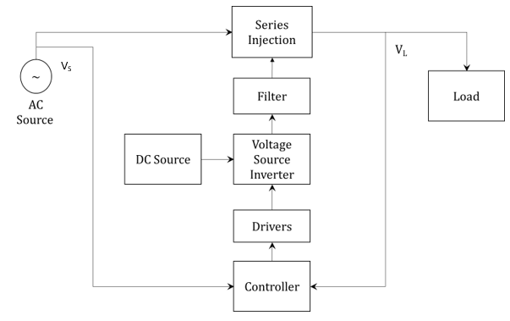
Figure 1: Block diagram of DVR connected to single-phase AC system.
Function of DVR
DVR is working in main three operating modes as protection mode, standby mode, and injection mode. In protection mode, DVR protects itself from higher magnitude current which occurs due to faulty conditions or mal operation of equipment in the system. Excess current may damage the DVR circuit, so it is protected by thyristors and breakers. In standby mode, DVR is not feeding any voltage to the system but keeps monitoring and analyzing the system voltage. As there is voltage variation in the system DVR suddenly operates in injection mode to feed the desired voltage to the system and keeps the system voltage at a constant, designed magnitude. [4]-[7] Equivalent circuit diagram of DVR is shown in Figure 2.

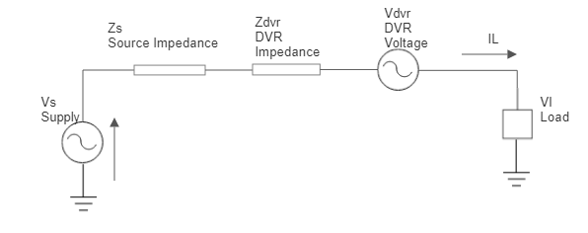
Figure 2: Equivalent circuit of DVR

Table -1: Parameters used for the prototype model

Sr No | Parameters | Nomenclature | Values
1 | Voltage | V | 48V
2 | Power | s | 100 W
3 | Frequency | f | 50 Hz
Table 2: List of components used in the model.

Sr No | Components | Module Name | Specification
1 | Voltage Sensors | ZMPT101b | Range – up to 250V
1 | Voltage Sensors | ZMPT101b | Supply – 5V to 30V
2 | Microcontroller | AT mega 328 | Operating Voltage – 5V
2 | Microcontroller | AT mega 328 | Supply voltage – 7 – 20V
2 | Microcontroller | AT mega 328 | 14 Digital I/O pins
2 | Microcontroller | AT mega 328 | 6 Analog input pins
2 | Microcontroller | AT mega 328 | 6 configurable PWM outputs
2 | Microcontroller | AT mega 328 | Serial, I2C communication support
3 | Voltage source Inverter (IGBT) | IGBT 25N120 | Voltage = 1200V
3 | Voltage source Inverter (IGBT) | IGBT 25N120 | Current = 25A
3 | Voltage source Inverter (IGBT) | IGBT 25N120 | TON = 50nS
3 | Voltage source Inverter (IGBT) | IGBT 25N120 | TOFF = 190nS
3 | Voltage source Inverter (IGBT) | IGBT 25N120 | TR = 60nS
3 | Voltage source Inverter (IGBT) | IGBT 25N120 | TF = 100nS
3 | Voltage source Inverter (IGBT) | IGBT 25N120 | Total response time = 400ns = 0.4μS
4 | Opto-coupler Drivers (MOSFET) | PC817
5 | DC Power Supply for Driver Circuit (Diode) | 1N4007 | Peak Inverse voltage of diode PIV > 2Vm. i.e. PIV > 2 X 22 = 44V.
5 | DC Power Supply for Driver Circuit (Diode) | 1N4007 | Diode current > load current > 1A
6 | LC Filter |  | C = 50µF
6 | LC Filter |  | L = 510µH
7 | Series Transformer |  | Voltage – 15V
7 | Series Transformer |  | N₁ : N₂ – 1:1

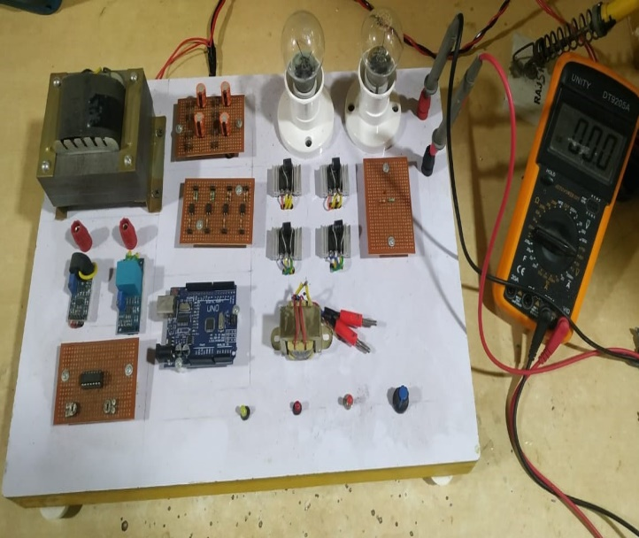

Fig -1: Overview of model.

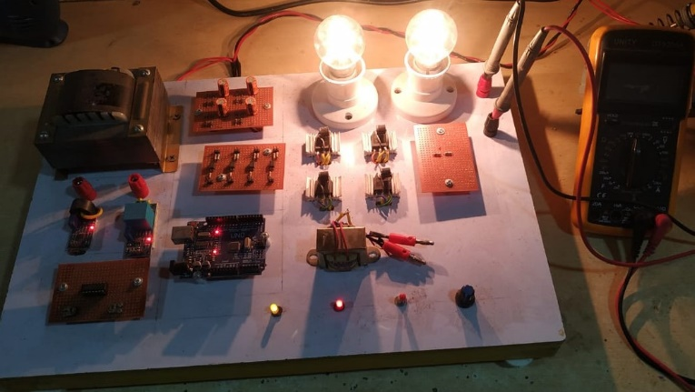
Fig -2 Results of model.
Prototype model is designed at voltage magnitude of 48V, 50Hz. 100W. Figure 4 shows the overview of the complete mode while Figure 5 shown the running condition of the system i.e., load is connected to the system. Voltage variation during sag and swell condition is measured using multimeter and analyzed as shown in Table 3.
Table 3: Prototype model results.
Parameter | Before DVR | After DVR
System voltage | 48V | 48V
Voltage during sag | 42V | 48V
Voltage during swell | 55V | 48V

4. MATLAB SIMULATION
Figure 6 shows a MATLAB simulation for DVR connected to a single-phase AC system. Under abnormal or faulty conditions in the system, DVR is used to feed or eject desired voltage from the system to stabilize the load voltage at constant magnitude. The Hysteresis bridge method is used as a controlling mechanism for DVR and PLL (phase locked loop) is used to provide pure sinusoidal voltage with the same phase as of the AC system as shown in Figure 7.
An additional DC source of magnitude 400V is connected to DVR through which DVR can provide reactive power to the AC system and makes system voltage at constant magnitude. The parameters used for MATLAB simulation are listed in Table 4. During normal conditions DVR is operating on standby mode and at abnormal conditions DVR injects voltage to the system by comparing the reference voltage and system voltage.
Table 4: Parameters used for MATLAB Simulation.
Sr. No | Parameters |  | Values
1 | Single Phase Source | V_{ac} | 311
2 | Frequency | f | 50
3 | DC Source | V_{dc} | 400
4 | Single Phase Load (RL) | V_{rms}  P  Q_{L}  Q_{c} | 220  100000W  5000VAR  0VAR
5 | Series Capacitance | C | 0.0047F
6 | Series Inductance | L | 0.0001H
7 | Voltage Sag | Switching Time | [0.15 0.27]
8 | Voltage Swell | Switching Time | [0.37 0.43]
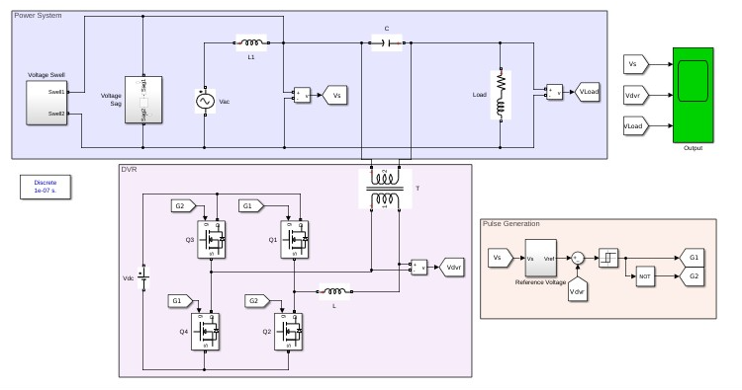 Figure 6: MATLAB Simulation for DVR connected to the single-phase AC system.
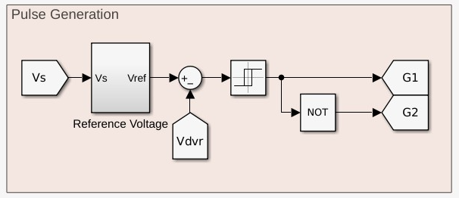
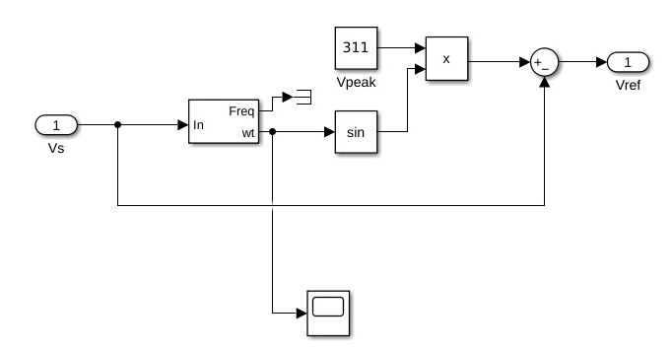 Figure 7: Controlling of DVR.

5. RESULT AND ANALYSIS
As there is voltage variation in the source voltage DVR injects desired voltage into the system to stabilize the load voltage. The voltage waveform of source voltage, DVR voltage and load voltage are shown in Figure 8. Total harmonic distortion in the system before and after using DVR is shown in Figure 9 and Figure 10 respectively.
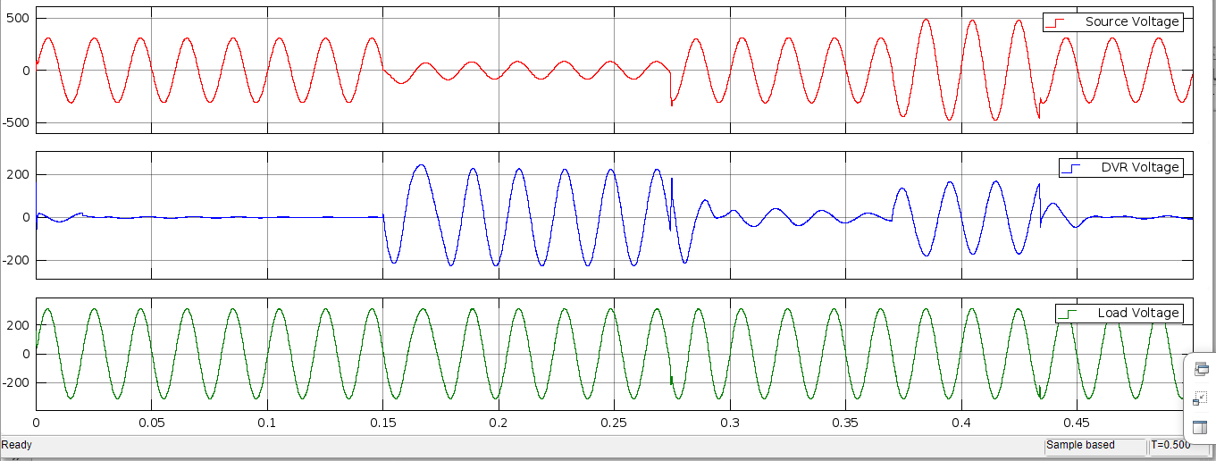
Figure 8: System voltage before and after using DVR.
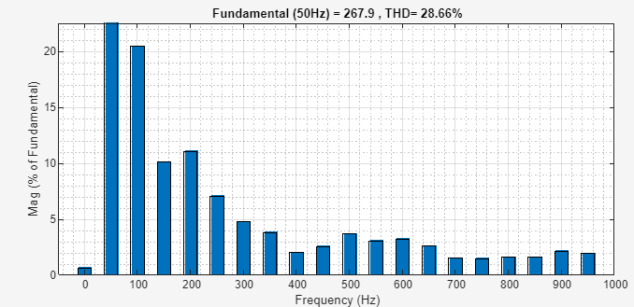
Figure 9: THD analysis before using DVR.
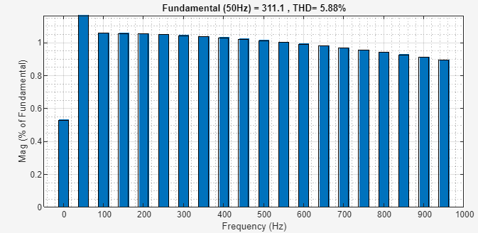
Figure 10: THD analysis after using DVR.
Table 5: THD analysis.
Parameter | Before DVR | After DVR
Voltage THD | 28.66 | 5.88
As shown in Table 5 THD % of the system before using DVR is 28.66% while after using DVR it is reduced to 5.88%. So, the power quality of the system improves with a minimum %THD and constant voltage magnitude.
6. CONCLUSIONS

This paper represents the DVR model which is used to mitigate power quality problems such as voltage sag, and voltage swell. A brief review of power quality problems such as transients, overvoltage, under voltage, sag, swell and interruption. The most significant part of improving power quality is voltage regulation. A single-phase AC system is upgraded with a DVR unit. DVR ensures that the system voltage must be constant at the desired value. The sudden removal of large loads or energizing of a large capacitor bank to the system can cause voltage variation in the system’s voltage magnitude. Sensitive loads may affect due to voltage variation in the system, their performance and accuracy become less some time which may lead to mal operation or data loss. DVR is used to stabilize the load voltage by providing desired voltage to the system through an external voltage source (DC source). The prototype model of voltage ratings 48V, 50Hz, and 100W is shown in this paper and the results are analyzed using a multimeter.

REFERENCES

- A. Moghassemi, S. Padmanaban, V. K. Ramachandaramurthy, M. Mitolo and M. Benbouzid, "A Novel Solar Photovoltaic Fed TransZSI-DVR for Power Quality Improvement of Grid-Connected PV Systems," in IEEE Access, vol. 9, pp. 7263-7279, 2021, doi: 10.1109/ACCESS.2020.3048022.
- Ankita Pakale and Mukund Mahagaonkar, “Power Quality Improvement by using DVR”, JoEEED, vol. 1, no. 1, pp. 1–4, Jun. 2023.
- A. JeraldineViji, R. Priya and B. Pushpa, "PV Combined ZSI-DVR with Fuzzy Logic Controller for Power Quality Improvement," 2021 International Conference on System, Computation, Automation and Networking (ICSCAN), Puducherry, India, 2021, pp. 1-6, doi: 10.1109/ICSCAN53069.2021.9526539.
- A. Moghassemi and S. Padmanaban, ‘‘Dynamic voltage restorer (DVR): A comprehensive review of topologies, power converters, control methods, and modified configurations,’’ Energies, vol. 13, no. 16, p. 4152, Aug. 2020.
- M. Prasad and A. K. Akella, ‘‘Voltage and current quality improvement by solar photovoltaic fed ZSI-DVR,’’ Procedia Comput. Sci., vol. 125, pp. 434–441, 2018
- J. Olamaei, S. Ebrahimi, and A. Moghassemi, ‘‘Compensation of voltage sag caused by partial shading in grid-connected PV system through the three-level SVM inverter,’’ Sustain. Energy Technol. Assessments, vol. 18, pp. 107–118, Dec. 2016.
- M. Rajkumar and S. R. Reddy, ‘‘Modeling and simulation of ZSI based DVR for voltage compensation,’’ in Proc. Int. Conf. Comput., Commun. Electr. Technol. (ICCCET), Tamil Nadu, India, Mar. 2011, pp. 346–351.

