Enhancing School Security System Using RFID: A comprehensive
Approach
Johnson Sirleaf Brisbane
Department of Computer Science and Applications
Sharda University
Uttar Pradesh, India
2021804623.johnson@ug.sharda.ac.in

ABSTRACT:
Ensuring the safety of students and punctuality in educational institutions is of prime importance. This study introduces and evaluates a school security system that uses radio frequency identification (RFID) technology. The system uses RFID identification cards issued to students to track entry and exit from the school premises. By swiping the RFID card, the system fixes the time and location, which facilitates efficient tracking of student movements. Notifications are automatically sent to parents or guardians, improving communication and awareness. This will also alleviate the problems of students coming from home and skipping lectures to have fun during lectures hours. This paper discusses the methodology, implementation process and technology behind RFID, and provides an overview of the system's architecture and its integration into the school's existing infrastructure. This study also examines the impact of an RFID-based school security system on improving overall security measures based on privacy and ethical considerations. The results suggest a positive correlation between the adoption of this system and improved security protocols in educational institutions.

Keywords: RFID, School Security, Attendance Tracking, Student ID, SMS Notification, Campus Safety.

- INTRODUCTION
In today's society, parents struggle with increasing concerns about the safety of their children, especially with the alarming increase in crimes and poor academic performances by students. The prevailing socio-economic landscape, characterized by long working hours for parents, exacerbates these concerns as the time available for direct parental supervision decreases.[3] One critical stage where these concerns converge is the period when children enter the classroom. It's not uncommon for bad guys to exploit this vulnerability and lure children in before they reach the safety of their facility. There are other times when students come to school and leave the premises of the school wandering off to have fun with friends. These alarming trends call for a proactive, technology-based approach to school safety.

Aware of the importance of these challenges, schools have an important responsibility to ensure the safety of their students. In addition to providing quality education, schools must prioritize measures that ensure the physical well-being of their schools. This includes student tracking mechanisms and monitoring; place, especially at critical times such as entering and leaving school. In addition, it is important that schools create effective communication channels with parents and keep them informed about their children and activities at school.[10] In response to these urgent issues, the proposed School Security System (SSS) using Radio Frequency Identification (RFID) technology appears as a strategic solution. Using RFID, the system aims to improve student safety by providing a robust mechanism to track students entering and exiting the school environment.[8] With this technological innovation, schools can not only reduce the risk of criminal activity, but also provide the ability to immediately alert parents if their child has missed important school lessons.

School Security System Using RFID explores the concept, design and implementation of an RFID-based school security system and is an important step towards strengthening the security infrastructure of educational institutions.[1] Later sections of this document discuss the system's architecture, its goals, benefits, and possible future improvements, and provide a comprehensive overview of its relevance to today's school security challenges.

- LITERATURE REVIEW:

S.no | Title | Year of Publication | Author | Journal Conference | objective | Findings | Conclusion
 | Online attendance system using RFID with object counter. | 2021 | Ankita Agrawal, A. Bansal | International Journal of Information and Computation Technology | To provide an effective means of taking attendance by scanning QR codes [1] | The problem of duplicate attendance is resolved in this paper, eliminating it by using a special object counter for the head count. | The system proved very much effective in a faster and more convenient way.
 | Smart Classroom Door Access System using Attendance Supervision Method through RFID based Mechanism | 2020 | Pushpa S., Priyanka A.S, Sagar S. Bhave | International Research Journal of Engineering and Technology (IRJET) | The purpose of RFID in monitoring student attendance as captured and posted in this study is to reduce the time spent during student collection and the opportunity for education administrators to take face-to-face class statistics to provide appropriate scores and attendance management decisions.[4] | It's easy to use and very accurate as well. | This project can therefore be of great help in implementing real-time tracking system tracking and tracking as well as providing security benefits
 | Students Attendance Management System Supported RFID and Fingerprint Reader | 2018 | Moth Mymt, Chaw Myat | IEEE Conference | This paper, presented that the Smart Attendance System  which avoids proxy attendance by two factor authentication  process with the help of TensorFlow, Image Processing  OpenCV, etc[7] | This product  will reduce / eliminate the attendance taking time in a class  hour. Because of its two-way verification (RFID – FACE ID),  It will reduce the malpractice in recording an attendance. It is  cost efficient and affordable. | This method of recording attendance is very effective.
 | Student Attendance Management System Using RFID and Face Recognition | 2022 | Unnati A Patel, Dr Swami Narayan,Priya R. | International Conference on Communication, Computing and Internet of things | In this paper, presented that the Smart Attendance System  which avoids proxy attendance.[5] | The system proved very effective in eliminating proxy attendance. | This method of recording attendance solves the problem imposed by traditional methods.

Having done an in-depth review and analysis of existing literatures and the evolution of School Security Systems developed, it has been established that previous and existing systems had some challenges. Although these systems solved some problems, they face challenges of scalability, integration, and real-time monitoring. Common weaknesses in previous systems range from manual attendance monitoring, a channel with parents, lack of real-time monitoring and an effective leave management module for parents.
Moreover, there was often a gap in communication between the school and parents; leading to increased worries among parents about the safety of their children and poor academic performance by students.

The proposed School Security System using RFID technology aims to address these flaws by leveraging the capabilities of RFID for efficient attendance tracking and real-time monitoring. The system automates the process of recording student arrivals and departures, eliminating the need for manual data entry and reducing the likelihood of errors. The leave management module is integrated within the system architecture to give parents/guardians the platform to request leave for their child/student.
This real-time data is then used to generate automated SMS notifications to parents, ensuring they are promptly informed about their child's attendance. Moreover, the RFID-based system enhances security by providing a comprehensive view of student movements within the school premises. The ability to track students in real time allows for proactive response to any irregularities or security concerns. The integration of a web-based system for both school administrators and parents ensures a transparent and accessible platform, fostering better communication and collaboration between the school and parents. By addressing the limitations of previous systems, the proposed SSS using RFID technology offers a more efficient, secure, and transparent solution for school security. The use of RFID represents a great advance in school security systems by simplifying the patrolling process but also improving all security measures.

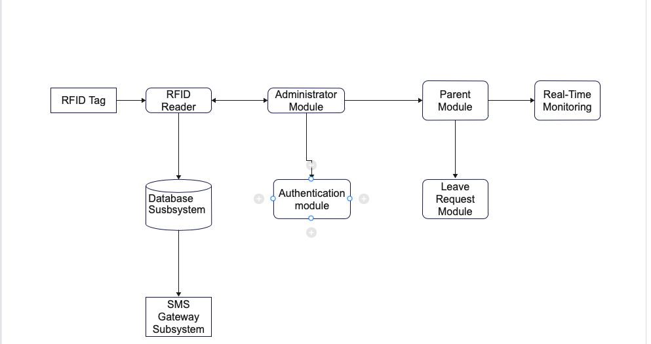
- SYSTEM ARCHITECTURE:
The system architecture of the RFID-based school security system is designed to seamlessly integrate radio frequency identification technology (RFID) into the existing infrastructure of educational institutions. The architecture includes core components that work together to provide effective presence monitoring, communication and enhanced security.
Fig.1: Block Diagram of the proposed System

- PROPOSED METHODOLOGY:
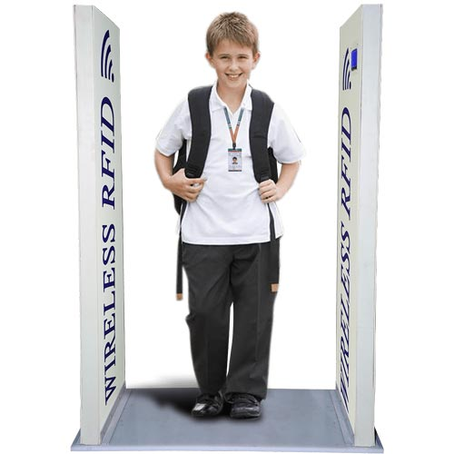
RFID Readers: At the heart of the system are RFID readers strategically placed at the entrance and exit points of the school. These readers record and register students’ arrival and exit time [5]. RFID tags make it possible to precisely monitor their movements in school premises. Integration of RFID readers into a network system follows suit, enabling real-time data transmission. To facilitate the communication between the RFID readers and the central database, protocols were established to ensure the accuracy of participant tracking.
Fig. 4: RFID Reader (m.IndiaMart.com)

RFID tags: Implementation of an RFID-based school security system involves extensive integration of hardware and software components. In the initial phase, the focus is on the establishment of the RFID infrastructure and the strategic placement of RFID readers at the most important entrance and exit points of the school premises. At the same time, RFID tags are embedded in each student's ID cards, which contain unique identification information important for accurate tracking [3]. Attached to each student and ID card contain unique identification information that facilitates the tracking of individual students as they move around the school environment. Information stored on RFID tags includes student IDs, class information, and other related information [9].



Fig. 3: RFID Tags. (m.IndiaMart.com) Fig. 4: Embedded RFID Card (m.IndiaMart.com)

Web-Based System: acting as a central hub for the school's security system. This system receives and processes data from RFID readers in real time. It provides a secure and user-friendly interface for school administrators to access attendance data, manage leave requests and generate reports [3]. The web-based system acts as the backbone of real-time communication with parents and ensures timely knowledge of the activities of the child and the school.

SMS gateway: Adding an SMS gateway to your web-based system is an important step in enabling automatic SMS notifications [6]. The system is scheduled to trigger SMS notifications based on attendance records and leave requests, providing parents with real-time updates on their children and school activities. Both parents and school administrators developed and implemented their own user interfaces in the web-based system. These user interfaces provide secure login mechanisms and intuitive navigation to access participant data, leave management functions and other related information. An SMS gateway is integrated into the web-based system. This gateway is responsible for sending automatic SMS notifications to parents to trigger attendance records and absence requests whenever the RFID ID card is swiped. Integrating this communication channel ensures that parents receive real-time feedback.[7]

Database: A strong database is essential for student information, attendance information and communication information from parents and to manage. The database is connected to a web-based system that ensures smooth data flow and secure archiving of sensitive information [10]. The system also includes special interfaces for both parents and school administrators in the web-based system. Database configuration is an important step to ensure offline storage and management of student information, attendance information, and parent communication. Establishing database connections to a web-based system facilitates the flow of real-time information. Developing a web-based system is an important part of the implementation process. This system acts as a central hub that receives and processes data from RFID readers. The development includes secure login mechanisms for both school administrators and parents, which ensures authenticated access to the system.[8]

Leave Management: These user interfaces provide secure login mechanisms and intuitive navigation to access participant data, leave management functions and other related information. In addition, the implementation of the leave management module simplifies the processing of leave requests within the system. Parents can submit requests online, and the module facilitates the approval and processing of these requests by school administrators, reducing administrative costs and ensuring a transparent communication channel. The development of the leave management module makes it easier to process requests for parental leave. This system-integrated module facilitates the submission and processing of leave requests online, reduces administrative costs and ensures a transparent communication channel between parents and schools.[5] Testing is done extensively to identify and correct any defects or problems that may occur after deployment. The entire system, including the integration between the RFID readers, the web-based system and the SMS gateway, is reviewed to ensure smooth functionality. Trainings are organized for school administrators and parents to get used to the functionality of the RFID-based school security system.

The seamless interaction of these components ensures the seamless operation of an RFID-based school security system, providing schools and parents with a comprehensive tool to improve student safety and communication [7]. Using RFID technology and web-based infrastructure, the system achieves its goals of effective attendance tracking, real-time parent engagement and improving the safety of the school environment.

- PROPOSED SOLUTIONS:

RFID Infrastructure Setup:
Implementation of an RFID-based school security system involves extensive integration of hardware and software components. In the initial phase, the focus is on the establishment of the RFID infrastructure and the strategic placement of RFID readers at the most important entrance and exit points of the school premises. At the same time, RFID tags are embedded in each student's ID cards, which contain unique identification information important for accurate tracking.

Database Configuration: Database configuration is an important step to ensure offline storage and management of student information, attendance information, and parent communication. Establishing database connections to a web-based system facilitates the flow of real-time information. Developing a web-based system is an important part of the implementation process. This system acts as a central hub that receives and processes data from RFID readers. The development includes secure login mechanisms for both school administrators and parents, which ensures authenticated access to the system. Integration of RFID readers into a network system follows suit, enabling real-time data transmission.

Leave Management: The development of the leave management module makes it easier to process requests for parental leave. This system-integrated module facilitates the submission and processing of leave requests online, reduces administrative costs and ensures a transparent communication channel between parents and schools.[5] Testing is done extensively to identify and correct any defects or problems that may occur after deployment. The entire system, including the integration between the RFID readers, the web-based system and the SMS gateway, is reviewed to ensure smooth functionality. Trainings are organized for school administrators and parents to get used to the functionality of the RFID-based school security system.

Web-Based System Development:
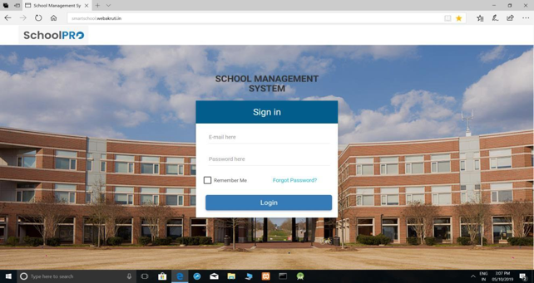
To facilitate the communication between the RFID readers and the central database, protocols shall be established to ensure the accuracy of participant tracking. Adding an SMS gateway to your web-based system is an important step in enabling automatic SMS notifications. The system is scheduled to trigger SMS notifications based on attendance records and leave requests, providing parents with real-time updates on their children and school activities. Both parents and school administrators will develop and implement their own user interfaces in the web-based system.
Fig.5: Proposed Admin. Module. School Security System Using Rfid- Pranjali Dandekar et al,www.irjmets.com

Integration of RFID Readers with Web System:
The entire system, including the integration between the RFID readers, the web-based system and the SMS gateway, is reviewed to ensure smooth functionality. Trainings are organized for school administrators and parents to get used to the functionality of the RFID-based school security system. Deployment is controlled and may begin with a testing phase to address unexpected challenges. Continuous maintenance will be established to deal with any problems that may arise after deployment.
Regular updates and additions are planned to adapt the system to changing information security needs and technological developments, which ensures its longevity and effectiveness. The deployment process is a collaborative effort between IT professionals, school administrators and parents who work together to successfully integrate an RFID-based school security system into the educational environment.

- CONCLUSION:

In conclusion, an RFID-based School Security System (SSS) is a key solution for student safety, parental anxiety and the need for effective management processes in educational institutions. The introduction of this system represents a proactive step towards using technology to create a safe and supportive learning environment. Thanks to RFID (Radio Frequency Identification) technology, SSS offers students a strong mechanism and #039; during and outside the school premises. Real-time communication enabled by automated text messages increases parental awareness and fosters collaboration between schools and parents to keep students safe.
The system not only simplifies attendance tracking, but also optimizes administrative processes, allowing school personnel to focus on strategic tasks instead of manual recording. An effective vacation management module further promotes a transparent and streamlined communication channel between parents and schools. In addition, SSS goes beyond immediate security aspects by promoting a culture of security in educational institutions. The adaptability of the system allows for future improvements, ensuring its relevance in the face of evolving security challenges.
As schools strive to create an environment that prioritizes the holistic well-being of students, an RFID-based school security system is a testament to the transformative possibilities of technology in education. By addressing parent concerns, promoting effective communication, and fostering a safe school environment, this system lays the foundation for a safer, more connected educational experience for both students and their families. By learning about such innovative solutions, educational institutions can play a key role in building a foundation for learning that extends beyond academic excellence to include broader aspects of student well-being and safety.

REFERENCES:

- Shashank Shukla, Shailee Shah, Pooja Save, “Rfid Base Attendance Management System” International Journal of Electrical and Computer Engineering (IJECE) December 2013.

- Moth Moth Mymt Thein, Chaw Myat Nweand Hla Myo Tun, “Students Attendance Management Supported RFID and Fingerprint reader” International Journal of Scientific and Technology Research (IJSTR) Volume 8, Issue 2, I July 2015.

- Elima Hussain, Priyanka Dugar, Vaskar Deka, Abdul Hunnan “RFID Based Student Attendance System” International Journal of Computer Application (IJCA) Vol 02, no 1, pp.11-123,2014.

- M. Oloyede, O. A. Adeyinka, S. A. Kayode, “Fingerprint Biometric Authentication for Enhancing Staff Attendance System”, International Journal of Applied Information Systems Vol 5, No.3, pages 19-24, 2013.

- Hanisah Binti Hamid, “RFID Based Systematic Student’s Attendance Management System”, November 2010.

- K. Domdouzis, B. Kumar, and C. Anumba, “Radio-Frequency Identification (RFID) applications: A brief introduction”, Advanced Engineering Informatics, Vol. 21, 2007, pp 350-355.

- Nurbek Saparkhojayev and Selim Guvercin. “Attendance control system based on RFID technology”, in 2012 IEEE IJCSI International Journal of Computer Science Issues.
- H. K. Nguyen, M. T. Chew, Centre of Technology-RFID- Based Attendance Management System, RMIT International University Vietnam, Ho Chi Minh City, Vietnam, School of Engineering and Advanced Technology, Massey University Albany, Auckland, New Zealand.

- Md. Sajid Akbar, Pronob Sarker, Ahmad Tamim Mansoor, Abu Musa Al Ashray, Jia Uddin -Face Recognition and RFID Verified Attendance System.

- Design of Attendance Monitoring System Using RFID 2021 7th International Conference on Advanced Computing & Communication Systems (ICACCS).

- School Security System Using Rfid- Pranjali Dandekar et al, International Research Journal of Modernization in Engineering Technology and Science- e-ISSN: 2582-5208- www.irjmets.com

