IMPACT OF ELECTRIC VEHICLES ON THE INDIAN MARKET
Mr Vivek Gupta (Assistant Professor), Ayush V, Prajna, Arnav Bhandari, Rishab M, Varun Hp
Centre for Management Studies, Jain (Deemed-to-beUniversity), Bangalore.

ABSTRACT
The Indian electric vehicle (EV) market is experiencing rapid expansion, having recorded sales of 455,733 units in FY2022. The government has set ambitious goals to achieve a 30% EV mix by 2030, aiming to decrease reliance on crude oil. The transition towards EVs is poised to bring about substantial environmental benefits and economic opportunities, creating advantages for businesses, investors, and consumers. Despite these positive prospects, several challenges persist, including financing difficulties, limited availability of services, skill gaps, concerns about driving range, and safety considerations. To propel the advancement of EV mobility in India, collaboration between EV retailers and financial institutions is essential, alongside investments in service centers, customer education initiatives, the enforcement of stringent safety measures, and the adoption of proactive marketing strategies.
KEYWORDS
Impact of electric vehicles, Impact of EV in India, Electric Vehicles (EVs), Indian market, Automotive industry, Green transportation, Sustainable mobility, EV market growth, Infrastructure development, Market segmentation, Market share, Adoption barriers.
INTRODUCTION
An electric car is a car that uses electricity as its driving force. Unlike traditional internal combustion engine (ICE) vehicles that use gasoline or diesel to power their engines, electric vehicles use electricity to generate electricity and drive the wheels. Electric cars are becoming increasingly popular due to their environmental benefits, energy efficiency and lower running costs. They also help reduce pollution and dependence on fossil fuels, making them an important part of fighting climate change and supporting transport.
Additionally, advances in battery technology continue to increase the range and performance of EVs, making them more efficient and practical for users. The electric vehicle industry relies on stable supplies of key components, particularly lithium-ion batteries.
The Indian government is actively promoting the use of electric vehicles through various policies and incentives. Electric cars have tax benefits, discounted sales and tax rates and no registration fees. The growth of electric vehicles in India is driven by a combination of government support, environmental concerns, rising fuel prices, infrastructure and consumer awareness. The Government of India launched the National Electric Mobility Mission Program (NEMMP) in 2013 to promote the use of electric vehicles. The Faster Program and Production of Hybrid and Electric Vehicles (FAME) provides financial support to manufacturers and buyers of electric vehicles. India is not alone when it comes to global energy consumption and security. As electric cars became popular around the world, Indian consumers were also influenced by these trends, increasing the interest and demand for electric cars.
The first electric buses were launched in India in the 1980s, but these initiatives were not approved due to competition and infrastructure. In the 2000s, with the increase in air pollution and dependence on fossil fuels, interest in electric vehicles increased again. Reva Electric Vehicles (later acquired by Mahindra & Mahindra) launched India's first commercial electric vehicle, the Reva, in 2001. However, its success was limited due to its high price and many limitations. One of the biggest barriers to using electric vehicles is the higher cost of electric cars compared to gasoline vehicles. Electric cars tend to be more expensive due to the cost of batteries and other technologies. This threshold price may affect price-sensitive customers. Although India has managed to expand the payment system, it is still not as widespread and simple as gas stations. Too much stress or worry about the battery and not being able to use a charging station is a real problem for many EV buyers, especially in remote areas of the city. Electric cars have come a long way in extending the range and some models may not be suitable for the long journeys common in India.
The variety of electric car models available in India is increasing but still lags behind the petrol cars available in the Indian market. Customers may not find an EV that meets their specific needs, such as size, style or performance. India's electric vehicle (EV) market is growing rapidly with 455,733 EVs sold in FY22. The Indian government has set an ambitious target of 30% electric vehicle penetration by 2030 and has introduced initiatives such as the National Electric Mobility Mission Plan (NEMMP) and Faster adoption and production of (hybrid and) electric vehicles (FAME) to reduce electric vehicle consumption in India. initiated policies. dependence on oil. State governments such as Assam, Telangana, Tamil Nadu and Gujarat have also introduced policies to encourage the production of electric vehicles. The introduction of electric vehicles in India will have global implications, both environmentally and economically. The transition to electric vehicles will reduce India's dependence on oil and disrupt the global oil market. With a population of 1.4 billion and a rapidly growing economy, India is likely to become a dominant player in the global electric vehicle market today.
India's transition to electric vehicles will have environmental impacts, including reduced emissions, noise and increased efficiency. Electric cars can reduce the negative impact of internal combustion engine (ICE) vehicles on the world's environment and increase fuel efficiency, increasing the need for electric cars. Additionally, the adoption of electric vehicles in India has opened up many economic opportunities for the country. India's electrification is a major step towards a clean, green future that benefits businesses, investors and consumers. Electric vehicles can lower operating costs for carriers such as Amazon, Door Dash and Big Pack, while OEMs can also produce vehicles at competitive prices. The Indian government is offering tax incentives to reduce start-up costs and pay for solutions that increase confidence in the technology.

The real estate sector can also benefit from EVs, as it requires construction of manufacturing units, industrial areas, and charging stations. The EV industry is expected to create five crore new jobs, and India's young talent pool is well-positioned to ride this growth. However, the country still faces significant challenges before reaching full adoption of electric vehicles. The government is pushing for indigenization of the supply chain under the Atma Nirbhar plan to support OEMs and provide access to features like navigation, vehicle diagnostics, and keyless control. EV retailing in India faces several challenges, including financing, service unavailability, limited competency, range anxiety, and safety concerns. EVs are relatively expensive and require significant upfront investment in the battery, making them unattractive to customers. To overcome these challenges, EV retailers must collaborate with banks and financial institutions to develop innovative financing solutions.Service unavailability is another significant challenge, as India needs more service centers for EVs. To address this, EV retailers must invest in setting up service centers and training personnel in EV technology. Additionally, they must invest in educating customers about EV technology and the benefits of electric mobility, as well as training mechanics in EV technology.
Range anxiety is another challenge, as customers may need to be reassured about the vehicle's range and charging infrastructure availability, especially in rural areas. To address this, EV retailers must invest in a robust charging infrastructure network and offer home charging solutions.Safety concerns are another significant challenge, as EVs present unique safety challenges due to high-voltage batteries and charging infrastructure risks. To address these concerns, EV retailers must implement strict safety protocols and standards, provide safety training, and provide accurate product life information.Lastly, EV retailers must adopt push marketing strategies to educate customers about EV benefits, such as social media campaigns, influencer marketing, and content marketing. By addressing these challenges, EV retailers can drive the growth of electric mobility in India and accelerate the transition towards a cleaner, more sustainable future.

OBJECTIVE OF THE RESEARCH:
Studying the effects of Electric Vehicles (EVs) on India's market is crucial right now. It helps us see how EVs are changing the car industry, the economy, the environment, and our lives in India. This research looks into many different aspects impacted by the rise of EVs. Here are some important areas it explores:
- Understanding EV Market Growth: Determining how quickly the EV market in India is growing and the direction in which it is headed. It helps in assessing the market's potential and predicting its future development.
- Exploring Consumer Adoption: Gain insights into why and how Indian consumers are embracing EVs. This includes understanding factors like consumer awareness, perceptions of EVs, and the motivations behind considering EVs for their next vehicle purchase.
- Assessing Government Policies: Evaluating the effectiveness of government policies, incentives, and regulations in encouraging EV adoption and reducing environmental impact is a crucial objective. It helps in determining if policy measures align with desired outcomes.
- Analysing Infrastructure Development: Examine the progress made in expanding and improving EV charging infrastructure across various regions in India. This objective highlights the accessibility and convenience of charging stations for EV users.
- Measuring Environmental Impact: To quantify the positive environmental effects of EVs, such as reduced greenhouse gas emissions and improved air quality. This objective demonstrates the broader societal benefits of EV adoption.
- Investigating Market Dynamics: Exploring the competitive landscape within the Indian EV market. It includes examining the roles played by both domestic and international manufacturers and how they influence market dynamics.
- Identifying Barriers and Challenges: The obstacles that hinder the widespread adoption of EVs in India. This includes challenges like range anxiety, upfront costs, and any other factors that discourage potential buyers.
- Predicting Future Trends: Making informed predictions about the future of the Indian EV market is a critical objective. This involves forecasting aspects such as market share, technological advancements, and shifts in consumer preferences.
- Assessing Economic Implications: Evaluate the economic consequences of the growing EV industry in India, including its potential to create jobs and its impact on the traditional automotive sector.
- Exploring Future Technological Developments: Anticipating forthcoming advancements in EV technology is crucial. This includes innovations related to battery technology, charging solutions, and autonomous driving features

REVIEW OF LITERATURE
ASSESSMENT OF SOCIAL FACTORS IMPACTING ELECTRIC VEHICLE ADOPTION IN INDIA (ABHIJEET K. DIGALWAR & ARPIT RASTOGI, 2022):
The study's findings reveal three key factors influencing the adoption of electric vehicles (EVs) in India. While infrastructure and financial considerations positively influence EV adoption rates, vehicle performance characteristics have a contrary effect. This suggests that individuals who prioritize vehicle performance aspects tend to exhibit a more reserved attitude toward adopting EVs.

INNOVATION IN THE E-MOBILITY ECOSYSTEM AND ITS IMPACT ON DOWNSTREAM SUPPLY CHAIN MANAGEMENT (AJAY SEROHI, 2021):
The study identifies two critical areas with untapped potential: the placement of charging stations in parking lots and apartments, and the lack of competitive advantage in services, processes, and downstream systems due to limited research and development capabilities. Additionally, domestic EV performance measures lag behind both conventional vehicles and global competitors such as Tesla.

ADDRESSING ELECTRIC VEHICLE ADOPTION CHALLENGES THROUGH THE SHARING ECONOMY (RUPESH KUMAR, 2020):
The study highlights the overpricing of electric vehicles, which primarily target the upper class and upper-middle-class demographics, leaving little room for purchase by individuals from other income levels. It raises concerns about the country's purchasing power and suggests leveraging the sharing economy to optimize resource management within the electric-powered transportation system.

EXPLORING BARRIERS AND OPPORTUNITIES FOR ELECTRIC VEHICLE ADOPTION IN INDIA (KUMAR PANT & ANNA UNIVERSITY, CHENNAI, 2023):
This comprehensive review identifies obstacles hindering EV acceptance in India, including limited infrastructure, concerns about driving range, high initial expenses, battery technology, and low public awareness. The study also explores the potential benefits of integrating vehicle-to-grid (V2G) systems to address these challenges and emphasizes the importance of collaborative efforts among stakeholders for a sustainable electric transportation future.

UNDERSTANDING CONSUMER PERCEPTION OF ELECTRIC VEHICLES IN INDIA (N.S LISSY & J. MAHALAKSHMI, 2022):
Amid declining fossil fuel reserves and rising costs, there's a growing interest in electric vehicles (EVs) as an alternative energy source in India. Despite government efforts to promote EVs, their adoption remains limited. This paper aims to investigate consumer attitudes and perceptions toward EVs to explore their potential acceptance in the Indian market.

THE CASE FOR GREEN SOLUTIONS: ELECTRIC AND HYBRID VEHICLES (SAMRAT RAY, 2023):
India ranks fourth globally in greenhouse gas emissions, with the transportation sector contributing significantly. To mitigate this, initiatives promoting eco-friendly mobility solutions, including electric vehicles, are being endorsed by the Indian government. These efforts align with the National Action Plan for Climate Change's objectives, emphasizing sustainable transportation practices to reduce emissions and combat climate change.

ENABLERS OF ELECTRIC VEHICLE ADOPTION IN INDIA: A POLICY REVIEW (DR. DEEPIKA PANDITA & VIMAL BHATT, 2023):
The document identifies various factors crucial for accelerating electric vehicle adoption in India, emphasizing the need for collaboration between the public and the government. It underscores the significance of policy considerations based on an extensive analysis of relevant literature, aiming to facilitate the expansion of electric vehicles within the Indian context.

THE GROWTH OF ELECTRIC VEHICLES IN INDIA (GAURAV VIKAS MOHANTY, 2022):
India's market for cost-effective and eco-friendly electric vehicles is expanding rapidly, driven by innovative hybrid and electric vehicle models introduced by automotive associations. With the electric vehicle industry poised for significant growth, established manufacturers are adapting to this shift by introducing new hybrid or electric vehicle models and establishing EV charging stations to support the increasing demand.

RECENT DEVELOPMENTS IN THE ELECTRIC VEHICLE INDUSTRY IN INDIA (VARIOUS SOURCES):
Recent reports indicate a significant surge in electric vehicle sales in India, with a notable increase in registrations and substantial investments in infrastructure and manufacturing. Government initiatives, including subsidies and favorable policies, are driving growth in the EV sector, positioning India as a promising hub for electric vehicle production and innovation.

DRIVING THE ELECTRIC VEHICLE REVOLUTION IN INDIA: A CASE STUDY OF TATA NEXON (ABHISHEK KUMAR & GIRI HALLUR, 2020):
The adoption of electric vehicles, such as the Tata Nexon, reflects a shift towards environmentally friendly transportation solutions in India. Innovative technological standards, coupled with consumer trust in brands like Tata Motors, are driving the entry into this emerging market.

POST-COVID-19 GREEN MOBILITY: OPPORTUNITIES FOR ELECTRIC VEHICLES IN INDIA (PURVA JAIN, 2020):
The ongoing COVID-19 pandemic has highlighted the importance of sustainable transportation solutions, presenting an opportunity for exponential growth in the electric vehicle industry in India. Despite limited adoption thus far, increased awareness of automotive emissions and a growing automotive sector create favorable conditions for the EV industry's expansion.

UNDERSTANDING CULTURAL FACTORS INFLUENCING ELECTRIC TWO-WHEELER ADOPTION IN INDIA (SUJIT KUMAR RAY & SANGEETA SAHNEY, 2021):
Cultural elements such as collectivism, masculinity, and a long-term orientation significantly influence Indian consumers' inclination towards electric two-wheelers. These findings underscore the importance of considering cultural factors in promoting electric vehicle adoption strategies in India.

RESEARCH METHODOLOGY
Research Design: This is like the game plan for the research. It shows how data will be collected and studied. Researchers can pick from different research plans, like experiments, surveys, observations, or case studies.
Data Collection: Researchers choose how they'll collect information. It could be through surveys, interviews, watching things happen, or doing experiments. The choice depends on what the research wants to find out.
Sampling: Researchers usually don't study everybody - they look at a smaller group called a "sample." How they pick this group is a big part of the research plan.
Data Analysis: Once the data is gathered, it needs to be looked at and understood. Different types of data (like numbers or words) might need different ways of looking at them, like doing math, reading and coding, or looking for patterns.
Validity and Reliability: Researchers work to make sure their findings are true and reliable. They do this by being careful with their tools, checking for mistakes, and trying things out before the main study.
Ethical Considerations: Researchers follow rules to make sure that everyone involved is treated fairly and respectfully. This means getting permission from people who take part, keeping things private, and being honest about what the study is for.
Documentation and Reporting: When the research is done, it's important to write it all down in a report. This helps others understand what was done and maybe do similar research themselves.
Data Interpretation and Conclusion: Researchers look at what the data says and make sense of it. They figure out what it means and how it helps add to what we already know.
Research Tools and Instruments: Depending on the study, researchers use different tools and gadgets. This could be surveys and questionnaires, computer software for math, or special machines for experiments.
In simple terms, research methodology is like a recipe for doing research. It shows you how to gather and study information in an organized and trustworthy way.

TYPES OF RESEARCH METHODOLOGY:
There are several types of research methodologies, each suited to different research goals and objectives. Here are some key research methodologies and their types:
Quantitative Research:
- Descriptive Research: This tool helps us describe things by collecting and analyzing data, often using surveys or observations.
- Correlational Research: We use this tool to see if two or more things are connected in some way.
- Experimental Research: Here, we change some things to see if they cause other things to happen.

Qualitative Research:
- Ethnography: Imagine this as diving deep into a specific group or culture to learn how they do things.
- Interviews: This tool lets us have deep, one-on-one or group talks with people to gather detailed information.
- Content Analysis: Think of this as examining written or visual materials, like documents or media, to understand what they're all about.
Mixed-Methods Research: Sometimes, we use a mix of the tools mentioned above to get a complete picture.
Action Research: This is like research done by the people who deal with real problems every day. They plan, act, watch what happens, and learn from it.
Case Study Research: Imagine diving really deep into a single case or situation, like a detective investigating a mystery. We use this tool to understand things in great detail.
Survey Research: This is like asking a lot of people the same set of questions, often using questionnaires. It helps us get a general idea of what many people think or do.
Historical Research: We use this tool to learn about events, developments, or things that happened in the past by studying old records, documents, and artifacts.
Longitudinal Research: This tool lets us watch something or someone for a long time to see how they change and develop over time.
Cross-Sectional Research: Imagine looking at different groups of people at one point in time to see how they compare.
Exploratory Research: This is like a sneak peek at a problem or situation to get a sense of what's going on before diving in.
Ex post facto Research: This tool helps us understand how things were affected by events or conditions after they happened.
Just like a handy person picks the right tool for the job, researchers choose the research method that fits their goals, what they have to work with, and what kind of information they need. It's like having a variety of tools in a toolbox to fix different things.

RESEARCH QUESTIONNAIR:
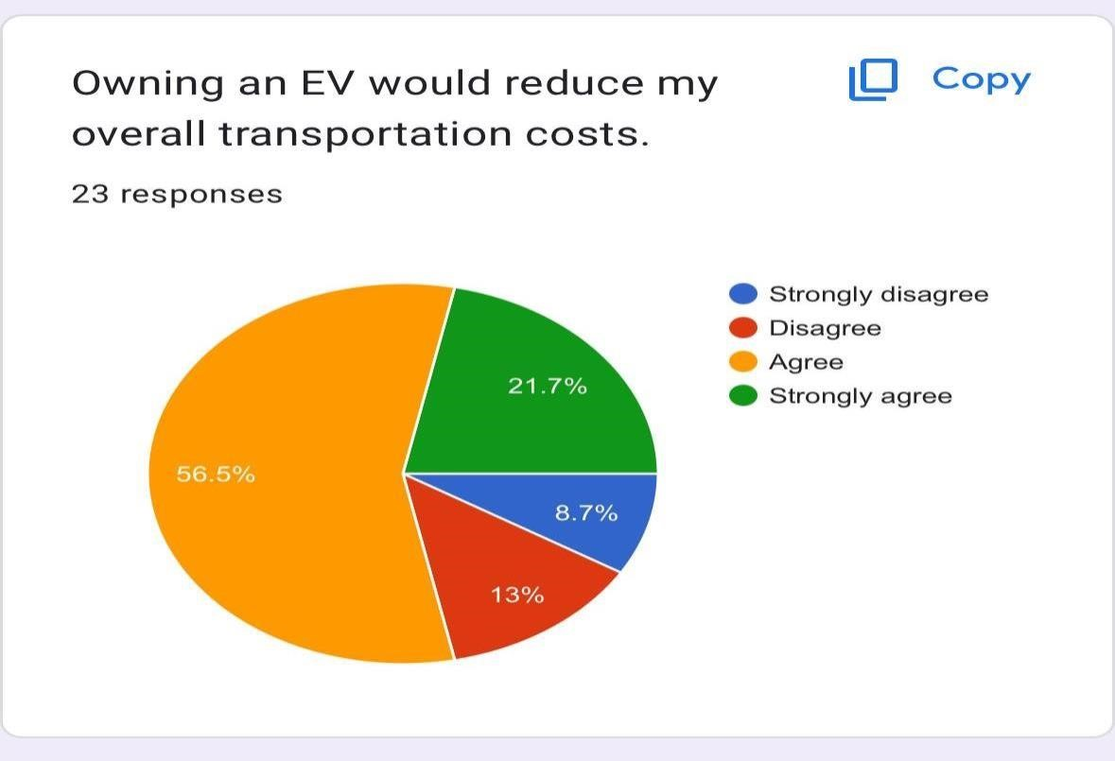

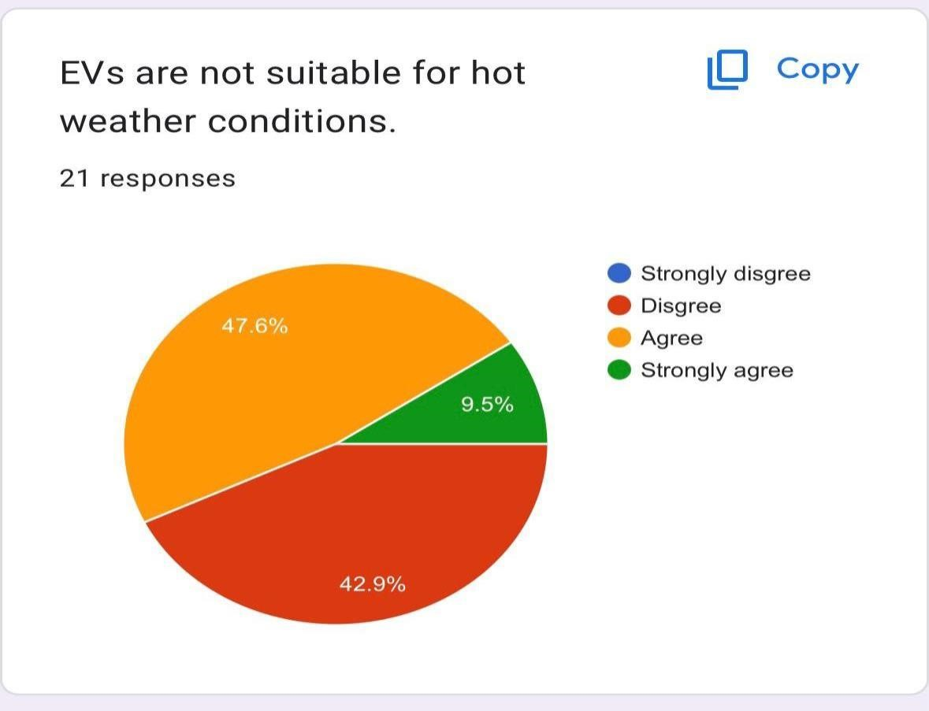
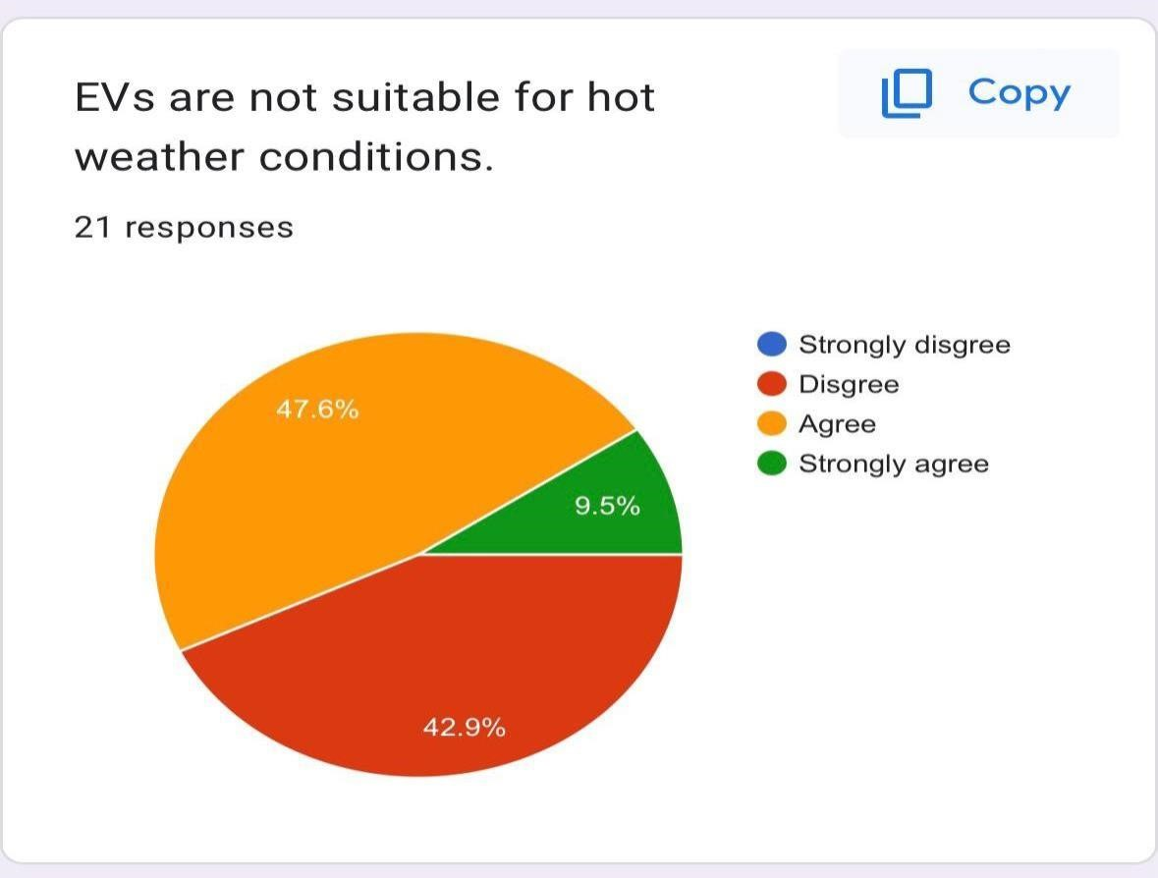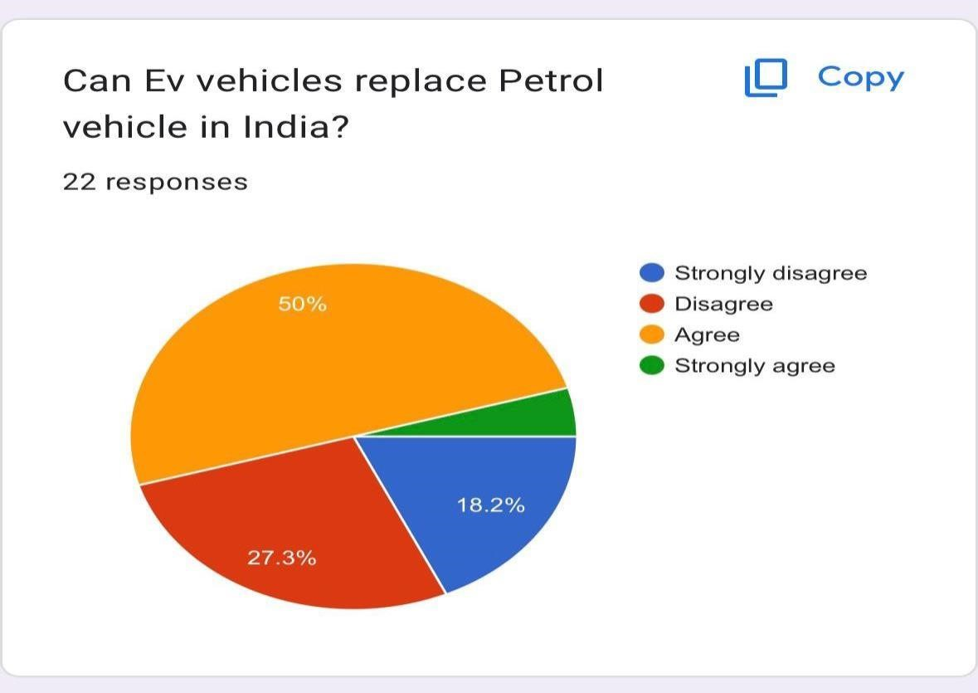
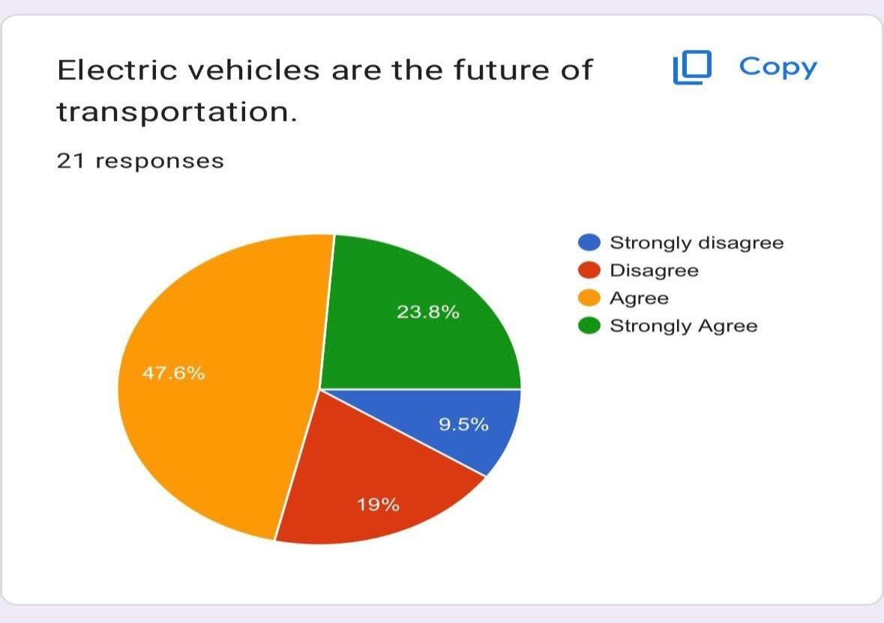

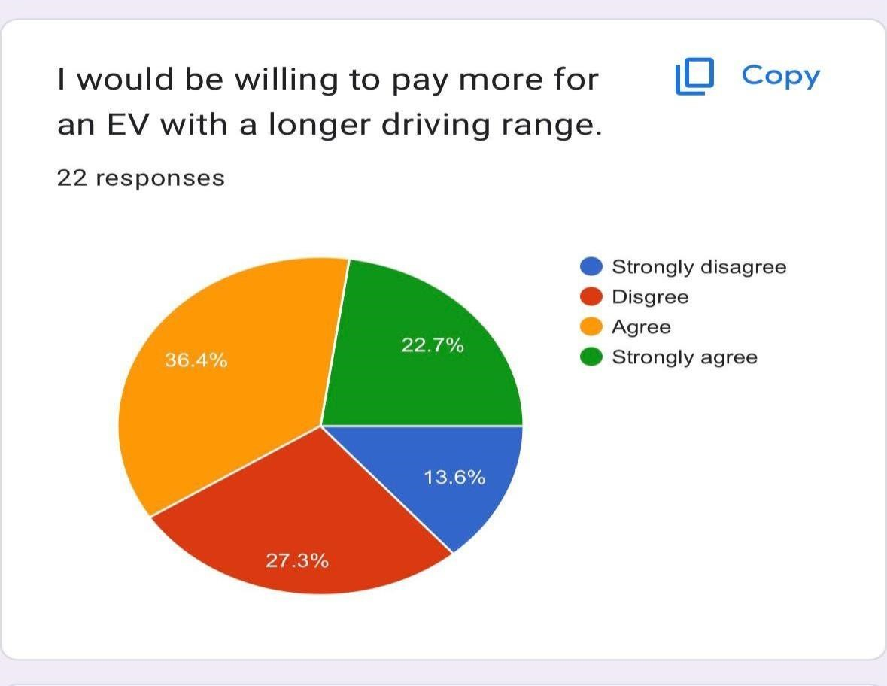
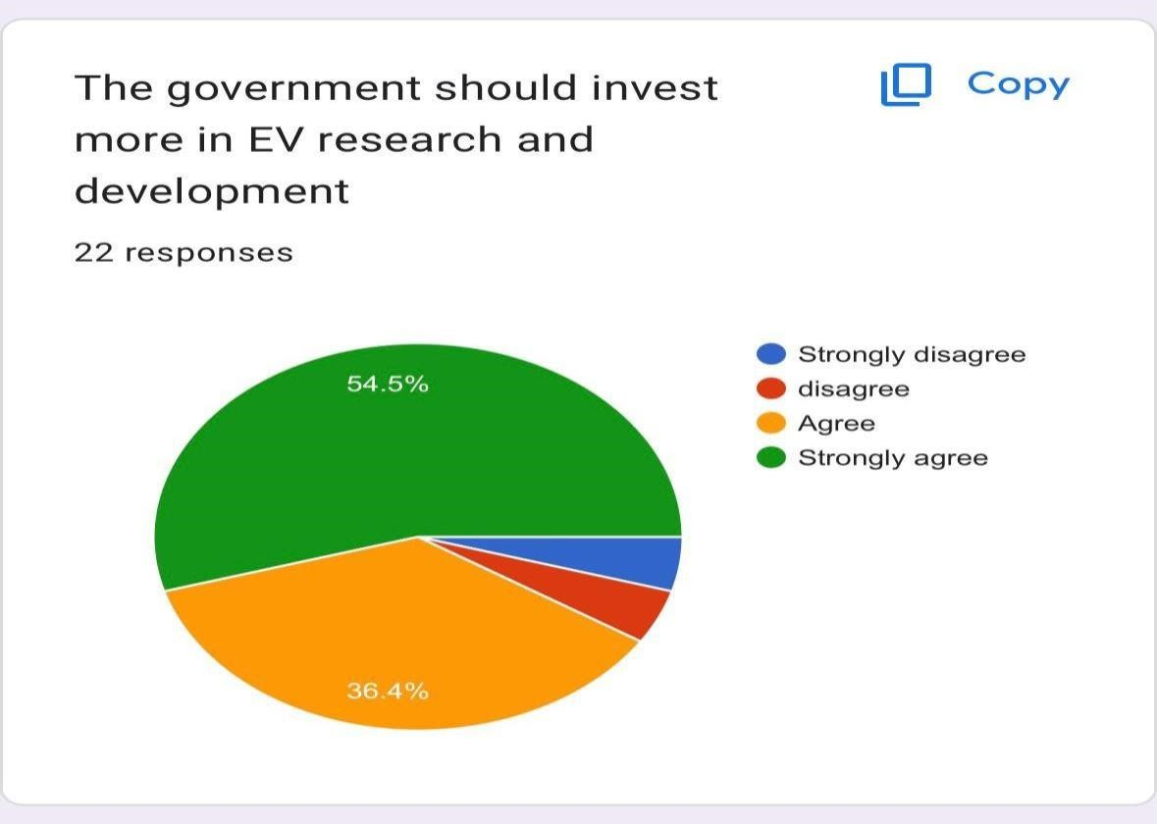

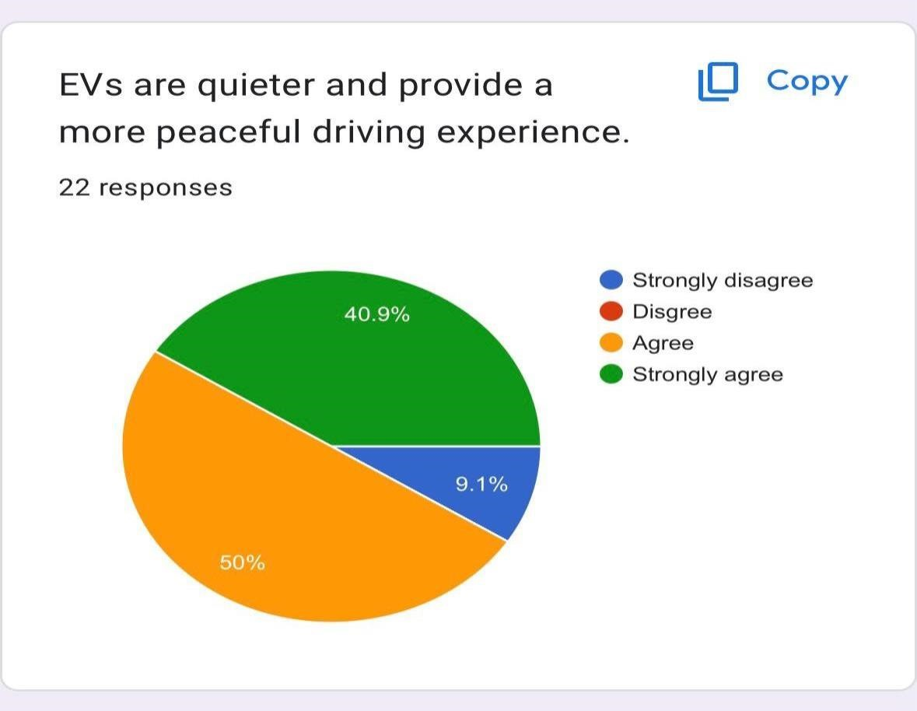
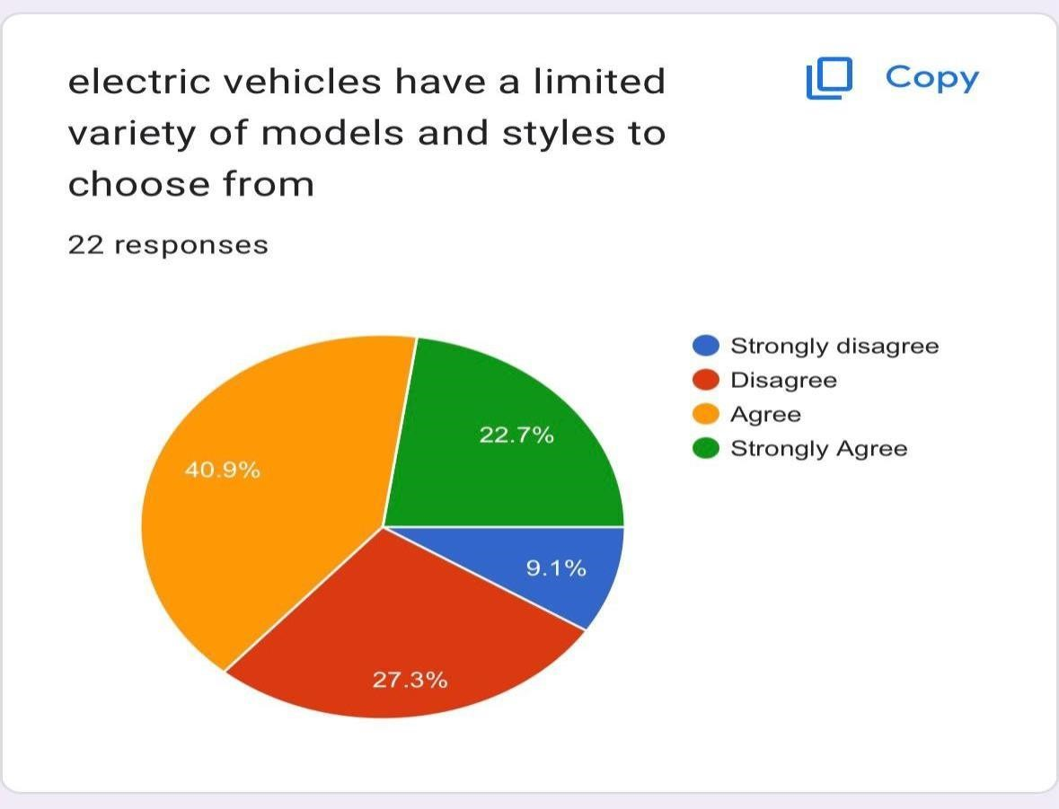

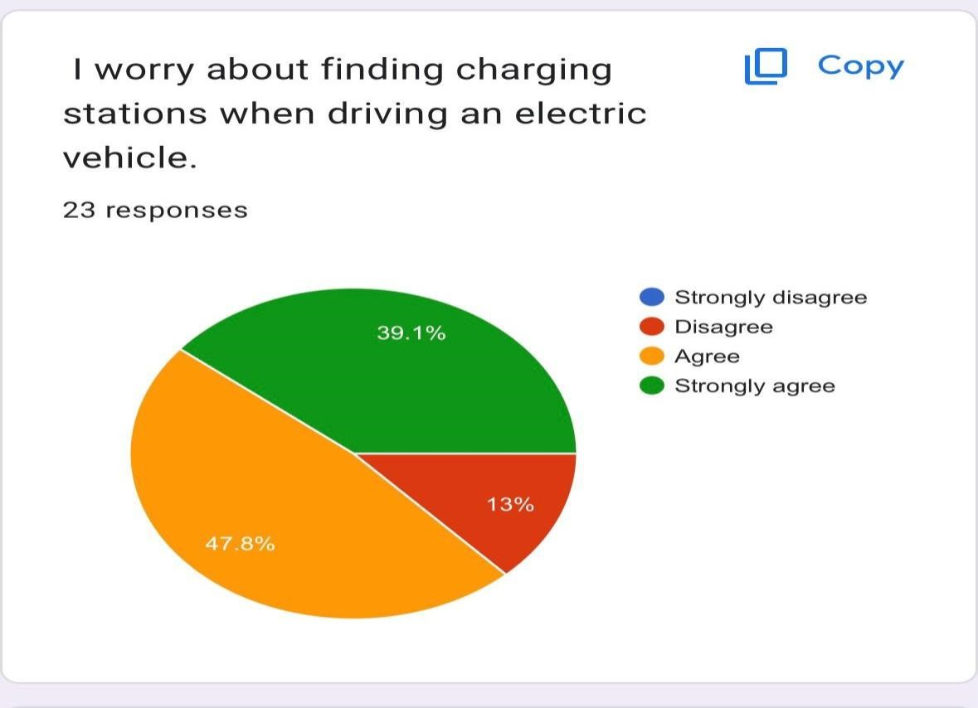
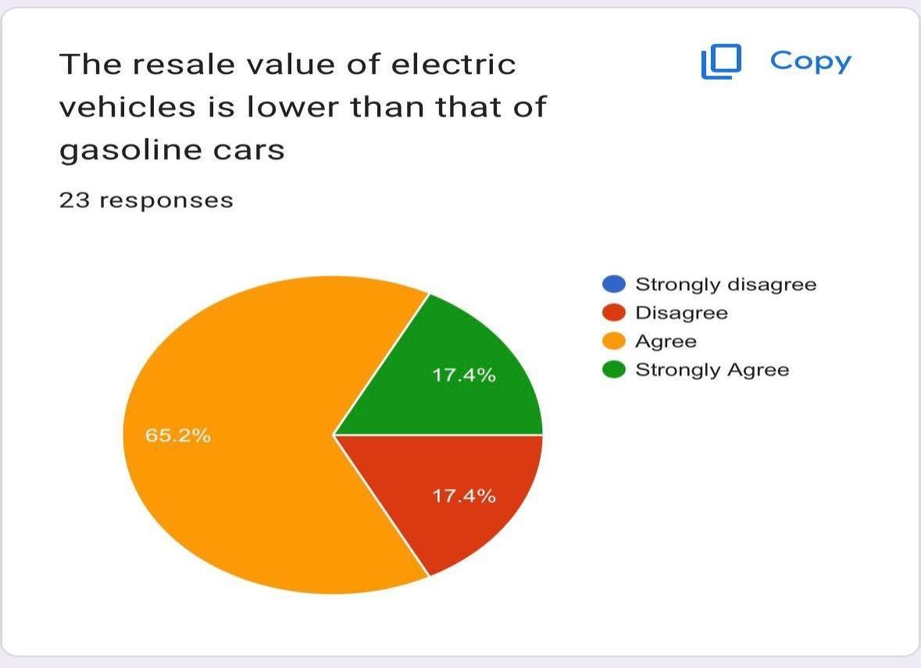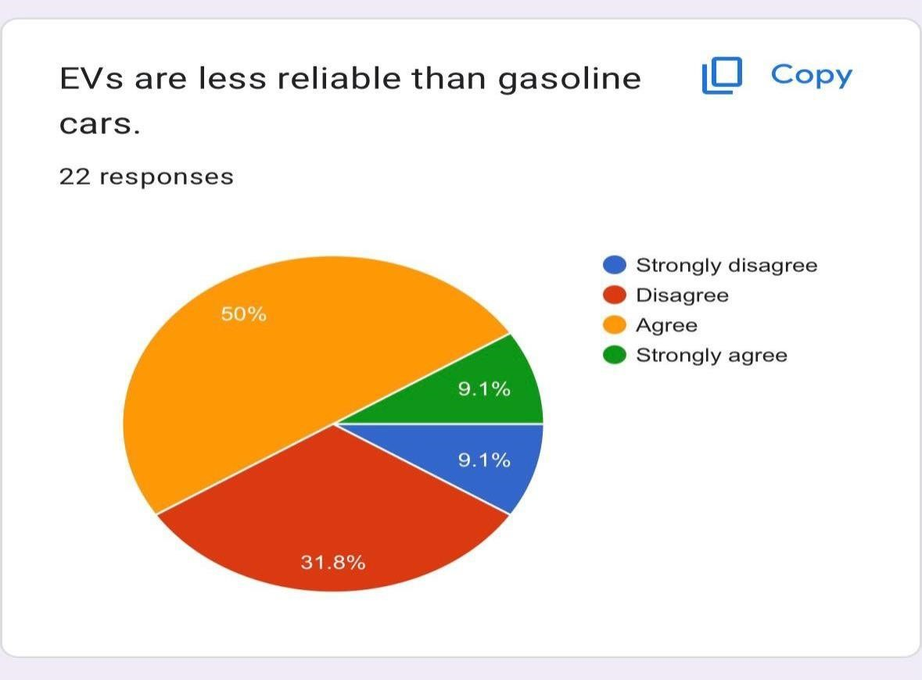
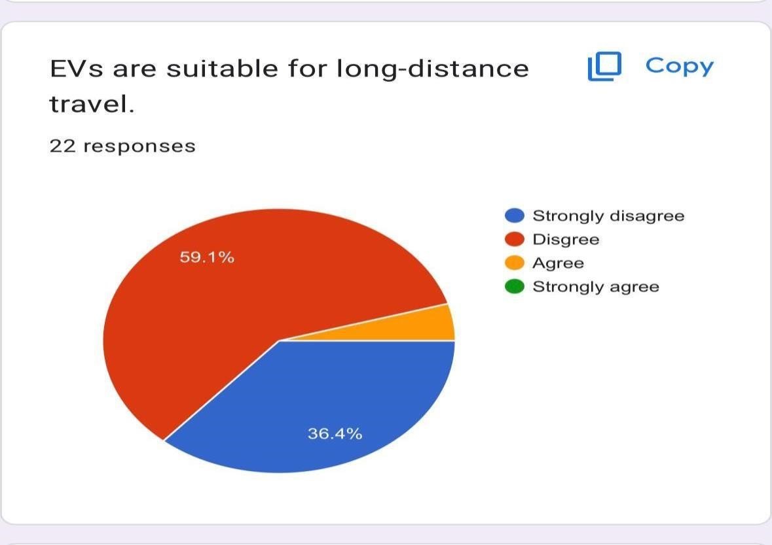

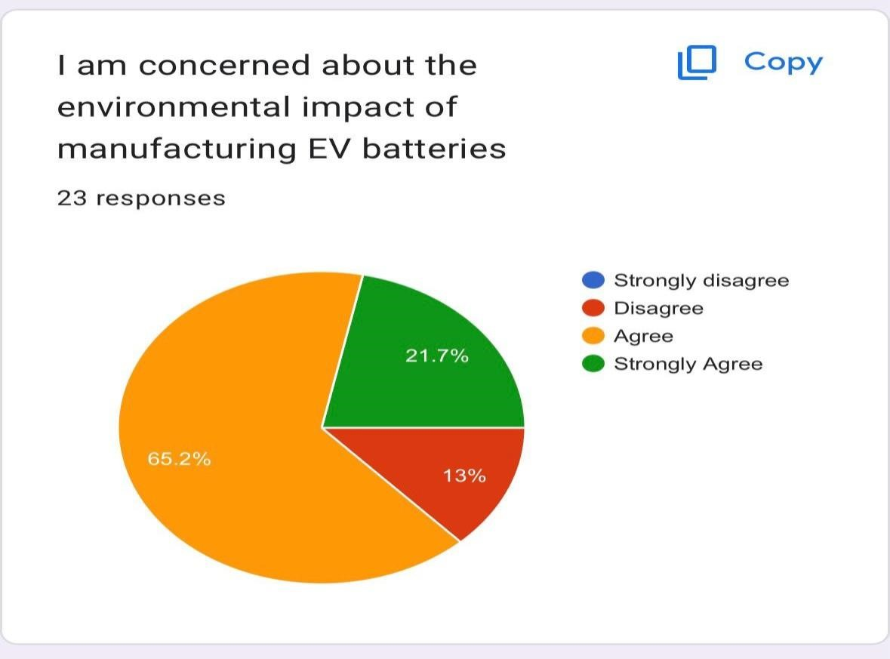
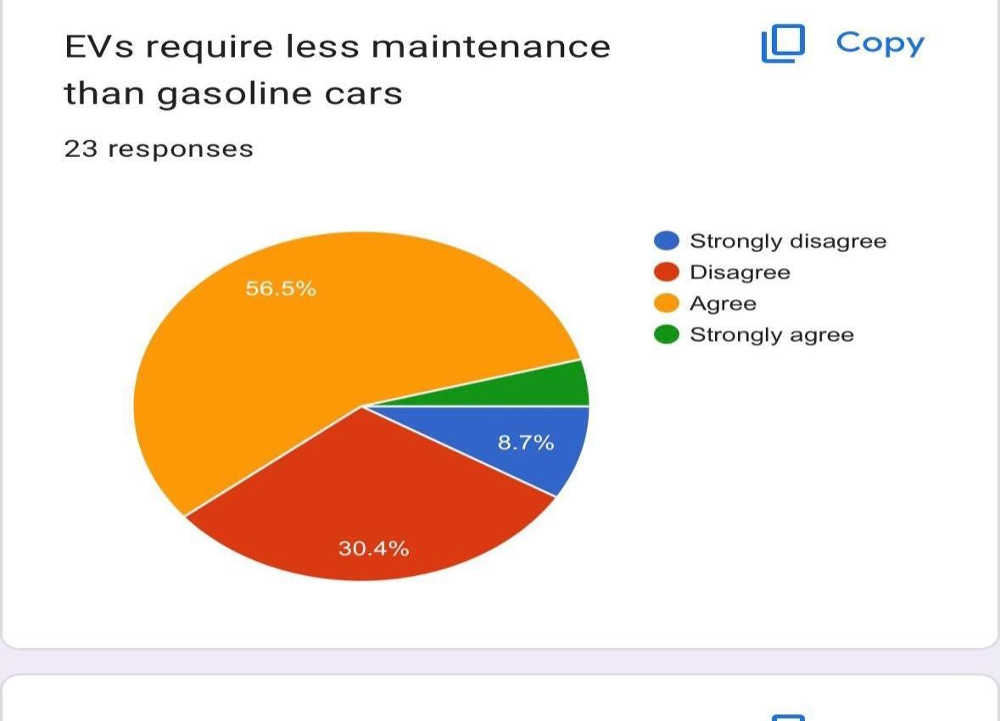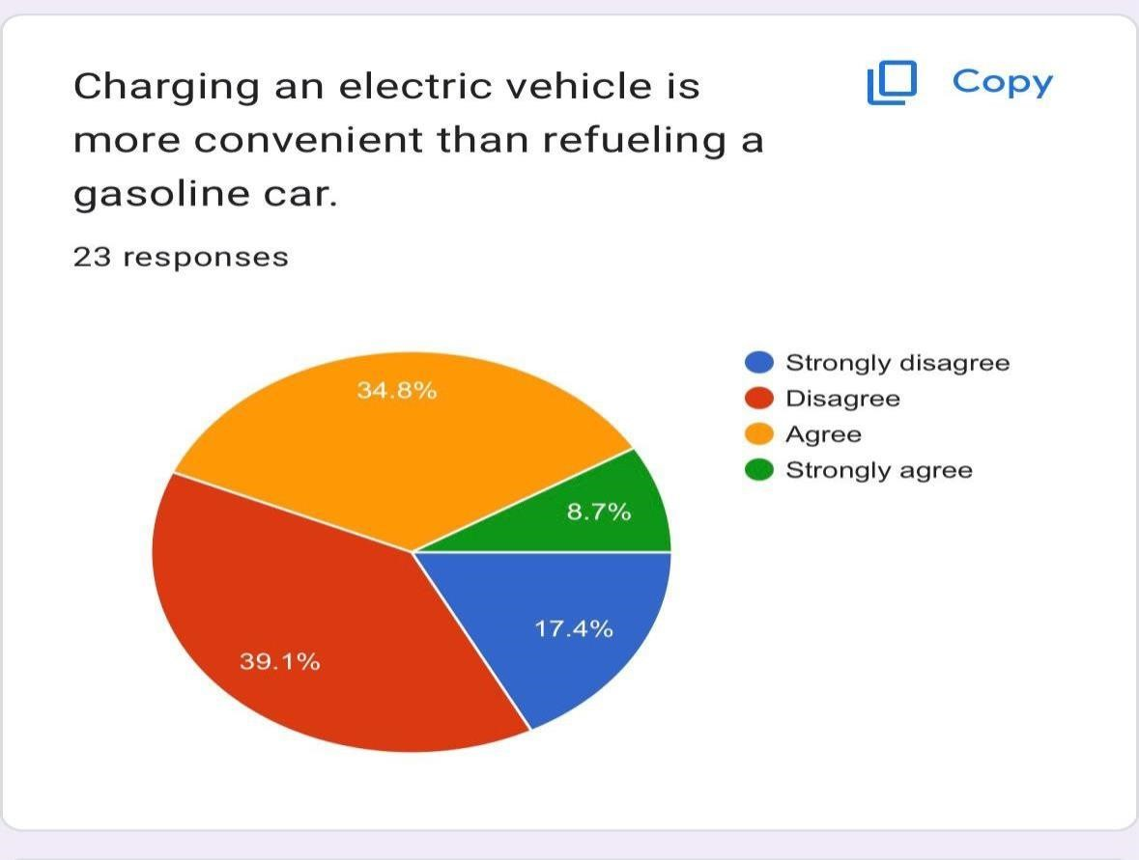
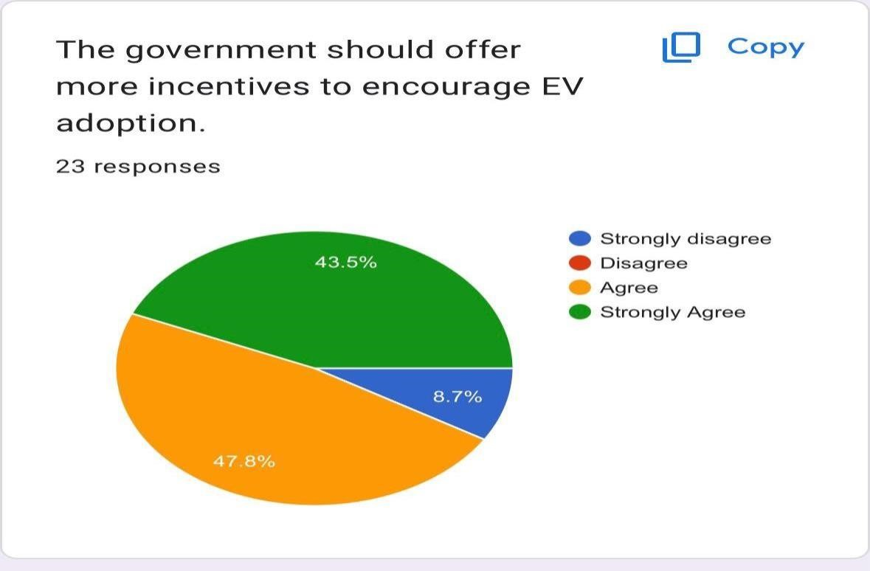

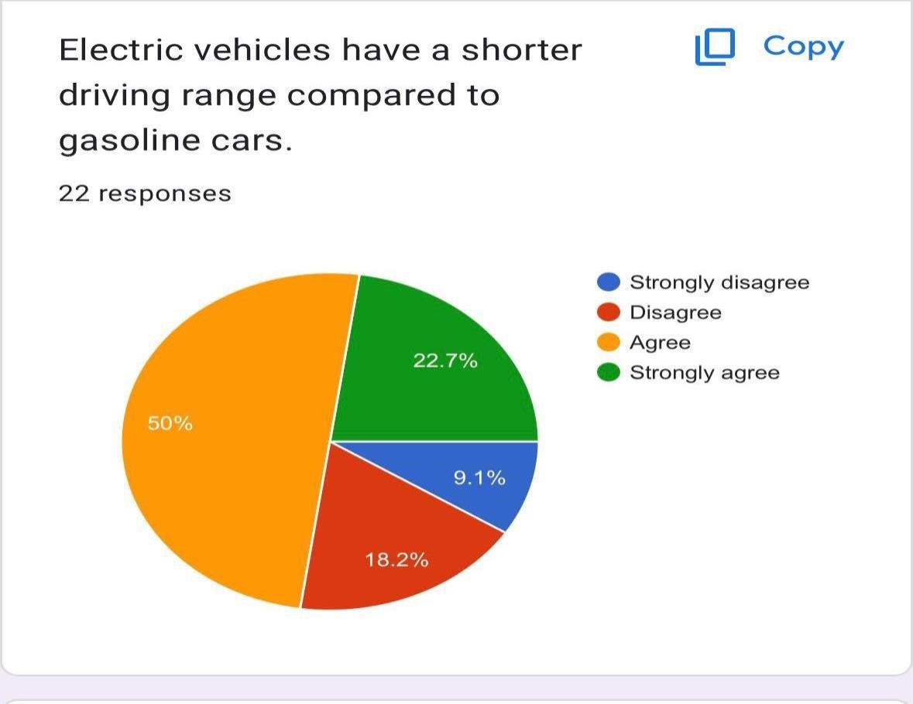
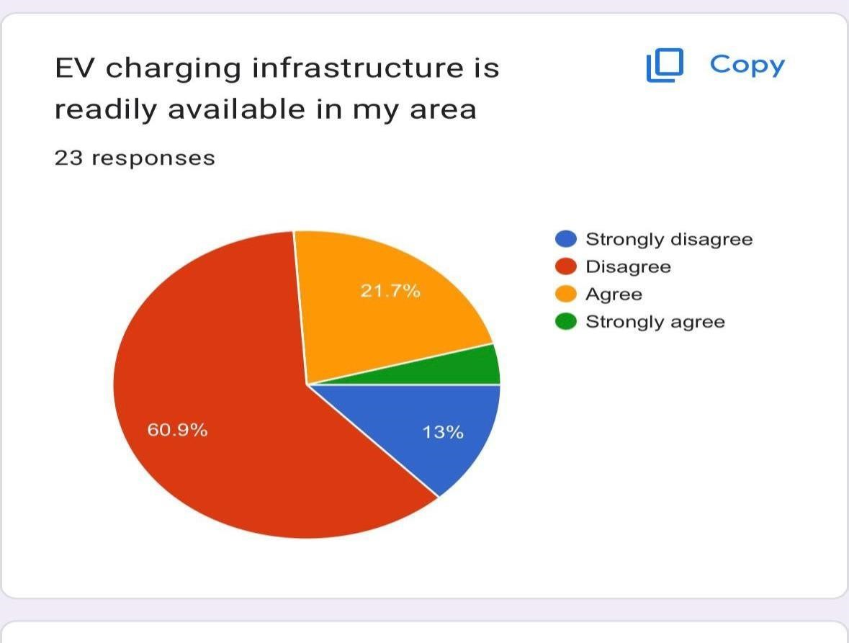

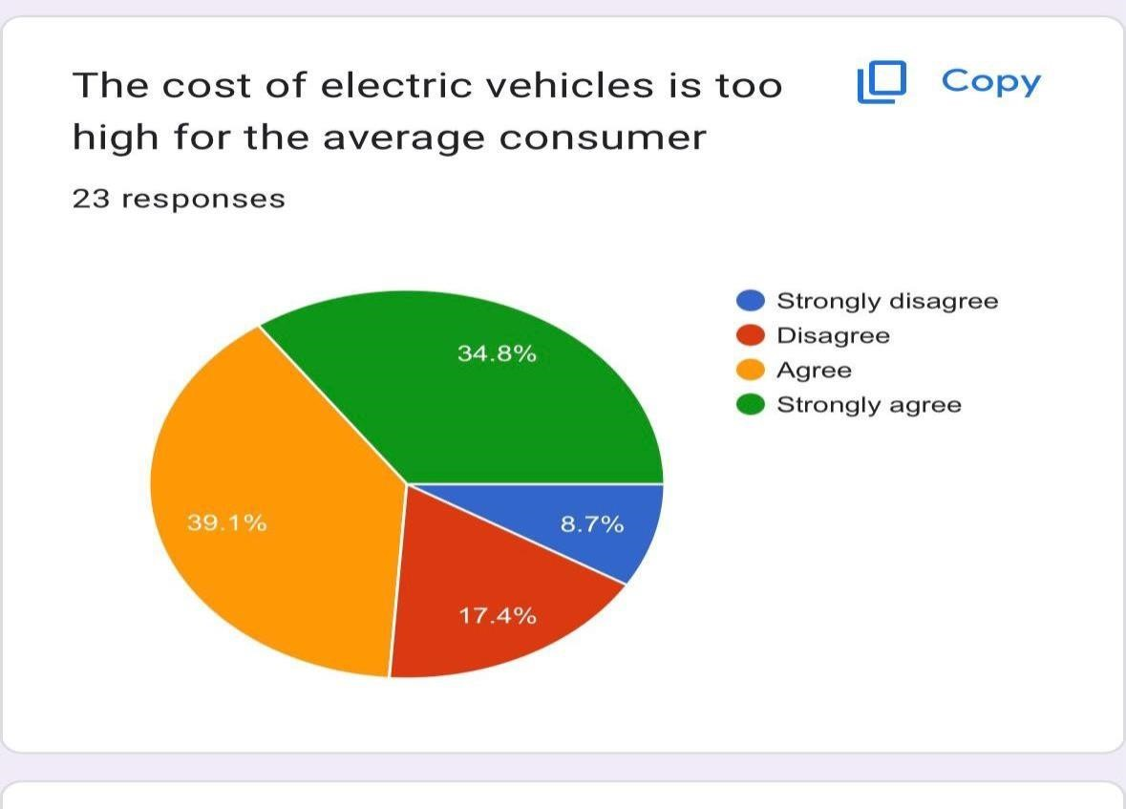
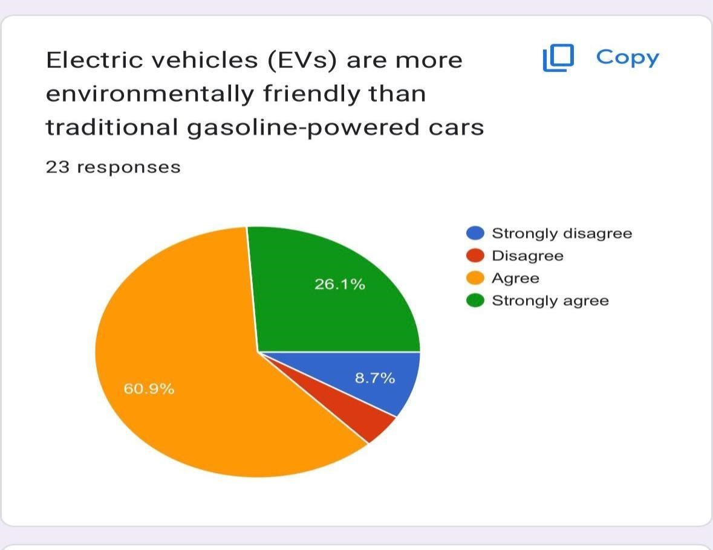

PRIMARY DATA
- We have used a combination of primary data and secondary data to collect the information.
- The data which we have collected through primary data provides us a deep understanding as to how people are accepting the EVs in the Indian market.
- 47.6% of the respondents agree that EV would be the future and nearly 36.4% of the respondents are ready to pay a higher price to purchase the electric vehicle and around 54.5% of respondents strongly agree that the government should invest in EV projects.
- As everything has pros and cons to it , Some of the cons that we have identified through the primary research are that 47.6% of the respondents agree that electric vehicles are not suitable during hot weather conditions and around 40.09% of the respondents agree that electric vehicles have limited varieties of models and styles to choose from and around 47.8% of the respondents agree that it is difficult to find the charging stations for these electric vehicles and are not available in most of the areas.
- And around 50% of respondents agree that electric vehicles are less reliable than gasoline vehicles and around 60% of the respondents agree that it is difficult to travel long distance using electric vehicles.

SECONDARY DATA
From the secondary data we have comprehended as to the adoption of EVs is reshaping the landscape of the Indian automobile industry. Here are the secondary findings:
- Growing Awareness and Interest: Various surveys have unveiled an escalating awareness and interest in EVs among the respondents. A noteworthy portion has expressed a readiness to contemplate EVs as their next vehicle purchase.
- Impact of Government Initiatives: Survey participants have recognized the significant influence of government incentives and policies in propelling EV adoption. Subsidies, tax advantages, and the enhancement of charging infrastructure emerged as pivotal drivers.
- Persistent Challenges: Despite the evident enthusiasm for EVs, obstacles such as range anxiety, limitations in charging infrastructure, and upfront expenses have been underlined as impediments to widespread adoption.
- Environmental Consciousness: The majority of survey participants have voiced concerns regarding environmental issues, with many regarding EVs as a positive step towards curbing emissions and ameliorating air quality.
- Encouraging Industry Growth: Our data paints a sanguine picture of the EV sector in India, with respondents anticipating sustained expansion, ushering in a more diverse array of EV alternatives.
- Aspirations for the Future: Respondents have exhibited keen interest in forthcoming developments, encompassing advancements in battery technology, extended driving ranges, and more cost-effective EV models.
- Innovation in Technology: Our study underscores the rapid strides made in electric vehicle (EV) technology, with a particular focus on battery advancements. These breakthroughs extend beyond merely extending driving ranges; they are also substantially decreasing charging times, a development that holds the potential to further expedite the adoption of EVs.
- Revolutionizing Urban Mobility: Our survey results shed light on the evolving perception of EVs as a solution to the challenges of urban congestion and pollution. A noteworthy portion of respondents expressed the belief that EVs possess the capacity to revolutionize urban mobility by reducing both traffic congestion and harmful emissions.
- Disrupting Established Automakers: The ascent of EVs has triggered significant disruptions within the traditional automotive sector. Respondents have astutely observed that well- established automakers are making the transition to EV production, marking a profound transformation in the industry's landscape.
- Enhancing Charging Infrastructure Accessibility: While acknowledging the existing hurdles, there is a prevailing sense of optimism concerning the expansion of charging infrastructure. Respondents anticipate a growing accessibility to charging stations, a pivotal factor in facilitating the widespread adoption of EVs in India.
- Prospects for Employment Growth: Our research findings underscore respondents' recognition of the potential for substantial job creation within the EV sector. With the industry's expansion, there is a collective expectation of increased employment opportunities, particularly in manufacturing and maintenance roles.
- Broader Environmental Gains: Beyond their impact on reducing greenhouse gas emissions, respondents have also emphasized the wider environmental benefits associated with EVs. These encompass a reduction in noise pollution, contributing to quieter urban environments, and a diminishing reliance on fossil fuels, resonating positively with those surveyed.

In light of these discoveries, it is evident that EVs have begun to exert a substantial impact on the Indian market. Nevertheless, addressing the challenges pinpointed in this study will be pivotal in ensuring the enduring growth of this sector. As the market undergoes transformation, the continuity of research and data collection will be indispensable in monitoring evolving consumer preferences and market trends. Overall to conclude we can say that nearly majority of the people agreed to adopt electric vehicles and contribute to the healthier environment by reducing the harmful emissions.

FURTHER STUDY:
Further study on the Impact of Electric Vehicles in India can focus on various aspects, such as:
- Extended Longitudinal Examination: Undertake a longitudinal study to monitor the changes in the Indian EV market over an extended duration. This approach would yield insights into the resilience and durability of observed trends, enabling the identification of patterns and anticipation of future developments.
- Comparative Regional Investigations: Broaden the research scope by conducting thorough comparative studies across various states and regions in India. Investigating regional disparities in EV adoption rates, infrastructure development, and policy effectiveness can inform targeted strategies for specific geographical areas.
- Comprehensive Consumer Surveys: Conduct more extensive consumer surveys to delve into the nuanced aspects of consumer behavior. Explore the psychological and social factors influencing EV adoption, address concerns, and pinpoint the specific preferences of diverse demographic groups.
- Technological Progress Assessments: Concentrate on the evolving technological landscape of EVs. Investigate the latest advancements in battery technology, charging infrastructure, and vehicle-to-grid integration. Evaluate how these advancements influence consumer perceptions and drive market growth.
- Public Perception and Awareness Evaluations: Conduct studies on public perception and awareness of EVs. Evaluate the effectiveness of awareness campaigns and educational initiatives designed to inform the public about the benefits, dispel myths, and elucidate the realities of EV ownership.
- Policy Impact Analysis: Undertake a thorough assessment of the impact of government policies and incentives on the EV market. Analyze the effectiveness of existing policies, propose enhancements, and explore innovative policy measures to further catalyze EV adoption.
- Collaborative Industry Research: Foster collaboration with EV manufacturers, energy providers, and other stakeholders. Conduct joint research initiatives to gain real-time insights into industry strategies, challenges, and opportunities. This collaborative approach can enhance the practicality of research findings.
- Cross-Cultural Investigations: Expand the research scope to encompass cross-cultural studies that compare the adoption and impact of EVs in other countries with similar or varying socio-economic conditions. Extract valuable lessons and best practices from global experiences that can be applied to the Indian context.
- Impact on Employment and Skill Development: Investigate the employment dynamics within the EV industry. Explore how the growth of EV manufacturing and infrastructure development contributes to job creation and assess the skill requirements for the evolving workforce.
- Public-Private Collaborative Studies: Explore the role of public-private partnerships in accelerating the growth of the EV market. Assess collaborative initiatives between government bodies, private businesses, and non-profit organizations in promoting sustainable transportation solutions.
- Urban Planning and Infrastructure Integration: Examine the integration of EVs into urban planning and infrastructure development. Assess how cities can optimize EV usage through smart city planning, dedicated EV lanes, and enhanced charging infrastructure.
- Cross-Industry Influence: Investigate the broader impact of EV adoption on related industries such as the energy sector, raw material supply chains, and urban development. Understand how the shift to EVs influences and shapes these interconnected sectors.

CONCLUSION:
In conclusion, the research on the impact of Electric Vehicles (EVs) on the Indian market sheds light on the transformative journey of the automotive industry in the country. As we navigate the complexities of a rapidly evolving landscape, the study has unraveled the intricate threads that connect the adoption and growth of EVs to various facets of India's economy, environment, and society.
The research outcomes emphasize the pivotal role of EVs in shaping the future of transportation in India. Witnessing a paradigm shift from traditional vehicles, the automotive market is undergoing substantial changes as EVs gain prominence. The study meticulously scrutinized the growth path of the EV market, uncovering valuable insights into its expanding reach, market share, and the driving forces behind this evolution. With consumers increasingly contemplating EVs for their next vehicle acquisition, it becomes imperative to comprehend their attitudes, motivations, and concerns. The research delves into consumer behavior, unraveling the intricate interplay of perceptions and intentions influencing the adoption or hindrance of electric vehicles.
Government policies and incentives play a decisive role in steering this transition, and the study assesses their efficacy in encouraging EV adoption and curbing emissions. It thoroughly examines the impact of regulatory measures, subsidies, and tax benefits, providing a comprehensive view of the policy landscape shaping the future of sustainable transportation in India.
Charging infrastructure emerges as a pivotal facilitator for widespread EV adoption, and the research evaluates its development and accessibility across diverse regions in India. Recognizing the crucial role of charging stations in enhancing the convenience and viability of EVs, especially in urban and rural areas, is a key aspect of the study.
Environmental considerations take center stage in the research, with a meticulous examination of the positive impacts of EVs on air quality and greenhouse gas emissions. As India grapples with environmental challenges, the study underscores the role of EVs in contributing to a cleaner and more sustainable future.
The research explores the economic ramifications of the EV industry, emphasizing its potential for job creation and investments. Traditional automotive manufacturing faces a transformative shift, and the study delves into the economic implications of this evolution.
Regional variations, consumer demographics, and manufacturer strategies are intricately incorporated into the fabric of this research, providing a nuanced understanding of the diverse factors influencing the EV landscape in different parts of India.
In essence, this research not only illuminates the present state of the Indian automotive market but also serves as a guiding compass towards a more sustainable, eco-friendly, and technologically advanced future. The multifaceted consequences of the increasing prevalence of EVs in India, as revealed by this study, serve as a roadmap for policymakers, industry leaders, and consumers alike. The insights garnered can inform informed decisions and actions in the pursuit of a cleaner, greener, and more efficient automotive ecosystem in the country.

REFERENCES:
Vidhi, R., & Shrivastava, P. (2018). A review of electric vehicle lifecycle emissions and policy recommendations to increase EV penetration in India. Energies, 11(3), 483. https://doi.org/10.3390/en11030483
Sharma, A., Kapoor, A., Prof. Saikat Chakrabarti, & Department of Electrical Engineering, Indian Institute of Technology Kanpur, Kanpur, India. (2019). Impact of plug-in electric vehicles on power distribution system of major cities of India: a case study. http://home.iitk.ac.in/~ansharma/EV_Report_V1.pdf
Goel, S., Sharma, R., & Rathore, A. K. (2021). A review on barrier and challenges of electric vehicle in India and vehicle to grid optimisation. Transportation Engineering, 4, 100057. https://doi.org/10.1016/j.treng.2021.100057
Das, P. K., & Bhat, M. Y. (2022). Global electric vehicle adoption: implementation and policy implications for India. Environmental Science and Pollution Research, 29(27), 40612–40622. https://doi.org/10.1007/s11356-021-18211-w
Tyagi, B., Sasidharan, C., Das, S., & Alliance for an Energy Efficient Economy (AEEE). (2019). A case study on potential impact of Electric Vehicle charging for an electricity distribution utility in India. In 2nd Int’l Conference on Large-Scale Grid Integration of Renewable Energy in India. https://regridintegrationindia.org/wp-content/uploads/sites/14/2019/11/10C_4_RE_India19_125_paper_Sasidharan_Chandana.pdf
Singh, V., Singh, V., & Vaibhav, S. (2021). Analysis of electric vehicle trends, development and policies in India. Case Studies on Transport Policy, 9(3), 1180–1197. https://doi.org/10.1016/j.cstp.2021.06.006
Nimesh, V., Sharma, D., Reddy, V. M., & Goswami, A. K. (2020). Implication viability assessment of shift to electric vehicles for present power generation scenario of India. Energy, 195, 116976. https://doi.org/10.1016/j.energy.2020.116976

