

Project
Centric
Learning

Submitted
in
partial
fulfilment
of
the
requirement
of
the
Bachelor
of
Business
Administration
Program
Offered
by
Jain
[
Deemed
to
be
University]
during
the
year
2021-2022
By
Reg
No.
Sem
Name
of
student
21BBAR0269

th
6

JAI KALLIANPUR

21BBAR0577
th
6

ROHAN RAJ
21
0004
BBAR
6
th

ABHAYA KUMAR A
21BBAR0639

6th

SARODE AISHWARYA RAM
21BBAR
0372

6th
MEGHANA H R

Under
the
guidance
of
Prof.
Thanga
Kumar

#133,
LalBagh
Road,
Bengaluru
–
560027
India
|
Phone:
+91
804
343
0200
E-mail:
info@cms.ac.in
|
Website:
n
www.cms.ac.i
GUIDE CERTIFICATE
CERTIFICATE
This is to certify that this project titled “A study on diversifying portfolio using alternate investments with special reference to real estate” and its information credibility is a record of the original and independent work carried out by Team Members name:

1. Rohan Raj

2. Jai Girish kallianpur

3. Abhaya Kumar A
4. Sarode Aishwarya Ram
5. Meghana H R
Under my guidance and supervision. This has not previously formed the basis of the award of any degree/diploma or other similar title of recognition.
Date: 20/03/2024
Place: Bangalore Guide’s Signature:
1.
2.
DECLARATION
We,
hereby
declare
that
the
Project
titled

“A study on diversifying portfolio using alternate investments with special reference to real estate”

credibility
with
particular
reference
to
companies
operating
in
Bangalore
is
prepared
by
us
during
the
academic
year
2023
–
2024
under
the
guidance
of
Prof.
THANGAKUMAR

This
project
is
not
based
on
any
previously
submitted
project
for
the
award
of
any
degree
or
diploma
offered
by
any
university.
It
is
the
result
of
our
own
effort.
Reg
No.
Sem
Name
of
student
Signature
of
the
students
BBAR
0577
21
th
6
ROHANN
RAJ
BBAR
0269
21
th
6
JAI KALLIANPUR

21
0004
BBAR
6
th
ABHAYA
KUMAR A
21BBAR0639

6th

SARODE AISHWARYA RAM

21BBAR
0372

6th
MEGHANA H R

Date: 20/03/2024
Place: BANGALORE
Signature:
ACKNOWLEDGEMENT
It
is
of
great
pleasure
that
we
take
this
opportunity
to
acknowledge
and
express
our
gratitude
to
all
those
who
helped
us
throughout
our
project.
First
of
all,
we
would
like
to
thank
the
almighty
for
helping
us
in
successfully
completing
our
project.
We
are
grateful
to
Dr.
DINESH
NILKANT
–
Director,
Jain
(
Deemed
to
be
University)
-
Centre
for
Management
Studies
for
providing
this
opportunity.
It
is
our
duty
to
express
a
deep
sense
of
gratitude
to
our
project
guide’s
Prof.
Thanga
Kumar

for
his
valuable
suggestions
and
guidance
throughout
the
work.
This
task
never
gets
completed
without
the
mention
of
our
beloved
parents,
family
members
and
friends,
who
cooperated
with
us
in
every
way.
No.
Sem
Name
of
student
21
0577
BBAR
6
th

ROHAN RAJ
21
0269
BBAR
6
th
JAI KALLIANPUR

BBAR
0004
21
th
6
ABHAYA
KUMAR A

21BBAR0639

6th

SARODE AISHWARYA RAM

21BBAR

6th
MEGHANA H R

TABLE OF CONTENTS

SLNO. | PARTICULARS | PAGE NO.
1 | COVER PAGE, GUIDE CERTIFICATE, ACKNOWLEDGEMENT AND DECLARATION
2 | TABLE OF CONTENTS
3 | INTRODUCTION
4 | OBJECTIVE
5 | REVIEW OF LITERATURE
6 | RESEARCH GAP
7 | DATA COLLECTION
8 | SWOT ANALYSIS
9 | INTERPRETATION
10 | OVERALL ANALYSIS
11 | FINDINGS
12 | CONCLUSION
13 | SUGGESTIONS
14 | REFERENCES

INTRODUCTION:
Diversification is a fundamental component of a wise investing plan, since it functions as a mechanism for mitigating risk and optimising returns. The conventional approach to portfolio diversification, which has historically focused on equities and bonds, is undergoing a transformation. Contemporary investors recognise the imperative of adopting a more extensive array of investment alternatives, sometimes referred to as alternative investments. The real estate sector has emerged as a promising and powerful asset class that warrants careful attention within the broader economic landscape.

The present study investigates the tactics and advantages associated with the diversification of investment portfolios by integrating alternative assets, with a specific focus on the realm of real estate. The conventional practise of prioritising stocks and bonds as the principal investment vehicles is becoming increasingly recognised as insufficient in the quest for achieving optimal risk-adjusted returns. Alternative assets, such as real estate, have gained popularity as they possess the ability to enhance and diversify investment portfolios.
The core premise that serves as the foundation for portfolio diversification is the judicious allocation of investments across several asset classes, resulting in a decreased vulnerability to individual risks. Conventional assets are susceptible to the fluctuations and changes in market dynamics and economic trends, whereas alternative investments, such as real estate, generally demonstrate a lower association with traditional markets. The aforementioned attribute establishes real estate as a potentially effective tool for stabilising investment portfolios, as it has the ability to reduce risks and improve overall portfolio stability.

Real property refers to a physical asset that possesses intrinsic value and practical usefulness. The property possesses distinctive attributes, such as the possibility for generating rental income and experiencing appreciation in value, which render it an appealing option for alternative investment. Additionally, investments in real estate offer tax benefits and serve as a safeguard against inflation, so increasing their attractiveness for the purpose of diversifying one's investment portfolio.

The scope of real estate investments encompasses several categories such as residential, commercial, and industrial buildings, alongside real estate investment trusts (REITs). The presence of diversity allows investors to adjust their level of real estate investment in accordance with their individual risk tolerance, investment timeframe, and overall financial goals. The objective of this study is to explore the intricacies of real estate investment options, shedding light on the ways in which investors can strategically utilise real estate as part of a diversified portfolio.

OBJECTIVE:
The objective of this study is to provide investors with a comprehensive viewpoint by analysing the inherent risks and challenges associated with real estate investing. Despite the alluring potential for attractive returns, real estate investments are not immune to many dangers, including market volatility, economic downturns, and property-specific challenges. Investors must possess a thorough comprehension of these risks in order to make well-informed selections and establish a diversified investment portfolio.
This research paper will look at real estate as an alternative investment to diversify investment portfolios. This study attempts to analyse the potential benefits and risks associated with adding real estate assets to conventional investment portfolios, with an emphasis on how such diversification can improve risk-adjusted returns, provide income stability, and reduce the impact of market volatility. This study will also look at alternative ways and tactics for incorporating real estate holdings into various portfolios, providing insights into asset allocation and portfolio development procedures.This study investigates the relationship between portfolio diversification and real estate in order to provide investors, financial experts, and policymakers with relevant insights into the possible benefits of adopting real estate as an alternative asset class to accomplish long-term financial objectives.
The objective of this study is to assess and examine the potential advantages and risks associated with portfolio diversification through the inclusion of alternative assets, with a specific focus on real estate. This study aims to comprehensively understand the impact of incorporating real estate assets into an investment portfolio on risk-adjusted returns and diversification benefits compared to conventional asset classes. The study will examine several methodologies for integrating real estate into a diversified investment portfolio, including factors such as market dynamics, property types, geographical locations, and investment durations. In addition, the research will evaluate the potential diversification techniques offered by real estate investment trusts (REITs), real estate crowdfunding, and direct property ownership. The study will additionally examine the legal framework and tax considerations associated with incorporating real estate investments into a diversified portfolio. This study endeavours to offer valuable insights into the performance and correlation of real estate investments with conventional asset classes through the use of empirical analysis and case studies. Moreover, the objective of this study is to offer investors, financial planners, and asset managers with insights and guidelines on the strategic utilisation of real estate as a means to enhance portfolio diversity, achieve superior risk-adjusted returns, and fulfil long-term investment goals. Ultimately, the objective is to contribute to the existing corpus of knowledge in the field of investment management by offering a comprehensive comprehension of the function of real estate as a viable alternative investment for the purpose of portfolio diversification.
This study's primary objective is to analyse and conduct research on the advantages, disadvantages, and potential outcomes of diversifying an investment portfolio by incorporating alternative assets, with a primary concentration on the real estate market. This study attempts to provide a thorough understanding of how diversifying a portfolio with real estate assets can increase risk-adjusted returns and provide advantages over traditional asset classes.

This study's objective is to examine the various strategies that can be utilised to include real estate assets in a diversified investment portfolio. This investigation will concentrate on market dynamics, as well as various property categories, geographical locations, and investment horizons. The creation of a competent diversification plan that optimises the risk and return characteristics of the portfolio will be greatly aided by a comprehensive comprehension of these aspects.
In addition, the significance of real estate investment vehicles as potential diversification alternatives, such as Real Estate Investment Trusts (REITs), real estate crowdfunding, and direct property ownership, will be investigated in depth over the course of this study. This study attempts to provide a comprehensive overview of the various options available to investors who wish to diversify their portfolios through real estate investments by undertaking an in-depth analysis of the benefits and limitations of each methodology.
In addition, the research will investigate the regulatory environment and the tax implications of real estate investment, with the intention of providing a comprehensive understanding of the legal framework and financial elements involved in diversifying one's investment portfolio through real estate. The objective of this study is to provide a thorough comprehension of the legal framework and financial considerations involved in diversifying one's investment portfolio through real estate. This necessitates undertaking an analysis of the potential effects of taxation and regulation on the investment decisions and profits of investors.

Using empirical analysis and case studies, this study will compare the performance of traditional asset classes to that of real estate investments in order to establish a solid foundation for the theoretical framework. Through an in-depth analysis of historical data and the application of real-world examples, the objective of this study is to provide a wealth of knowledge regarding the interrelationships, risk, and return characteristics of real estate when it is included in a diversified investment portfolio. The primary objective of this research is to provide investors, financial planners, and asset managers with insightful recommendations and guiding principles regarding the strategic incorporation of real estate to enhance portfolio diversification. These recommendations and guidelines will be presented within the context of the strategic incorporation of real estate to promote portfolio diversification. The primary objective of this study is to provide evidence-based solutions and insights to various investment community stakeholders. The objective is to provide them with access to the necessary materials so they can make well-informed decisions that are consistent with their long-term investment objectives. By augmenting our understanding of the importance of real estate as an attractive diversification option for investment portfolios, this study aims to contribute to the rapidly expanding field of investment management. Specifically, we hope to contribute to this discipline by advancing the investment management field.

In summary, the objective of this study is to offer a full understanding of the role played by alternative investments, with a specific focus on real estate, in the process of portfolio diversification. By conducting a thorough analysis of the potential advantages and obstacles linked to the incorporation of real estate into investing plans, our aim is to provide investors with vital knowledge and understanding. By utilising this knowledge, investors have the ability to enhance the efficiency of their investment portfolios, effectively manage unpredictability, and actively pursue sustainable development within the present dynamic and ever-changing financial landscape

Review of literature:
Literature study concentrating on portfolio diversification through alternative investments, with a special emphasis on real estate, and accompanying citations:

1. Diversification and Modern Portfolio Theory:
- Harry Markowitz's (1952) Modern Portfolio Theory (MPT) serves as the core framework, arguing for diversification to optimise risk-adjusted returns in investment portfolios.

2. Real Estate's Role in Diversification:
- Hoesli and MacGregor (2000) emphasise the integration of real estate in investment portfolios to increase diversification benefits, stressing its ability to reduce overall risk.

3. Real Estate Risk-Return Profile:
- Gallimore, Stevenson, and Webb (2010) investigate the risk-return characteristics of real estate investments, illuminating how real estate can be a vital component in achieving a balanced risk-return profile.

4. Asset Allocation and Correlation Analysis:
- Liang and McIntosh (2008) investigate the relationship between real estate and traditional asset classes, demonstrating how including real estate can improve portfolio diversity and risk-adjusted returns.

5. Real Estate Investment techniques: Miles and McCue (1984) explain the advantages and disadvantages of various real estate investment techniques such as direct ownership, Real Estate Investment Trusts (REITs), and real estate partnerships.

6. Measuring the Performance of Real Estate Investments:
- Pagliari and Saunders (2008) dig into real estate performance measuring tools such as Net Asset Value (NAV) and Internal Rate of Return (IRR), providing insights into assessing real estate investment performance.

7. Factors Affecting Real Estate Investing:
- Geltner and Mei (1995) investigate the elements that influence real estate investments, including interest rates, economic indicators, and market dynamics, to gain a better knowledge of the real estate investment landscape.

8.Real Estate Investment Trusts and Portfolio Diversification:
- Hoesli and Reka (2013) examine the function of Real Estate Investment Trusts (REITs) in portfolio diversification, assessing their ability to improve risk-adjusted returns in a diversified investment portfolio.

9. Private Real Estate Investments vs. Public Real Estate Investments:
- Mei and Lee (1994) examine the variations in risk-return profiles of private and public real estate investments, as well as the implications for portfolio diversification.

10. Real Estate Market Dynamics: Geltner and Miller (2001) provide insights into real estate market dynamics, including market cycles and their impact on real estate investments, which is useful for building diversified portfolios with real estate exposure.

This study of the literature covers several aspects of diversifying portfolios with alternative investments, with a focus on integrating real estate to obtain optimal risk-adjusted returns. It includes significant publications, empirical investigations, and analytical techniques pertinent to the topic.

Research gap:

Identifying research gaps in a study on diversifying a portfolio with alternative investments, particularly real estate, is critical for moving the industry forward. Here are several research gaps that could be investigated:

1. Long-Term Real Estate Impact: Research the long-term effects of real estate investments on portfolio diversification. Is there a time horizon where real estate exhibits greater benefits, and what elements contribute to this?

2. Geographical Diversification: Investigate how geographical diversification in real estate investments influences total portfolio risk and return. Are there best practises for selecting real estate assets in various regions?

3. Real Estate Asset Classes: Learn more about the performance of various real estate asset classes, such as residential, commercial, industrial, and retail buildings, and how they contribute to portfolio diversification.

4. Market circumstances and Economic Factors: Examine how economic cycles and market circumstances affect the efficiency of real estate as a diversification investment. Are there any economic indicators that real estate investors should keep an eye on?

5. Alternative Metrics: Look at metrics other than typical risk and return measures to evaluate the benefits of real estate in a diversified portfolio. This may incorporate environmental, social, and governance (ESG) considerations.

6. Investor Behaviour: Research how investors behave and make decisions when including real estate into their portfolios. How can personal preferences and biases affect the efficacy of diversification strategies?

7. Real Estate Investment Vehicles: Examine the performance and suitability of various real estate investment vehicles, such as direct property ownership, Real Estate Investment Trusts (REITs), and real estate crowdfunding, for different investor profiles.

8. Regulatory Environment: Examine how changes in real estate regulations, tax policies, or government incentives affect the attractiveness of real estate as a diversification investment.

9. Risk Management Strategies: Research real estate-specific risk management strategies, such as hedging techniques or the use of derivatives, and their significance in increasing portfolio diversification.

10. Cross-Asset Class Correlations: Investigate the changing correlations between real estate and other asset classes through time, taking into account factors such as interest rates, inflation, and macroeconomic developments.

Identifying and filling these research gaps could provide useful insights for both academics and practitioners in the subject of real estate portfolio diversification.

The following additional research openings could be examined:

Assessing Dynamic Risk in Diversification of Real Estate:
When integrating real estate into a portfolio, the majority of research focuses on risk assessments from the past. A research lacuna could be the absence of a dynamic risk assessment system that accounts for fluctuating market conditions and their impact on the risk profiles associated with real estate as an alternative investment.

The Impact of Technological Innovations on Real Estate Investments:
The significance of technologies such as blockchain, artificial intelligence, and smart contracts in the diversification of real estate investments is still in its infancy. The effect of these technologies on the risk-return profile and profitability of real estate investments within a diversified portfolio could be investigated.

Behavioural Aspects of Real Estate Diversification:
Understanding investor biases and behaviour when diversifying into real estate has received scant attention. Research might focus on the behavioural factors that impact real estate decision-making, risk perception, and portfolio diversification techniques.

Responsible Real Estate Investments for Diversification of Portfolios:
Given the increasing importance of sustainability, there is a lack of research examining the importance of sustainable real estate investments in diversification strategies. The effect of ESG (Environmental, Social, and Governance) issues on the risk and return profile of diversified portfolios that include real estate is a promising area of study.

Optimal Asset Allocation Techniques for Diverse Investor Profiles:
Taking into account factors such as age, risk aversion, and financial objectives, research could enhance optimal allocation techniques based on diverse investor profiles. Individual and institutional investors may obtain useful information from diversification strategies that are tailored to specific investor categories.

Strategies for Diversification of Global Real Estate:
Existing research frequently focuses on a particular geographical region or country. There is a dearth of research that investigates optimal real estate diversification strategies across diverse global markets, taking geopolitical and economic concerns into account.

Risk Evaluation in Emerging Real Estate Markets Emerging markets present both new challenges and opportunities. There is a lack of research evaluating the risk and return profiles of real estate diversification in these economies, taking into consideration political stability, regulatory frameworks, and economic volatility.

The impact of economic downturns on real estate diversification:
How economic crises, such as recessions or market downturns, affect the viability of real estate diversification programmes is an important research gap. Understanding the performance of real estate as a diversification asset during economic downturns may assist in growth of.
Addressing these research voids will significantly advance knowledge in the field of portfolio diversification via the use of real estate as an alternative investment, providing investors, financial analysts, and regulators with practical insights.

Data Collection
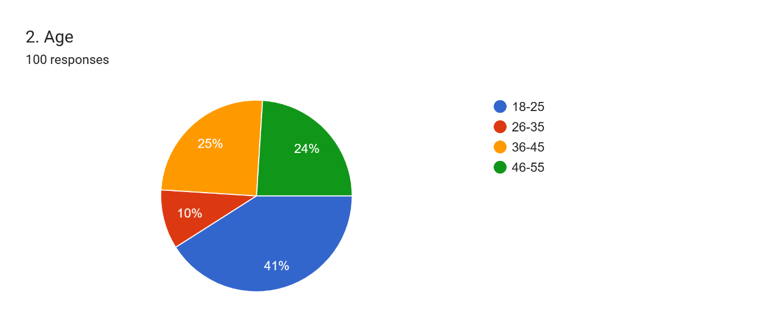

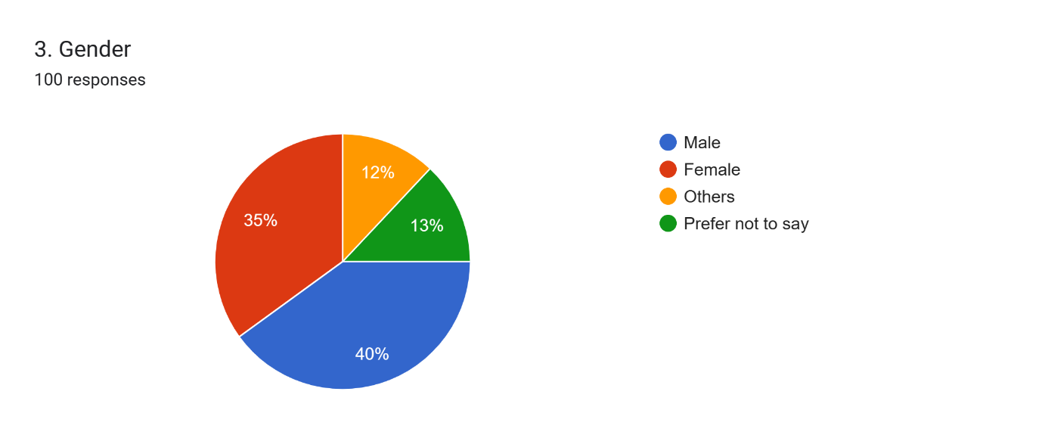

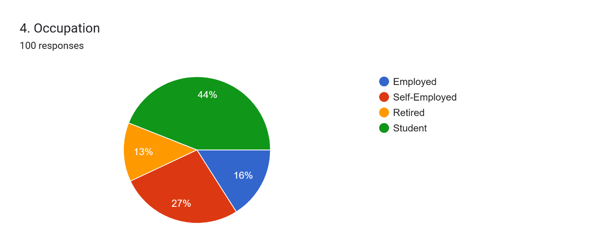
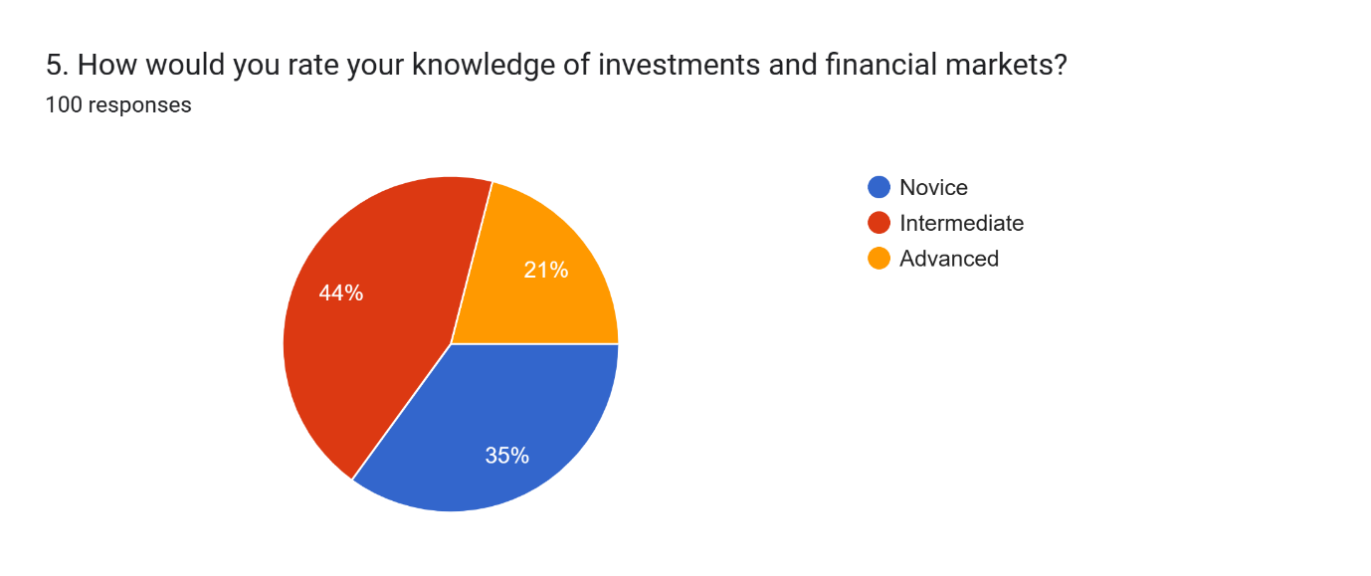
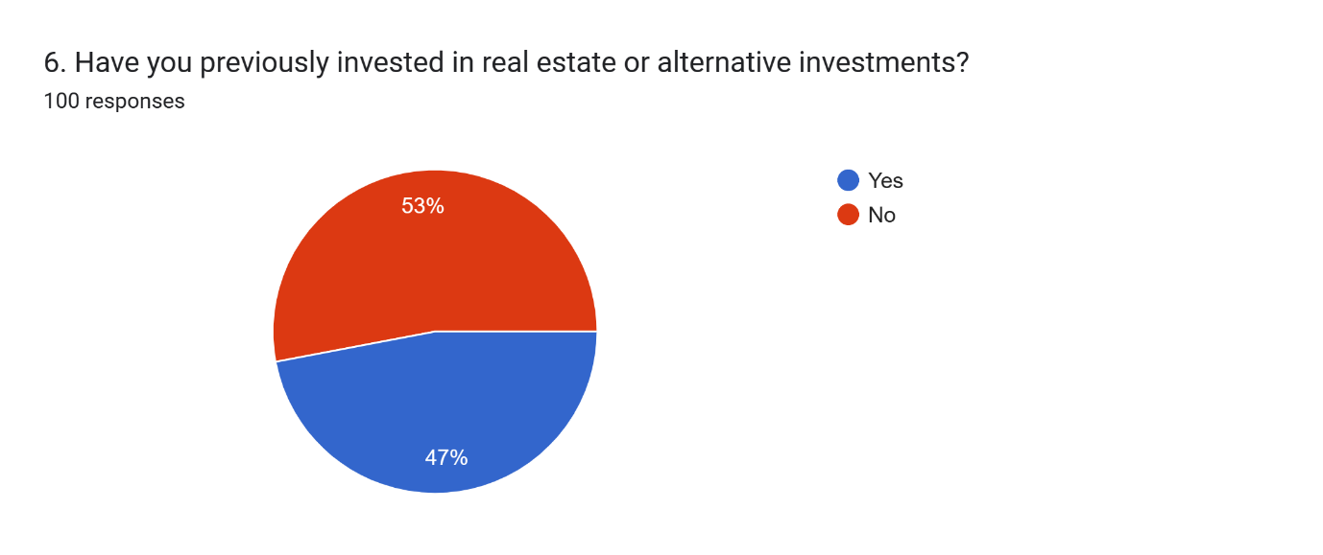
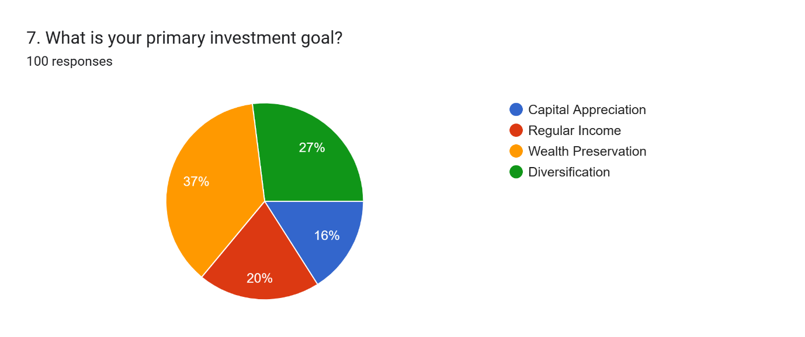
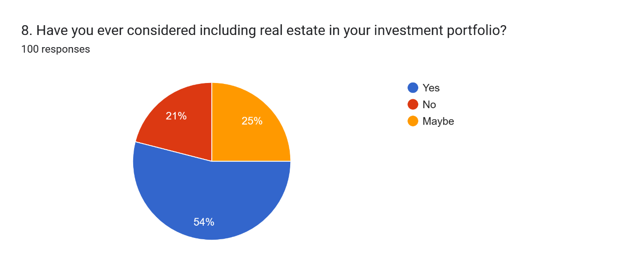
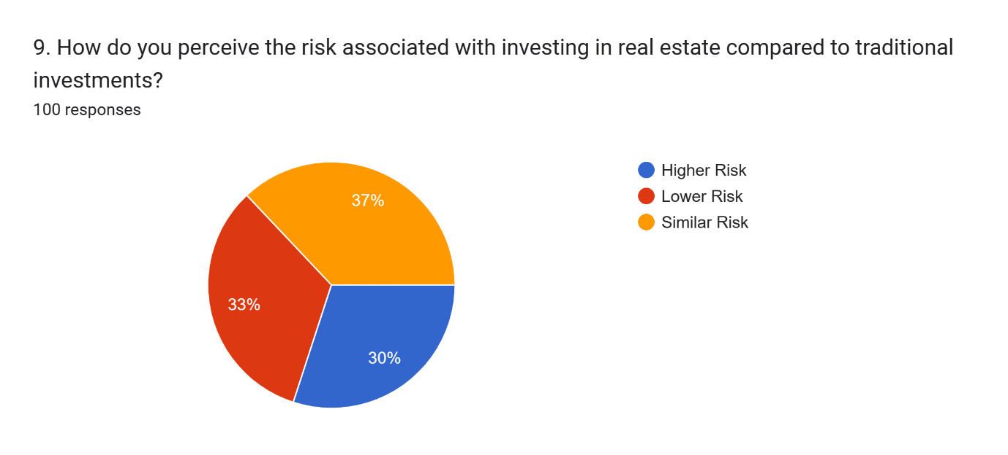
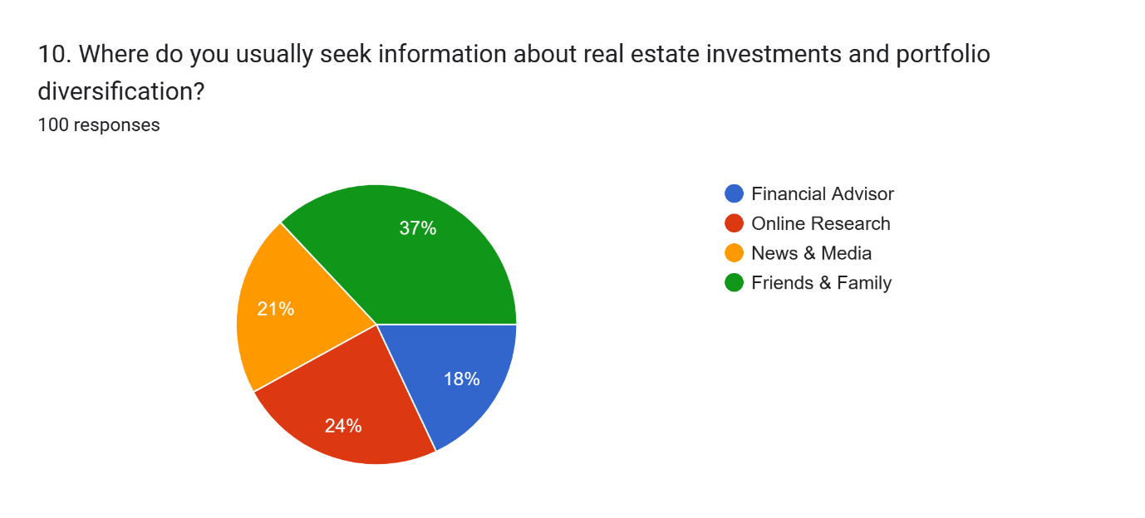
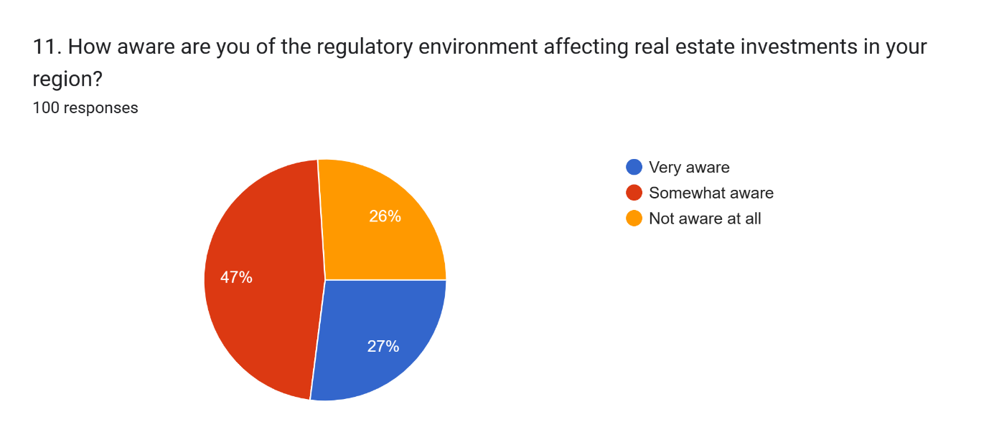
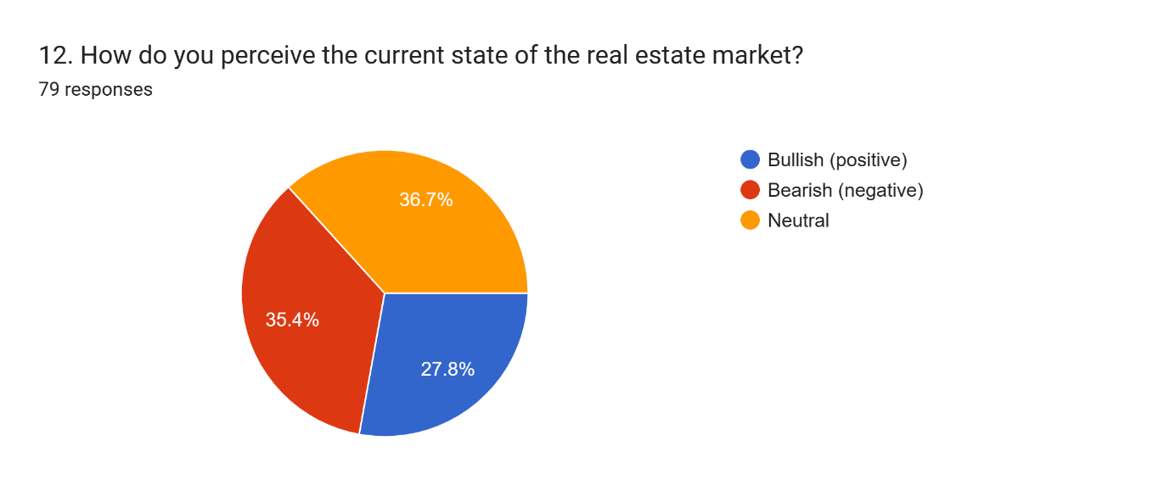

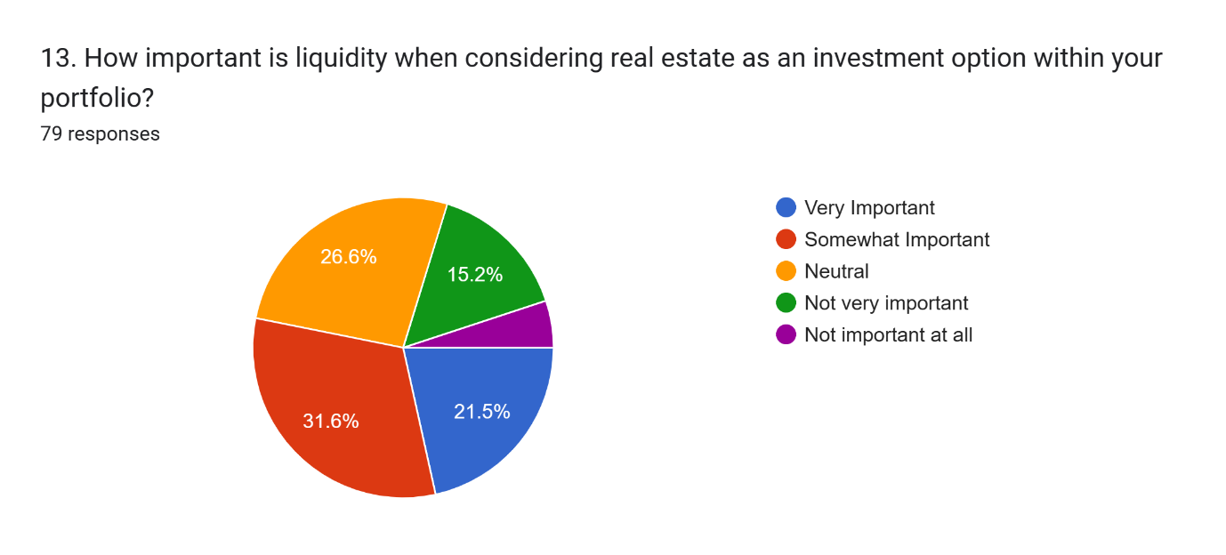
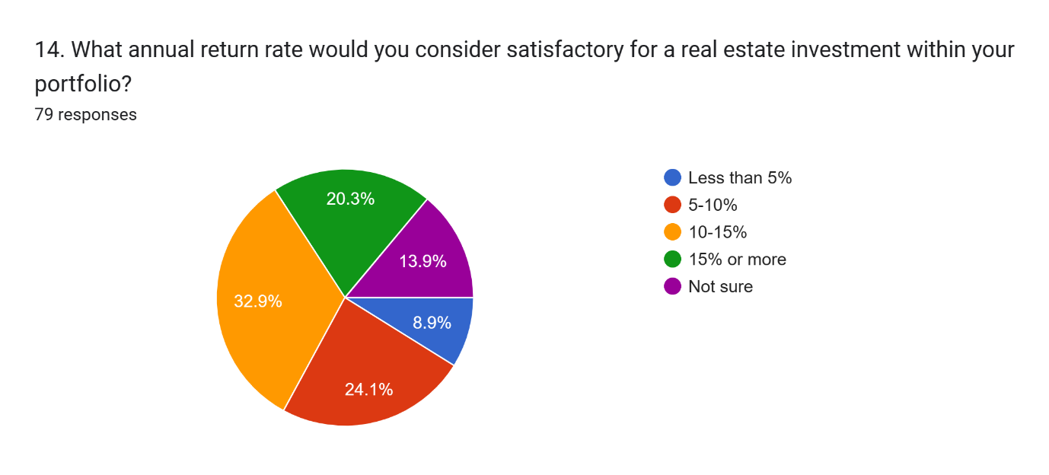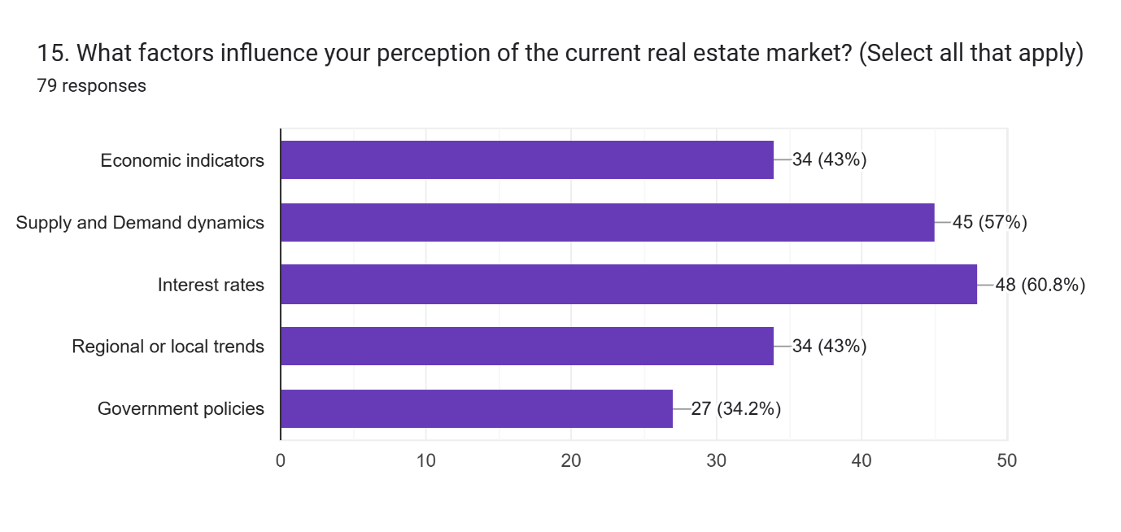

SWOT ANALYSIS
Strengths:
1. Real-world application: Real estate is a tangible asset class with intrinsic value, making it a popular choice for portfolio diversification.
2. Historical performance: Real estate investments have shown resilience and stability over time, providing a hedge against inflation and market volatility.
3. Diversification benefits: Including real estate in a portfolio can reduce overall risk by spreading investments across different asset classes.
4. Income generation: Real estate investments often provide steady income streams through rental yields, which can enhance portfolio returns.
5. Tax advantages: Real estate investments offer various tax benefits, such as depreciation deductions and capital gains tax advantages.

Weaknesses:
1. Illiquidity: Real estate investments are relatively illiquid compared to other asset classes, making it challenging to quickly liquidate holdings in times of need.
2. High transaction costs: Acquiring and managing real estate assets can involve significant transaction costs, such as brokerage fees, legal expenses, and maintenance costs.
3. Market cycles: Real estate markets are subject to cyclical fluctuations, influenced by factors like economic conditions, interest rates, and demographic trends, which can impact investment returns.
4. Management complexities: Active management and oversight are required for real estate investments, including property maintenance, tenant management, and regulatory compliance.
5. Concentration risk: Overexposure to real estate assets can expose investors to concentration risk, especially if the market experiences downturns or specific property sectors underperform.

Opportunities:
1. Market diversification: Real estate investments offer opportunities to diversify portfolios geographically and across different property types, such as residential, commercial, and industrial.
2. Emerging trends: Innovations in real estate technology (PropTech) and alternative investment vehicles (e.g., real estate investment trusts - REITs) present new avenues for portfolio diversification and risk management.
3. Globalization: Increasing globalization allows investors to access real estate markets worldwide, potentially enhancing diversification and returns.
4. Sustainable investing: Growing interest in sustainable and socially responsible investing (SRI) has created opportunities for real estate investments in environmentally friendly and socially impactful projects.
5. Demographic shifts: Changing demographics, such as urbanization and aging populations, can create investment opportunities in specific real estate sectors, such as senior housing and multifamily developments.

Threats:
1. Economic downturns: Economic recessions or market downturns can negatively impact real estate values and rental incomes, affecting portfolio performance.
2. Regulatory changes: Changes in government policies, zoning regulations, tax laws, and interest rates can influence real estate market dynamics and investment returns.
3. Environmental risks: Natural disasters, climate change, and environmental hazards pose risks to real estate investments, leading to property damage and financial losses.
4. Competitive pressures: Intense competition in the real estate market can affect property valuations, rental yields, and investment returns, especially in saturated or oversupplied markets.
5. Technological disruption: Disruptive technologies and changing consumer preferences may affect the demand for traditional real estate assets, requiring adaptation and innovation to remain competitive.

INTERPRETATION
1.Level of Knowledge: Novice: 35% Intermediate: 44% Advanced: 21% The majority of respondents fall into the intermediate category, suggesting a moderate level of understanding of investments and financial markets. This indicates that the surveyed individuals have some level of familiarity with investment concepts, including the potential benefits of diversification.
2. Previous Investment Experience: Yes: 53% No: 47% A slight majority of respondents have previously invested in real estate or alternative investments, indicating that a significant portion of the surveyed population has some exposure to these asset classes
3.Primary Investment Goal: Capital Appreciation: 16 Regular Income: 20 Wealth Preservation: 37 Diversification: 27 The majority of respondents indicated wealth preservation as their primary investment goal, followed by diversification. This suggests that many investors prioritize maintaining the value of their investments over time and see diversification as a means to achieve this goal. Regular income is also a significant consideration for a substantial portion of respondents, indicating a preference for investments that generate consistent cash flow. Capital appreciation, while important, is the least selected option, suggesting that preserving wealth and generating income are more immediate concerns for the surveyed investors.
4.Consideration of Real Estate in Investment Portfolio: Yes: 54 No: 21 Maybe: 25 A majority of respondents have considered including real estate in their investment portfolios, with over half indicating a definite interest. This suggests a significant level of awareness and potential willingness to explore real estate as an investment option among the surveyed individuals.

5.Perception of Risk Associated with Real Estate Investments: Higher Risk: 30 Lower Risk: 33 Similar Risk: 37 The responses are evenly split between perceiving real estate investments as higher risk, lower risk, or similar risk compared to traditional investments. This indicates a diverse range of opinions regarding the risk profile of real estate investments. However, it's noteworthy that a slightly higher percentage of respondents perceive real estate as having similar or lower risk compared to traditional investments. This suggests that a significant portion of investors may view real estate as a relatively stable or even safer investment option, potentially due to factors such as perceived asset tangibility, long-term appreciation potential, and income-generating capabilities.
6.Information Sources for Real Estate Investments and Portfolio Diversification: Financial Advisor: 18 Online Research: 24 News & Media: 21 Friends & Family: 37 The majority of respondents rely on information from friends and family, indicating that personal networks play a significant role in shaping their investment decisions. This suggests that investors value peer recommendations and anecdotal experiences when considering real estate investments and portfolio diversification. Additionally, online research is another prominent source of information, highlighting the importance of accessible digital resources in educating investors about real estate opportunities and strategies.
7.Awareness of Regulatory Environment: Very aware: 27 Somewhat aware: 47 Not aware at all: 26 A substantial portion of respondents indicate at least some level of awareness of the regulatory environment affecting real estate investments in their region. However, there is also a significant percentage of respondents who are not fully aware of these regulations. This suggests that while many investors recognize the importance of understanding the regulatory landscape, there may be gaps in knowledge that could potentially impact their investment decisions or risk management strategies.
8.Perception of the Current State of the Real Estate Market: Bullish (positive): 27.8% Bearish (negative): 35.4% Neutral: 36.7% Respondents' perceptions of the current state of the real estate market are divided, with a slightly higher percentage expressing a bearish sentiment. This indicates uncertainty or caution among investors regarding the outlook for real estate investments.
9.Importance of Liquidity: Very Important: 21.5% Somewhat Important: 31.6% Neutral: 26.6% Not Very Important: 15.2% Not Important at All From the responses, it's evident that a significant portion of investors consider liquidity to be important when evaluating real estate as an investment option within their portfolio. The combined percentage of respondents selecting "Very Important" and "Somewhat Important" (53.1%) suggests that a majority prioritize at least some level of liquidity in their real estate investments. This indicates that while investors recognize the potential benefits of real estate, such as long-term appreciation and income generation, they also value the ability to access cash relatively quickly if needed. The proportion of respondents indicating "Neutral" suggests a sizable segment with a balanced view on liquidity, neither emphasizing it nor dismissing it outright. The lower percentages for "Not Very Important" suggest that a smaller portion of investors are willing to accept lower liquidity in their real estate holdings, perhaps in exchange for other perceived benefits of real estate investing, such as stability or potential returns.
10.Satisfactory Annual Return Rate: Less than 5%: 8.9% 15% or more: 20.3% 5-10%: 24.1% 10-15%: 32.9% Not Sure: 13.9% The responses to this question indicate a varied range of expectations regarding satisfactory annual return rates for real estate investments within investors' portfolios. The largest proportion of respondents (32.9%) consider annual return rates between 10-15% to be satisfactory, indicating a preference for moderate to high returns. This suggests that a significant portion of investors have relatively optimistic expectations for the performance of their real estate investments. Additionally, a notable percentage of respondents (20.3%) seek even higher returns, indicating a subset of investors with more ambitious return targets. Conversely, the lower percentages for "Less than 5%" and "Not Sure" suggest that fewer investors are content with lower returns or are uncertain about their return expectations.
11.factors influence your perception of the current real estate market? Economic Indicators: 34 (43%) Economic indicators are significant factors influencing investors' perceptions of the real estate market. These indicators could include GDP growth, employment rates, inflation, consumer confidence, and overall economic stability. Investors recognize that a strong economy generally correlates with favorable conditions for real estate investments, as it stimulates demand for properties and increases purchasing power. Conversely, economic downturns may lead to reduced demand and lower property values. Supply and Demand Dynamics: 45 (57%) Supply and demand dynamics are crucial considerations for understanding the real estate market. Investors acknowledge that imbalances between supply and demand can significantly impact property prices and rental yields. High demand coupled with limited supply tends to drive property values higher, while oversupply can lead to price declines and reduced rental income. Understanding these dynamics helps investors assess market conditions and identify potential investment opportunities or risks. Interest Rates: 48 (60.8%) Interest rates play a pivotal role in shaping investors' perceptions of the real estate market. Changes in interest rates influence mortgage rates, financing costs, and the attractiveness of real estate investments relative to other asset classes. Lower interest rates typically stimulate demand for real estate by making borrowing cheaper and increasing affordability. Conversely, rising interest rates may dampen demand and lead to decreased property values. Investors closely monitor interest rate movements to gauge the potential impact on real estate market dynamics and investment returns. Regional or Local Trends: 34 (43%) Regional or local trends encompass factors specific to particular geographic areas, such as population growth, job opportunities, infrastructure development, and demographic shifts. Investors recognize that real estate markets can vary significantly from one region to another, with different areas experiencing unique supply-demand dynamics and economic conditions. Monitoring regional or local trends helps investors identify emerging opportunities and tailor their investment strategies to specific market conditions. Government Policies: 27 (34.2%) Government policies, including tax regulations, zoning laws, housing policies, and stimulus measures, can have a profound impact on the real estate market. Investors acknowledge that changes in government policies can affect property values, investment incentives, and market sentiment. For example, tax incentives for homeownership or infrastructure investments may stimulate demand for real estate, while regulatory changes or housing market interventions could influence market stability and investor confidence.

Overall analysis:

A thorough examination of the topic "A Study on Diversifying Portfolios Using Alternative Investments with Special Reference to Real Estate" reveals the significance of diversification as well as the possible benefits of including real estate, an alternative investment, into investment portfolios.

Risk Management and Diversity:

Diversification is a fundamental investment idea that seeks to spread exposure to a single asset or risk across other assets. The study acknowledges the importance of portfolio diversification in achieving a balance of risk and return.

Portfolio Diversification and Alternative Investments:

Real estate and other alternative assets are important components of portfolio diversification. They usually have a low correlation with traditional asset classes like equities and bonds, giving a potential to boost risk-adjusted returns while lowering portfolio risk.

Alternative investment in real estate:

Real estate, a tangible asset with inherent worth, holds promise as an alternative investment. Its potential to generate rental income, appreciate in value, and serve as an inflation hedge makes it an appealing asset for portfolio diversification.

Real Estate Investment Types:

The scope of the research is expected to encompass residential, commercial, industrial, and retail establishments. Each type has its own risk-return profile and diversification benefits, allowing investors to adapt their portfolios to their risk tolerance and investing goals.

Real Estate Investment Vehicles

As real estate investment vehicles, real estate investment trusts (REITs), real estate crowdfunding, and direct property ownership may be studied. The analysis of these investment vehicles illustrates how real estate can be successfully integrated into a diverse portfolio.

Market dynamics and geographical considerations:

Real estate investment necessitates an in-depth understanding of market dynamics as well as physical location. The research looks at how these variables affect the profitability and portfolio diversification potential of real estate investments.

Regulatory Environment and Tax Implications:

Regulation compliance and tax issues have a big impact on real estate investments. An in-depth examination of the legal structure and tax ramifications enables investors to make informed judgements about diversifying their real estate investments.

Case studies and analytic evidence:

The use of empirical analysis and case studies provides valuable insights into the historical performance of real estate investments within diverse portfolios. It allows an evidence-based technique to appreciate how real estate affects total portfolio performance.

Strategy Suggestions:

The study's findings will almost certainly include strategic recommendations for investors, asset managers, and financial planners. These advice may include guidance for strategically integrating real estate for optimal diversification, risk management, and long-term investment goals.

The Relationship between Real Estate and Liquidity:
The evaluation of the liquidity of real estate investments holds significant importance. Real estate assets sometimes exhibit lower liquidity compared to other financial assets. The present study aims to examine the impact of this liquidity limitation on diversification and portfolio rebalancing strategies.

Approaches for Enhancing Leverage and Financing:
This study aims to examine the impact of utilising mortgages or alternative financing methods to leverage real estate on the overall risk and return of the investment portfolio. A comprehensive comprehension of the relationship between leverage, returns, and risk is crucial in formulating an efficacious diversification plan.

A Comparative Analysis of Performance between Traditional Assets and Other Financial Instruments.
The research is anticipated to be doing a comparative analysis of the historical performance of real estate in relation to traditional assets such as shares and bonds. Gaining a comprehensive comprehension of the performance of real estate throughout diverse market circumstances and economic cycles is crucial in order to make informed judgements regarding diversification.

The Psychological Factors Impacting Real Estate Investments:
An Analysis of the psychological factors that shape the decision-making process of investors seeking to diversify their portfolios through real estate. This paper examines the influence of investor biases, risk perception, and emotions on real estate investments, highlighting their significant implications for portfolio diversification strategies.

The present study aims to examine the effect of economic indicators, including interest rates, GDP growth, and unemployment rates, on real estate investments and the subsequent decisions on diversification in the future. A comprehensive grasp of these macroeconomic dynamics can facilitate the development of an effective asset allocation strategy.

The objective of this study is to provide a comparative analysis of risk, specifically focusing on real estate in relation to alternative assets such as private equity, commodities, and hedge funds. This comparative analysis provides insights into the varying degrees of risk associated with different strategies for achieving effective portfolio diversification.
The concept of tax-advantaged real estate diversification refers to the strategy of utilising tax benefits to achieve a diversified portfolio in the real estate sector.

This study aims to explore strategies for achieving tax efficiency in diversifying real estate investments. The objective of this analysis is to examine the tax implications associated with gains, losses, and income generated through investments in real estate, with the aim of optimising tax efficiency within a portfolio that is diversified.
The study examines the correlation between investor demographics and the diversification of real estate investments.
This study aims to examine the impact of different investor demographics, including age, income level, and risk tolerance, on their inclination to engage in real estate diversification. The customization of diversification strategies is necessary in order to align with the unique characteristics and preferences of individual investors.

The Influence of Economic Policies: An Analysis of the Effects of Government Policies, Including Monetary and Fiscal Policies, on Real Estate Investments and Prospective Diversification Strategies. Having a comprehensive understanding of the impact of legislative changes on real estate assets is crucial in order to develop an educated diversification strategy.

The topic of discussion is to the relationship between real estate and its ability to withstand and recover from crises.

This study aims to examine the performance of real estate investments throughout past economic downturns, such as the 2008 financial crisis. The rigorous examination of the resilience of real estate as an alternative investment during periods of economic adversity is essential for the purpose of risk evaluation.

The Integration of Big Data and Analytics: An Examination of the Potential Application of Big Data and Advanced Analytics in Optimising Real Estate Diversification Strategies. Leveraging data-driven insights to facilitate informed decision-making in real estate investing and portfolio allocation.
These additional points contribute to the comprehensive study, shedding light on many facets of the subject matter. Their contributions enhance the comprehension of how portfolio diversification, specifically through the inclusion of real estate as an alternative investment, may be effectively maximised to achieve long-term financial objectives.

Finally, the study highlights the importance of real estate as an alternative investment for portfolio diversification. It analyses market dynamics, investment vehicles, and regulatory elements to provide a full understanding of how real estate can be strategically integrated to improve portfolio performance and limit risk.
Findings:

These are the findings of a study on portfolio diversification through alternative investments, with a particular focus on real estate. Real estate has the potential to enhance the overall performance of a portfolio by providing a new source of returns. Due to its unique risk-return profile, real estate investments can contribute positively to the risk-adjusted returns of a portfolio.

Risk Mitigation through Diversification Adding real estate to a portfolio can help mitigate risk. The correlation between real estate and conventional asset classes such as equities and bonds is typically weaker. Adding real estate to a portfolio may therefore increase diversification benefits while decreasing volatility.

Capital Protection and Inflation Hedge:
Real estate investments, particularly in physical assets, can provide inflation protection and capital preservation. Real estate investments typically appreciate over time, making them a possible hedge against inflation's corrosive effects.

Cash Flow and Sources of Income:
Real estate investment trusts (REITs) and rental properties can generate a steady stream of income through rental yields or dividends. This feature could be beneficial for portfolio investors.

Real Estate Industry and Geographic Variables : Different real estate sectors (e.g., residential, commercial, and industrial) and geographic locations can generate risk-return profiles with unique characteristics. Depending on their risk tolerance and investment objectives, investors may be interested in particular industries or sectors.
The study may recommend optimal portfolio allocation methods, such as the proportion of a portfolio that should be allocated to real estate to maximise diversification benefits while considering individual risk preferences into account.

Comparing Real Estate Investment Vehicles:
Examining the performance and characteristics of various real estate investment vehicles, such as direct ownership, REITs, and real estate crowdfunding, can shed light on the benefits and drawbacks of each option, thereby facilitating more informed investment decisions.

Effects on Finance and Regulation:
It is essential to comprehend the regulatory environment and tax implications of real estate transactions. This information helps investors navigate legal requirements and make tax-efficient investment decisions.

Potential for Investing Over the Long Term:
The study may emphasise the significance of a long-term perspective when investing in real estate, as the benefits often accrue over time, which is consistent with a buy-and-hold approach.
These findings shed light on the dynamics of real estate as an alternative investment, emphasising its potential to increase portfolio diversity and positively contribute to an investor's overall objectives.

CONCLUSION
Diversifying a portfolio with alternate investments like real estate can provide stability and potentially higher returns. Real estate offers unique benefits such as rental income, appreciation, and a hedge against inflation. However, it's important to thoroughly research the market, understand the risks involved, and consider factors like location, property type, and economic indicators before investing. Additionally, diversification across various real estate assets can further mitigate risks and enhance overall portfolio performance.
Real estate investments come with their own set of risks, including market fluctuations, vacancy rates, and maintenance costs. Investors should assess these risks and develop strategies to mitigate them, such as thorough due diligence, investing in diversified real estate assets, and maintaining adequate liquidity.
Asset Allocation: When incorporating real estate into a portfolio, investors should consider their overall asset allocation strategy. Real estate can complement traditional assets like stocks and bonds by providing diversification benefits and potentially reducing portfolio volatility.
Market Research: Conducting comprehensive market research is essential before investing in real estate. This includes analyzing local market trends, economic indicators, demographic data, and regulatory factors that may impact property values and rental demand.
Investment Vehicles: Investors can access the real estate market through various investment vehicles, such as direct ownership of properties, real estate investment trusts (REITs), real estate crowdfunding platforms, or real estate partnerships. Each option offers different levels of liquidity, risk, and potential returns.
Tax Considerations: Real estate investments often come with unique tax advantages, such as depreciation deductions, capital gains tax treatment, and the ability to defer taxes through like-kind exchanges (1031 exchanges). Investors should consult with tax professionals to maximize these benefits and optimize their after-tax returns.
Diversification Strategies: Diversifying across different types of real estate assets, such as residential, commercial, industrial, or agricultural properties, can help spread risk and enhance overall portfolio resilience. Additionally, investing in properties located in diverse geographic regions can further reduce exposure to localized market risks.
Long-Term Outlook: Real estate is typically considered a long-term investment, and investors should adopt a patient and disciplined approach. While short-term market fluctuations may occur, focusing on the underlying fundamentals of the real estate market and maintaining a long-term perspective can help investors navigate through market cycles and achieve their financial goals.
By carefully considering these factors and implementing a well-thought-out diversification strategy, investors can effectively integrate real estate into their investment portfolios and potentially enhance their risk-adjusted returns over time.

Suggestions:

There exist several potential concepts.

Analysis of Historical Performance: This study aims to investigate the historical performance of real estate investments in comparison to conventional asset classes like stocks and bonds. The primary objective of this study is to analyse the trade-offs that exist between risk and gain within a diverse range of temporal contexts.

This study aims to analyse different approaches utilised in the division of assets. This paper aims to analyse several asset allocation techniques that use real estate, including Risk Parity, Tactical Asset Allocation, and Modern Portfolio Theory (MPT). This study aims to analyse the impact of employing alternative methodologies on the returns and risk of a portfolio.

This article aims to analyse several approaches of acquiring real estate, encompassing direct ownership, Real Estate Investment Trusts (REITs), and real estate crowdfunding. The objective of this study is to assess the efficacy of each strategy and identify any potential risks associated with its use.

This study aims to quantify and visually represent the advantages of incorporating real estate assets into a diversified investment portfolio. Statistical methodologies, including association analysis, standard deviation measurement, and the Sharpe ratio, can be employed to illustrate the potential of real estate in augmenting risk-adjusted investment returns.

Risk management is a critical aspect to consider while engaging in real estate investing, since it involves identifying and mitigating any hazards that may arise. Within this context, it is essential to recognise the most significant dangers linked with real estate investment. Real estate investment involves a multitude of risks that need proficient management. This section will examine the risks pertaining to liquidity and market cycles, which are widely recognised as significant hazards in the realm of real estate investing. Liquidity risk is a significant consideration when making investments in the real estate sector. In contrast to stocks and bonds, real estate holdings generally exhibit a characteristic of illiquidity, which implies that they lack the ability to be easily and promptly converted into cash. Selling a house can pose challenges and consume a significant amount of time, mostly attributable to the substantial work involved in effectively marketing the property and engaging in price negotiations. Individuals who have made financial investments may have challenges in swiftly obtaining their funds, particularly in the event of an economic downturn or an urgent need for liquid assets. When engaging in real estate investment, it is imperative for individuals to meticulously evaluate and strategize for potential financial hazards. One should also take into account the impact of market changes on real estate acquisitions as an additional factor to examine. The real estate sector Examine several approaches to minimise these risks through the implementation of a comprehensive and multifaceted plan.

An Examination of Market Trends and Outlook: The objective of this study is to analyse the prevailing market trends within the real estate sector and assess their potential impact on individuals' inclination to invest in real estate as an additional asset. When examining the underlying reasons, it is important to take into account the shifts in population, the rise in urbanisation, and the developments in technology.

An Examination of the Regulatory Environment: The objective of this research is to analyse the regulatory environment in relation to real estate investments, with a specific focus on the tax implications and prospective regulatory modifications that may impact investment choices.

Kindly incorporate case studies illustrating the effective diversification of portfolios by purchasers or corporations through the utilisation of real estate assets. The primary emphasis should be placed on the methodologies utilised and the resulting outcomes.

The Benefits of Global Diversification One should contemplate the benefits associated with expanding one's real estate investments on a global scale. Examine the comparative performance of real estate assets in the United States in relation to other countries.

The main aim of this study is to investigate the decision-making process of individuals in relation to real estate investments, with a particular focus on the potential mistakes that may arise while seeking to diversify their holdings.

Practical Implementation: Offer guidance to investors seeking to integrate real estate into their business ventures on the execution of your concepts. The discussion should encompass several subjects, such as property selection, doing essential research, and implementing monitoring methods.

In the context of real estate diversification and the pursuit of a diverse range of possibilities, it is imperative to identify novel topics for future investigation. Academics have a profound interest in the investigation of emerging real estate trends, notably those pertaining to sustainable and impact investing.

By adhering to these principles, individuals may contribute to the execution of a thorough investigation on the significance of real estate in the diversification of investment portfolios. This will furnish consumers and scholars with significant information.

References:

Jurevičienė, D., & Jakavonytė, A. (2015). Alternative investments: valuation of wine as a means for portfolio diversification. Business: Theory and Practice, 16(1), 84-93.

Pézier, J., & White, A. (2008). The relative merits of alternative investments in passive portfolios. The Journal of Alternative Investments, 10(4), 37.

Briere, M., Oosterlinck, K., & Szafarz, A. (2015). Virtual currency, tangible return: Portfolio diversification with bitcoin. Journal of Asset Management, 16, 365-373.

Szado, E. (2009). VIX futures and options: A case study of portfolio diversification during the 2008 financial crisis. The Journal of Alternative Investments, 12(2), 68-85.

Vallabhaneni, M. (2022). Alternative Investments Portfolio Management. Message from the Editor-in-Chief.

Anson, M. J., Fabozzi, F. J., & Jones, F. J. (2010). The handbook of traditional and alternative investment vehicles: investment characteristics and strategies (Vol. 194). John Wiley & Sons.

Conner, A. (2003). Asset Allocation Effects of Adjusting Alternative Assets for Stale Pricing. Journal of Alternative Investments, 6, 42-52.

Jennings, W. W. (2010). A Simple Stock–Bond Categorization of Alternative Investments. The Journal of Investing, 19(4), 31-49.

