INVESTIGATING THE LONG-TERM EFFECTS OF CLIMATE CHANGE ON SPECIFIC VULNERABLE ECOSYSTEM SUCH AS CORAL REEFS

Manisha Tripathi – Assistant Professor, Department of Management, – Center for Management Studies, Jain (Deemed-to-be-University), Bangalore
Priya Darak – BBA student, Center for Management Studies, Jain (Deemed-to-be-University.
Preksha Thakkar - BBA student, Center for Management Studies, Jain (Deemed-to-be-University.
Sakshi Gokani - BBA student, Center for Management Studies, Jain (Deemed-to-be-University.
Yash Agarwal - BBA student, Center for Management Studies, Jain (Deemed-to-be-University.
Yashas A - BBA student, Center for Management Studies, Jain (Deemed-to-be-University.

ABSTRACT

This research paper thoroughly examines the significant impacts of climate change on coral reefs, shedding light on their vulnerable status as vital marine ecosystems. The study analyses the consequences of rising sea temperatures, ocean acidification, extreme weather events, and sea level rise, all of which pose a threat to coral reefs.
In addition to these direct dangers, the paper explores the broader effects on marine biodiversity, fisheries, and coastal communities that rely on these ecosystems. It explains how these various challenges intersect, creating a complex network of ecological and socioeconomic vulnerabilities. The paper's main conclusion emphasizes the urgent need for immediate action to address climate change. It emphasizes the importance of protecting coral reefs and highlights the critical role they play for both current and future generations. The paper serves as a powerful reminder of the interconnectedness between the health of coral reefs and the well-being of the planet, and calls for determined efforts to ensure their long-term survival and resilience.

KEYWORDS
Great barrier reef, Ecosystem, reefs, Ocean acidification, Exposure environment, Marine region, Climate, Polar, Temperature, Symbiotic algae, Coral Bleaching.

INTRODUCTION

This research paper will explore the multifaceted impacts of climate change on coral reefs, delving into the rising sea temperatures that lead to coral bleaching events, the acidification of oceans affecting the ability of corals to build their skeletons, the intensification of extreme
weather events that physically damage reefs, and the rising sea levels that threaten their very existence. Moreover, it will delve into the cascading effects of coral reef degradation on marine biodiversity, fisheries, and coastal communities.

As we delve deeper into the intricate relationship between climate change and coral reefs, it becomes increasingly evident that our actions are inextricably linked to the fate of these vulnerable ecosystems. To understand and address the long-term consequences of climate change on coral reefs is to recognize the urgency of mitigating greenhouse gas emissions, adopting sustainable environmental policies, and preserving the biodiversity that defines these unique marine habitats.

This research paper endeavours to shed light on the complex challenges faced by coral reefs and serves as a call to action to protect and restore these critical ecosystems for the benefit of present and future generations.
One of the most important issues of our day, climate change has far-reaching effects beyond only the increase in global temperatures. The world's vulnerable ecosystems, which include delicate and intricate settings like coral reefs, are among the many victims of this worldwide problem. These coral reefs, sometimes known as the "rainforests of the sea," are essential for maintaining marine biodiversity, preserving coastal areas, and ensuring the livelihoods of millions of people.
However, because of their extreme sensitivity to climatic changes, they are among the first ecosystems to clearly demonstrate the grave and terrifying implications of climate change.

Coral reefs are intricate ecosystems made up of thousands of different species of fish, coral, and other marine life that survive in a precarious equilibrium. The calcium carbonate exoskeletons secreted by corals, which provide the physical framework for the entire ecosystem, are the essential component that underpins the vibrant biodiversity of coral reefs.
Unfortunately, the increase in greenhouse gas emissions brought on by human activity has resulted in a number of connected phenomena, including ocean acidification, sea level rise, and global warming, all of which endanger the longevity and health of coral reefs.

Sea surface temperatures have risen as a result of global warming, which is primarily caused by the release of carbon dioxide and other greenhouse gases. Due to their limited thermal range, which supports the symbiotic interaction between coral polyps and the photosynthetic algae, coral reefs are extremely sensitive to even little temperature rises. This symbiosis is disrupted by high temperatures, which causes coral bleaching. Corals lose their brilliant colours and become more vulnerable to illness and mortality.

Coral reef ecosystems as a whole run the risk of collapsing due to an increase in the frequency and severity of coral bleaching episodes.
Ocean acidification, a consequence of increasing levels of carbon dioxide, poses a significant threat to coral reefs. When the oceans absorb excessive carbon dioxide from the atmosphere, they become more acidic. This increased acidity hampers the ability of corals to build and maintain their skeletons made of calcium carbonate, which in turn affects reef growth and structure. Consequently, coral reefs have a reduced ability to recover from disturbances like bleaching or physical damage, making them even more vulnerable to other stressors.

Moreover, rising sea levels resulting from the expansion of seawater and melting of polar ice put coral reefs at risk. Coral reefs can only grow in the photic zone, the shallow part of the ocean where sunlight can reach. As sea levels rise, these reefs face the possibility of submersion beyond their viable depth, which reduces sunlight exposure and hampers growth. This not only impacts the size and structure of reefs but also compromises their ability to offer crucial coastal protection against erosion and storms.
In summary, the extensive impacts of climate change have significant consequences for fragile ecosystems like coral reefs. These ecosystems, with their delicate balance and sensitivity to environmental changes, act as early indicators of the broader ecological effects of global warming, ocean acidification, and sea level rise. It is vital that urgent global action is taken to address the imminent threats facing coral reefs, including efforts to mitigate climate change and implement conservation and restoration strategies. Failure to act decisively risks irreversible loss of biodiversity, ecosystem services, and cultural heritage associated with these invaluable marine environments.

STATEMENT OF PROBLEM

Climate change has a major impact on both coral reefs and polar regions. Higher temperatures can cause coral bleaching, which causes corals to expel symbiotic algae, causing them to lose their vibrant colour and eventually die. Ocean acidification makes it difficult for corals to form calcium carbonate skeletons, weakening their structures.
The effects of climate change are particularly evident in the polar regions. Rising temperatures cause glaciers and glaciers to melt, causing sea levels to rise. This has far-reaching consequences for global sea levels, coastal communities, and ecosystems.
Additionally, the loss of sea ice in the Arctic affects marine life and disrupts ecosystems, while in the Antarctic, warming waters impact ice shelves and the habitats of various species.

OBJECTIVES

- To investigate and understand the long-term effects of climate change on certain ecosystems.
- To assess and document the diverse impacts of climate change on these ecosystems, including changes in species distribution, ecosystem services and resilience.
- To emphasize the urgent need for immediate action to address climate change
- To Understand these impacts is critical for developing conservation and adaptation strategies to mitigate the negative impacts of climate change on the world's fragile ecosystems.
- To assess the resilience of ecosystems to environmental changes and provides insight into the ability of ecosystems to adapt or recover.

REVIEW OF LITERATURE

The assessment of the possible and anticipated impacts of global climate change on coral reef ecosystems and the populations connected to them is the main focus of this report.

An analysis of the knowledge now available about coral reef populations and the potential impact of future climate change on coral reefs loss and deterioration. Increased mass coral bleaching, falling calcification rates, and a variety of other modifications to subtle but fundamentally alterative physiological and ecological processes are only a few of the observed effects on coral reefs.

A small island nation in the western Indian Ocean called The Seychelles is particularly susceptible to the effects of climate change. The Intergovernmental Panel on Climate Change (IPCC) expressed worry about the potential economic and social consequences of this vulnerability in 2001.Given their reliance on natural resources, including water and coral reefs, to provide for their fundamental requirements, small island states should be prepared to adapt to such changes.

Changes are already evident in the Seychelles, according to an analysis of long-term data on precipitation, air temperature, and sea surface temperature. Events that are predicted to take place as a result of future climate change include the mass coral bleaching in 1998 and the increase in dry spells that led to drought conditions in 1999.

These comparisons show that the Seychelles will experience a substantially warmer and wetter climate under the IS92 scenarios than under the SRES predictions. However, a wetter climate means longer dry spells with more powerful precipitation events rather than easily available water. The management of water resources in the Seychelles will probably be under tremendous strain as a result of these observations.
The model predicts that increases in sea surface temperature would lead to repeated bouts of coral bleaching and possibly coral extinction in the Seychelles region by 2040. The protection of coral-resilient places is a crucial adaptive strategy because the cover of many coral reefs near the Seychelles has already changed.

Many species, including polar bears, amphibians, and coral, have been impacted by global climate change (GCC)'s increased temperatures and other environmental repercussions. These comparisons show that the IS92 scenarios depict a significant amount of war.
Predictions are made about how the combined effects of climatic stress and toxicants will manifest at the population, community, and individual levels (e.g., population growth rate, extinction risk), as well as at the individual level (e.g., reduced survival and reproduction).

The authors explore how several ecological mechanisms are anticipated to have an impact on population- and community-level responses to toxicants under GCC. The potential for resistance to and recovery from toxicant exposure may be diminished by stress brought on by GCC. At the population or community level, long-term toxicant exposure can lead to the development of a tolerance to this stressor, but this tolerance may come at the expense of a decreased capacity to tolerate a subsequent climatic stress (or the opposite).

Additionally, GCC can cause significant changes in community makeup, which may impact how vulnerable communities are to additional stressors. For anticipating the combined effects of GCC and toxicants on populations and communities, ecological modelling based on species features (including life cycle traits, population vulnerability, sensitivity to toxicants, and sensitivity to climate change) can be a promising method. Environ.

A serious danger to the integrity of ecosystems and biodiversity around the world is climate change. The 118 countries that have ratified the UN Framework Convention on Climate Change (UNFCCC), which went into effect in 2008.

RESEARCH METHODOLOGY

This research paper is about analysing the impact of climate change on vulnerable ecosystems specifically Coral Reefs. To conduct this study in the most effective manner we are going to be adopting the descriptive method of research.
Our methodology to analyse this topic in depth involves the collection of field data pertaining to Corals.
The data is collected to Questionnaire’s that have been circulated around individual of different age groups to understand the level of understanding they have towards this topic.
We have also referred to secondary resources to widen our knowledge of the above research topic.

RESEARCH ANALYSIS

The study unveils a nuanced understanding of public perceptions towards coral reef conservation. It reveals a spectrum of opinions ranging from strong agreement to indifference or disagreement on various aspects related to coral reef degradation.
The survey data reveals a mixed but generally positive outlook on the future of coral reefs. While a significant portion of respondents (52%) acknowledge their depletion, there’s a noticeable willingness to explore solutions.

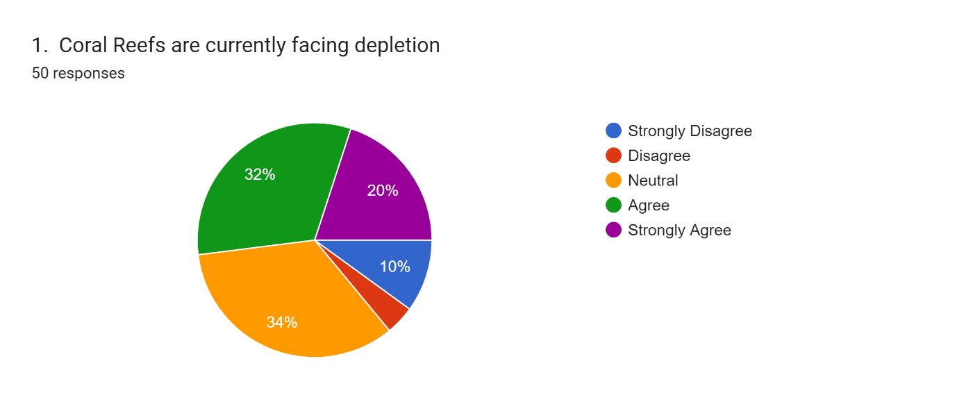

This positive trend continues with awareness of major threats, with over 60% recognizing the negative impact of climate change, rising sea temperatures, and ocean acidification.

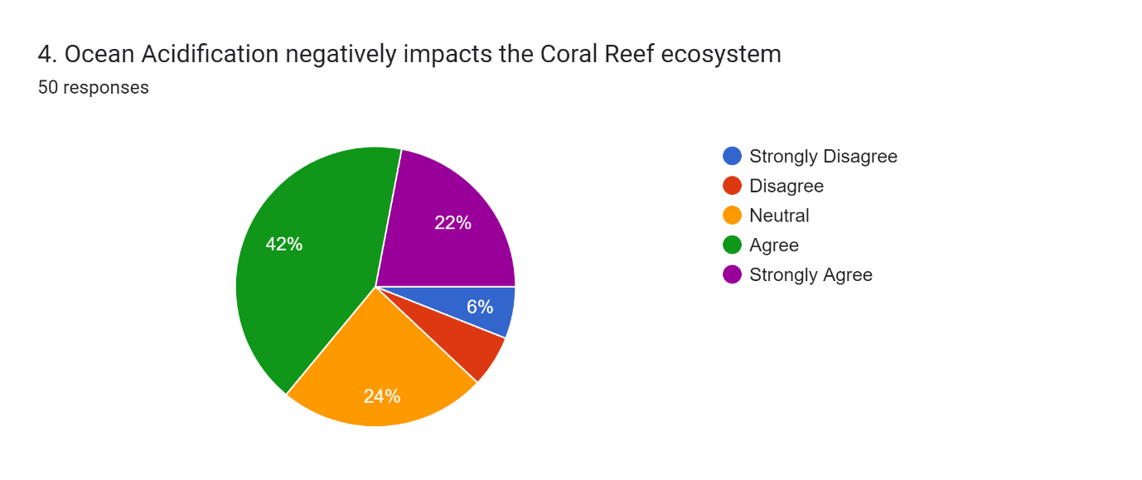

One significant aspect highlighted in the analysis is the impact of climate change on coral reefs. While there is a consensus on its detrimental effects, the data also reflects a notable proportion of respondents who are neutral or disagree, suggesting a need for further education on the subject.

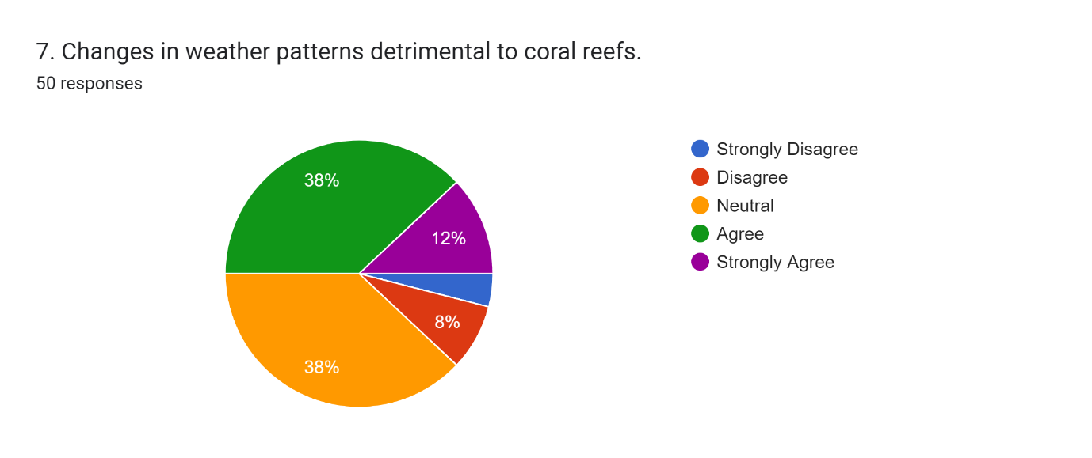

Similarly, the acknowledgement of human activities as a contributing factor to coral reef decline indicates a growing awareness, albeit with some remaining uncertainties that could be addressed through targeted outreach programs.
While solid majority (58%) link human activities to coral reef decline, a considerable portion remains neutral (36%), highlighting the need for targeted education and outreach.
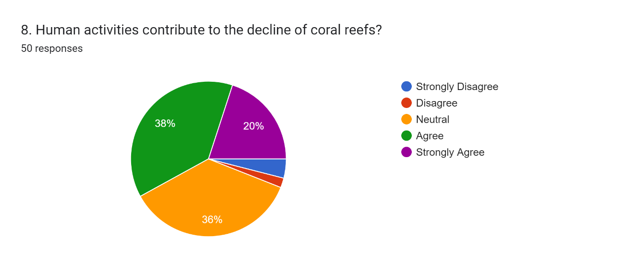

Similarly, disagreements emerge regarding specific solutions, with varying opinions on the effectiveness of international collaboration, business sustainability practices, and the impact of rising sea levels.

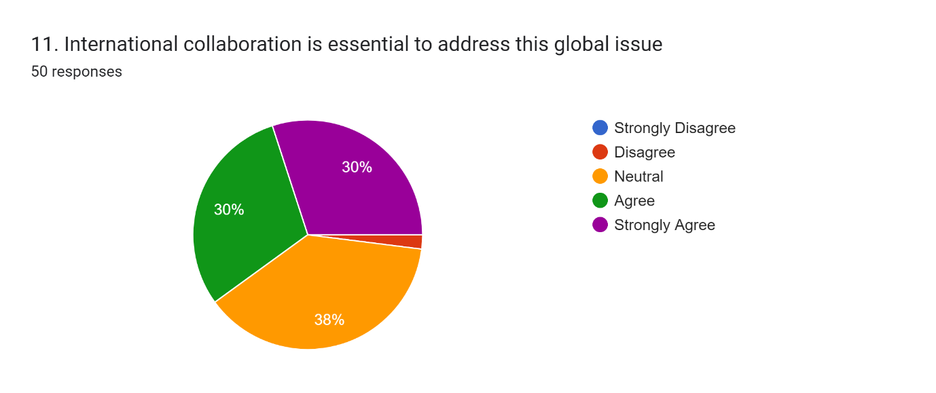

Moreover, the findings underscore the importance of sustainable practices and responsible tourism in mitigating the adverse effects on coral reefs. The overwhelming support for these initiatives reflects a growing recognition of the role individuals and businesses can play in conservation efforts.

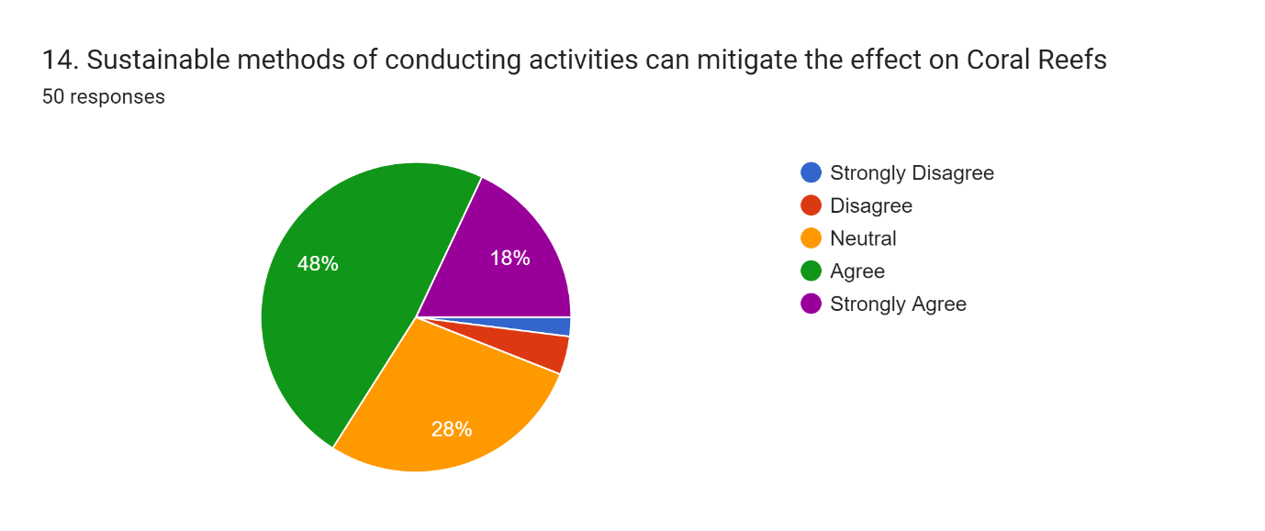

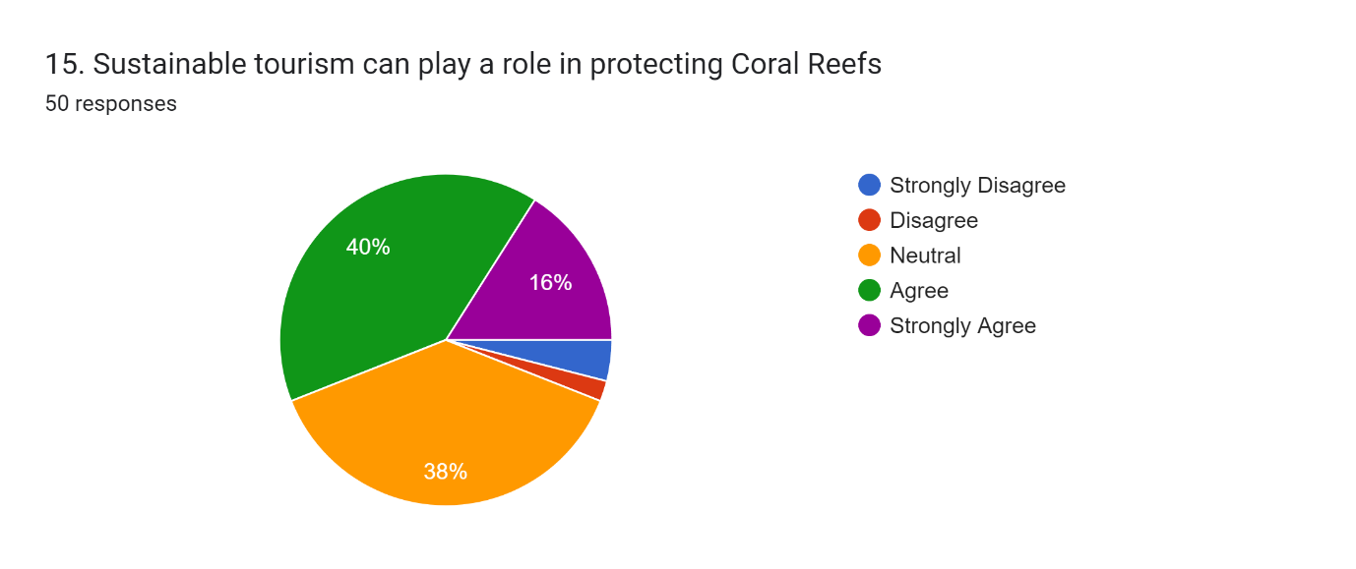

Despite these nuances, the data offers encouraging signs. Overwhelming support exists for awareness campaigns (82%) and education initiatives (88%), showcasing the public’s desire to be informed and take action. Sustainable practices (64%) and responsible tourism (85%) are also seen as key solutions, with even hesitant groups acknowledging their potential.

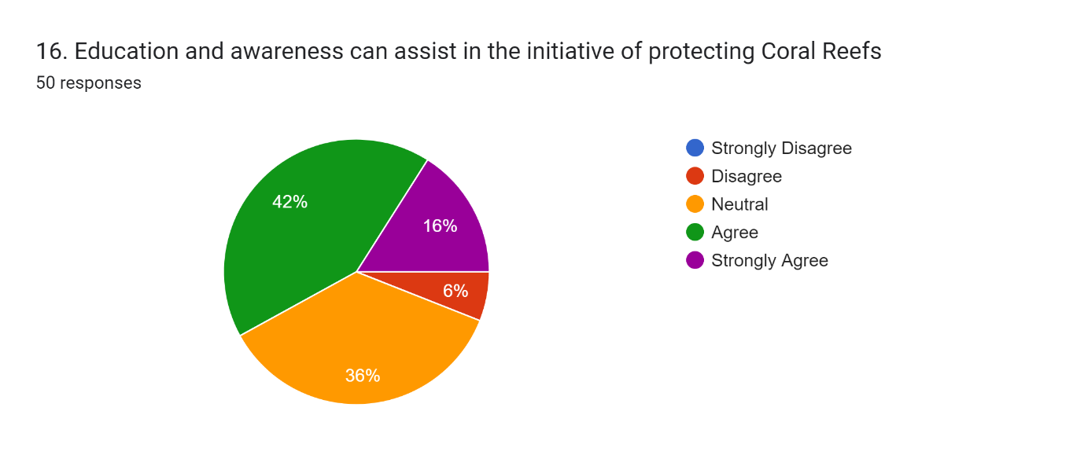

However, the analysis also reveals a segment of the population that remains sceptical or undecided, highlighting the need for continued advocacy and education to garner broader support.

Further investigation into the subtleties of public attitudes and beliefs regarding coral reef protection is essential. Even while the data shows a generally optimistic view and a readiness to investigate solutions, there are some underlying difficulties that demand more investigation.
For example, knowing what influences different opinions about how beneficial different conservation techniques are can help develop focused intervention tactics.

People's views and behaviours about coral reef conservation may be influenced by variables like

- Socioeconomic level
- Cultural beliefs
- Information access.

By identifying and addressing these variables we can develop and organise tailored outreach programmes can be created to –

- Close knowledge gaps
- Promote increased engagement
- Increase awareness
- Increase support for conservation initiatives.

It is also crucial to look at how environmental education influences how the general public feels and behaves when it comes to protecting coral reefs.
Education programmes have the capacity to both raise people's understanding of the value of coral reefs and give them the tools they need to take meaningful action in their preservation.
We can foster a culture of sustainability and environmental stewardship by including environmental education into public awareness campaigns, school curricula, and community outreach initiatives.
Additionally, by engaging a variety of audiences and promoting a feeling of global connection in conservation efforts, digital platforms and social media channels can increase the reach and impact of educational activities.

CHALLENGES AND RECOMMENDATIONS

- It will take a comprehensive and coordinated effort to address the many issues that climate change has brought about for marine environments, polar regions, and coral reefs.

- One of the main challenges is comprehending the intricate relationships between many stressors that endanger the resilience and well-being of coral reefs and polar ecosystems, such as ocean acidification, rising temperatures, and human activity.

- Interdisciplinary research projects that integrate ecological, climatological, and socioeconomic viewpoints must be given top priority in order to successfully address these issues.

- Tracking trends, spotting weaknesses, and developing adaptive management plans all depend on long-term observation, data collection, and modelling.

- The development and implementation of conservation measures and sustainable practices necessitate close collaboration between scientists, policymakers, local people, and stakeholders.

- Promoting understanding, stewardship, and support also requires public awareness campaigns, educational programmes, and interaction with indigenous populations.

CONCLUSION

The study on the effects of climate change on coral reefs emphasises how urgent action is needed to save these important ecosystems. Extreme weather, ocean acidification, rising temperatures, and sea level rise are all risks to coral reefs. These issues put the livelihoods of coastal populations in jeopardy in addition to endangering marine biodiversity.
The results demonstrate how ecological and socioeconomic well-being are closely linked to the health of coral reefs. To reduce climate change and put conservation plans into action, there must be an immediate worldwide partnership. For coral reefs to be preserved for future generations, sustainable practices, awareness, and education are essential. The resilience and survival of these priceless marine ecosystems, as well as the wellbeing of our world, depend on our collective action.

REFERENCES

https://www.iucn.org/resources/issues-brief/coral-reefs-and-climate-change

https://www.researchgate.net/publication/226289185_The_Impact_of_Climate_Change_on_Coral_Reef_Ecosystems
https://www.iucn.org/resources/issues-brief/coral-reefs-and-climate-change
https://www.researchgate.net/publication/226289185_The_Impact_of_Climate_Change_on_Coral_Reef_Ecosystems
https://www.worldwildlife.org/magazine/issues/fall-2015/articles/how-does-climate-change-affect-coral-reefs
https://scied.ucar.edu/learning-zone/climate-change-impacts/corals-and-climate
https://www.nytimes.com/2021/10/04/climate/coral-reefs-climate-change.html
https://acadpubl.eu/hub/2018-119-17/1/4.pdf

