THE IMPACT OF ARTIFICIAL INTELLIGENCE ON EMPLOYMENT
Manisha Tripathi – Assistant Professor, Department of Management, Center for Management Studies, JAIN (Deemed-to-be University), Bangalore
Varsha S Reddy – BBA student, Center for Management Studies, JAIN (Deemed-to-be University)
Gaurav Pandey - Center for Management Studies, JAIN (Deemed-to-be University)
Shyam Sunder Mittal - Center for Management Studies, JAIN (Deemed-to-be University)
Chirag Daga - Center for Management Studies, JAIN (Deemed-to-be University)
Nitish Kumar Poddar - Center for Management Studies, JAIN (Deemed-to-be University)
Omkaar P Thadhani - Center for Management Studies, JAIN (Deemed-to-be University)

ABSTRACT
This research paper delves into the intricate relationship between artificial intelligence (AI) and employment dynamics, aiming to comprehend the impact of AI on various industries and the resultant consequences on workforce participation and unemployment rates. Through an extensive review of literature, this paper evaluates the evolving landscape of jobs in the wake of AI integration and provides insights into potential strategies for mitigating unemployment challenges. The findings of this research will be instrumental in informing policy decisions and workforce development initiatives in the context of an AI-driven economy.

KEYWORDS
Artificial intelligence, unemployment, technology, automation, humans, robots.

INTRODUCTION
The rapid growth of AI technology has launched a new age in the global economy, revolutionizing industries and altering the nature of labor. The socioeconomic environment is undergoing fundamental shifts as computers grow increasingly skilled at executing jobs that were formerly the sole realm of human labor. While the incorporation of AI offers increased efficiency, increased output, and the capacity to address some of society's most serious concerns, it is not without consequences. The influence of AI on employment and its contribution to rising unemployment rates is one of the most pressing problems that has surfaced in the aftermath of this technological revolution.
The introduction of AI-powered automation has caused a paradigm shift in how work is planned, executed, and rewarded. Traditional labor-intensive occupations, which were traditionally dependent on human dexterity and cognitive ability, are now being outsourced to robots with advanced algorithms and learning capabilities. This change is not limited to assembly lines and factory floors; it is affecting a wide range of industries, including banking, healthcare, transportation, and customer service. The ramifications are far-reaching, affecting every aspect of the labor market, from manual laborers to knowledge workers, blue-collar to white-collar jobs.
At the heart of this shift is AI systems' extraordinary ability to process and analyses huge volumes of data with unprecedented precision and speed. Machine learning algorithms, powered by neural networks and deep learning architectures, have exhibited an astounding ability to recognize subtle patterns, make judgements, and even generate creative outputs. This has resulted in the development of autonomous systems capable of performing complicated tasks, ranging from self-driving vehicles navigating metropolitan landscapes to algorithms anticipating financial market movements with remarkable accuracy.
The repercussions of this technical leap are obvious in the displacement of human labor from tasks that machines now perform efficiently and economically. Routine, rule-based jobs, which account for a sizable share of the labor market, are especially vulnerable to automation. Administrative jobs, data input, and repetitive manufacturing processes are among the first to be impacted by AI-powered systems. In essence, AI is changing the fundamental nature of employment, necessitating a re-evaluation of the talents and qualities most valued in today's job market.
The implications of this technology disruption are most clearly felt in certain historically labor-intensive industries. For example, the manufacturing sector, which has long been a pillar of industrial countries, is undergoing a fundamental upheaval. Human employees are being replaced at an unprecedented rate by automated assembly lines outfitted with robotic arms and AI-driven quality control systems. This transformation not only changes the worker makeup, but it also calls into question conventional economic models and societal structures based on traditional industrial industries.
Furthermore, the consequences of AI-induced unemployment go beyond economic considerations, infiltrating the social fabric of towns and nations. Workers who have been laid off face the onerous task of reskilling and reorienting themselves in an economy that requires new and growing skill sets. Unemployment and underemployment are looming, prompting a rethinking of educational and training paradigms. Furthermore, demographic and geographical imbalances are compounded, as certain communities bear a disproportionate share of the pain of job relocation while others benefit from the technology revolution.
Given these trends, governments, economists, and industry executives face the imperative of devising solutions to traverse this critical juncture. Multifaceted solutions must include targeted workforce development initiatives, strong social safety nets, and forward-thinking educational policies. Furthermore, a sophisticated knowledge of the evolving link between AI and employment is required to drive policy decisions that strike a balance between encouraging technological innovation and protecting employees' livelihoods.
Finally, the rise of Artificial Intelligence is reshaping the landscape of employment in unprecedented ways. As machines progressively take over roles previously held for human labor, the employment dynamics are changing dramatically. While the incorporation of AI offers increased production and efficiency, it also raises concerns about job loss and labor displacement. This article attempts to untangle the delicate relationship between AI and employment, investigating the industries most affected, job roles at risk, and viable solutions to the resulting issues. This research seeks to give significant insights for policymakers, industry leaders, and stakeholders interested in defining the future of work in the age of AI by putting light on these critical challenges.

STATEMENT OF PURPOSE
The goal of this study is to perform a thorough examination of the influence of Artificial Intelligence (AI) on employment dynamics and its role in rising unemployment rates. This study intends to identify vulnerable job roles and tasks susceptible to automation by evaluating the transformative effects of AI across numerous businesses and sectors. It also tries to investigate prospective techniques and policies for addressing unemployment issues, such as focused workforce development and educational programmes. The research findings aim to give significant insights for policymakers, industry leaders, and stakeholders in developing effective solutions to the emerging interaction between AI and employment.

OBJECTIVES
- To evaluate the amount of AI integration and its influence on employment in various businesses and sectors.
- To identify certain occupational roles and functions that are most vulnerable to automation as AI technologies improve.
- To investigate the demographic and socioeconomic consequences of AI-induced unemployment, including potential inequities in labor-force participation.
- To investigate and assess existing policy frameworks and solutions for dealing with the difficulties faced by AI-driven employment displacement.
- To develop novel ideas and recommendations for governments, employers, and educational institutions to adapt to the changing environment of employment in the age of AI.

REVIEW OF LITERATURE
Frey and Osborne's seminal work evaluates the susceptibility of various jobs to computerization, providing a framework for understanding which tasks are most vulnerable to automation. Their findings highlight the potential magnitude of job displacement due to the integration of AI.
Bessen's research delves into the nuanced relationship between AI adoption and job creation, emphasizing the importance of demand-side factors in shaping employment outcomes in the context of technological advancements.
This comprehensive report provides a global perspective on the evolving job market, offering insights into the skills and occupations most affected by technological disruptions, and suggesting strategies for workforce adaptation and reskilling.
The OECD working paper assesses the risk of job automation across OECD member countries, highlighting variations in susceptibility based on occupation, education, and skill levels. The study informs policy discussions regarding workforce planning and development.
Brynjolfsson and McAfee provide a comprehensive examination of how technological advancements, particularly in AI, are reshaping economies and labor markets, and propose strategies for adapting to this new paradigm.
This study explores the polarization of the labor market in the UK, examining how technological changes have led to a divergence in the quality and nature of jobs available, contributing to socio-economic disparities.
McKinsey's research provides insights into the sectors and tasks that are most likely to be impacted by automation, emphasizing areas where human skills and creativity remain irreplaceable.
Building on their previous work, Brynjolfsson and McAfee delve into the broader societal and economic implications of the technological revolution driven by AI, offering a roadmap for navigating this transformative era.
This paper critically examines the relationship between automation, productivity, and employment, challenging conventional wisdom regarding the direct displacement of labor due to technological advancements.
This updated edition of their earlier work provides further insights into the accelerating pace of technological change, emphasizing the need for adaptive policies and workforce strategies.
Susskind and Susskind examine the evolving role of professionals in the face of technological advancements, including AI. They argue that many tasks traditionally performed by human experts may be automated, reshaping the landscape of professional work.
Acemoglu and Restrepo's research provides a nuanced analysis of the interplay between automation and the creation of new tasks. It highlights how technological advancements both displace and reinstate labor, shedding light on the complex dynamics of job transformation.
The passage highlights the impending impact of artificial intelligence (AI) on jobs and society. It emphasizes that AI's ability to replace human roles may lead to unemployment before ethical concerns are fully addressed. As a result, unemployment is projected to be the primary social issue related to AI. This underscores the urgency of proactive measures to address this impending challenge.

RESEARCH METHODOLOGY
This study adopts a literature review methodology to scrutinize the nexus between AI and unemployment. Drawing upon a wide array of scholarly articles, reports, and relevant publications, this research endeavours to compile and critically evaluate existing knowledge on the subject matter. The review encompasses empirical studies, theoretical frameworks, and expert perspectives to construct a comprehensive understanding of how AI technologies may influence employment patterns. By synthesizing insights from diverse sources, this paper aims to shed light on potential implications for the labour market and provide valuable insights for policymakers, researchers, and practitioners in the field.

RESEARCH ANALYSIS
In our survey, we asked about the role of artificial intelligence in contributing to unemployment, and these were the responses.
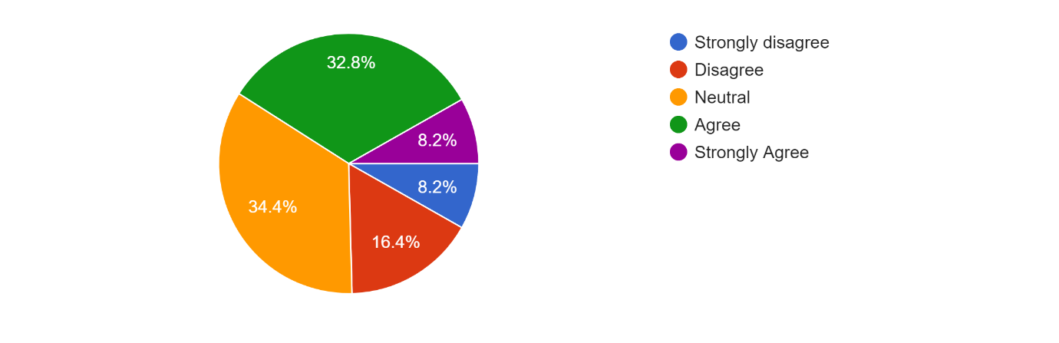
A significant portion of respondents either agree (32.8%) or strongly agree (8.2%) that artificial intelligence is a significant factor contributing to unemployment. Conversely, a smaller percentage either disagree (16.4%) or strongly disagree (8.2%) with this statement. Meanwhile, a notable portion hold a neutral stance (34.4%).
The survey results show that people have mixed feelings about AI's effect on unemployment. Some acknowledge its role, while others disagree. It really shows how complex this issue is, and we need to find ways to handle job changes while making sure everyone benefits from AI's advancements.

In our survey, we inquired about the job losses resulting from automation in industries due to AI, and here are the findings.
In summary, a majority of respondents either agree (54.1%) or strongly agree (3%) that automation in industries due to AI has led to job losses. Conversely, a smaller percentage either disagree (11.5%) or strongly disagree (2.9%) with this statement. Meanwhile, a significant portion hold a neutral stance (29.5%).
It's evident from the survey that many believe AI-driven automation in industries has indeed caused job losses. This sentiment is shared by a majority of respondents, indicating a growing concern about the impact of technological advancements on employment stability.

We asked whether AI in manufacturing has displaced human workers in our survey and this is what we found:
34.4% neither agree nor disagree. They may lack personal experience with AI in customer service or feel uncertain about its impact. Again 34.4% believe AI has reduced the need for human agents in customer service. This belief may stem from positive experiences with AI-driven systems or observations of industry trends. 18% do not think AI has reduced the need for human agents in customer service. Possible reasons include experiences with ineffective AI systems or concerns about job displacement. 11.5% strongly believe AI has significantly reduced the need for human agents in customer service. Reasons could include efficient AI systems or widespread AI adoption. 2% strongly disagrees with the notion that AI has reduced the need for human agents in customer service. Possible reasons include scepticism about AI capabilities or the value of human empathy. Overall, while there is a split in opinions, a substantial portion of respondents believe AI has impacted the need for human agents in customer service, with a significant number both agreeing and strongly agreeing with this notion. However, there are also dissenting opinions, with some respondents disagreeing or strongly disagreeing, citing concerns about effectiveness, job displacement, and the importance of human interaction.
The opinions on AI's role in customer service are varied, reflecting the diverse experiences and observations of the respondents. While some perceive AI's contribution to reducing the need for human agents positively, others express scepticism or even opposition, underscoring the ongoing debate surrounding the integration of AI in customer-facing roles.

We asked our respondents if AI in manufacturing has replaced humans, and this is what they thought:

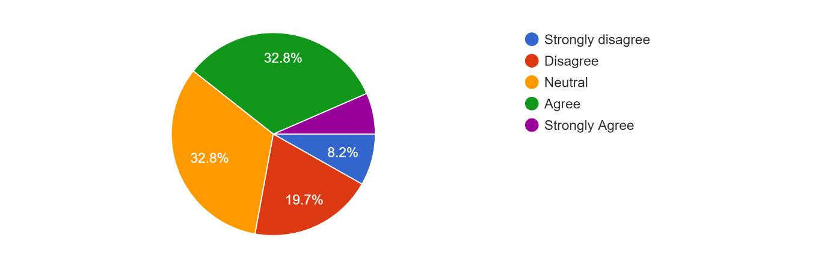
While 32.8% remain neutral or lack sufficient information, an equal percentage agree that AI has displaced human workers. Conversely, 19.7% disagree, citing new job opportunities or augmented human capabilities. A smaller percentage, 8.2%, strongly agree, emphasizing job losses due to automation. Only 6% strongly disagree, arguing for the continued importance of human labour in manufacturing.
The survey findings highlight the contentious issue of AI's impact on manufacturing jobs. While some acknowledge the displacement of human workers due to AI, others argue for the emergence of new opportunities or the complementary relationship between AI and human labour. These differing perspectives emphasize the complexity of navigating technological advancements in the manufacturing sector.

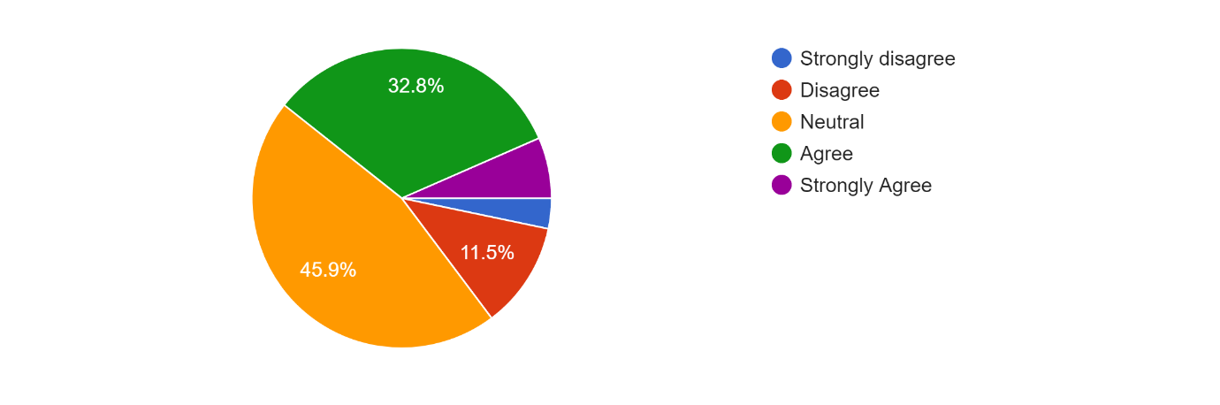
When asked whether AI technologies contributed to the decline of certain traditional job sectors, this is what the respondents felt: 45.9% of respondents hold a neutral stance, 32.8% agree, 11.5% disagree, 8% strongly agree, and 5% strongly disagree with the statements regarding the impact of AI technologies on unemployment and traditional job sectors.
The survey shows different opinions about how AI affects traditional jobs. Some say it's a reason for job loss, some don't agree, and many are unsure. It's clear that AI is changing things, but it's not easy to say exactly how.

In our survey, we asked if the implementation of AI has led to a decrease in demand for manual labour:
The analysis shows varied opinions on AI's effect on manual labour demand. While 27.9% remained neutral, 41% agreed that AI decreased demand. Conversely, 21.3% disagreed, citing emerging roles. A minority, 8.2%, strongly agreed with significant job displacement, while only 1.4% strongly disagreed, highlighting AI's role in creating jobs.
People have different views on whether AI reduces the need for manual work. Some think it does, while others see new jobs coming up because of it. It's a mixed bag, showing that AI's impact on jobs isn't straightforward.

Our respondents were also asked whether AI's impact on the job market is a concern for the future and this is how they felt:
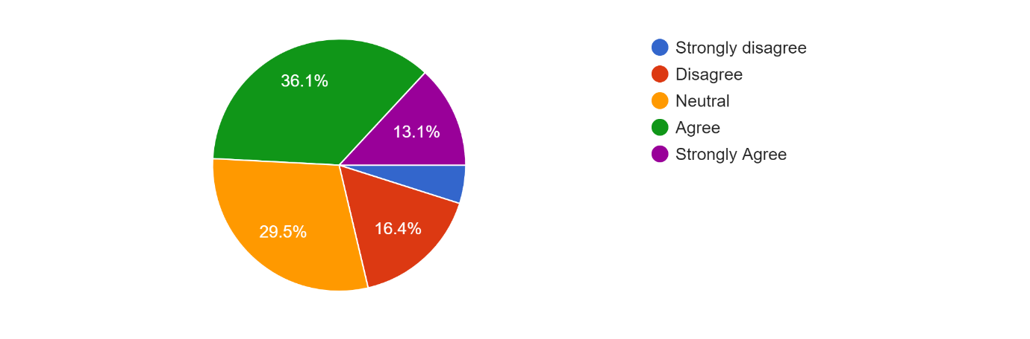
The analysis reflects diverse views on AI's future impact on the job market. While 29.5% remained neutral, 36.1% expressed concern about job displacement. Conversely, 16.4% were
Here is what the respondents said in our survey when asked about the rise of AI in white-collar professions has resulted in job displacement:
Opinions vary on whether AI in white-collar professions causes job displacement. While 44.3% are neutral, 37.7% agree with displacement. Conversely, 11.5% disagree, emphasizing new opportunities. A smaller portion, 4.9%, strongly agrees with significant displacement, while only 1.6% strongly disagrees, citing AI's role in enhancing productivity.
People are divided on whether AI taking over white-collar jobs is a problem. Some think it is, while others say it's creating more opportunities. It's a debate that shows how AI is changing the job landscape, especially in office jobs.

In our survey, we asked about AI's influence on hiring processes has led to job discrimination and these were the findings:

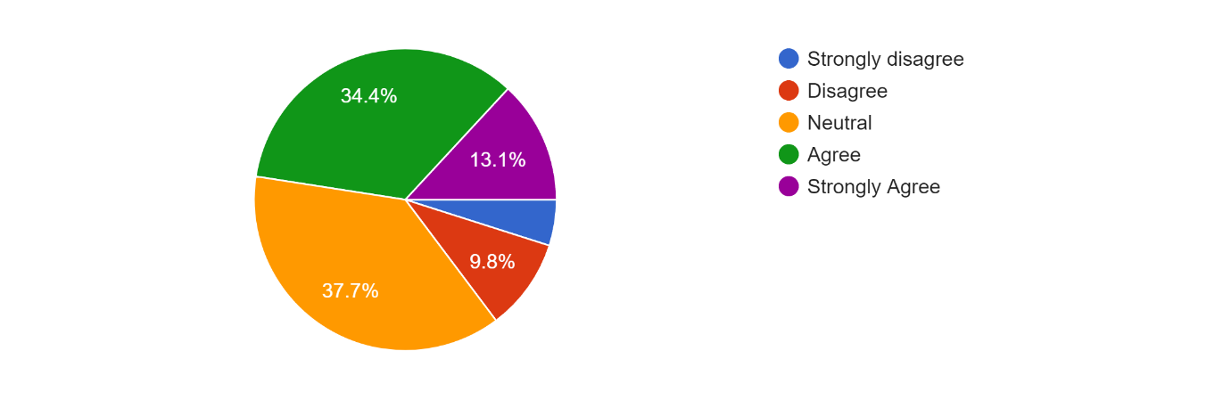
Opinions vary on whether AI in hiring processes leads to job discrimination. While 37.7% remained neutral, 34.4% agreed with the concern. Conversely, 13.1% disagreed, highlighting AI's potential to minimize bias. A smaller portion, 13.1%, strongly agreed, citing evidence of discrimination. Only 5.6% strongly disagreed, advocating for AI's ability to reduce bias.
People disagree on whether AI in hiring is unfair. Some say yes, some aren't sure, and some say AI can actually be fair. It's complicated.

The following is how the respondents interpreted the introduction of AI in transportation is contributing to unemployment:
Opinions vary on whether AI in transportation contributes to unemployment. While 37.7% remained neutral, 26.2% agreed with job displacement concerns. Conversely, 21.3% disagreed, citing new job opportunities. A smaller portion, 8.2%, strongly agreed with significant job losses, while only 6.7% strongly disagreed, expressing confidence in AI's job creation potential.
People aren't sure if AI in transportation is making job loss. Some worry it is, some don't, and some think it creates new jobs. It's a mixed bag.

In our survey, we asked if the fear of AI causing unemployment is hindering its widespread adoption:
Opinions vary on whether fear of AI causing unemployment hinders its adoption. While 27.9% remained neutral, 44.3% agreed it is a barrier. Conversely, 14.8% disagreed, pointing to other obstacles. A smaller portion, 11.5%, strongly agreed, while only 1.7% strongly disagreed.
People don't agree on whether fear of AI causing unemployment stops its use. Some are unsure, while many think it's a problem. However, some disagree, saying there are other issues. Very few are strongly sure about it.

We asked whether the education system should adapt to prepare individuals for an AI-dominated job market and this is what most respondents felt:
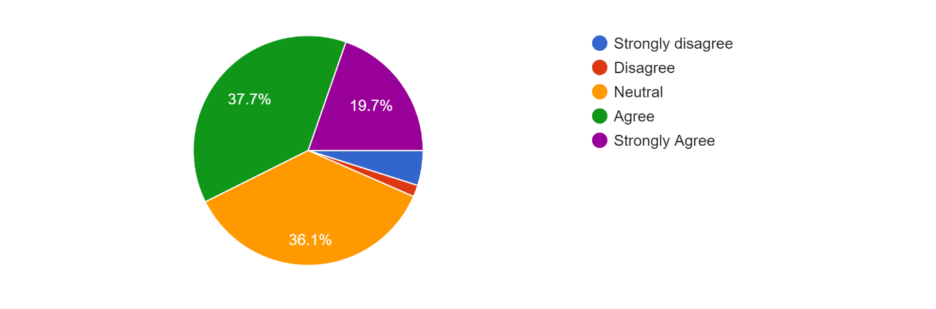
Opinions vary on whether the education system should adapt for an AI-dominated job market. While 36.1% remained neutral, 37.7% agreed with adaptation, emphasizing AI-related skills. Conversely, only 1.6% disagreed, satisfied with the current system. A notable 19.7% strongly agreed, advocating for comprehensive changes, while 4.8% strongly disagreed, possibly due to scepticism about AI's impact.
Views are mixed on whether the education system should change for an AI-dominated job market. Some are not sure, while many think the system should teach AI-related skills. However, some disagree, thinking the current system is fine. Few are strongly sure one way or the other.

In our survey, we asked whether governments should implement policies to mitigate the impact of AI on unemployment and this is what our respondents felt:
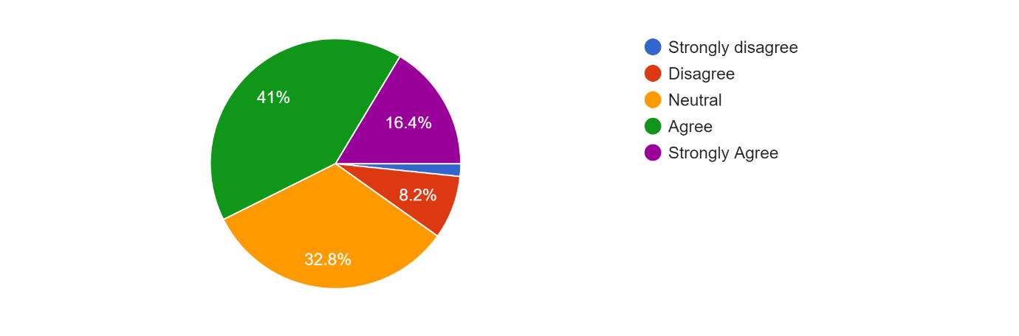
Opinions vary on whether governments should intervene to mitigate AI-related unemployment. While 32.8% remained neutral, 41% agreed with policy intervention. Conversely, 8.2% disagreed, and 16.4% strongly agreed with proactive measures. Only 1.5% strongly disagreed with government intervention.
Opinions vary on whether governments should act to reduce AI-related unemployment. Some are not sure, while many think policies should be made to reduce AI's impact on unemployment. However, some disagree, saying government action isn't needed. Few are strongly sure one way or the other.

AI has the potential to create new job opportunities in emerging industries.
Majority agree AI can create new jobs in emerging industries. 39.3% are neutral, 45.9% agree, and 11.5% strongly agree. A small portion, 3.1%, disagree. No respondents strongly disagree.
AI's potential to generate new job opportunities in emerging industries is widely acknowledged, with many recognizing its capacity for innovation and growth. While some uncertainties persist, the overall sentiment is optimistic about AI's role in shaping future employment landscapes.
The consensus on the need to retrain and upskill workers affected by AI-driven unemployment reflects a proactive approach towards addressing the challenges posed by technological advancements. Investing in workforce development ensures individuals can adapt and thrive in a rapidly evolving job market.

We asked whether public awareness about the relationship between AI and unemployment needs improvement and here are the responses we gathered:
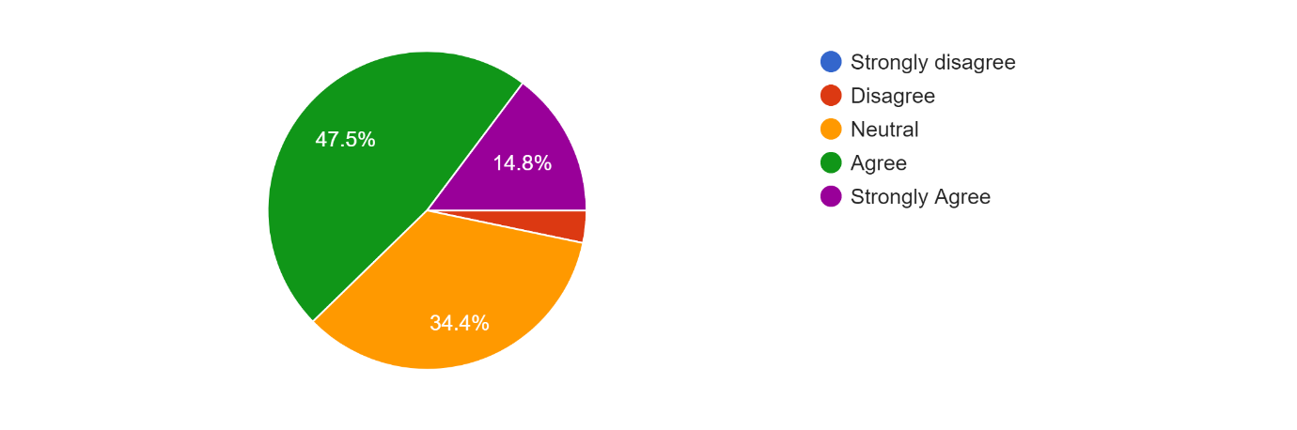
The analysis highlights that the majority, comprising 47.5% who agree and 14.8% who strongly agree, believe that public awareness about the relationship between AI and unemployment needs improvement. Conversely, only 2.9% disagree, while 34.4% remain neutral on the matter. No respondents strongly disagree.
There's a clear recognition of the importance of public awareness regarding the relationship between AI and unemployment. Enhancing understanding and fostering informed discussions can empower individuals and policymakers to navigate the complexities of AI's impact on society effectively.
The debate surrounding the balance between AI's benefits in efficiency and productivity versus its potential negative impact on unemployment underscores the need for comprehensive approaches to maximize the advantages of AI while mitigating its adverse effects. Striking a balance requires careful consideration of societal, economic, and ethical factors to ensure inclusive and sustainable progress.

Challenges and Recommendations:
Challenges:
- One of the primary challenges associated with AI replacing humans is the displacement of the workforce. As automation takes over tasks traditionally performed by humans, there is a risk of job loss and economic instability.
- Another challenge lies in the disparity between the skills required for AI-related roles and those possessed by workers at risk of displacement. Many workers may lack the necessary skills for transitioning to AI-related positions, exacerbating unemployment and widening the skills gap.
- The increasing reliance on AI raises ethical concerns regarding fairness, accountability, and transparency. Algorithms may perpetuate biases or make decisions that are difficult to explain or justify, leading to mistrust and potential harm.
- The socioeconomic impact of AI replacing humans is multifaceted, with implications for income inequality, social cohesion, and access to opportunities. Certain demographics or regions may be disproportionately affected, exacerbating existing inequalities.

Recommendations:
- To mitigate the impact of job displacement, policymakers and businesses should prioritize investments in reskilling and upskilling programs. These initiatives can equip workers with the skills needed to adapt to the evolving labor market.
- Stakeholders must collaborate to develop and enforce ethical guidelines for AI development and deployment. This includes promoting diversity in AI teams, ensuring transparency in algorithmic decision-making, and addressing bias and discrimination.
- Governments can implement supportive policies such as income support, job retraining programs, and labor market reforms to facilitate transitions in the workforce. These policies should prioritize inclusivity and support those most vulnerable to displacement.
- Addressing the challenges of AI replacing humans requires collaboration among stakeholders, including governments, businesses, academia, and civil society. Open dialogue and collaboration can facilitate the development of holistic solutions that balance technological advancement with societal well-being.

Conclusion:
Artificial Intelligence (AI) has revolutionized the employment landscape, introducing both benefits and challenges. AI-driven automation streamlines tasks across industries, boosting productivity but also raising concerns about job displacement. It enhances human capabilities in fields like healthcare and finance but may render some jobs obsolete, particularly in transportation and administration. Yet, AI creates new opportunities, demanding skills like data science and AI development. Collaborative efforts among governments, educational institutions, and businesses are essential to offer training programs and address socioeconomic implications like income inequality. Proactive measures are crucial to navigate AI's impact on employment effectively, ensuring a smooth transition to an AI-driven future. Policymakers must anticipate shifts in the job market and implement policies that facilitate reskilling and upskilling initiatives to meet evolving demands. Moreover, fostering a culture of continuous learning and adaptability is vital to equip individuals with the skills needed to thrive in an AI-powered economy. By harnessing the potential of AI while addressing its challenges, societies can realize the transformative benefits of technology while safeguarding the well-being of the workforce.

References
https://www.sciencedirect.com/science/article/abs/pii/S0313592621000126
https://www.sciencedirect.com/science/article/abs/pii/S0954349X22001291
https://dl.acm.org/doi/abs/10.1145/2483852.2483865
https://dergipark.org.tr/en/pub/jyasar/issue/60163/781167
https://link.springer.com/article/10.1007/s12197-023-09616-z
http://dspace.unive.it/handle/10579/17930
https://www.degruyter.com/document/doi/10.1515/bis-2018-0018/html
https://journals.sagepub.com/doi/abs/10.1177/0894439317698637

