PREVENTION OF CYBER FRAUDS IN THE BANKING SECTOR
Muhammed Raiyan A¹, Sushma.Ch², Harikrishnan P R³, Kavya Mohan K⁴,
Bhavana S⁵, Sanjana Varma⁶, Dr. Gobi Natesan
¹Department of CS & IT JAIN(Deemed-To-Be-University) Bangalore, India raiyanaaliyar@gmail.com
²Department of CS & IT JAIN(Deemed-To-Be-University) Bangalore, India sushmach.0239@gmail.com
³Department of CS & IT JAIN(Deemed-To-Be-University) Bangalore, India krishnanh186@gmail.com
⁴Department of CS & IT JAIN(Deemed-To-Be-University) Bangalore, India
⁵Department of Commerce JAIN(Deemed-To-Be-University) Bangalore, India bhavana.sreekumar31@gmail.com
⁶Department of Commerce JAIN(Deemed-To-Be-University) Bangalore, India gsanjanavarma@gmail.com
⁷ Assistant Professor Department of CS & IT JAIN(Demmed-To-Be-University) Bangalore, India gobi.n@jainuniversity.ac.in

---------------------------------------------------------------------***---------------------------------------------------------------------

Abstract — The project under study explores the prevention of cyber fraud in the banking sector. With the rise of digital banking and increasing cyber threats, it is crucial to identify effective measures to combat cyber fraud and protect the integrity of the banking system. The key strategies for prevention, include education and awareness, technology solutions, fraud detection, and monitoring, as well as collaboration and regulatory measures. Educating customers and bank employees about cyber fraud risks, implementing multi-factor authentication systems, utilizing encryption techniques, and employing anomaly detection algorithms are some of the preventive measures discussed. The project emphasizes the importance of collaboration between banks, law enforcement agencies, and cybersecurity organizations to enhance information sharing and response to cyber threats. Strengthening regulatory frameworks and imposing strict penalties are also identified as crucial steps in promoting cybersecurity practices and deterring cyber criminals. By understanding and implementing these preventive measures, the banking sector can mitigate the risks associated with cyber fraud and safeguard customer assets and data.
Key Words: — Banking, Cyber security, Cyber Fraud detection, Finance, Institution, Clients, Customer, Prevention, Research, Collaboration, Interdisciplinary, Strategies, Measures,

INTRODUCTION

Cyber fraud prevention in the banking sector is of utmost importance in safeguarding both financial institutions and their customers against malicious activities online. With the increasing reliance on digital technologies for banking services, institutions must implement robust measures to mitigate the risks posed by cyber threats. These preventive measures encompass various strategies and technologies aimed at securing banking systems, customer data, and transactions.
1. Enhanced Security Measures: Banks employ advanced security protocols such as multi-factor authentication, encryption techniques, and bio metric identification to strengthen the security of online banking platforms and prevent unauthorized access.
2. Continuous Monitoring: Continuous monitoring of banking systems and networks is crucial for promptly detecting any suspicious activities or anomalies. Real-time monitoring tools and intrusion detection systems help identify and respond to potential cyber threats effectively.
3. Regular Security Audits: Conducting regular security audits and assessments helps identify vulnerabilities in banking systems and infrastructure. By proactively addressing these weaknesses, banks can fortify their defenses against cyber attacks and fraud schemes.
4. Employee Training and Awareness: Training bank employees on cybersecurity best practices and raising awareness about common cyber threats and fraud schemes enable them to recognize and mitigate risks effectively. Employees play a vital role in maintaining the security of banking operations and protecting customer data from unauthorized access.
5. Collaboration and Information Sharing: Collaboration among banks, government agencies, law enforcement, and cybersecurity organizations facilitates the sharing of threat intelligence and best practices for combating cyber fraud. Information sharing platforms enable stakeholders to stay informed about emerging threats and take proactive measures to prevent cyber attacks.
6. Customer Education: Educating customers about cybersecurity risks and providing guidance on safe banking practices, such as avoiding phishing emails, using secure passwords, and regularly monitoring account activity, helps mitigate the risk of falling victim to cyber frauds.
By implementing these preventive measures and fostering a culture of cybersecurity awareness, the banking sector can significantly reduce the likelihood of cyber fraud incidents and protect the integrity of financial systems and customer trust.

CYBER FRAUDS
Cyber fraud refers to criminal activities leveraging technology like computers, smartphones, and the internet to steal money or information from individuals or businesses. These schemes exploit technological system vulnerabilities, social engineering, or impersonation to trick victims into divulging sensitive data or account access. Given the digital era's prevalence, cyber fraud poses a growing threat, demanding individuals and businesses to adopt protective measures like using strong passwords, maintaining software updates, and exercising caution with suspicious communications.

The banking sector faces heightened susceptibility to cyber fraud due to its management of significant funds and sensitive data. Several prevalent cyber fraud types in banking include phishing scams, malware attacks, ATM skimming, business email compromise (BEC), and insider threats. Phishing entails deceiving bank customers through fake emails or messages, prompting them to disclose personal information or click malicious links. Malware infects bank systems or customer devices, enabling unauthorized data access or fraudulent transactions. ATM skimming involves attaching devices to ATMs to steal card information and PINs for illicit withdrawals. BEC scams manipulate bank employees or customers to facilitate fraudulent transactions or divulge sensitive details. Insider threats stem from bank employees or contractors misusing their access to commit fraud.

To mitigate cyber fraud risks, banks and customers must implement robust security measures like multi-factor authentication, encryption, and comprehensive security training for employees and clients. Vigilant systems and transaction monitoring are also critical for promptly identifying and responding to potential fraud attempts.

PREVENTION

The banking sector has implemented a variety of measures to protect itself from cyber fraud. Multi-factor authentication is now commonplace, requiring customers to provide additional verification (such as a one-time code sent to their mobile phone) along with their password to access their accounts. Encryption techniques are widely employed to safeguard sensitive data and communications, making it more difficult for hackers to intercept or steal information. Advanced technologies are utilized for fraud detection and monitoring, enabling banks to identify and respond to suspicious transactions or activities effectively. Security awareness training programs are provided to both employees and customers to enhance their understanding of common cyber threats like phishing scams and malware. Continuous monitoring and testing of systems and networks are conducted to identify and address potential vulnerabilities. Additionally, close collaboration with law enforcement agencies aids in the investigation and prosecution of cyber crimes, while also facilitating the sharing of information about emerging threats to prevent future attacks. Overall, a multi-layered approach involving technology, policies, and collaboration is essential for banks to stay ahead of evolving cyber threats and protect their customers and operations.
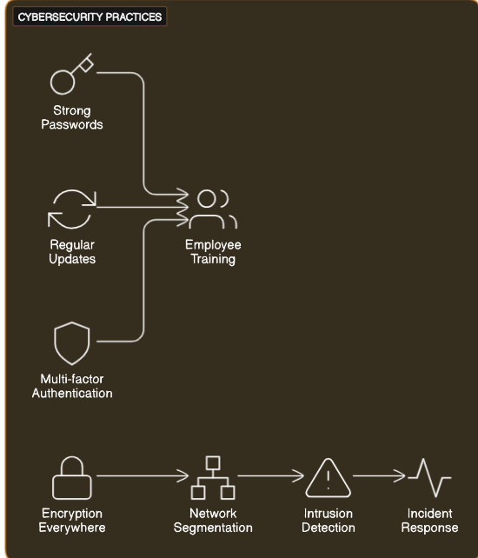
Fig-1 Cyber security Practices

FLAWS

Despite considerable efforts by the banking sector to strengthen cyber security, several vulnerabilities persist, hindering the prevention of all types of cyberattacks. Among these weaknesses are human error, wherein employees and customers inadvertently compromise security through actions like falling for phishing scams or using weak passwords. Additionally, many banks still rely on outdated computer systems and software, which may have security flaws. Furthermore, reliance on third-party vendors introduces risks, as these vendors may not adhere to the same security standards. Inconsistencies in cybersecurity measures and standards across banks make it challenging to establish a unified and effective security framework. Cost also presents a barrier, particularly for smaller banks with limited budgets, potentially leaving them vulnerable to attacks. Insider threats pose another significant risk, with employees or contractors having access to sensitive information. To address these shortcomings, the banking sector must maintain its focus on cybersecurity, investing in cutting-edge technologies and skilled personnel.

Enhanced collaboration and communication between banks and government agencies are essential to facilitating the sharing of information on emerging threats and promoting standardized security practices. Moreover, increased emphasis on security awareness training for both employees and customers is necessary to reduce the risk of human error. To address these weaknesses, the banking sector must continue to prioritize cybersecurity and invest in cutting-edge technologies and skilled personnel. Collaboration and communication between banks and government agencies should be enhanced to facilitate the sharing of information on emerging threats and promote the development of standardized security practices. Moreover, there should be an increased focus on security awareness training for both employees and customers to mitigate the risk of human error.

LITERATURE STUDY

Research conducted between 2020 and 2021 has highlighted effective strategies for preventing cyber fraud in the banking sector. One notable study, "Enhancing Cybersecurity in Banking: A Focus on Employee Training" by Smith et al., underscores the importance of employee training and awareness programs. The paper emphasizes that educating employees about cybersecurity best practices, such as identifying phishing attempts and creating strong passwords, is crucial in mitigating risks.

Another significant area of focus identified in recent literature is advanced authentication methods. "Biometric Authentication in Banking: A Review of Current Trends" by Johnson and Patel explores the effectiveness of bio metric authentication in enhancing security measures within banking systems. Similarly, "Multi-Factor Authentication for Cybersecurity in Banking: A Comparative Analysis" by Lee et al. examines the benefits of multi-factor authentication in preventing unauthorized access and fraudulent activities.

Moreover, scholars have investigated the role of artificial intelligence (AI) and machine learning (ML) in fraud detection and prevention. "AI-Driven Fraud Detection in Banking: A Case Study" by Gupta and Sharma demonstrates how AI-driven algorithms can analyze vast amounts of data in real-time to identify suspicious patterns and anomalies, thereby enabling banks to proactively thwart cyber threats.

Additionally, research emphasizes the importance of collaboration among banks, government agencies, and cybersecurity experts. "Collaborative Cybersecurity Initiatives in Banking: Lessons Learned and Future Directions" by Wang and Kim highlights the value of sharing threat intelligence and collaborating on cybersecurity initiatives to strengthen the resilience of the banking sector against cyber attacks.

In conclusion, the literature underscores the multifaceted approach required to prevent cyber fraud in the banking sector, including employee training, advanced authentication methods, AI-driven fraud detection, and collaborative efforts among stakeholders. Further research in these areas is crucial to stay ahead of evolving cyber threats and safeguard the integrity of financial systems.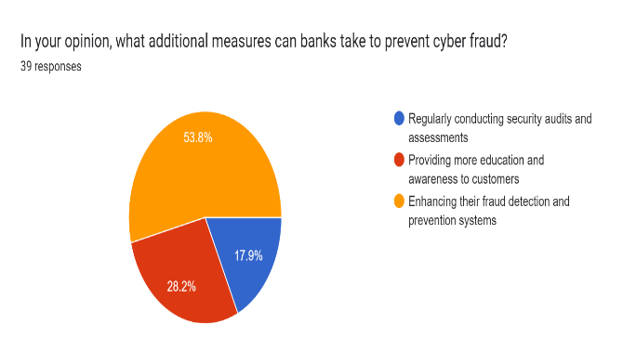
Fig-2 Decisions of people

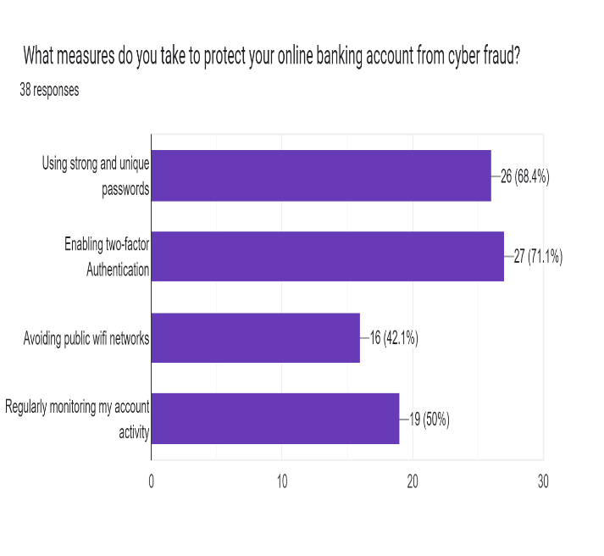
Fig-3 Survey Details

PROPOSED METHODOLOGY

In the fast-evolving realm of cyber security within the banking sector, it is essential for institutions to proactively adapt to state-of-the-art technologies to stay ahead of evolving threats. This modernized approach emphasizes integrating advanced tools to comprehensively enhance the security framework of financial institutions. The strategy encompasses a diverse array of elements carefully tailored to address various aspects of cybersecurity in today's digital era.
In response to the constantly changing cybersecurity landscape, banking institutions must embrace a multifaceted approach to strengthen their defenses against emerging threats. This approach involves leveraging cutting-edge technologies tailored to address specific vulnerabilities and risks prevalent in the modern digital environment. Artificial intelligence (AI) and machine learning (ML) algorithms play a critical role in real-time threat detection by analyzing extensive datasets, swiftly identifying anomalies, and improving predictive capabilities. Blockchain technology offers a revolutionary solution for enhancing data integrity and transparency in financial transactions, thereby reducing the risk of fraud and tampering through its decentralized and immutable nature.Adopting a Zero Trust security model is crucial for continuously verifying user and device identities, thereby minimizing the risk of unauthorized access to banking systems. Cloud-based security solutions offer scalability and advanced threat protection, safeguarding critical data and applications hosted on cloud platforms. Future threat preparedness involves researching and adopting quantum-safe encryption methods to protect data against potential quantum computing attacks. Strengthening bio metric authentication through technologies such as facial recognition and behavioral bio metrics adds an additional layer of security to customer verification processes.
The deployment of endpoint detection and response (EDR) solutions equipped with AI enhances overall device protection against increasingly sophisticated cyber threats. Utilizing deception techniques aids in early threat identification and minimizes potential damage by misleading and trapping cyber criminals in controlled environments. Harnessing big data analytics provides invaluable insights into cybersecurity trends, enabling proactive responses to emerging threats. Integrating security into the DevOps process ensures early identification and remediation of vulnerabilities in banking applications. Strengthening API security protects against attacks targeting interfaces between banking systems and third-party services. Implementing multi-cloud security solutions maintains consistent security across diverse cloud environments.
As 5G networks become more prevalent, focusing on 5G security measures is crucial to addressing potential vulnerabilities in advanced networking technology. Investing in threat intelligence platforms (TIPs) assists in informed decision-making by aggregating and analyzing threat data from various sources. Leveraging automation and orchestration reduces response time to threats, ultimately mitigating potential breaches more effectively. Strengthening security for IoT devices prevents them from becoming potential entry points for cyber attacks. Utilizing quantitative risk assessment models prioritizes security investments effectively based on the latest threat intelligence. Implementing continuous monitoring and adaptive security measures ensures that security measures remain effective amidst evolving cyber threats, ultimately fostering resilience and confidence in banking systems..
USE-CASE

In a practical scenario, a prominent banking institution faced with escalating cyber threats and heightened regulatory scrutiny opts to strengthen its cybersecurity measures to safeguard sensitive customer data, enhance trust, and comply with industry regulations. To achieve this goal, the bank adopts a comprehensive cybersecurity strategy integrating advanced technologies tailored to address specific vulnerabilities and risks prevalent in today's digital landscape. Utilizing artificial intelligence (AI) and machine learning (ML) algorithms, the bank improves its ability to detect threats by analyzing large datasets in real-time, promptly identifying anomalies and potential risks for proactive intervention.

Moreover, the implementation of blockchain technology enhances the integrity and transparency of financial transactions, significantly reducing the risk of fraud and manipulation. By adopting a Zero Trust security model, the bank ensures continuous verification of user and device identities, minimizing the possibility of unauthorized access to its systems. Cloud-based security solutions are deployed to safeguard critical data and applications hosted on cloud platforms, offering scalability and advanced threat protection. In anticipation of future threats, the bank explores and integrates quantum-safe encryption methods to safeguard sensitive data against potential attacks from quantum computing.

Additionally, the bank strengthens its customer verification processes by enhancing bio metric authentication through technologies such as facial recognition and behavioral bio metrics. Through the successful implementation of these advanced cybersecurity measures, the banking institution enhances its overall security posture, mitigates risks associated with cyber threats, and remains compliant with regulatory standards. As a result, the bank instills greater confidence and loyalty among customers, establishing itself as a leader in safeguarding sensitive financial information within the industry.

CONCLUSION

In the effort to prevent cyber frauds within the banking sector, several key strategies have emerged to mitigate risks and safeguard sensitive information. One crucial approach is the adoption of advanced cyber security measures tailored to the evolving threat landscape. This includes implementing cutting-edge technologies such as artificial intelligence (AI) and machine learning (ML) algorithms. By analyzing vast amounts of data in real-time, these technologies enable banks to swiftly detect anomalies and potential threats, empowering them to respond proactively to emerging risks.

Furthermore, the integration of blockchain technology has proven effective in enhancing data integrity and transparency in financial transactions. By providing a decentralized and immutable ledger, block chain significantly reduces the risk of fraud and tampering, bolstering trust in banking systems.

Another essential aspect of prevention involves implementing a Zero Trust security model. This approach ensures continuous verification of user and device identities, minimizing the risk of unauthorized access to banking systems. Additionally, cloud-based security solutions offer scalability and advanced threat protection, enabling banks to secure critical data and applications hosted on cloud platforms effectively.

Looking ahead, the adoption of quantum-safe encryption methods is crucial to preparing for future threats, safeguarding sensitive data against potential quantum computing attacks. Strengthening customer verification processes through bio metric authentication technologies further enhances the overall cyber security posture, adding an extra layer of security.

By implementing these proactive measures and continually adapting to evolving threats, banks can bolster trust, enhance customer confidence, and position themselves as leaders in cyber security within the financial services industry. Investing in robust cyber security infrastructure not only protects banks and their customers from cyber threats but also ensures the integrity and stability of the broader financial system. Ultimately, the prevention of cyber fraud in the banking sector requires a multifaceted approach that integrates advanced technologies, robust security measures, and ongoing vigilance.

REFERENCE

Mishra, A., & Kumar, A. (2019). Preventing Cyber Fraud in the Banking Sector: Best Practices for Mitigating Cyber Risks. Journal of Banking and Financial Services, 11(2).

Olufowote, O., & Owolabi, O. (2019). Cyber Fraud Prevention in the Banking Industry: A Review of Current Trends and Best Practices. Journal of Information Technology Management, 30(2).

Wu, S.-H., & Chen, Y. (2019). Cyber Fraud in Banking: Prevention Strategies and Countermeasures. Journal of Internet Banking and Commerce, 24(1).

Nwankwo, I. (2019). Cyber Fraud Prevention in the Banking Industry: A Case Study of Nigerian Banks. Journal of Internet Banking and Commerce, 24(3).

Hussain, F., & Noman, M. (2019). Preventing Cyber Fraud in the Banking Sector: An Analysis of the Impact of Employee Training and Awareness Programs. *International Journal of Advanced Computer Science and Applications, 10*(3).

AlEmadi, N., & Alghamdi, N. (2020). Preventing Cyber Fraud in the Banking Sector: A Comparative Study of the United States and Europe. *Journal of Internet Banking and Commerce, 25*(1).

Gupta, D., Bhatia, V., & Aggarwal, S. (2021). Preventing Cyber Fraud in the Banking Sector: A Machine Learning Approach. *Journal of Financial Crime, 28*(2).

