Eventos An Event Management Website

1st Priyanshu Patel
Parul Institute of Engineering and Technology
Parul University
Vadodara,India ppriyanshu024@gmail.com

4th Vishwam Patel
Parul Institute of Engineering and Technology
Parul University Vadodara, India
vishwampatelpatel2510@gmail.com
2nd Mihir Kubavat
Parul Institute of Engineering and Technology
Parul University
Vadodara, India mihirkubavat02@gmail.com
3rd Mukul Patel
Parul Institute of Engineering and Technology
Parul University
Vadodara, India mpjexo2702@gmail.com

5th Maheshwari Sagar Assistant Professor
Parul Institute of Engineering and Technology
Parul University Vadodara, India
maheshwari.sagar29433@parulunivers ity.ac.in

Abstract
Event management is the application of project management to the creation and development of large or small scale events such as festivals, conferences, ceremonies, formal parties, concerts, or conventions. he last few years have seen a rapid growth in the event management industry.Considering the existing system problems related to event management we are developing an android application for event management. This application will be accessible only for android. Application will mainly focus on birthday party, marriage functions and social events. The application will be developed using Android studio and back end will be managed in SQL database. Application will have easy and feasible GUI for all type of users. User needs to Login at the initial phase, set his/her profile details including location, choices, email-id, etc. User can modify or change His/her profile at any stage. The core phase of the application will display list of events based on the user profile details. This event will further contain description about event, its exact location, ticket rates (if any), date and time. These details will be firstly verified by the administrator to fulfill the security protocols. In this paper we present an android mobile phone application to make it easier for a layman to plan an event in a hassle-free manner. This application will assist him/her in planning a successful and fun event.
Keywords — Strategic partnership, Customer Acquisition, Planning Management, Organizational Communication.

Introduction
“Eventos” is an event organizing website in which we can get different services on the website. We all are having busy time schedule in today’s life so it becomes very difficult to physically visit different places for different services. Eventos is a place where you can easily get all the required services for organizing events at one place which includes services venues,decorations,music,food and many more. We have used React for the frontend, for the backend nodeJS and Express and for database we have used the Mongo database as it is very secure and efficient.

The problem statement for an event management website revolves around creating an online platform that efficiently
facilitates the planning, organization, and execution of various events. The website aims to streamline the entire event management process, making it more convenient for event organizers, participants, and attendees. We all are having busy time schedule in today’s life so it becomes very difficult to physically visit different places for different services.Eventos is a place where you can easily get all the required services for organising events at one place which includes services venues,decorations,music,foo and many more. Currently we are aiming to one city but we would like to expand it in Future.after launching it in future we will work on Development,General management and Event marketing. Main motto of ours is to avail all the services on the online platform.

During the complete implementation we have worked on Visual Studio Code (VSCode).Visual Studio Code is a free source-code GUI (Graphical User Interface) editor made by Microsoft for Windows, Linux and macOS. Features include support for debugging, syntax highlighting,intelligent code completion, snippets, code refactoring, and embedded Git. Users can change the theme, keyboard shortcuts, preferences, and install extensions that add additional functionality.It also provides extension to work in a team with a multi user experience. Even compiling and deploying of the application was done easily with the help of VSCode. For the database implementation, We have used Mongo Database. It’s a flexible, scalable, NoSQL cloud database. It allows you to store your app data and uses realtime listeners to keep the data in sync. It works well in all situations regardless of your internet conn

Literature Survey

This course enhances students' analytical, organizational, and creative thinking skills by preparing detailed event plans, organizing, executing, and evaluating events, developing event themes, selecting venues, budgeting, protocol, and etiquette.[1] This text provides a managerial and developmental approach to event management, focusing on basic theory, best practice, and applied methods. It is

XXX-X-XXXX-XXXX-X/XX/$XX.00 ©20XX IEEE

interactive, user-friendly, and outcomes-based, using case studies, theoretical principles, practical examples, and relevant legislation.[2]
Event management has gained prominence in academia and applied fields in the last 30 years, despite its existence for as long as mankind. This paper reviews current events in event management and suggests future developments.[3] Research on leadership's importance in organizational success has been disappointing due to its oversimplified assumption that leadership influence is a one-way process.[4]

Event Management literature claims significant growth and investment, but is often uncritical and self-congratulatory. This paper examines Global Event Management, focusing on single issue and cyclical types, and data from Live Aid, FIFA World Cup, and Sydney Olympics. It concludes that Event Management is based on neo-liberalism and communitarianism, resulting in a Reformist attitude towards Events and leisure, contrasted with the critical tradition in Leisure Studies.[5] This book provides a practical guide on identifying, evaluating, and managing event sustainability issues and impacts. It is applicable to events of any style and scale, anywhere in the world, and offers a step-by-step guide for utilizing events for good, despite their potential to consume resources, emit emissions, and generate waste.[6]

The event industry is a relatively new academic field, with a focus on education, research, and evaluation. This conference aims to address these issues, particularly in Australia, where the debate surrounding the Sydney 2000 Summer Olympic Games has significantly impacted the events sector. It is crucial for setting future research, educational, and professional directions.[7] Strategic Sports Event Management offers students and event managers insights into managing sports events of all scales and types. The book provides a practical guide to planning, organizing, managing, and evaluating events, emphasizing the importance of adopting a strategic approach. It uses international case studies and in-depth studies of the London Olympic Games, providing real-world insights into both large and small events.[8]

4e is a comprehensive text for the Diploma in Events Management and Advanced Diploma, covering event management skills such as design, planning, marketing, staging, staff management, and ensuring safety for tourism, cultural, business, and sporting events.[9] Scholars have researched customer acquisition less than customer retention since 1983, with 45 papers on retention and 7 on customer acquisition.[10] This paper explores the intersection of advertising, CRM, and call center management, focusing on demand as a function of past service. Unlike previous studies, it highlights the lack of focus on firms' supply constraints in fulfilling advertising demand.[11] The article explores the role of customer expectations in predicting customer satisfaction, arguing that satisfaction is determined by both actual performance and customer expectations. It presents a theoretical model explaining this relationship, and presents an empirical study proving its importance. The article provides insights into factors driving satisfaction and offers guidance for businesses.[12]
Our work analyzes the trade-off between acquisition and retention using a dynamic approach, capturing the dynamic nature of resource allocation over time. We use stochastic optimization instead of regression, empirical, or deterministic techniques, focusing on state transitions and the 'customer equity test'.[13] CRM literature reveals various representations, with operational CRM focusing on tactical efficiency and analytic CRM focusing on strategy and effectiveness. Organizations often prioritize operational CRM, focusing on customer demand and market challenges, while analytic CRM seeks new infrastructure and processes to understand customer needs. To build intelligent dialogue and long-lasting relationships, companies need quality information, appropriate processes, and harmony.[14]
Banks face significant challenges in customer acquisition due to limited profitable customers and competition. Often, they target mass markets, hoping some customers will become customers. Customer acquisition is crucial for businesses to generate profits and attract partners, investors, influencers, and prospects. Sustainable and systematic strategies are essential for success in this process.[15] This introductory book explores the multi-disciplinary nature of events management, providing practical skills and professional knowledge for students. It covers various events, including sports, music, arts, corporate events, tourism, and public and voluntary sectors. Key issues like health, safety, risk management, sustainability, and market- oriented business are discussed. The book also covers marketing, finance, project management, strategy, operations, event design, and human resources.[16]

Marketing is a process that creates value for customers and builds strong relationships. Customer acquisition is a key marketing process, especially for startups. It is a part of customer lifecycle management, which involves getting, keeping, and growing a customer base. The relationship between marketing, customer lifecycle, and acquisition is crucial for a company's success.[17] This research study investigates organizational communication in higher education and staff members' perceptions of communication and job satisfaction. Results show that gender differences and service years don't significantly impact satisfaction, but education and job classification do. The study highlights the multifaceted nature of satisfaction.[18]

This course teaches students to develop analytical, organizational, and creative thinking skills for special events, including planning, organizing, executing, and evaluating, and examining facilities like administrative, catering, and meeting services.[19] The article explores the role of customer expectations in predicting customer satisfaction, arguing that satisfaction is determined by both actual performance and customer expectations. It presents a theoretical model explaining this relationship, and presents an empirical study proving its importance. The article provides insights for businesses to improve customer satisfaction and loyalty.[20]

Methodology
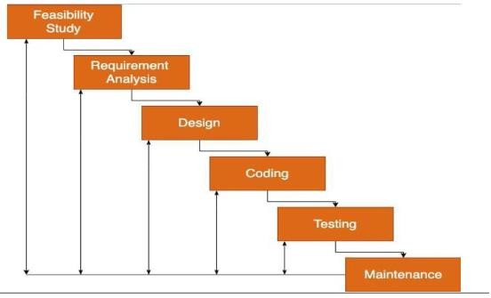

FEASIBILITY STUDY
Technical Feasibility:-After considering our project functionalities and technical needs we decided to go with the following technologies - Frontend – React Backend – Node , Express Database – MongoDB All the above- mentioned technologies are open sources therefore it is feasible to use with the knowledge of basics in each of them it would be easy for us to manage the project too.
  - Operational Feasibility:- In the current scenario where the virtual world is the new normal, our
project will excel greatly along the users who want to avail services online. We have kept the
application pretty simple and handy so everyone can take advantage of it and use it without
any inconvenience.
  - Implementation Feasibility:- The Functional requirements of our project will be easily fulfilled
by the technologies we have mentioned. All the technologies we are using are easily supported
by all the mobile phones. Hence, the implementation is feasible.
- SYSTEM STUDY REQUIREMENT

USER CHARACTERISTICS:-
- User(buyer): can view services , place booking request,payment
- User(seller): can upload details about service they are providing.

HARDWARE AND SOFTWARE REQUIREMENTS
For Manager the basic software requirements are as follows
- Good Browser
- Good internet connection
For Manager the basic hardware requirements are as follows
- Device to run the web application
For End User the basic software requirements are as follows
- Good internet connection
For End User the basic hardware requirements are as follows
- Device to run the web application

CONSTRAINTS
- As it is a web application, constantly needs internet
- Response time can vary depending on the devices

SYSTEM DESIGN

Use Case:-

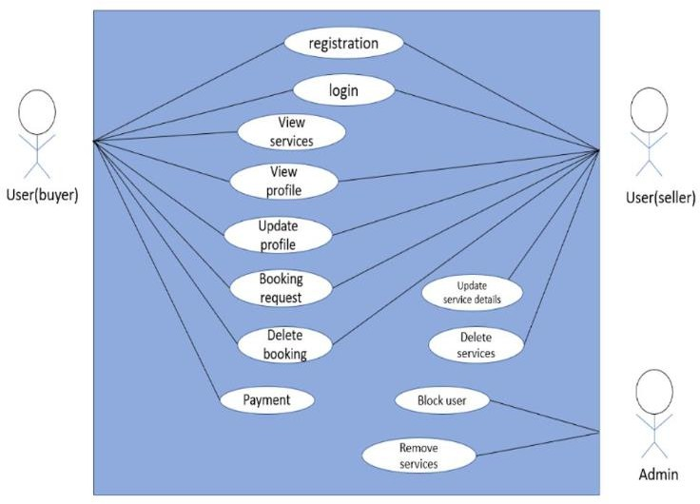

Activity Diagram:-
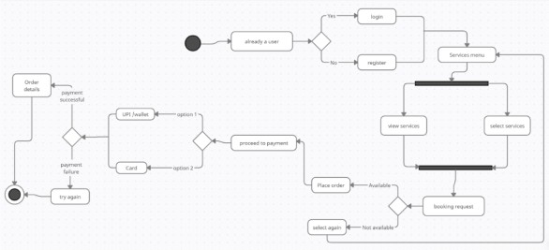

- Coding Snipet:-
While writing our code we took the utmost care to follow the basic coding standards while writing a Flutter code like:
- Following proper naming conventions of local variables, global variables, constants and functions.
- Doing proper indentation.
- Proper error handling.

TESTING:-
  - TESTING PLAN
The method of testing used in this project is White Box testing as in White Box testing, the tester has the complete knowledge and understanding of the code.
  - TESTING STRATEGEY
The development process repeats this testing sub-process a number of times for the following phases.
  - Unit Testing.
  - Integration Testing
Unit Testing tests a unit of code (module or program) after coding of that unit is completed.
Integration Testing tests whether the various programs that make up a system, interface with each other as desired, fit together and whether the interfaces between the programs are correct.
  - TESTING METHOD
There are two kinds of testing mainly Blackbox and Whitebox testing:
- In black-box testing a software item is viewed as a Blackbox, without knowledge of its internal structure or behaviour. Possible input conditions based on the specifications (and possible sequences of input conditions), are presented as test cases.

Future Work
    - Mobile Application Development
Building a dedicated mobile application can make our service more accessible to users on the go.
With features like real-time notifications for new listings and instant messaging, we can create a seamless and user- friendly experience.

User Reviews and Feedback
Implementing a user review system can enhance the credibility of our service. It allows past users to share their experiences, providing valuable insights for prospective users in choosing roommates and accommodations.

Safety and Verification
Ensuring the safety and security of users is paramount. Implementing background checks and identity verification procedures for users can build trust within the community.

Conclusion
  - We provide a semi-automated system which easy to use and with good response time to get services for an event.
  - We have tried to keep UI alluring and easy enough for users to user.
  - Small step to make event organising system online and automated.

Acknowledgment
On the very outset of this report, we would like to extend our sincere and heartfelt obligations towards all the personages who have directly or indirectly helped in this endeavor. Without their active guidance, help, cooperation and encouragement, we wouldn’t have made the headway in the project.We are ineffably indebted to our instructor for her guidance, encouragement and conscientiousness to accomplish this project. We are extremely thankful for her support. We wouldalso like to express our gratitude to our Head,along with University for giving us this opportunity.Last but not least, we would also like to acknowledge with a deep sense of reverence, our gratitude towards our family members who have always supported us morally. Any omission in this brief acknowledgement does not mean lack of gratitude

References
    - . B. A. Alvarez and R. V. Casielles (2004). “Consumer evaluations of sales promotion: the effect on brand choice,” European Journal of Marketing, Vol. 39(1/2), pp. 54-70.
    - . D. Andrews (2016). “Product information and consumer choice confidence in multi-item sales promotion,” Journal of Retailing and Consumer Services, Vol. 28, pp. 45-53.
    - . V. L. Ang F. Buttle (2006). “Managing for successful customer acquisition: An exploration,” Journal of Marketing Management, Vol. 22, pp. 295–317.
    - . V. Badrinarayanan D. A. Laverie (2011). “Brand advocay and sales effort by retail sales people: antecedents and influence and influence of identification with manufacturerss brands,” Journal of Personal Selling Sales Management, Vol. 31(2), pp. 123-140.
    - . J. U. Becker, G. Greve and S. Albers (2009). “The impact of technological and organizational implementation of CRM on customer acquisition, maintenance, and retention,” International Journal of Research in Marketing, Vol. 26, pp. 207–215.
    - . P. D. Berger and N. I. Nasr (1998). “Customer Lifetime Value: Marketing Models and Applications,” Journal of Interactive Marketing, Vol. 12(1), pp. 17–30.
    - . R. C. Blattberg, G. Getz and J. S. Thomas (2001), Customer Equity. Boston: Harvard Business School Press and (2003), “The Impact of Relationship Characteristics on Profitable Lifetime Duration,” Journal of Marketing, Vol. 67 (January), pp. 77-99.
    - .M. Brengman and K. Willems (2009). “Determinants of fashion store personality: a consumer perspective,” Journal of Product Brand Management, Vol. 18(5), pp. 346–355. doi: 10.1108/10610420910981828.
- F. Buttle (2009). “Managing the customer lifecycle: customer acquisition,” Customer relationship management: Concepts and technologies (225–254) (2nd ed.). London: Taylor Francis.
- I. A. Castro, S. Diego and J. Ward (2012). “The Importance of Warmth and Competence in the Acquisition and Retention of New Customer,” Advanced in Consumer Research, Vol. 40, pp. 947-.948.
- Chetty, S., Campbell-Hunt, C. (2004). A Strategic Approach to Internationalization: A Traditional Versus a “Born-Global” Approach. Journal of International Marketing, 12(1), 57-81.
12).L. Jeseviciute-Ufartiene, “Organization self- development based on mind activity expansion
in management,” Management Theory and Studies for Rural Business and Infrastructure Development. Research Papers, vol. 5, no. 24, pp. 55-62, 2010.
- M. Rac, “Analyzes of situation. Middle of sociality,” Man and Environment, Moscow: Knowledge publishing, No.5/90. 1990.
- A. M. Efendioglu and A. T. Karabulut, “Impact of strategic planning on financial performance of companies in Turkey,” International Journal of Business and Management, vol. 5. no. 4. pp. 3-12, April 2010.
- Y. Sarason and F. Tegarden, “The erosion of the competitive advantage of strategic planning,” Journal of Business and Management, vol. 9, no. 1, pp. 1-21, 2003.
- A. Valackiene, “Efficient corporate communication: Decisions in crisis management,” Inzinerine Ek Onomika- Engineering Economics, vol. 21, no. 1, pp. 99-110, 2010.
- M. Seeman, “On the meaning of alienation,” in Continuities in the Language of Social Research, P. Lazarsfeld, A. Pasanella, and M. Rosenberg Ed., New York: Free Press, 1972.
- Statistic Department of Lithuania Republic. (May 15, 2009). [Online]. Available: http://db1.stat.gov.lt
- M Herremans (2005), Management planning and control supporting knowledge incentive organisations, The Learning organisation (vol.12, issue.4).
- S. M. Dobson (1980), Planning and Control of purchasing performance: A new concept, Long
Range planning (vol.13,issue.3)

