Reducing detergent from river using bio augmentation.
Jayesh Pagar
Jayesh Pagar, Department of biotechnology, H.P.T Arts & R.Y.K Science College, Nashik.
Abstract: This project is based on reducing detergent from river which is been released in any form it may be from washing clothes, soaps, shampoos, etc. we cannot separate as it mixed in water. So, detergent degrading bacteria should be used. Bacterial species that can degrade detergent easily are pseudomonas, bacillus subtilis, Staphylococcus, coliform bacteria i.e E.coli. Degrading efficiency depends on strain that is used which can be determined by measuring optical density or doing titration.
Keywords: Detergent, Optical density, bacterial degradation.
Introduction:
Detergent are chemical compound and are amphipathic molecules that contain both polar and hydrophobic group.
The components of detergents are non- biodegradable in nature. So, when any detergent is used during washing; its components can not be later disposed of and remain in water for long. This leads to heavy water pollution. As Many laundry detergents contain approximately 35 to 75 per cent phosphate salts. Phosphates can cause a variety of water pollution problems. For example, phosphate tends to inhibit the biodegradation of organic substances. Non-biodegradable substances cannot be eliminated by public or private wastewater treatment.
Some bacterias are able to degrade detergent. So, it can be used to reduce water pollution. Bacterial strains used in this are pseudomonas aeruginosa, Bacillus subtilis, E.coli, Staphylococcus aureus. Among these 4 B.subtilis can be used as it is not considered pathogenic or toxigenic for humans, animals and plants. By observing it is been confirmed that when nutrients are depleted it starts death phase where reduction of bacteria takes place.
Body of paper.
For confirming degradation of detergent by bacteria, 2gm of detergent powder was added in 100ml of water. Then inoculation of bacteria was done by keeping aseptic condition. After every 24 hours measuring of optical density was done where increase and decrease of reading indicates growth of bacteria and reduction of detergent. At start turbidity increase which indicates growth of bacteria and at end decrease in turbidity indicates reduction of detergent.
Optical density table:-
Day | Blank | B.subtilis | Pseudo | S.aures | E.coli
1 | 0.30 | 0.34 | 0.35 | 0.32 | 0.40
2 | 0.30 | 0.37 | 0.37 | 0.34 | 0.47
3 | 0.30 | 0.45 | 0.45 | 0.38 | 0.50
4 | 0.30 | 0.44 | 0.48 | 0.37 | 0.51
5 | 0.30 | 0.41 | 0.44 | 0.34 | 0.53
6 | 0.30 | 0.39 | 0.43 | 0.34 | 0.51
7 | 0.30 | 0.35 | 0.40 | 0.32 | 0.48
8 | 0.30 | 0.33 | 0.38 | 0.30 | 0.42
9 | 0.30 | 0.30 | 0.34 | 0.30 | 0.38
10 | 0.30 | 0.27 | 0.30 | 0.29 | 0.33
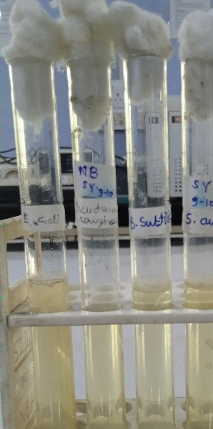
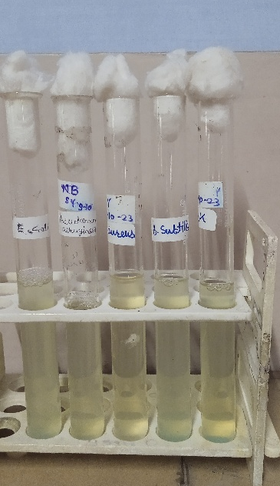
Before After
Percentage of degradation can be calculated by formula O.D1-O.D2/t2-t1
Results:-
By this table all 4 selected bacteria are able to degrade detergent. Bacillus subtilis can be used as it is able to degrade most of detergent which is 80% which is calculated by above formula where O.D is taken of blank and one bacteria and time is 24hrs. It concludes that for degradation at least 10 days are required as it will help to reduce water pollution. For future this bacteria can be used to reduce some hazardous chemicals which make imbalance in environment.
References:
www.Vedantu.com
www. Research.net.com
Environmental biotechnology vision

