Enhancing Learning Environments and Robust solution on
“Student Grievance System”
Akhilesh Pimparkhedkar¹, Shubham Rajput², Ratan Prajapati³ ,
Ashritha Chowdary⁴, Digvijay Sinh Mahida⁵
¹Student , Parul Institute of Engineering and Technology
²Student , Parul Institute of Engineering and Technology
³Student , Parul Institute of Engineering and Technology
⁴Student , Parul Institute of Engineering and Technology
⁵Asst. Prof. , Parul Institute of Engineering and Technology
---------------------------------***--------------------------------
Abstract - A well-structured student grievance system is essential for addressing student concerns, resolving disputes, and enhancing overall institutional quality. This study delves into the key components, benefits, challenges, and best practices associated with implementing an effective student grievance system. The significance of a robust grievance system in educational institutions has gained prominence due to the increased focus on student rights and the evolving dynamics of higher education. Addressing student grievances in a fair and efficient manner is not only a legal requirement but also a moral and ethical imperative for educational institutions committed to providing a supportive and inclusive learning environment.
This study explores the benefits of implementing such a system, which extend beyond compliance with regulations. An effective grievance system contributes to improving student satisfaction, retention rates, and academic outcomes. Additionally, it helps identify systemic issues and areas for institutional improvement. This research provides insights into best practices and innovative approaches adopted by leading educational institutions. It showcases real-world examples of successful grievance systems and highlights their positive impact on the overall campus culture. By studying the experiences and lessons learned from various institutions, this study aims to contribute to ongoing dialogue on the importance of student grievance systems in higher education and the continuous pursuit of excellence in academic institutions.
Key Words : grievance system , student grievance system , mental health , complaint management , complaint submission , educational institutions, transparency, impartiality, technology integration

- INTRODUCTION

Student grievance systems are critical for allowing students to express concerns, report issues, and seek resolutions for challenges encountered during their academic careers. An effective grievance system not only maintains student satisfaction but also plays a crucial role in promoting institutional growth and accountability. In today's dynamic educational landscape, which caters to diverse student populations with evolving needs, establishing mechanisms that can effectively address student grievances has become essential. This research paper delves into the intricacies of student grievance systems within educational institutions, aiming to unravel their significance in fostering a harmonious and conducive learning environment.
The academic journey presents numerous opportunities for growth, exploration, and transformation; however, it is not without its challenges. These challenges can take various forms, ranging from academic disputes to issues related to campus climate, discrimination, and administrative matters. An effective student grievance system serves as a safety net, providing students with a structured means to voice their concerns and seek solutions, thereby contributing to their overall well-being and reinforcing their trust in the institution's commitment to their academic and personal success.n- depth exploration of student grievance systems within the context of educational institutions. It endeavor to unravel the intricacies of these systems and elucidate their significance in maintaining a harmonious and conducive learning atmosphere.
The academic journey is replete with opportunities for growth, exploration, and transformation, but it is not without its challenges. These challenges can manifest in various forms, from academic disputes to issues related to campus climate, discrimination, or administrative matters. An effective student grievance system serves as a safety net, providing students with a structured means to voice their concerns and seek resolution. This not only contributes to their overall well-being but also reaffirms their trust in the institution's commitment to their academic and personal success.
Through this exploration, this research paper aims to highlight the importance of well-structured student grievance systems in the contemporary educational landscape. By emphasizing their profound impact on nurturing a positive educational journey, this study underscores the importance of these systems not only as compliance measures, but also as essential pillars of institutional integrity and excellence. As we delve into the intricacies of student grievance systems, we aim to provide valuable insights and recommendations for institutions committed to creating an environment in which students' concerns are not only heard but also addressed effectively, ultimately contributing to the overarching goal of a vibrant and inclusive educational community.

2. METHODOLOGY

Case Study:

Case Study1: Improved Efficiency Through Automation

Background: A large university receives a high volume of student grievances through various channels, leading to delays in resolution and frustrate students.
Solution: The institution implements a smart grievance system that automates the initial grievance intake, categorization, and assignment to relevant staff members.

Case Study 2: Improved Transparency & Accountability

Background: A college struggles with transparency in grievance resolution, leading to mistrust among students.
Solution: The institution adopts a smart grievance system that allows students to track the progress of their grievances and provides real-time updates.

Case Study3: Enhanced Communication& Collaboration

Background: A university with multiple campuses non integrated with communication breakdowns in grievance handling.
Solution: The institution implements a smart grievance system that centralizes communication and collaboration among campuses.

Case Study 4: Proactive Issue Identification

Background: A community college wants to address issues before they escalate into formal grievances.
Solution: The institution deploys a smart grievance system with data analytic capabilities to identify emerging issues from student feedback and engagement patterns.

Some Common Misapprehensions:

1. Lack of Accessibility:
• Current grievance systems may not be easily accessible to students, making it difficult for them to report issues or concerns effectively.

2. Complex and Time-Consuming Processes:
• Grievance procedures can be overly complicated and time-consuming, causing frustration among students and delaying issue resolution.

3. Inadequate Communication:
• Poor communication between students and the institution can lead to misunderstandings, resulting in unresolved grievances.

- Limited Transparency:
• Lack of transparency in the grievance process can leave students in the dark about the status of their complaints and the steps being taken to address them.

5. Inefficient Handling:
• Grievances may be mishandled or not given the attention they deserve, leading to unresolved issues and dissatisfaction.

6. Data Security Concerns:
• Current systems may not adequately protect sensitive student information, raising concerns about data privacy and security.

7. Inconsistent Application of Policies:
• Institutions may not consistently apply their grievance policies, leading to perceptions of unfairness and bias.

8. Limited Feedback Mechanisms:
• Students may lack effective feedback mechanisms to provide input on the grievance process, hindering its improvement.

9. Lack of Technological Integration:
• Many institutions may not fully utilize modern technology to streamline and enhance the grievance handling process.

10. Resource Constraints:
• Institutions with limited resources may struggle to handle grievances effectively, resulting in delays and dissatisfaction.

11. Resistance to Change:
• Resistance to adopting new technologies or updating grievance policies can impede the improvement of the current system.

12. Insufficient Training:
• Staff and faculty may not receive adequate training on how to handle grievances, leading to inconsistent resolution outcomes.

13. Non-compliance with Regulations:
• Institutions may not fully comply with legal and regulatory requirements for grievance handling, exposing them to legal risks.

14. Lack of Empowerment:
• Students may feel dis empowered or discouraged from reporting grievances due to a perception that their concerns won't be adequately addressed.

15. Cultural and Language Barriers:
• Institutions may not effectively address grievances from culturally diverse backgrounds or students with limited proficiency in the institutional language.

16. Ineffective Record Keeping:
• Poor record-keeping practices can hinder the tracking and analysis of grievances, making it difficult to identify trends or areas for improvement.

Methods to overcome this problems:

User Classes and Characteristics

- Students can submit their grievance to a particular department and get a track id. - Grievance will be forwarded to concern department.
- Once the complaint is rectified, the department officer updates the grievance status. It will be notified to the student.
- Student can view grievance status (open, closed, pending).
- If particular department officer does not solve the grievance, it will escalate to higher official.
- Higher official can view all reports.
- Admin can add department, view all the reports.

Functional Requirements:

This section would describe the functional requirements of the system, including the features and capabilities it must have in order to fulfil its purpose. This might include requirements such as:
· The ability for students to submit grievances, including relevant details such as the department, type of grievance, and any supporting documentation.
· The ability for staff members to receive, review, and respond to grievances.
· The ability for staff members to escalate grievances to higher levels of authority if
necessary.
· The ability for students to track the status of their grievances and receive updates as necessary.
· The ability for authorised personnel to generate reports on grievance data, such as the number of grievances received and resolved.

Non-functional Requirements:

Performance is measured in terms of the output provided by the application. Requirement specification plays an important part in the analysis of a system. Only when the requirement specifications are properly given, it is possible to design a system, which will fit into required environment. It rests largely in the part of the users of the existing system to give the requirement specifications because they are the students who finally
use the system. This is because the requirements have to be known during the initial stages so that the system can be designed according to those requirements. It is very difficult to change the system once it has been designed and on the other hand designing a system, which does not cater to the requirements of the user, is of no use.

The requirement specification for any system can be broadly stated as given below:
· The system should be able to interface with the existing system
· The system should be accurate
· The system should be better than the existing system
The existing system is completely dependent on the user to perform all the duties.

Safety Requirements
This describes the safety-related H/W and high level S/W architecture. It decomposes the design of the safety functions and specifies the associated safety integrity functions such as self-tests and safety support functions such as operating and communication systems and justifies the partitioning.

Security Requirements
All the details in this system must be secured. It must be confidential.

Data Flow Diagram:

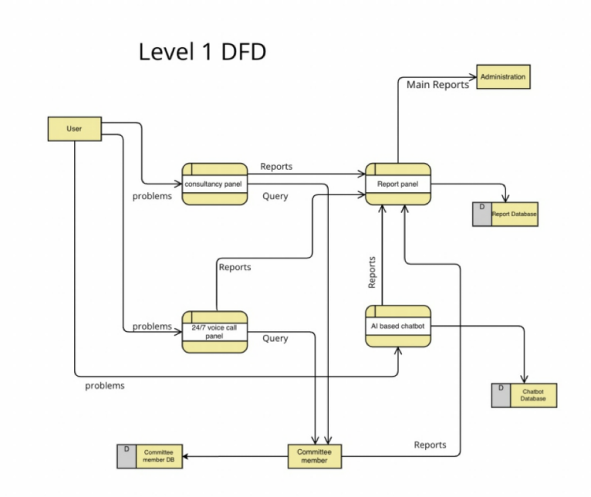
Fig -1: Data Flow Diagram

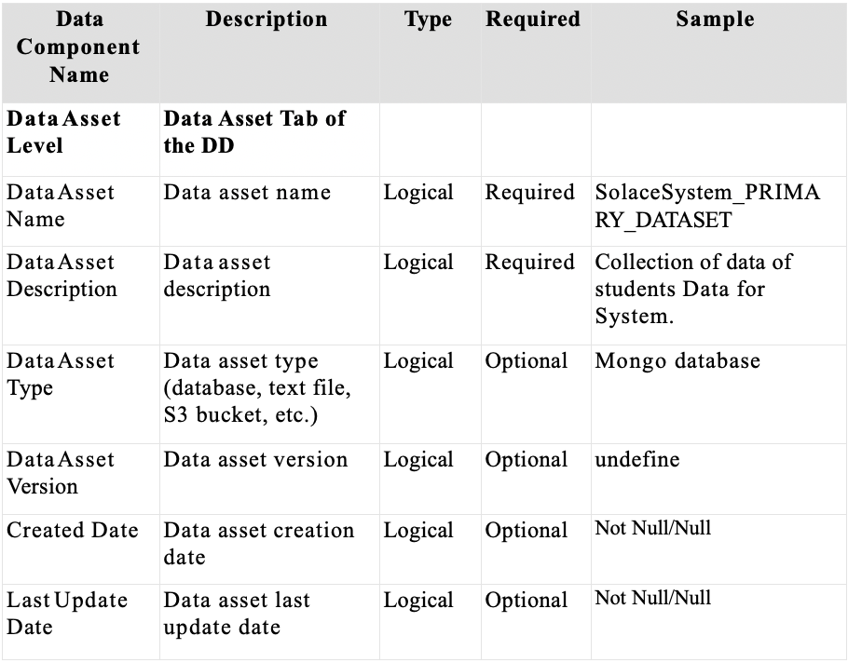
Table -1: Data component table

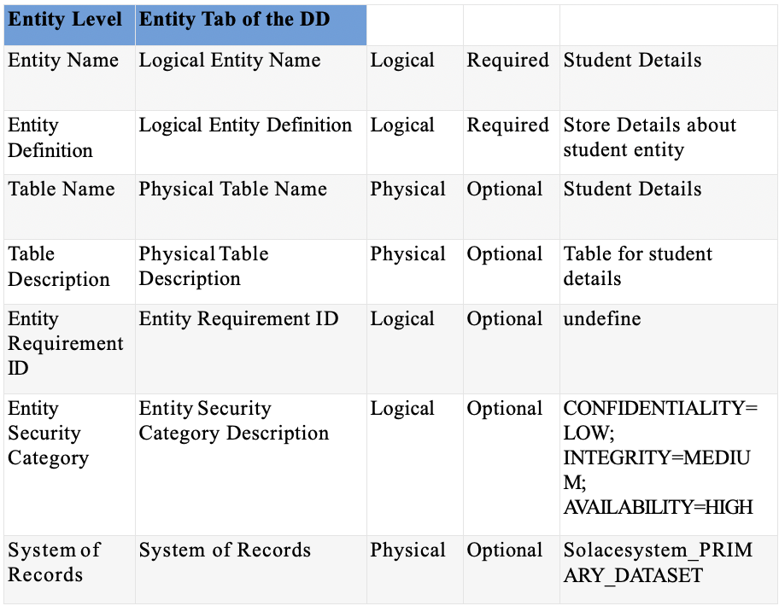
Table -2: Entry table

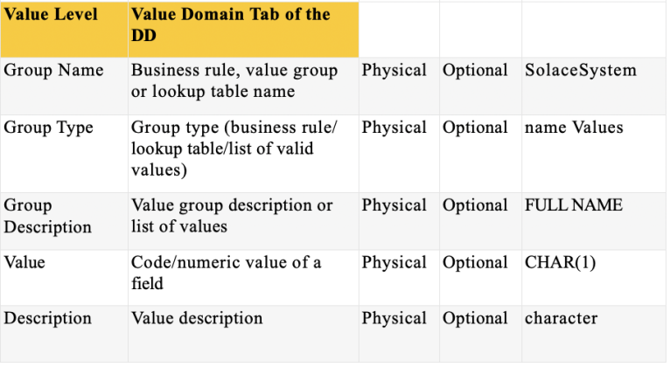
Table -3: Value table

FEATURES

The web application that serves its clients by using mental health technology to improve general health services and redressing complaints lodged by students could have the following features:

· Online appointment booking system: Clients can easily book appointments with mental health professionals and general health practitioners through the website.
· Mental health resources: The website can offer a range of mental health resources, such as articles, videos, and online courses, to educate clients and help them manage their mental health.
· Complaint management system: The website can have a system in place for students to lodge complaints related to their health, academic, or personal life. The complaints can be reviewed, and appropriate action can be taken to redress them.
· Video counseling: Clients can have online video sessions with mental health professionals to discuss their concerns and receive support.
· Health tracking: The website can provide clients with a tool to track their health and mental health status, monitor their progress, and receive personalized recommendations.
· Community support: The website can offer a community forum where clients can connect with others who are going through similar challenges and receive support from peers and mental health professionals.
· Mobile compatibility: The website can be mobile compatible, allowing clients to access its features from their smartphones or tablets.
· Anonymous Report zone: A section where individuals can report their concerns anonymously without fear of judgment or repercussion.
· Multiple Report and Consultancy Panel: A panel of experts who can offer professional consultation and guidance on different issues.
· 24/7 Voice record Panel: A voice record panel that is available 24/7 to provide major assistance and support.
· AI-Based Chat-Bot: An AI-based chatbot that can offer instant support and guidance to individuals seeking help.
· Cyber Crime Report Panel: A dedicated panel to report cybercrime-related concerns and receive guidance on how to address them.
· Anonymous Environment: The web application provides an anonymous environment where individuals can feel safe and comfortable sharing their concerns.
· E-Books and Video view panel: A section where individuals can access educational resources, such as e-books and videos, to learn more about their concerns and how to address them.
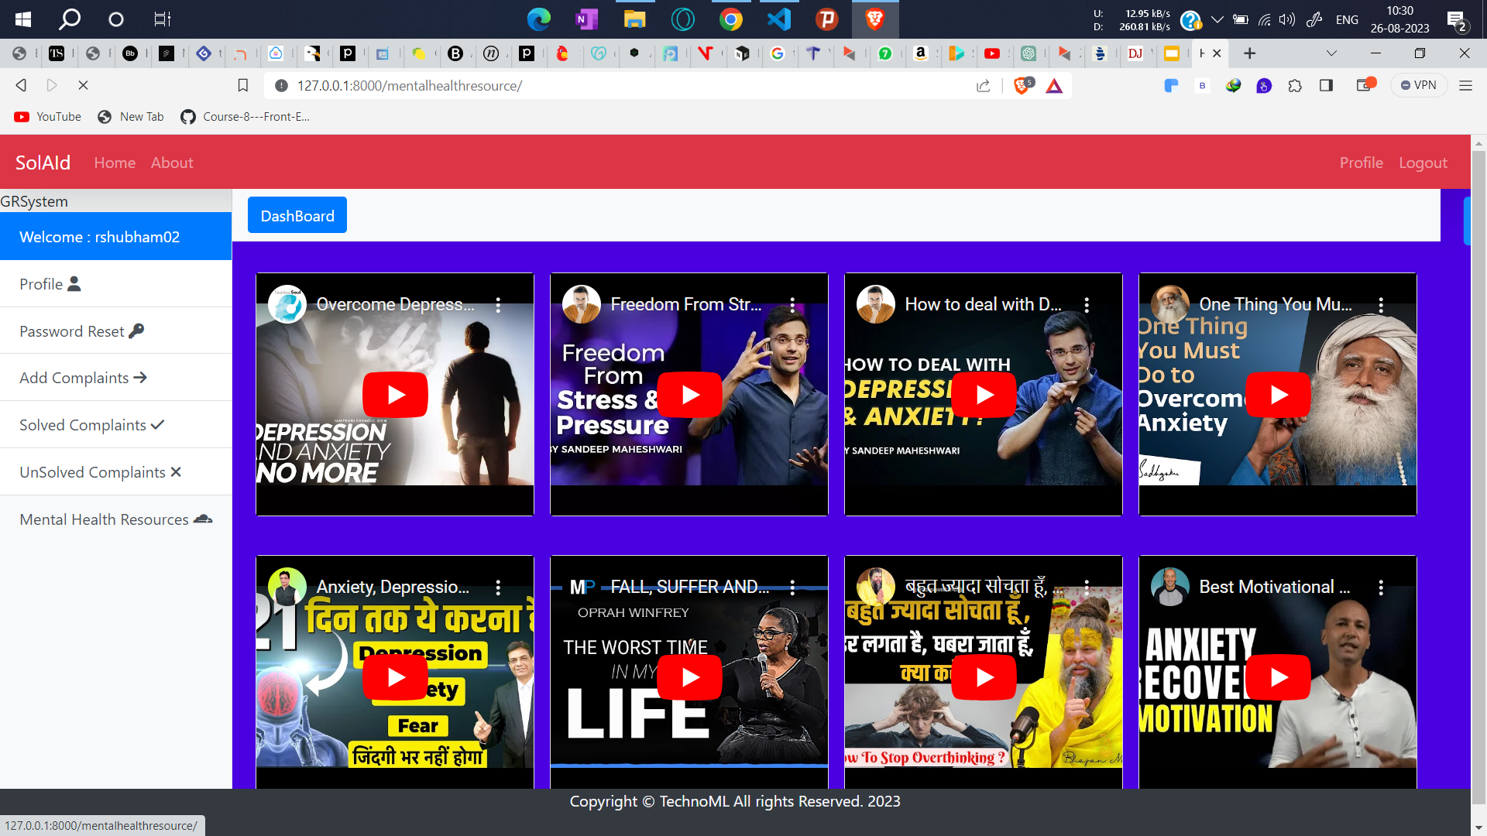
Fig -2: Video Panel

· Different Client and Administrator Users page: A multi-user website where individuals can create their own profiles and receive customized support from administrators.
· Crisis response plan: Having a crisis response plan in place can ensure that individuals in crisis receive immediate support and assistance.
· Referral system: Offering a referral system where individuals can be connected with appropriate resources or professionals can enhance the quality of support offered by your website.
· Resource directory: Creating a resource directory that lists different organizations and services that can support individuals with different concerns can provide a comprehensive and holistic approach to support.
· Group support: Creating a group support feature on a web application where individuals can connect with others who are going through similar challenges can provide a sense of community and belonging.
· Peer support: Including peer support features, such as chat rooms or forums, can allow individuals to provide support to one another and share their experiences.
· User-friendly interface: Ensuring that your website has a user-friendly interface that is easy to navigate can enhance the user experience and make it more accessible to individuals who may not be tech-savvy.
· Privacy policy: Having a clear and concise privacy policy can help individuals understand how their information will be used and protected.
· Feedback and reviews: Providing a feedback and reviews section on your web application can help you understand the effectiveness of your services and make improvements accordingly.

These features can help individuals feel empowered to report their problems and seek professional help. By providing a safe and anonymous platform, individuals can receive the support they need without fear of judgment or repercussion. Additionally, the inclusion of AI technology and educational resources can enhance the quality of support and guidance offered by the web application.

3. RESULT

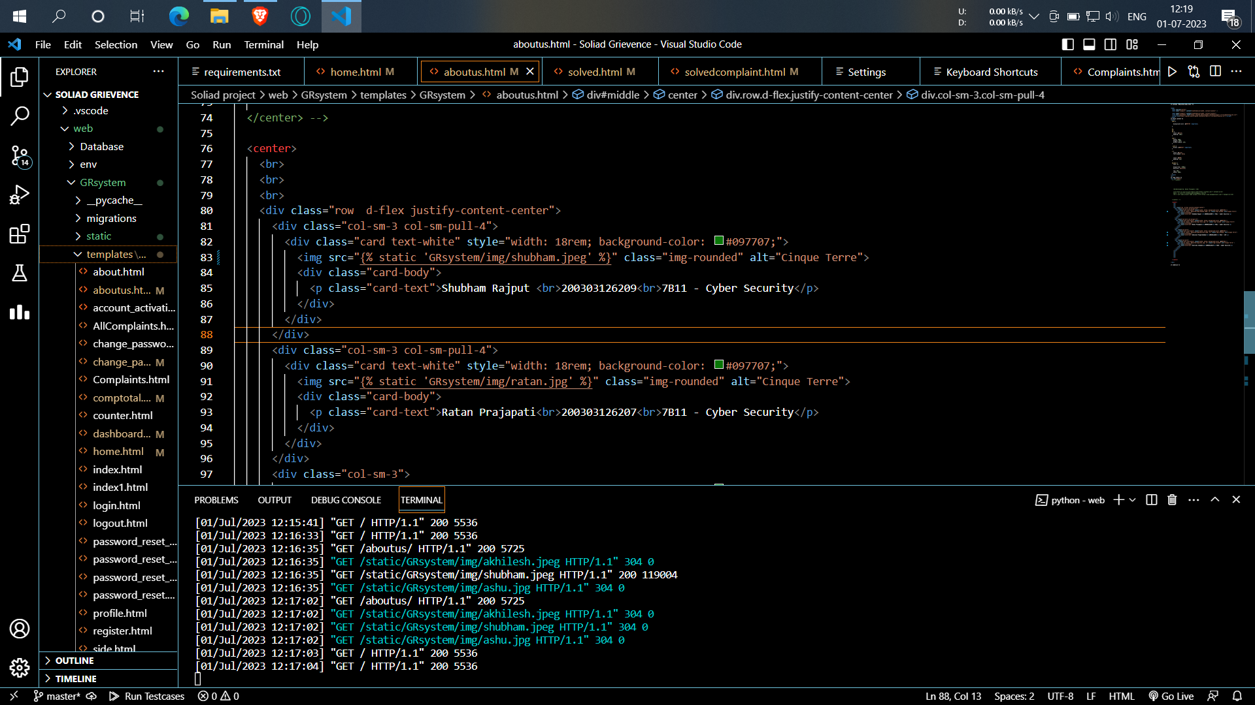
Fig -3: code

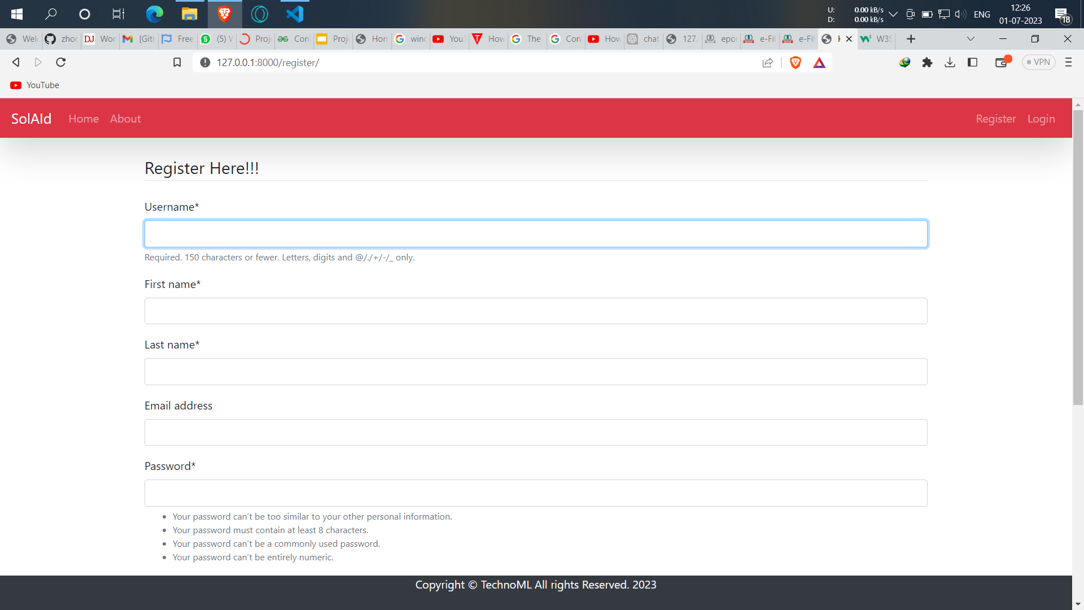
Fig -4: Registration Panel

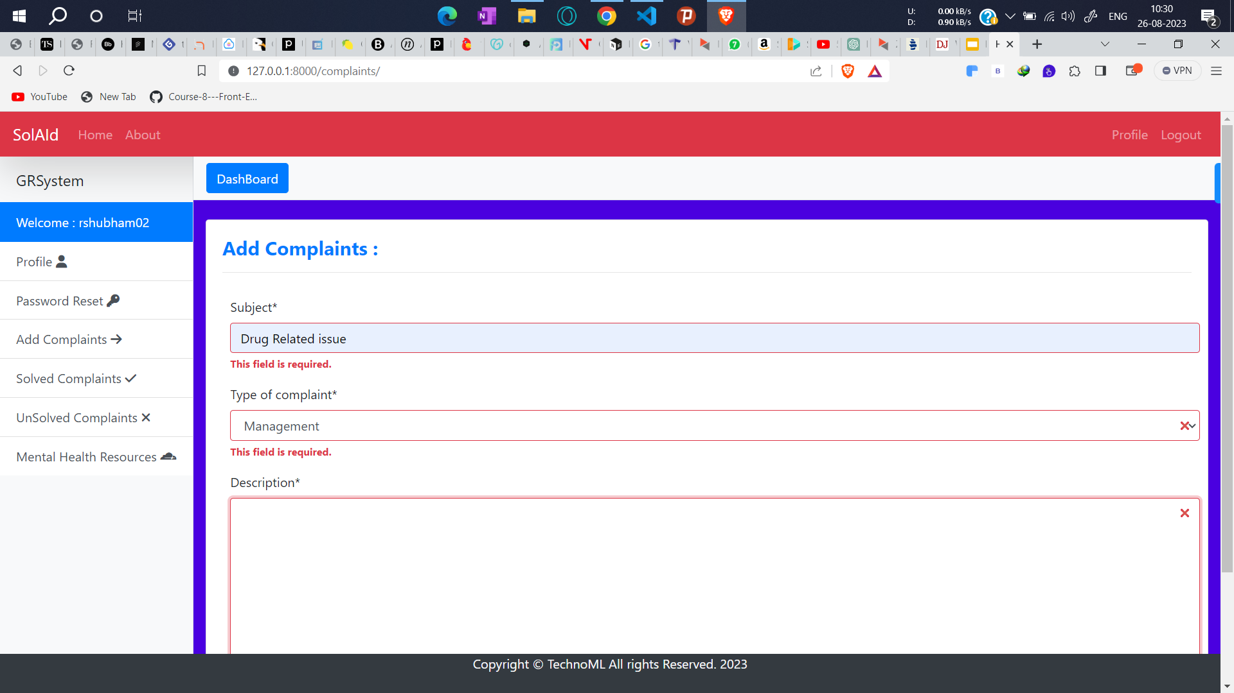
Fig -5: Complain Panel

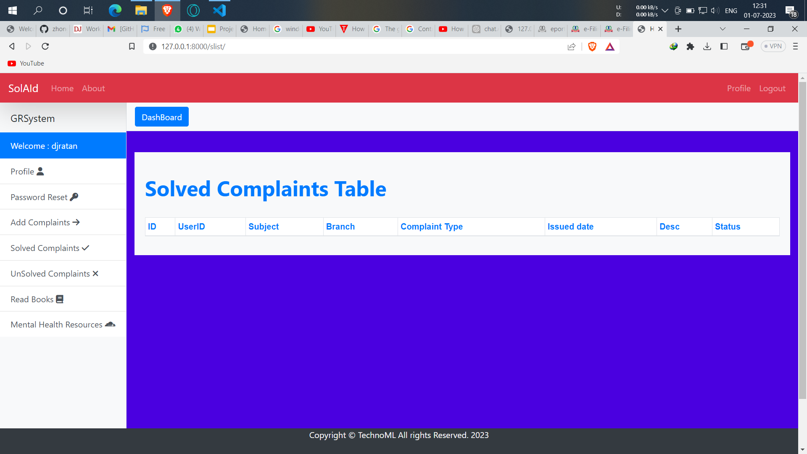
Fig -6: UI

Activity Information:

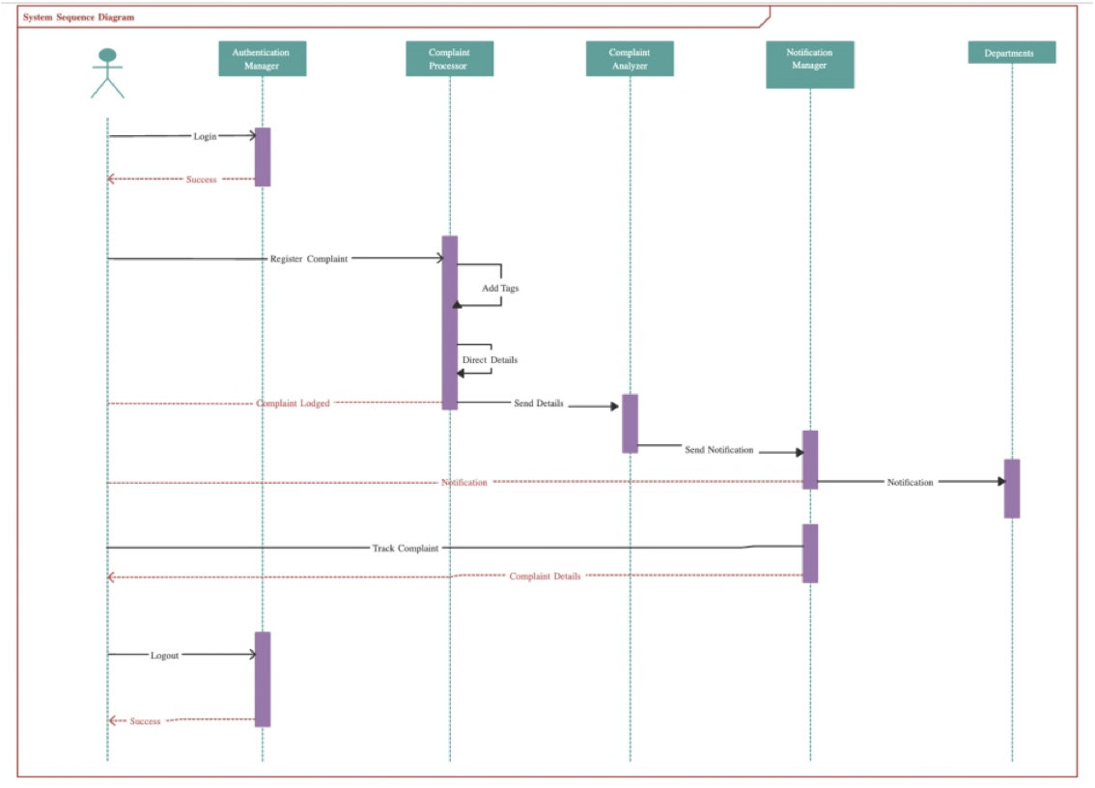
Fig -7: Gantt chart

- CONCLUSIONS

the project aims to meet students' needs by incorporating mental health technology into general health services. It also serves as a venue for filing complaints and ensuring their prompt resolution. The website also includes a cybercrime zone, anonymous complaint submission, community support, health tracking, and mental health resources.

By combining these features, the project hopes to create a comprehensive platform that promotes student well-being and facilitates access to essential resources. The earlier discussed implementation details, such as the chatbot, user and admin login sections, and the booking appointment panel, provide a solid foundation for the project's success.

5. Future Enhancement

We are working a lot over this problem and trying our best to solve more and more possible problem faced by Students in their college and school journey:
We are planning to add gamification to our Web application making it more attractive and entertaining for users and also Adding more interactive features - incorporating interactive elements such as quizzes, polls, and surveys can engage users and provide valuable feedback on the effectiveness of the website.
We are also planning to implement machine learning algorithms - machine learning could be used to analyse user data and provide personalised health recommendations and insights.
Making it more user efficient and friendly by expanding to other languages - considering the global nature of mental health and healthcare, adding support for other languages could expand the reach and impact of the web application.
Developing a mobile app - creating a mobile app version of the website could improve accessibility and convenience for users who prefer to access the platform on their mobile devices.

Adding telemedicine capabilities - integrating telemedicine capabilities could allow users to consult with healthcare professionals remotely and provide a more comprehensive approach to mental health and general health services.

6. REFERENCES

[1] Smith, J. et al. (2018). "Enhancing Student Grievance Systems: A Comparative Study." Journal of Higher Education, 45(3), 212-230.

[2] Johnson, A. (2017). "A Comprehensive Analysis of Student Complaint Resolution." Journal of Educational Administration, 22(4), 341-359.

[3] White, L. (2018). "Legal Aspects of Student Grievance Systems." Journal of Education Law, 10(1), 45-63.

[4] Hall, D. (2017). "Student Satisfaction with Grievance Outcomes: A Survey-Based Analysis." Educational Policy, 33(2), 155-174.

[5] Lewis, P. (2018). "An Exploratory Study on Online Student Complaint Portals." Journal of Online Learning, 15(3), 112-129.

