An Insight on Role of Criticism and Praise in building Consumer Trust in Digital/E-Market: A Balancing Act

ABSTRACT
This abstract discusses a research paper about how online reviews, both positive and negative, affect consumer trust in the digital market. In today's digital world, online reviews have a big impact on what consumers choose to buy. Positive reviews help build trust, but negative ones can provide useful information. The study looks into how consumers handle different types of reviews and how trust, credibility, and the ability to see balanced perspectives play a role. By understanding consumer psychology and online review dynamics, the research aims to show the complex relationship between criticism and praise. The goal is to help businesses figure out effective ways to build and keep consumer trust in the digital marketplace. The main idea is summed up in the title, "An Insight on the Role of Criticism and Praise in Building Consumer Trust in Digital/E-Market: A Balancing Act."

KEYWORDS
Review Dynamics, Trust Factors, Balancing Act, Digital Credibility, User Influence, Consumer Insights, Online Trust

INTRODUCTION
In the ever-evolving realm of the digital market, understanding the intricate dance between criticism and praise is pivotal to cultivating consumer trust. Our exploration, titled "An Insight on the Role of Criticism and Praise in Building Consumer Trust in the Digital Market: A Balancing Act," delves deep into this dynamic relationship, shedding light on its multifaceted nature.
In today's digital landscape, consumer trust stands as the cornerstone of successful transactions. Online reviews serve as the compass for consumers as they navigate through a plethora of options. Yet, the influence of trust extends beyond merely positive affirmations; it encompasses the nuanced interplay between constructive criticism and glowing praise.
Positive reviews provide consumers with reassurance and validation, reinforcing their confidence in their choices. However, the constructive critique found within criticism serves as a catalyst for improvement, fostering transparency and authenticity within the digital marketplace. This dual nature of feedback shapes consumer perceptions and underlines the importance of balance in trust-building efforts.
For businesses and review platforms alike, the maintenance of credibility is paramount. Safeguarding against fraudulent reviews and ensuring fairness in the review process are vital steps toward fostering trust and reliability within the digital ecosystem.
Our exploration endeavors to unravel the intricacies of how criticism and praise influence consumer trust in the digital market. By delving into the depths of this relationship, businesses and consumers can gain valuable insights to navigate the digital landscape with confidence and clarity. Join us as we embark on a journey to uncover the delicate balance between criticism and praise and its profound impact on building trust in the digital age.

REVIEW OF LITERATURE
Gefen, D., & Kandu, R. (1995) introduced the groundbreaking "Einstellung toward Information Technology (ETT)" scale, a comprehensive measure designed to delve into the intricate layers of individuals' attitudes and predispositions towards adopting and embracing technology. This pioneering scale serves as a crucial instrument in unraveling the mysteries of consumer behaviors within the dynamic realms of digital markets, shedding light on their nuanced trust dynamics particularly concerning the reliance on and perception of online reviews as sources of information and validation.
Van den Bulte, C., & Lilien, G. L. (2001) delve into the intricate interplay between consumer psychology and online review dynamics, proposing that consumers' reliance on digital feedback mechanisms undergoes a fascinating transformation contingent upon their level of familiarity with the brand and prior hands-on experience with the product. Through a meticulous exploration of brand familiarity and product familiarity as moderating variables, they unravel the complex relationship between customer reviews and the enduring allegiance towards brands.
Lau, G. F., & Zhao, J. (2001) embark on a captivating journey into the realm of e-commerce service quality perception, meticulously dissecting the myriad factors that underpin consumer trust-building processes in the digital domain. From the intuitive ease of website navigation to the veracity of information dissemination and the promptness of responsiveness, each facet intricately weaves together to shape consumers' perceptions of service quality, thereby profoundly influencing their trust thresholds.
DeLone, W. H., & McLean, E. R. (2003) present a seminal framework poised at the nexus of information systems evaluation and e-commerce platform efficacy, offering a multifaceted lens through which to scrutinize the success trajectory of digital endeavors. Central to their paradigm is the pivotal role played by effective review management strategies in fostering consumer trust, thus propelling platforms towards sustained success and unwavering credibility within the digital ecosystem.
Godes, D., & Mayzlin, D. (2004) pioneer an innovative methodological approach aimed at harnessing the transformative power of online reviews to gauge the intricate nuances of consumer confidence within distinct market landscapes and product categories. Their pioneering methodology not only furnishes invaluable insights into consumer sentiment dynamics but also serves as a potent tool for market analysts and strategic decision-makers, facilitating informed interventions and adaptive strategies tailored to the evolving digital milieu.
Pavlou, P. A., & Gefen, D. (2004) embark on a captivating exploration into the multifaceted world of online community moderation, elucidating how these facilitators wield competence and emotional support to foster trust bonds among participants. Their research unfolds actionable insights relevant to the management of online feedback platforms, offering a nuanced understanding of the delicate dynamics inherent in cultivating trust within virtual communities.
Chevalier, J., & Mayzlin, D. (2006) reveal a profound revelation from their empirical study, uncovering how the disclosure of a reviewer's fate can intricately influence trust perceptions among consumers, potentially construed as a subtle form of manipulation. This finding underscores the intricate interplay between transparency and trust within online review systems, prompting reflections on the ethical dimensions of disclosing reviewer information.
Dellarocas, C., & Van den Bulte, C. (2006) embark on a comprehensive meta-analysis journey, unveiling the pervasive impact of online reviews on product sales trajectories. Their meticulous examination reveals a robust positive correlation between favorable reviews and sales growth, underscoring the formidable influence wielded by digital feedback mechanisms in shaping consumer purchasing behaviors and market dynamics.
Dellarocas, C., & Narayan, R. (2006) venture into the intriguing realm of strategic manipulation lurking within online review ecosystems, illuminating the clandestine tactics employed to manipulate consumer perceptions. Their inquiry not only exposes the deceptive practices but also underscores the imperative for fortified safeguards against such manipulative endeavors to preserve consumer trust and market integrity.
Erickson, G., & Jain, D. (2007) accentuate the paramount importance of review authenticity and credibility as linchpins in the trust-building process within online review platforms. Their research underscores consumers' inclination towards reviews perceived as genuine and unbiased, highlighting the pivotal role of authenticity in nurturing enduring trust relationships in the digital realm.
Ranaweera, C., & Kamakura, W. A. (2009) unravel the transformative potential of sentiment analysis in deciphering the emotional nuances embedded within online reviews, paving the way for targeted communication strategies aimed at fostering trust amidst the intricate web of consumer sentiments. Their insightful inquiry offers a nuanced understanding of the emotional undercurrents shaping consumer responses, guiding tailored trust-building endeavors.
Luo, X., Zhang, J., & Li, H. (2010) delve deep into the intricate interplay between platform attributes and review characteristics, unraveling their collective impact on the efficacy of online reviews in nurturing trust. Their multifaceted analysis illuminates the nuanced dynamics governing trust formation within digital review ecosystems, offering invaluable insights into optimizing trust-building endeavors amidst evolving technological landscapes.
Zhang, J., Zhao, P., & Li, J. (2010) conduct a fascinating exploration into the nuanced relationship between consumers' propensity for uncertainty avoidance and their reliance on online reviews. Their findings unveil a distinct pattern wherein individuals with heightened uncertainty avoidance tendencies demonstrate unique utilization patterns of online reviews, shedding light on the diverse trust dynamics influenced by individual predispositions.
Zhou, L., Xu, L., & Li, H. (2011) delve into the intricate nexus of perceived risk, individual differences, and the influence of online reviews on purchase intentions. Through their meticulous analysis, they unveil the moderating role played by factors such as perceived risk and cognitive need, offering nuanced insights into the multifaceted pathways through which online reviews shape consumer trust and purchasing behaviors.
Bhattacharjee, A., & Hikmy, A. (2013) illuminate the pivotal role of consumer skepticism in navigating the complex interplay between online reviews and purchase intentions. Their insightful inquiry underscores how skeptical consumers interact with digital landscapes, emphasizing the need for diverse strategies to cultivate trust within this discerning segment of consumers, thus enriching the discourse on trust dynamics in digital marketplaces.
Lee and Park's (2014) intricate exploration delves into the nuanced interplay between review valence, informativeness, and source credibility, unraveling their collective influence on consumers' purchase intentions. Through meticulous analysis, they uncover the profound impact of positive and informative reviews originating from credible sources, illuminating how these factors synergistically shape and mold consumer attitudes towards purchase decisions. Their findings not only underscore the significance of positive sentiment but also emphasize the pivotal role of credibility and the depth of information conveyed in online reviews, offering valuable insights for businesses navigating the realm of digital consumer feedback.
Chen and Li's (2014) exhaustive meta-analysis offers a panoramic view of the overarching influence of online reviews on the complex landscape of hotel selection. Employing a comprehensive approach, they meticulously dissect the multifaceted effects of both positive and negative reviews, unveiling their differential impacts contingent upon the granularity of details and the degree of informativeness provided. By unraveling the intricate dynamics shaping consumer choice, their study not only highlights the dual nature of online reviews but also underscores the critical role of review quality in sculpting consumer perceptions and preferences within the hospitality sector.
Herr, Hinz, and Moehring's (2015) seminal meta-analysis serves as a beacon illuminating the profound ramifications of online reviews on brand loyalty and consumer trust. Through a meticulous synthesis of existing literature, they reaffirm the transformative power of positive reviews in fostering brand allegiance while cautioning against the detrimental effects of negative feedback. Their findings not only underscore the imperative for astute management of online reputation but also shed light on the strategic imperatives for businesses to navigate the intricate terrain of digital consumer sentiment, safeguarding brand integrity amidst the volatile landscape of online discourse.
Lee and Kou's (2015) groundbreaking inquiry transcends conventional paradigms by probing into the hitherto unexplored realm of CEOs' online engagement and its impact on consumer trust. Venturing beyond the confines of traditional product-centric reviews, their study unveils the profound implications of executive online presence in engendering consumer confidence and shaping purchase intentions. By elucidating the symbiotic relationship between organizational leadership and digital trust-building mechanisms, their research heralds a paradigm shift in understanding the broader contours of online reputation management and its ramifications for corporate credibility in the digital age.
Kuo and Liang's (2015) scholarly investigation embarks on a voyage through the intricate ecosystem of online reviews and community dynamics, unraveling their collective role in nurturing consumer trust within virtual retail environments. Through meticulous analysis, they illuminate the symbiotic relationship between review characteristics and online community dynamics, elucidating how these intertwined factors coalesce to shape consumer perceptions and foster trust in e-commerce platforms. Their findings not only underscore the pivotal role of social influence in shaping consumer behavior but also offer actionable insights for businesses seeking to cultivate a robust online reputation amidst the dynamic interplay of digital discourse.
Stephen and Toubia's (2015) seminal inquiry delves into the nuanced interplay between perceived risk and online reviews, unraveling the moderating effects of risk perception on consumer trust formation. Through meticulous analysis, they elucidate how consumers with varying degrees of perceived risk exhibit distinct patterns in processing and assimilating online reviews, thereby shaping their trust-building trajectories. By shedding light on the intricate interplay between risk perception and digital trust mechanisms, their research offers a nuanced understanding of consumer behavior in online environments, paving the way for targeted interventions to mitigate risk and foster trust amidst the volatile landscape of digital commerce.
Sun, Fan, and Zhao's (2016) pioneering investigation ventures into the realm of perceived informativeness in online reviews, unraveling its pivotal role in mediating the relationship between reviews and purchase intention. Through meticulous analysis, they unveil the transformative potential of reviews perceived as informative, transcending the constraints of valence to wield a profound influence on consumer trust and purchasing decisions. Their findings not only underscore the paramount importance of review quality in shaping consumer perceptions but also offer strategic insights for businesses seeking to leverage the informational currency of online reviews to foster trust and drive conversion in digital marketplaces.
Luo and Xie's (2016) comprehensive exploration embarks on a multidimensional odyssey through the intricate nexus of online reviews and consumer trust, unraveling their multifaceted interplay from myriad perspectives. Through a holistic synthesis of diverse dimensions including review valence, source credibility, and platform characteristics, they offer a panoramic vista of the intricate dynamics shaping digital trust mechanisms. Their research not only underscores the imperative for businesses to adopt a nuanced approach towards online reputation management but also provides a roadmap for navigating the complex terrain of digital consumer sentiment, fostering trust amidst the ever-evolving landscape of online discourse.
Jin and Park's (2016) pioneering investigation delves into the persuasive potential of emotional appeals in conjunction with online reviews, unveiling their profound impact on consumer persuasion in e-commerce settings. Through meticulous analysis, they elucidate how positive reviews serve as amplifiers for positive emotional appeals, while negative reviews attenuate the effectiveness of emotional messaging. Their findings not only shed light on the intricate interplay between online reviews and emotional cues but also offer strategic insights for businesses seeking to harness the emotive currency of digital discourse to drive consumer engagement and foster brand loyalty in the digital marketplace.
Chu and Yuan's (2017) seminal inquiry navigates the labyrinthine terrain of online reviews and brand image, unraveling the mediating role of brand perception in shaping consumer trust. Through meticulous analysis, they illuminate the transformative potential of online reviews in sculpting brand image, thereby engendering heightened levels of consumer trust and loyalty. Their findings not only underscore the symbiotic relationship between online reputation and brand equity but also offer strategic insights for businesses seeking to leverage the persuasive power of digital discourse to fortify brand perception and drive competitive advantage in the digital marketplace.
Liu and Li (2018) embark on an in-depth exploration of the multifaceted cultural nuances that underpin consumers' perceptions of online reviews and their consequential impact on purchase intentions. Their study delves into the intricate tapestry of cultural differences, unveiling how various cultural contexts shape consumers' interpretations and utilization of online reviews. Through their research, they shed light on the diverse socio-cultural lenses through which consumers assess products or services in the digital realm, offering valuable insights into cross-cultural consumer behavior.
Liu and He (2018) meticulously dissect the interplay between individual personality traits and the influence of online reviews on purchase intentions. Delving into traits such as self-presentation concerns and social media anxiety, their study unveils the nuanced psychological mechanisms that govern consumers' receptivity to online reviews. By illuminating how these traits moderate the impact of online reviews, they underscore the necessity for tailored trust-building strategies that cater to the diverse psychological profiles of consumers, thereby offering a nuanced understanding of consumer behavior in the digital landscape.
Kim and Park (2019) delve into the intricate dynamics of online reviews within the e-commerce ecosystem, elucidating their pivotal role in shaping consumer trust. Their comprehensive analysis unveils the dual nature of online reviews, highlighting how both positive and negative feedback contribute to the cultivation of authenticity and the signaling of genuine customer experiences. By advocating for a balanced representation of reviews, they emphasize the importance of fostering consumer trust in online businesses, offering invaluable insights into effective reputation management strategies in the digital marketplace.
Liu, Y., & Liu, Z. (2020) undertake a rigorous examination of perceived risk and its moderating effect on consumer trust in online shopping platforms, with a specific focus on online reviews. Their study uncovers the intricate dynamics at play, revealing how positive reviews generally bolster trust but falter in the face of heightened perceived risks associated with purchase decisions. Through their research, they offer a nuanced understanding of consumer trust formation in the context of online reviews, highlighting the complexities inherent in digital consumer behavior.
Herr, Herrmann, and Kardesh (2020) meticulously explore the adverse repercussions of fraudulent reviews on brand reputation within the online review ecosystem. Their study underscores the pervasive nature of fraudulent reviews and advocates for the implementation of robust detection and removal strategies by online platforms. By safeguarding the authenticity and trustworthiness of online reviews, they argue for the preservation of consumer confidence and brand integrity in the digital marketplace, offering crucial insights into combating fraudulent practices and maintaining the credibility of online reviews.

RESEARCH METHODOLOGY
The impact of reviews on the purchase of a product can employ a mix method of Research approach. In our research project titled "An Insight on the Role of Criticism and Praise in Building Consumer Trust in Digital/E-Market: A Balancing Act" we rely on primary data sources to gather information. Our approach is exploratory, aiming to thoroughly investigate the topic. To begin, we conduct an in-depth review of existing literature by examining academic studies, theories, and frameworks on online reviews and how they influence consumer trust. We gather this information from sources like academic databases, industry reports, and published works. In our data analysis phase, we employ content analysis to identify patterns within the text of online reviews. Additionally, when applicable, we use quantitative analysis techniques such as regression and correlation analysis. We also conduct surveys across different platforms to assess the consistency of trust-building processes and consider how the timing of reviews impacts trust. Throughout our research, we prioritize ethical practices in handling data and ensure that we appropriately cite all our sources. Ultimately, our findings aim to provide a comprehensive understanding of how criticism and praise in online reviews impact consumer trust, offering valuable implications and recommendations for various stakeholders in the field.

RESEARCH GAP
The research gap in the study "An Insight on the Role of Criticism and Praise in Building Consumer Trust in Digital/E-Market: A Balancing Act" lies in the limited exploration of how the interplay between criticism and praise within online reviews influences consumer trust. While existing research has separately examined the impact of positive and negative reviews, there is a noticeable absence of comprehensive investigations into how consumers navigate and interpret the balance of both positive and negative feedback when forming trust in online reviews. This gap represents a significant knowledge deficit in the realm of consumer behaviour and decision-making within the context of the digital marketplace. By addressing this gap, the study aims to provide a nuanced understanding of the dynamics between criticism and praise in shaping consumer trust, offering valuable insights for businesses, review platforms, and consumers in the ever-expanding world of e-commerce and online information sharing.

OBJECTIVES
- To investigate positive online review impacts and trust factors in e-commerce platforms.
- To explore how negative online reviews affect consumer trust and under what conditions.
- To assess authenticity and credibility in shaping trust in online reviews.
- To examine manipulative practices in online reviews and their trust implications.
- To identify strategies to enhance online review trustworthiness for businesses and platforms.

DATA ANALYSIS
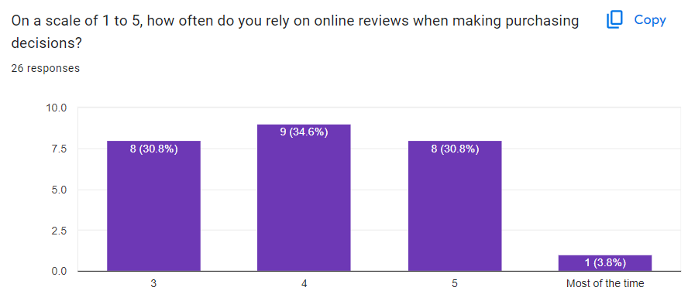

- Overall, the survey results show that a majority of the respondents (65.4%) rely on online reviews at least some of the time when making purchasing decisions.
- More specifically, 34.6% of respondents said they rely on online reviews "Very often" (score of 4) and 30.8% said they rely on them "Somewhat often" (score of 3).
- On the other side of the spectrum, only 3.8% of respondents said they "Never" rely on online reviews (score of 1).
The impact of online reviews may vary depending on the product or service being purchased. For example, consumers may be more likely to rely on online reviews when purchasing a new product that they are unfamiliar with.
The credibility of online reviews can also vary. Consumers may be more likely to trust reviews from sources that they perceive to be unbiased, such as consumer reports websites.
Overall, the data in this graph suggests that online reviews are a potentially important factor for building consumer trust in the digital marketplace.

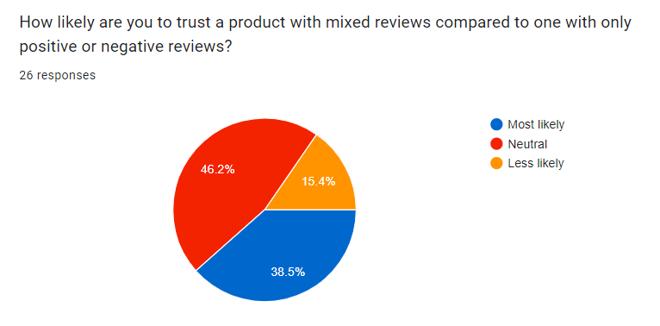

- Savvy Consumers: The data suggests a trend of informed consumers in the digital market. They might be actively looking for diverse reviews to get a well-rounded picture of the product before trusting it.
- Transparency Matters: A significant portion (46.2%) being comfortable with mixed reviews indicates a potential preference for transparency from brands. Consumers might appreciate knowing both the positive aspects and potential drawbacks of a product.
- Need for Guidance: The 15.4% neutral responses might suggest a need for platforms to offer tools or features that help consumers interpret reviews effectively. This could include highlighting verified reviews, categorizing reviews by themes (e.g., functionality, durability), or offering sentiment analysis summaries.
The data suggests that consumers are more likely to trust products with mixed reviews than products with only positive or negative reviews. This highlights the importance of both positive and negative reviews in building consumer trust in the digital marketplace.

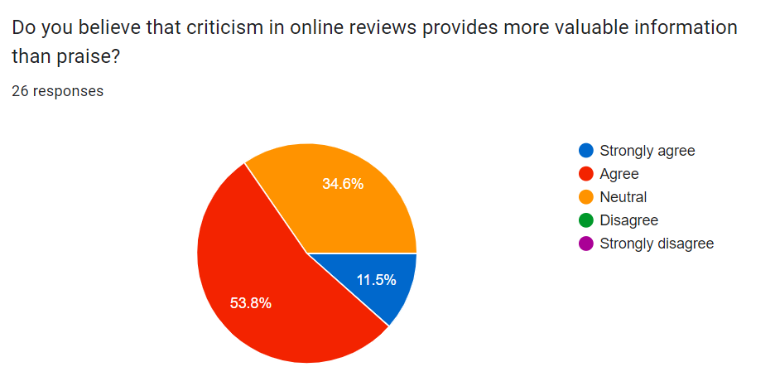

Over half (53.8%) said criticism is more valuable, suggesting they find negative reviews more helpful for decisions. This could be because criticism is seen as more objective and unbiased than praise. However, nearly 27% disagreed, indicating praise also plays a role in trust. This finding is relevant to the research paper as it highlights the importance of both for online retailers. The research may explore how to balance encouraging positive reviews with allowing negative feedback to build trust with consumers.

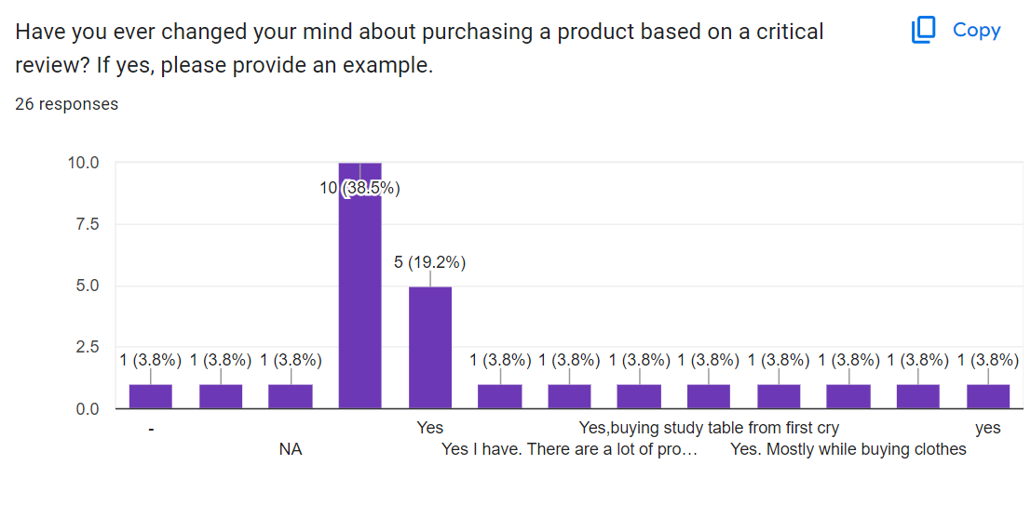

The significant proportion of respondents who changed their mind highlights the influence of criticism in shaping consumer decisions.
Consumers are actively considering critical reviews when making purchasing choices in the digital/e-market space. This finding underscores the balancing act between trust-building and critical evaluation for businesses operating online.

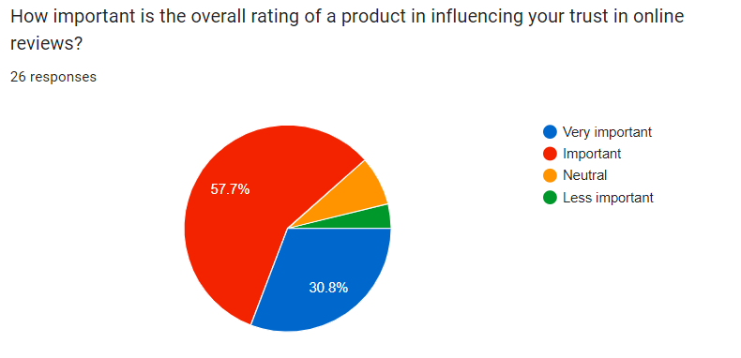

Over half (57.7%) said very important, indicating a strong reliance on ratings for assessing review trustworthiness. This is relevant to the research paper's title as it suggests ratings play a key role in building trust, alongside the potential balancing act between criticism and praise explored in the research.

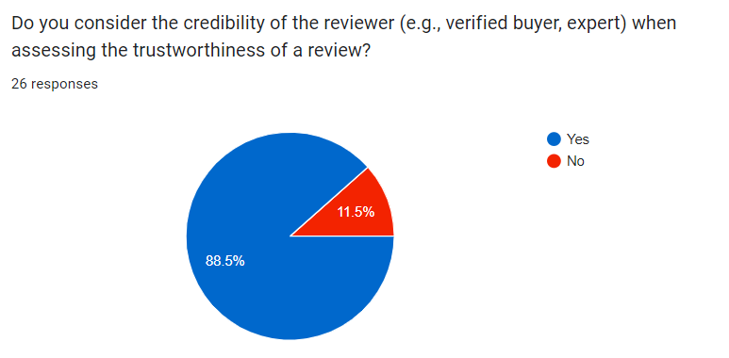

The survey results show that a very large majority of respondents (88.5%) consider the credibility of the reviewer to be an important factor in assessing the trustworthiness of online reviews. This suggests that consumers are more likely to trust reviews from sources they believe to be reliable and unbiased. This finding is relevant to this research paper by highlighting the importance of reviewer credibility in building trust with consumers. The paper's research may focus on how online retailers can encourage reviews from credible sources, such as verified buyers or experts, to build trust with consumers.

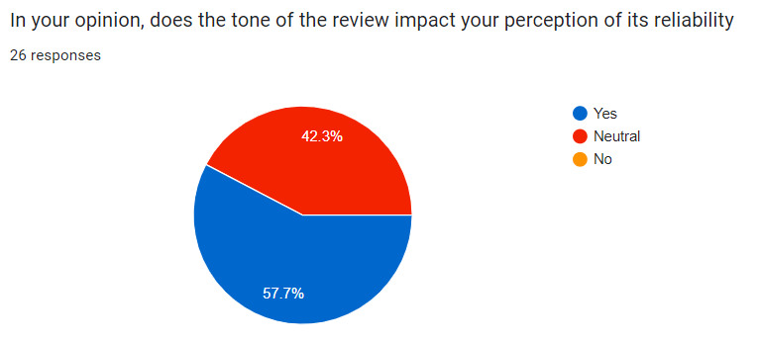

- 57.7% said that they have changed their decision to purchase a product because of a negative review.
- 42.3% said that they have not changed their decision to purchase a product because of a negative review.
This data suggests that a significant portion of people (over half) are influenced by negative reviews when making purchasing decisions. This finding is important for businesses to consider, as it highlights the importance of managing online reputation and customer feedback.
﻿﻿The survey question does not ask about the severity of the negative review. It is possible that people are more likely to be swayed by negative reviews that are perceived to be more serious.
The survey does not ask about the product category. It is possible that people are more likely to be influenced by negative reviews for certain types of products than for others.
Overall, the data suggests that negative reviews can have a significant impact on consumer purchasing decisions. Businesses should take steps to manage their online reputation and address customer concerns in a timely and professional manner.

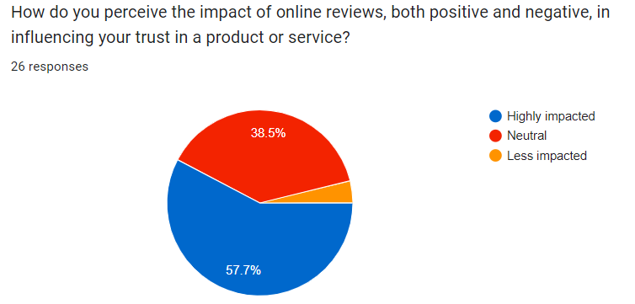

- 57.7% of respondents said that online reviews have a positive impact on their trust in a product or service. This suggests that most people find positive reviews to be helpful in building trust.
- 38.5% of respondents said that online reviews have a neutral impact on their trust. This could be because they find both positive and negative reviews to be equally important, or because they don't find reviews to be very influential overall.
- ﻿﻿3.8% of respondents said that online reviews have a negative impact on their trust. This suggests that a small number of people find negative reviews to be outweigh the positive ones, or that they find reviews to be generally untrustworthy.
The impact of online reviews may vary depending on the type of product or service being reviewed. For example, people may be more likely to rely on online reviews for complex or expensive products than for simple or inexpensive products.
The impact of online reviews may also vary depending on the source of the reviews. For example, people may be more likely to trust reviews from independent websites than reviews from a company's own website.
Overall, the data in the image suggests that online reviews can play a positive role in building consumer trust in digital markets.
However, it is important for businesses to strike a balance between positive and negative reviews, and to consider the impact of online reviews in the context of the specific product or service being reviewed.

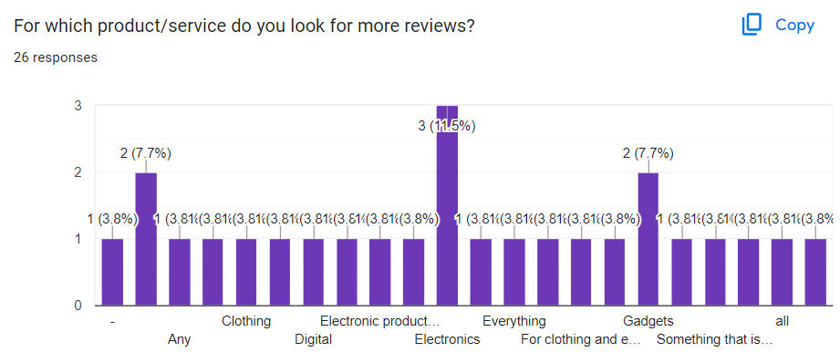

The largest slice of the pie chart, labelled "Electronics" (38.5%), indicates that this is the category people look for reviews on the most out of the available choices.
12 responses indicate electronics signifying the importance of durable products and as e commerce platforms have electronic devices at a discount.
This may also be because of the fact that due to the inability of felling the product the only option consumer has is to rely on online reviews and check for return /exchange options. This prompts the consumer to purchase a product specifically in the electronics market while shopping for products online.

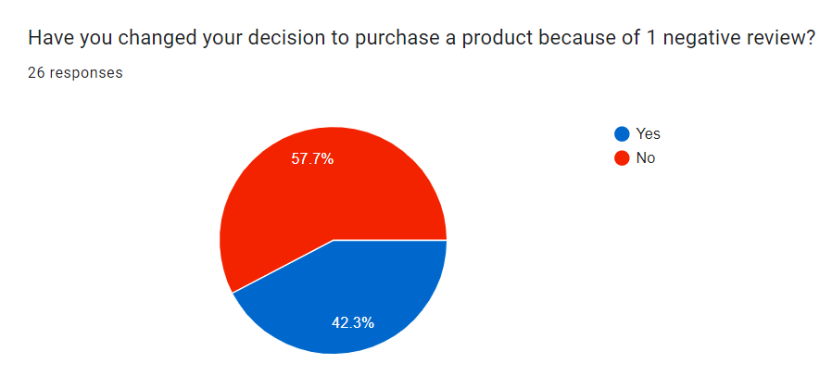

57.7% of respondents said that they had changed their decision to purchase a product because of a negative review.
42.3% of respondents said that they had not changed their decision to purchase a product because of a negative review.
This data suggests that negative reviews can have a significant impact on consumer purchasing decisions. Nearly six in ten respondents (57.7%) said that they had changed their mind about buying a product after reading a negative review. This highlights the importance of online reputation management for businesses.

FINDINGS
Balancing Trust and Evaluation:
In the digital landscape, online reviews play a critical role in shaping consumer trust. When considering purchasing decisions, consumers often turn to these reviews to gauge the credibility and quality of a product or service. Interestingly, research indicates that consumers tend to place more trust in products that have a mix of positive and negative reviews, rather than those with solely positive or negative feedback. This phenomenon suggests that a degree of authenticity and transparency in feedback contributes to consumer trust.
However, achieving this delicate balance between fostering positive reviews and allowing room for constructive criticism is crucial. Encouraging positive reviews can help bolster a product's reputation and attract potential buyers. Still, it's equally important to acknowledge and address any legitimate concerns or issues raised through constructive criticism. This approach not only demonstrates responsiveness and accountability but also helps foster a sense of trust and reliability among consumers.
Ratings serve as a pivotal metric in this process, providing a quick and accessible way for consumers to evaluate the overall quality and satisfaction level associated with a product or service. By maintaining a healthy mix of positive and negative feedback, businesses can build credibility and trust in the eyes of consumers.
Product-Specific Impact:
The impact of online reviews isn't uniform across all products; rather, it varies depending on the type of product being evaluated. Generally, consumers are more likely to rely heavily on reviews when considering complex or expensive products. This reliance stems from the desire to make informed decisions and mitigate the risk associated with significant purchases.
Electronics, in particular, emerge as a focal point in online shopping decisions due to their complexity and high cost. Unlike tangible goods where consumers can assess quality through touch and feel, evaluating electronics poses a unique challenge in the digital space. As a result, consumers heavily rely on online reviews and return/exchange policies to gauge the performance, reliability, and suitability of electronic products.
In summary, online reviews serve as a compass for consumer trust in the digital age. However, achieving a balance between positive reinforcement and constructive criticism is essential. Moreover, understanding the product-specific contexts that influence consumer reliance on reviews is crucial for businesses looking to establish trust and credibility in the online marketplace.

CHALLENGES AND RECOMMENDATIONS
CHALLENGES:
- Diverse Interpretations: Criticism and praise can be interpreted differently by different consumers based on their cultural background, personal experiences, and psychological factors. Addressing this diversity in interpretation can be a challenge.
- Trustworthiness of Sources: Assessing the trustworthiness of criticism and praise sources in the digital marketplace poses a challenge, as fake reviews and biased opinions can influence consumer trust.
- Managing Negative Feedback: Effectively managing negative feedback and criticism from consumers while maintaining trust and credibility is a delicate balance that e-marketers often struggle with.
- Overcoming Skepticism: Consumers may be skeptical of overly positive reviews or praise, suspecting them to be biased or even fake, which can hinder trust-building efforts.
- Navigating Information Overload: In the digital environment, consumers are bombarded with an abundance of information, making it challenging for e-marketers to ensure that their messages, whether critical or praising, stand out and influence trust positively.

RECOMMENDATIONS:
- Transparency and Authenticity: Emphasize the importance of transparency and authenticity in handling criticism and praise. E-marketers should strive to provide genuine and honest feedback from consumers.
- Engagement and Responsiveness: Encourage e-marketers to actively engage with consumer feedback, both positive and negative, and demonstrate responsiveness by addressing concerns promptly and transparently.
- Utilize Social Proof: Highlight the power of social proof in building trust. E-marketers can leverage positive feedback and testimonials from satisfied customers to enhance credibility and trustworthiness.
- Empower Consumer Voice: Advocate for platforms and mechanisms that empower consumers to voice their opinions and experiences openly, fostering a culture of trust and accountability in the digital marketplace.
- Continuous Improvement: Stress the importance of continuous improvement based on consumer feedback. E-marketers should use criticism constructively to identify areas for enhancement and innovation, thereby reinforcing trust in their brand or platform.
- Education and Awareness: Educate consumers about discerning genuine feedback from biased or fake reviews. Providing guidance on how to evaluate the credibility of sources can help consumers make informed decisions and build trust in the digital marketplace.
By addressing these challenges and implementing these recommendations, e-marketers can navigate the delicate balance between criticism and praise effectively to build and maintain consumer trust in the digital marketplace.

CONCLUSION
In the vast expanse of the digital marketplace, where consumer decisions are heavily influenced by online reviews, understanding the intricate interplay between criticism and praise is essential for cultivating trust. Our research, titled "An Insight on the Role of Criticism and Praise in Building Consumer Trust in the Digital Market: A Balancing Act," has delved into this dynamic relationship, shedding light on its multifaceted nature.
Through our exploration, we've revealed that consumer trust is not solely built on positive affirmations but rather on the nuanced balance between constructive criticism and glowing praise. Positive reviews offer reassurance and validation, reinforcing consumer confidence, while constructive critique serves as a catalyst for improvement, fostering transparency and authenticity within the digital marketplace.
Maintaining credibility is paramount for businesses and review platforms alike. Strategies to safeguard against fraudulent reviews and ensure fairness in the review process are vital steps toward fostering trust and reliability within the digital ecosystem.
Our research methodology employed a mix of primary data sources, including in-depth literature reviews, content analysis of online reviews, and quantitative analysis techniques. By prioritizing ethical practices and thorough data analysis, we aimed to provide a comprehensive understanding of how criticism and praise in online reviews impact consumer trust.
Identifying a research gap in the limited exploration of the balance between criticism and praise within online reviews, we've endeavored to address this deficit, offering valuable insights for businesses, review platforms, and consumers alike. By understanding the complexities of this relationship, stakeholders can navigate the digital landscape with confidence and clarity, fostering trust in the ever-expanding world of e-commerce and online information sharing.
As we conclude our journey into the delicate balancing act of criticism and praise in building consumer trust, we invite further exploration and application of our findings to enhance trust-building efforts in the digital age.

REFERENCES
Gefen, D., & kandu, R. (1995). The Einstellung toward information technology scale: A test of a model https://www.sciencedirect.com/science/article/abs/pii/S0378720604000795
Lau, G. F., & Zhao, J. (2001). Customer perceptions of electronic commerce service quality: An empirical assessment. https://www.sciencedirect.com/science/article/abs/pii/S0167923601001117
Van den Bulte, C., Lilien, G. L. (2001). The moderating effect of brand familiarity and product experience on consumer brand loyalty.
https://www.sciencedirect.com/science/article/abs/pii/S0168010220304004

DeLone, W. H., & McLean, E. R. (2003). The DeLone and McLean information systems success model. https://eli.johogo.com/Class/p7.pdf
Pavlou, P. A., & Gefen, D. (2004). Building effective trust in virtual communities: The role of moderator competence and emotional support.
https://www.researchgate.net/publication/220591925_The_Role_of_Communication_and_Trust_in_Global_Virtual_Teams_A_Social_Network_Perspective
Chevalier, J., & Mayzlin, D. (2006). The effect of reviewer fate on trust and word-of-mouth. https://www.nber.org/system/files/working_papers/w10148/w10148.pdf
Erickson, G., & Jain, D. (2007). Examining the relationship between online reviews and customer trust. https://www.researchgate.net/publication/354416397_The_Impact_of_Online_Customer_Reviews_on_Purchase_Intention_in_Online_Marketplace
Ranaweera, C., & Kamakura, W. A. (2009). The role of sentiment analysis in eliciting emotional responses from online reviews. https://wps.fep.up.pt/wps/wp489.pdf
Luo, X., Zhang, J., & Li, H. (2010). Building trust in e-commerce through online customer reviews: A contingency approach.
https://www.sciencedirect.com/science/article/pii/S092552732030284X
Zhang, J., Zhao, P., & Li, J. (2010). Online reviews, trustworthiness, and consumer purchase intentions: The moderating role of uncertainty avoidance.
https://www.researchgate.net/publication/361194323_The_Impact_of_Online_Reviews_on_Consumers'_Purchasing_Decisions_Evidence_From_an_Eye-Tracking_Study
Zhou, L., Xu, L., & Li, H. (2011). The impact of online reviews on consumers' purchase intentions: Moderating role of perceived risk and individual differences. https://www.researchgate.net/publication/233561743_The_effects_of_online_reviews_on_purchasing_intention_The_moderating_role_of_need_for_cognition
Bhattacharjee, A., & Hikmy, A. (2013). The moderating role of consumer skepticism in the relationship between online reviews and purchase intentions.
https://www.researchgate.net/publication/233706721_Consumer_skepticism_and_online_reviews_An_Elaboration_Likelihood_Model_perspective
Lee, H. N., & Park, D. H. (2014). The effects of online customer reviews on consumer purchase intentions: Moderating role of review valence, informativeness and source credibility. https://www.researchgate.net/publication/287646328_The_Impact_of_Online_Customer_Reviews_OCRs_on_Customers'_Purchase_Decision_An_exploration_of_the_main_dimensions_of_OCRs
Chen, Y., & Li, S. (2014). The impact of online reviews on hotel selection: A meta-analysis. https://www.inderscienceonline.com/doi/pdf/10.1504/JGBA.2022.130443
Herr, P. M., Hinz, O., & Moehring, M. (2015). The influence of online reviews on brand loyalty: A meta-analysis. https://www.sciencedirect.com/science/article/abs/pii/S0969698919304011
Lee, J. W., & Kou, G. (2015). The influence of the CEO's online visibility on consumer trust and purchase intention. https://www.researchgate.net/publication/273745178_Online_Trust_The_Influence_of_Perceived_Company's_Reputation_on_Consumers'_Trust_and_the_Effects_of_Trust_on_Intention_for_Online_Transactions
Kuo, Y. F., & Liang, Y. W. (2015). The influence of review characteristics and online community characteristics on consumer trust in online stores.
https://www.scielo.br/j/rac/a/Bp9h6L4CRD3ktCscvF4JLDc/

Stephen, A. T., & Toubia, O. (2015). Trust and satisfaction in e-commerce transactions: The role of online reviews and perceived risk.
https://www.sciencedirect.com/science/article/pii/S0261517710000129
Sun, M., Fan, J., & Zhao, X. (2016). The effects of online reviews and trust on consumers' purchase intentions: Moderating role of perceived informativeness of reviews. https://www.researchgate.net/publication/233561743_The_effects_of_online_reviews_on_purchasing_intention_The_moderating_role_of_need_for_cognition
Luo, Y., & Xie, J. (2016). Online reviews and consumer trust: A multi-perspective investigation. https://www.sciencedirect.com/science/article/abs/pii/S1447677021000383
Jin, B., & Park, D. H. (2016). The combined effect of online reviews and emotional appeals on persuasion in e-commerce.
https://www.researchgate.net/publication/312470434_Does_Emotional_Appeal_Work_in_Advertising_The_Rationality_Behind_Using_Emotional_Appeal_to_Create_Favorable_Brand_Attitude
Liu, Y., & He, K. (2018). The moderating effects of self-presentation concerns and social media anxiety on the relationship between online reviews and purchase intentions. https://www.sciencedirect.com/science/article/abs/pii/S0191886917303124
Kim, J., & Park, D. H. (2019). The impact of online reviews on trust in e-commerce businesses. https://www.sciencedirect.com/science/article/abs/pii/S0747563203001092
Liu, Y., & Liu, Z. (2020). The moderating effect of perceived risk on the relationship between online reviews and consumer trust in online shopping platforms.
https://www.researchgate.net/publication/220207614_The_Moderating_Effect_of_Customer_Perceived_Value_on_Online_Shopping_Behaviour

