A STUDY ON WATER POLLUTION AND ITS CAUSES

AUTHOR
M.Yuva Prasanna
(131701028)
B.A., L.L.B.,(Hons)
Saveetha School of Law
Saveetha Institute of Medical and Technical Science
Chennai-77
uvaprasanna@gmail.com
Phone no: 9952420686

CO-AUTHOR
Ms.J.Gayathri
Assistant Professor
Saveetha School of Law,
Saveetha Institute of Medical and Technical Sciences (SIMATS),
Saveetha University,
Chennai- 600 077.
Email : gayathrij.ssl@saveetha.com
Contact:9597401331

A STUDY ON WATER POLLUTION AND ITS CAUSES
AUTHOR: M.Yuva prasanna
CO-AUTHOR: J.Gayathri
ABSTRACT:
Basically the Water pollution means it is the contamination of water sources by substances which make the water unusable for drinking, cooking, cleaning, swimming, and other activities. Pollutants include chemicals, trash, bacteria, and parasites. All forms of pollution eventually make their way to water. Air pollution settles onto lakes and oceans. Land pollution can seep into an underground stream, then to a river, and finally to the ocean. Thus, waste dumped in a vacant lot can eventually pollute a water supply.Water pollutants may cause disease or act as poisons. Bacteria and parasites in poorly treated sewage may enter drinking water supplies and cause digestive problems such as cholera and diarrhea. Hazardous chemicals, pesticides, and herbicides from industries, farms, homes and golf courses can cause acute toxicity and immediate death, or chronic toxicity that can lead to neurological problems or cancers. Many water pollutants enter our bodies when we use water for drinking and food preparation. The pollutants enter the digestive tract. From there, they can reach other organs in the body and cause various illnesses. Chemicals come in contact with the skin from washing clothes, or from swimming in polluted water and may lead to skin irritations. Hazardous chemicals in water systems can also affect the animals and plants which live there. Sometimes these organisms will survive with the chemicals in their systems, only to be eaten by humans who may then become mildly ill or develop stronger toxic symptoms.

KEYWORD:Hazardous, Contamination, Drinking water, Pollution, Chemicals.

INTRODUCTION:
Water pollution (or aquatic pollution) is the contamination of water bodies, usually as a result of human activities, so that it negatively affects its uses. Water bodies include lakes, rivers, oceans, aquifers, reservoirs and groundwater. Water pollution results when contaminants are introduced into these water bodies. Water pollution can be attributed to one of four sources: sewage discharges, industrial activities, agricultural activities, and urban runoff including stormwater. It can be grouped into surface water pollution (either fresh water pollution or marine pollution) or groundwater pollution. For example, releasing inadequately treated wastewater into natural waters can lead to degradation of these aquatic ecosystems. Water pollution can also lead to water-borne diseases for people using polluted water for drinking, bathing, washing or irrigation. Water pollution reduces the ability of the body of water to provide the ecosystem services (such as drinking water) that it would otherwise provide.Sources of water pollution are either point sources or nonpoint sources. Point sources have one identifiable cause, such as a storm drain, a wastewater treatment plant or an oil spill. Non-point sources are more diffuse, such as agricultural runoff. Pollution is the result of the cumulative effect over time. Pollution may take the form of toxic substances or pathogenic organisms. Contaminants may include organic and inorganic substances. Heat can also be a pollutant, and this is called thermal pollution. Many water pollutants enter our bodies when we use water for drinking and food preparation. The pollutants enter the digestive tract. From there, they can reach other organs in the body and cause various illnesses. Chemicals come in contact with the skin from washing clothes, or from swimming in polluted water and may lead to skin irritations. Hazardous chemicals in water systems can also affect the animals and plants which live there. Polluted water reduces Dissolved Oxygen (DO) content, thereby, eliminates sensitive organisms like plankton, molluscs and fish etc.Biocides, polychlorinated biphenyls (PCBs) and heavy metals directly eliminate sensitive aquatic organisms. Hot waters discharged from industries, when added to water bodies, lowers its DO content. The polluted water usually contains pathogens like virus, bacteria, parasitic protozoa and worms; therefore, it is a source of water borne diseases like jaundice, cholera, typhoid, amoebiasis etc. The aim of this research is to study about water pollution and its causes to the Ecosystem.

OBJECTIVE:
- To know about the water pollution and its effects
- To understand about the substances that affect the quality of the groundwater
- To know about the impact of water pollution

REVIEW OF LITERATURE:
- Charles E (2000): Within this text, the reader is attuned to the role biology can and should play in combating the alarming increase in water pollution. Both the urgency of the problem and the biological techniques that are being developed to cope with the water pollution crisis are scrutinized
- P.K. Goel (2014): Humans have altered the aquatic environment in a large number of ways, and we regularly get exposed to a multitude of information about various environmental problems via mass media and other sources. These problems vary in terms of severity, geographical spread and duration.
- Uppsala University (2008): There are two old proverbs that wittingly illustrate which strategies we should avoid if we as professionals really want to achieve something substantial in practice and make a change; one of these proverbs is "not seeing the forest for the trees"
- Brian Moss (2007): Agriculture disrupts all freshwater systems hugely from their pristine states. The former reductionist concept of pollution was examining individual effects of particular substances on individual taxa or sub-communities in freshwater systems, an essentially ecotoxicological concept.
- Chaudhry FN (2015): Water pollution has become a global problem now a day’s ongoing evaluation of water resource policy is needed to counter this problem. Deaths and diseases are caused worldwide due to water pollution and approximately 14000 people die every day due to water pollution.
- Anil K Dwivedi (2011): Our survival on Earth depends on three basic resources – water, air and soil, nature’s three valuable gifts to mankind. Among which water is the most important component as it forms the basic medium for origin of life. Demand of water rose six-fold between 1900 and 1995, more than double the rate of population growth (Postel, 1997).
- P.D. Abel (2012): Presents an examination of the scale of water pollution problems, and, through case studies, explores the type of investigations biologists need to undertake in solving them. The text draws comparisons between British and European practice.

- Rene P. Schwarzenbach (2015): Water quality issues are a major challenge that humanity is facing in the twenty-first century. Here, we review the main groups of aquatic con- taminants, their effects on human health, and approaches to mitigate pollution of freshwater resources.
- A. K. Tripathi (2015): Water pollution occurs when harmful substances—often chemicals or microorganisms—contaminate a stream, river, lake, ocean, aquifer, or other body of water, degrading water quality and rendering it toxic to humans or the environment.
- Anil K Dwivedi (2017): Thesis Statement Water pollution has had devastating effects on the environment, which include irreversible effects to the ocean's ecosystem, health problems and abnormal conditions. interference of the ocean's ecosystem - Plastic storage bags can kill animals in the oceans like dolphins, turtles and whales.
- Rohit Sharma (2020): The Yamuna river has become one of the most polluted rivers in India as well as in the world because of the high-density population growth and speedy industrialization.
- A.Parker (1932): The growth of industry and of the population during the last century, especially in the north of England, gave rise to several undesirable conditions, including gross contamination of rivers, which in some cases became little better than open sewers.
- Aram Tirgar (2020): Due to the importance of water, the negative effects of water pollution on human health and the lack of proper knowledge of the state of research in this regard, the purpose of this study was to analyse scientific publications on water pollution in Iranian journals of environmental health.
- Shahid Ahmed (2018): Water pollution is a national and global issue. Humans and all living species in the world are facing the worst results of polluted water. The present study investigates the level of awareness about water pollution in Delhi, its causes, its health effects and solutions among the youth in Delhi.
- Rozina Khatun (2017): Water is life for all but this water is polluting day by day in severe conditions. So it can be said that our life (water) is not safe now. We are in crisis period. Water pollution is a major serious problem for all over the world. It affects drinking water, rivers, lakes and oceans all over the world.
- Subodh Kumar (2017): Water pollution in India is a major problem. In recent years due to industrialization and urbanization in India, this problem has become gigantic. Right to access water is a basic human right. The Indian constitution does not make this right a specific right.
- J M Barnes (2017): The Plankenbrug River runs past the dense settlement of Kayamandi, on the outskirts of Stellenbosch. This site was chosen to study the impact of water pollution from formal and informal urban developments on water quality and associated health factors.
- Prashant Sharma (2003): Water contamination is the sullying of water bodies, ordinarily as a consequence of human exercises. Water bodies incorporate for example lakes, streams, seas, springs and groundwater.
- Jack T.Trevors (2020): Water, Air, & Soil Pollution is an international, interdisciplinary journal on all aspects of pollution and solutions to pollution in the biosphere. This includes chemical, physical and biological processes affecting flora, fauna, water, air and soil in relation to environmental pollution.
- Narcis Duteanu (2018): This study focuses on water resources management and shows the need to enforce the existing international bilateral agreements and to implement the Water Framework Directive of the European Union in order to improve the water quantity and quality received by a downstream country of a common watershed

METHODOLOGY:
This research paper is done on the basis of non doctrinal research. The sample size is about 200 samples. The information taken for the research paper is from books, journals, articles, Internet etc.It includes relevant case laws for the research as evidence as well as references. The research paper has included the SPSS statistics which has a number of samples based on the gender variation and opinion variation it includes chi-squared table and interpretation for each table. The table is done on the basis of the questions asked to the public. The paper has been cited with citations with references.

ANALYSIS:
AGE FREQUENCY:

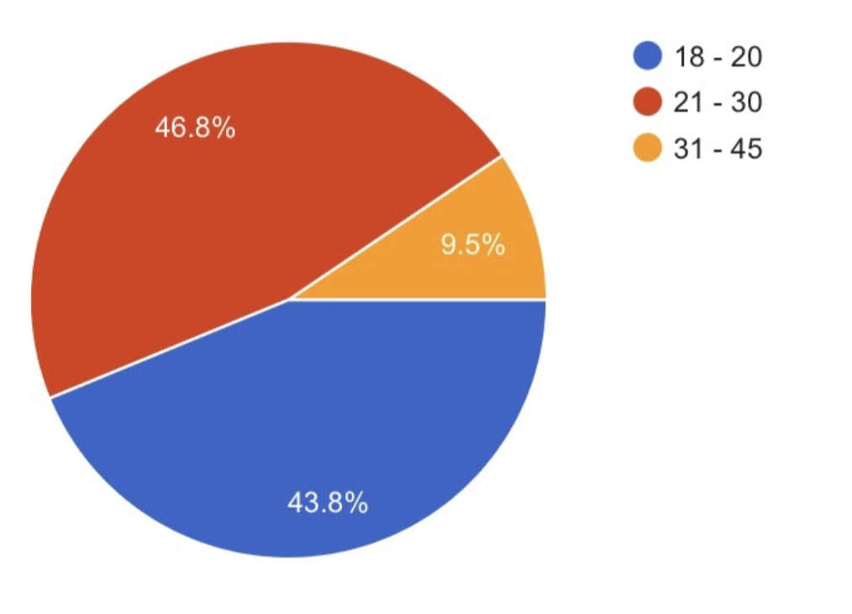
Legend: This figure represents the frequency of age of the respondents.
Inference: ​With respect to the current survey results, the age frequency chart is created out of the survey responses received from several people. The present frequency table is based on the age of the persons. Among the persons who are below 20, there were (17.5%) sample responses taken. Those who were between 30-40 there were (25%) sample responses taken and between those who were 40 & above , there were (19%) sample responses for this survey. Thus, on the whole there were about 200 samples taken for the present survey.

EDUCATION QUALIFICATIONS:
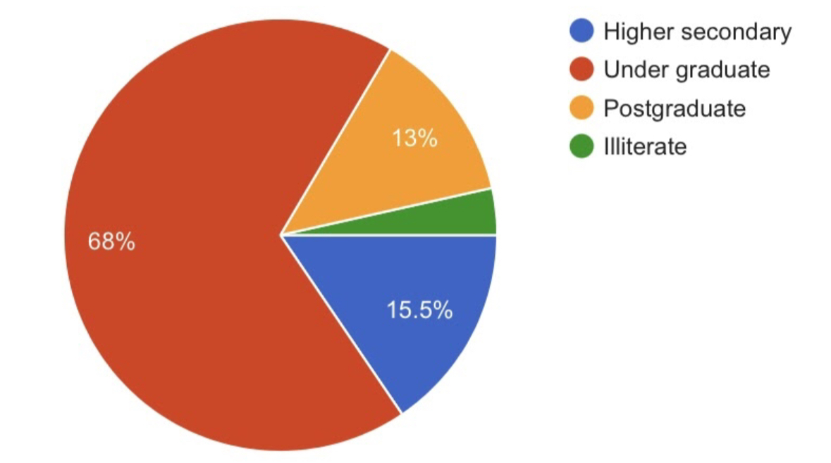

Legend: This figure represents the frequency of educational qualifications of the respondents.
Inference: ​With respect to the current survey results, the educational qualifications frequency chart is created out of the survey responses received from several people. The present frequency table is based on the educational qualifications of the persons. Among the persons who are students below 12th and above, there were (10%) sample responses taken and among the students pursuing UG, there were about (52%) sample responses taken. Among those who have students pursuing PG there were (32%) sample responses taken for this survey. Thus, on the whole there were about 200 samples taken for the present survey.

GENDER FREQUENCY:
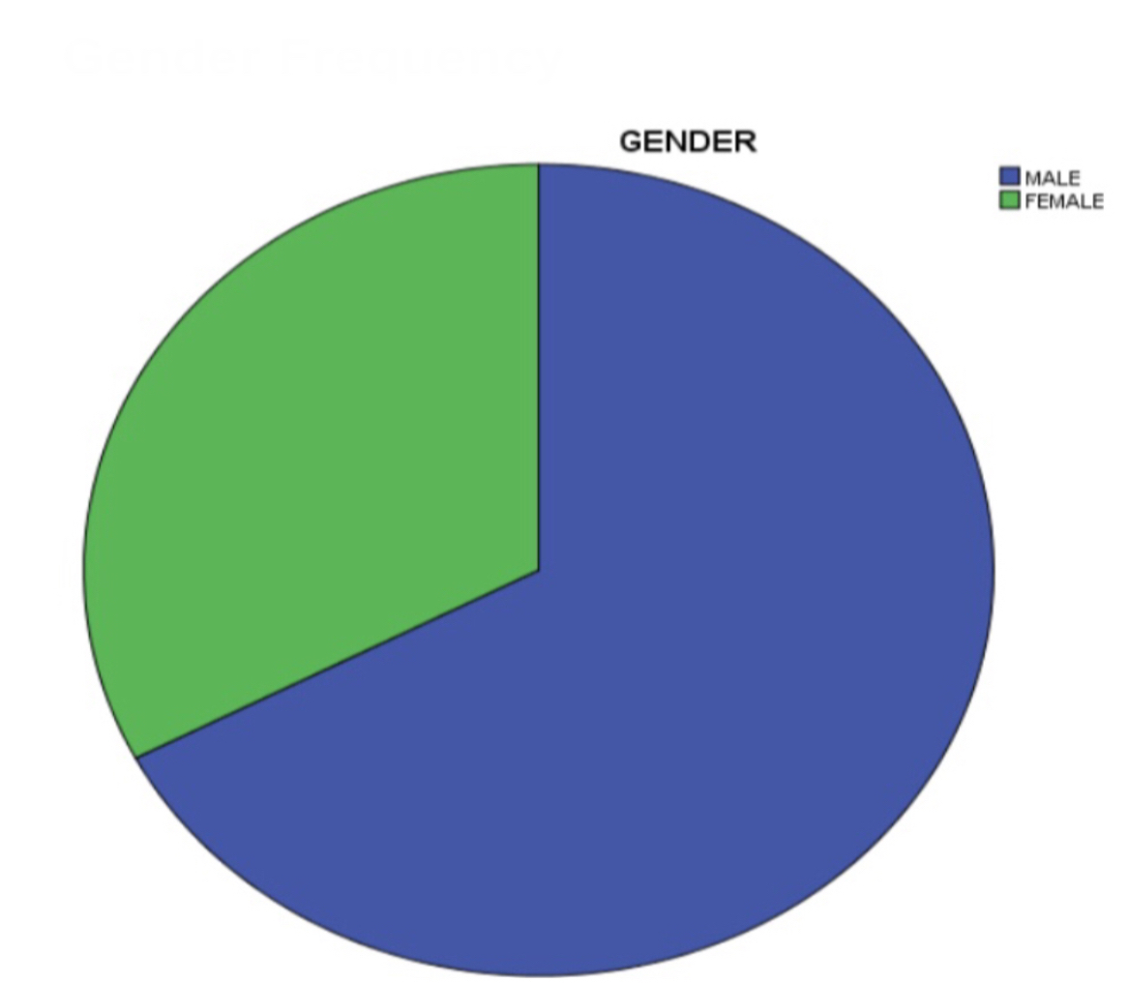

Legend: This figure represents the frequency of gender of the respondents.
Inference: With respect to the current survey results, the gender frequency chart is created out of the survey responses received from several people. The present frequency table is based on the gender of persons who were taken as samples. Among the samples, the number of female responses are comparatively more when compared to the number of responses by male samples. The sample response from females is 89 (44.5%) and the response from male is 111 (55.5%) in number. Thus, on the whole there were about 200 samples taken for the present survey.

GRAPH 1: THE RIGHT TO CLEARWATER FUNDAMENTAL RIGHT TO LIFE UNDER INDIAN CONSTITUTION ?
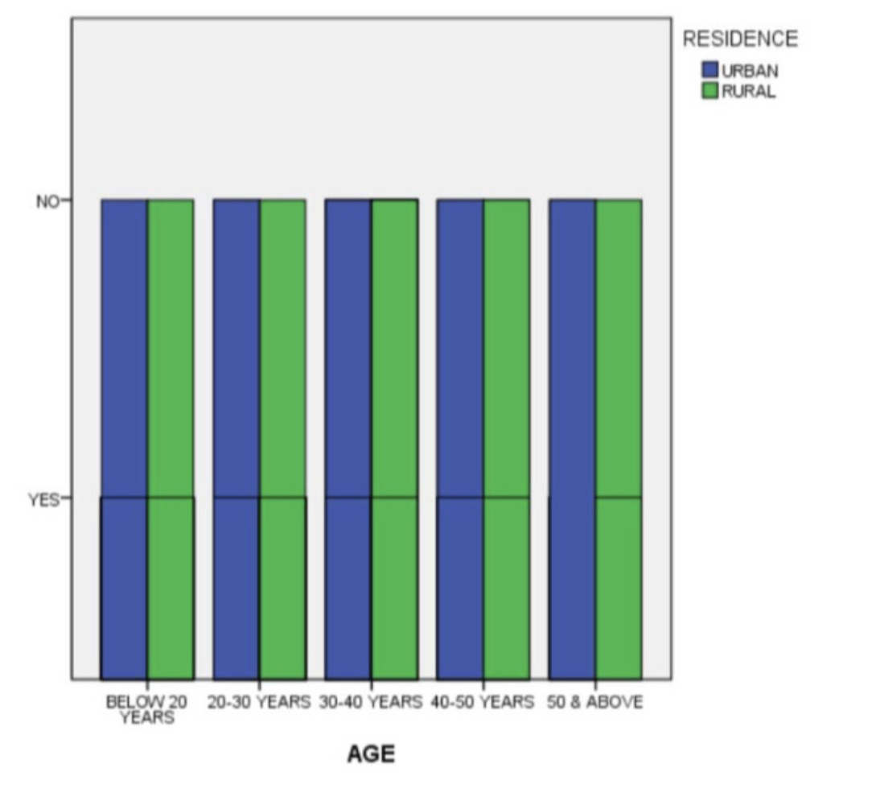
Legend: From the graph, it is observed that it exhibits the residence distribution of the respondents among different age groups of the respondents and their opinion on the fundamental right to clean water.

GRAPH 2: THE ACT OF HUMAN IS THE MAJOR CAUSE FOR WATER POLLUTION ?
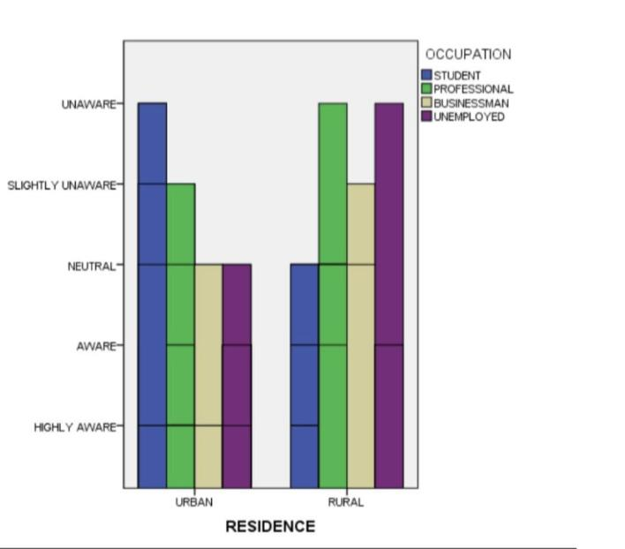
Legend: From the graph, it is observed that it exhibits the age distribution of the respondents among different residence groups of the respondents and their opinion on the act of humans being the major cause for water pollution.

GRAPH 3: DO YOU AGREE THAT WATER POLLUTION HAS INCREASED IN THE PAST FEW YEARS ?

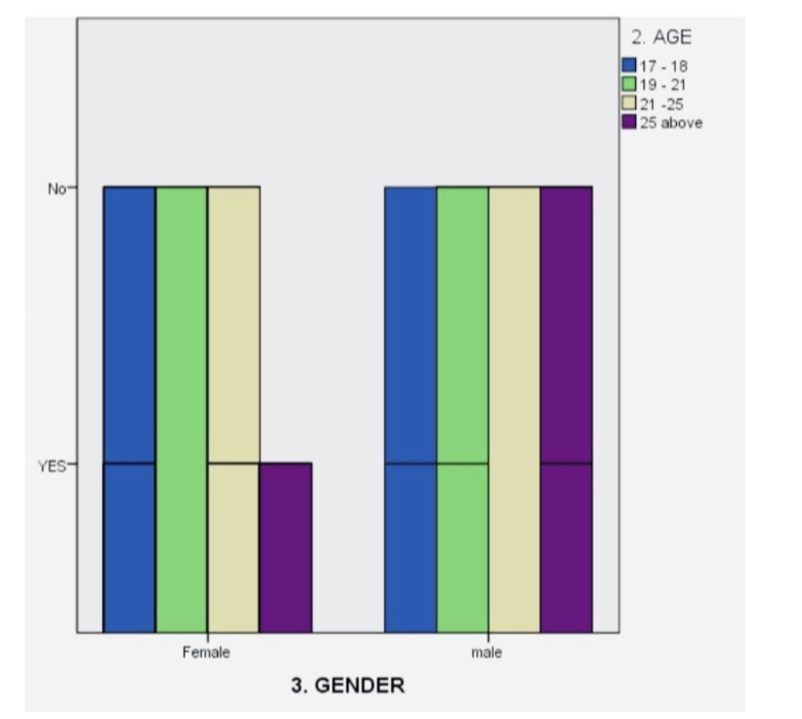

Legend: From the graph, it is observed that it exhibits the occupation distribution of the respondents among different residence groups of the respondents and their opinion on the increase of water pollution day by day.

GRAPH 4: ON THE SCALE OF 1-10 RATE YOUR OPINION HOW FAR DOES INDUSTRY AFFECT THE WATER BODIES ?

Legend: From the graph, it is observed that it exhibits the occupation distribution of the respondents among different residence groups of the respondents and their opinion on
Industry affects the water bodies.

GRAPH 5: ON THE SCALE OF 1-10 RATE YOUR OPINION THAT HOW EFFECTIVE IS WATER POLLUTION NOWADAYS?

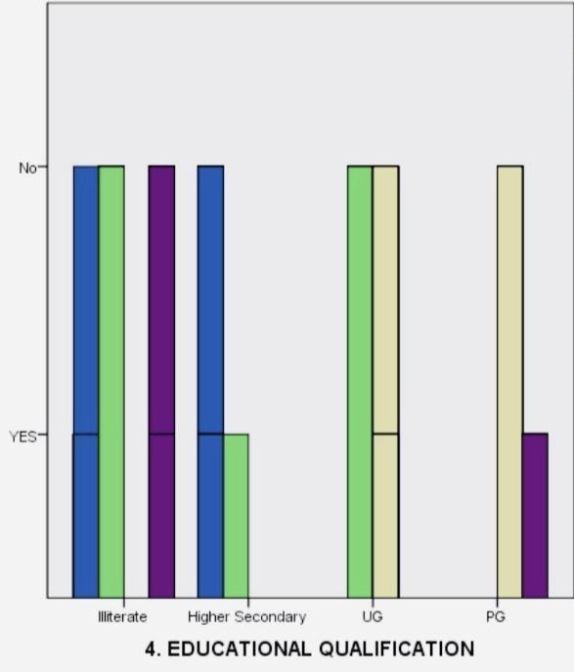

Legend: From the graph, it is observed that it exhibits the occupation distribution of the respondents among different residence groups of the respondents and their opinion on effects of water pollution .

GRAPH 6: DO YOU AGREE THAT CREATURES LIVING IN THE WATER IS AFFECTS BECAUSE OF WATER POLLUTION ?

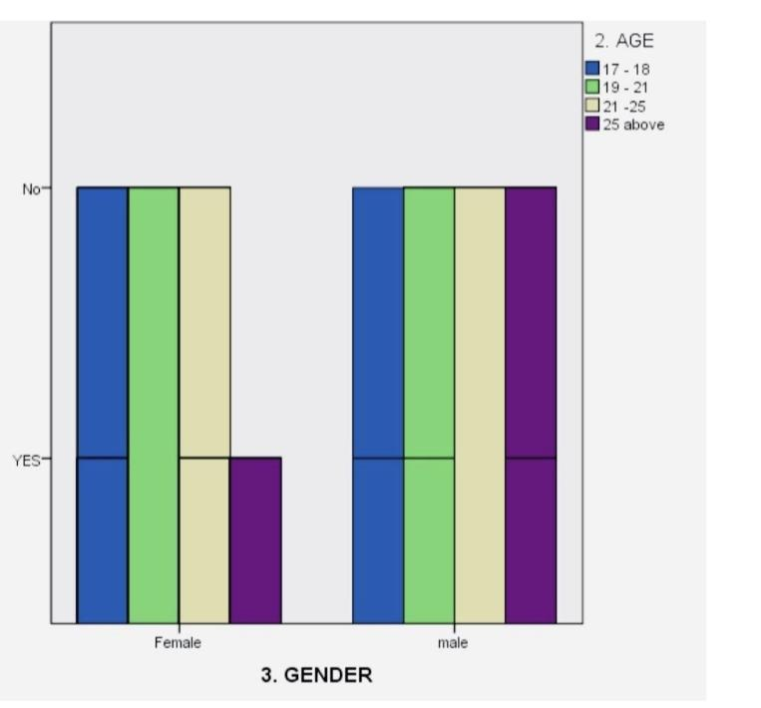
Legend: From the graph, it is observed that it exhibits the occupation distribution of the respondents among different residence groups of the respondents and their opinion on
Creatures which are all affected by water pollution .

Results: From the survey: In graph 1, it is observed that it exhibits the residence distribution of the respondents among different age groups of the respondents and their opinion on fundamental rights to clean water. The maximum responses collected from the respondents who are residing in urban areas between the age group of 20-40 years were aware about the fundamental right to clean water. From the survey: In graph 2, it is observed that it exhibits the age distribution of the respondents among different residence groups of the respondents and their opinion on the human are the only reason of water pollution . The maximum responses collected from the respondents who are residing in urban areas between the age group of 20-30 years strongly agree that mere silence would amounts labours , Whereas the minimum responses collected from the respondents who are residing in rural areas between the age group 30-40 shows neutral opinion. From the survey: In graph 3, it is observed that it exhibits the occupation distribution of the respondents among different residence groups of the respondents and their opinion on increasing of water pollution . The maximum responses collected from the respondents who are residing in urban areas who are students strongly aware of water pollution , Whereas the minimum responses collected from the respondents who are residing in rural areas who are unemployed are unaware. From the survey: In graph 4, it is observed that it exhibits the occupation distribution of the respondents among different residence groups of the respondents and their opinion on industry affect water bodies. The maximum responses collected from the respondents who are residing in urban areas who are students strongly aware of effects of plastic, Whereas the minimum responses collected from the respondents who are residing in rural areas who are unemployed are unaware. From the survey: In graph 5, it is observed that it exhibits the occupation distribution of the respondents among different residence groups of the respondents and their opinion on agriculture labours in India. The maximum responses collected from the respondents who are residing in urban areas who are students strongly aware of agricultural industries, Whereas the minimum responses collected from the respondents who are residing in rural areas who are unemployed are unaware. From the survey: In graph 6, it is observed that it exhibits the occupation distribution of the respondents among different residence groups of the respondents and their opinion on creatures affected by water pollution. The maximum responses collected from the respondents who are residing in urban areas who are students strongly aware of water pollution , Whereas the minimum responses collected from the respondents who are residing in rural areas who are unemployed are unaware.
Discussion: From the survey: In graph 1, it is observed that it exhibits the residence distribution of the respondents among different age groups of the respondents and their opinion on the fundamental right to clean water. The maximum responses collected from the respondents who are residing in urban areas between the age group of 20-40 years were aware about the right to clean water. From the survey: In graph 2, it is observed that it exhibits the age distribution of the respondents among different residence groups of the respondents and their opinion on act of humans is the major cause for water pollution. The maximum responses collected from the respondents who are residing in urban areas between the age group of 20-30 years strongly agree that humans are the main cause of water pollution, Whereas the minimum responses collected from the respondents who are residing in rural areas between the age group 30-40 shows neutral opinion. From the survey: In graph 3, it is observed that it exhibits the occupation distribution of the respondents among different residence groups of the respondents and their opinion on increasing of water pollution in the past few years. The maximum responses collected from the respondents who are residing in urban areas who are students strongly aware about water pollution , Whereas the minimum responses collected from the respondents who are residing in rural areas who are unemployed are unaware. From the survey: In graph 4, it is observed that it exhibits the occupation distribution of the respondents among different residence groups of the respondents and their opinion on industry affects the purity of water bodies.The maximum responses collected from the respondents who are residing in urban areas who are students strongly aware of effects of water pollution, Whereas the minimum responses collected from the respondents who are residing in rural areas who are unemployed are unaware. From the survey: In graph 5, it is observed that it exhibits the occupation distribution of the respondents among different residence groups of the respondents and their opinion on how effective water pollution is nowadays. The maximum responses collected from the respondents who are residing in urban areas who are students strongly aware of water pollution, Whereas the minimum responses collected from the respondents who are residing in rural areas who are unemployed are unaware. From the survey: In graph 6, it is observed that it exhibits the occupation distribution of the respondents among different residence groups of the respondents and their opinion on effects of water pollution .The maximum responses collected from the respondents who are residing in urban areas who are students strongly aware of water pollution, Whereas the minimum responses collected from the respondents who are residing in rural areas who are unemployed are unaware.
LIMITATION:
The major limitation of my study is a sample frame. The sample frame in bus stands and markets have to be roofed for educated samples. The restrictive area of sample size is also another major drawback. The physical factors are the most impactful and a major factor inventing the study.

CONCLUSION:
Thus I conclude by saying that Use Less Plastic it is very difficult to break down plastic after it is produced. Much of the plastic we consume ends up in the world’s water supply, where it is even harder to fish out and safely throw away.If you can use as few plastic items as possible, you are helping the environment. Plastic waste also spreads decay in the water supply. Reuse Items when you buy something that is not recyclable, such as plastic, it is better to reuse this item as many times as possible. This habit limits your consumption and means less of those products will end up in the world’s rivers, lakes, and oceans. Garbage Disposal Even though most homes have a garbage disposal system in the sink, it is better to use it as rarely as possible. It is better to throw them in the trash can when possible. Limit the Use of Detergents and Bleaches While it is okay to use detergents and bleaches in dishwashers and washing machines, it is better to limit your use as much as possible. Use Phosphate-Free Detergent Phosphates present in cleaners are harmful chemicals. Phosphates lead to algae blooms and reduce the oxygen in the water that kills fish and other aquatic animals. About using pesticides in the land.

REFERENCES:
- Adamson, John. 2008. Law for Business and Personal Use. Cengage Learning.
- Altschuler, Bruce E., Celia A. Sgroi, and Margaret R. Ryniker. 2016. Understanding Law in a Changing Society. Routledge.
- Cerioni, Giovanni, and Lucio Donato Moscardi. 1852. A Narrative of the Conversion from Popery of the Rev. G. Cerioni and the Rev. L. D. Moscardi Formerly Padre Berardo Da Jesi, and Padre Leonardo Da Camarda ... Written in Italian by Signor Cerioni, and Principally Translated into English under His Own Eye ... Second Edition.
- Desty, Robert, and Charles Andrew Ray. 1887. Western Reporter ...: All Cases Determined in the Courts of Last Resort, as Follows: Ohio, Supreme Court. Indiana, Supreme Court. Illinois, Supreme Court. Missouri, Sup. Ct. and Courts of Appeals. From September, 1885 [to October, 1888] ..
- Eggers, Peter Macdonald. 2013. Deceit: The Lie of the Law. CRC Press.
- Great Britain. Court of Chancery, Thomas Vernon, and John Raithby. 1828. Cases Argued and Adjudged in the High Court of Chancery: Originally Published by Order of the Court, from the Manuscripts of Thomas Vernon : With References to the Proceedings in the Court, and to Later Cases : Together with Tables of the Names of the Principal Cases, and of the Cases Cited in the Notes : Also, of the Principal Matters and of the Matters Contained in the Notes.
- Hart, William, Roderick D. Blanchard, and Janis Walter. 2006. Litigation and Trial Practice. Cengage Learning.
- Ingeborg, Schwenzer, Hachem Pascal, and Kee Christopher. 2012a. “Part IV Validity, 18 Fraud and Duress.” Global Sales and Contract Law. https://doi.org/10.1093/law/9780199572984.003.0018.
- ———. 2012b. “Part IV Validity, 19 Consequences of Mistake, Fraud, and Duress.” Global Sales and Contract Law. https://doi.org/10.1093/law/9780199572984.003.0019.
- Jessup, Carol M. n.d. “Government Contract Fraud.” Encyclopedia of White-Collar and Corporate Crime. https://doi.org/10.4135/9781452276175.n200.
- Lok Sabha Debates. 1987.
- Meiners, Roger E., Al H. Ringleb, and Frances Edwards. 2008. The Legal Environment of Business. Cengage Learning.
- Miller, Richard E. 2005. Writing at the End of the World. University of Pittsburgh Pre.
- M., O. F., and F. M. O. 1915. “Fraud: Executory Contract of Sale: Right of Vendee to Affirm Contract and Sue on the Fraud.” California Law Review. https://doi.org/10.2307/3473566.
- Novak, Michael. n.d. Choosing Presidents: Symbols of Political Leadership. Transaction Publishers.
- Redfern, Alan. 2004. Law and Practice of International Commercial Arbitration. Sweet & Maxwell.
- “Sample Case Study.” 2017. Contract and Procurement Fraud Investigation Guidebook. https://doi.org/10.4324/9781315172224-14.
- Shuy, Roger W. 2005. “Discourse Ambiguity in a Contract Fraud Case: US v. David Smith.” Creating Language Crimes. https://doi.org/10.1093/acprof:oso/9780195181661.003.0008.
- ———. 2016. “Government Contract Fraud.” The Language of Fraud Cases. https://doi.org/10.1093/acprof:oso/9780190270643.003.0002.
- Silverstone, Howard, and Michael Sheetz. 2011. Forensic Accounting and Fraud Investigation for Non-Experts. John Wiley & Sons.
- Smith, Edwin Burritt, and Ernest Hitchcock. 1884. Reports of Cases Adjudged and Determined in the Supreme Court of Judicature and Court for the Trial of Impeachments and Correction of Errors of the State of New York: With Copious Notes and References, Table of Citations &c.

PLAGIARISM :
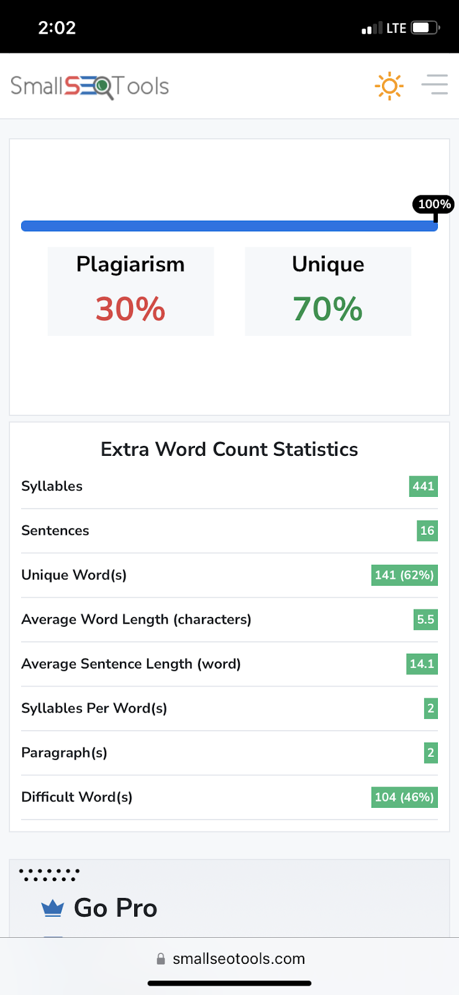

M. Yuva Prasanna, (131701028), B.A., L.L.B.,(Hons), Saveetha School of Law, Saveetha Institute of Medical and Technical Science, Email:uvaprasanna@gmail.com, Phone no: 9952420686.
J. Gayathri, Assistant Professor, Saveetha School of Law, Saveetha Institute of Medical and Technical Science, Email:gayathrij.ssl@saveetha.com , Phone no: 9597401331.

