Detection of Leaf Disease Using Artificial Neural Network

Abstract: Leaf diseases like Alternaria Alternata significantly affect agricultural productivity and food security, posing daunting challenges to farmers and stakeholders in the agricultural sector. The timely and accurate identification of such diseases is imperative for implementing effective management strategies and minimizing crop losses. Leveraging the capabilities of ANN technology, this study delves into the development of a robust and automated system for detecting Alternaria alternata infection in tomato leaves. By harnessing the power of machine learning algorithms, particularly deep learning methodologies, the proposed ANN model can analyze intricate patterns and subtle deviations in leaf images, facilitating precise disease diagnosis with remarkable accuracy. Through comprehensive experimentation and validation, the effectiveness and reliability of the ANN-based detection system are demonstrated, showcasing its potential as a practical tool for real-world agricultural applications. The integration of advanced technologies like ANN into agricultural practices signifies a significant step forward in the quest for sustainable and resilient food production systems, empowering farmers with innovative solutions to combat plant diseases and ensure global food security in an ever-evolving agricultural landscape.
Keywords: Artificial Neural Network, Image Classification, Feature Extraction, Segmentation, Model Evaluation.

INTRODUCTION
Tomato (Solanum lycopersicum) cultivation plays a pivotal role in global agriculture, contributing significantly to both economic and dietary needs. However, the health and yield of tomato plants are constantly threatened by various diseases, among which Alternaria Alternata (commonly known as Alternaria leaf spot) stands as a prominent adversary. This fungal pathogen is notorious for causing leaf diseases in tomato plants, leading to severe reductions in crop quality and quantity. Detecting and managing Alternaria alternata early is crucial for sustainable tomato production. Within the agricultural domain, the vitality of healthy plant development cannot be overstated. It serves as the bedrock of successful crop cultivation. Yet, the progress of these plants is persistently challenged by an array of diseases. If these ailments remain undetected during their early stages, they can exert a substantial toll, resulting in a noticeable decline in plant growth and consequently agricultural yields. The project objective revolves around the creation of a comprehensive framework, identifying and categorizing the various diseases that frequently plague tomato plants, undermining their growth potential. This multifaceted endeavor encompasses two core components: the initial detection of these tomato plant diseases, a critical step in preventing their escalation, and the subsequent stage, where the detected diseases are not just isolated but comprehensively recognized and categorized. This holistic approach forms the cornerstone of this project contribution to the agricultural sector, where informed decision-making is pivotal to enhancing crop health and productivity.
The project focuses on detecting tomato leaf diseases using image processing techniques and MATLAB simulation.
1. Tomato Disease Detection: The primary aim of the project is to utilize image processing techniques to identify healthy and diseased tomatoes from the dataset of tomato images.
2. Pattern Analysis: Upon identifying a potential disease, the project seeks to analyze the visual patterns and characteristics associated with the disease. This analysis helps in understanding the unique manifestations of different tomato diseases.
3. Disease Classification and Verification: After pattern analysis, the project centers on accurately classifying the disease types. MATLAB serves as the practical tool for this task, facilitating disease verification by processing and comparing image data, potentially employing machine learning or pattern recognition algorithms.
4. Comparative Analysis: The final objective involves evaluating various features and techniques. The project aims to determine the most effective approach for tomato disease detection, considering factors like accuracy and computational efficiency, thereby identifying the most practical precaution for real-world agricultural applications.
On leaves, alternaria leaf spot manifests as relatively large brown spots with a diameter of 0.5 to 0.75 inches (12–18 mm). As the fungus spreads, the patches turn black. Leaf spots appear most quickly.
The application of Artificial Neural Networks (ANNs) for the leaf diseases detection, such as Alternaria alternata on tomato leaves, represents a crucial advancement in the field of agriculture and plant pathology.
1. Agricultural Impact Leaf disease poses a significant threat to crop yields and quality. By utilizing ANNs, the project aims to provide a powerful tool for early and accurate disease detection. This technology has the potential to revolutionize farming practices by:
• Enabling early detection of disease, which is essential for timely treatment and prevention.
• Reducing the need for excessive chemical treatments, resulting in cost savings and reduced environmental impact.
• Enhancing crop productivity and overall yield, ultimately contributing to global food security.
2. User-Friendly Interface In this project work, a user-friendly interface is designed that allows farmers and agricultural experts to easily utilize the ANN-based system. The interface includes the following features:
• Image Input: Users can upload leaf images, and the system will analyze them for disease detection.
• Disease Classification: The system provides information about the type of disease detected and its severity.
• Recommendations: Based on disease identification, the system may offer treatment recommendations or prevention strategies.
3. Scalability One of the key advantages of ANNs is their scalability. The model can be trained on a wide range of crops and diseases, including Alternaria alternata on tomato leaves, making it adaptable to various agricultural scenarios. As the dataset and model continue to expand, the system’s accuracy and disease coverage will improve.
4. Real-time Monitoring The application of ANNs in leaf disease detection allows real-time monitoring of crops, including tomato leaves. Farmers can regularly scan their fields, enabling them to respond promptly to disease outbreaks, such as Alternaria alternata. This level of vigilance is crucial for minimizing crop damage and ensuring optimal yields.
5.Challenges and Considerations Despite the promise of ANNs, there are certain challenges and considerations to address in the application of this technology:
• Data Quality: High-quality images are essential for accurate detection. Ensuring data collection and maintenance may require additional resources and effort.
• Model Generalization: ANNs may require continuous training and fine-tuning to generalize well to different crops and disease variants.
• Accessibility: The system’s accessibility to farmers in remote or resource-constrained regions needs to be addressed to ensure equitable distribution of this technology. Therefore, the application of Artificial Neural Networks in the detection of leaf diseases, including Alternaria alternata on tomato leaves, is poised to have a profound impact on agriculture. By harnessing the power of machine learning and image analysis, farmers are empowered with a valuable tool to protect their crops, enhance yields and contribute to sustainable farming practice.
LITERATURE REVIEW
Mohammed A. Hussein, Amel H. Abbas (2019) The proposed system consists of two phases: establishing a knowledge base through preprocessing techniques and using a support vector machine classifier for disease detection and diagnosis. The knowledge base was created using a set of training samples and the classifier was trained using this knowledge base. The paper also mentions the use of 799 sample images for testing and training purposes. Following preprocessing, the support vector machine method—the suggested machine learning algorithm in this system—will use the useful picture characteristics that are collected using the feature extraction technique as training examples. Using a digital camera, the images will be first obtained for the detecting phase. Subsequently, the image processing methods discussed during the training phase will be implemented, and ultimately, a support vector machine (SVM) will classify the case as either infected or healthy.
Vibhor Kumar Vishnoi, Krishna Kumar (2022) Convolutional Neural Networks (CNN) are a class of deep neural networks designed for image processing . CNN are likely employed for disease detection in apple plants based on leaf images. Convolutional layers apply convolution operations to input images, detecting features like edges and textures. Pooling Layers reduces the spatial dimensions of the convolutional output, preserving essential information while reducing computational load. Fully Connected Layers make decisions based on the features learned in the previous layers. CNN excel at automatically learning relevant features from images, crucial for identifying disease-related patterns. CNN recognize hierarchical features, capturing spatial relationships in images. CNN require substantial labeled data for effective training, which may be a limitation. Training deep CNN can be computationally demanding and time-consuming. CNN may overfit the training set, resulting in good performance on previously seen data but subpar performance on fresh, unseen data.
Nithyashree. D, Ramya. B, Rohith Kumar. V, Birundha. R (2020) Decision Tree (DT) involves the extraction and classification using a decision tree clustering algorithm. The system aims to improve disease detection accuracy and automatically spray fertilizers and pesticides. The significance of early disease identification and the financial losses brought on by plant leaf diseases are also highlighted in the paper. A classification algorithm called DT assists in the analysis and categorization of pictures by using a variety of features that are derived from the images. The DT method can be trained on a dataset of photos with known illness labels in order to generate a model for the purpose of detecting leaf diseases. Afterwards, this model may be applied to categorise fresh pictures and determine if a leaf is ill or healthy. Decision Tree algorithms are capable of accurately diagnosing various leaf diseases by classifying them according to visual attributes. DT algorithms are wellsuited for real-time or near-real-time applications in agriculture because of their ability to handle massive amounts of visual data quickly.
METHODOLOGY
Dataset of leaf images that are healthy and diseased needs to be collected to detect leaf diseases using Artificial Neural Network (ANN) Algorithm. Preprocessing the image can be used to enhance it. It is possible to extract from the image pertinent information like texture features or color histograms. Training and testing sets can be created from datasets. Utilizing the testing results, assess the model's performance and make any adjustments. Lastly, use the trained model to identify leaf diseases in practical situations.
• Image of the leaf is given as input.
• Noise removal is done in pre-processing by using filters.
• Separation of affected and not affected part is done in segmentation by using grey level matrix.
• Feature Extraction is done to convert into binaries.
• Classification is done by Artificial Neural Network algorithm.
• Prediction is done to identify the disease of leaf. In output, the identified disease will be displayed along with curing methods
For the purpose of performing the previously stated prediction tasks, multiple-layer perceptron systems and a basic backpropagation technique for learning have been used. The network's following parameters are subsequently changed using an evolutionary strategy:
• Number of hidden layers
• Number of neurons in each layer
• Each layer's neurons use a different transfer function; neurons in the same layer will use the same transfer function.
This can be implemented through the creation of a genetic algorithm for a particular type of neural networks which is composed of a random N-digit binary bit string. If the permissible transfer functions have hyperbolic tangents and linear bounds, the sole restrictions on the aggregate amount of hidden layers may be the greatest possible number of neuron for each layer. This is going to assist in narrowing into the best possible space for searching. Consequently, the sum of the number of neurons within each hidden layer can be described as a four-bit number as well, whereas the transfer function of each layer might be represented as a two-bite number, suggesting therefore a total of six bits are needed for each layer. Due to the potential for more than ten hidden levels of difficulty, the bit string as a whole will have a length of 60,000 bits long.
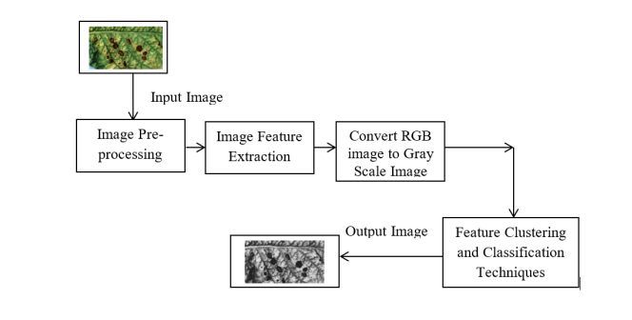
Fig 1 Block diagram
The proposed approach attempts to develop an economically sustainable pathogen classification apparatus for leaves from tomato plants while also developing a disease recognition and classification model. A variety of techniques for processing images have been implemented by the system to process images.
SIMULATION RESULTS
The dataset is initially split into two fundamental subsets, the training and testing sets. This is a common practice in machine learning. These data sets are populated with images sourced from the Kaggle dataset, a reputable resource in the data science community. The actual implementation of the project is carried out using a combination of MATLAB, JavaScript, and jQuery scripts. When a specific image is input into the system, it undergoes a series of transformations. Initially, the image is converted from its original state to grayscale, a critical step often used in simplifying and standardizing image data. Subsequently, the preprocessed image, enriched and cleaned by preprocessing techniques such as noise reduction and contrast enhancement, is presented for further analysis. Feature extraction becomes the focus, where relevant characteristics are distilled from the image. This process can include the identification of edges, textures, or more advanced features, all aimed at creating a meaningful representation of the image. The final transformation in this phase involves converting the preprocessed image into binary data, typically binary values (0s and 1s), which simplifies data representation for subsequent computational analysis. Finally, the binary data and the preceding processes lay the foundation for Phase 2, where specific machine learning or computer vision tasks can be executed on this prepared data, ranging from image classification to object detection and more complex analyses.
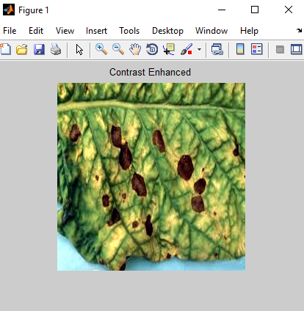
Fig 2 Input image
Figure 1 represents the input image (tomato leaf). The input image has to be collected from the Kaggle dataset. The implementation is done in Python by usingMatlab. The image will then be provided as input, and the preprocessing method will display the preprocessed image after first converting the normal image to a grayscale image. Next, feature extraction is used to transform this preprocessed image into binary data.
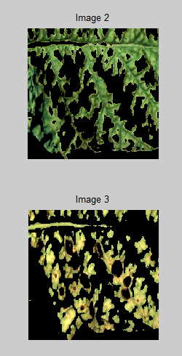
Fig 3 Segmented image

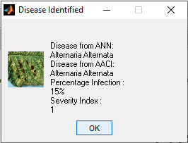
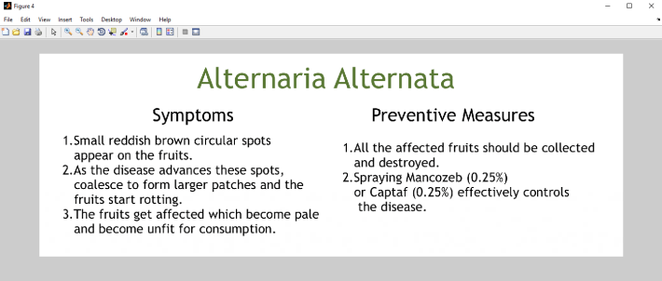
Fig 4 Result
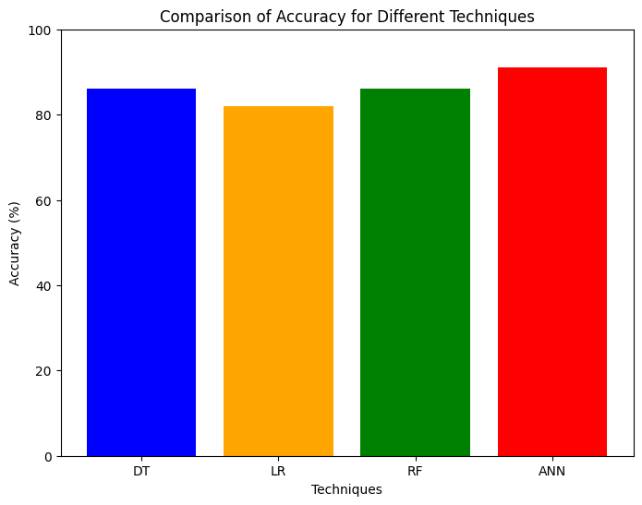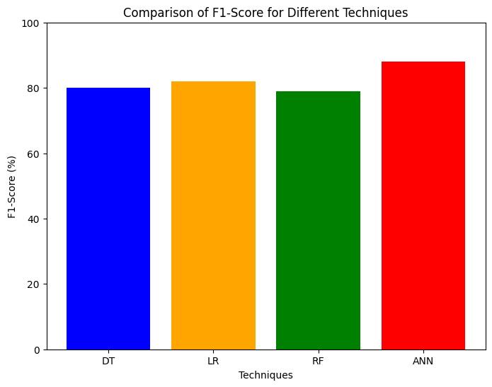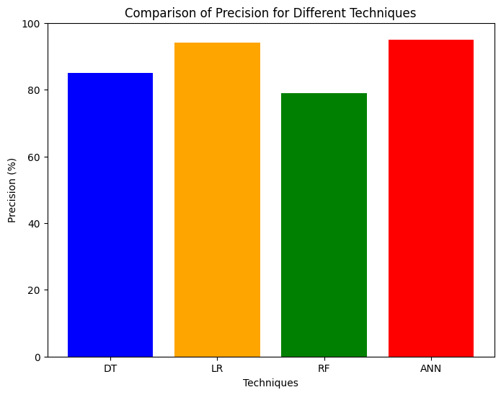

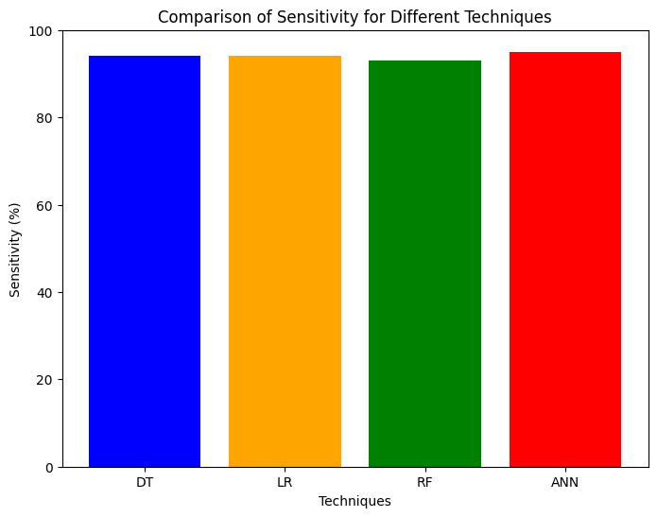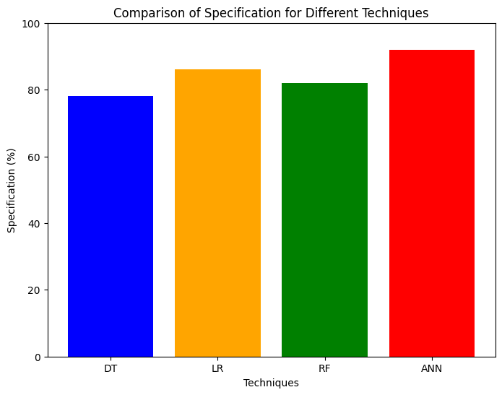
Fig 5 Algorithm wise performance for different parameters
Table 1 Comparison table
Parameters | DT | LR | RF | ANN
Accuracy | 86% | 82% | 86% | 91%
F1-Score | 80% | 82% | 79% | 88%
Sensitivity | 85% | 94% | 79% | 95%
Specification | 94% | 94% | 93% | 95%
Precision | 78% | 86% | 82% | 92%

CONCLUSION
The project embarked on an initial exploration of various methodologies for the detection of leaf diseases. Despite the limited prior focus on this issue, the agricultural sector continues to call for cutting-edge advancements in predictive capabilities. In light of this demand, there arises a clear necessity to devise a highly precise algorithm capable of both minimizing noise in the data and accurately predicting disease occurrences. The methodology adopted for disease identification hinges on image analysis, specifically through the synergistic integration of a Gray-Level Co-Occurrence Matrix with fuzzy clustering, resulting in a hybrid approach. This choice of method was driven by the recognition that traditional techniques yielded subpar results in the realm of agricultural leaf and image identification. To further enhance the process, a hybrid technology was introduced to bolster the performance of the Gray-Level Co-Occurrence Matrix when used in conjunction with artificial neural networks (ANN) for image compression. An additional noteworthy advancement was the successful implementation of the Gray-Level Co-Occurrence Matrix algorithm, which proved highly effective in achieving superior segmentation results for images in a variety of formats, including jpg, jpeg, and png. The adoption of ANN-based image disease detection, as opposed to conventional compression methods, revealed markedly enhanced performance and accuracy, reaffirming the potential of artificial neural networks in this domain. This comprehensive approach represents a pivotal step toward revolutionizing disease detection in the field of agriculture, with the potential to significantly bolster crop health and productivity.
REFERENCES
Vibhor Kumar Vishnoi, Krishan Kumar, Brajesh Kumar, Shashank Mohan and Arfat Ahmad Khan, “Detection of Apple plant diseases using leaf images through Convolutional Neural Network”, Dec.2022, doi 10.1109/2022.3232917.
2. V. K. Vishnoi, K. Kumar, and B. Kumar, ‘‘A comprehensive study of feature extraction techniques for plant leaf disease detection,’’ Multimedia Tools Appl., Vol. 81, no. 1, pp. 367–419, Jan. 2022, doi: 10.1007/s11042-021-11375-0.
3. Sunil C.K, Jaidhar C.D., Nagamma Patil, “Cardamom Plant Disease Detection Approach Using EfficientNetV2”, Dec.2021, doi 10.1109/2021.3138920.
4. J. A. Pandian, V. D. Kumar, O. Geman, M. Hnatiuc, M. Arif, and K. Kanchanadevi, ‘‘Plant disease detection using deep convolutional neural network,’’ Appl. Sci., vol. 12, no. 14, p. 6982, Jul. 2022, doi:10.3390/app12146982.
5. A. M. Mostafa, S. A. Kumar, T. Meraj, H. T. Rauf, A. A. Alnuaim, and M. A. Alkhayyal, ‘‘Guava disease detection using deep convolutional neural networks: A case study of guava plants,’’ Appl. Sci., vol. 12, no. 1, p. 239, Dec. 2021.
6. V. K. Vishnoi, K. Kumar, and B. Kumar, ‘‘Crop disease classification through image processing and machine learning techniques using leaf images,’’ in Proc. 1st Int. Conf. Adv. Comput. Future Commun. Technol. (ICACFCT), Dec. 2021, pp. 27–32.
7. P. Wspanialy and M. Moussa, ‘‘A detection and severity estimation system for generic diseases of tomato greenhouse plants,’’ Com-put. Electron. Agricult., vol. 178, Nov. 2020, Art. no.105701, doi:10.1016/j. compag.2020.105701.
8. R. Thangaraj, S. Anandamurugan, and V. K. Kaliappan, ‘‘Automated tomato leaf disease classification using transfer learning-based deep convolution neural network,’’ J. Plant Diseases Protection, vol. 128, no. 1, pp. 73–86, Feb. 2021, doi: 10.1007/s41348-020- 00403-0 33.
9. J. A. Pandian, K. Kanchanadevi, V. D. Kumar, E. Jasińska, R. Goňo,Z. Leonowicz, and M. Jasinski, ‘‘A five convolutional layer deep convolutional neural network for plant leaf disease detection,’’ Electronics, vol. 11,no. 8, p. 1266, Apr. 2022, doi: 10.3390/electronics11081266.
10. A. Almadhor, H. T. Rauf, M. I. U. Lali, R. Damaševičius, B. Alouffi, and A. Alharbi, ‘‘AIdriven framework for recognition of guava plant diseases through machine learning from DSLR camera sensor based high resolution imagery,’’ Sensors, vol. 21, no.
11, p. 3830, Jun. 2021. 11. S. Theodoridis, ‘‘Chapter 18 - neural networks and deep learning,’’ in Machine Learning, 2nd ed., S. Theodoridis, Ed. New York, NY, USA: Academic Press, 2020, pp. 901–1038, doi: 10.1016/B978-0-12-818803-3.00030-1.
12. M. Agarwal, S. Gupta, and K. K. Biswas, ‘‘A new Conv2D model with modified ReLU activation function for identification of disease type and severity in cucumber plant,’’ Sustain. Comput., Informat. Syst., vol. 30, Jun. 2021, Art. no. 100473, doi: 10.1016/j.suscom.2020.100473.
13. P. Wspanialy and M. Moussa, ‘‘A detection and severity estimation system for generic diseases of tomato greenhouse plants,’’ Comput. Electron. Agricult., vol. 178, Nov. 2020, Art. no. 105701, doi:10.1016/j.compag.2020.105701.
14. V. K. Vishnoi, K. Kumar, and B. Kumar, ‘‘Plant disease detection using computational intelligence and image processing,’’ J. Plant Diseases Protection, vol. 128, no. 1, pp. 19– 53, Feb. 2021, doi: 10.1007/s41348-020-00368-0.
15. B. Liu, Z. Ding, L. Tian, D. He, S. Li, and H. Wang, ‘‘Grape leaf disease identification using improved deep convolutional neural networks,’’ Frontiers Plant Sci., vol. 11, p. 1082, Jul. 2020, doi: 10.3389/fpls.2020.01082. 16. S. Barburiceanu, R. Terebes, and S. Meza, ‘‘Grape leaf disease classification using LBPderived texture operators and colour,’’ in Proc. IEEE Int. Conf. Automat., Quality Test., Robot. (AQTR), May 2020, pp. 1–6, doi:10.1109/AQTR49680.2020.9130019.

ACKNOWLEDGEMENT

Thanks for Sri Ramakrishna Institute of Technology, Coimbatore, India to provide us the environment and support to complete our project in successful manner.

Ms.MK Anuvarshini, Ms. M Shaalini and Ms.J Steffy Jenisha are pursuing final year Bachelor Degree in Department of Electronics and Communication Engineering at Sri Ramakrishna Institute of Technology, Coimbatore, Tamilnadu, India.

