Smart Grid Technology : Simplifying the Complexities of Modern Energy Management

Ninad A Chaudhary¹
Department of Electrical Engineering SSBT’s College of Engineering and Technology,Jalgaon ninadchaudhary999@gmail.com
Kunal L Jiri ²
Department of Electrical Engineering SSBT’s College of Engineering and Technology,Jalgaon kunaljiri222@gmail.com

ABSTRACT
This paper explores the transformative role of smart grid technology in simplifying contemporary energy management complexities. By integrating advanced communication and automation, smart grids enhance efficiency, reliability, and sustainability in power distribution, paving the way for a more resilient and responsive energy infrastructure Through the integration of cutting-edge communication and automation, smart grids not only bolster efficiency but also elevate the reliability and sustainability of power distribution. This research sheds light on the potential of smart grids to create a more resilient and responsive energy infrastructure, addressing the challenges of our rapidly evolving energy landscape. The exploration extends beyond the surface benefits, delving into the nuanced ways in which smart grids empower energy systems to adapt and evolve. This adaptive prowess not only simplifies the complexities of energy management but also fosters a more resilient and responsive energy infrastructure. The intricate interplay of technological advancements within smart grids forms the bedrock for a paradigm shift in how we conceptualize, distribute, and consume energy resources. As the world grapples with the pressing need for sustainable energy solutions, this research sheds light on the multifaceted contributions of smart grid technology. By paving the way for a harmonized and dynamic energy ecosystem, smart grids stand poised to redefine the future of energy management, offering a promising path towards a more sustainable and resilient global energy landscape.

Keywords-Advanced Metering Infrastructure (AMI), Distributed Energy Resources (DERs)

INTRODUCTION
Smart Grid Technology represents a paradigm shift in the landscape of energy management, ushering in an era of unprecedented efficiency, sustainability, and reliability in power distribution networks. This paper endeavors to demystify the intricate workings of smart grids, making this transformative technology accessible to a diverse audience.
At its core, a smart grid integrates advanced sensing, communication, and control technologies into traditional power grids. These enhancements empower utilities and consumers alike to monitor, analyze, and optimize energy usage in real-time. Our exploration begins by elucidating the fundamental principles that underpin smart grid functionality. From
intelligent sensors and communication networks to automated control systems, we unravel the technological tapestry that enables seamless integration of renewable energy sources, electric vehicles, and diverse consumer demands.

The benefits of smart grids are manifold, and we dissect them comprehensively. Improved efficiency is a cornerstone, achieved through dynamic load balancing, predictive maintenance, and outage management. Enhanced reliability stems from the grid's ability to self-heal and adapt to changing conditions swiftly. Sustainability takes center stage as smart grids facilitate the integration of renewable energy sources, reducing carbon footprints and fostering a greener energy ecosystem.

Navigating through the applications of smart grid technology, we showcase its transformative impact on diverse sectors. From smart homes with real-time energy monitoring and demand response capabilities to smart cities orchestrating integrated energy systems, the reach of this technology extends far beyond traditional power grids. We also delve into the role of smart grids in bolstering grid resilience, critical in the face of increasing natural disasters and cyber threats.

Crucially, our paper caters to a broad audience. For experts in the field, it offers a nuanced exploration of the latest advancements and emerging trends. Simultaneously, those new to smart grid concepts find a clear and accessible overview that serves as a gateway to understanding this complex technology. As we unravel the layers of smart grid intricacies, we invite readers to join us on a journey to unlock the potential of Smart Grid Technology, recognizing its pivotal role in shaping the future of energy systems.
In an era marked by burgeoning energy demands and a dynamic landscape of power consumption, the integration of Smart Grid Technology stands as a pivotal force reshaping the intricacies of modern energy management. This innovative approach transcends traditional paradigms, offering a sophisticated framework that not only addresses the complexities of energy distribution but also introduces a new era of efficiency, resilience, and sustainability. As we delve into the realms of Smart Grid Technology, we unravel a tapestry of solutions designed to navigate the challenges of our evolving energy ecosystem, promising a future where intelligent grid systems seamlessly orchestrate the flow of power for a smarter, more sustainable world.
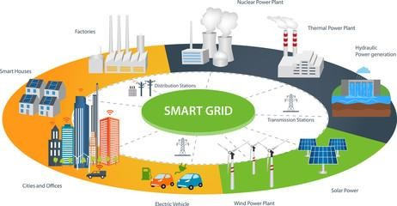
Fig 1. Smart Grid system

HISTORICAL DEVELOPMENT AND EVOLUTION OF THE SMART GRID

The smart grid has evolved significantly over time. Initially, power grids were conventional, with limited communication and control capabilities. In the 20th century, advancements like SCADA (Supervisory Control and Data Acquisition) systems improved monitoring. The concept of a smart grid emerged in the late 20th century, emphasizing digital technology integration for enhanced efficiency and reliability.

In the early 2000s, pilot projects and research initiatives explored smart grid components, including advanced metering systems. The focus shifted towards incorporating renewable energy sources and accommodating two-way communication for better grid management.

Around 2010, countries globally began implementing smart grid technologies, deploying smart meters, sensors, and automation to optimize energy distribution. Integration of ICT (Information and Communication Technology) became crucial for real-time data analysis, enabling quicker response to disruptions.

As of my last knowledge update in January 2022, ongoing developments involve leveraging artificial intelligence, machine learning, and IoT (Internet of Things) for

predictive maintenance, demand response, and grid resilience. The evolution of smart grids continues as technology advances and the need for sustainable, efficient energy systems grows. In recent years, the smart grid's evolution has seen a heightened focus on cybersecurity due to the increased interconnectivity and reliance on digital systems. Governments and industry stakeholders are emphasizing robust security measures to protect against potential cyber threats, ensuring the integrity and reliability of the grid.

Renewable energy integration has been a pivotal aspect of the smart grid's evolution, with a growing emphasis on accommodating distributed energy resources (DERs) like solar panels and wind turbines. Smart grids enable better

management of these decentralized energy sources, facilitating a more resilient and sustainable power infrastructure.

Grid modernization efforts continue to address challenges such as grid congestion, power quality issues, and the aging infrastructure. Smart grid technologies, including advanced sensors and communication networks, help in real-time monitoring and control, contributing to the overall stability of the power grid

The development of microgrids, localized energy systems capable of operating independently or in conjunction with the main grid, has gained momentum. Microgrids enhance resilience during outages and provide flexibility in managing energy resources efficiently.

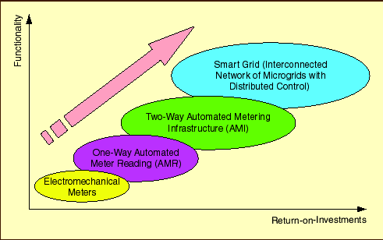
Fig 2. Evolution of smart Grid

As we move forward, ongoing research explores emerging technologies like blockchain for secure energy transactions, edge computing for faster data processing, and advanced analytics for more precise demand forecasting. The evolution of smart grids remains dynamic, driven by the pursuit of sustainability, reliability, and adaptability in the face of a rapidly changing energy landscape

COMPONENTS AND ARCHITECTURE OF A SMART GRID SYSTEM

The smart grid comprises various components and follows a sophisticated architecture to enable efficient and intelligent energy management. Some key components and aspects of the smart grid include:
- Smart Meters:
  - Smart meters are advanced devices that monitor and record electricity usage in real-time.
  - They facilitate two-way communication between consumers and utilities, enabling better demand response and grid management.

- Sensors and Automation:
  - Distributed sensors throughout the grid provide real-time data on electricity flow, voltage, and equipment status.
  - Automation systems use this data to optimize grid operations, detect faults, and respond swiftly to disruptions.

- Communication Networks:
  - Robust communication networks, including fiber optics and wireless technologies, enable seamless data exchange between grid components.
  - These networks support the flow of information for monitoring, control, and coordination within the smart grid.

- Advanced Metering Infrastructure (AMI):
  - AMI includes smart meters, communication networks, and data management systems.
  - It allows utilities to collect, analyze, and manage data from smart meters for billing, demand response, and system optimization.
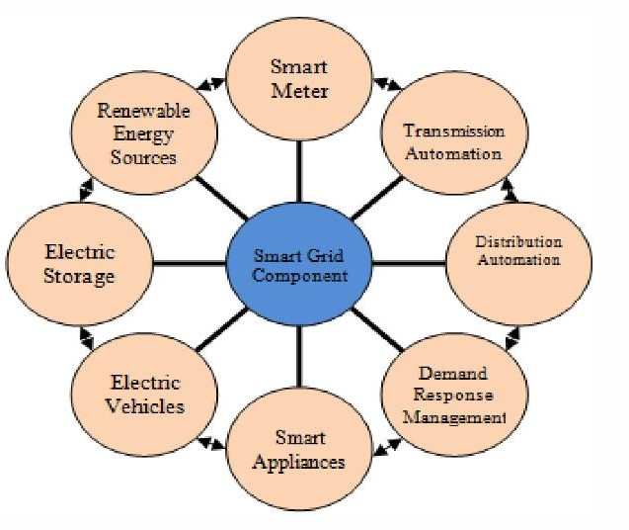
Fig 3. Components of Smart Grid
- Grid Management Systems:
  - Supervisory Control and Data Acquisition (SCADA) systems monitor and control grid operations.
  - Energy Management Systems (EMS) optimize power generation, distribution, and consumption in real-time.

- Energy Storage Systems:
  - Batteries and other energy storage technologies play a crucial role in balancing supply and demand, managing intermittent renewable energy sources, and enhancing grid stability.

- Renewable Energy Integration:
  - Smart grids facilitate the integration of renewable energy sources like solar and wind power.
  - Inverters and grid-tied technologies ensure smooth incorporation of these decentralized energy resources.

- Demand Response Programs:
  - Demand response systems enable utilities to adjust electricity usage during peak periods, improving grid efficiency and reliability.

- Cybersecurity Measures:
  - Robust cybersecurity protocols protect the smart grid from potential cyber threats, ensuring the integrity and security of critical infrastructure.

- Microgrids:
  - Microgrids are smaller, localized energy systems that can operate independently or connect to the main grid.
  - They enhance grid resilience and support local energy generation and consumption.

The architecture of the smart grid involves the seamless integration of these components, creating a dynamic and responsive energy ecosystem that meets the challenges of the modern electricity grid.

ADVANCED METERING INFRASTRUCTURE (AMI) AND SMART METERING

Advanced Metering Infrastructure (AMI) refers to systems that measure, collect, and analyze energy consumption using equipment such as electricity meters, gas meters, and water meters. These systems communicate either on request or on a scheduled basis. They encompass hardware, software, communications, common energy consumption displays and controllers, customer communication systems, meter data management software, and supplier business systems.
Government agencies and water, electricity, and gas companies are increasingly adopting Advanced Metering Infrastructure (AMI) systems as part of broader "Smart Grid" initiatives. AMI builds upon Automated Meter Reading (AMR) technology by facilitating two- way meter communication, enabling commands to be sent to meters and other metering equipment for various purposes, including utility-based tariff information, consumption hours, responding to requests, and remotely disconnecting and connecting energy.

Wireless technologies play crucial roles in establishing local area networks, configuring networks of up to thousands of meters to transmit and receive information with the central server of the energy supply company.

The network established between the measuring equipment and the central server enables the collection and distribution of information to energy suppliers and subscribers. Subscribers can adjust their consumption patterns to reduce costs using the information provided by the system. Tariffs can also be employed to manage consumption increases during peak hours.

Advanced Metering Infrastructure (AMI) comprises an integrated system of equipment, communications, and information management systems for energy providers to remotely collect real-time customer consumption information. AMI utilizes radio-based technology to read meters, eliminating the need for manual meter reading.

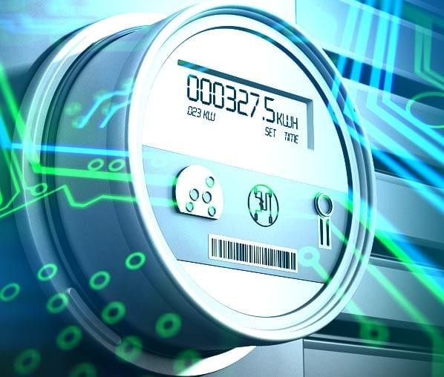
Fig 4. Advanced Metering Infrastructure

INTEGRATION OF RENEWABLE ENERGY SOURCES INTO THE SMART GRID

The integration of renewable energy sources into the smart grid is a crucial aspect of transitioning towards a sustainable and resilient energy infrastructure. This process involves several key considerations and technologies:

- Grid-Connected Renewable Systems:
  - Technology: Solar photovoltaic (PV) panels, wind turbines, hydropower systems.
  - Integration: Smart grid technologies enable the seamless connection of renewable energy systems to the grid, allowing for bidirectional power flow.

- Distributed Energy Resources (DERs):
  - Technology: Small-scale renewable installations, energy storage systems.
  - Integration: Smart grid management incorporates DERs, optimizing their operation and ensuring grid stability by managing fluctuations in power generation.

- Advanced Inverters:
  - Technology: Inverters that convert DC power from solar panels or wind turbines into AC power for the grid.
  - Integration: Advanced inverters support grid stability by providing grid support functions, such as voltage and frequency regulation.

- Demand Response Programs:
  - Technology: Communication networks, smart meters.
  - Integration: Smart grids facilitate demand response, allowing consumers to adjust their electricity usage based on renewable energy availability, enhancing grid flexibility.

- Energy Storage Systems (ESS):
  - Technology: Batteries, pumped hydro storage.
  - Integration: Energy storage helps smooth out intermittent renewable generation, storing excess energy during high production periods and releasing it during times of low production.

- Microgrids:
  - Technology: Localized generation and storage.
  - Integration: Microgrids enable communities to operate independently or in coordination with the main grid, optimizing the use of renewable resources and enhancing resilience.

- Predictive Analytics and Forecasting:
  - Technology: Machine learning algorithms, weather forecasting.
  - Integration: Predictive analytics enhance the accuracy of forecasting renewable energy generation, helping grid operators plan and manage resources effectively.

- Grid-Responsive Incentives:
  - Technology: Smart grid platforms, communication networks.
  - Integration: Incentive programs encourage consumers to align their energy usage with renewable energy availability, contributing to a more sustainable and balanced grid.

The integration of renewable energy into the smart grid not only addresses environmental concerns but also enhances grid reliability and efficiency. This process requires a sophisticated interplay of technologies and adaptive strategies to accommodate the variability inherent in renewable energy sources. As smart grid technologies continue to advance, the integration of renewables will play a pivotal role in shaping the future of sustainable energy systems.
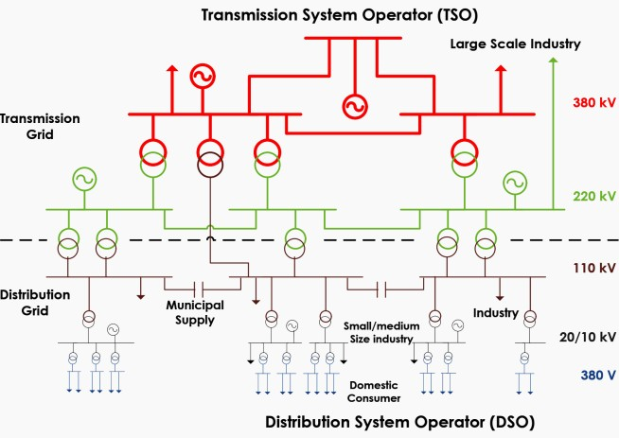

LOAD MANAGEMENT IN SMART GRIDS

Load management in smart grids is a strategy to efficiently balance electricity supply and demand. Through real-time communication and sensors, smart grids monitor consumption patterns. This

data allows for proactive adjustments, optimizing energy distribution, reducing peak loads, and enhancing the reliability and sustainability of the electrical grid

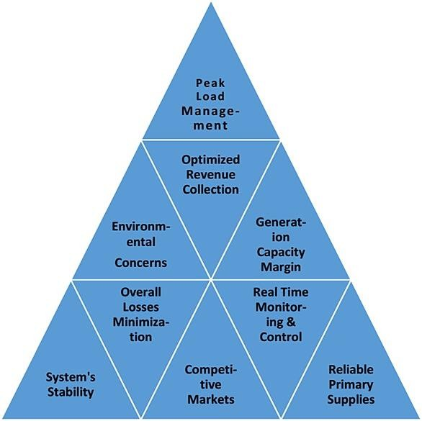
Fig 6. Load Management System

SMART GRID ANALYTICS: DATA COLLECTION, ANALYSIS, AND DECISION MAKING
Smart grid analytics involve the comprehensive process of collecting, analyzing, and leveraging data to inform decision-making within modern electrical grids. The foundation of these analytics lies in real-time monitoring, data gathering, and advanced analysis techniques.

Data Collection:
Smart grids rely on a network of sensors, smart meters, and other devices to collect vast amounts of data in real-time. These devices measure electricity consumption, voltage levels, equipment health, and environmental factors. The continuous flow of data provides a detailed and dynamic view of the grid's operational status.

Data Analysis:
Analytics platforms process the collected data using advanced algorithms, statistical models, and machine learning techniques. These analyses uncover patterns, identify anomalies, and generate insights into grid performance. Predictive analytics can forecast future demand, potential faults, and optimize energy distribution, contributing to enhanced efficiency and
reliability.

Decision Making:
Informed by data analytics, decision-making in smart grids becomes more agile and precise. Grid operators can respond promptly to fluctuations in demand, identify and address potential issues before they escalate, and optimize resource allocation. This results in improved grid stability, reduced downtime, and better overall management of the electrical infrastructure.

Smart grid analytics play a crucial role in transforming traditional power systems into intelligent, adaptive networks. By leveraging data-driven insights, utilities can enhance grid reliability, optimize energy delivery, and pave the way for a more sustainable and resilient energy future.

CYBERSECURITY CHALLENGES AND SOLUTIONS IN SMART GRIDS

Smart grids, essential for modernizing energy distribution, face cybersecurity challenges stemming from their complex network of interconnected devices. One significant concern is the vulnerability of communication networks that link various components within the smart grid infrastructure. These networks can be susceptible to attacks, such as man-in-the-middle or eavesdropping, compromising the confidentiality and integrity of data transmitted.

Unauthorized access is another critical issue, as cyber attackers may attempt to infiltrate smart grid systems to manipulate or disrupt operations. This unauthorized access could lead to unauthorized control over critical infrastructure, potentially causing widespread outages or manipulating data to create false information.

To address these challenges, robust encryption methods play a vital role in securing communication channels. Implementing strong encryption algorithms helps protect data during transmission and storage, making it significantly harder for malicious actors to intercept or manipulate information.

Continuous monitoring is essential for identifying and responding to potential cyber

threats promptly. Intrusion detection systems and security analytics can be employed to monitor network activities, detect anomalies, and trigger alerts or automated responses when suspicious behavior is identified.

Secure protocols, such as secure authentication and access controls, should be implemented to restrict and regulate user access to smart grid components. This helps prevent unauthorized individuals from gaining control over critical systems and ensures that only authorized personnel can make changes or access sensitive information.

Regular updates and patch management are crucial for keeping smart grid components resilient against evolving cybersecurity threats. This involves applying security patches promptly to address known vulnerabilities and maintaining up-to-date security protocols to adapt to new challenges.

Collaboration between utilities, government agencies, and cybersecurity experts is paramount. Sharing threat intelligence, best practices, and coordinating response efforts can enhance the overall cybersecurity posture of smart grids, creating a more robust defense against cyber threats in this rapidly evolving landscape.

REGULATORY AND POLICIES CONSIDERATIONS FOR SMART GRID DEPLOYMENT

The deployment of smart grids involves navigating various regulatory and policy considerations to ensure a smooth and secure transition. Regulatory frameworks need to address issues related to data privacy, cybersecurity, interoperability, and consumer protection.

- Data Privacy: Regulations must define how consumer data collected by smart grid technologies will be handled, stored, and shared. Clear guidelines on consent, anonymization, and the purpose of data usage are crucial to protect individuals' privacy.

- Cybersecurity Standards: Governments and regulatory bodies should establish cybersecurity standards and requirements for smart grid
deployments. These standards should cover communication protocols, encryption, access controls, and incident response to mitigate potential cyber threats and vulnerabilities.

- Interoperability: To promote a seamless integration of various smart grid components, regulations should encourage or mandate interoperability standards. This ensures that devices and systems from different manufacturers can work together efficiently, fostering a more flexible and scalable smart grid infrastructure.

- Grid Resilience: Regulatory frameworks should address the resilience of smart grids against natural disasters, cyber attacks, and other emergencies. This may involve setting requirements for redundancy, backup systems, and rapid recovery strategies to minimize disruptions to energy services.

- Consumer Protection: Regulations should focus on protecting consumers' interests, including fair pricing, transparent billing practices, and mechanisms for dispute resolution. It's essential to ensure that the deployment of smart grid technologies does not disadvantage or exploit consumers.

- Energy Efficiency Targets: Governments can set energy efficiency targets and incentives to encourage the adoption of smart grid technologies. This can be achieved through regulatory mechanisms such as performance- based regulations, subsidies, or tax incentives for utilities and consumers investing in energy- efficient solutions.

- Grid Modernization Plans: Regulatory bodies can require utilities to develop comprehensive grid modernization plans, outlining their strategies for incorporating smart grid technologies. These plans should align with broader energy policies and address both short- term and long-term goals.

- Stakeholder Engagement: In the development of regulatory frameworks, involving stakeholders such as utilities, technology providers, consumer advocates, and environmental groups is crucial. This collaborative approach helps ensure that regulations consider diverse perspectives and potential impacts on different stakeholders.

A well-crafted regulatory framework can provide the necessary guidance and incentives for a successful and responsible deployment of smart grids, fostering innovation while safeguarding privacy, security, and the interests of both utilities and consumers.

10. BENEFITS OF IMPLEMENTING SMART GRIDS:

- Increased Energy Efficiency: Smart grids enable better monitoring and control of energy usage, leading to more efficient distribution and reduced wastage, contributing to overall energy conservation.

- Enhanced Reliability: With real-time monitoring and automated responses to faults or outages, smart grids can improve the reliability of electricity supply, reducing downtime and inconvenience for consumers.

- Integration of Renewable Energy: Smart grids facilitate the seamless integration of renewable energy sources, such as solar and wind power, by efficiently managing fluctuations and optimizing the balance between supply and demand.

- Cost Savings: Improved operational efficiency, reduced maintenance costs through predictive maintenance, and optimized energy distribution can result in cost savings for utilities and, in turn, potentially for consumers.

- Grid Flexibility: Smart grids provide a more flexible and adaptable infrastructure, allowing for easier accommodation of new technologies, distributed energy resources, and changes in consumer behavior.

- Demand Response: Smart grids enable demand response programs, allowing consumers to adjust their electricity usage in response to real-time pricing or grid conditions. This can lead to reduced peak demand and associated costs.

11. CHALLENGES/ ISSUES FOR OF IMPLEMENTING SMART GRIDS:
- Initial Cost: The upfront investment required for deploying smart grid infrastructure, including advanced meters, sensors, and communication systems, can be substantial, posing a financial
challenge for utilities and stakeholders.

- Cybersecurity Risks: The increased connectivity in smart grids introduces cybersecurity vulnerabilities. Protecting against potential cyber threats and ensuring the integrity of the system becomes a critical challenge.

- Privacy Concerns: The collection and analysis of detailed data about individual energy usage raise privacy concerns. Striking a balance between leveraging data for grid optimization and safeguarding consumer privacy is a significant challenge.

- Standardization and Interoperability: Ensuring that various components of smart grids from different manufacturers can work seamlessly together requires standardization and interoperability, which can be challenging to achieve.

- Grid Resilience: Smart grids may be susceptible to physical and cyber attacks, posing a threat to the overall resilience of the energy infrastructure. Implementing measures to enhance grid resilience becomes crucial.

- Education and Consumer Engagement: Successfully implementing smart grids requires educating consumers about the benefits and encouraging their active participation. Achieving widespread consumer engagement can be challenging due to varying levels of awareness and understanding.

- Regulatory Barriers: Complex regulatory frameworks and barriers may slow down the adoption of smart grid technologies. Clear and supportive regulations are essential for fostering innovation and investment in this sector.

- Transition Period Challenges: Transitioning from traditional to smart grid infrastructure involves coordination among various stakeholders, including utilities, regulators, and consumers. Managing this transition period without disruptions to the existing energy supply is a considerable challenge.

While the implementation of smart grids offers numerous benefits for the energy sector, addressing these challenges is crucial to ensure a smooth and successful transition to a more

sustainable and efficient energy infrastructure.

12. FUTURE TRENDS AND INNOVATIONS

- Advanced Metering Infrastructure (AMI) Enhancements: Ongoing advancements in AMI technology will lead to more sophisticated smart meters capable of providing real-time data analytics, improved accuracy, and enhanced two- way communication between utilities and consumers.

- Edge Computing: Implementing edge computing within smart grids will enable quicker data processing and analysis at the edge of the network. This can enhance real-time decision- making, reduce latency, and optimize grid performance.

- Artificial Intelligence (AI) and Machine Learning: The integration of AI and machine learning algorithms will enable smarter grid management. These technologies can predict energy demand, optimize distribution, detect anomalies, and enhance grid resilience by learning from historical data and real-time information.

- Blockchain for Energy Transactions: Blockchain technology can be utilized for secure and transparent energy transactions within smart grids. It enables decentralized and tamper- resistant record-keeping, facilitating peer-to-peer energy trading and enhancing overall grid efficiency.

- Distributed Energy Resources (DERs) Integration: The integration of DERs, such as solar panels, wind turbines, and energy storage systems, will become more seamless. Smart grids will efficiently manage the variability of these resources, enabling a more resilient and sustainable energy infrastructure.

- 5G Connectivity: The widespread adoption of 5G technology will enhance communication capabilities within smart grids. It will enable faster and more reliable data exchange, supporting the increasing number of connected devices and applications in the grid.

- Cybersecurity Advancements: Continuous
advancements in cybersecurity technologies will be crucial to protect smart grids from evolving threats. This includes the use of advanced encryption, intrusion detection systems, and anomaly detection to safeguard critical infrastructure.

- Grid Edge Intelligence: Grid edge intelligence involves deploying smart devices and sensors at the edge of the grid to gather and analyze data locally. This allows for quicker decision-making, reducing the need for centralized processing and improving overall grid responsiveness.

- Microgrids and Localized Energy Systems: The rise of microgrids and localized energy systems will contribute to grid resilience and support decentralized energy generation. These systems can operate independently or seamlessly integrate with the main grid as needed.

- Electrification of Transportation: The growing adoption of electric vehicles (EVs) will impact smart grids. Smart charging infrastructure and demand response programs will be essential to manage the increased demand for electricity and optimize charging schedules.

- Augmented Reality (AR) and Virtual Reality (VR): AR and VR technologies will play a role in training and maintenance activities within smart grid operations. They can provide immersive experiences for training personnel and facilitate remote monitoring and maintenance of grid infrastructure.

These trends reflect a dynamic and evolving landscape in smart grid technology, driven by the ongoing quest for efficiency, sustainability, and resilience in the energy sector.

13. CONCLUSION
In conclusion, the research paper has delved into the transformative potential of smart grids in revolutionizing energy management practices.
As our world grapples with the challenges of climate change, resource scarcity, and increasing energy demands, the integration of smart grid technologies emerges as a pivotal solution.
Through an exploration of various facets including efficiency enhancement, demand- response mechanisms, renewable energy integration, and grid resilience, it becomes evident that smart grids offer a multifaceted

approach towards a sustainable energy future.
Smart grids serve as the backbone of the modern energy landscape, enabling the seamless integration of diverse energy sources while optimizing consumption patterns. The implementation of advanced monitoring, control, and communication technologies empowers stakeholders to make informed decisions in real- time, thereby mitigating grid instability and enhancing reliability. Moreover, by fostering a two-way flow of information between utilities and consumers, smart grids foster greater transparency, accountability, and engagement within the energy ecosystem.
Furthermore, the research underscores the economic benefits associated with smart grid deployment, ranging from cost savings through operational efficiency gains to the creation of new business models and job opportunities. As governments, businesses, and communities strive to meet ambitious sustainability targets, smart grids emerge as a critical enabler of energy transition initiatives, facilitating the integration of renewable energy resources and the reduction of greenhouse gas emissions.

REFERENCES

- Greentech Media Report on Smart Grid Technology.
- N.S. Sodha, A.S. Kushwaha and Dr. Sunita Chohan, "Smart Grid using Wide Area Measurement System (W AMS) for Indian Transmission Grid - Road Ahead," International Conference on Roadmap for Smart Grid, August 2011.
3] Mohanty SP, Choppali U, Kougianos E. Everything you wanted to know about smart cities: the internet of things is the backbone. IEEE Consum Electron Mag 2016;5:60–70.
- Nam T, Pardo TA. Smart city as urban innovation: Focusing on management, policy, and context. In: Proceedings of the 5th international conference on theory and practice of electronic governance.p.185- 94.
- Fang X, Misra S, Xue G, Yang D. Smart grid—the new and improved power grid: A survey. IEEE Commun Surv Tutorials 2012;14:944–80.
- Momoh JA. Smart grid design for efficient and flexible power networks operation and control. In: Power systems conference and exposition, 2009.
PSCE’09. IEEE/PES; 2009. p. 1-8
- Pazheri F, Khan H, Ahamed I. Smart grid implementation across the globe: A survey. In: Innovative Smart Grid Technologies-India (ISGT India), 2011 IEEE PES; 2011. p. 1-5.
- Tuballa ML, Abundo ML. A review of the
development of Smart Grid technologies. Renew Sustain Energy Rev 2016;59:710–25
- C. Neureiter, D. Engel and M. Uslar, "Domain Specific and Model Based Systems Engineering in the Smart Grid as Prerequesite for Security by Design", MDPI Electronics _ Special Issue on Smart Grids Cybersecurity, 2016.
- B. Brusso and B. K. Bose, "Power electronics—Historical perspective and my experience [history]", IEEE Ind. Appl. Mag., vol. 20, no. 2, pp. 7-81, Apr. 2014
- J. Rabkowski, D. Peftitsis and H. P. Nee, "Recent advances in power semiconductor technology" in Power Electronics for Renewable Energy Systems Transportation and Industrial Applications, Hoboken, NJ, USA:Wiley, pp. 69- 106, 2014.
[12]S. R. Bull, "Renewable energy today and tomorrow", Proc. IEEE, vol. 89, no. 8, pp. 1216-
1226, Aug. 2001.

