Use of artificial intelligence in web technology

Abhishek Sharma¹, Akhshay Dwivedi², Ajay Kushwaha³, Ayush Pratap Rao^{4, 5}Mr Ankit Saini
^{1,2,3,4} Student,Department of Computer Science and Information Technology,KIET Group Of Instititions
Ghaziabad, India
⁵ Professor, Department of Computer Science and Information Technology,KIET Group Of Instititions
Ghaziabad, India

Abstract— AI is rapidly being used in web development domain to perform more complex tasks. Artificial and human intelligence both are fueling the current world of web development. Programmers are incorporating AI in the tools and web projects they are designing to make them more automated and optimized. AI is spreading throughout the world of tech and will continue to do so in upcoming years as well and its direct impact can be seen in the world of web development. AI is used in large as well as small scale projects. Machine learning algorithms are increasingly used in data analytics and trend prediction. This helps the developers to create more personalized and intuitive websites. In this research paper we will discuss how and to what extent exactly AI is being used in designing web applications.
Keywords— Artificial intelligence, web development.

INTRODUCTION
Artificial intelligence is the theory and development of computer systems capable of performing tasks that historically required human intelligence. The use of AI is rapidly increasing in different sectors, development of web applications or web technology is one of them. Recently, web development has grown to an extent that whole new industries are rising in this field. Developers are offering customers personalized and enhanced experiences which they are achieving by using AI in the development. AI is playing a vital role in reshaping web design and development. Contribution of AI to web technology has increased manifold in recent years as the benefits of employing AI in web development are numerous. A shift in web development is observed due to the evolution of AI which is influencing everything from website design to user experience, search optimization and accessibility. Integrating AI tools into web development is necessary in our fast-paced world. Both developers and businesses profit from these tools. AI tools analyze user behavior to deliver the content which is relevant and suggest products or services. The future of web technology is hard to imagine without using artificial intelligence in creating web services and web applications.

Increasing use of AI in digital field shown by diagrams and graphs:

Tech Giants like apple, google, Microsoft, Facebook and amazon are leveraging AI technology in multiple ways. Production, recycling, design, development, transportation and infrastructure production can be controlled by machines instead of humans. The following diagram shows the cumulative number of AI acquisitions made by leading tech companies from 2010 to 2019:

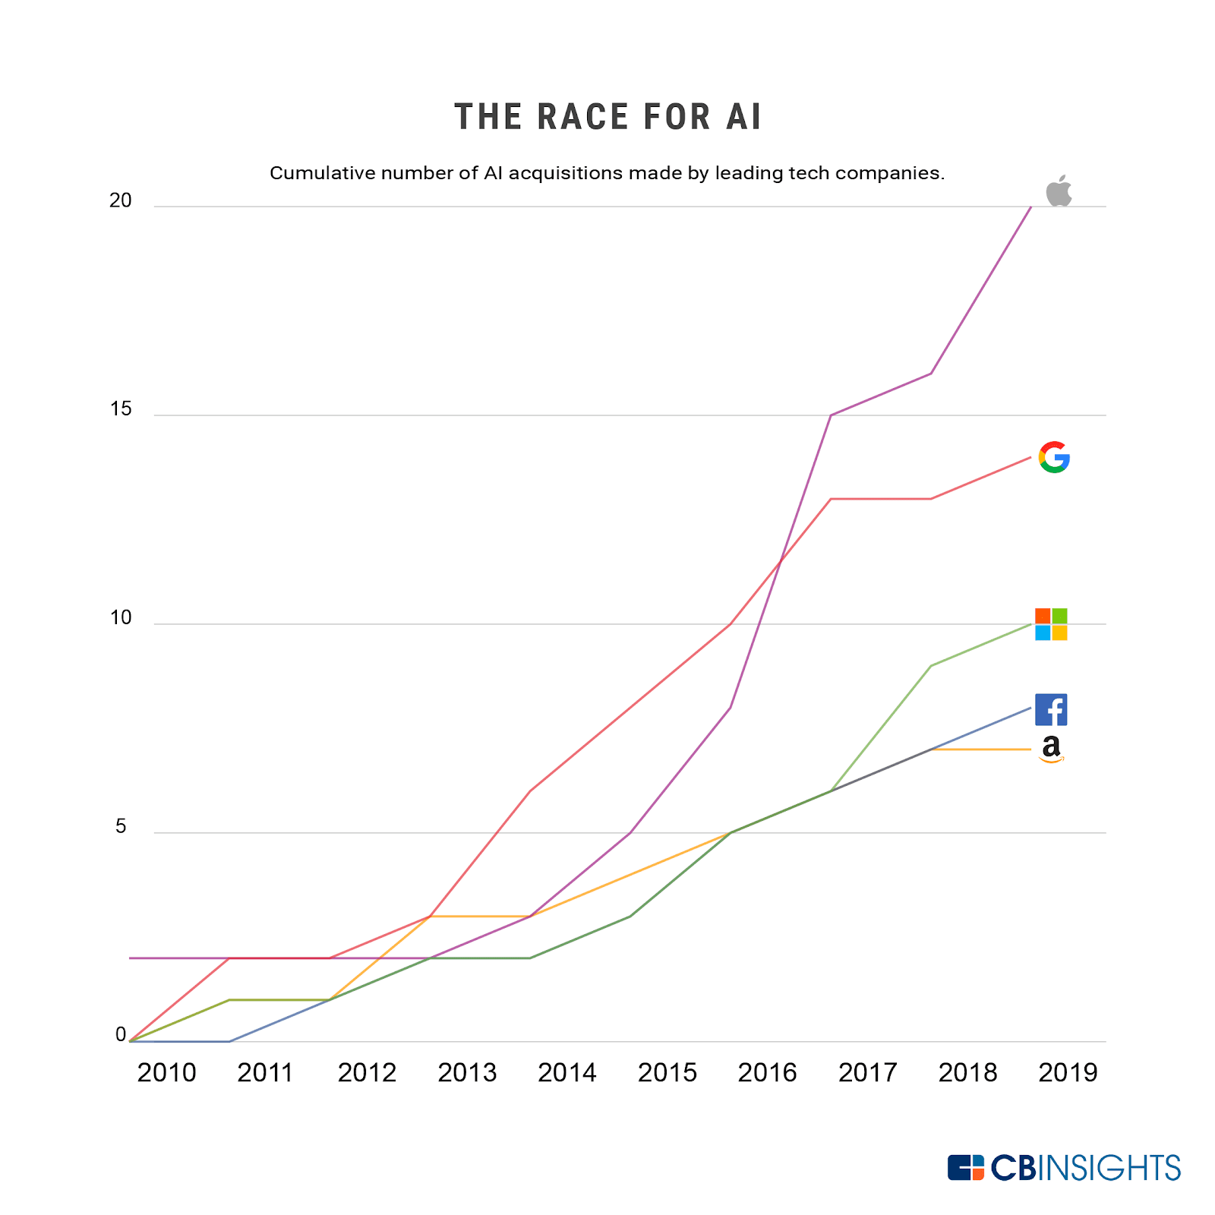

The following bar graph shows the revenues(in billion US dollars) from the artificial intelligence software market worldwide starting from from 2018 and also predicting the trend up to 2025:

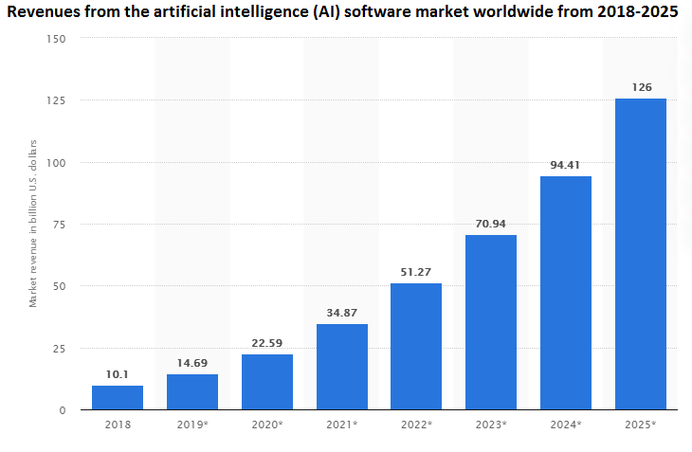

The graph below shows that the enrollment in ML course in top universities in the world over the years :

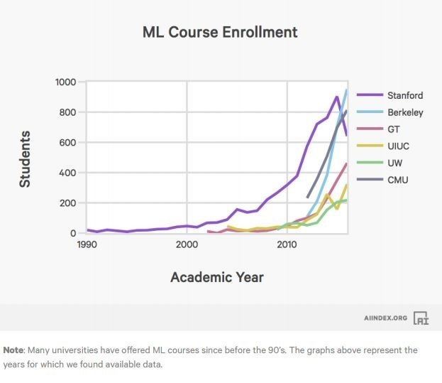

How AI contributes to web development:

Helps chatbots in better reply predictions:
As we know, chatbots are being used to predict correct reactions and responses to the queries of users. Increased use of AI in chatbots increases business sales with better reply predictions.

Optimization of UIs by deep learning:
AI excels through deep learning algorithms. With minimum supervision, these deep learning algorithms help in the decisions related to website designs and development activities associated. The algorithm first observes the existing pages of the website, then it applies various design combinations and makes them attractive as well as functional.

Empowering voice based conversations:
Voice based conversations help users to escape from the hustle of typing anything they want to search on the web. Voice search statistics of google in 2021 states that more than 25% of the users are using voice-based search. Natural language processing is an area of AI which is used to interact between humans and machines by converting speech to text.

Faster coding:
Coding is made easier and faster with AI assisting in web development. Automated coding cuts the turnaround time and enables developers to build more intuitive apps in a short timeframe.

Quality assurance:
In a web development business, quality assurance and maintenance can get quite tedious and monotonous. This employes the use of AI algorithms to improve the speed and performance of the websites as well as help to correct data and inferences.

Personalised user experience:
Businesses are now offering unique and personalized experiences to the users with the help of AI powered websites. A personalized experience means organizing the website according to the interest of the users. AI does this by machine learning over a period.

Conducting customer behaviour analysis:
By monitoring their daily activity on the platform, customization experience is provided to the users. Additionally, image recognition allows businesses to filter out all the inappropriate content that is uploaded as fake reviews by so called customers who are haters or frauds.

Artificial intelligence tools:
AI tools have revolutionized web development. Many design and development processes of websites have been automated in web development by AI and machine learning. Here is a list of some popular AI tools which are used in development along with the role they play in web development:

- TensorFlow:
TensorFlow is an open source, end-to-end platform for creating applications which use machine learning. Dataflow and differentiable programming are used by the symbolic math library to perform various tasks focused on training and inference of deep neural networks.

- Firedrop:
It is a web development tool which uses machine learning to assign all the operations to an AI-powered chatbot called Sacha. Sacha is an AI assistant which requires answers from the users about previously defined question after which they are led to the entire web development process.

- Adobe sensei:
Adobe sensei is an AI tool that automates design to create better designs in lesser time period. This tool identifies the pattern in an image and manipulates them thus cutting down hours of manual editing. Patching processes are being introduced to web designers to accelerate workflow by a huge percentage.

- Wix website builder:
This is a custom web development tool which is used to build an entire website based on the info that it is guven by the developer. It also offers design suggestions from which the developer can choose from and it’s operations are changed based on the design and options the developer chooses.

- Screpy:
Screpy helps to build a well optimized website. This tool can be used to thoroughly audit and analyze your website
And make the necessary changes. It offers a syntax checker which is useful in checking codes for the website being developed. It also offers page speed monitoring feature which enables the developers to track the status of webpage essentials.

- 10Web:
It is an AI website builder tool by WordPress which enables the developer to build the website comparatively faster than usual with the help of AI. This tool offers services like professional website creation, image generation, content generation and quick customization.

Effect Of AI on Backend & Frontend Developers:

AI is being used increasingly by both front end and back-end developers to make websites. Front end developers use AI to create the most intuitive and engaging user experiences while back-end developers use it to ensure smooth operations and data management.

AI in front end development:

Front end development focuses on the user’s interaction with the website. Creating a seamless user experience is the goal of front-end developers. They focus on building a website which is visually appealing but also intuitive and user friendly. Now, let’s investigate how front-end developers use AI in their development:

- AI chatbots are increasingly being used by front-end developers to interact with users in real time, providing information, answering questions and even helping with transactions. Natural language processing and machine learning is used to understand user queries and improve their responses over time.

- Voice activated devices for example Amazon is using AI to provide personalized product recommendations. AI is used to design the interfaces of these websites which understand and respond to voice commands which ltimately makes the website more accessible and easier to use.

- Personalized content delivery is being driven by AI lately. User’s behavior such as their browsing history, time spent on different pages and their interaction with the website can be analyzed by machine learning algorithms.

AI in Back end development:

Back-end development of a website involves server management, database interactions and application logic.

- Automated coding refers to the coding done by code generators and auto-completion tools. A lot of machine learning algorithms can learn from previous codes, hence suggesting methods and practices which improve the overall quality and efficiency of the code.

- Security enhancements to the website can be made by AI. Anomalies in network traffic can be detected by AI algorithms and machine learning can be used to improve these security systems making them more effective.

Future of AI in web development:

With the advancement of technology, new techniques and tools are introduced in web development. The relentless pace of change has revolutionized the way programmers are approaching web development process. Creativity, adaptability and human intuition to problem solving skills are some of the actionable recommendations offered by AI. Traditionally, web development required extensive coding and testing but recently the incorporation of AI into web development has shifted this landscape. AI influenced everything from web design to accessibility, user experience and even search engine optimization. There are a few important questions which automatically arise when we think about the future of AI in web development such as: Will AI take over web development and replace web developers?

- The prediction of AI influence on web development is as follows:

As the time is passing, Ai is becoming more sophisticated so the incorporation of AI driven functionalities into the web design is inevitable. Simplifying the design process, accurately predicting the user behavior and personalizing the user experience can be expected in future as AI is being incorporated in web development as AI algorithms tend to understand the behaviors of the users.

AI driven website builders and development tools could streamline the entire website creation process from design to development. In future, the entire web development process can be expected to be automated with the help of the AI tools which might change the role of developers and ultimately making the web development more accessible to non-technical individuals. But one thing is for sure and that is the human touch in creativity and decision-making will always remain irreplaceable.

Conclusion:

In this study, the use and role of artificial intelligence has been explored from a learning viewpoint. The study also explores the contribution and increasing role of AI in web development discussing various AI tools like TensorFlow, firedrop, screpy etc. which are being incorporated in web development and how these tools contribute to the web development process. The pace at which the use of AI is increasing in web development process and the effects of incorporation of AI in web development on developers has also been discussed along with the future of AI in web development highlighting the impact it will have on the complete web development process.

References

[1] How and why to incorporate AI into web development. [Online]. Available: https://www.freecodecamp.org/news/how-ai-boosts-website-development/

[2] How Artificial Intelligence is impacting the web development. [Online]. Available:
https://www.geeksforgeeks.org/how-artificial-intelligence-is-impacting-the-web-development/

[3] 15 Graphs you need to see to understand AI in 2021. [Online]. Available:
https://spectrum.ieee.org/the-state-of-ai-in-15-graphs

[4] Why AI won’t replace web developers anytime soon. [Online]. Available: https://careerfoundry.com/en/blog/web-development/ai-and-web-development/

[5] How web developers are already using AI (front & Backend Developer Data). [Online]. Available:
https://blog.hubspot.com/website/are-web-developers-using-ai

[6] Du Preez, S. J., Lall, M., & Sinha, S. (2009, May). An intelligent web-based voice chat bot. In IEEE EUROCON 2009 (pp. 386-391). IEEE.

[7] Rodgers, P. A., Huxor, A. P., & Caldwell, N. H. (1999). Design support using distributed Web-based AI tools. Research in Engineering Design, 11, 31-44.

