“COMPARATIVE ANALYSIS OF AN ARCH SHAPE STONE-CONCRETE & GENERAL RCC BRIDGE CONSIDERING IRC LOADING USING ANALYSIS TOOL STAAD.PRO”
Akash Ghode¹, Hitesh Kodwani²
¹ Research Scholar, Civil Engineering Dept., Sam Global University, Raisen-464551, Madhya Pradesh, India (corresponding author).

² Assistant Professor, Civil Engineering Dept., Sam Global University, Raisen-464551, Madhya Pradesh, India

Abstract
Bridge is a defined structure which is used to cover obstacles disconnecting the roadways and such a bridge can be in the form of flyover or crossways which are used in railways, roadways, elevated metro, underground metro, cover hilly areas and even a pedestrian cross. The obstacle to be crossed may be a river, a road, railway or a valley. In other words, a bridge is a structure for carrying the road traffic or other moving loads over a depression or obstruction such as a channel, road or railway. A bridge is an arrangement made to cross an obstacle in the form of a low ground or a stream or a river without closing the way beneath.
This study provides comparative analysis of a Arch shape stone-concrete (RCC) & General RCC bridge considering IRC loading using analysis tool staad.pro. To determine shear performance of the bridge under vehicular loading. The results are summarized in the comparative analysis in order to identify which bridge is capable to resist laden and unladen loads quite effectively.
Keywords: Analysis, bridge, staad.pro, IRC, structure, forces, displacement, stone masonry.

I. Introduction
Bridges have been used for connecting two points which is dugged in obstacles such as rivers or canals or it's a traffic flow in the form of a flyover. Such bridges are used by small vehicles, commercial vehicles, railways and other forms of motorways which are using such routes for their regular travel. Such reasons need to be addressed due to its high utility giving this to be an appropriate reason to be modelled and analyzed safely. So this scattering of load is specifically influenced to best bridge (Deck section) and after that longitudinal support and in addition cross brace. After that the long individual from bridge superstructure like brace is transported the heap towards the substructure of Bridge and afterward establishment to soil. The plan of superstructure is by and large utilized with RCC, however nowadays in length range individual from Bridge utilizing with PSC, forget significantly more preferred standpoint and security of Structure.

To investigate the shear performance of the interface between concrete and stone, the interfacial shear test of concrete - stone was carried out by using the modelling in staad.pro. The effects of different loading conditions, material strength and different forms of embedded steel bars on interfacial shear properties are considered.
II. Arch bridges

The fundamental guideline of a curve bridge is its bent plan, which doesn't push load forces straight down, however, all things considered, they are passed on along the bend of the curve to the backings on each end. These backings (called projections) convey the heap of the whole bridge and are liable for holding the curve in the exact unmoving position. Passing on of powers across the curve is done through a focal cornerstone on the highest point of the curve. Its weight pushes the encompassing rocks down and outward, making the whole design extremely unbending and solid.
Due to this plan, stone and wood curve spans turned out to be extremely famous during the Roman Empire, whose modellers figured out how to work more than 1000 stone curve spans in Europe, Asia and North Africa. A large number of those extensions stay standing even today, allowing us the opportunity to actually see the miracles of the old design. Roman plans were typically made with crescent curves, albeit a few fragmented curve spans were made during their rule. These segmental curve spans had one essential plan advantage that isolated them from common crescent extensions – they empowered bridge manufacturers to move the curve of the extension a lot higher and bring down the mass of the whole construction. These progressions empowered extensions to a lot simpler endure the burdens of floods and solid streams. During the existence of the Roman Empire, they assembled much wondrous bridge, extended water passages with different curves, spans with flood openings on the docks, and numerous others.
Fig 1: Arch Bridges

III. Objectives
1) To determine the stability of the structure with considering vehicular load IRC: 6-2014.
2) To determine the variation in structural stability of a structure with stone and reinforced concrete in a arch type bridge geometry.
3) To Compare Stone lining RC structure with General RCC structure using an analysis tool.
4) Comparative study carried out between the vehicular and the seismic load analysis results
IV. Literature review
L. Di Sarno et.al (2012) the research project aims at studying the seismic behaviour of existing R.C. bridges together with the analysis of the effectiveness of isolation systems. The research program focuses on the assessment of an old R.C. viaduct with frame piers through PsD test. The experimental program will be performed at the European Laboratory for the Assessment of Structures of Joint Research Center at Ispra (Italy). In particular, two of the twelve piers will be built in scale 1:2.5 whereas the remaining part of the viaduct will be numerically simulated.
A refined numerical model has been used for preliminary simulation of the seismic response of the entire viaduct; the model has been calibrated using literature results and experimental data coming from a test campaign carried out at the University Roma Tre on R.C. frame piers. This allowed to select a couple of piers to be physically tested during the experimentation. All the key aspects of the problem have been here addressed: the most suitable test rig configuration, the integration scheme to be adopted during the PsD test, the selection of input, the numerical model for both isolated and non-isolated case.
Lina Ding et.al (2012) in the examination paper, the nonlinear limited component investigation, consolidating the model refreshing strategy was utilized to anticipate the conduct of a 30-year-old piece support connect. The first limited component model dependent on the plan drawings is refreshed by changing the solidness boundaries of the supports, piece, shear connectors and heading with the goal that the vibration properties of the model match the field vibration estimation information. The refreshed model addresses the current state of the extension better than the first model that depends on the plan outlines. The heap conveying limit of the scaffold was determined utilizing the first and refreshed limited component models, individually, with thought of nonlinear material properties. The impact of the shear connectors on the heap conveying limit is extraordinarily examined.
The examination completed on the first model shows that the heap conveying limit of the extension is 1.67 occasions a definitive burden determined in the plan code and 20% higher than the limit determined by the exact equation. This demonstrates that the observational equation disparages the heap conveying limit of extensions. The limited component model is then refreshed dependent on the field vibration tests. The nonlinear examination on the refreshed model shows that the scaffold extreme burden conveying limit is about 1.49 occasions the ostensible burden, suggesting the extension is as yet protected under the current traffic condition, while 12% not exactly that assessed from the plan model. This activity exhibits that the refreshed model can address the real state of the extension better and the heap conveying limit dependent on the refreshed model can give a more reasonable state of the scaffold.
S.Basilahamedand A.R.R.Kalaiyarrasi (2018) the research paper analyzed a single span two lane t-beam bridge by varying the span of 25m, 30m, 35m and 40m where the width was kept constant. The bridge models are subjected to the IRC class AA and IRC class 70Rtracked loading system in order to obtain maximum bending moment and shear force. The problem in continuum mechanics was approximated by FEM (finite element method) in STAAD Pro, which is general method of structural analysis.
From the analysis it is observed that with the increase in the span, Courbon’s method and finite element method have no significant variation. Courbon’s method gives the average result with respect BM values in the longitudinal girder as compared to Guyon Massonet method. The results were analyzed and it was found that the results obtained from the finite element model are lesser than the results obtained from one dimensional analysis, which means that the results obtained from I.R.C. loadings are conservative and FEM gives economical design.
Xiaoke Li et.al (2012) the research paper introduced main dimensions and drawings and further discussed the static analytical results of the bridge. The numerical model was built by the integrated solution system for bridge and civil engineering- MIDAS/Civil. The piles, pile caps, piers, bent caps, deck slabs and connections between two contiguous reinforced concrete hollow slabs were all simulated. The forces and displacements of arch under the given loads and load combinations can be calculated close to the actual values.
The distributions of bending moment, axial force, shear force and vertical displacement along the arch axis prove that sedimentation displacement of arch toe and arch temperature are the key factors and need to be considered seriously during design process.
Ravikant and Jagdish Chand (2019)in the examination of bridge support plan, three same models were ready in the STAAD star and afterwards their loadings are changed by IRC codes, Euro codes and AASHTO details separately. The range of the extension is taken as 25m in which braces are built. The size of longitudinal braces is taken as2000x500 mm and cross supports are 1500x250 mm. There are three longitudinal braces that are considered to have dividing 2600 mm c/c and cross supports are considered as 5000mm c/c. The plan of braces is done utilizing the product STAAD Pro. The relative boundaries of the examination were the shear force, bending moment and space of steel in the plan of extension supports for example longitudinal supports and cross braces because of the utilization of various loading as indicated by IRC codes, Euro codes and AASHTO determination.
The end got from the outcomes expressed that In an examination of every one of the three codes, Euro code plans are over supported as contrast with the other two for example IRC codes and AASHTO particulars. In the plan of extension braces with Euro codes shear forces, bending moment and diversion are practically twofold as contrast with the other two for example IRC codes and AASHTO details. Plan of scaffold supports (up to 25m) utilizing IRC codes is generally practical and more secure when contrasted with the other two for example AASHTO details and Euro codes. IRC codes have the best blend of loading and plan strategies as contrast with the other two for example AASHTO particulars and Euro codes. Since the plan of extension brace utilizing IRC codes get the base worth of redirection and twisting second so subsequently IRC Class A loading is the most conservative and ideal loading for the plan of bridge support in INDIA.
Alessandro Rasulo et.al (2020) the researchpaper presented a finite element model for assessing the nonlinear behavior of RC bridge piers under combined axial, shear, and bending moment. The model explicitly takes into account the response caused by the shear capacity deterioration due to the interaction with flexural deformation.
This important effect has been introduced through the incorporation of a zero-length shear spring in series with a flexural column element and a rotational slip spring. A phenomenological curve for the shear response has been proposed and calibrated, realistically capturing the monotonic and cyclic response of columns, including the pinching, the stiffness softening, and the strength deterioration due to deformations and cyclic load reversals. A good agreement between the numerical prediction and experimental data was observed.
S.Basilahamedand A.R.R.Kalaiyarrasi (2018) the research paper analyzed a single span two lane t-beam bridge by varying the span of 25m, 30m, 35m and 40m where the width is kept constant. The bridge models are subjected to the IRC class AA and IRC class 70Rtracked loading system in order to obtain maximum bending moment and shear force. The analysis was carried out using IRC codal provisions. T-beam bridge decks are one of the major types of cast in situ concrete decks which consist of a concrete slab integral with girders. The problem in continuum mechanics is approximated by FEM (finite element method) in STAAD Pro, which is general method of structural analysis.
The results were analyzed and it was found that the results obtained from the finite element model are lesser than the results obtained from one dimensional analysis, which means that the results obtained from I.R.C. loadings are conservative and FEM gives economical design.
B. OzdenCaglayan et.al (2012) the examination paper introduced appraisal of a stupendous substantial curve connect with an all out length of 210 meters having three significant ranges of 30 meters and a stature of 65 meters, which is situated in a quake inclined area in southern piece of the turkey. Three-dimensional limited component model of the scaffold was produced utilizing a monetarily accessible general limited component examination programming and in view of the results of a progression of top to bottom speed increase estimations that were directed nearby, the model was refined. By utilizing the underlying boundaries acquired from the dynamic and the static tests, adjusted model of the extension structure was gotten and this model was utilized for important computations in regards to primary appraisal and assessment.
V. Methodology
Fig 2: Flow Chart

VI. Analysis Results
Bending Moment KN-m
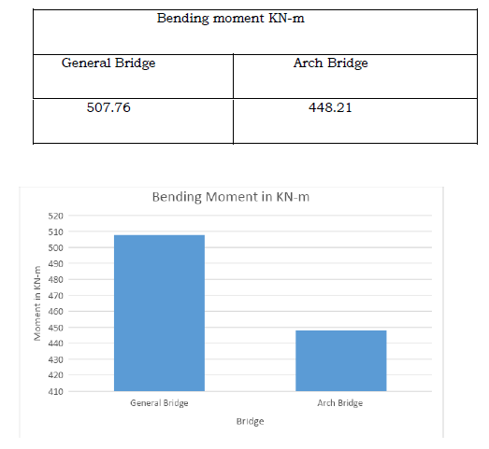
Fig 3: Comparative analysis of Bending Moment in KN-m
Shear Force KN-m
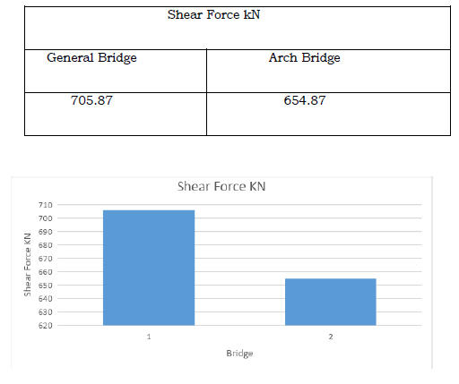
Fig 4: Comparative analysis of Shear Force in KN
Axial Force KN
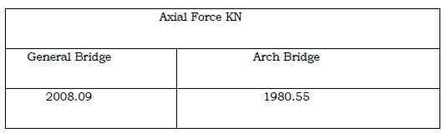
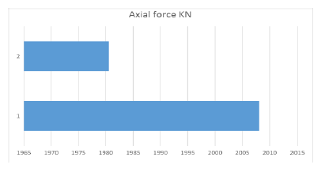
Fig 5: Comparative analysis of Axial Force in KN
Maximum Deflection in mm

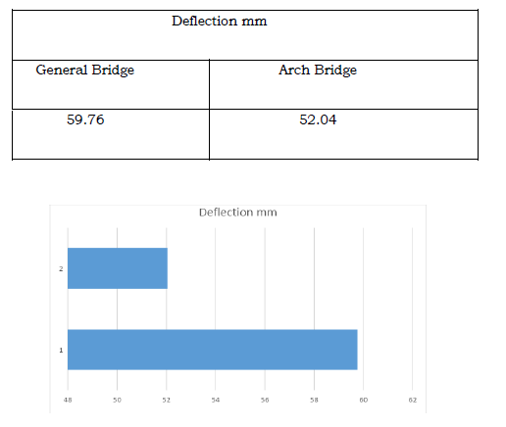
Fig 6: Comparative analysis of Deflection in mm

Cost Analysis
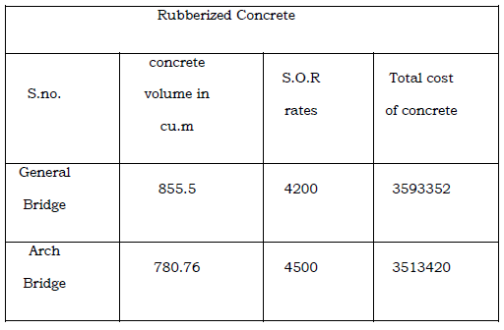

VII. Conclusion
Following are the ends according to the examination
  - Shear force in known as the unbalance force observed due to transmission of load from beam to column, in our study it is observed that with Arch Bridge it can be minimized in all the cases considered for study.
  - Axial force is known as the vertical force observe in piers, this force is meant to distribute load from pier to earth. It is observed in the results that with Arch Bridge Distribution of vertical forces can be processed easily.
  - In terms of bending moment it is observed that minimum bending is Arch Bridge, which is resulting in comparatively most economical in comparison as bending moment is directly proportional to reinforcement requirement.
  - In case of deflection we observed that maximum deflection is obtained in General concrete in all cases when comparing with Arch Bridge.
  - In this study, it can be concluded that Arch Bridge results in economical section also rate analysis of both can show the Variation in cost of both.

References:

- Alessandro Rasulo, Angelo Pelle, Davide Lavorato, Gabriele Fiorentino, Camillo Nuti and Bruno Briseghella, [Finite Element Analysis of Reinforced Concrete Bridge Piers Including a Flexure-Shear Interaction Model], Appl. Sci. 2020, 10, 2209; doi:10.3390/app10072209.
- B. OzdenCaglayan, Kadir Ozakgul and OvuncTezer, [Assessment of a concrete arch bridge using static and dynamic load tests], Structural Engineering and Mechanics, Vol. 41, No. 1 (2012) 83-94.
- L. Di Sarno, G. Della Corte, R. De Risi, M. Erdik , C. Yenidogan, A. Marioni, M. Sartori, F. Taucer, P. Pegon and R. Ceravolo, [Seismic analysis and retrofitting of an existing R.C.highway bridge: investigation through pseudo-dynamic], 15 WCEE Lisboa 2012.
- Lina Ding, Hong Hao, Yong Xia and Andrew J. Deeks, [Evaluation of Bridge Load Carrying Capacity Using Updated Finite Element Model and Nonlinear Analysis], Advances in Structural Engineering,Volume 15 No. 10 2012.
- Ravikant and Jagdish Chand, [Design and Analysis of Bridge Girders using Different Codes], International Journal of Engineering Research & Technology (IJERT), ISSN: 2278-0181, Vol. 8 Issue 07, July-2019.
- S.Basilahamed and A.R.R.Kalaiyarrasi, [COMPARATIVE ANALYSIS AND DESIGN OF T-BEAM BRIDGE DECK BY RATIONAL METHOD AND FINITE ELEMENT METHOD, Proceedings of National Conference on Sustainable Construction Materials, March 27-28, 2018.

