IOT BASED ATTENDANCE SYSTEM USING FINGERPRINT SENSOR
Biradar Dhanshree¹ | Hajare Arti² | Siddiqui Anam³ | Ghogare Nikita⁴ | Yerate Anjali I.⁵
¹Electronics and Telecommunication Engineering & Vishweshwarayya Abhiyantriki Padvika Mahavidyalaya ²Electronics and Telecommunication Engineering & Vishweshwarayya Abhiyantriki Padvika Mahavidyalaya ³Electronics and Telecommunication Engineering & Vishweshwarayya Abhiyantriki Padvika Mahavidyalaya ⁴Electronics and Telecommunication Engineering & Vishweshwarayya Abhiyantriki Padvika Mahavidyalaya ⁵Electronics and Telecommunication Engineering & Vishweshwarayya Abhiyantriki Padvika Mahavidyalaya

ABSTRACT
To provide reliable, time-saving and automatic class attendance system, the concept of Internet of Things (IoT) based class attendance monitoring system using embedded Linux platform is presented in this project . The study is focused on the design and implementation of fingerprint detection and recognition system using Arduino Uno. The system takes fingerprint of students, and analyzes, detects and recognizes fingerprint using sensor .After collecting processing data, the system generates a final attendance record and uploads it in a cloud server. The cloud server has been implemented using python based web framework. The record can be accessed remotely from a user-friendly, web application using the Internet. Finally, the system is also capable of sending an email notification with the final record to the teachers and students in a specific time. Tests and performance analysis were done to verify the efficiency of this system

INTRODUCTION
When it comes to tracking employees and their attendance, biometric time and attendance systems have gained popularity in the business world. The biometric attendance system has been used for many years by companies that are looking for ways to improve efficiency and reduce costs. The biometric attendance system can be used as an alternative to paper-based or manual attendance records, which are often inaccurate and difficult to track. The purpose of this guide is to give an explanation of biometric systems and how they have so many advantages that will prove valuable to all companies in the future. You will be able to gain a deeper understanding of how the systems work by the end of this, and who knows… maybe they will be implemented in your workplace soon.A biometric attendance system might sound a bit intimidating, but it is simply a system that requires an employee’s physical features for them to clock in and out. While this can be done using a variety of features, including the face, hand geometry, retina, vein recognition, and voice recognition, the most common feature used is a fingerprint. For the sake

of simplicity, this guide will refer to fingerprint biometric systems, though it works similarly with other physical features. The amount of time a person spends working for a particular business is equivalent to how much that person gets paid. It, therefore, has become extremely important to track the time every employee spends working on the tasks given to them.
Because biometrics collect data from employees' retinas, fingerprints, faces, and other unique identification details, some businesses are hesitant to utilize biometrics for fear that the information will be misused or hacked, or in the worst-case scenario, the company will sell the information, as some of the social chat apps do. However, solutions like Time Dynamo are so safe that no hacker can get into them, which has inspired many businesses, large and small, to use it, and it proves that the data isn't sold. So, you can use the Biometric Attendance System without hesitation. In this project, we are going to design a Fingerprint Sensor Based Biometric Attendance System using ESP Wi-fi Module. Simply we will be interfacing fingerprint sensor with ESP Wi-fi Module & OLED Display to design the desired project. In this project, we used the fingerprint sensor and ESP Wi-fi Module to take and keep attendance data and records.
The biometric attendance system is a great upgrade over the existing online time and attendance tracking systems in the market today. The previous systems weren’t fool proof as there were a lot of cases where the employees could log in for one another or in other words show a proxy attendance of a person who hasn’t entered the office.

METHODOLOGY
An OLED Display & Fingerprint Sensor is interfaced with Node MCU ESP8266 12E Board. The I2C pins of OLED Display, example SDA & SCL are connected to Node MCU D2 & D1 pins respectively. Similarly, the fingerprint sensor is connected to UART pins D5 & D6. The fingerprint sensor Tx and Rx wire’s color may vary. In my case, the color is yellow and blue where yellow is Tx and Blue is Rx. So connect it by finding appropriate color wires else the module won’t be detected by Node MCU. The R305 fingerprint sensor is supplied with 5V through Vin pins of Node MCU.
The ESP8266 Wi-Fi Module will collect the fingerprint data from multiple users and sends it over the internet to a website. The Enrolment of fingerprints is done on the Server using R305 or R307 or any other compatible Fingerprint Sensor and verification is done on the client with the transmission of fingerprint templates over the network, The website that is coded in PHP has a database and records of attendance. By logging into the website, you can collect all the attendance records of each user including personal details as well as incoming & outgoing timing. The data can also be downloaded and exported to an excel sheet.

BLOCK DIAGRAM

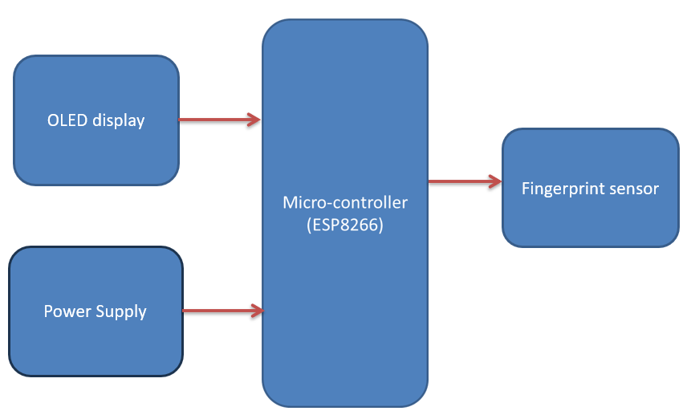

COMPONENTS USED
ESP Wi-fi Module

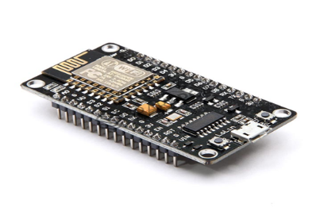
An ESP8266 Wi-Fi module is a SOC microchip mainly used for the development of end-point IoT (Internet of things) applications. It is referred to as a standalone wireless transceiver, available at a very low price. It is used to enable the internet connection to various applications of embedded systems. It can work as either a slave or a standalone application. If the ESP8266 Wi-Fi runs as a slave to a microcontroller host, then it can be used as a Wi-Fi adaptor to any type of microcontroller using UART or SPI. If the module is used as a standalone application, then it provides the functions of the microcontroller and Wi-Fi network.
OLED Display
OLED (Organic Light-Emitting Diode) is a self light-emitting technology composed of a thin, multi-layered organic film placed between an anode and cathode. In contrast to LCD technology, OLED does not require a backlight. OLED possesses high application potential for virtually all types of displays and is regarded as the ultimate technology for the next generation of flat-panel display
This 0.96 Inch I2C/IIC 4pin OLED Display Module BLUE can be interfaced with any microcontroller using SPI/IIC/I2C protocols. It is having a resolution of 128×64. The package includes display board, display, 4 pin male header pre-soldered to board.

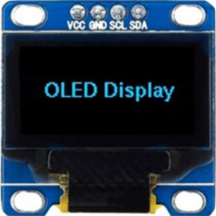

OLED monochrome 128×64 dot matrix display module. The characteristics of this display module are high brightness, self-emission, high contrast ratio, slim/thin outline, wide viewing angle, wide temperature range and low power consumption. OLED’s are the future of displays, as they possess some of the greatest advantages over both conventional display technologies of LCD’s and LED‘s.
Fingerprint Sensor
Since the R307 Fingerprint Sensor is quite popular, you will get numerous tutorials, guides, sample codes and libraries are available on the internet, which will help you use this sensor and get started with it. This sensor is great for building electric safes, home automation projects, attendance related projects, etc
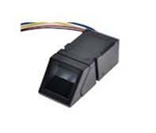
These modules are typically used in safes - there's a high powered DSP chip that does the image rendering, calculation, feature-finding and searching. Connect to any microcontroller or system with TTL serial, and send packets of data to take photos, detect prints, hash and search. You can also enroll new fingers directly - up to 162 finger prints can be stored in the onboard FLASH memory. There's a red LED in the lens that lights up during a photo so you know its working.
Connecting Wires
A connecting wire allows travels the electric current from one point to another point without resistivity. Resistance of connecting wire should always be near zero. Copper wires have low resistance and are therefore suitable for low resistance. Twisting the wires together and soldering is often the best method, but there are two ways of doing this. If possible, you should twist the wires in-line before soldering as this makes a stronger (and neater) join than twisting the ends together
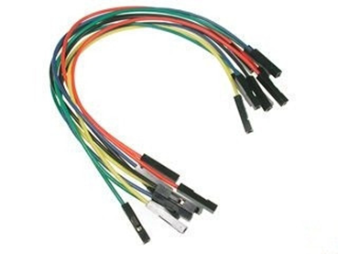

CIRCUIT DIAGRAM
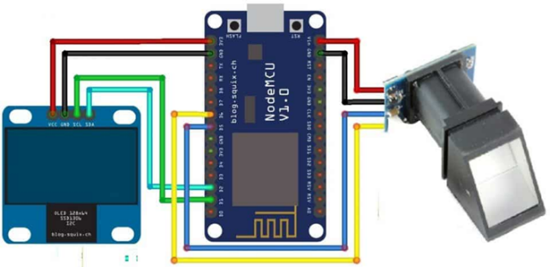
RESULT

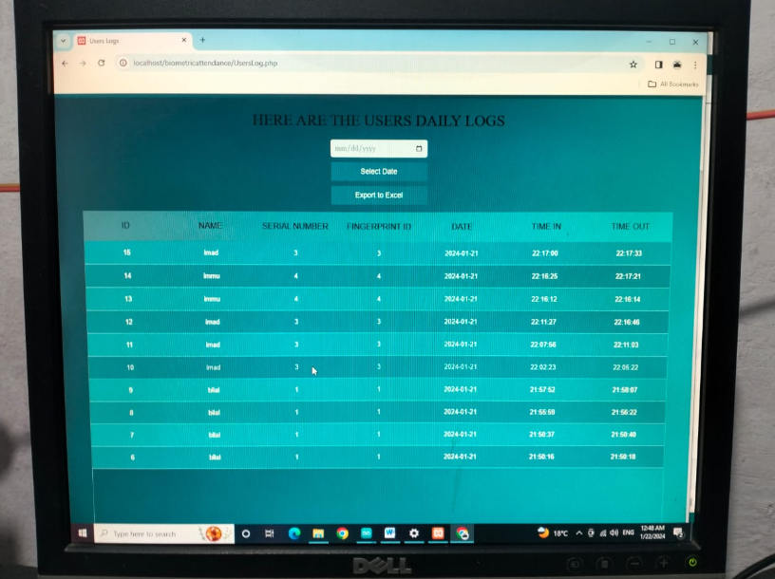
When the code is uploaded in the ESP module ,it will try the connection with it. Once it is connected ,it will display connected on the OLED display. Hence, now we can register the users or students using the website. The user fingerprint is taken twice and stored in the EEPROM of the Fingerprint Sensor. It is to be noted that only 127 fingerprints can be stored in this R307 module.
When the fingerprints of each user is stored, we can now start scanning and registering the users. If the fingerprint is not matched then the display will show an error
Hence , we can now see the attendance registered as shown in below image on the website

CONCLUSION
This comprehensive study of the literature intended to discover emerging research directions in IoT-based attendance systems. To provide a complete discussion of the problems and potential solutions in this field, the literature was carefully examined. The search was conducted using a wide range of well-known terms associated with smart attendance systems, and the outcomes were carefully reviewed. s. Most of the selected research was evidence-based, highlighting the numerous benefits that a Smart attendance system can offer for both teachers and students. The SLR found some shortcomings, especially in terms of study methods, the precision of data collecting, and probable misclassification.It's designed to automate and streamline the process of keeping track of students' attendance. It helps to substitute digital platforms for paper attendance records. It also makes it simpler for teachers to track attendance. These systems provide detailed reporting and analytics for data-driven decision-making.It can even send out reminders when someone is late or missing. The system enables real-time monitoring of students' performance. They promote the use of accurate, thorough, and proactive student attendance monitoring.

REFERENCE
1) Patel, R., Patel, N., Gajjar, M.: Online students attendance monitoring system in classroomusing radio frequency identiﬁcation technology: a proposed system framework. Int.J. Emerg. Technol. Adv. Eng. )
2) 2(2), 61–66 (2012)2. Gowri, Ch.S.R., Kiran, V., Rama Krishna, G.: Automated intelligence system for attendancemonitoring with open CV based on internet of things (IoT). Int. J. Sci. Eng. Technol. Res.(IJSETR) 5(4), 905–913 (2016)
3) Shoewu, O., Olaniyi, O.M., Lawson, A.: Embedded computer-Based lecture attendancemanagement system. Afr. J. Comput. ICT 4(3), 27–36 (2011)
4) Mani Kumar, B., Praveen Kumar, M., Rangareddy: RFID based Attendance monitoringsystem using IOT with TI CC3200 Launchpad. Int. J. Mag. Eng. Technol. Manag. Res. 2(7),1465–1467 (2015)
5) Uddin, M.S., Allayear, S.M., Das, N.C., Talukder, F.A.: A location based time andattendance system. Int. J. Comput. Theor. Eng 6(1), 12 (2014)

