A Review on Enhancing the Coefficient of Performance of Vapor Compression Refrigeration Systems through Electromagnetic Assistance and Utilization of Eco-Friendly Refrigerants

Aman I. Nagpure, Chirag S. Katre, Saurabh R. Roge, Pankaj N. Choudhary,
Dr. Ashish S. Raut.

Abstract

This study explores the prospects of improving the COP of VCR systems by employing electromagnetic field assistance in conjunction with a range of refrigerants. Further it investigate the potential enhancements in energy efficiency and cooling capacity that can be achieved through the integration of electromagnetic field assisted VCR systems with various new refrigerants. A comprehensive analysis of the influence of electromagnetic fields on refrigerant behaviour and performance, as well as the impact of different refrigerants on system COP, is studied in this paper. The results of this study have implications on how VCR systems might be designed and optimized for greater sustainability and energy efficiency.

Keywords

Coefficient of Performance (COP), Vapor Compression Refrigeration (VCR), electromagnetic assistance, refrigerant selection, energy efficiency.

- Introduction
For cooling and refrigeration applications the VCR system is a broadly used technology. However, there is an ongoing effort to improve the energy efficiency of VCR systems due to their significant energy consumption. This research aims to address this challenge by exploring the potential benefits of integrating electromagnetic assistance and varying refrigerants within VCR systems. Vapor-compression refrigeration, the most used method for cooling down cars and buildings, is one of the various refrigeration cycles that involves phase transitions in the refrigerant. It is also used in a wide range of other commercial and industrial services, including freezers for homes and businesses, large warehouses for the storage of chilled or frozen food and meat, refrigerated trucks, and train coaches. Large-scale vapor-compression refrigeration systems are widely utilized in petrochemical, chemical, and natural gas processing plants, among other industrial sectors.
- Effect of Nano Particles On Various Refrigerant
In a vapor compression refrigeration system the use of Al2O3 nanoparticle-based nanofluid. Nanofluid was synthesized with Al2O3 nanoparticles at varying mass fractions, using compressor lubricant oil as the base fluid. Two different refrigerants (R134a and R600a) were investigated, with performance parameters including COP and how much power it consume, what is the compressor discharge pressure and evaporator pressure, and also the required pull-down time. (Yogesh Joshi et al., 2021). Utilizing aluminium oxide (Al2O3) nanoparticle suspensions in vapor compression systems with different refrigerant mass charges to reduce indirect emissions in refrigeration systems. They tested high GWP (Global Warming Potential) R134a and low GWP R600a refrigerants with different nanofluid mass fractions.(Joshi et al., 2022).
The utilization of amine treated graphene quantum dots (AGQD) based nanosuspensions in a vapor compression refrigeration cycle. In the first phase, AGQD nanosuspensions are synthesized and their thermophysical properties are evaluated, showing significant improvements in thermal conductivity, minimal changes in density and viscosity, and decreased specific heat. (Joshi et al., 2023). Exploration of methods for enhancing the thermodynamic performance of vapor compression refrigeration systems through the use of nanofluids. It discusses the benefits of incorporating nanofluids in refrigeration systems, emphasizing their impact on efficiency and cooling performance. Various aspects of nanofluid application are reviewed, providing valuable insights for optimizing refrigeration systems.(Mishra, 2017).

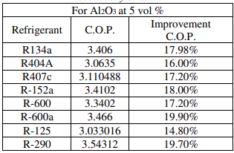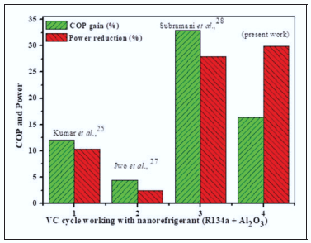
Table 1: “Enhancement in C.O.P using Figure 1. “A comparison of COP gain and power
Al2O3 at 5 vol % nanofluid in secondary reduction for VC refrigeration system working with
circuit”.(Mishra, 2017) nanorefrigerant (R134a+Al₂O₃)”.(Kundan & Singh, 2021)

The usage of an ammonia absorption refrigeration system's working fluid, composed of NH3-H2O-LiBr. While this fluid lessens the amount of energy used in the generator, it also limits the effectiveness of ammonia absorption, leading to an inadequate COP. TiO2 nanoparticles are mixed to the working fluid to alleviate this.(Jin et al., 2021). Investigation of the NH3 (ammonia) – H2O (water) – Lithium Bromine fluid in an (VARS) ammonia absorption refrigeration system, which reduces generator power wastage and improves COP. However, it lowers ammonia absorption efficiency, leading to an unsatisfactory COP.(Bhattad et al., 2018). Utilization of nanofluids in vapor compression systems for air conditioning and refrigeration, specifically in the condenser. Nanoparticles are employed to enhance heat transfer, consequently reducing power consumption by lowering the condensing pressure.(Dooley, 2012).
Performance of a ZrO2 nanoparticle-infused working fluid in a vapor compression refrigeration system. ZrO2 nanoparticles and R152a refrigerant are combined to create nano refrigerant. R152a has a substantially lower global warming potential (GWP) than R134a, with only 140 compared to R134A's 1300. The study investigates the usage of ZrO2 nanoparticles in the refrigeration system with both R134a and R152a.(Suresh Kumar et al., 2016). “The use of nanorefrigerants, specifically R134a with Al2O3 nanoparticles (20 nm in size), to improve the heat transfer properties of vapor compression refrigeration cycles. Several performance metrics are evaluated, including coefficient of performance, cooling capacity, energy consumption, and temperature differentials between the condenser and evaporator”.(Kundan & Singh, 2021).

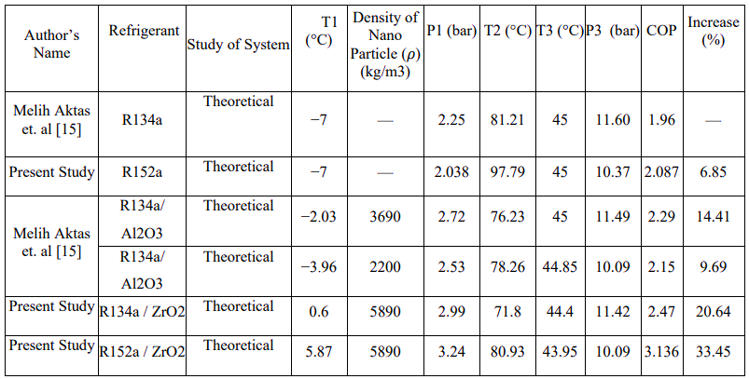
Table 2: Comparative study for the validation process of using Nano-particles

Improving thermal properties in thermal engineering using nanoparticles has extended to refrigeration systems. Nanoparticle-doping enhances heat transfer mechanisms in lubricants and refrigerants, improving system performance. However, challenges like stability, agglomeration, and sedimentation impact sustainability. While promising, questions regarding cost, toxicity, stability, erosion, viscosity, and clogging require further investigation.(Yıldız et al., 2021).
The use of TiO2(Titanium dioxide)-R600a nanorefrigerant in a standard domestic purpose refrigerator without the system modifications. The results demonstrated that these nano-refrigerants functioned safely and effectively in the refrigerator. When 0.5 g/L TiO2-R600a was used, the nanopartical+refrigerant outperformed pure isobutene and hydrocarbon, resulting in a 9.6% reduction in energy usage.(Bi et al., 2011). The use of nanofluids in refrigeration systems to enhance energy efficiency. It discusses the basics, historical developments, nanoparticle production techniques, nanofluid preparation, and limitations. The review categorizes literature into two sections: fundamental properties of nanofluids and their application in refrigeration systems.(Majgaonkar, 2016). The use of graphene nanolubricant in vapor compression systems to enhance the efficiency of the eco-friendly refrigerant R600a. Graphene nanoparticles were dispersed into the base lubricant at different quantities.. The results show that utilizing the graphene nanolubricant improves performance w.r.t pull-down time, coefficient of performance (COP), power required, and capacity to cool when compared to the base lubricant..(Babarinde et al., 2020).
The use of nanorefrigerant, a nanofluid containing Al2O3 nanoparticles diffused in PAG oil, in a domestic purpoes refrigerator with HFC134a as a refrigerant. Experimental tests on energy consumption and freezing capacity were conducted with varying mass fractions of Al2O3 nanoparticles. The results demonstrate that the refrigerator operates normally and safely with this nanorefrigerant mixture.(Anish, 2018). In a vapor compression refrigerator, the performance of LPG containing 60% C₃H₈ (R290) and 40% C₄H₁₀ (R600) with R134a. LPG outperformed R134a in terms of design temperature and pull-down time. It increased the COP by 9.5% and reduced power usage by 12%, making it a viable option for R134a in home refrigerators..(Babarinde et al., 2015).
- Magnetic Field Effect On Vapour Compression Refrigeration System
“An attempt has been made to carry out an experimental investigation on the variations in the performance of vapor compression refrigeration system (VCRS) with the application of magnetic configurations. Magnetic configurations used for the present work were pair of magnets (MC-1) and Halbach array (MC-2) with the magnetic field intensities of 3000 and 7200 Gauss, respectively. The coefficient of performance (COP) was first determined in the absence of a magnetic field and then with the application of magnetic configurations on the condenser liquid line”.(R. Deshmukh et al., 2022). The effect of neodymium-iron-boron magnets on thermal system condensation heat transfer coefficient. Using four 3000 Gauss intensity magnetizers, experiments involving tetrafluroethane condensation in an 8.38 mm diameter tube with different saturation temperatures and mean vapor quality were carried out..(R. G. Deshmukh et al., 2023).
A simulation model for analyzing and forecasting magnetic field patterns and magnetic flux density on pipes utilizing various magnet configurations such as series, parallel, and Halbach arrays. It employs Neodymium-35 magnets for stable magnetic strength.(Jadhav et al., 2022). The magnetic field's impact on a nano-lubricant (CuO and PAG oil) in a vapour compression refrigeration system. Magnetic field atomizes the fluid, reducing its specific volume and viscosity. This lowers compressor power, increases heat transfer, and enhances mechanical efficiency.(Vara Prasad & Dilip Kumar, 2018).
Magnetic refrigeration (MR) as a promising technology for room temperature cooling, driven by the magnetocaloric effect (MCE). It discusses the principles, theory, and thermodynamics of MCE, highlighting the essential properties of magnetocaloric materials for effective room temperature MR.(Romero Gómez et al., 2013). Electromagnet-based cooling system using the magneto-caloric properties of Gadolinium. Unlike traditional vapor-compression systems, this design is environmentally friendly, quiet, and has a longer lifespan due to its lack of refrigerants or moving parts.(Saad et al., 2019)

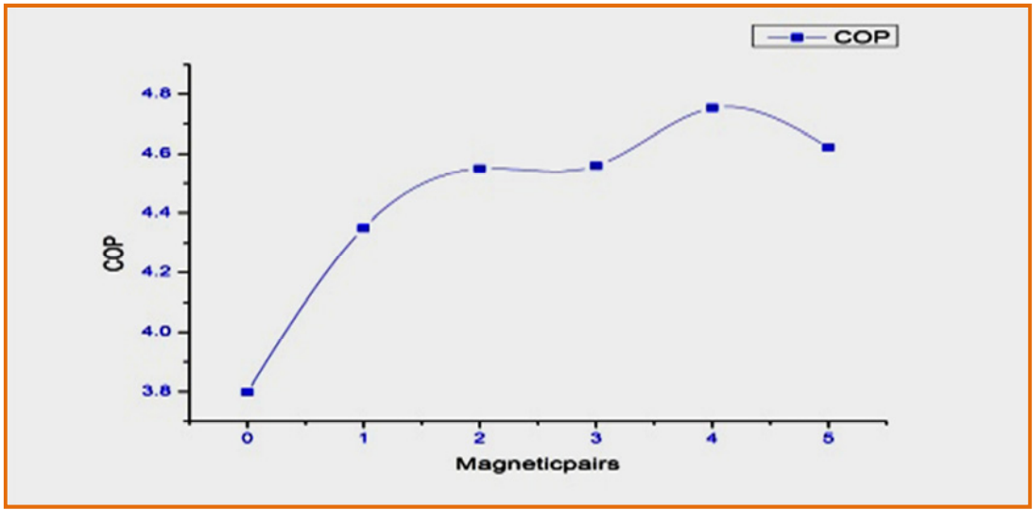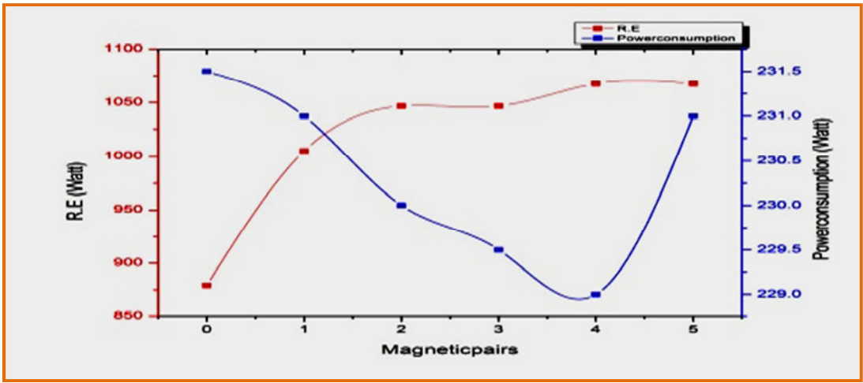
Fig.2. Influence of magnetic power on COP (R134a) Fig.3. R.E. magnetic power and power consumption. (Vara Prasad & Dilip Kumar, 2018)

“MnCoGe magnetocaloric alloy and BiSbTe thermoelectric alloy were combined to form composite materials that could be used for solid-state cooling. The magnetostructural transition temperature decreased from ambient temperature to 270 K as a result of the phase shift of MnCoGe from orthorhombic to hexagonal phase”.(Li et al., 2023). The rotor clutch sub-assembly is a critical component in automotive compressors, facilitating their operation. It is made up of the hub, rotor, stator, bearing, and armature. The stator houses the coils, while the rotor is driven by the engine pulley via a belt drive. The hub is drawn to the rotor by an electromagnetic field created when a direct current is given to the rotor terminal, allowing torque to be transferred to the compressor shaft.(Meena & Sen, 2018). Emerging solid-state technologies with the potential to surpass the limitations of vapor compression refrigeration. The comparison involves various performance parameters using a 2D model that simulates the behaviour of both Active Magnetic Regenerative (AMR) and Active Electrocaloric Regenerative (AER) parallel plates regenerators in the room temperature range.(Aprea et al., 2017).
“The phenomenon of the magnetocaloric effect along with recent progress and the future needs in both the characterization and exploration of new magnetic refrigerant materials with respect to their magnetocaloric properties are discussed. Also the recent progress in magnetic refrigerator design is reviewed”.(Pecharsky & Gschneidner, 1999). A magnetic refrigerator utilizes a rotating magnetic wheel with rings of magnetic material, superconducting magnet coils, and helium gas for efficient heat transfer, enabling cryogenic cooling without the need for an initial liquid helium charge.(Barclay et al., 1987). Applying a magnetic field to vapor compression systems lowers fluid viscosity, reducing pumping power and enhancing heat transfer, resulting in up to 21.87% higher Coefficient of Performance (COP), potentially saving energy in global refrigeration and air conditioning.(Tipole et al., 2016). The highly efficient hybrid magnetic refrigerator combines vapor compression and magnetic refrigeration cycles in a compact design. An evaporator and heat exchanger efficiently link the two cycles, allowing a magnetic substance to dissipate and absorb heat. This heated refrigerant is then cooled by the vapor compression evaporator and used in a heat exchanger to cool outside air, providing effective cooling and heating capabilities.(Classification, 2007).

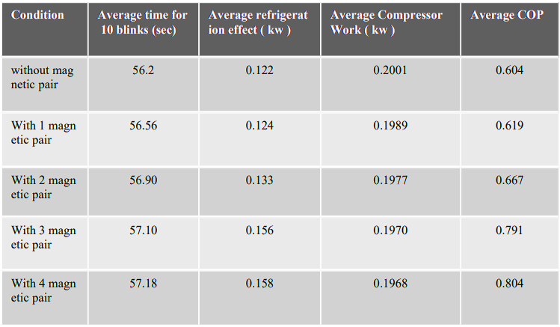
Table 3: Experimental VCRS using R134a (Katkar et al., 2021)

Designed for magnetocaloric refrigeration units, this assembly comprises a magnetocaloric core with electromagnetic coil winding capability. It's equipped with various cooling structures (micro-channels, fins, or heat pipes) to dissipate heat generated by the coils. In some configurations, magnetic yokes with micro-channel structures enhance heat management and overall system performance.(Radhakrishnan, 2012). The study investigates how subjecting R134a to magnetic fields can enhance its efficiency, heat transfer capabilities, and overall performance within refrigeration systems. The outcomes point to promising prospects for advancing refrigeration technology by harnessing the potential of magnetic manipulation for optimizing R134a as a refrigerant.(Katkar et al., 2021).
- Analysis of the performance evaluation of VCRS system by using magnetic field and nanoparticles
Multiwalled carbon nanotubes and poly (methylmethacrylate) are used to generate thin and flexible composite sheets for electromagnetic interference (EMI) shielding. These films exhibit a conductive network within an insulating PMMA matrix, and their conductivity increases with higher MWCNT content. The EMI shielding efficiency also rises with MWCNT content, showing promise for far-field EMI shielding, with absorption playing a significant role, suggesting potential for near-field EMI shielding.(Kim et al., 2004). Using Bi03Sb17Te3 (BST) as the matrix and La(Fe092Co0.08) 11.9Si1.1 LFS nanoparticles, magnetic nanoparticles were integrated into thermoelectric (TE) materials. Due to Te vacancies at the LFS&BST, the x LFS & BST nanocomposites (x is equal to 0.1, 0.2, 0.3, 0.4)% demonstrated improved TE performance, lowering thermal conductivity and raising Seebeck coefficient. At 380 K, the 0.2%LFS&BST obtained ZT is equal to 1.11 and retained magnetocaloric characteristics, making it attractive for dual TE/MC applications.(Xing et al., 2021). MCE provides more environmentally friendly and cost-effective cooling than vapor-compression systems. The search for suitable magnetic refrigerant materials has been a major focus, with challenges including tailoring transition temperatures near room temperature, achieving large temperature changes per unit of magnetic field, wide operating temperature ranges, minimizing hysteresis, cost-effective fabrication of magnetocaloric regenerators, reducing the volume of permanent magnets, and ensuring corrosion resistance, nontoxicity, and high thermal conductivity.(Khattak, 2017).
- Natural Refrigerant
In accordance with international agreements harmful synthetic refrigerants are being phased out (e.g., Montreal Protocol, Kyoto Protocol, Paris Accord). The Refrigerant Qualitative Parametric (RQP) model assesses 16 refrigerants for the typical Vapour Compression Cycle, favoring environmentally friendly alternatives such as CO2, NH3, HCs, R-152a, and R-1234yf.(Abas et al., 2018). The refrigeration and air-conditioning business is at a crossroads, since conventional refrigerants are being phased out due to environmental concerns. CO2, NH3, and hydrocarbons (e.g., R290, R600, R600a) are environmentally benign refrigerants that are already in use and show promise. This paper emphasizes their significance, demonstrates systems that use these alternatives, and investigates efficiency improvements.(Sruthi Emani & Kumar Mandal, 2018).

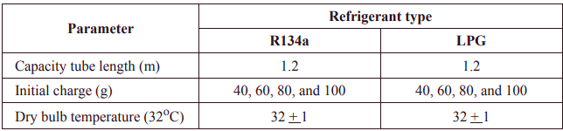
Table 4: Continuous and cycling experiment ranges and conditions. (Babarinde et al., 2015)

In order to solve environmental concerns associated with refrigerants such as R22, the usage of natural refrigerant R290 appears to be a promising alternative. Over a range of evaporating temperatures, a thermodynamic investigation of R290 and R22 in a conventional vapor compression cycle was performed. R290 had a little lower COP than R22, although it may obtain greater COP values in specifically constructed systems. R290, with its excellent environmental and thermophysical characteristics, is deemed a favourable substitute for R22 in practical applications.(Choudhari & Sapali, 2017). Using a range of eight natural refrigerants, a two-stage cascade refrigeration system is optimized to identify the ideal refrigerant pair for various operating temperatures. The selection on basis of system performance and volumetric cooling capacity.(Sarkar et al., 2013).
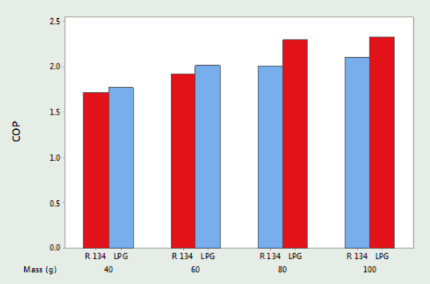
Fig. 4: The impact of refrigerant charges on the performance rating of the system.(Babarinde et al., 2015)

In this study, ammonia, isobutane, and propane vapor compression refrigeration cycles with a constant pressure mixing ejector as an expansion device are compared. It identifies optimal ejector area ratios and cooling COPs for varying conditions, emphasizing the refrigerant's impact on system performance. The application of an internal heat exchanger is deemed unprofitable, and the study highlights potential COP enhancements.(Sarkar, 2009). The use of natural refrigerants as eco-friendly alternatives to synthetic refrigerants, particularly HFCs, in AC systems and refrigeration systems. It discusses recent research and development efforts and considers various refrigeration cycles involving natural refrigerants, highlighting their minimal environmental impact.(Riffat et al., 1997). "Options for low-global-warming-potential and natural refrigerants Part 2: Performance of refrigerants and systemic irreversibilities" likely thoroughly examines low-GWP and natural refrigerants. This section assesses their efficiency, cooling performance, and systemic irreversibilities across various systems, offering valuable insights into environmental impact and operational aspects for sustainable refrigeration technology decisions..(Nawaz & Ally, 2019).

Conclusion

The study explored a variety of novel techniques to improving the efficiency and sustainability of refrigeration systems. These studies demonstrated promising avenues for reducing energy consumption, minimizing environmental impact, and improving the overall performance of cooling and refrigeration systems, ranging from the application of magnetic fields to the use of nanofluids and nanoparticles and the exploration of natural refrigerants. As the world seeks more eco-friendly alternatives, these findings pave the way for greener and more efficient refrigeration technologies, offering significant potential for a more sustainable future in cooling and air conditioning applications.
Bibliography

Abas, N., Kalair, A. R., Khan, N., Haider, A., Saleem, Z., & Saleem, M. S. (2018). Natural and synthetic refrigerants, global warming: A review. Renewable and Sustainable Energy Reviews, 90(February), 557–569. https://doi.org/10.1016/j.rser.2018.03.099
Anish, M. (2018). Performance Study of a domestic refrigerator using CuO / AL 2 O 3 -R22 a nano- refrigerant as working fluid Performance study of a domestic refrigerator using CuO / AL 2 O 3 -R22 nanorefrigerant as a working fluid. 12(March), 12–16. https://doi.org/10.9790/1684-12441216
Aprea, C., Greco, A., Maiorino, A., & Masselli, C. (2017). A comparison between electrocaloric and magnetocaloric materials for solid state refrigeration. International Journal of Heat and Technology, 35(1), 225–234. https://doi.org/10.18280/ijht.350130
Babarinde, T. O., Akinlabi, S. A., Madyira, D. M., & Ekundayo, F. M. (2020). Enhancing the energy efficiency of vapour compression refrigerator system using R600a with graphene nanolubricant. Energy Reports, 6, 1–10. https://doi.org/10.1016/J.EGYR.2019.11.031
Babarinde, T. O., Ohunakin, O. S., Adelekan, D. S., Aasa, S. A., & Oyedepo, S. O. (2015). Experimental study of LPG and R134a refrigerants in vapor compression refrigeration. International Journal of Energy for a Clean Environment, 16(1–4), 71–80. https://doi.org/10.1615/InterJEnerCleanEnv.2016015644
Barclay, I. J. A., Walter, F., Prenger, F. C., & Zimm, C. B. (1987). United States Patent ( 19 ). 19.
Bhattad, A., Sarkar, J., & Ghosh, P. (2018). Improving the performance of refrigeration systems by using nanofluids: A comprehensive review. Renewable and Sustainable Energy Reviews, 82, 3656–3669. https://doi.org/10.1016/J.RSER.2017.10.097
Bi, S., Guo, K., Liu, Z., & Wu, J. (2011). Performance of a domestic refrigerator using TiO2-R600a nano-refrigerant as working fluid. Energy Conversion and Management, 52(1), 733–737. https://doi.org/10.1016/j.enconman.2010.07.052
Choudhari, C. S., & Sapali, S. N. (2017). Performance Investigation of Natural Refrigerant R290 as a Substitute to R22 in Refrigeration Systems. Energy Procedia, 109(November 2016), 346–352. https://doi.org/10.1016/j.egypro.2017.03.084
Classification, P. (2007). ( 12 ) Patent Application Publication ( 10 ) Pub . No .: US 2007 / 0240428A1. 1(19).
Deshmukh, R. G., Zanwar, D. R., Joshi, S. S., & Joshi, Y. G. (2023). Impact of magnetic field generated using neodymium-iron-boron magnetic pairs on condensation heat transfer coefficient for tetrafluroethane (R134a). Materials Today: Proceedings. https://doi.org/10.1016/J.MATPR.2023.08.220
Deshmukh, R., Zanwar, D., Joshi, S., & Chakrabarty, S. (2022). Experimental investigations on the performance of a vapor compression refrigeration system under the influence of magnetic field generated using magnetic pair and Halbach array. Energy Sources, Part A: Recovery, Utilization, and Environmental Effects. https://doi.org/10.1080/15567036.2021.2024302
Dooley, K. J. (2012). Apparatus and Method of Using Nanofluids to Improve Energy Efficiency of Vapor Compression Systems. 1(19), 28–31. https://patents.google.com/patent/US20120017614A1/en
Jadhav, S. M., Mahalingam, A., Ugle, V. V., & Kamaraj, L. (2022). Increasing the waste heat absorption performance in the refrigeration system using electromagnetic effect. International Journal for Simulation and Multidisciplinary Design Optimization, 13. https://doi.org/10.1051/smdo/2022010
Jin, Z., Li, S., Zhou, R., Xu, M., Jiang, W., & Du, K. (2021). Experimental investigation on the effect of TiO2 nanoparticles on the performance of NH3 – H2O - LiBr absorption refrigeration system. International Journal of Refrigeration, 131, 826–833. https://doi.org/10.1016/J.IJREFRIG.2021.08.009
Joshi, Y. G., Zanwar, D. R., Joshi, S. S., & Bhave, N. A. (2022). Experimental investigation of Al2O3 nanosuspension in vapor compression refrigeration system using tetrafluoroethane and iso-butane refrigerants. Materials Today: Proceedings, 50, 1804–1813. https://doi.org/10.1016/J.MATPR.2021.09.209
Joshi, Y. G., Zanwar, D. R., Joshi, S. S., & Gupta, V. (2023). Performance investigation of vapor compression refrigeration system using novel amine treated graphene quantum dots based nanosuspension. Thermal Science and Engineering Progress, 38, 101678. https://doi.org/10.1016/J.TSEP.2023.101678
Katkar, S. A., Dakare, R. A., Darlinge, S. M., Lautawar, S. C., & Jaju, S. (2021). EasyChair Preprint Magnetic Devices for Improving (R134a) Refrigerant Properties MAGNETIC DEVICES FOR IMPROVING (R134a) REFRIGERANT PROPERTIES.
Khattak, K. S. (2017). Nanostructured Materials For Magnetic Refrigeration by Khurram S . Khattak A Dissertation submitted to The Faculty of The School of Engineering and Applied Science of The George Washington University in partial satisfaction of the requirement for the degr.
Kim, H. M., Kim, K., Lee, C. Y., Joo, J., Cho, S. J., Yoon, H. S., Pejaković, D. A., Yoo, J. W., & Epstein, A. J. (2004). Electrical conductivity and electromagnetic interference shielding of multiwalled carbon nanotube composites containing Fe catalyst. Applied Physics Letters, 84(4), 589–591. https://doi.org/10.1063/1.1641167
Kundan, L., & Singh, K. (2021). Improved performance of a nanorefrigerant-based vapor compression refrigeration system: A new alternative. Proceedings of the Institution of Mechanical Engineers, Part A: Journal of Power and Energy, 235(1), 106–123. https://doi.org/10.1177/0957650920904553
Li, L., Wei, P., Ke, B., Nie, X., Zhu, W., Zhao, W., & Zhang, Q. (2023). Optimizing magnetocaloric and thermoelectric performance of MnCoGe/BiSbTe composites by regulating magnetostructural transition and element diffusion. Materials Characterization, 199, 112760. https://doi.org/10.1016/J.MATCHAR.2023.112760
Majgaonkar, A. S. (2016). Use of Nanoparticles In Refrigeration Systems : A Literature Review Paper * Corresponding Author. International Compressor Engineering, Refrigeration and Air Conditioning, and High Performance Buildings Conferences, 1–10.

Meena, A., & Sen, S. (2018). Performance Optimization of Compressor Rotor Clutch Sub-assembly Using Electro-Magnetic Analysis. SAE Technical Papers, 2018-April, 1–6. https://doi.org/10.4271/2018-01-0484
Mishra, R. S. (2017). Method for improving thermodynamic performance of vapour compression refrigeration system using nanofluids- A Review. International Journal of Research in Engineering and Innovation, 2(4), 374–383. http://www.ijrei.com
Nawaz, K., & Ally, M. R. (2019). Options for low-global-warming-potential and natural refrigerants Part 2: Performance of refrigerants and systemic irreversibilities. International Journal of Refrigeration, 106, 213–224. https://doi.org/10.1016/j.ijrefrig.2019.05.030
Pecharsky, V. K., & Gschneidner, K. A. (1999). Magnetocaloric effect and magnetic refrigeration. Journal of Magnetism and Magnetic Materials, 200(1–3), 44–56. https://doi.org/10.1016/S0304-8853(99)00397-2
Radhakrishnan, P. (2012). Ste-. 1(19).
Riffat, S. B., Afonso, C. F., Oliveira, A. C., & Reay, D. A. (1997). Natural refrigerants for refrigeration and air-conditioning systems. Applied Thermal Engineering, 17(1), 33–42. https://doi.org/10.1016/1359-4311(96)00030-0
Romero Gómez, J., Ferreiro Garcia, R., De Miguel Catoira, A., & Romero Gómez, M. (2013). Magnetocaloric effect: A review of the thermodynamic cycles in magnetic refrigeration. Renewable and Sustainable Energy Reviews, 17, 74–82. https://doi.org/10.1016/J.RSER.2012.09.027
Saad, A., Jamal, A., Othman, A., Daif, K., Bahri, Z., Al-abbasi, O., & Nabhan, M. (n.d.). Magneto-Caloric-Effect-Based Quasi-Static Cooling System. 7–11.
Sarkar, J. (2009). Performance characteristics of natural-refrigerants- based ejector expansion refrigeration cycles. Proceedings of the Institution of Mechanical Engineers, Part A: Journal of Power and Energy, 223(5), 543–550. https://doi.org/10.1243/09576509JPE753
Sarkar, J., Bhattacharyya, S., & Lal, A. (2013). Selection of suitable natural refrigerants pairs for cascade refrigeration system. Proceedings of the Institution of Mechanical Engineers, Part A: Journal of Power and Energy, 227(5), 612–622. https://doi.org/10.1177/0957650913487730
Sruthi Emani, M., & Kumar Mandal, B. (2018). The Use of Natural Refrigerants in Refrigeration and Air Conditioning Systems: A Review. IOP Conference Series: Materials Science and Engineering, 377(1). https://doi.org/10.1088/1757-899X/377/1/012064
Suresh Kumar, V. P., Baskaran, A., & Manikandan Subaramanian, K. (2016). A performance study of Vapour compression refrigeration system using ZrO2 Nano particle with R134a and R152a. International Journal of Scientific and Research Publications, 6(12), 410. www.ijsrp.org
Tipole, P., Karthikeyan, A., Bhojwani, V., Patil, A., Oak, N., Ponatil, A., & Nagori, P. (2016). Applying a magnetic field on liquid line of vapour compression system is a novel technique to increase a performance of the system. Applied Energy, 182, 376–382. https://doi.org/10.1016/J.APENERGY.2016.08.129
Vara Prasad, G. V. V. S., & Dilip Kumar, K. (2018). Employing Magnetic Field to Liquid Channel of Nano Lubricant (CuO& PAG Oil) Rigged VCR System by Using R134a Refrigerant. Materials Today: Proceedings, 5(9), 20518–20527. https://doi.org/10.1016/j.matpr.2018.06.429
Xing, L., Cui, W., Sang, X., Hu, F., Wei, P., Zhu, W., Nie, X., Zhang, Q., & Zhao, W. (2021). Enhanced thermoelectric performance and atomic-resolution interfacial structures in BiSbTe thermo-electro-magnetic nanocomposites incorporating magnetocaloric LaFeSi nanoparticles. Journal of Materiomics, 7(5), 998–1006. https://doi.org/10.1016/j.jmat.2021.02.013
Yıldız, G., Ağbulut, Ü., & Gürel, A. E. (2021). A review of stability, thermophysical properties and impact of using nanofluids on the performance of refrigeration systems. International Journal of Refrigeration, 129, 342–364. https://doi.org/10.1016/J.IJREFRIG.2021.05.016
Yogesh Joshi, Dinesh Zanwar, & Sandeep Joshi. (2021). Performance investigation of vapor compression refrigeration system using R134a and R600a refrigerants and Al2O3nanoparticle based suspension. Materials Today: Proceedings, 44, 1511–1519. https://doi.org/10.1016/j.matpr.2020.11.732.

